New York City College of Technology, CUNY
CURRICULUM MODIFICATION PROPOSAL FORM
This form is used for all curriculum modification proposals. See the Proposal Classification Chart for information about what types of modifications are major or minor. Completed proposals should be emailed to the Curriculum Committee chair.

Title of Proposal | CST4800 Prerequisite Change
Date | 11/5/18
Major or Minor | Minor
Proposer’s Name | Ossama Elhadary
Department | Computer Systems Technology
Date of Departmental Meeting in which proposal was approved | 5/11/18
Department Chair Name | Hong Li
Department Chair Signature and Date | 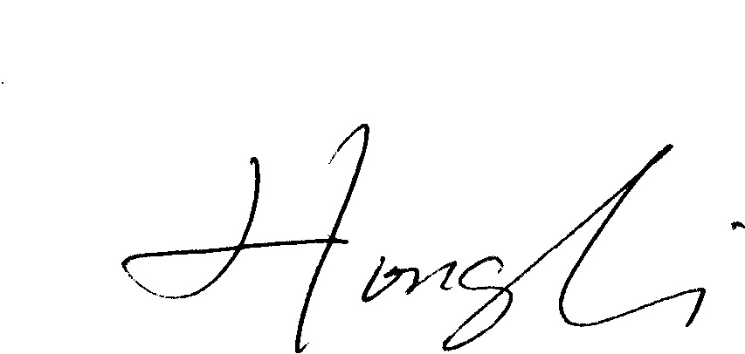 11/09/2018
Academic Dean Name | Kevin Hom
Academic Dean Signature and Date
Brief Description of Proposal  (Describe the modifications contained within this proposal in a succinct summary. More detailed content will be provided in the proposal body. | Change the prerequisites of CST4800 (Project Management) from two CST36XX courses to three CST35XX courses or higher.
Brief Rationale for Proposal  (Provide a concise summary of why this proposed change is important to the department. More detailed content will be provided in the proposal body). | After the latest curriculum change, we reevaluated the CST4800 and determined that three CST35XX courses or higher will be sufficient preparation for the CST4800 Project management course. The Two CST36XX as prereq in previous modules do not apply to the current curriculum in each track as the tracks contain courses in different level CST35xx, CST36xx and CST47xx  With two CST36xx courses as prerequisites, many of the students can only take this course during their last semester and any scheduling conflict in this case might limit their ability to graduate on time. With three prerequisite CST35xx or higher courses on the other hand, the students have more flexibility in takin this course without jeopardizing the integrity of the program.
Proposal History  (Please provide history of this proposal: is this a resubmission? An updated version? This may most easily be expressed as a list). | This is a new proposal

Please include all appropriate documentation as indicated in the Curriculum Modification Checklist.

For each new course, please also complete the New Course Proposal and submit in this document.

Please submit this document as a single .doc or .rtf format. If some documents are unable to be converted to .doc, then please provide all documents archived into a single .zip file.

ALL PROPOSAL CHECK LIST
Completed CURRICULUM MODIFICATION FORM including:
- Brief description of proposal
- Rationale for proposal
- Date of department meeting approving the modification
- Chair’s Signature
- Dean’s Signature
Evidence of consultation with affected departments
List of the programs that use this course as required or elective, and courses that use this as a prerequisite.
Documentation of Advisory Commission views (if applicable).
Completed Chancellor’s Report Form.

EXISTING PROGRAM MODIFICATION PROPOSALS

Documentation indicating core curriculum requirements have been met for new programs/options or program changes.
Detailed rationale for each modification (this includes minor modifications)

Chancellor report from
Section AV: Changes in Existing Courses

AV.1. Computer Systems Technology

CST 4800 Project Management

From: |  | To:
Course Number: |  | Course Number:
Course Title: |  | Course Title:
Description: |  | Description:
Class Hours : |  | Class Hours:
Lab Hours : |  | Lab Hours:
Credits: |  | Credits:
Prerequisite: | Two CST36XX | Prerequisite: | Three CST35XX or higher
Corequisites: |  | Corequisites:
Pre- or corequisites: |  | Pre- or corequisites:

Rationale: After the latest curriculum change, we reevaluated the CST4800 and determined that three CST35XX or higher will be sufficient preparation for CST4800 Project management

