3/11/2019

NEW YORK CITY COLLEGE OF TECHNOLOGY
OF
THE CITY UNIVERSITY OF NEW YORK

A PROPOSAL TO ESTABLISH
AN UNDERGRADUATE DEGREE PROGRAM LEADING TO
A BACHELOR OF SCIENCE DEGREE
IN HEALTH COMMUNICATION

SPONSORED BY THE DEPARTMENT OF HUMANITIES
Ann Delilkan, Chair

Prepared by Denise Scannell, David Lee and Zheng Zhu
College Representative: Provost Bonne August
Dean Justin Vazquez-Poritz, School of Arts and Sciences
Contact: Communication Curriculum Committee Chair Denise Scannell

Acknowledgements
The proposers would like to thank the following people for their support:
From outside of City Tech:
Linda Aldoory, University of Maryland
Priscilla De Jesus, NYC Department of Health and Mental Hygiene
Kathryn Greene, Rutgers University
Elaine Hsieh, University of Oklahoma
Gary Kreps, George Mason University
Theresa Thompson, University of Dayton
From within City Tech:
Nina Bannett, NYCCT Department of English Chair
Lucas Bernard, NYCCT Business Department Chair
Josef Bohm, NYCCT Health Services Administration Coordinator
Renata Budny, NYCCT Restorative Dentistry Chair
Douglas Davis, NYCCT Communication Design Chair
Marta Effinger-Crichlow, NYCCT African American Studies Chair
Sunghoon Jang, NYCCT Computer Engineering Technology Department Chair
John McCullough, NYCCT Entertainment Technology Department Chair
Peter Parides, NYCCT Social Sciences Department Chair
Justine Pawlukewicz, NYCCT Human Services Department Chair
Margaret Rafferty, NYCCT Nursing Department Chair
Diana Samaroo, NYCCT Chemistry Department Chair
Maura Smale, NYCCT Ursula C. Schwerin Library Department Chair
David Smith, NYCCT Dean of School of Professional Studies
Julian Williams, NYCCT Liberal Arts and Arts/ Liberal Arts and Sciences Director
Andleeb Zameer, NYCCT Biological Sciences Chair
(See Appendix G: Letters of Support)
Articulation Agreement Letters of Support:
- Vincent Cheng, Deputy Chair, Department of Speech, Communication and Theatre, Borough of Manhattan Community College
- Louis A. Lucca, Director of Communication Studies, LaGuardia Community College
(See Section 5, Articulation Agreements)
The proposers also are grateful for the assistance of Sharon Boyd, Ann Delilkan, Christopher Swift, Justin Vazquez-Poritz, and numerous others.

Table of Contents
Curriculum Modification Proposal Form 6
- Purposes and Goals 8
  - Description of Program Purpose 8
  - Educational Goals and Career Objectives 8
  - Brief Rationale for Program 9
  - National and Local Educational Trends 11
    - Health and Communication Degrees: A Growth Industry 11
    - Health Communication Degrees Nationwide 12
    - Communication Degrees in New York and Surrounding Areas 12
    - Other Health Degrees: How is Health Communication Different? 12
    - Concluding National and Local Trends Overview 14
  - Faculty Interest and Commitment 14
    - National, College-wide and Departmental Support 14
    - Health Sciences Interprofessional Taskforce 14
  - Relation to Existing Departmental or College Offerings 15
    - Health Services Administration 15
    - Human Services 16
    - Nursing 16
    - Business and Communication Design 17
    - Biological Sciences 17
    - English 17

- Needs and Justification 18
  - Meeting Occupational, Economic and Educational Needs 18
    - About the Communication Field 18
    - About Health Communication 18
    - The Growth of Health Care 19
    - Occupational Demand for Trained Communicators 21
    - Meeting the Needs of Students (Two Areas of Concentration) 21
      - Area of Concentration #1: Health Communication and Culture 22
      - Area of Concentration #2: Health Promotion and Media 23
    - Meeting the Needs of CUNY 24
    - Meeting the Needs of City Tech 25

- Student Interest and Enrollment 26
  - Surveys Show Strong Student Interest 26
  - Other Indicators 26
  - Estimate of Enrollment 26

- Curriculum 27
  - Curriculum Rationale 27
  - Degree Requirements 27
  - Sample Course Sequence 31
  - Course Descriptions 33
  - Accrediting or Licensure Requirements 36
  - Non-Course Requirements (i.e. Thesis or Comprehensive Exam) 36

- Articulation Agreements 36

- Faculty 39
  - Anticipated Number of Full Time Faculty 40
  - Anticipated Number of Adjunct Faculty 40
  - Effect on Established Programs 41

- Cost Assessment 41
Appendix A: Health Communication Degrees Nationwide 42
Appendix B: Communication Degrees in New York and Surrounding Areas 44
- Private Institutions 44
- State University of New York (SUNY) 44
- Selected New Jersey and Connecticut Institutions 45
- City University of New York (CUNY) 45
  - Senior Colleges 45
  - Junior Colleges 46
Appendix C: Jobs in Health Communication 48
- Selected Indeed.com Search Results 48
- Complete Job Postings 49
  - Constituency Communications Officer (Planned Parenthood) 49
  - Communications Director (NYU Langone Health) 51
  - Communication and Advocacy Advocate (Global Health Strategies) 54
Appendix D: Student Survey Results 56
- Spring 2018 Pilot Survey 56
- Fall 2018 Online Survey 57
Appendix E: New Course Outlines 62
- COM 1400 Introduction to Media Studies 63
- COM 2405 Principles of Persuasion 69
- COM 2406 Gender and Health Communication 74
- COM 3402 Communication in Multicultural Healthcare Settings 82
- COM 3403 Health Communication and Education 90
- COM 3503 Health, Media and Communication Technology 97
- COM 3404 Crisis and Emergency Risk Communication 103
- COM 3405 Public Health Campaigns 110
- COM 3500 U.S. Health Policy and Communication Advocacy 116
- COM 3501 Introduction to Healthcare Interpreting 124
- COM 3502 Communicating Health Narratives 130
- COM 4000 Health Communication Research Methods and Design 138
- COM 4100 Senior Seminar 144
- COM 4200 Professional Internship 149
Appendix F: Internship Forms 150
Appendix G: Letters of Support 155
Part 1: From outside City Tech 155
- Linda Aldoory, University of Maryland 156
- Priscilla DeJesus , NYC Department of Health and Mental Hygiene 157
- Kathryn Greene, Rutgers University 158
- Elaine Hsieh, University of Oklahoma 159
- Gary Kreps, George Mason University 160
- Theresa Thompson, University of Dayton 161
Part 2: From within City Tech 163
- Nina Bannett, English Department 164
- Lucas Bernard, Business Department 165
- Josef Bohm, Health Services Administration 166
- Renata Budny, Restorative Dentistry 167
- Douglas Davis, Communication Design 168
- Marta Effinger-Crichlow, African American Studies 169
- Sunghoon Jang, Computer Engineering Technology 170
- John McCullough, Entertainment Technology 171
- Peter Parides, Department of Social Science 172
- Justine Pawlukewicz, Human Services 173
- Margaret Rafferty, Department of Nursing 174
- Diana Samaroo, Chemistry Department 175
- Maura Smale, Ursula C. Schwerin Library 176
- David Smith, School of Professional Studies Dean 177
- Julian Williams, Director of Liberal Arts and Sciences 178
- Andleeb Zameer, Biological Sciences 179
Appendix H: Library Form 180
Appendix I: New Course Proposal Forms 182
Appendix J: Chancellor’s Report Forms 232
References and Works Cited 248

New York City College of Technology, CUNY

CURRICULUM MODIFICATION PROPOSAL FORM
This form is used for all curriculum modification proposals. See the Proposal Classification Chart for information about what types of modifications are major or minor. Completed proposals should be emailed to the Curriculum Committee chair.
Title of Proposal | Bachelor of Science in Health Communication
Date | 12/14/2018
Major or Minor | Major
Proposer’s Name | Dr. Denise Scannell  Dr. David Lee  Dr. Zheng Zhu
Department | Humanities
Date of Departmental Meeting in which proposal was approved | 10/4/2018 and 12/6/2018
Department Chair Name | Dr. Ann Delilkan
Department Chair Signature and Date | 12-18-2018
Academic Dean Name | Dr. Justin Vazquez-Poritz
Academic Dean Signature and Date | 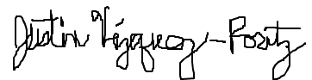  1/27/19
Brief Description of Proposal  (Describe the modifications contained within this proposal in a succinct summary. More detailed content will be provided in the proposal body. | The Department of Humanities of the School of Arts and Sciences at New York City College of Technology proposes a Bachelor of Science (BS) degree program in Health Communication. The proposed program provides the fundamental knowledge, values, and skills for communication professionals in health care, wellness, educational, media and other occupations. The proposal includes 14 new courses required for the degree.
Brief Rationale for Proposal  (Provide a concise summary of why this proposed change is important to the department. More detailed content will be provided in the proposal body). | Communication is a nationally recognized field of study and ranks among the top majors in popularity across higher education. Communication skills are highly valued by employers. NYCCT is one of two CUNY senior colleges without a Communication program. In recent decades, CUNY campuses have added Communication programs, but none offer a Health Communication concentration. Communication problems in healthcare are estimated to be a major cause of injury and death. Unclassified, undeclared, and non-degree seeking students will have new health-related baccalaureate options at NYCCT as a result of this program. In an online survey of these students, 63% were interested in a Health Communication major (N=193).
Proposal History  (Please provide history of this proposal: is this a resubmission? An updated version? This may most easily be expressed as a list). | 12/17/2018- 1st submission.  2/19/2019-Revised 2nd submission  3/11/2019-Revised 3rd submission
Please include all appropriate documentation as indicated in the Curriculum Modification Checklist.
For each new course, please also complete the New Course Proposal and submit in this document.
Please submit this document as a single .doc or .rtf format. If some documents are unable to be converted to .doc, then please provide all documents archived into a single .zip file.
ALL PROPOSAL CHECK LIST
Completed CURRICULUM MODIFICATION FORM including:
- Brief description of proposal | x
- Rationale for proposal | x
- Date of department meeting approving the modification | x
- Chair’s Signature | x
- Dean’s Signature | x
Evidence of consultation with affected departments  List of the programs that use this course as required or elective, and courses that use this as a prerequisite. | x
Documentation of Advisory Commission views (if applicable).
Completed Chancellor’s Report Form. | x
EXISTING PROGRAM MODIFICATION PROPOSALS
Documentation indicating core curriculum requirements have been met for new programs/options or program changes.
Detailed rationale for each modification (this includes minor modifications)

Purpose and Goals

Description of Program Purpose
The Humanities Department in the School of Arts and Sciences of New York City College of Technology, City University of New York, seeks to register a Bachelor of Science degree in Health Communication. The proposed program provides the fundamental knowledge, values, and skills for communication professionals in health care, wellness, educational, media and other occupations. The Health Communication Bachelor of Science (HCBS) strengthens NYCCT’s commitment to providing innovative baccalaureate programs, enhancing the national reputation of our college and complementing existing programs in allied health. It builds capacity and resources, deepening connections between NYCCT and the community—with medical practices, hospitals, tech and media companies, activist organizations and not-for-profits. The major adds an important program option for unclassified students, transfer students, A.S. in Health Sciences students, as well as creating employment opportunities in a large number of exciting health and communication careers.

1.2 Educational Goals and Career Objectives
The HCBS builds upon existing communication courses offered by the Humanities Department. This proposal also contains 14 new required courses for the major. Students pursuing the degree are educated in a greater range of health communication topics than those that are available in existing allied health programs. Topics include: health advocacy and activism; health promotion campaigns; health information and communication technologies; provider-patient interactions; communication interventions on health disparities; the culture-centered approach; narrative medicine; the role of the mass media and globalization in influencing health outcomes; communicating grief and loss, and others related to communication, medicine and public health. A well-rounded, robust curriculum, grounded in humanities, behavioral sciences, biological sciences and public health practice, positions graduates to benefit from advances in medicine, healthcare, and new media. Graduates are prepared to participate in local/global conversations, decision-making and advocacy in health, science, technology, enterprise, and policy. In addition, the program provides an excellent foundation for students interested in pursuing graduate level training in communication and/or public health.
Graduates of the program will be able to:
- Communicate clearly and concisely in speech, writing and multimedia
- Think critically to find solutions to communication problems
- Function as communication professionals in occupational settings
- Gain an understanding of communication in interpersonal, intercultural, mediated, organizational, and political contexts
- Research, evaluate and cite information sources
- Identify, evaluate and effectively respond to ethical issues in communication
- Value cultural diversity and consider the influence of culture on health outcomes
- Recognize structural, biological and behavioral determinants of health
- Challenge disparities related to gender, race, ethnicity, income, sexual orientation, age or ability
- Pursue graduate level study in communication and/or public health
The HCBS degree will prepare its graduates for a variety of health-related occupations where communication is involved. Designed to cover numerous skill sets and competencies, the curriculum prepares graduates for jobs in healthcare, media, education, tech and other industries. The list that follows is not exhaustive, but suggests some of the possible career paths.
Job titles in Health Communication may include:

- Communications Consultant
- Health Educator
- Health/Medical Marketer
- Medical Translator
- Language Access Coordinator
- Medical Mediator/ Arbiter
- Patient Navigator
- Patient Advocate
- Social Media Manager
- Multimedia Content Creator
- Publicist
- Media Relations Assistant
- Hospital Ombudsman
- Health Campaign Worker
- Community Outreach
- Constituency Communications Officer
- School Health Care Program Manager
- Office of Disability Services
- Medical Grants Writer
- Health Reporter
- Communication Coach
- Standardized Patient Trainer
- Hospital Officer of Communications
- Public Relations Director
- Public Information Officer
- Health Promotion Specialist
- Peer Health Promoter
- Research Analyst
- Medical Training Supervisor
- Communication Specialist
- Quality Assurance Associate
- Evaluation Consultant
- Event Coordinator
- Media Planner
- Associate Brand Manager
- Health Personnel Assistant
- Medical Center Publications Editor
- Hospice Worker/Manager
- Internal Communications Coordinator
- Health Care Consultant
- Health Risk Assessment Outreach
- Project Coordinator
- Healthcare Recruiter
- Onboarding Assistant
- Activities Director
- Pharmaceutical Salesperson/Marketer
- Associate Program Planner
- Marketing Director
- Safety Compliance Affiliate
- Nonprofit Fund Raiser
For more information see Appendix C: Jobs in Health Communication.

1.3 Brief Rationale for Program
1. Communication is a nationally recognized field of study and ranks among the top ten majors in popularity across higher education. Within the Communication field, Health Communication is the most funded and cited subdiscipline (NCA, 2017), but surprisingly, there are few undergraduate programs dedicated to it. In recent decades, CUNY campuses have added baccalaureate programs in Communication, but none offer a Health Communication concentration.
2. CUNY community colleges have created associate degree programs in Communication that educate students in Health Communication, but choices for students looking to continue baccalaureate studies in this area are limited to expensive out-of-state programs (such as Montclair State's concentration in Health Communication) or private schools (such as the Media, Culture, and Communication/Global Public Health B.S. program at New York University).
3. As detailed in the A.S. in Health Sciences proposal, about 900 students come to City Tech each year hoping to go into Nursing, Radiological Technology, Dental Hygiene, or other allied health fields, but these competitive programs accept only about 275 students per year. Presently, students unable to meet the entrance requirements for these majors may register as “Unclassified” or enter into a placeholder degree program unrelated to their career or academic interests. The Health Communication B.S. gives these motivated students more options in the pursuit of a degree related to healthcare.
4. In an online survey of 193 unclassified, undeclared, non-degree seeking and LAA/ LAS students, 90% of respondents agreed that NYCCT needed more baccalaureate programs in health. 63% were interested in a Health Communication major.
5. Communication skills are highly valued by employers within health care industries (ZipRecruiter, 2018). In a 2013 survey by the Association of American Colleges and Universities, 93% of employers said clear communication is important, and 75% wanted more focus on communication skills in college (Moore, 2018).
6. No significant new resources are needed to establish the Health Communication B.S. in the Humanities Department (unlike technical programs where expensive equipment or lab/ clinical facilities are needed). The new major builds on course offerings already available in Humanities and other departments. Needs for equipment, facilities and new faculty hires will be reassessed as enrollment grows.
7. The new major's curriculum is congruent with the CUNY Master Plan (2016), especially in terms of affordability, online education, digital literacy, and workforce development. The program makes every effort to be cost effective and convenient for students. Many courses are hybrid and utilize free digital technologies for research and communication. Wherever possible we have selected zero cost or low-cost textbooks. There are no mandatory uniforms or equipment. Students prepare to enter the workforce through internships and service-learning opportunities.
8. The program is consistent with City Tech's educational goals, in terms of developing knowledge from a range of disciplinary perspectives; using technologies for communication, inquiry, analysis, and productive work, and valuing ethical, credible and factual communication (“Our Mission,” 2018).
9. Communication is widely acknowledged to be a key factor in the delivery of health care. Problems related to miscommunication are estimated by to be a major driver of rising health care costs and higher rates of healthcare acquired injury, illness and death (Institute of Medicine, 2015; James, 2013; “Joint Commission,” 2012; Makary and Daniel, 2016).

1.4 National and Local Educational Trends

1.4.1 Health and Communication degrees: Two growth industries
This program meets an urgent need. More students are going to college than ever before. 1.9 million bachelor's degrees were granted in the 2014-2015 school year —a 32% increase over the previous decade (NCES, 2018). The National Center for Education Statistics projects that college enrollment will climb 15 percent by 2025 (Lederman, 2017). Federal spending increased for student aid and faculty research in March 2018 (Kreighbaum, 2018; Seltzer, 2018). The Georgetown Center on Education and the Workforce estimates the average lifetime worth of a bachelor's degree at $2.8 million, with holders of a bachelor’s degree earning 84% more than those with just a high school diploma, and 31% more than those with an associate’s degree (Carnevale, Rose & Cheah, 2011).
The fastest growing majors are in health. Since 2005, the number of students who majored in health-related fields increased by 168% (NCES, 2018), corresponding to an increased demand for health care workers (Kavilanz, 2018).
Communication, #2 on the Princeton Review’s Top 10 College Majors (“Top 10 College Majors” 2018), is another growth area in higher education. Communication bachelor degrees constitute one quarter of all degrees granted in the Humanities, and they are the only degree in the Humanities showing growth, according to data presented by the National Communication Association (NCA, 2017). NCA reports that Communication graduates earn more than English or Social Science graduates, and they have the lowest rates of unemployment among those degrees (NCA, 2018).
This chart shows that, in about 40 years, the number of communication and health bachelor degrees increased over 300%, a dramatic illustration of their growing popularity.

Adapted from Table 322.10. National Center for Education Statistics (NCES, 2017).

1.4.2 Health Communication Degrees Nationwide
Out of over 800 Communication baccalaureate programs in the U.S., we found just 14 offering a B.A. or B.S. in Health Communication (and 2 offering certificates). They are mostly outside of the New York Metropolitan area. Health Communication degrees are more numerous at the graduate level, with some offered by top-tier institutions such as Harvard, Cornell, John Hopkins and Purdue. Among approximately 250 graduate programs in Communication, 36 offer M.A., M.S., and/or Ph.D. degrees in Health Communication. Harvard offers Master of Public Health (M.P.H.) and Doctor of Public Health (D.P.H) in Health Communication.

1.4.3 Communication Degrees in New York and Surrounding Areas
While there are 14 undergraduate degrees in Health Communication, nationwide, and 36 at the graduate level, there are very few in New York State, the New York metropolitan area or the tri-state area. Limiting our search to New York City, Southern and Central New York State, and New Jersey and Connecticut, we estimate there are at least 64 higher education institutions offering degrees in Communication. SUNY has 11 such programs, CUNY has 14, and 18 of them are at private institutions in New York State. In nearby NJ and CT, we found 21 Communication Programs.
To respond to the increased demand for undergraduate Communication degrees, CUNY junior and senior colleges continue to add programs (Baruch and BMCC are recent examples). We note that City Tech is one of only two Senior Colleges that does not offer a Communication degree (the other is John Jay).
The number of Communication baccalaureate programs across CUNY indicate the relevance and popularity of COM degrees. However, the needs of students seeking a degree in this field are currently not being met at City Tech. Having reviewed the CUNY inventory of academic programs in Communication, a Health Communication focus is not offered at any other campus, justifying the advance of our proposal.

1.4.4 Other Undergraduate Health Degrees at CUNY—How Is Health Communication Different?
CUNY has 27 baccalaureate level health programs. Here is a list of selected bachelor programs at CUNY, in allied health fields, that share some similarities with ours. Note that two of them are at NYCCT.
Institution | Degree(s)
Brooklyn College | B.S. & B.A. in Health and Nutrition Sciences
York College | B.S. in Community Health Education and Health Science
CUNY School of Professional Studies | B.S. in Health Information Management (online)  B.S. in Health Services Administration (online)
New York City College of Technology | B.S. in Health Services Administration  B.S. in Human Services
Hunter College | B.S. in Community Health
Lehman College | B.S. in Health Education and Promotion
The HCBS program shares many of the ethical values stated in the descriptions of these programs available online. For example, social justice, health equity and addressing differential health outcomes according to race, ethnicity, gender and socioeconomic status are primary concerns.
Otherwise, there are major differences in topics and curriculum. While they are important areas of study, the following are not a primary focus of the HCBS program:
- Medical record keeping/ information management
- Medical billing
- Financial and revenue management of healthcare facilities
- Administrative and managerial tasks in healthcare industries
- Medical informatics, analytics, or data mining
- Case management
- Human Services, Social Work
- Mental health counseling and psychotherapy
There are also differences in degree path. For example, Hunter students working towards a Community Health B.S. take public health courses (such as Epidemiology) not offered at our institution. Hunter students take only one course in Health Communication (COMHE 30400 Introduction to Health Communication Theory and Practice), and the course description for this class does not mention provider-patient communication or public health campaigns, which are central to the proposed HCBS curriculum. While Lehman’s program in Health Education and Promotion does not offer any courses with the title “Health Communication,” there is a course called HEA 400 Program Planning and Evaluation about “planning and evaluating health education and promotion programs” in schools, health care settings and workplaces. Our course COM 3405 Public Health Campaigns appears to be comparable, but with greater focus on mass media health campaigns.
The other major difference between HCBS and other health-related BS programs is disciplinary perspective. While the HCBS faculty have Communication degrees, other programs have faculty from different disciplines. For example, Hunter’s Community Health B.S. faculty include an Epidemiologist, two Medical Doctors (M.D.s) and an Educational Administrator Ph.D./ Certified Health Education Specialist (CHES) (“Community Health Faculty,” 2018).
Our review of City Tech allied health programs identified major differences between degrees, related to both subject matter, disciplinary perspective and desired employment outcomes for graduates. Details can be found below in Section 1.6, “Relation to Existing Departmental or College Offerings.”
While we estimate that these other health-related degrees are of highest relevance and value for graduates seeking health care careers, we believe that there is room in the CUNY curricular inventory for even greater variety in degree offerings.

1.4.5 Concluding National and Local Trends Overview
This section summarized some of the major differences between HCBS and other CUNY healthcare related undergraduate degrees. The review of existing programs shows that Health Communication is an area of study well positioned to meet an increased demand for four-year undergraduate degrees in both communication and allied health care. The need for such a degree is not currently being met by existing programs.

1.5 Faculty Interest and Commitment
The Humanities Department has faculty with expertise in a variety of areas of communication, including health, interpersonal, organizational, intercultural, international and digital communication; rhetoric/persuasion; media studies and critical race/gender studies. Two new Communication hires in 2015 have enabled the department to expand its offerings and strengthen the existing communication curriculum. The three core Communication faculty are devoting all of their teaching hours to courses in the new program.

1.5.1 National, College-wide and Departmental Support
We are proud to include letters of support from Health Communication scholars from around the country (See Appendix G: Letters of Support). These highly regarded scholars run Health Communication academic programs, research centers, and edit scholarly journals. They strongly endorse this proposal and provide convincing arguments for its approval. In addition, the proposal has received widespread support across the three schools of NYCCT.
This proposal was presented to the Department of Humanities and passed unanimously at a department meeting on October 4, 2018. After more letters of support were added to the proposal, it was again unanimously approved on December 6, 2018.
This proposal also includes letters of support from a number of City Tech department chairs and program coordinators, as listed in the Acknowledgements section on page 2. Earlier efforts to add curriculum in Health Communication also received endorsement. In 2016, the course proposal for COM 2403 Health Communication received letters of support from Margaret Rafferty (Nursing); Josef Bohm (HSA), and Christine Thorpe (Health and Human Services). Communication faculty have guest lectured on Health Communication topics in Interdisciplinary courses such as ARTH 2101 Healing the Body: The Visual Culture of Medicine and PSY 3405 Health Psychology. Communication faculty members have also worked with allied health faculty developing Health Sciences curricula, as detailed in the next section.

1.5.2 Health Sciences Interprofessional Task Force
Starting in 2016, Communication faculty participated in an Interprofessional Task Force convened for the purpose of creating new curricula in Health Sciences. A “Communication in Healthcare Committee” was formed during these meetings, which included Professors Margaret Rafferty, Carmel Dato, and Linda Paradiso (Nursing), Maureen Archer and Christine Macarelli (Dental Hygiene), and others. Subject matter was identified related to improving communication in health care, including:
- Provider/ patient interaction with simulation exercises for students
- Public health campaigns/ social marketing
- Social/ family/peer support for health/illness
- Communication theory
This collaboration produced a course proposal for COM 1403 Introduction to Healthcare Communication intended to be one of five core course offerings in the proposed Associate of Science in Health Sciences (A.S.H.S.). An initiative of School of Professional Studies Dean David Smith and Health Services Administrator Program Coordinator Josef Bohm, the A.S.H.S. was approved by the College Council on December 4, 2018.

1.6 Relation to Existing Departmental or College Offerings
The Health Communication B.S. is the first degree ever offered by the Humanities Department. Currently approved and established courses for the program include:
COM 1330 Public Speaking
COM 1332 Introduction to Human Communication
COM 2401 International Communication
COM 2402 Intercultural Communication
COM 2403 Health Communication
COM 2404 Interpersonal Communication
COM 3401 Business and Professional Communication
NYCCT’s highly regarded baccalaureate degrees in allied health, including Human Services and Health Services Administration, are similar to HCBS in that they are dedicated to improving public health and preparing students with career skills to enter the health care workforce. There are significant differences in subject matter that justify the advance of the HCBS degree, however. These are briefly described in the next section.

1.6.1 Health Services Administration
While graduates of HCBS perform administrative duties and may serve in managerial positions, the administration of health care facilities is not a primary focus. In his letter of support, HSA Coordinator Josef Bohm endorses this proposal and attests to the importance of communication in healthcare. The program proposal includes the following HSA and HSCI courses as electives:
Social Marketing in Healthcare Settings | HSA 4970
Legal Aspects of Health Care | HSA 3560
Introduction to Health Care Delivery and Careers | HSCI 1101
An Integrative Perspective in Healthcare Professions | HSCI 2301
Health Dynamics | HSCI 2201

1.6.2 Human Services
There are major differences between Health Communication and Human Services in terms of subject matter and post-graduate employment. According to the National Organization for Human Services website:
“Human services professional" is a generic term for people who hold professional and paraprofessional jobs in such diverse settings as group homes and halfway houses; correctional, intellectual disability, and community mental health centers; family, child, and youth service agencies, and programs concerned with alcoholism, drug abuse, family violence, and aging (NOHS, no date).
The Human Services curriculum includes courses in counseling, case management, substance abuse, HIV/AIDS, child welfare, gerontology, and the criminal justice system that are outside of our expertise and not included in the HCBS. While HUS students are trained to be direct service providers with specific clinical competencies in mental health assessment, counseling and case work, HCBS students are not.
Simulation and role-play exercises, part of Human Services curricula, are also included in two new COM courses, COM 1403 Introduction to Healthcare Communication and COM 2403 Health Communication. Nursing students also engage in activities designed to simulate care and decision making in clinical settings. Presently, simulating provider/patient communication is an educational practice available only to NUR and HUS students at NYCCT. The addition of simulation exercises to some HCBS courses provides opportunities for students outside of HUS and NUR to experience this valuable form of training.
HEA 1102 Community Health and HEA 2108 Women’s Health Issues are included as electives in the HCBS degree. Discussions with HUS Chair Justine Pawlukewicz and other Human Services faculty have greatly benefitted this proposal and we are grateful for the letter of support provided.

1.6.3 Nursing
Two Nursing/Human Services courses at City Tech address communication issues in health care:
- HUS/NUR 3100 Interprofessional Communication, Collaboration, and Quality Care in Health and Human Services
- NUR 4080 Communication and Behavior in Nursing.
Based on the course descriptions (and based on conversations with Nursing faculty) we note some similarities in subject matter, such as the necessity of interprofessional collaboration and the use of simulation to improve healthcare communication. Communication faculty members at City Tech have worked in medical schools, providing communication training in simulation labs. Communication faculty have also received training from NYCCT Nursing faculty Carmel Dato and Kevin McGirr in Motivational Interviewing (MI) techniques, used to encourage healthy behaviors. We are in consultation with Nursing Chair Margaret Rafferty, Professor Linda Bradley and other Nursing faculty about having our students participate in simulation exercises, both in the City Tech simulation labs as well as the CUNY/NYU New York Simulation Center (NYSIM). The COM faculty will continue to rely on the clinical expertise of NUR faculty for guidance and we look forward to coordinating our curriculum efforts.
In her letter of support, NUR Chairperson Margaret Rafferty, notes that only half of applicants to the Nursing program will be accepted, and, of those that do get in, only about 60% graduate. Dr. Rafferty writes “The Bachelor of Science Degree in Health Communication will complement the Nursing department by providing an excellent alternative for students.”

1.6.4 Business and Communication Design
Health Communication as a public health practice is often associated with Health and Social Marketing. Just as advertising and marketing techniques are used to sell products, Health Marketing uses similar techniques to encourage healthy behaviors, such as getting vaccinated, quitting smoking, etc.
There are courses in advertising and marketing in the NYCCT Department of Business, including MKT 1100 Essentials of Marketing, MKT 1102 Principles of Selling and MKT 1210 Marketing Research. We have listed MKT 1210 Marketing Research as an elective, and have consulted with Department of Business Chairperson Lucas Bernard to ensure there that our courses are complimentary. In his support letter, Chairperson Lucas Bernard notes the critical need for trained communicators in health care and remarks on the proposal’s vocational and intellectual merits.
Similarly, in Communication Design there is COMD 3500 Campaign Development where students create products and packaging. This course has been included as an HCBS elective, as it may be relevant to students designing posters and multimedia health campaigns. We hope that students interested in marketing and campaigns from a health perspective are aware of offerings in our department, designed to fulfill oral communication and flexible core requirements. In his email of support, Communication Design Chair Douglas Davis notes the relevance of the campaigns course to health communication and offers departmental approval.

1.6.5 Biological Sciences
As a program concerned with human health, BIO 1101 Biology I and BIO 2311 Human Anatomy and Physiology I are built into HCBS program specific degree requirements. Students are further encouraged to consider BIO 2312 Human Anatomy and Physiology II to fulfill elective requirements. Another recommended elective is BIO 3524 Nutrition. In order to address public misinformation, our students need a scientific foundation in human biology, and we are grateful to rely on the expertise of Biological Sciences to help students achieve their educational goals. These courses provide grounding in the physical sciences and contribute to the justification of this program as a bachelor of science degree. In his email of support, Biological Sciences Chair Andleeb Zameer extends departmental approval for the inclusion of these BIO courses in the HCBS program.

1.6.6 English
In addition to the required core sequence of ENG 1101 and 1121, the HCBS contains as recommended electives ENG 1710 Introduction to Language and Technology, and ENG 3404 The Literature of Illness and Care. Media Studies is part of Communication bachelor programs at CUNY, including Brooklyn College, College of Staten Island, Hunter College, Queens College, and School of Professional Studies. To be consistent with other COM programs, HCBS contains a new course called COM 1400 Introduction to Media Studies, focused on print, radio, TV and internet industries and policies. There are other courses related to the role of the media in influencing audiences (COM 2405 Principles of Persuasion) and informing the public about health risks (COM 3404 Crisis and Emergency Risk Communication, COM 3405 Public Health Campaigns, and COM 3503 Health, Media and Communication Technology). These latter courses are included in the Health Promotion and Media concentration (see section 2.1.5). City Tech has a number of media studies experts. In her letter of support, English Chair Nina Bannett relayed that, upon reading the proposal, there is a strong interest among English faculty to be involved in teaching Media Studies and Persuasion at NYCCT. Communication faculty members welcome this opportunity to collaborate with English and would be grateful for their contributions.

2. Needs and Justification

2.1 Meeting occupational, economic and educational needs
This program meets educational and occupational demands produced by two powerful national trends: the rise of communication studies as a field and the increased demand for health care professionals. In what follows we summarize the Communication field and its thriving sub-discipline, Health Communication. Next, we describe the increased demand for health care professionals with communication skills, and summarize the new program and its two areas of concentration: Health Communication and Culture and Health Promotion and Media.

2.1.1 About the Communication Field
Communication (also called “Communications,” “Communication Arts” or “Communication Studies”) is among the oldest of academic disciplines, beginning as Rhetoric and Oratory in ancient times. In the intervening millennia, it has become an umbrella term encompassing a range of other disciplines, including, but not limited to Speech, Media Studies, Journalism, Public Relations, Advertising and Broadcasting. Even graphic arts have rebranded themselves by including the word “Communication” in their degree title.
The vitality of Communication owes to its centrality in our globalized, interconnected, high-tech world. With mass media, the internet, mobile devices and “the information age” the field grown rapidly to meet opportunities in the twenty-first century. Some of the top global companies sell, as their primary products, access to information and media, and the means to communicate with others. Accordingly, Communication is among the most practical and popular academic pursuits, providing a path to a variety of careers, including those in medical, health and wellness industries.

2.1.2 About Health Communication
Widely acknowledged to be essential to health care delivery, the need for improved communication in health care is indicated by some troubling statistics. Although not reported on death certificates, medical error is estimated to be the third leading cause of death in the United States (Makary and Daniel, 2016; James, 2013). By one estimate, 80% of medical errors can be linked to poor communication between providers (“Joint Commission,” 2012). The Institute of Medicine estimates that each year, misdiagnosis due to “inadequate collaboration and communication among clinicians, patients, and their families” results in one out of every ten patient deaths (IOM, 2015). Some studies report an 84% to 95% rate of miscommunication in clinical encounters (Ruben, 2016, p. 4).
The CDC defines Health Communication as “The study and use of communication strategies to inform and influence individual decisions that enhance health.” Vanderbilt University’s Center for Effective Health Communication (CEHC) states, “Health Communication is a broad field that includes health literacy, numeracy, risk communication, medical decision making, patient centered communication, cross-cultural communication and other related areas.” Authors of a textbook on evidence-based approaches in health care write, “health communication links the fields of communication and health and is increasingly recognized as a necessary element of efforts to improve personal and public health” (Howlett, Rogo, and Shelton, 2014, p. 55).
Health Communication, the fastest growing subfield within the Communication discipline (NCA, 2018), is also an interdisciplinary research area that bridges work in psychology, sociology, nursing, public health, health education and behavioral medicine, among other fields. Health communication scholarship is published in top academic and medical journals, including JAMA and Social Science & Medicine (NCA, 2018). Research is funded by NIH and other top funding agencies.
In addition to being an academic discipline, Health Communication is the name of a sought-after form of professional expertise in clinical settings, public health departments, emergency response agencies, nonprofits, and media and commercial enterprises. Health Communication specialists at the CDC help manage inter-agency communications, media relations, and disease prevention campaigns. They translate complex scientific knowledge into accessible and actionable advice for the public. Public Information Officers at state and local health departments build community relations and interface with the local, national and global media outlets in the event of an emergency.
Despite its growing popularity and relevance to the healthcare industry, Health Communication is underrepresented at the undergraduate level. While some undergraduate Communication degrees have an optional concentration, HCBS is among the first of its kind to exclusively focus on Health Communication. Besides meeting the demand for baccalaureate degrees in Communication, the Health Communication B.S. responds to a growing need for health care professionals with communication skills.

2.1.3 The Growth of Health Care
The chart on the next page from Forbes magazine (Wright, 2013) dramatically illustrates the growth of health care jobs:
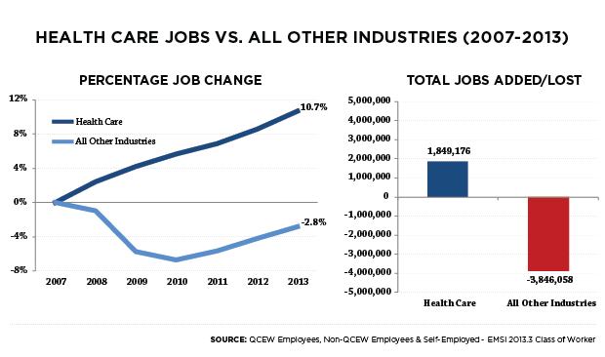
Compared to 3% shrinkage in other industries, health care grew 11% in just seven years (Wright, 2013).
According to a 2016 report from the NYS Division of Labor, the U.S. spent three trillion dollars on health care in 2014. Health care accounts for 17.5% of the U.S. Gross Domestic Product, and health care spending is expected to grow at an average rate of 5.8% per year between 2015 and 2025 (NYSDOL, 2016). Factors contributing to increased health care expenditures include an aging U.S. population, new procedures, medicines and devices. The Affordable Care Act insured 20 million previously uninsured Americans (Bakalar, 2017). Average life expectancy went from 73.7 to 78.8 years between 1980 and 2013 due to improved health care, nutrition, sanitation, and infectious disease control (NYSDOL, 2016). The CDC reports an over 10% rise in obesity since 1999 (Hales, Carroll, Fryar & Ogden, 2017) which is a risk factor for numerous chronic diseases. Other contributing factors include extreme weather, climate change, population growth and migration.
According to U.S. Bureau of Labor Statistics, by 2024, there will be a 19% increased demand for qualified health care workers—more than any other profession. There are already 18.9 million people employed in health care, an increase of about four million since 2005 (Liu, 2018). Healthcare workers, on average, have a higher median income than other professions. Some of the fastest growing occupations are in health care. For example, Home Health Aides and Personal Care Aides (#3 and #4 on the BLS list of Fasting Growing Occupations), and Medical Assistants (#13) require communication skills but often have no specific postsecondary degree requirements. Having a B.S. in Health Communication would likely give applicants a decided advantage over those who do not have a four-year degree. The New York Times reports that students with a “Medical Assistant” Associate Degree struggle to find work and incur debt from for-profit trade schools (Carey, 2014). We predict that having a bachelor’s degree in Health Communication will better position medical workers for higher paying jobs than they were previously eligible for with only an associate degree.
Given the increased need for both communication degrees and health care professionals who can communicate, the success of the NYCCT Health Communication Bachelor of Science is likely.

2.1.4 Occupational Demand for Trained Communicators
In Fall 2018, using a proprietary labor market analytics service called EMSI, School of Arts and Sciences Dean Justin Vazquez-Poritz conducted a keyword search for general education learning outcomes in recent job listings. “Communications” had the highest numerical result. In the 2-year period between September 2016 and August 2018, there were 2.16 million job postings that had “communications” as a requested skill, with 444,669 of those postings being “unique” (meaning, not for the same job). This was more than 4 times the number of job postings requesting any of the other general education skills. The second highest was “writing” which was requested in 404,498 job postings within the same 2-year period, with 102,159 of those being unique.
A search of Indeed.com (Fall 2018) using the search term “Health Communication” (without quotes) retrieved 501,140 job postings in the United States, with 21,077 in the NYC area. Examples of job titles included “Public Health Advisor,” “Language Access Coordinator,” “Staff Training Specialist,” “Community Health Representative” and many others. These results indicate strong occupational demand for communication skills.

2.1.5 Meeting the Needs of Students (Two Areas of Concentration)
The Health Communication B.S. provides a solid grounding in Communication studies, preparing students for careers in healthcare, media and other industries. Program-specific degree requirements (78 credits) prepare majors for advanced course work. The foundational courses are designed to:
- Orient students towards Communication studies and its subdisciplines
- Provide best practices and theories for the study of Health Communication
- Increase understanding of interpersonal and mediated communication processes
- Improve interpersonal communication fluency through simulation exercises
- Familiarize students with media industries and mediated influences on health
- Utilize communication and information technologies in research and analysis
- Develop communication skills contributing to career opportunities and long-term advancement
Health Communication can be broadly divided up into two areas: “face to face” and “mediated” (Kreps, 2015). The former is health care delivery focused, while the latter is health promotion focused. In health care settings, providers speak with patients, their family members, and to other providers. By contrast, “mediated” forms of communication take place using a variety of media (e.g. pamphlets and posters, radio, TV, social media, etc.). “Mediated” Health Communication primarily involves the study of media influences and the design and evaluation of health campaigns promoting disease prevention and management.
To give our students options, we created two areas of concentration, above the program specific requirements, that roughly correspond to the distinction between face-to-face and mediated Health Communication:

Area of Concentration #1: Health Communication and Culture
This track is intended for students interested in communication that takes place in-person, primarily in medical settings, but also privately between family members and caregivers. This track intersects with topics, research and methods in interpersonal and intercultural communication (two other, major subdisciplines in the Communication field). Interpersonal health communication is a term covering in-person interactions between patients and providers, and between a patient and caregivers outside of medical settings. Effective interpersonal communication, a core competency in medical education and long a concern in healthcare (“bedside manner”)—produces better outcomes through improved provider-patient interactions.
Students in this concentration study how people manage illness through effective and appropriate social interactions with health care providers, family members, networks, and supportive others. Students learn about institutional constraints on communication (for example, how communication is limited by the doctor’s schedule) and technological adjuncts and impediments to effective interpersonal communication (for example, Computerized Provider Order Entry systems (CPOE) and Electronic Health Records (EHR)). Interprofessional communication is also a major consideration, where health care is delivered by hierarchically ordered, interdisciplinary teams, perhaps using different terminology or privileging different symptoms or systems. Implications for improving provider–patient communication in medical or home-care settings; interactions between front office staff and patients in managing appointments and medical records—all are types of interpersonal encounters that receive close attention. Students benefit from simulated medical encounters, an essential component of medical school, nursing, and human services education.
An additional organizational focus familiarizes students with systems of health care and how institutions are organized. The interface between clinics/hospitals and third parties (including private insurers, Medicaid, Medicare, device and technology providers, pharmaceutical sales representatives, etc.) reveal complex interlocking communication processes that successful health care delivery depends upon. Students learn about institutional and structural determinants of health and communication, through an understanding of managed care, standards of care, and the difference in perspective between population health and methodological individualism. Students study team-building; continuity of care and “hand-off” communications; motivational interviewing; physician assimilation; emotional experiences of health professionals; privacy and ethical concerns, and communicating about stress and burnout.
Courses critically compare health care in the United States to other models of health care delivery, globally, investigating the impact of a for-profit system on the quality of provider-patient interactions. Through an examination of political ideologies, policies, law and regulations, students discover structural determinants of health, such as access to health care, and institutional sexism, racism, ageism, ableism, homophobia, etc. Students are introduced to a participatory, culture-centered approach (Dutta, 2008) that seeks to empower (rather than control) communities (p. 58).
Issues related to culture permeate every aspect of health. The Health Communication and Culture concentration examines different cultural perspectives on disease and medicine; how childcare, aging, and caregiving are managed cross-culturally; and the socially constructed nature of attitudes towards health. Health care disparities related to language, race, ethnicity, gender, sexual orientation, age, religion and socioeconomic status are central concerns, with particular attention paid to linguistic barriers. With an estimated 800 different languages spoken (Roberts, 2010), there is no city more linguistically diverse than NYC, a fact that presents challenges to health care professionals. Concepts of cultural competence and functional health literacy are unpacked through study of NYC cultures and languages, including at-risk and hard-to-reach populations. Students consider language access and explore the role of patient advocates, medical translators and other communication specialists in addressing health care inequities.

Area of Concentration #2: Health Promotion & Media
The term “health promotion” refers to the promotion of healthy behavior using media (Kreps, 2015), but it also refers to a social movement that seeks to tackle health inequities using collaborative and participatory approaches (Dixey, et al, 2013). Our use of the term is meant to connote both meanings. As a social movement, health promotion can be traced back to the “Ottawa Charter,”—a document resulting from the first International Conference on Health Promotion, in 1986. The Charter called for a “new public health” that recognized social, structural and environmental health determinants, including income, workplaces, housing, pollution, nutrition, education, social support, media, cultural differences, and others (“Ottawa Charter” 1986). Appearing at approximately the same historical moment, Health Communication could be considered a “wing” of health promotion (Cross, et al, 2017).
Focus in this concentration is less on interpersonal communication in clinical settings and more on internet, mass media communications, and media portrayals of health and illness. The creation and evaluation of health campaigns over a variety of media channels are also covered. The intersection of media and health are clear: we learn about health risks and new medical developments from the news, while millions of dollars are spent each year on campaigns to promote nutrition, exercise and other preventative measures, warning the public about health risks. Television advertisements market pharmaceuticals directly to consumers outside of medical settings. High profile cases of disease and death place issues on the public radar and become emblematic of policy and ideological differences.
The Health Information Technology for Economic and Clinical Health Act (HITECH Act), part of the American Recovery and Reinvestment Act of 2009 (ARRA), provides financial incentives to health care providers that adopt electronic health record systems and secure patient portals. The Health Promotion and Media track will cover these information and communication technologies and their implications for healthcare. Topics include: how health information is accessed online and how patients can obtain secure access to their own medical records and communicate with their providers. Students engage with and participate in online communities to better understand the value of virtual support networks, and how social media platforms can contribute to increased health literacy and self-efficacy.
The Health Promotion & Media concentration examines the history and impact of public health campaigns. The CDC reports that half of all Americans live with chronic diseases (CDC, 2018). They are the leading causes of disability and death and one of the main drivers of increasing costs. Lifestyle modification is a central focus of health campaigns, to the extent that chronic diseases can be avoided and managed through diet, exercise, regular checkups, and by quitting harmful habits like smoking. Students learn the dominant theories and models used to explain how health behaviors are influenced, employing methods such as audience analysis and media monitoring. At-risk and hard to reach populations are identified, as students address public health issues of concern, tailoring “culturally sensitive” health campaigns to target audiences. The track also critically examines possible unintended consequences of health campaigns, such as paternalism and victim-blaming (Guttman, 2000).
The internet, mobile and “wearable” technologies have opened up new possibilities for health promotion, in addition to raising privacy concerns. Prior to these technologies, messaging was only unidirectional (an ad on the bus; a PSA on the radio, for instance). Communication technologies allow for participation in multi-directional conversations about health and medicine. User data, such as steps, heart rate, etc., can be used to deliver integrated and tailored information. Audiences can become participants in health campaigns through social media, sharing their personal experience with others in their network. Active audiences, using participatory, multidirectional communication technologies, allow for public health campaigns that are coproduced by their target populations. The possibilities for innovative health campaigns are just starting to be realized, and HCBS will prepare graduates to find improved campaign strategies for their own communities.
The two areas of concentration have a great amount of pedagogical overlap, in that both areas educate students about fundamental topics, issues and theories in Health Communication related to health care institutions, media, policies and politics. While a consideration of cultural differences and an understanding of intercultural communication is pivotal for both concentrations, the Health Communication and Culture track has a greater focus on opportunities for translators in medical settings, and includes an optional language sequence. Students choose from these 3000 level courses in consultation with their academic advisors and they are encouraged to select courses from both concentrations as desired, in consideration of their particular educational and vocational orientations.
In conclusion, the Health Communication B.S. serves City Tech students interested in health careers, both inside and outside of clinical settings. The range of topical interests covered by the two concentration areas provide students with a well-rounded undergraduate education that will prove attractive to prospective employers, while providing a path to postgraduate education in a variety of subjects.

2.1.6 Meeting the needs of City University of New York
A 2017 CUNY press release touting a new strategic plan speaks of “…connecting our students and campuses better across our large university system, taking full advantage of all of our resources, adopting technology to meet our goals, including significant growth of online programs, and building more collaborations and partnerships with other institutions, public and private, domestic as well as international, to leverage our strengths” (“CUNY Announces New Strategic Vision…” 2017).
The Health Communication B.S. at City Tech is aligned with these goals in the following ways. First, we are building interconnections across CUNY campuses by setting up articulation agreements. It is our intention that students in Communication or Health Sciences Associate programs are allowed to matriculate easily into our bachelor’s. Articulation agreements with graduate programs in Communication and Health with ensure a path to postgraduate study.
We also embrace the adoption of new technologies and online resources to meet strategic goals. Manyof our courses are online or hybrid, and use Zero Cost Textbooks when available. Course delivery takes place in person as well as online using The Open Lab and Blackboard. Students use information technologies in their research, joining online communities and conducting media monitoring using free online applications.
The program also helps to achieve the goal of building community partnerships, providing innovative internships and experiential learning opportunities. We look forward to arranging internships with medical providers, governmental and non-governmental agencies, and private enterprises. By forming networks of professional opportunities for graduates, HCBS can help fulfill the CUNY vision.
Another CUNY strategic goal is to improve bachelor’s degree graduation rates. The Health Communication B.S. is designed to help achieve this goal at City Tech, by providing a new degree path.

2.1.7 Meeting the needs of City Tech
Our program addresses the 6% four-year graduation rate at NYCCT (U.S. News Best Colleges, 2018) by providing an alternative for those students not accepted into the competitive allied health programs, but still seeking to pursue their health-related educational and professional interests.. As described in the ASHS proposal, a number of students (about 625 each year) come to City Tech seeking admission into the Nursing, Radiology or Dental Science degree programs, but do not meet the entrance requirements. Some are provisionally admitted to their desired programs but do not make satisfactory progress towards admission. The Health Communication B.S. provides a viable option for these students for continuing their progress towards a baccalaureate degree that is broadly situated within allied health.
General education, grounded in Humanities and Liberal Arts and Sciences, provides the foundation for higher education at a technical college such as NYCCT, but there are presently few baccalaureate degrees offered at City Tech within the Liberal Arts tradition (Technical and Professional Writing being a notable exception). One key advantage of the HCBS degree is its flexibility. Because Communication degrees are broad in scope, they can be applied to a variety of career paths. Communication graduates are valued by employers for the “soft skills” they bring, including attention to interpersonal dynamics, teamwork, written and verbal skills.
The City Tech 2014-2019 Strategic Plan contains the goal of strengthening the General Education curriculum (“Strategic Plan…” 2014). Many of the courses in our program are designed to meet the learning outcomes of the Pathways Flexible Common Core, including Individual and Society, World Cultures and Global Issues, U.S. Experience in Its Diversity and Creative Expression.
HCBS supports efforts at City Tech to identify new fields where program development would be advantageous. We have identified an emergent profession with growth potential, as the need for healthcare professionals rises.

3. Student Interest and Enrollment

3.1 Surveys Show Strong Student Interest
During the Spring 2018 semester, an anonymous survey was administered to 118 students in six classes (COM 2402, ENG 1101, SPA 1102, COM 1332, FRE 1101, and THE 2280). 31% of respondents were either “Interested” or “Very Interested” in the new major, indicating the appeal of a Health Communication major. Since a majority of these students reported that they already had a major, our follow up online survey targeted undeclared, non-degree seeking, and LAA/LAS students. Additional questions allowed students to select subject areas of interest. The link was emailed from the SoPS Dean’s office on 9/11/2018, and by 9/30 we had received 193 responses, providing more encouraging evidence. Highlights from the survey include:
- 122 respondents were “somewhat” or “very” interested in Health Communication major (about 63%).
- 127 respondents identified as undeclared, undecided, or Liberal Arts and Arts/Liberal Arts and Sciences majors (about 66%).
- 32% identified as Nursing (38), Rad Tech (15) and Dental Hygiene (9) majors.
- 172 respondents agreed that City Tech students would benefit from having more bachelor degree options related to health (about 90%).
Other interesting findings, indicating strong interest in the Health Communication B.S., can be found in Appendix D, “Student Survey Results.”

3.2 Other Indicators
Another indirect way of estimating student interest in a Communication program is the City Tech Speech Competition, which attracts dozens of enthusiastic students across campus, annually. According to the NYCCT 2017-2018 Fact Sheet, enrollment overall has increased by 50% over the last 12 years, and there are 9809 non-degree seeking, continuing education students at City Tech (2016-2017). We hope to attract students not current on a degree track. As a new program, HCBS will be able to accept qualified applicants that were not accepted into the competitive allied health programs such as Nursing and Rad Tech. Once operational, the Associate of Science in Health Sciences will enroll numerous students in COM 1403 Introduction to Healthcare Communication, introducing them to Health Communication as a degree path and occupation.

3.3 Estimate of Enrollment
The CUNY Academic Program Inventory provides evidence of robust enrollment in Communication programs at CUNY. For example, the Communication B.A. launched at Brooklyn College in 2007 saw a five-fold increase in enrollment in its first five years. The A.A. in Communication at LaGuardia launched in 2009 increased enrollment by eight-fold in three years (CUNY Office of Research and Assessment, 2013). Given growing demand for Communication and health related degrees; the increasing number of Communication degree programs at CUNY, and student interest as indicated by surveys and other measures, we conservatively estimate that 10 students will enroll in the program every year, over the course of the first four years. Enrollment is likely to increase as publicity and word-of-mouth increases awareness of the degree across CUNY. In the event that enrollment is low in any particular course, it can be administered as Independent Study.

4. Curriculum

4.1 Curriculum Rationale
The proposed Health Communication major prepares students to apply theoretical, practical and critical understandings of communication in healthcare settings and mediated contexts. Graduates employ social scientific and humanistic approaches to communication in a variety of occupational environments, both inside and outside of healthcare industries. In addition to the Required Core (12 credits), Flexible Core (18 credits) and College Option (12 credits), there are 62 credits of program specific degree requirements, providing a solid foundation in Communication, media studies, health education and research methodologies. Two courses from Social Sciences (Introduction to Psychology and Health Care Ethics) provide psychological and philosophical perspectives. An additional 15 credits are selected from the two areas of concentration. The Health Communication and Culture concentration has classes in International and Interpersonal Communication, as well courses on health narratives and medical interpreting. The Health Promotion and Media concentration has courses in health media and communication technology, health policy and advocacy, and crisis, risk and emergency communication. The final 12 credits are obtained through a methods course, a professional Internship, and Senior Seminar where students get practical experience in the field.

4.2 Degree Requirements for Health Communication Bachelor of Science
General Education Common Core: 42 Credits
- Required Core (4 courses, 12 credits)
English Composition (2 courses, 6 credits)
ENG 1101 English Composition I 3
ENG 1121 English Composition II 3
Mathematical and Quantitative Reasoning (1 course, 3 credits)
MAT 1190 or higher 3
Life/ Physical Science (1 course, 3 credits)
(Any approved course) 3
- Flexible Core (6 courses, 18 credits)
From the list of approved courses select one course from each of the following areas; no more than two courses may be selected from any discipline.
World Cultures and Global Issues (Any approved course) 3
US Experience in its Diversity (Any approved course) 3
Creative Expression (Any approved course) 3
Individual and Society (Any approved course) 3
Scientific World (Any approved course) 3
One additional course (Any approved course) 3
Recommended: MAT 1272 Statistics (SW, MQR, STEM) 3
- College Option requirement (12 credits):
COM 1330 Public Speaking 3
or
COM 1403 Introduction to Healthcare Communication 3
One interdisciplinary liberal arts and sciences course 3
Two additional liberal arts courses 6
In meeting their General Education requirements overall, students must take at least one advanced liberal arts course or two sequential courses in a world language.
Students focusing on health communication and culture may benefit from two sequential courses in any world language.
Writing-intensive course requirements. Students at NYCCT must complete two courses designated Writing Intensive (WI) for an associate degree (one from Gen Ed and one from the major). For the baccalaureate level, two additional courses designated WI must be completed, one from Gen Ed and one from the major.
Program Specific Degree Requirements (11 courses, 35 credits) There are six required core communication courses (18 credits), including one prerequisite (COM 2403) and one department capstone (COM 3401). Specific courses listed indicate double duty courses, i.e., program degree requirements that also meet general education requirements in that category.
BIO 1101 Biology I (SW, LPS) 4
BIO 2311 Human Anatomy and Physiology I (SW, LPS--stem) 4
PSY 1101 Intro to Psychology (IS) 3
COM 1332 Intro to Human Communication (IS)
OR 3
COM 1403 Introduction to Healthcare Communication
LIB 1201 Research and Documentation for the Information Age (IS) 3
COM 1400 Media Studies 3
PHIL 2203/ID Health Care Ethics (IS, ID) 3
COM 2403 Health Communication (IS, WI) 3
COM 2404 Interpersonal Communication (IS) 3
COM 2405 Principles of Persuasion 3
COM 3401 Business and Professional Communication (IS, WI) 3
Additional Upper Level Discipline Courses (15-18 credits, 5-6 courses). Students complete 15-18 credits in 3000-4000 level Health Communication courses, including one required (COM 3402 Communicating in Multicultural Healthcare Settings). Under advisement, students may opt to build a career-focused concentration with electives outside the communication program.
*COM 3402 Communicating in Multicultural Healthcare Settings 3
COM 2406 Gender and Health Communication 3
COM 3403 Health Communication and Education 3
COM 3501 Introduction to Healthcare Interpreting 3
COM 3502 Communicating Health Narratives 3
COM 3404 Crisis and Emergency Risk Communication 3
COM 3405 Public Health Campaigns 3
COM 3500 U.S. Health Policy and Communication Advocacy 3
COM 3503 Health Media and Information Technology 3
Additional Required Courses (12 credits) Students must take additional 4000-level Communication courses to fulfill the remaining 12-hour degree requirement.
COM 4000 Health Communication Research Methods and Design 4
COM 4100 Senior Seminar 4
COM 4200 Professional Internship 4
Free Elective Credits to Equal 120
Total General Education Common Core Credits 42
Program-Specific Required Discipline-Course Credits 62
Total Credits Required for the Degree 120
Sample Degree Concentration Options (15 credits of 3000-Level Discipline Electives, 9 credits of General Electives)
1) Health Communication and Culture
AFR 1502 The Sociology of Urban Poverty 3
HEA 1102 Community Health 3
COM 2402 Intercultural Communication 3
COM 2406 Gender and Health Communication 3
COM 3402 Communicating in Multicultural Healthcare Settings 3
COM 3501 Introduction to Healthcare Interpreting 3
COM 3502 Communicating Health Narratives 3
PSY 3505/ID Health Psychology 3
2) Health Promotion and Media
MKT 1210 Market Research 3
ENG 2700 Introduction to Professional and Technical Writing 4
COM 3404 Crisis and Emergency Risk Communication 3
COM 3402 Communicating in Multicultural Healthcare Settings 3
COM 3405 Public Health Campaigns 3
COMD 3500 Campaign Development 3
COM 3503 Health Media and Information Technology 3

Recommended Electives to Achieve 120 Degree Credits

(Students may select from a wide variety of courses, including, but not limited to, those below. Note that some of the courses below may have prerequisites)

AFR 1462 | Blacks in Science, Technology and Business | 3
AFR 1502 | The Sociology of Urban Poverty | 3
AFR 1501 | Seminar in Current Community Problems | 3
ANTH 2000 | Medical Anthropology (WI) | 3
BIO 2312 | Human Anatomy and Physiology II | 3
BIO 3524 | Nutrition | 2
ARTH 2101ID | Healing the Body: The Visual Culture of Medicine* (IS) | 3
COM 1335 | Group Communication | 3
COM 1403 | Introduction to Healthcare Communication | 3
COM 2401 | International Communication (WCGI, WI) | 3
COM 2402 | Intercultural Communication (IS, WI) | 3
ENG 1710 | Introduction to Language and Technology *(IS) | 4
ENG 2700 | Introduction to Professional and Technical Writing | 4
ENG 3404 | The Literature of Illness and Care* (IS, WI) | 3
HEA 1102 | Community Health | 3
HEA 2108 | Women’s Health Issues | 3
HSA 4970 | Social Marketing in Healthcare Settings | 3
HSA 3560 | Legal Aspects of Health Care | 3
HSCI 1101 | Introduction to Health Care Delivery and Careers | 3
HSCI 2301 | An Integrative Perspective in Healthcare Professions | 3
HSCI 2201 | Health Dynamics | 3
MKT 1210 | Marketing Research | 3
COMD 3500 | Campaign Development | 3
PSY 3405/ID | Health Psychology (IS, ID) | 3
PSY 2303 | Psychology of Aging* (IS) | 3
SPA 1401 | Spanish for Health Professionals* (WCGI) | 3
SOC 1101 | Elements of Sociology* (IS) | 3
SOC 2303 | Law and Society* (IS) | 3
*Denotes Flexible Core Courses. WI Denotes Writing Intensive offerings

4.3 Sample Course Sequence
First Year
First Semester
ENG 1101 English Composition I 3
MAT 1190 3
PSY 1101—Flexible core (Individual and Society) 3
Flexible core (US Experience in Its Diversity) 3
COM 1330 or COM 1403 (College Option Oral) 3 15 Credits
First Year
Second Semester
ENG 1121 English Composition II 3
BIO 1101 (LPS/SW + SCI L Science I Lab) 4
Flexible core (Creative Expression) 3
Flexible core (World Cultures and Global Issues) 3
LIB 1201 Research and Documentation in the Info Age 3 16 credits
Second Year
First Semester
Language sequence I or liberal arts course (College Option) 3
BIO 2311 Flexible core (LPW/SW + SCI L Science I Lab) 4
Any flexible core 3
COM 1332 Intro to Human Communication 3
COM 1400 Media Studies 3
16 credits
Second Year
Second Semester
Language sequence II or advanced liberal arts course 3
PHIL 2203/ID Health Care Ethics 3
COM 2403 Health Communication (WI) 3
COM 2404 Interpersonal Communication 3
Discipline Course (e.g., COM 2406 Gender and Health Communication) 3
15 credits
Third Year
First Semester
COM 2405 Principles of Persuasion 3
COM PSY 3405/ID Health Psychology 3
COM 3401 Business and Professional Communication (WI) 3
Discipline Course Required COM 3402 3
(Communicating in Multicultural Healthcare Settings)
Elective (e.g. AFR 1502 The Sociology of Urban Poverty) 3
15 credits
Third Year
Second Semester
COM 4000 Research Design 4
Discipline Course (e.g., 3502 Communicating Healthcare Narratives) 3
Discipline Course (e.g., COM 3403 Health Communication and Education) 3
Interdisciplinary liberal arts & sciences course 3
(e.g. ARTH 2101ID Healing the Body: The Visual Culture of Medicine)
Degree Course (if not met by Gen Ed) or General Elective 3
(e.g. CST 1000 Foundations of Computing)
16 credits
Fourth Year
First Semester
Senior Seminar 4100 4
Discipline Course (e.g. COM 3501 Introduction to Healthcare Interpreting) 3
Elective (e.g., ANTH 2000 Medical Anthropology) 3
Elective (e.g., HEA 1102 Community Health) 3
Elective (e.g., SPA 1400 Spanish for Healthcare Professionals) 3
16 credits
Fourth Year
Second Semester
Senior Internship 4200 4
Elective (e.g., HEA 2108 Women’s Health Issues) 3
Elective (e.g., HSCI 2201 Safety for Health Care Professionals) 3
Discipline Course (e.g., COM 3500 U.S. Health Policy and Communication Advocacy) 3
13 credits

Double Duty: Specific courses listed indicate double duty courses, i.e., program degree requirements that also meet general education requirements. Choosing to take advantage of double duty can speed up progress toward graduation and increase elective credits. Consult with an advisor about your options.

4.4 Course Descriptions
The Communication faculty designed 14 new courses for the Health Communication B.S., based on established Communication baccalaureate programs nationwide. Course numbers, titles and catalog descriptions appear below. Course syllabi, with details on prerequisites, flexible core, etc. are in Appendix E: New Course Outlines.
COM 1400 Introduction to Media Studies
Introduction to the history, structure and operations of media industries in today’s changing media marketplace. Study of the historical development and convergence of print, radio, film, TV, internet, and gaming. Students identify interrelationships between media platforms and communication channels to understand their pervasive presence and decisive influences. Communication theories help explain the intersecting forces of culture, commerce, regulatory policy and the public interest that have shaped the media.
COM 2405 Principles of Persuasion
Principles of persuasive communication from humanistic and social-scientific perspectives. Topics include rhetorical approaches to audiences, persuasion, propaganda, source credibility and message framing. Students participate in online discussion, critique media products, create a persuasive media campaign and give oral presentations.
COM 2406 Gender and Health Communication
This course explores current healthcare practices, experiences, and systems that are both affecting and affected by gender norms, performances, and representations. A critical review and analysis of the ways sexual minorities have been treated by health institutions in the major stages of human history are conducted. Students learn the complex interplay among health, communication, and gender, with specific foci on how gender-based communication practices affect people’s everyday decision and choices in medical care, and what can be done to improve the current healthcare system.
COM 3402 Communicating in Multicultural Healthcare Settings
This upper-division course focuses on multicultural health communication within the United States. Special emphasis is placed on the difficulties and challenges to multi-cultural health communication, and the importance of cultural competence for patient satisfaction, patient compliance, and other positive healthcare outcomes. Students examine cultural attitudes, beliefs, and practices integrated into U.S. healthcare policies and systems. Students apply analytical and practical approaches to investigate important issues across diverse healthcare contexts and platforms.
COM 3403 Health Communication and Education
This course provides students with an in-depth understanding of contemporary pedagogical approaches to health communication studies. It is designed to provide students with the fundamental skills and knowledge necessary for careers in health communication and health education. The course emphasizes health promotion, education and communication strategies for working with individuals, organizations and communities.

COM 3503 Health, Media and Communication Technology
Healthcare experts call for the global adoption of communication and information technologies to reduce costs and improve access, efficiency and quality. Telehealth, secure patient portals, websites, social media and mobile applications have the potential to address multiple goals across systems of health care delivery. This course provides a broad overview of medical media and communication technologies used in the delivery and administration of modern healthcare systems. Online health communities outside of medical contexts are also a focus. Topics include finding credible information online, Computerized Provider Order Entry (CPOE) systems, Electronic Health Records (EHRs) and the digital divide.
COM 3404 Crisis and Emergency Risk Communication
Effective communication is critical in the event of a crisis, since the situation is evolving and the public need for information is high. This course focuses on communication during emergencies, such as environmental disasters, mass shootings, disease outbreaks, and food and drug safety incidents, etc. Students learn core principles in Emergency Risk Communication. Case studies illustrate best practices and pitfalls, as students prepare for the challenges of communicating in a variety of scenarios, across numerous channels, with diverse target audiences.
COM 3405 Public Health Campaigns
Concepts and skills for developing, implementing and evaluating health communication campaigns. Students utilize best practices in health message design to explore techniques for formative research, audience segmentation, message development and evaluation. Effective strategies and potential challenges are considered in the development of a multimedia health campaign using multiple communication channels. Translating scientific insights for accessibility are also covered. Specific emphasis on approaches to designing culturally sensitive interventions and reaching under-served populations.
COM 3500 U.S. Health Policy and Communication Advocacy
This course reviews and analyzes some of the key policies affecting patients’ healthcare experiences and the outcomes of their medical procedures. The review of these central policies includes an extensive survey of the past and present decision-making processes at the level of local and national governments where policies were debated and enacted. Students learn the major social, cultural, or political events that have affected the creation, implementation, and transformation (or abolition) of healthcare policies, how current policies affect populations from diverse cultural and socioeconomic backgrounds, and what they can do to help disadvantaged groups receive equal healthcare and proper medical treatments.
COM 3501 Introduction to Healthcare Interpreting
This course introduces students to the healthcare interpreting profession. Students explore the various roles, relationships, and communicative tasks in interpreter-mediated medical encounters and examine wide-ranging communication strategies available to interpreters. Students gain a broad understanding of health communication approaches to interpretation studies, and explore bilingual healthcare challenges within diverse U.S. medical contexts.
COM 3502 Communicating Health Narratives
This course focuses on patient narratives within the framework of health communication. Students concentrate on “thinking with stories,” and developing the ability to read and hear health narratives. Students consider how health narratives relate to their own lives, examine the rhetorical and social aspects of the account as told, and analyze cultural and structural patterns in healing and illness stories. Special emphasis is placed on recognizing patient agency, communication competency, and healthcare comprehension within the narratives.
COM 4000 Health Communication Research Methods and Design
This course provides an overview of the social scientific methodologies communication researchers use to investigate human communication behaviors. Topics of investigation include understanding the preliminary considerations that go into selecting qualitative, quantitative, or mixed methods research designs. Special attention is paid to defining various approaches, considering diverse worldviews, reviewing literature, understanding theory, thinking critically about questions and solutions, anticipating ethical issues, and developing writing strategies. Aspects of communication research are explored through readings, lectures, published research, and statistical problems Upon completion, students will have a better understanding of the processes and applications of research, as well as their importance in various career paths. The final outcome is a thesis proposal that will be completed in COM 4100 Senior Seminar.
COM 4100 Senior Seminar
The objective of this class is to provide students with the opportunity to produce a longer, more detailed research paper, based upon primary sources, and utilizing the research methods and analytical skills acquired in COM 4000 Health Communication Research Methods and Design and other upper-division Communication courses. This course also provides an opportunity for students to identify their chosen area of study within the health communication field, and begin the internship process. The instructor will assist in topic selection for the seminar.
COM 4200 Professional Internship
Students work with a faculty advisor to identify organizations that offer internship opportunities, such as hospitals, private practices, dental offices, schools, businesses, media outlets, non-governmental organizations, community centers, etc. Students gain valuable, hands-on experiences, applying classroom learning to occupational settings.

4.5 Accrediting or Licensure Requirements
There are no requirements for licensure or accreditation, although students are encouraged to complete free training and certification programs, publicly available online through various agencies. These training programs may be useful for resume building, providing added value when students are considered as candidates for internships and post-graduate employment. Some of these opportunities include:
CDC Learning Connection: U.S. The Centers for Disease Control and Prevention offers online training in healthcare topics, in some cases providing Continuing Education (CE) credits and/or certification.
Crisis and Emergency Risk Communication (CERC) Training: The CDC provides CERC training for managing public health crises.
FEMA National Preparedness Course Catalog: The U.S. Federal Emergency Management Agency offers online training in preparedness planning, including certificates of completion for National Incident Management System.
OSHA Train: The U.S. Occupational Safety and Health Administration provides free certification in workplace safety and reporting.
WHO Courses of Study: The World Health Organization links to other free online training opportunities.
NYC Health Training: New York City Department of Health and Mental Hygiene's may offer relevant training in capacity building, electronic reporting systems, and health education topics.

4.6 Non-Course Requirements (e.g. thesis or comprehensive exam)
A thesis is required in COM 4100 Senior Seminar, as noted in the above course description and detailed in the course proposal below (see Appendix E: New Course Outlines).

5. Articulation Agreements
There are a number of CUNY Junior Colleges that we wish to partner with:
- Borough of Manhattan Community College (Contact: Eva Kolbusz-Kijne, Chair, Speech, Communications and Theater Arts)
- Bronx Community College (Contact: Debra Gonsher, Chair of Communication Arts and Sciences Department)
- Kingsborough Community College (Contact: Cindy Greenberg, Director of Speech Communications, Department of Communications and Performing Arts)
- LaGuardia Community College (Contact: Louis Lucca, Director of Communication Studies, Humanities Department)
We have reached out to several of these institutions and have received two letters in support of the program, each expressing willingness to cooperate on articulation agreements.
The first letter is from Dr. Vincent (Tzu-Wen) Cheng, BMCC Communication Studies Program Coordinator (next page).
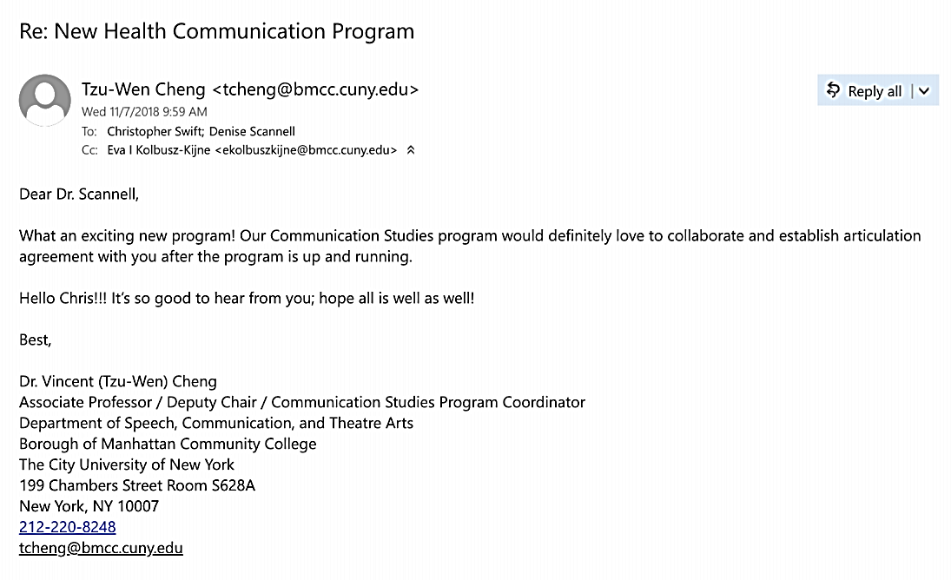
The second letter is from Dr. Louis Lucca, LaGuardia Community College Director of Communication Studies:
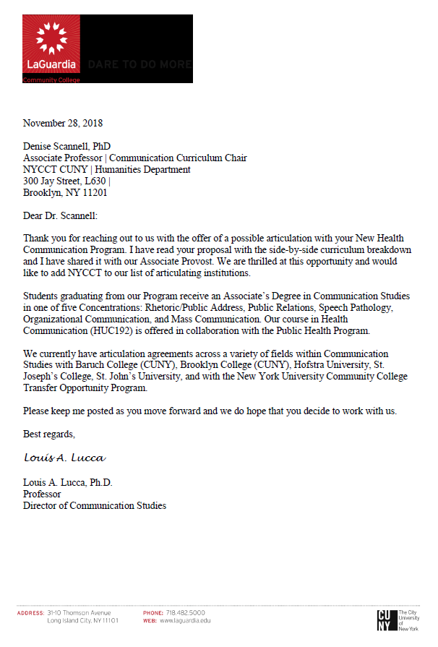
These letters indicate the viability of the HCBS degree and interest in establishing articulation agreements.

6. Faculty
The Humanities Department has three full time faculty already teaching some of the foundational courses of the program, including:
COM 1330 Public Speaking
COM 1332 Introduction to Human Communication
COM 2401 International Communication
COM 2402 Intercultural Communication
COM 2403 Health Communication
COM 2404 Interpersonal Communication
COM 3401 Business and Professional Communication
Communication faculty are excited by the prospect of teaching a progressive course sequence, integrating research and teaching, and mentoring cohorts of majors. Below are full time faculty profiles and teaching assignments.
Denise Scannell, Associate Professor, Ph.D. Communication University of Oklahoma.
New courses to be taught:
Communicating Health Narratives COM 3502
Introduction to Healthcare Interpreting COM 3501
Introduction to Healthcare Communication COM 1403
Health Communication Research Methods and Design COM 4000
Senior Seminar COM 4100
Additional Qualifications (certifications/licenses; occupational experience; scholarly contributions, etc.)
- Communication Curriculum Co-chair
- Publications: Italian Americana; Philosophy, Method and Cultural Criticism; Italian Passages: Making and Thinking History; Foods of Affection; Narratives, Health, and Healing; Communication Theory, Research, and Practice; The Human Sustainable City: Challenges and Perspectives from the Habitat Agenda.
- Awards: National Communication Association (NCA) Advancing the Discipline Grant (2019).
David Lee, Assistant Professor, Ph.D. Communication, University of South Florida
New courses to be taught:
Introduction to Healthcare Communication COM 1403
Introduction to Media Studies COM 1400
Health, Media and Communication Technology COM 3503
Principles of Persuasion COM 2405
Public Health Campaigns 3405
Health Communication Research Methods and Design COM 4000
Additional Qualifications (certifications/licenses; occupational experience; scholarly contributions, etc.)
- Publications: Health Communication; Qualitative Research in Medicine and Health Care; International Journal of the Inclusive Museum
- Awards: Principal Investigator, National Communication Association (NCA) Advancing the Discipline Grant (2019); CUNY Faculty Fellowship Publication Program (FFPP) (2018); PSC-CUNY Grant (2016); Open Educational Resource Fellow (2016, 2017)
- ORISE Research Fellow, Centers for Disease Control and Prevention (CDC) 2009-2010
- Standardized Patient and Communication Coach, USF Medical School (2006-2007)
Zheng Zhu, Assistant Professor, Ph.D. in Communication, Washington State University
Course to be taught:
U.S. Health Policy and Communication Advocacy COM 3500
Health Communication and Education COM 3403
Gender and Health Communication COM 2406
Communicating in Multicultural Healthcare Settings COM 3402
Additional Qualifications (certifications/licenses; occupational experience; scholarly contributions, etc.)
- Publications in: Asian Journal of Communication; Journal of Chinese Overseas; Iowa Journal of Communication; Journal of International Students; Journal of Arts and Humanities; International Journal of Learning, Teaching and Educational Research; Studies in Media and Communication.
- Awards: National Communication Association (NCA) Advancing the Discipline Grant (2019).

6.1 Anticipated Number of Full Time Faculty
There are 14 new courses, not all running at the same time (see sample program sequence, p. 25), and, while we estimate that existing faculty members are able to teach the majority of classes, we will request another tenure track hire as enrollment increases. The successful candidate will have a strong quantitative research background, in order to be able to teach statistics in the COM 4000 Research Methods course. The new hire would also preferably have occupational experience in clinical settings and/or public health. The new hire would not necessarily need to be made until year three or four of the program, when an estimated 30-40 students are enrolled (based on an estimate of 10 enrollees each year). We understand, of course, that the ability to hire new faculty is contingent on numerous factors, including state and federal budgeting. In the event that a new tenure track line is not available, we can consider the possibility of hiring a lecturer or adjunct professor to serve in this capacity until a tenure line becomes available.

6.2 Anticipated Number of Adjunct Faculty
The Humanities Department already has a pool of 20+ Communication faculty teaching COM 1330 Public Speaking. The Health Communication BS is readily scalable, given this ‘standing reserve’ of able COM faculty at the ready to begin teaching other courses besides COM 1330. COM discipline specific courses that could be taught by adjunct COM faculty include:
COM 1335 Group Communication
COM 2404 Interpersonal Communication
COM 3401 Business and Professional Communication
COM 1332 Introduction to Human Communication
COM 2401 International Communication
COM 2402 Intercultural Communication
Our estimate of anticipated number of adjunct faculty is dependent on the ability to hire an additional full-time faculty member. In the event that another full timer is not available, we project that five eligible adjuncts currently teaching three sections of COM 1330 each would instead dedicate three credit hours to one of the more advanced courses above, per semester. Assuming the same or similar levels of enrollment in COM 1330, this would necessitate the hire of two additional instructors to cover the five COM 1330 sections then needing coverage.
English faculty at City Tech are well qualified to teach COM 1400 Introduction to Media Studies, and we understand that some faculty may be interested in teaching in this area. As mentioned earlier (1.6.5), this collaboration is in the best interests of students, given the scholarly expertise about media in the English Department.

6.3 Effect on Established Programs
We expect the Health Communication BS program to have a positive effect on established programs at City Tech in various ways. Nursing, Radiology, Dental Hygiene, Human Services and Health Services Administration can now suggest health curriculum options for otherwise qualified students not admitted into those degree programs. Enrollment in the HCBS degree will positively affect college-wide enrollment, as these majors fulfill credits in Social Sciences, Biology and other departments. Students currently unclassified, undeclared, and non-degree seeking now have more options for pursuing a four-year degree at City Tech. We expect the HCBS program to contribute to the improvement of retention and graduation rates at the college.

7. Cost Assessment
Current classroom equipment is sufficient for instruction delivery of all courses in the proposal. We are not requesting new equipment, laboratories or capital expenditures. Other than our regular maintenance and replacement of current existing equipment, no additional equipment is required. The need for new resources in the years ahead—such as faculty, equipment, spaces or facilities— will be driven by enrollment growth.
We expect HCBS to increase enrollment overall, as students not admitted to the competitive allied health programs have a new baccalaureate option. As enrollment increases, we do anticipate the need for an additional tenure line to hire an Assistant Professor.

Appendix A: Health Communication Degrees Nationwide
Baccalaureate Degrees
Institution | Location | Degree(s) offered
Ashland Univ. | Ashland, OH | B.A. Health and Risk Communication
Cornerstone Univ. | Grand Rapids, MI | B.A. Health Communication
Juniata College | Huntington, PA | Program of Emphasis, Health Comm.
Montclair State Univ. | Montclair, NJ | B.A. Comm. Studies, Health Concentration
New York University | New York, NY | B.S. in Media, Culture & Communication /Global Public Health
Ohio University Southern | Athens, OH | B.A. Health Communication
Otterbein University | Westerville, OH | B.A. Health Communication
Pacific Union College | Angwin, CA | B.S. Health Communication
San Diego State Univ. | San Diego, CA | B.S. Health Communication
South Dakota State Univ. | Brookings, SD | B.S. Communication, Health Comm. minor
Southeast Missouri State Univ. | Cape Girardeau, MO | B.S. Health Communication
Univ. of Evansville | Evansville, IL | B.A./B.S. Health Communication
Univ. of Houston | Houston, TX | B.A. Health Communication
Grand Valley State Univ. | Allendale, MI | B.A./B.S. in Health Communication
Univ. of Kentucky | Lexington, KY | Health Comm. Undergraduate Certificate
Univ. of Wisconsin (Stout) | Menomonie, WI | Health Comm. Prof. Development Certificate
Source: Undergraduate Programs in Communication (NCA, 2017)

Graduate Degrees
Institution | Location | Degree(s) offered
Boston University | Boston, MA | M.A. Health Communication
Chapman University | Orange, CA | M.S. in Health and Strategic Communication
Colorado State University | Fort Collins, CO | M.P.H. Health Communication Concentration
Cornell University | Ithaca, NY | Ph.D. Communication (Health Comm. focus)
East Carolina University | Greenville, NC | M.A., Graduate Certificate, Health Comm.
George Washington University | Washington, D.C. | M.P.H. Public Health Comm. and Marketing
George Mason University | Fairfax. VA | M.A., Ph.D. (Health Communication focus)
Harvard T.H. Chan School of Public Health | Cambridge, MA | M.P.H./ Dr.P.H. Health Communication Concentration
Indiana-Purdue University | Indianapolis, IN | M.A., Ph.D., Health Communication
James Madison University | Harrisonburg, VA | M.S. Comm. Studies, Health Concentration
Johns Hopkins University | Baltimore, MD | M.A. Health Communication Concentration
Kent State University | Kent, OH | M.A. Health Communication
Northwestern University | Evanston, IL | M.S. Health Communication
Ohio University | Athens, OH | Ph.D. Health Communication
Portland State University | Portland, OR | M.S.
Purdue University | West Lafayette, IN | M.A., Ph.D.
Rutgers University | New Brunswick, NJ | Ph.D.
Texas A & M University | College Station, TX | Ph.D.
Ohio State University | Columbus, OH | M.A., Ph.D.
Tufts University | Medford, MA | M.S. and Graduate Certificate
University at Buffalo-SUNY | Buffalo, NY | M.A., Ph.D.
University of Cincinnati | Cincinnati, OH | M.A. and Graduate Certificate
University of Florida | Gainesville, FL | M.A., Ph.D.
University of Georgia | Athens, GA | M.A., Ph.D.
University of Houston | Houston, TX | M.A. Health Communication
University of Illinois | Champaign, IL | M.S. (online) in Health Communication
University of Iowa | Iowa City, IA | M.S., Ph.D., and Graduate Certificate
University of Kentucky | Lexington, KY | M.A., Ph.D., and Graduate Certificate
University of Memphis | Memphis, TN | M.A., Ph.D.
University of Miami | Miami, FL | M.A., Ph.D.
University of North Carolina | Chapel Hill, NC | M.A. and Graduate Certificate
University of North Carolina | Charlotte, NC | M.A.
University of Oklahoma | Norman, OK | M.A., Ph.D.
University of South Carolina | Columbia, SC | Graduate Certificate in Health Communication
University of Utah | Salt Lake City, UT | M.A., Ph.D., and Graduate Certificate
University of Wisconsin | Madison, WI | Ph.D.
Western Kentucky University | Bowing Green, KY | Graduate Certificate
Source: Graduate Programs in Communication (NCA, 2017) and school websites

Appendix B: Communication Degrees in New York and Surrounding
I. Private Institutions:
Institution | Location | Areas | Degrees
Adelphi University | Garden City | Communication | BA
College of Mount Saint Vincent | Bronx | Communication | BA
Cornell University | Ithaca | Communication | BS, MA, PhD
Fordham University | Bronx | Communication and Media Studies | BA/MA
Hofstra University | Hempstead | Speech Communication, Rhetoric, & Performance Studies | BA, MA
Iona College | New Rochelle | Mass Communication | BA, MA
Ithaca College | Ithaca | Strategic Communication | BA, MA
Manhattan College | Riverdale | Communication | BA
Marymount Manhattan College | NYC | Communication Arts | BA
Mercy College | Dobbs Ferry | Humanities | BS
Molloy College | Rockville Centre | Communication Arts & Sciences | BA
New York University | NYC | Media, Culture & Communication | BA, MA, PhD
Pace University | NYC | Communication Studies | BA
St. Francis College | Brooklyn | Communication Arts | BA
St. John's University | Queens | Mass Communication | BS, MS
St. Thomas Aquinas College | Sparkill | Communication Arts | BA
Syracuse University | Syracuse | Communication & Rhetorical Studies | BA, MA
Utica College | Utica | Communication Arts | BA
II. State University of New York (SUNY) campuses:
SUNY Albany | Albany | Communication | BA, MA, PhD
SUNY Buffalo | Buffalo | Communication | BA, MA, PhD
SUNY College Brockport | Brockport | Communication | BA, MA
SUNY College Buffalo | Buffalo | Communication | BA
SUNY College Fredonia | Fredonia | Communication | BS
SUNY College Geneseo | Geneseo | Communication | BA
SUNY College New Paltz | New Paltz | Communication & Media | BA
SUNY College Oneonta | Oneonta | Communication Arts | BA/BS
SUNY College Oswego | Oswego | Communication Studies | BA, MA
SUNY College Plattsburgh | Plattsburgh | Communication Studies | BA/BS
SUNY College Potsdam | Potsdam | English & Communication | BA, MA

III. Other Communication Degrees in New Jersey and Connecticut:
College of New Jersey | Ewing | Communication Studies | BA
College of Saint Elizabeth | Morristown | Communication | BA
Farleigh Dickenson University | Teaneck | Communication | BA, MA
Kean University | Union | Communication | BA, MA
Montclair State University | Montclair | Communication Studies | BA, MA
Rider University | Lawrenceville | Communication and Journalism | BA
Rowan University | Glassboro | Communication Studies | BA
Rutgers University | New Brunswick | Communication | BA, MA, PhD
Seton Hall University | South Orange | Communication Studies | BA, MA
Thomas Edison State College | Trenton | Communications (online degree) | BA
Albertus Magnus College | New Haven | Communications | BA
Central Connecticut State Univ. | New Britain | Communication | BA, MS
Eastern Connecticut State Univ. | Willimantic | Communication | BA
Fairfield University | Fairfield | Communication | BA, MA
Quinnipiac College | Hamden | Communications | BA, MA
Sacred Heart University | Fairfield | Communication and Media Studies | BA, MA
Southern Connecticut State Univ. | New Haven | Communication | BS
University of Bridgeport | Bridgeport | Mass Communication | BA
University of Connecticut | Storrs | Communication | BA, MA, PhD
University of Hartford | W. Hartford | Communication | BA, MA
Western Connecticut State Univ. | Danbury | Communication & Media Arts | BA
Source: Undergraduate Programs in Communication (NCA, 2017)
IV. Communication (and related) Degrees at CUNY
a) Senior Colleges
Brooklyn College | Dept. of Speech Communication Arts and Sciences  - B.A. in Speech  - B.A. in Speech-Language Pathology, Audiology, Speech and Hearing Science  - M.S. in Speech-Language Pathology  - M.A. in Speech-Public Communication (not presently accepting applicants)  - Clinical Doctorate in Audiology  Dept. of Television & Radio  - B.S. in Broadcast Journalism  - B.A. in Television and Radio  - B.A. in Communication (interdisciplinary; concentrations in Visual and Media Studies, and Interpersonal and Intercultural Communication)
City College | Media & Communication Arts Department  - B.A. in Advertising & Public Relations  - B.F.A. in Print & Broadcast Journalism  - M.F.A. in Media Arts Production
College of Staten Island | Dept. of Media Culture  - B.A. in Cinema Studies  - B.S. in Communications (interdisciplinary)  - M.A. in Cinema and Media Studies
Hunter College | Dept. of Film and Media Studies  - B.A. in Film  - B.A. in Media Studies
John Jay College of Criminal Justice | N/A
Lehman College | Dept. of Journalism, Communication, and Theatre  - B.A. in Multilingual Journalism  - B.A. in Mass Communication  Dept. of Speech-Language-Hearing Sciences  - B. A. in Speech Pathology and Audiology  - M.A. in Speech-Language Pathology
Medgar Evers College | Dept. of Mass Communication, Creative and Performing Arts, and Speech  - A.A. in Liberal Arts
NYC College of Technology | N/A
Queens College | Dept. of Media Studies  - B.A. in Media Studies  - B.A. in Film Studies  - M.A. in Media Studies  Dept. of Linguistics and Communication Disorders  - B.A. in Communication Sciences and Disorders  - M.A. in Speech-Language Pathology
School of Professional Studies | Online Baccalaureate  - Bachelor of Arts in Communication and Media
York College | Dept. of Performing and Fine Arts  - B.A. in Speech Communication and Theatre Arts
Baruch College | Dept. of Communication Studies  - B.A. in Business Communication - Corporate Communication  - B.A. Communication Studies

b) Junior Colleges
Borough of Manhattan Community College | Dept. of Speech, Communications, & Theatre Arts  - A.A.S. in Video Arts and Technology  - A.A. in Communication Studies
Bronx Community College | Dept. of Communication Arts and Sciences  - A.A. in Liberal Arts & Sciences (concentrations in Media Studies and Speech Pathology)
Kingsborough Community College | Communications and Performing Arts  - A.S. in Speech Communication (concentrations in Public Communication and Speech Pathology/Language/Audiology/Speech Hearing Sciences)
LaGuardia Community College | Humanities Department  - A.S. in Communication Studies (concentrations in Public Relations, Speech Pathology, Mass Communication, Organizational Communication, Public Address)

Appendix C: Jobs in Health Communication

I. Indeed.com Job Search
A search of Indeed.com (September, 2018) using the search term “Health Communication” (without quotes) retrieved 501,140 job postings in the United States, with 21,077 job postings in the NYC area. Here are some examples:
Job Title | Description | Location | Education
Constituency Communications Officer | Create communications to support media relations efforts | Planned Parenthood | Bachelor’s degree (unspecified)
Public Health Advisor, Bureau of Tuberculosis Control/TB Clinic Operations | Organizing materials and events to communicate with healthcare providers about current TB data and guidelines | Dept. of Health and Mental Hygiene | Baccalaureate degree in health, social or biological sciences
Language Access Coordinator, Bureau of Communications | Translate critical public health messages | Department of Health and Mental Hygiene | Baccalaureate degree
Population Management and Staff Training Specialist | Assessing educational needs of patients, the target populations and their families | Care for the Homeless | Bachelor’s Degree Health Education; Health Promotion; Community Health, or Public Health
Program Coordinator-Health Clearance | Ensure compliance for students in clinical programs | Pace University | Baccalaureate degree required.
Health & Disabilities Coordinator | Coordinating health/dental, environmental safety and nutrition programs | Hudson Guild | Bachelor’s degree in a health-related field
Community Health Representative | Holding education sessions with seniors | NYU Langone Health | No requirements
Community Relations Manager | Builds/ maintains relationships with community-based organizations & leaders | Visiting Nurse Service of New York (VNSNY) | Bachelor’s degree required
Project Coordinator | Assist in planning and managing Columbia’s Women's Health Initiative | Columbia University | Requires bachelor's degree
Program Assistant | Keep records, communicate with staff and clients about policies and procedures | The Bridge, Inc. (Mental health Outpatient) | Bachelor’s Degree Preferred (BA, BS)
Community Engagement Specialist | Community needs assessment, identify target populations, participate in community events & social media platforms | SUNY Downstate Medical Center | PREFERRED: Bachelor's in Communications…
Educational Specialist, Health and Wellness | Provide young people (ages of 13- 24) with education around health and wellness | Hetrick-Martin Institute | Bachelor's degree in health education, public health, or related
GetCoveredNYC Outreach team specialist | Identifies and executes proactive strategies to connect more New Yorkers to key city services | Public Engagement Unit (PEU) of NYC Human Resources Administration (HRA) | Baccalaureate
Regional Manager, Safety Training & Compliance | Conducts field safety inspections for safe work environments | DNAta | Bachelor’s degree
Global Health Program Coordinator | Organizing and coordinating activities for med student global health programs | Mount Sinai | Bachelor’s degree required.
The above results are a convenience sample of relevant job postings appearing on the first four pages of results. The criteria for inclusion was that they required a four-year degree and were in some way related to medicine or health. The same criteria were used to retrieve sample job postings appearing below.

II. Complete Job Postings
https://jobs.lever.co/ppfa/cb08add9-abee-46e0-abcc-6484459cb5db (Retrieved 9/16/2018)

Constituency Communications Officer
NEW YORK, NY EXPERIENCE – MEDIA FULL TIME
Planned Parenthood Federation of America (PPFA) is the nation’s leading women’s health care provider, educator, and advocate, serving women, men, teens and families. For over 100 years, PPFA has done more than any other organization in the United States to improve women’s health and safety, prevent unintended pregnancies, and advance the right and ability of individuals and families to make informed and responsible health care decisions.
Planned Parenthood Federation of America (PPFA) seeks a dynamic and effective Constituency Communications Officer who will sit on the Constituency Communications team, which is part of Planned Parenthood’s (PPFA) Communications and Culture Department that is focused on engaging key communities PPFA serves via authentic and culturally competent communication and media strategies. This person will support the Constituency Communications team in the execution of national media engagement opportunities for PPFA to better engage communities of color, particularly Black communities, as well as young people, LGBTQ people, and people of faith. This person will also execute communications plans, identify partnership opportunities, and support event execution. This position requires critical thinking around how external systems impact PPFA’s work through the lens of structural a and intersections with reproductive health care and rights.
DUTIES AND RESPONSIBILITIES
Draft press releases, statements, advisories, op-ed pieces, memos, briefings, message guidance, fact sheets, and other material that supports media relations efforts.
Engage with media outlets that reach communities of color, young people, and LGBTQ people; pitch reporters to proactively promote PPFA initiatives; respond to inquiries from reporters.
Identify journalists to connect more deeply with and actively work to foster and maintain relationships with key outlets.
Participate fully in brainstorming and planning sessions on PPFA communications work.
Identify and share innovative new ideas for promoting PPFA and its initiatives.
Work in close partnership with affiliates to help them deepen their relationships with media targets and partners; serve as a resource to affiliate staff on media relations strategy development.
Develop and execute local media strategies to raise awareness about Planned Parenthood's work in communities of color.
Assist in monitoring or breaking news in the reproductive rights and justice movement, as well as human rights and social justice spaces.
Lead drafting and shepherding of review of rapid response materials.
Conduct research tasks on a variety of political and health subjects through a lens of people of color, young people, LGBTQ people, and people of faith to inform our messaging and strategy.
Update press and media contact lists, circulate clips, distribute press releases, process pay orders and contracts; other administrative duties as assigned.
REQUIREMENTS / TECHNICAL EXPERTISE
Bachelor’s degree or related experience.
2+ years experience working in a communications or media related field, preferably working directly with media outlets and reporters aimed at reaching communities of color.
Experience working with communities of color.
Excellent communication and writing skills as well as an ability to write and edit proficiently and quickly.
PERSONAL QUALITIES / OTHER ATTRIBUTES
Understanding of structural racism.
Knowledge of communicating with diverse groups, working with a multicultural workforce, and exhibiting sensitivity and appreciation of cultural differences.
Knowledge of key media targets and an understanding of news media.
Team player with a sense of humor.
TRAVEL 25-50%
DIVERSE CANDIDATES ARE ENCOURAGED TO APPLY
Planned Parenthood Federation of America is an equal employment opportunity employer and is committed to maintaining a non-discriminatory work environment, and does not discriminate against any employee or applicant for employment on the basis of race, color, religion, sex, national origin, age, disability, veteran status, marital status, sexual orientation, gender identity, or any other characteristic protected by applicable law. Planned Parenthood is committed to creating a dynamic work environment that values diversity and inclusion, respect and integrity, customer focus, and innovation.
https://jobs.nyulangone.org/job/8125849/director-communications-new-york-ny/?utm_campaign=google_jobs_apply&utm_source=google_jobs_apply&utm_medium=organic (Retrieved 9/16/2018)

Director -Communications
Job ID: 1047776_RR00024497
Area of Talent: Marketing/Public Affairs, NYU Langone Health
Position Type: Full-Time/Regular
Location: NYU Langone Health
Shift: 09:00 AM to 05:00 PM variable hours
NYU Langone Health is a world-class, patient-centered, integrated academic medical center, known for its excellence in clinical care, research, and education. It comprises more than 200 locations throughout the New York area, including five inpatient locations, a children’s hospital, three emergency rooms and a level 1 trauma center. Also part of NYU Langone Health is the Laura and Isaac Perlmutter Cancer Center, a National Cancer Institute designated cancer center, and NYU School of Medicine, which since 1841 has trained thousands of physicians and scientists who have helped to shape the course of medical history. For more information, go to nyulangone.org, and interact with us on Facebook, Twitter, YouTube and Instagram.
We have an exciting opportunity to join our team as a Director – Communications.
Position Summary:
This position will be responsible for the development and implementation of a strategic, innovative internal communications plan and related programs in support of NYU Langone health systems vision and key strategic initiatives across a variety of internal communications vehicles, including intranet content, electronic newsletters, events, and leadership communications. This position will actively drive employee engagement, culture and brand building, and change management efforts through institution-wide communications for more than 20,000 employees across existing and future communication channels. In close collaboration with colleagues across Human Resources (HR), Information Technology, Office of Development & Learning (ODL), external communications, and various administrative offices, this role will help to position NYU Langone a top employer of choice. The position reports directly to the senior director of institutional communications. Qualified candidates must be able to simultaneously conceive, manage, execute, and coordinate a number of complex internal communications projects within tight timelines and budget parameters.
Job Responsibilities:
- Lead Internal Communications for the NYU Langone Health system, managing and optimizing applicable communication channels, working closely with leaders within the Communications and Marketing function and other functions to drive message alignment, providing counsel, planning and support of key system-wide priorities to advance the goals of the organization. Develop brand-appropriate messaging and content for internal audiences that continuously emphasize and promote the vision, culture and values of NYU Langone. Develop and implement a strategic internal communications plan to enhance key communications vehicles, including intranet sites and internal communications channels.
- Develop and execute a broad-based internal communications program to engage, align, and inspire employees within the NYU Langone Health System, including the hospitals, medical school, research centers and offsite locations. Efforts will drive consistency in internal messaging across the entire organization and connect offsite locations and employees to the broader corporate culture.
- Plan and oversee execution of an editorial/content generation process for electronic communications vehicles to inform, engage and energize employees, regardless of location.
- Partner with HR and ODL to provide strategic counsel and message development in support of key, organization-wide strategic initiatives.
- Create messaging and tools to engage and empower managers and departmental/site communicators to engage in productive, proactive two-way communication with staff.
- Work in partnership with the senior director of institutional communications, develop and implement a consistent voice and tone for leadership communications. Lead efforts in conjunction with Information Technology and other designated collaborators within the organization to overhaul the intranet portal and adopt appropriate governance to drive adoption and utilization of the vehicle, along with means of measuring engagement.
- Establish Internal Communications Scorecard to track metrics that measure the impact of internal communications activities.
- Build relationships to enhance professional image of and support for Internal Communications, including participation in various committees, i.e. Employee Recognition, Emergency Management, Patient Satisfaction, etc.
- Manage Internal Communication staff members, including: (1) senior associate who oversee newsletter production process and content and (2) senior writer/editor, who runs point on content production and executive communications support for select members of leadership.
- Maintain and update as necessary, the institutional style guide and related resources/tools for advancing consistent, brand-appropriate internal communications initiatives.
Minimum Qualifications:
- Bachelor degree required, preferably in communications, journalism or English.
- Minimum of 10 years of experience working in a hospital, medical center or corporate communications department, including 3 to 5 years of experience in internal employee communications.
- Experience developing and implementing strategic communications plans across a highly matrixed organization and in alignment with the goals of the organization.
- Proven track record increasing staff engagement via implementation of a social intranet and related content/editorial calendar for the portal, development of institutional messaging and content, and connecting with diverse, disparate audiences, including staff who do not have regular access to computers.
- Supervisory and management experience, including management of freelancers and departmental or project budgets.
- Proven ability to understand and apply concepts and best practices used in issue identification, message formulation, communication delivery, and audience targeting, including the ability to use analytics to gauge and boost readership and engagement.
- Demonstrated success in building internal business relationships at a senior level with a proven track record of success in internal communications.
- Excellent writing and editing skills.
- Familiarity with blog editing software and content management systems.
- Executive presence and demeanor.
- Creative self-starter with excellent judgment; proactive; able to manage multiple priorities, stakeholders, and projects and follow through to completion; a problem-solver and team player; and deadline oriented.
Preferred Qualifications:
- Healthcare expertise.
- Knowledge of medicine, science or health care field.
- In-depth knowledge of local and national health care delivery system and current issues in health care / academic medical centers.
- Ability to translate complex health care information for the lay audience.
Qualified candidates must be able to effectively communicate with all levels of the organization.
NYU Langone Health provides its staff with far more than just a place to work. Rather, we are an institution you can be proud of, an institution where you’ll feel good about devoting your time and your talents.
NYU Langone Health is an equal opportunity and affirmative action employer committed to diversity and inclusion in all aspects of recruiting and employment. All qualified individuals are encouraged to apply and will receive consideration without regard to race, color, gender, gender identity or expression, sex, sexual orientation, transgender status, gender dysphoria, national origin, age, religion, disability, military and veteran status, marital or parental status, citizenship status, genetic information or any other factor which cannot lawfully be used as a basis for an employment decision.
http://globalhealthstrategies.com/careers/current-openings/ (Retrieved 9/16/2018)

Communications & Advocacy Associate
Working at Global Health Strategies means that you’re passionate about social and economic justice, and see these goals as inseparable from public health and global development.
You have ambitious, out-of-the-box ideas and know how to roll up your sleeves and get the job done. You’re always seeking a better solution and the next opportunity to drive change. New challenges wake you up. You may be early in your career, but you’re ready for responsibility and influence.
You believe in the power of human stories and evidence to change hearts and minds, and you’re at home in both worlds. You’re an excellent written communicator. You know that hard work and organization is behind every victory.
Everything is a learning opportunity. You surround yourself with diverse perspectives and people who inspire you to be better. You pay it forward by supporting others. Teams are more seamless, productive, enthusiastic and creative with you on them. For you, no job is too big, no task too small.
You want a job that’s not a 9-to-5 obligation, but a purpose-driven environment with good food and better people (and the occasional office-wide lip sync video). And we would be thrilled to have you.
About the Role
Our Associates are exceptional researchers and content producers. As the backbones of their teams, they know how execute effectively while bringing fresh ideas to their work. Specific responsibilities include:
Communications
- Making complex concepts accessible and actionable to a wide audience through key messages, fact sheets, social media posts and creative digital materials
- Getting journalists excited about an issue or announcement by identifying the right media contacts, drafting compelling pitches and press releases and maintaining relationships
- Elevating the voice and expertise of high-level influencers by writing opinion pieces at key moments, prepping them for interviews, drafting speeches and talking points for events
- Following and tracking trends in media coverage, key announcements, new evidence and high-level conversations that may impact priority global health challenges
Advocacy
- Identifying strategic moments and new champions to influence target stakeholders and amplify our clients’ strategic goals
- Getting partners on the same page through careful coordination, relationship management and message alignment
- Getting partners, influencers and decision-makers in the same place by supporting high-level events, including identifying invitees and speakers, developing agendas or presentations, and managing the logistics
- Building new coalitions of support for an issue with dedicated outreach, organization and relationship management
- Following and tracking trends in global health policies and funding opportunities
Client/Project Management
- Keeping tabs on all the moving pieces of your work and the broader project, often in a fast-paced environment
- Over-communicating with managers on progress and challenges
- Liaising with and supporting clients and key partners
- Tracking project team monthly activities and account deliverables
- Organizing team calendars and travel logistics
- Increasing your efficiency as you become familiar with the team, work and issue area
- Attending events and meetings with senior management on behalf of clients
Required Qualifications
- Bachelor’s degree
- 1-2 years of work experience
- Microsoft Office proficiency
Valuable Qualifications
- Foreign language skills (French or Spanish, in particular)
- International work experience
- Communications, public relations or journalism experience
- Public health, global development or campaign experience
- Master’s degree in a related field
- Experience with Adobe Suite of creative tools (Illustrator, InDesign, Photoshop) or Canvas

Appendix D: Student Survey Results

Part I: Spring 2018 Pilot
In Spring 2018, an anonymous survey was administered to 118 students in six classes (COM 2402, ENG 1101, SPA 1102, COM 1332, FRE 1101, & THE 2280). 31% were either “Interested” or “Very Interested” in the new major. The survey questions and results appear below:
Humanities Department Student Survey
Health Communication Bachelor of Science Degree Spring 2018 (Pilot)
Survey Questions and Data:
1. How interested would you be in majoring in Health Communication?
Very interested or interested | 37 | 31%
Neutral | 35 | 29%
Not very interested or not interested | 42 | 36%
Did not know | 4 | 3%
Mean 29.5, Median: 36
3. Students often come to City Tech because they are interested in health majors offered by the School of Professional Studies. If you did not qualify for a Health program, how likely would you be to major in Health Communication?
Very likely or likely | 34 | 29%
Neutral | 31 | 26%
Not very likely or not likely | 47 | 40%
Did not know | 6 | 5%
Mean: 29.5, Median: 32.5
4. Given a choice between the following health-related specializations, which one(s) would you choose?
Health communication in interpersonal situations | 25 | 21%
Health technology and media | 52 | 43%
Health in cultural contexts | 19 | 16%
Health in business settings | 23 | 19%
Political and legal aspects to health communication | 16 | 13%
*Respondents could check more than one box.
6. Please provide your current or planned major (fill in the blank)
Health and Related Majors/Undecided N=39 (33%)
Dental Hygiene | 2
Human Services | 3
Nursing | 4
Radiology | 3
Bioinformatics | 3
Communication/ Sociology | 2
Liberal Arts and Arts | 15
Liberal Arts and Sciences | 7
Total | 39
Majors Unrelated to Health, Liberal Arts, etc. N=80 (67%)
Emerging Media/Tech | 2
COM Design (Game/graphic) | 10
Architect Tech/Design | 13
Hospitality Management | 6
Construction Tech/Mgmt. | 3
Entertainment Tech | 9
Applied Math | 1
Bio Informatics | 3
Marketing/ Advertising | 2
Legal Studies | 7
Environmental Com Studies | 2
Engineering (Computer/Mech/ Civil/ Elec) | 9
Accounting | 2
Computer Systems Tech | 11
Total | 80

Part II: Online Survey, Sept. 2018
In September 2018, a follow-up survey was conducted online, using Survey Monkey. We offered a $25 gift card sweepstakes to motivate students to participate. The link was sent by the SoPS Dean to undeclared, undecided and LAA/LAS students. In a month we received 193 responses.
The survey questions and results appear below:
Humanities Department
Health Communication Bachelor of Science Online Student Survey
Sept 11-Sept 29, 2018
The Humanities Department is proposing a new Bachelor of Science in Health Communication. The CDC defines Health Communication as “The study and use of communication strategies to inform and influence individual decisions that enhance health.” Here are some of the topics we will study:
- Provider/ patient communication;
- Public health campaigns;
- Reducing dangerous medical errors that result from miscommunication;
- How to empower underserved communities and social groups.
Graduates will be prepared for a variety of occupations in healthcare, media, industry, government, and non-governmental organizations.
Please answer these questions to the best of your ability. Your answers are anonymous. The last question is an invitation to enter your email address, for a chance to win a $25 gift card. Your email will not be linked to your answers.
Thanks for participating!
The Communication Curriculum Committee
NYCCT Humanities Department
- How interested would you be in majoring in Health Communication?
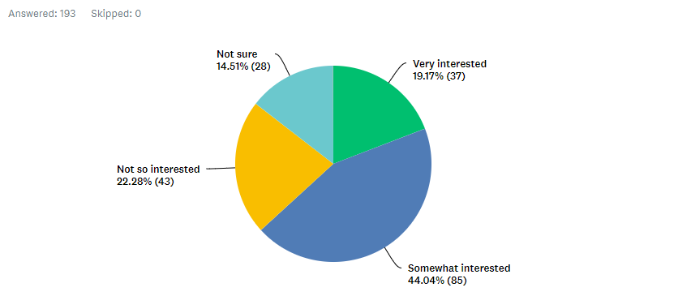
- If you already have a major: If City Tech had a Health Communication major at the time that you started here, how interested would you have been in making it your major?
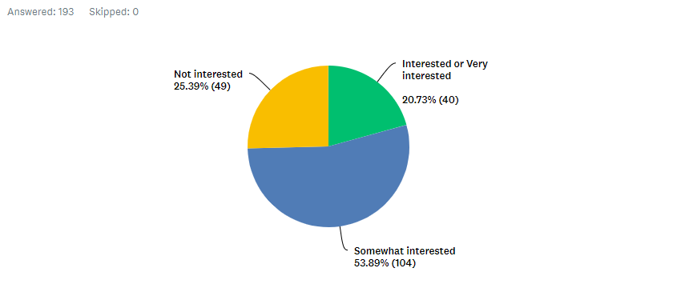

- What is your current major?
Major | Percent response | N
Liberal Arts and Sciences (LAS) | 29.53% | 57
Undeclared/ Undecided/ Non-degree Seeking | 20.21% | 39
Nursing | 19.69% | 38
Liberal Arts and Arts (LAA) | 16.06% | 31
Radiologic Tech & Medical Imaging | 7.77% | 15
Dental Hygiene | 4.66% | 9
Hospitality Management | 1.55% | 3
Other (please specify) * | 1.55% | 3
Health and Human Services | 1.04% | 2
Health Services Administration | 0.52% | 1
Communication Design | 0.52% | 1
Computer Engineering Technology/ Electromechanical | 0.52% | 1
Computer Science | 0.52% | 1
Applied Physics | 0.52% | 1
Professional & Technical Writing | 0.52% | 1
Construction Management Technology | 0.52% | 1
Career & Technology Teacher Education | 0.52% | 1
Applied Mathematics | 0.52% | 1
Mechanical Engineering Technology | 0.52% | 1
Law & Paralegal Studies | 0.52% | 1
Entertainment Technology | 0.52% | 1
Civil Engineering Technology | 0.52% | 1
Business & Tech of Fashion | 0.52% | 1
*(“PCY,” “Undeclared Health Care” and “Undecided.”)
- Do you think that City Tech students would benefit from having more bachelor degree options that are related to health?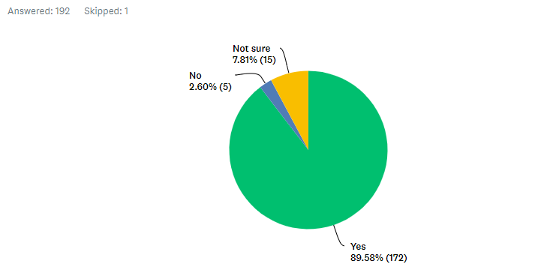
- Choose the answer that best describes you.
- I would like to get into the Nursing Program, Rad Tech, Dental Hygiene, or another competitive healthcare program.
- I would NOT like to get into the Nursing Program, Rad Tech, Dental Hygiene, or another competitive healthcare program.
- Not sure
- Not applicable
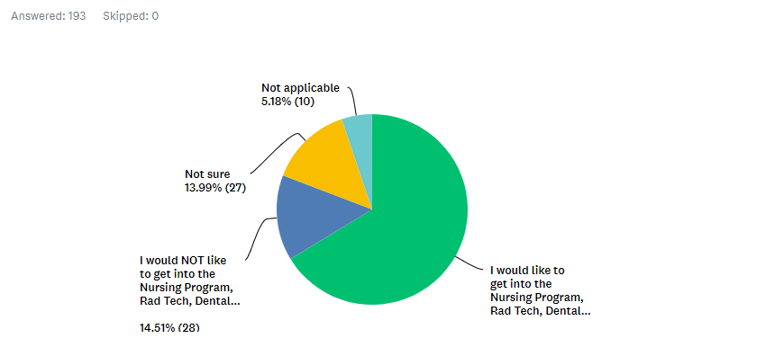
- If you wanted to get into Nursing, Rad Tech or Dental Hygiene, but did not qualify, how likely would you be to consider Health Communication as a major?
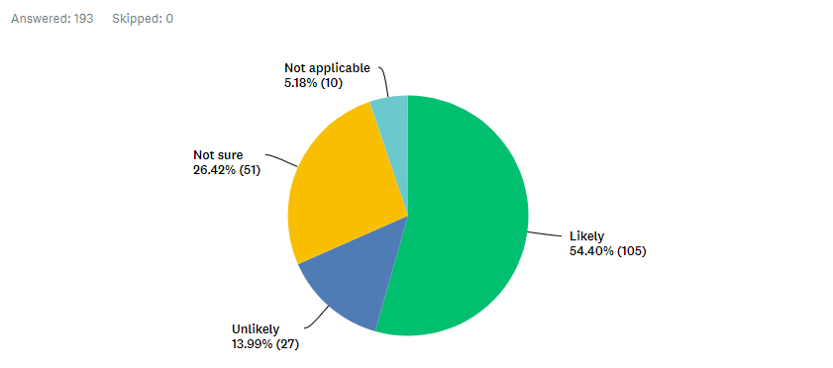
- Given a choice between the following two areas of concentration in Health Communication, which would you choose?
- Health Communication and Culture N=140 (72.54%)
- Health Promotion and Media N=53 (27.46%)

- Which Health Communication topics are you interested in? (You can check more than one).
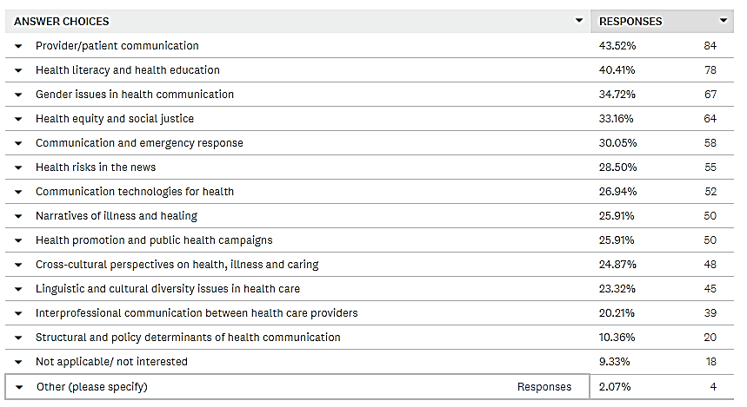Total N=193
Other: “Something with healthcare /insurance companies,” “OBGYN,” “Nursing,” “I would love to help spread health services all over the world …”

Appendix E: New Course Outlines

COM 1400 Introduction to Media Studies
Prepared by D.Lee
Hours and Credits: 3 credits (3 hours)
Pathways category: U.S. Experience in its Diversity
Pre-requisites: ENG 1101
COURSE/CATALOG DESCRIPTION: Introduction to the history, structure and operations of media industries in today’s changing media marketplace. Study of the historical development and convergence of print, radio, film, TV, internet, gaming. Students identify interrelationships between media platforms and communication channels to understand their pervasive presence and decisive influence. Communication theories help explain the intersecting forces of culture, commerce, regulatory policy and the public interest that have shaped the media.
Projected Student Enrollment: 24
Textbook: Understanding Media and Culture: An Introduction to Mass Communication ISBN: 978-1-946135-26-1 This is a free, zero-cost, Open Educational Resource (OER) textbook.
Other required reading:
- Encyclopedia Britannica entry “Journalism”
- “What is investigative journalism?” by Mark Lee Hunter and Nils Hanson (Chapter 1 of Story Based Inquiry: a Manual for Investigative Journalists” edited by Mark Lee Hunter). UNESCO Open Access Publishing. ISBN 9 789231 041891
Recommended Reading:
- Campbell, R., Martin, C., & Fabos, B. (2013). Media & Culture: Mass Communication in a Digital Age. ISBN-13: 978-1457668739
- Jenkins, H. (2008). Convergence Culture: Where Old and New Media Collide. ISBN: 978-0-8147-4281
Additional handouts and links to web-based resources will be posted to Blackboard.
COURSE SPECIFIC LEARNING OUTCOMES
Participants successfully completing the course will be able to:
- Describe historical development and structure of the media today
- Understand the regulatory framework governing the media
- Identify key events in history of print, journalism, public relations, radio, TV and new media
- Examine the past and present of racist and sexist stereotypes in radio, film and TV
- Analyze implications of challenges and changes facing media in contemporary society
- Discuss trend towards mergers in media industries and their social impact
- Consider media effects and the formation of public attitudes
- Examine and analyze how media products are used by audiences to meet social needs
- Participate in current policy debates
- Determine how internet/ new media have changed the media consumer experience
Assessment: A review of student performance conducted by the professor will show if students have met all of the competencies identified for this course. These competencies include written assignments, oral presentations, examinations, research projects, online and in-class discussions and posted exercises.
GENERAL EDUCATION LEARNING OUTCOMES
Upon the successful completion of this course, students are expected to:
- Gather, interpret, and assess information from a variety of sources and points of view.
- Evaluate evidence and arguments critically or analytically.
- Produce well-reasoned written or oral arguments using evidence to support conclusions.
Flexible Core Learning Outcomes (U.S. Experience in its Diversity)
Learning Outcomes | Assessment Methods
Identify and apply the fundamental concepts and methods of a discipline or interdisciplinary field exploring the U.S. experience in its diversity, including, but not limited to, anthropology, communications, cultural studies, economics, history, political science, psychology, public affairs, sociology, and U.S. literature. | The interdisciplinary approach to media studies involves concepts and theories from communications, English and cultural studies perspectives. In written reports and oral presentations, students are assessed in their ability to identify key technologies, products and events in the history of mass media, using concepts and methods originating from these disciplines.
Analyze and explain one or more major themes of U.S. history from more than one informed perspective. | On discussion board students comment on key historical events and milestones such as the 1906 Pure Food and Drug Act; the formation of the Federal Communication Commission, and the rise of Facebook. These are used to illustrate major historical themes, including convergence; economic transformation; regulation and acculturation.
Evaluate how indigenous populations, slavery, or immigration have shaped the development of the United States. | There is a discussion board prompt about case examples of the portrayal of African Americans, Latinos and other minority groups, starting a discussion of discrimination, media bias, and racism in U.S. history.
Analyze and discuss common institutions or patterns of life in contemporary U.S. society and how they influence, or are influenced by, race, ethnicity, class, gender, sexual orientation, belief, or other forms of social differentiation. | Final project option includes thematic study of how a certain group are portrayed in the media. Students investigate the influence of ethnocentrism, racism, sexism and other forms of discrimination in the media and the use of media platforms such as Twitter as a mobilizing force for political reaction.
TEACHING AND LEARNING METHODS
- Discussions and lectures
- Readings and research
- Online-learning using videos, podcast, etc.
- Multi Multimedia student presentations
- Exams
OVERVIEW OF ASSIGNMENTS
Weekly Blackboard Discussion Board Participation: (15%) Each week the instructor posts links to videos, podcasts, news articles and websites, then pose a few questions related to these links as well as the readings. Each week students write an (approximately one page) response to the questions posed, making references to the links and weekly readings, as well as sharing experiences and links of their own. Please pose at least one discussion question in your response, and try to respond to the discussion questions posed by your classmates. Spelling and grammar mistakes detract from your grade.
Exams: (20%) Two exams are given online through Blackboard to assess your knowledge media studies and concepts covered during the semester. Questions are multiple choice, T/F, or matching and include questions where students have to apply theory to given contexts. As students are completing this on their own, they are allowed to use course texts and materials, however, there is a time limit on the exam so the student should be prepared prior to starting.
Media Analysis: (2 presentations with speaking outline, 15% per) This assignment is an opportunity for students to research a particular media product, such as a show, movie, video game, or other artifact. The media text can be contemporary or it can be something historical. Students are provided with a sample outline and checklist specifying key features of the analysis, including plot, characters, production details and historical/ cultural significance. Both analyses are presented extemporaneously in class (3-5 minutes), using PowerPoint and a Speaking Outline.
Final Project: (Proposal: 5%; Oral Presentation 15%; Paper 15%) The Final Project presents the opportunity for students to pursue a subject of interest in Media Studies. The instructor assists in finding a topic that is both relevant to the class and useful for the student. You may choose only ONE of the two options below.
- The Media and Your Major: Students at City Tech are working towards a great variety of degrees, often preparing them for an occupation. Whether your major is in Construction, Hospitality, Communication, Nursing or Professional and Technical Writing, the media intersects with it in some way. You are encouraged to choose a topic at the intersection of Media Studies and your chosen career path. A diverse number of topics can be imagined based on this premise, including, but not limited to:
- An Architecture major presenting a study of an Architecture Today magazine
- A Law and Paralegal major presenting a study of how lawyers are portrayed on TV
- A Health Communication major presenting critical analysis on the TV show Scrubs
- A Physics major showing how scenes in The Last Jedi contravene the laws of physics
- A Human Services major reporting on a documentary about mental illness
- A Hospitality Major presenting an analysis of a media campaign for Sandals resort
- Other Media Studies Topics: Other Final Project topics are considered, including for students who have yet to select their major. Students can select from a list of topics provided, or they can come up with another topic not listed, in consultation with the instructor. Topics could include, but are not limited to:
- A report on a fan community for some form of media
- A look at career opportunities in film, television or other industry
- An analysis of your favorite film, show, video game, or other media product, using some concept or theory from media studies
- A thematic study of how a certain group are portrayed in the media
- Others?

Participation: Student participation includes (a) active and timely participation during in class oral/written work, blackboard discussions, and group activities; (c) punctual arrival to class and consistent class presence; (d) punctual submission of graded assignments (written and oral); (e) collegial and cooperative interactions with the professor and peers; and (g) professionally acceptable classroom behavior, including demonstrating ethical communication and avoiding audible and visual distractions during lectures and presentations.
GRADING PROCEDURE
- Weekly Discussion Board: 15%
- Exams: 10% each =20%
- Media Analysis: 10% each =20%
- Final Project:
  - Proposal 5%
  - Oral Presentation 15%
  - Paper 15% =35%
  - Participation 10%
= 100%
COURSE SCHEDULE, TOPICS, AND ASSIGNMENTS READINGS
Week 1 Understanding media convergence Ch. 1 & 2
Week 2 Print media Ch. 3 & Journalism
Week 3 Journalism, the rise and fall? Ch. 4
Week 4 Media Analysis #1 Presentations Ch. 5
Week 5 Newspapers and magazines Ch. 6
Week 6 The recording industry and radio Ch. 7
Week 7 Movies and film studies Ch. 9
Week 8 Media Analysis #2 Presentations Ch. 10
Week 8 Television Ch. 11
Week 9 Electronic gaming Ch. 12
Week 9 The internet and mobile Ch. 13
Week 10 Advertising and Public Relations Ch. 14
Week 11 Policy, ethics and economics of the media Ch. 15 & 16
Week 12 The future: Surveillance, free speech, and VR
Week 13 Final Presentations
Week 14 Final Presentations
Week 15 Final Presentation

RECOMMENDED ATTENDANCE AND CURRICULUM STANDARDS
It is the conviction of the Humanities Department that a student who is not in a class for any reason is not receiving the benefit of the education being provided. Missed class time includes not just absences but also latenesses, early departures, and time outside the classroom taken by students during class meeting periods. Missed time impacts any portion of the final grade overtly allocated to participation and/or any grades awarded for activities that relate to presence in class.
Students are expected to turn in original work of high standard. Papers are graded on given criteria as well as on spelling, grammar, and appearance. Students are expected to have read assigned material before coming to class. Assignments must be turned in on time. Late work can be penalized up to 10%. No make-up exams allowed unless a) students miss an exam due to an emergency that is documented and verifiable; b) students contact the professor as soon as possible. Late assignments are not accepted during finals week.
CAMPUS POLICIES AND SERVICES
Understanding Plagiarism: The New York City College of Technology Academic Integrity Policy states, “Students and all others who work with information, ideas, texts, images, music, inventions, and other intellectual property owe their audience and sources accuracy and honesty in using, crediting, and citing sources. As a community of intellectual and professional workers, the College recognizes its responsibility for providing instruction in information literacy and academic integrity, offering models of good practice, and responding vigilantly and appropriately to infractions of academic integrity. Accordingly, academic dishonesty is prohibited in The City University of New York and at New York City College of Technology and is punishable by penalties, including failing grades, suspension, and expulsion.” (See pp. 73-76 in the student handbook). The following are some examples of plagiarism:
- Copying another person’s actual words without the use of quotation marks and footnotes attributing the words to their source.
- Presenting another person’s ideas or theories in your own words without acknowledging the source.
- Using information that is not common knowledge without acknowledging the source.
- Failing to acknowledge collaborators on homework and laboratory assignments.
- Internet Plagiarism includes submitting downloaded term papers or parts of term papers, paraphrasing or copying information from the internet without citing the source, and “cutting and pasting” from various sources without proper attribution.
Writing Center (located in the basement level of the Library): The Writing Center offers free interactive tutorial services for students who need help with writing, grammar, organization, APA/MLA, etc.
Technology Support: iTec, Room G601, (718)-254-8565; email: itec@citytech.cuny.edu
Website: http://websupport1.citytech.cuny.edu/index.html
Reasonable Accommodation: We are committed to providing reasonable accommodation to students with disabilities. Qualified students with disabilities are provided reasonable academic accommodations if determined eligible by the Office of Students Support Services (OSSS). Prior to granting disability accommodations in this course, the instructor must receive written verification of a student’s eligibility from OSSS, which is located in room A-237. It is the student’s responsibility to initiate contact with the OSSS staff and to follow the established procedures for having the accommodation notice sent to the instructor.
Humanities Department Commitment to Student Diversity: The Humanities Department complies with the college wide nondiscrimination policy and seeks to foster a safe and inclusive learning environment that celebrates diversity in its many forms and enhances our students’ ability to be informed, global citizens. Through our example, we demonstrate an appreciation of the rich diversity of world cultures and the unique forms of expression that make us human.
References
Barlow, A. & Westengard, L. (2018). The 25 Most Influential American Sitcoms. Santa Barbara, CA: Praeger, 2018.
Bird, S. E. (2003). The audience in everyday life: Living in a media world. New York: Routledge.
Bogle, D. (1988). Blacks in American films and television: An encyclopedia. New York: Garland Pub.
Brennen, B. (2012). Qualitative research methods for media studies. New York: Routledge
Chan, J. M., & Lee, F. L. (2017). Advancing comparative media and communication research. New York: Routledge
Durham, M, & Kellner, D. Eds. (2012). Media and Cultural Studies: Keyworks. New York. Wiley-Blackwell
Entman, R. M., & Rojecki, A. (2000). The black image in the white mind: Media and race in America. Chicago: University of Chicago Press.
Iyengar, S. (1991). Is anyone responsible? How television frames political issues. Chicago: University of Chicago Press.
McChesney, R.W. (2015). Rich media, poor democracy: Communication politics in dubious times. New York: The New Press
Miller, T., & Kraidy, M. M. (2016). Global media studies. Cambridge: Polity Press
Rheingold, H. (2003). Smart mobs: The next social revolution. Cambridge, MA: Basic Books.
Sloan, L., & Quan-Haase, A. (2017). The SAGE handbook of social media research methods. Thousand Oaks, Sage Publications
Tenner, E. (1996). Why things bite back: Technology and the revenge of unintended consequences. New York: Knopf.
Whitty, M. T., & Johnson, A. N. (2009). Truth, lies and trust on the Internet. New York: Routledge.

COM 2405 Principles of Persuasion
Prepared by D. Lee
Hours and Credits: 3 credits (3 hours)
Pathways: U.S. Experience in its Diversity
Pre-requisite: ENG 1121 or higher
CATALOG/COURSE DESCRIPTION: Principles of persuasive communication from humanistic and social-scientific perspectives. Topics include rhetorical approaches to audiences, persuasion, propaganda, source credibility and message framing. Students participate in online discussion, critique media products, create a persuasive media campaign and give oral presentations.
Projected Student Enrollment: 24
Textbook: Jones, J.G. and Simons, H.W. (2017). Persuasion in Society, 3rd. Ed. Routledge. ISBN: 978-1138825666 ($83.71 new)
COURSE INTENDED LEARNING OUTCOMES
Participants completing the course will be able to:
- Identify persuasive strategies used in advertising and marketing
- Understand rhetorical and social scientific approaches to studying persuasion
- Consider the ethics of persuasive appeals and be critical of compliance gaining techniques
- Investigate intercultural and gender factors of rhetorical situations/ persuasive strategies
- Review mediated contexts (television, internet, etc.) where persuasion takes place
- Analyze messages for effectiveness according to target audiences
- Find credible sources and critique unethical appeals
Assessment: A review of student performance conducted by the professor will show if students have met all of the competencies identified for this course. These competencies include written assignments, oral presentations, examinations, research projects, online class discussions and posted exercises.
GENERAL EDUCATION LEARNING OUTCOMES:
Upon the successful completion of this course, students are expected to:
- Gather, interpret, and assess information from a variety of sources and points of view
- Evaluate evidence and arguments critically or analytically
- Produce well-reasoned written or oral arguments using evidence to support conclusions
Flexible Core Learning Outcomes (U.S. Experience in its Diversity)
Learning Outcomes | Assessment Methods
Identify and apply the fundamental concepts and methods of a discipline or interdisciplinary field exploring the U.S. experience in its diversity, including, but not limited to, anthropology, communications, cultural studies, economics, history, political science, psychology, public affairs, sociology, and U.S. literature. | Through papers and oral presentations, students are assessed on their ability to apply principles and concepts from persuasion research, which is interdisciplinary in scope. Students are exposed to ideas originating from communication, public address, political science, social psychology and other fields.
Analyze and explain one or more major themes of U.S. history from more than one informed perspective. | Exams and evaluation criteria measure the application of persuasion theory concepts (such as social proof and inoculation) on consumerism, mass media and advertising, which are major themes of U.S. history.
Analyze and discuss common institutions or patterns of life in contemporary U.S. society and how they influence, or are influenced by, race, ethnicity, class, gender, sexual orientation, belief, or other forms of social differentiation. | Discussion prompts and critical analysis papers are assessed for their consideration of social class, belief, race, ethnicity and gender, as influenced by persuasive communication.

TEACHING AND LEARNING METHODS
- Discussions and lectures
- Readings and research
- Multimedia text
- Design-based assignments
- Class Debates
- Individual and collaborative projects
- Student presentations
- Online-learning
OVERIVIEW OF ASSIGNMENTS
Weekly Blackboard Discussion Board Participation: (15%) Students are expected to attend class and participate in class discussion and activities. During each class meeting students complete in-class assignments and students not present won’t receive credit. Additionally, students demonstrate engagement with the readings and lectures by answering Online Discussion Board prompts and posting discussion questions.
Exams: (20%) Two exams given online through Blackboard to assess your knowledge of persuasion theory and concepts covered during the semester. Questions are multiple choice, T/F, or matching and include questions where students have to apply theory to given contexts. As students are completing this on their own, they are allowed to use textbook, however, there is a time limit on the exam so the student should be prepared prior to starting.
Critical Analysis Paper/Presentation: (2 per student, worth 12.5% per). Students find an example of persuasion in the media and analyze it using “variables” of the rhetorical situation, applying appropriate persuasion/propaganda theories as discussed in class. The objective of the assignment is to evaluate the persuasive text and make an argument about why the text is effective/not effective for its given audience/purpose, explained through the theories we have been discussing.
- Analysis #1: Written Persuasion (newspaper, magazine, or online article)
- Analysis #2: Visual Persuasion (video or print ad, meme, billboard, etc.)
Each analysis is presented extemporaneously in class (3-5 minutes), using PowerPoints and a Speaking Outline.

Persuasive Campaign Project: (Proposal: 5%; Oral Presentation 10%; Paper 15%) In groups, you create a Persuasive Campaign focusing on any topic of your choosing. Use whatever persuasion strategies we have been discussing in class to create some “mass media” message (in the form of billboard, website, social media meme, radio/TV commercial, etc.) which you present to the class. You also do a final analysis paper which includes research of the topic you address (what does the actual evidence say, what are other views to this issue, why did you make the choices you did to persuade your chosen audience?) Each campaign is presented extemporaneously in class (4-6 minutes), using PowerPoints and a Speaking Outline.
Participation: Student participation includes (a) active and timely participation during in class oral/written work, blackboard discussions, and group activities; (c) punctual arrival to class and consistent class presence; (d) punctual submission of graded assignments (written and oral); (e) collegial and cooperative interactions with the professor and peers; and (g) professionally acceptable classroom behavior, including demonstrating ethical communication and avoiding audible and visual distractions during lectures and presentations.
GRADING PROCECDURE:
- Weekly Discussion: 15%
- Exams: 20%
- Critical Analysis Papers: 12.5% each 25%
- Persuasive Campaign Project: 30% (all parts total)
- Participation 10%
COURSE SCHEDULE, TOPICS AND ASSIGNMENTS
Week | Objectives and Assignments Due | Readings
Week 1: | Intro to the course; defining persuasion and propaganda | Chapter 1
Week 2: | Rhetorical perspectives; “fast” and “slow” routes to persuasion | Chapter 2
Week 3: | Ethics of persuasion; audience segmentation and targeting | Chapter 3
Week 4: | Co-active persuasion; identifying persuasive strategies  Critical Analysis #1 Due | Chapter 4
Week 5: | Source credibility, creating images, brands and spokespeople | Chapter 5
Week 6: | Compliance gaining; framing and reframing | Chapter 6
Week 7: | Techniques in product advertising and political campaigns | Chapter 7
Week 8: | Culture, entertainment, memes | Chapter 8
Week 9: | Visual persuasion, signs, symbols | Chapter 9
Week 10: | Persuasive speaking; activism and social movements  Critical Analysis #2 Due | Chapter 10
Week 11: | Identifying political bias in supposedly ‘objective’ news reports | Chapter 11
Week 12: | Infotainment and factoids  EXAM 1 (on Blackboard)
Week 13: | Exam Review and Final Presentation Workshop | Chapters 12-15
Week 14: | Final Presentations  EXAM 2 (on Blackboard)
Week 15: | Final Presentations --Final papers due on Blackboard
RECOMMENDED ATTENDANCE AND CURRICULUM STANDARDS
Attendance: It is the conviction of the Humanities Department that a student who is not in a class for any reason is not receiving the benefit of the education being provided. Missed class time includes not just absences but also latenesses, early departures, and time outside the classroom taken by students during class meeting periods. Missed time impacts any portion of the final grade overtly allocated to participation and/or any grades awarded for activities that relate to presence in class.
Students are expected to turn in original work of high standard. Papers are graded on given criteria as well as on spelling, grammar, and appearance. Students are expected to have read assigned material before coming to class. Assignments must be turned in on time. Late work can be penalized up to 10%. No make-up exams allowed unless a) students miss an exam due to an emergency that is documented and verifiable; b) students contact the professor as soon as possible. Late assignments are not accepted during finals week.
CAMPUS POLICIES AND SERVICES
Understanding Plagiarism: The New York City College of Technology Academic Integrity Policy states, “Students and all others who work with information, ideas, texts, images, music, inventions, and other intellectual property owe their audience and sources accuracy and honesty in using, crediting, and citing sources. As a community of intellectual and professional workers, the College recognizes its responsibility for providing instruction in information literacy and academic integrity, offering models of good practice, and responding vigilantly and appropriately to infractions of academic integrity. Accordingly, academic dishonesty is prohibited in The City University of New York and at New York City College of Technology and is punishable by penalties, including failing grades, suspension, and expulsion.” (See pp. 73-76 in the student handbook). The following are some examples of plagiarism:
- Copying another person’s actual words without the use of quotation marks and footnotes attributing the words to their source.
- Presenting another person’s ideas or theories in your own words without acknowledging the source.
- Using information that is not common knowledge without acknowledging the source.
- Failing to acknowledge collaborators on homework and laboratory assignments.
- Internet Plagiarism includes submitting downloaded term papers or parts of term papers, paraphrasing or copying information from the internet without citing the source, and “cutting and pasting” from various sources without proper attribution.
Writing Center: (located in the basement level of the Library Building): The Writing Center offers free interactive tutorial services for students who need help with writing, grammar, organization, APA/MLA, etc.
Technology Support: iTec, Room G601, (718)-254-8565; email: itec@citytech.cuny.edu
Website: http://websupport1.citytech.cuny.edu/index.html

Reasonable Accommodation: We are committed to providing reasonable accommodation to students with disabilities. Qualified students with disabilities are provided reasonable academic accommodations if determined eligible by the Office of Students Support Services (OSSS). Prior to granting disability accommodations in this course, the instructor must receive written verification of a student’s eligibility from OSSS, which is located in room A-237. It is the student’s responsibility to initiate contact with the OSSS staff and to follow the established procedures for having the accommodation notice sent to the instructor.
Humanities Department Commitment to Student Diversity: The Humanities Department complies with the college wide nondiscrimination policy and seeks to foster a safe and inclusive learning environment that celebrates diversity in its many forms and enhances our students’ ability to be informed, global citizens. Through our example, we demonstrate an appreciation of the rich diversity of world cultures and the unique forms of expression that make us human.
References:
Aristotle. (2000). Rhetoric. South Bend: Infomotions.
Burke, K. (1969). A rhetoric of motives. Berkeley: University of California Press
Dillard, J., Shen, Lijiang, & Gale Group. (2013). The SAGE handbook of persuasion developments in theory and practice (2nd ed., Gale virtual reference library). Los Angeles: SAGE.
Ewen, S. (1996). PR! A social history of spin (1st ed.). New York: Basic Books.
Eyman, D. (2015). Digital rhetoric: Theory, method, practice. Ann Arbor: University of Michigan Press
Goodman, B., Goodman, R. Dretzin, S. M., Rushkoff, D., Ark Media, WGBH, & PBS Home Video. (2004). The Persuaders: Americans are Swimming in a Sea of Messages. Alexandria: PBS Home Video.
Messaris, P. (1997). Visual persuasion: The role of images in advertising. Thousand Oaks, Calif.: Sage Publications.
Mintz, A. (2012). Web of deceit: Misinformation and manipulation in the age of social media. Medford, N.J.: CyberAge Books.
O'Reilly, T., & Tennant, Mike. (2009). The age of persuasion: How marketing ate our culture. Berkeley, Calif.: Counterpoint: Distributed by Group West.
Royster, J. J. & Kirsch, G. E. (2012). Feminist rhetorical practices: New horizons for rhetoric, composition, and literacy studies. Carbondale: Southern Illinois University Press.
Saxon, J. (2017). Why Your Customers’ Attention is the Scarcest Resource in 2017. American Marketing Association. Retrieved from: https://www.ama.org/partners/content/Pages/why-customers-attention-scarcest-resources-2017.aspx
Tellis, G. (2004). Effective advertising: Understanding when, how, and why advertising works. Thousand Oaks, Calif: Sage Publications.

COM 2406 Gender and Health Communication
Prepared by Z. Zhu
Hours and Credits for Lecture/lab: 3 credits (3 hours)
Pathways category: U.S. Experience in its Diversity
Course Pre-requisite: ENG1121 or higher
COURSE/CATALOG DESCRIPTION: Gender-related health issues have always been the subjects of sensitive social, cultural, and political debates. This course explores current healthcare practices, experiences, and systems that are both affecting and affected by gender norms, performances, and representations. A critical review and analysis of the ways sexual minorities have been treated by health institutions in the major stages of human history are conducted in the class. Students learn the complex interplay among health, communication, and gender, with specific foci on how gender-based communication practices affect people’s everyday decision and choices in medical care, and what we can do to improve the current healthcare system and environment.
Projected Enrollment: 24
Textbook Title: Gender and Health: The Effects of Constrained Choices and Social Policies
Authors: Chloe E. Bird, Patricia P. Rieker
Year: 2008; Publisher: Cambridge University Press, ISBN-10: 0521682800
Paperback: $27 (used), $30.14 (new)
Additional Readings (the instructor will provide students with specific information about the journal articles in class):
- Gabbard-Alley, A. S. (2009). Health communication and gender: A review and critique. Health Communication, 7(1), 35-54.
- Jefferson, L., Bloor, K., Birks, Y., Hewitt, C., & Bland, M. (2013). Effect of physicians’ gender on communication and consultation length: A systematic review and meta-analysis. Journal of Health Services Research & Policy, 18 (4), 242-248.
- Journal of Gender, Culture, and Health
COURSE INTENDED LEARNING OUTCOMES
Upon the successful completion of this course, students are expected to:
- Understand, broadly and deeply, about the changing U.S. healthcare system, with a specific attention to the ways women and sexual minorities have been affected by the major healthcare policies and established medical procedures.
- Critically analyze the healthcare practices and medical treatments that are often labeled as normal and scientifically proven procedures for populations who usually do not identify themselves as the gender-ed others.
- Know how to communicate, properly, with individuals or groups holding different gender identities in various healthcare settings, as a doctor, patient, family member of the patient, healthcare personnel and administrator.
- Apply the key class concepts to the critical examination of gender-specific health issues that are causing debates and controversies in our society.
- Develop a communication-centered program or campaign that can raise people’s awareness about the current situation of woman and LGBTQ communities in receiving healthcare and provide a solution that help them receive equal care and support, through conducting proper research, such as literature review, data collection and analysis.
- Deliver clear, organized, and well-articulated individual presentations about gender-themed research projects.
Assessment: A review of student performance conducted by the professor will show if students have met all of the competencies identified for this course. These competencies include written assignments, oral communication, examinations, analytical papers, interviews, reports, research projects, class discussions and posted exercises.
GENERAL EDUCATION LEARNING OUTCOMES:
Upon the successful completion of this course, students are expected to:
- Gather, interpret, and assess information from a variety of sources and points of view.
- Evaluate evidence and arguments critically or analytically.
- Produce well-reasoned written or oral arguments using evidence to support conclusions.
General Education Learning Outcomes (U.S. Experience in its Diversity)
Learning Outcome | Assessment
Identify and apply the fundamental concepts and methods of a discipline or interdisciplinary field exploring the U.S. experience in its diversity, including, but not limited to, anthropology, communications, cultural studies, economics, history, political science, psychology, public affairs, sociology, and U.S. literature. | Students review reading materials rooted in a wide range of fields, including communication studies, cultural studies, historical analysis, sociology, and human psychology. Both mid-term and final exams, parts of the analytical essays, and parts of the critical interview analysis require students to understand and analyze gender-related health issues from these different lenses.
Analyze and explain one or more major themes of U.S. history from more than one informed perspective. | Parts of the mid-term exam and critical interview analysis, and one analytical essay demonstrate whether students have developed an accurate and in-depth understanding about different gender groups have been treated in healthcare system in the U.S. and throughout major historical stages and gender-related social movements.
Analyze and discuss common institutions or patterns of life in contemporary U.S. society and how they influence, or are influenced by, race, ethnicity, class, gender, sexual orientation, belief, or other forms of social differentiation. | Parts of the midterm and final exams, at least one analytical essay, parts of the critical interview analysis, and parts of the final program development paper will require students to demonstrate their knowledge and critical understanding of the ways gender intersects with race, class, religious beliefs, age, and national identities when communicating about difficult common health issues.

TEACHING AND LEARNING METHODS:
Review critical texts and policies
- Discussions and lecture
- Critical Readings and research
- Multimedia text and communication
- Design-based assignments
- Individual and collaborative projects
- Student presentations, oral feedback, Q& A
- Online-learning
OVERVIEW OF ASSIGNMENTS
Assignment 1 – Gender-Themed Analytical Essays
Students will write 3 essays that can demonstrate their critical understanding of a specific gender-related health issue in relation to the concept(s) covered in the required reading materials, lectures, and class discussions. Students can pick any current, controversial, and important issues/events that recently caught public attention and triggered intense debates. Students must draw on 1-2 class concepts when writing the analysis and clearly explain how the concepts relate to the issue that is being analyzed. This is a very important part of this assignment because it shows whether students can apply what they learned in class to the understanding and analysis of a real issue involving health and gender. The essay must be written in separate paragraphs, grammatically correct format, with clear and appropriate academic language. Detailed instruction will be provided in class.
Assignment 2 – Critical Interview Report and Analysis
Students will conduct one in-depth and detailed interview with a member of a marginalized gender group/community. The Interview should be no less than 30 minutes, no more than an hour. Please prepare your list of interview questions and confirm the list with the course instructor before conducting the interview. The interview should seek to answer the following general questions:
- What is your major concern, or people from your group’s major concern about the existing healthcare system/structure?
- Do you think your community’s needs are fully and fairly represented by the current healthcare policies or the people who are supposed to speak on behalf of you for your healthcare needs?
- What is your personal experience at the hospital or a doctor’s office?
- Have your heard of other people’s stories about their personal struggles with receiving proper medical treatments, especially from those with whom you identify as sharing the same gender identity?
- In your opinion, what are the major reasons that cause the inequalities in healthcare system, if you think there are inequalities in the first place. What should we do, through communication, to make it equal and supportive to all gender groups?
After the interview is completed, students need to write a paper analyzing the answers provided by the interviewee. The analysis should provide a deep reflection on the ways the interviewee perceives the U.S. healthcare system, in relation to the concepts covered in the class. The interview report part should be no less than 2 pages, no more than 3 pages. The report needs to be a clear and organized summary of the interview transcript. The analysis is the major part of this assignment. Students need to write between 4-5 page-long analysis of the interview. Both the report and analysis must be written in standard academic format. Detailed instruction and guidance will be provided in class.
Assignment 3 – Midterm and Final Exam
Students will complete midterm and final exams in class. Both the midterm and final exams will consist of 25 multiple-choice questions respectively. The questions will come from the required reading materials, in-class lectures, and discussions. The study guides for the midterm and final exams will be provided in class, precisely 1 week before the exam days.
Assignment 4 – Program Development Paper, 10-15 pages.
Students will design a communication-centered program/campaign that is tailored to a specific gender group/community. In this paper, students need to identify the gender group, explain their concerns and struggles with certain aspects of the existing healthcare policies, medical practices, or treatments at particular healthcare settings. The next step is to develop a solution using effective communication strategies to help these people communicate their needs to the organizations or even individuals who can and are likely willing to work with them in resolving the problem(s) and helping them receive equal health support. For this paper, students need to
- Conduct extensive research about the gender group they intend to study and help
- Create a communication-centered program/campaign that is aimed at helping these people communicate their needs to those who can and are potentially interested in working with them to obtain equal treatment. This should be the focus of the paper.
- Discuss the possible strength and weakness of the program/campaign.
Assignment 5 – Individual Presentations for Critical Interview Report and Analysis, and Final Program Development Paper. Students will present their 1) interview report and analysis, and 2) the final program development papers in class. The presentation will be graded based on the following criteria:
- The use of voice, pronunciation, eye contact, body movements, appropriate outfit, and the level of enthusiasm invested in expressing ideas to the audience.
- The organization of the main ideas in the speech body.
- The way the Introduction and Conclusion are structured.
- Examples/supporting materials that are used to support the main ideas.
- Visual aids that are used to illustrate the main points.
- The interactions between the presenter and audience during Q&A sessions.
Class Participation: Students are expected to attend class on time and actively contribute to the class discussions and various other activities throughout the semester. Please note that the class participation is an integral part of any communication course, especially at the advanced level. The course instructor will frequently ask questions to test if students have completed the assigned readings and whether they are following the class. Students need to be prepared for answering these questions and interacting with the instructor and their classmates, in active and respectful ways.
Grade Distribution
Assignments | Points and Percentage
Gender-Themed Analytical Essays | 90 (15%)
Mid-Term Exam | 100 (17%)
Final Exam | 100 (17%)
Critical Interview Report and Analysis | 80 (13%)
Individual Presentation for Critical Interview Report and Analysis | 40 (6%)
Program Development Paper | 100 (17%)
Individual Presentation for Final Program Development Paper | 60 (10%)
Class Participation | 30 (5%)
Total Points and Percentage | 600 (100%)

COURSE SCHEDULE, TOPICS AND ASSIGNMENTS
Week 1: Gender Differences in Health: Are They Biological, Social, or Both? Class Orientation and Syllabus Review. Assigned reading: Chapter 1 from the main text. In class lecture and discussion about how gender identities and performances have been and are being positioned by the healthcare system, policies, cultural norms in medical settings, and healthcare professionals. The course instructor provides detailed instruction on how to write gender-themed analytical papers.
Week 2: Gender and Barriers to Health: Constrained Choice in Everyday Decisions. Assigned reading: Chapter 2 from the main text and the additional article written by Anne S. Gabbard-Alley. In class lecture and discussion about the difficult choice(s) that women and sexual minorities usually struggle with to receive proper healthcare support and benefits, and how “communication” plays a role in either enabling or limiting the choices they have? The course instructor provides early guidance about the critical interview reports and analysis.
Week 3: National Health Policies and Constrained Choice – Part 1. Assigned reading: Chapter 3 from the main text and additional article (s) from Journal of Health Services Research & Policy. In class lecture and discussion about the existing U.S. healthcare policies that either directly or indirectly affect the women and LGBTQ communities’ choices and experiences with receiving proper healthcare support and benefits. The first gender-themed analytical paper is due in class.
Week 4: National Health Policies and Constrained Choice – Part 2. Assigned reading: articles from Journal of Gender, Culture, and Health, Journal of Communication in Healthcare, and Public Health Reports. Continued in class lecture and discussion about the current healthcare system and policies that are specifically affecting the gendered minorities’ experiences with medical care and support.
Week 5: The Impact of Community on Health. Assigned reading: Chapter 4 from the main text and additional articles from Health Communication and Journal of Health Services Research & Policy. In class lecture and discussion about the power of community support in helping women and LGBTQ members fight against unequal healthcare system, with a specific focus on the role that strategic communication plays in the process of creating and reinforcing community support. Second gender-themed due.
Week 6: Students give presentations on their critical interview reports and analysis. The course instructor provides study guide for the mid-term exam. The critical interview reports/analysis paper due.
Week 7: Students complete their mid-term in class.
Week 8: Priorities and Expectations: Men’s and Women’s Work, Family Life, and Health. Assigned reading: the book entitled Gender Lives, written by Julia Wood. Chapter 5 from the main text and additional articles from Health Communication and Journal of Gender, Culture, and Health. In class lecture and discussion about the traditional gender hierarchy that normalizes the everyday struggle men and women often deal with in balancing between professional responsibilities, social life, and family obligations, and how the existing healthcare practices and policies either support or start challenging the hierarchical structure. Part of the discussion will be focused on the common health issues that men and women are facing; such as STD prevention and treatment, the gender stereotype of women as the child care provider, and men’s difficulties of communicating about certain health issues due to the cultural impact of toxic masculinity, which silences men and oppresses their voices seeking prompt medical attention. The course instructor provides detailed instruction on how to write and present the final program development paper.
Week 9: Special Topic 1 – Understanding Gay Men’s Experiences with Health Policies and the Larger Cultural, Political, and Healthcare System that Affect the Creation and Implementation of the Key Policies. Assigned reading: articles from Journal of Communication in Healthcare, Journal of Gender, Culture, and Health, and Health Communication. In class lecture and discussion about gay community’s common experiences and struggles with using healthcare services across different medical environments and settings, and how different communication technologies, strategies, and/or platforms can be adopted to help improve their healthcare experiences. The third gender-themed paper due.
Week 10: Special Topic 2 – Understanding Lesbian Women’s Experiences with Health Policies and the Larger Cultural, Political, and Healthcare System that Affect the Creation and Implementation of the Key Policies. Assigned reading: articles from Health Communication, Public Health Reports, and Journal of Gender, Culture, and Health. In class lecture and discussion about Lesbian community’s common experiences and struggles with using healthcare services across different medical environments and settings, and how different communication technologies, strategies, and/or platforms can be adopted to help improve their healthcare experiences.
Week 11: Special Topic 3 – Understanding Transgender Individuals’ Experiences with Health Policies and the Larger Cultural, Political, and Healthcare System that Affect the Creation and Implementation of the Key Policies. Assigned reading: articles from Health Communication, Journal of Communication in Healthcare, and Journal of Gender, Culture, and Health. In class lecture and discussion about transgender community’s common experiences and struggles with using healthcare services across different medical environments and settings, and how different communication technologies, strategies, and/or platforms can be adopted to help improve their healthcare experiences.
Week 12: Gender and Individual Health Choices. Assigned reading: Chapter 6 from the main text. In class lecture and discussion about the various complicated situations where one struggles among their gender identities, religious beliefs, professional roles, political affiliations, and cultural views when making decisions in 1) signing up for a specific health benefit system and 2) voting for healthcare policies.
Week 13: Becoming an Effective and Respectful Communicator in Healthcare Settings. Assigned readings: articles from Health Communication, Journal of Communication in Healthcare, and Journal of Health Services Research & Policy. In class lecture and discussion about how to communicate, effectively and respectfully, with individuals or groups holding different gender identities, as a doctor, patient, medical personnel, healthcare administrator, and/or friends and family members of those who need medical attention and support. The course instructor provides study guide for the final exam.
Week 14: Students give presentations about their final program development papers.
Week 15: Students complete their final exams in class.
RECOMMENDED ATTENDANCE AND CURRICULUM STANDARDS
Attendance: It is the conviction of the Humanities Department that a student who is not in a class for any reason is not receiving the benefit of the education being provided. Missed class time includes not just absences but also latenesses, early departures, and time outside the classroom taken by students during class meeting periods. Missed time impacts any portion of the final grade overtly allocated to participation and/or any grades awarded for activities that relate to presence in class.
Students are expected to turn in original work of high standard. Papers will be graded on given criteria as well as on spelling, grammar, and appearance. Students are expected to have read assigned material before coming to class. Assignments must be turned in on time. Late work can be penalized up to 10%. No make-up exams allowed unless a) students miss an exam due to an emergency that is documented and verifiable; b) students contact the professor as soon as possible. Late assignments will not be accepted during finals week.
CAMPUS POLICIES AND SERVICES
Understanding Plagiarism: The New York City College of Technology Academic Integrity Policy states, “Students and all others who work with information, ideas, texts, images, music, inventions, and other intellectual property owe their audience and sources accuracy and honesty in using, crediting, and citing sources. As a community of intellectual and professional workers, the College recognizes its responsibility for providing instruction in information literacy and academic integrity, offering models of good practice, and responding vigilantly and appropriately to infractions of academic integrity. Accordingly, academic dishonesty is prohibited in The City University of New York and at New York City College of Technology and is punishable by penalties, including failing grades, suspension, and expulsion.” (See pp. 73-76 in the student handbook). The following are some examples of plagiarism:
- Copying another person’s actual words without the use of quotation marks and footnotes attributing the words to their source.
- Presenting another person’s ideas or theories in your own words without acknowledging the source.
- Using information that is not common knowledge without acknowledging the source.
- Failing to acknowledge collaborators on homework and laboratory assignments.
- Internet Plagiarism includes submitting downloaded term papers or parts of term papers, paraphrasing or copying information from the internet without citing the source, and “cutting and pasting” from various sources without proper attribution.
Writing Center (located in the basement level of the Library Building): The Writing Center offers free interactive tutorial services for students who need help with writing, grammar, organization, APA/MLA, etc.
Technology Support: iTec, Room G601, (718)-254-8565; email: itec@citytech.cuny.edu
Website: http://websupport1.citytech.cuny.edu/index.html
Reasonable Accommodation: We are committed to providing reasonable accommodation to students with disabilities. Qualified students with disabilities will be provided reasonable academic accommodations if determined eligible by the Office of Students Support Services (OSSS). Prior to granting disability accommodations in this course, the instructor must receive written verification of a student’s eligibility from OSSS, which is located in room A-237. It is the student’s responsibility to initiate contact with the OSSS staff and to follow the established procedures for having the accommodation notice sent to the instructor.
Humanities Department Commitment to Student Diversity: The Humanities Department complies with the college wide nondiscrimination policy and seeks to foster a safe and inclusive learning environment that celebrates diversity in its many forms and enhances our students’ ability to be informed, global citizens. Through our example, we demonstrate an appreciation of the rich diversity of world cultures and the unique forms of expression that make us human.
References
Barker, M., & Richards, C. (2013). Sexuality and gender for mental health professionals: A practical guide. Thousand Oaks, CA: Sage.
Basnyat, I. (2017). Theorizing the relationship between gender and health through a case study of Nepalese street-based female sex workers. Communication Theory, 27 (4), 388-406.
Bird, C. E., & Rieker, P. P. (2008). Gender and health: The effects of constrained choices and social policies. Cambridge, UK: Cambridge University Press.
Eliason, M. J., & Chinn, P. L. (2017). LGBTQ cultures: What health care professionals need to know about sexual and gender diversity. Philadelphia, PA: LWW.
Gabbard-Alley, A. S. (2009). Health communication and gender: A review and critique. Health Communication, 7(1), 35-54.
Jefferson, L., Bloor, K., Birks, Y., Hewitt, C., & Bland, M. (2013). Effect of physicians’ gender on communication and consultation length: A systematic review and meta-analysis. Journal of Health Services Research & Policy, 18 (4), 242-248.
Kolander, C., Ballard, D., & Chandler, C. (2014). Contemporary women’s health (5th ed.). New York City, NY: McGraw-Hill.
Moore, L. J., & Lorber, J. (2002). Gender and the social construction of illness (2nd ed.). Lanham, MD: AltaMira Press.
Richter, R. (2015). Medical outcasts: Gendered and institutionalized xenophobia in undocumented forced migrants’ emergency health care. Lanham, MD: Lexington Books.
Street, R. L. (2002). Gender differences in health care provider-patient communication: Are they due to style, stereotypes, or accommodation? Patient Education and Counseling, 48 (3), 201-206.
Wood, J. T. (2012). Gendered lives (10th ed.). Boston, MA: Cengage learning.

COM 3402 Communicating in Multicultural Healthcare Settings
Prepared by Z. Zhu and D. Scannell
Hours and Credits: 3 credits (3 hours)
Pathways category: U.S. Experience in its Diversity
Course Pre-requisite: COM 1332 or 1403, ENG 1121 or higher
or department permission
Course/Catalog Description: This upper-division course focuses on multicultural health communication within the United States. Special emphasis is placed on the difficulties and challenges to multi-cultural health communication, and the importance of cultural competence for patient satisfaction, patient compliance, and other positive healthcare outcomes. Students examine cultural attitudes, beliefs, and practices integrated into U.S. healthcare policies and systems. Students apply analytical and practical approaches to investigate important issues across diverse healthcare contexts and platforms.
Projected Student Enrollment: 24
Required Textbooks:
1. Huff, R. M., Kline, M. V., & Peterson, D. V. (Eds.). (2015). Health promotion in multicultural populations: A handbook for practitioners and students (3rd ed.). Los Angeles: SAGE. ISBN-13: 978-1452276960; ISBN-10: 145227696X ($35.79 used)
2. Fadiman, A. (1998). The spirit catches you and you fall down: A Hmong child, her American doctors, and the collision of two cultures. New York: Farrar, Straus and Giroux. ISBN-10: 0374533407 ($10.20 new)
Supplemental Readings:
Journal of Health Communication; Health Communication; Journal of Communication in Healthcare; The American Journal of Public Health; Institute for Indigenous Knowledge & Development Organization
Course Learning Outcomes
Upon the successful completion of this course, students are expected to:
- Develop knowledge of the concepts and theories deployed by health communication educators and scholars in their analysis of cultural diversity as communication phenomena
- Gather, interpret, and assess health communication competencies in the United States from a variety of sources and points of view
- Develop an understanding of the causes and consequences of ineffective cultural communication competencies in public health settings
- Analyze and discuss current healthcare systems in U.S. society and how they influence, or are influenced by cultural diversity
- Identify how healthcare is structured in the state and city of New York
- Demonstrate an ability to discuss healthcare practices and processes as they apply to race, ethnic and indigenous groups, gender, age, religions, and class
- Identify the roles of culture and communication in advancing health equity and quality
- Examine health communication literature, topics, and current events for use in class discussions, as well as informal and formal writing assignments
Assessment Methods
- Reading and discussion will be measured through grading of written responses and oral participation.
- Written analysis of texts will be measured through grading of essays
- Knowledge of texts will be measured through oral presentations and exams
- Development of effective and creative multicultural program assignment
GENERAL EDUCATION LEARNING OUTCOMES
Upon the successful completion of this course, students are expected to:
- Gather, interpret, and assess information from a variety of sources and points of view.
- Evaluate evidence and arguments critically or analytically.
- Produce well-reasoned written or oral arguments using evidence to support conclusions.
Flexible Core Learning Outcomes (U.S. Experience in its Diversity)
Learning Outcomes | Assessment Methods
To develop knowledge of the concepts and theories deployed by health communication educators and scholars in their analysis of cultural diversity as a communication phenomenon; and to identify models of communication between patient and provider, and key practices in multicultural healthcare settings. | 1. Analytic Paper (inquiry, reasoning skills, and comprehension)  2. Book Response Essay (analytic, synthesis, comprehension, self-reflection)  3. Program Development Paper/Presentation (develop the ability to discuss ideas through writing and speaking; demonstrate inquiry, problem-solving, organizational and professional skills)  4. Midterm  5. Individual research report/presentation (develop and strengthen the ability to discuss concepts and ideas through writing and speaking)
To examine historical texts in order to understand emergent changes to U.S. and NY healthcare systems (aging and diverse populations, class stratification, Immigration, health reform); and to demonstrate an understanding of multi-cultural movements from western and non-western perspectives. | 1. Analytic Paper (inquiry, reasoning skills, and comprehension)  2. Book Response Essay (analytic, synthesis, comprehension, self-reflection)  3. Program Development Paper/Presentation (develop the ability to discuss ideas through writing and speaking; demonstrate inquiry, problem-solving, organizational and professional skills)  4. Midterm  5. Individual research report/presentation (develop and strengthen the ability to discuss concepts and ideas through writing and speaking)
To analyze and discuss contemporary healthcare institutions, and how they influence, or are influenced by cultural diversity; to identify healthcare practices and processes as they apply to race, ethnic and indigenous groups, gender, sexual orientation, age, religions, and class, etc. | 1. Analytic Paper (inquiry, reasoning skills, and comprehension)  2. Program Development Paper/Presentation (develop the ability to discuss ideas through writing and speaking; demonstrate inquiry, problem-solving, organizational and professional skills)  3. Individual research report/presentation (develop and strengthen the ability to discuss concepts and ideas through writing and speaking).
TEACHING AND LEARNING METHODS
- Discussions and lectures
- Readings and research
- Multimedia text and communication
- Design-based assignments
- Individual and collaborative projects
- Student presentations
- Online-learning
GRADING PROCEDURE: One exam, one analytical paper, one program development paper, one research paper, two presentations
Assignments | Points and Percentage
Analytical Paper | 20 points (5%)
Book Response Essay | 20 points (5%)
Program Development Paper | 50 points (12.5%)
Presentation about the Program Development Paper | 40 points (10%)
Mid-Term Exam | 100 points (25%)
Final Research Paper | 80 points (20%)
Final Paper Presentation | 50 points (12.5%)
Class Participation | 40 points (10%)
Total Points | 400 (100%)

OVERVIEW OF ASSIGNMENTS
1, Analytical Paper (20 points)
Students conduct research on a current incident or event that occurred in a healthcare setting. The incident or event needs to be example of how a cross-cultural issue affects the communication, working or personal relationship between individuals or groups at a specific healthcare environment. Students need to explain how that particular incident was handled by the administration or the department responsible for handling such incident, what should have done to prevent such incident from occurring, and what needs to be done in the future to improve the overall cross-cultural communication experience in similar healthcare organizations. The paper must be written in academic format structured in APA style.
2, Book Response (20 points)
Students construct a 4-5-page critical response essay for the book, The Spirit Catches You and You Fall Down: A Hmong Child, Her American Doctors, and the Collision of Two Cultures, by Anne Fadiman. Students will review the book as it relates to issues or themes discussed in the course. For example, what is the main topic or problem addressed? How does the work relate to a health communication and the biomedical model? What is your critical evaluation of the situation (your thesis)? Why have you taken that position? What has changed in U.S. healthcare? What did you learn from this book? Would you assign blame for Lia's tragedy? If so, to whom? What do you think Anne Fadiman feels about this question? The paper must be written in academic format structured in APA style.
3, Program Development Paper (50 points)
Students outline and design a multicultural communication program that serves to support, improve, or transform the existing environment of a particular type of healthcare organization. Students must provide a strong rationale for creating the program, identify the target audience they intend to tailor the program to, and include a list of events or activities that are going to help the participants develop or strengthen their cultural competence. The paper must be written in academic format following APA style
4, Presentation on Program Development Paper (40 points)
Students present their multicultural communication program paper (project) in class. The presentation will be assessed for the following criteria: content, structure, time management (6-8 minutes), eye contact, use of voice, language, body movement/posture, emotional appeal, and visual aid design (PowerPoint). There will be questions from the instructor and students about the program design. The presenters should be prepared for answering these questions.
5, Mid-Term Exam (100 points)
The mid-term exam covers the assigned book chapters and additional journal articles. Mid-term exam will be structured in the format of multiple-choice questions.
6, Final Research Paper (80 points)
Students conduct research on a larger, current, and sensitive healthcare issue involving cross-cultural communication. Students will need to develop a theoretical framework using literature central to multicultural health communication, identify research question(s), collect data, and produce findings. This research paper must be written in academic format structured in APA style.
7, Final Paper Presentation (50 points)
Students present their final papers in class. The presentation will be graded on the following criteria: content, structure, time management (6-8 minutes), eye contact, use of voice, language, body movement/posture, emotional appeal, and visual aid design (PowerPoint). There will be questions from the instructor and students about the program design. The presenters should be prepared for answering these questions.
8, Class Participation (40 points)
Students are expected to attend classes punctually and regularly, and actively contribute to the in-class discussions and various activities organized by the professor.
Course Schedule, Topics, and Assignments
Week 1 – Culture, Health Promotion, and Cultural Competence & Cross-Cultural Concepts of Health and Disease: Reading due – chapter 1 and 2. Professor provides lectures on both chapters and holds discussion. Professor provides instruction for writing the book response essay.
Week 2 – The Ethics of Health Promotion Intervention in Culturally Diverse Populations: Reading due – chapter 3 and additional materials from Journal of Health Communication and Health Communication. Professor provides lecture on the assigned reading materials and holds discussion.
Week 3 – Models, Theories, and Principles of Health Promotion and Their Use with Multicultural Populations: Reading due – chapter 4 and additional material(s) from Journal of Communication in Healthcare. Professor provides lecture on the assigned reading materials and holds discussion. Book response essay is due in class. Students confirm their analytical papers’ topics with professor.
Week 4 – Cross-Cultural Communication and Health Literacy in Multicultural Populations: Reading due – chapter 8 and additional materials from Journal of Health Communication and The American Journal of Public Health. The analytical paper is due in class.
Week 5 - Special Topic 1 - Religion, Rituals, and Health: Reading due – assigned materials from Journal of Health Communication and The American Journal of Public Health. Professor provides lecture on the assigned journal articles. The discussion will be focused on how the different religious beliefs and practices affect communication in healthcare settings, including doctor-patient communication, and how providers communicate with family members. Professor provides guidance for writing and presenting the program development paper.
Week 6 – Special Topic 2 - Ethnic Identities and Healthcare Experience: Reading due – chapters 9 and 11, and additional materials from Health Communication, Journal of Communication in Healthcare, and The American Journal of Public Health. Professor provides lecture on both chapters and holds discussion about the assigned journal articles. The discussion will be centered on the Hispanic and Latino American, American Indians, and Alaskan Native populations’ healthcare experiences. Professor provides study guide for the mid-term exam.
Week 7 – Mid-Term Exam
Week 8 – Program Development Paper and Presentation are due in class
Week 9 – Continued Special Topic 2 - Ethnic Identities and Healthcare Experience: Reading due – chapters 10 and 12, and additional materials from Journal of Health Communication and Journal of Communication in Healthcare. Professor provides lecture on both chapters and holds discussion about the assigned journal articles. The discussion will be centered on the African American and Asian American populations’ healthcare experiences.
Week 10 – Continued Special Topic 2 - Ethnic Identities and Healthcare Experience: Reading due – chapters 13 and 14, and additional materials from Health Communication and The American Journal of Public Health. Professor provides lecture on both chapters and holds discussion about the assigned journal articles. The discussion will be focused on the Pacific Islander and Arab American populations’ healthcare experiences.
Week 11 – Special Topic 3 - Gender, Sexuality, and Healthcare Experience: Reading due – assigned materials from Journal of Health Communication and Journal of Communication in Healthcare. Professor provides lecture on the assigned journal articles and holds discussion about how gender identities, performances, and sexual orientations are being positioned by the healthcare system, with a specific focus on the sexual minorities and transgender groups’ interactions with healthcare professionals.
Week 12 – Special Topic 4 - Ageism in Healthcare: Reading due – assigned materials from Journal of Communication in Healthcare and The American Journal of Public Health. Professor provides lecture on the assigned journal articles and holds discussion about senior citizens’ healthcare experiences, with a specific focus on their common struggles with ageist stereotypes and treatments. Professor provides guidance on how to write and present the final research paper.
Week 13 – Special Topic 5 - Illegal Immigration and Changing Healthcare System: Reading due – assigned materials from The American Journal of Public Health, Journal of Health Communication, and Health Communication. Professor provides lecture on the assigned journal articles and holds discussion about undocumented immigrants’ healthcare experiences, with a specific focus on how the changing political climate shapes those experiences.
Week 14 – Special Topic 6 on Multicultural Health: Power Hierarchy and Class Stratification: Reading due – assigned materials from Journal of Communication in Healthcare and Health Communication. Professor provides lecture on the assigned journal articles and holds discussion about various ways the rank differences affect the work productivity and day-to-day interpersonal relationships between the healthcare professionals and personnel. The discussion will be also centered on the class stratification in our society, with a specific focus on how class stratification leads to power inequality and unequal treatments at the healthcare settings.
Week 15 – Final Paper and Presentation are due in class.
RECOMMENDED ATTENDANCE AND CURRICULUM STANDARDS
Attendance: It is the conviction of the Humanities Department that a student who is not in a class for any reason is not receiving the benefit of the education being provided. Missed class time includes not just absences but also latenesses, early departures, and time outside the classroom taken by students during class meeting periods. Missed time impacts any portion of the final grade overtly allocated to participation and/or any grades awarded for activities that relate to presence in class.
Students are expected to turn in original work of high standard. Papers will be graded on given criteria as well as on spelling, grammar, and appearance. Students are expected to have read assigned material before coming to class. Assignments must be turned in on time. Late work can be penalized up to 10%. No make-up exams allowed unless a) students miss an exam due to an emergency that is documented and verifiable; b) students contact the professor as soon as possible. Late assignments will not be accepted during finals week.
CAMPUS POLICIES AND SERVICES
Understanding Plagiarism: The New York City College of Technology Academic Integrity Policy states, “Students and all others who work with information, ideas, texts, images, music, inventions, and other intellectual property owe their audience and sources accuracy and honesty in using, crediting, and citing sources. As a community of intellectual and professional workers, the College recognizes its responsibility for providing instruction in information literacy and academic integrity, offering models of good practice, and responding vigilantly and appropriately to infractions of academic integrity. Accordingly, academic dishonesty is prohibited in The City University of New York and at New York City College of Technology and is punishable by penalties, including failing grades, suspension, and expulsion.” (See pp. 73-76 in the student handbook). The following are some examples of plagiarism:
- Copying another person’s actual words without the use of quotation marks and footnotes attributing the words to their source.
- Presenting another person’s ideas or theories in your own words without acknowledging the source.
- Using information that is not common knowledge without acknowledging the source.
- Failing to acknowledge collaborators on homework and laboratory assignments.
- Internet Plagiarism includes submitting downloaded term papers or parts of term papers, paraphrasing or copying information from the internet without citing the source, and “cutting and pasting” from various sources without proper attribution.
Writing Center (located in the basement level of the Library Building): The Writing Center offers free interactive tutorial services for students who need help with writing, grammar, organization, APA/MLA, etc.
Technology Support: iTec, Room G601, (718)-254-8565; email: itec@citytech.cuny.edu
Website: http://websupport1.citytech.cuny.edu/index.html
Reasonable Accommodation: We are committed to providing reasonable accommodation to students with disabilities. Qualified students with disabilities will be provided reasonable academic accommodations if determined eligible by the Office of Students Support Services (OSSS). Prior to granting disability accommodations in this course, the instructor must receive written verification of a student’s eligibility from OSSS, which is located in room A-237. It is the student’s responsibility to initiate contact with the OSSS staff and to follow the established procedures for having the accommodation notice sent to the instructor.
Humanities Department Commitment to Student Diversity: The Humanities Department complies with the college wide nondiscrimination policy and seeks to foster a safe and inclusive learning environment that celebrates diversity in its many forms and enhances our students’ ability to be informed, global citizens. Through our example, we demonstrate an appreciation of the rich diversity of world cultures and the unique forms of expression that make us human.
References
Goodwin, D. (2018). Cultures of caring: Healthcare 'scandals', inquiries, and the remaking of accountabilities. Social Studies of Science. 48 (1), 101-124.
Fadiman, A. (1998). The spirit catches you and you fall down: A Hmong child, her American doctors, and the collision of two cultures. New York, NY: Farrar, Straus and Giroux.
Huff, R. M., Kline, M. V., & Peterson, D. V. (Eds.). (2015). Health promotion in multicultural populations: A handbook for practitioners and students (3rd ed.). Los Angeles, CA: SAGE.
Macken, L., & Hyrkas, K. (2014). Work climate, communication and culture – Workforce issues and staff retention. Journal of Nursing Management, 22 (8), 951-952.
Ritter, L. A., & Graham, D. H. (2017). Multicultural Health (2nd ed.). Burlington, MA: Jones & Bartlett Learning.

COM 3403 Health Communication and Education
Prepared by Zheng Zhu
Hours and Credits for Lecture/lab: 3 credits (3 hours)
Pathways category: U.S. Experience in its Diversity
Course Pre-requisite: COM 1332 or 1403, ENG 1121 or higher
Department permission
CATALOG/COURSE DESCRIPTION: This course provides students with comprehensive view and in-depth understanding of contemporary pedagogical approaches to the health communication studies. It is designed to provide students with the fundamental skills and knowledge necessary for careers in health communication and health education. The course emphasizes health promotion, education and communication strategies for working with individuals, organizations and communities.
Projected Student Enrollment: 24
Textbook:
Cottrell, R. R., Girvan, J. T., McKenzie, J. F., & Seabert, D. (2017). Principles and Foundations of Health Promotion and Education (7th ed.). London, UK: Pearson. ISBN-13: 978-0134517650. ($85.07 new)
Additional Readings: American Journal of Health Education, Communication Education Journal, Health Communication Journal, Health Education Research, Health Education Journal
COURSE INTENDED LEARNING OUTCOMES
Upon the successful completion of this course, students are expected to demonstrate/describe:
- Grasp the core and foundational knowledge central to U.S. health education as an applied discipline
- Analyze healthy behavior and understand how to best address it by applying the theories and models learned in class
- Develop an understanding of the history of national disease prevention and health promotion activities
- Explore opportunities for professional specialization in health education
- Analyze and understand the skills of those currently working in health communication and education
- Examine criteria for ethical professional practice in health education
- Identify and analyze the key risk factors affecting health promotion and longevity
- Evaluate trends potentially affecting health education in the future
Assessment Methods
- Reading and discussion will be measured through grading of written responses and oral participation
- Written analysis of texts will be measured through the grading of essays
- Knowledge of texts will be measured through oral presentations and exams
- Research projects and group assignments will be graded according to upper level academic standards

GENERAL EDUCATION LEARNING OUTCOMES:
Upon the successful completion of this course, students are expected to:
- Gather, interpret, and assess information from a variety of sources and points of view.
- Evaluate evidence and arguments critically or analytically.
- Produce well-reasoned written or oral arguments using evidence to support conclusions.
Flexible Core Learning Outcomes (U.S. Experience in its Diversity)
Learning Outcome | Assessment
Identify and apply the fundamental concepts and methods of a discipline or interdisciplinary field exploring the U.S. experience in its diversity, including, but not limited to, anthropology, communications, cultural studies, economics, history, political science, psychology, public affairs, sociology, and U.S. literature. | Students learn about key factors that have been and are currently affecting the development, transformation, or reform of the health education system through reading the assigned materials and actively participating in class discussions. Students examine critical issues and analyze how they interact with each other in the process of building or changing the health education system through completing the following assignments: critical analysis paper, health setting & health educator interview, and health issues debate.
Analyze and explain one or more major themes of U.S. history from more than one informed perspective. | Parts of the mid-term exam will be focused on testing students’ knowledge and understanding of how U.S. health education system has evolved through the past decades, especially during the key historical moments when fundamental changes in health education occurred. Students will gain insights to health education through interviewing a health educator.
Analyze and discuss common institutions or patterns of life in contemporary U.S. society and how they influence, or are influenced by, race, ethnicity, class, gender, sexual orientation, belief, or other forms of social differentiation. | Students will participate in a class debate regarding the institutional policies of U.S. health education. Part of the debate will challenge students to acknowledge changing populations within urban and rural areas, education disparities, and career opportunities.
TEACHING AND LEARNING METHODS
- Discussions and lectures
- Readings and research
- Multimedia text and communication
- Debate
- Design-based assignments
- Individual and collaborative projects
- Student presentations and feedback
- Online-learning
GRADING PROCEDURE: Two exams, one critical analysis paper, one group debate, two research papers, two presentations, class participation
Assignments | Points and Percentage
Critical Analysis Paper | 40 (8%)
Media-Term Exam | 100 (20%)
Health Setting & Health Educator Interview Report | 80 (16%)
Health Issues Debate | 40 (8%)
Individual Research Paper | 60 (12%)
Individual Paper Presentation | 30 (6%)
Final Exam | 100 (20%)
Class Participation | 50 (10%)
Total Points | 500 (100%)
OVERVIEW OF ASSIGNMENTS
1. Critical Analysis Paper (40 points) Students write analytical paper that examines a particular issue or topic that they find interesting and significant to discuss in contemporary health education. The analysis should be focused on identifying, discussing, and resolving the problem (s) or weakness in the health curriculum structure or pedagogical strategies. The paper must be written in academic format and follow the APA formatting style.
2. Media Term and Final Exams (100 points each) Students need to take two major exams in one semester. Both exams cover the chapters in the textbook and reading materials discussed during the class hours. The exams are structured in the format of multiple-choice questions.
3. Health Setting & Health Educator Interview (80 points) Students will obtain one experience (minimum of 2 hours) in a health setting including: government, voluntary agencies, schools, corporate wellness, and/or healthcare. The purpose is to: (1) learn about and appreciate an actual setting in which health promotion and education takes place, (2) learn what an actual health educator does during work hours, (3) make contact and build relationships that may help in the future with internships and jobs, and (4) determine the health promotion and education career path best for the student. Students will participate in a class discussion regarding their chosen health setting. Students will interview a current health educator (from the above health settings) in any of the following settings: government, voluntary agencies, schools, corporate wellness, and/or health care. The purpose is to gain insight into the background and issues facing current health education professionals. Students will turn in a formal report discussing the health educator’s: educational preparation and background, experience as a professional, personal and professional philosophies and goals, concerns/issues regarding health education in the school and community, opinion about the future of health education program needs, projections of health education for the future, and a summary of the interview including student’s personal reflection
4. Health Issues Debate (40 points) In groups of two, students will choose an issue with one student presenting the "pro" side and the other student presenting the "con" side of the issue to the class. The presentation should not exceed 10-12 minutes. After both sides of the issue have been presented, the class will be given an opportunity to respond. Students as individuals will submit a 2 to 3 page outline (with a minimum of 4 citations) that includes both the pro and con sides of the issue as well as the position the student takes on his/her issue.
5. Individual Research Paper (60 points) Students will write a paper detailing their career plan in health education, research, or a specific professional health sector. Students need to explain why they choose this career path, what types of skills, qualifications, and experiences that they need to possess in order to become successful in their chosen careers, what kind of significant contribution they plan to make to our society, what the challenges are for pursuing this health profession. This paper must be written in academic format following APA style.
6. Individual Presentations (30 points) Students will deliver individual presentations. The individual presentation will be based on the final career plan paper. Students need to prepare a visual aid (PowerPoint) for the presentations, dress and behave professionally, and speak effectively. For the speaking part, students will be graded on the following criteria: content, structure, time management, language, body movement, eye contact, use of voice, and emotional appeal. The individual presentation should be no less than 6 minutes, no more than 8 minutes.
7. Class Participation (50 points) Students must frequently and actively participate in class activities and discussions. The professor organizes various in-class activities, small writing assignments, and discussions that test whether students have completed the assigned reading materials and stay on track with the class content.
Course Schedule, Topics, and Assignments
Week 1 – The History of Health and Health Education: Reading due – chapters 1 and 2. The professor provides lecture on both chapters and organizes in-class discussion. The discussion will be focused on the tuning points in the history of health education, what caused these turning points, and how the changes in the health education affect our current health practices and perception of health
Week 2 – Philosophical Foundations of Health Education: Reading due – chapter 3 and additional material(s) from the journal Health Education Research. The professor provides lecture on chapter 3 and holds discussion about the assigned journal article(s). The discussion will be focused on the theoretical framework and pedagogical principles that inform the contemporary health education system, with a specific focus on the structural development of health curriculum.
Week 3 – Theories, Planning, and Research Models (part 1): Reading due – chapters 4 and 9. Professor provides lecture on both chapters, focusing on how to outline a research project on health education issues. This process includes 1) a search for the relevant literature, 2) identifying research questions, 3) collecting data, and 4) data analysis.
Week 4 – Theories, Planning, and Research Models (part 2): Reading due – the assigned material(s) from the journals Health Education Journal and Health Education Research. Professor discusses the assigned readings and organizes group discussions on identifying feasible and important research topics. Students will read and discuss high-quality publications and outline their group research projects. The professor provides instruction on how to conduct Health Setting & Health Educator Interview and write the formal report about the interview.
Week 5 – Ethics and Health Education: Read due – chapter 5 and assigned material(s) from the journals Health Education & Behavior and American Journal of Health Education. The professor provides lecture on chapter 5 and holds discussion about the assigned journal article(s). The discussion will be focused on various ethical issues and concerns that are commonly seen in teaching, learning, and doing research about health. The critical analysis paper is due in class.
Week 6 – The Settings for Health Education: Reading due – chapter 7. The professor provides lecture on chapter 7 and holds discussion, which will be centered on how health information has been and is being shared, narrated, articulated, discussed, and translated across different educational, cultural, and professional settings. Professor provides study guide for the mid-term exam.
Week 7 – Mid-Term Exam
Week 8 - Health Setting & Health Educator Interview Report Due in Class
Week 9 – Special Topic 1 on Contemporary Health Education: The Facts, Cultural Myth, and Popular Cultural Representations of Epidemic Diseases: Reading due – assigned material(s) from American Journal of Health Education and Health Education Research. Professor provides an overview summarizing the major points covered by the assigned journal articles and holds discussion with students about these points.
Week 10 – Special Topic 2 on Contemporary Health Education: The Controversies and Changing Formation of Sex Education in the United States: Reading due – assigned material(s) from American Journal of Health Education, Health Education & Behavior, and Health Education Journal. The professor provides an overview summarizing the major points covered by the assigned journal articles and holds discussion about these points.
Week 11 – Special Topic 3 on Contemporary Health Education: Health Profession and Future Trends: Reading due – Chapter 10 and assigned material(s) from Health Education Journal. The professor provides lecture on chapter 10 and holds discussion about the assigned journal article(s). The discussion will be focused on the current situation of health industry, the opportunities and challenges in the job market, and how to develop a successful career in health as an educator, researcher, and practitioner. The professor provides guidance on health issues debate and individual paper & presentation.
Week 12 – Health Issues Debate is due in class.
Week 13 – Special Topic 4 on Contemporary Health Education: Critical Health Literacy: Reading due – Chapter 6 and assigned material(s) from American Journal of Health Education and Health Education Research. Professor provides lecture on chapter 6 and holds discussion about the assigned journals articles. The Discussion will be focused on the role health educator plays in teaching and enabling students to identify and examine healthy and unhealthy information, messages, and representations that are embedded in our day-to-day exposure to popular media, cultural texts, and public discourse. The professor provides study guide for the final exam
Week 14 – Individual Paper and Presentation are due in class.
Week 15 – Final exam is due in class.
RECOMMENDED ATTENDANCE AND CURRICULUM STANDARDS
Attendance: It is the conviction of the Humanities Department that a student who is not in a class for any reason is not receiving the benefit of the education being provided. Missed class time includes not just absences but also latenesses, early departures, and time outside the classroom taken by students during class meeting periods. Missed time impacts any portion of the final grade overtly allocated to participation and/or any grades awarded for activities that relate to presence in class.
Students are expected to turn in original work of high standard. Papers will be graded on given criteria as well as on spelling, grammar, and appearance. Students are expected to have read assigned material before coming to class. Assignments must be turned in on time. Late work can be penalized up to 10%. No make-up exams allowed unless a) students miss an exam due to an emergency that is documented and verifiable; b) students contact the professor as soon as possible. Late assignments will not be accepted during finals week.
CAMPUS POLICIES AND SERVICES
Understanding Plagiarism: The New York City College of Technology Academic Integrity Policy states, “Students and all others who work with information, ideas, texts, images, music, inventions, and other intellectual property owe their audience and sources accuracy and honesty in using, crediting, and citing sources. As a community of intellectual and professional workers, the College recognizes its responsibility for providing instruction in information literacy and academic integrity, offering models of good practice, and responding vigilantly and appropriately to infractions of academic integrity. Accordingly, academic dishonesty is prohibited in The City University of New York and at New York City College of Technology and is punishable by penalties, including failing grades, suspension, and expulsion.” (See pp. 73-76 in the student handbook). The following are some examples of plagiarism:
- Copying another person’s actual words without the use of quotation marks and footnote attributing the words to their source.
- Presenting another person’s ideas or theories in your own words without acknowledging the source.
- Using information that is not common knowledge without acknowledging the source.
- Failing to acknowledge collaborators on homework and laboratory assignments.
- Internet Plagiarism includes submitting downloaded term papers or parts of term papers, paraphrasing or copying information from the internet without citing the source, and “cutting and pasting” from various sources without proper attribution.
Writing Center (located in the basement level of the Library Building): The Writing Center offers free interactive tutorial services for students who need help with writing, grammar, organization, APA/MLA, etc.
Technology Support: iTec, Room G601, (718)-254-8565; email: itec@citytech.cuny.edu
Website: http://websupport1.citytech.cuny.edu/index.html
Reasonable Accommodation: We are committed to providing reasonable accommodation to students with disabilities. Qualified students with disabilities will be provided reasonable academic accommodations if determined eligible by the Office of Students Support Services (OSSS). Prior to granting disability accommodations in this course, the instructor must receive written verification of a student’s eligibility from OSSS, which is located in room A-237. It is the student’s responsibility to initiate contact with the OSSS staff and to follow the established procedures for having the accommodation notice sent to the instructor.
Humanities Department Commitment to Student Diversity: The Humanities Department complies with the college wide nondiscrimination policy and seeks to foster a safe and inclusive learning environment that celebrates diversity in its many forms and enhances our students’ ability to be informed, global citizens. Through our example, we demonstrate an appreciation of the rich diversity of world cultures and the unique forms of expression that make us human.
References
Abu-Rish, E., Kim, S., Choe, L., Varpio, L., Malik, E., White, A. A., Craddick, K., Blondon, K., Robins, L., Nagasawa, P., Thigpen, A., Chen, L., Rich, J., & Zierler, B. (2012). Current trends in interprofessional education of health sciences students: A literature review. Journal of Interprofessional Care, 26 (6), 444-451.
Benes, S., & Alperin, H. (2016). The essentials of teaching health education: Curriculum, instruction, and assessment (1st ed.). Champaign, IL: Human Kinetics.
Calhoun, J. G., Wrobel, C. A., & Finnegan, J. R. (2011). Current state in U.S. public health competency-based graduate education. Public Health Reviews, 33 (1), 148-167.
Cottrell, R. R., Girvan, J. T., McKenzie, J. F., & Seabert, D. (2017). Principles and Foundations of Health Promotion and Education (7th ed.). London, UK: Pearson.
Leahy, D., Burrows, L., McCuaig, L., Wright, J., & Penney, D. (2016). School health education in changing times: Curriculum, pedagogies and partnerships. London, UK: Routledge.
Lin, L. P., & Khairuzzaman, N. K. W. (2014). A brief review on multimedia-based health education applications: Current trend and future potential. Education in Medicine Journal, 6 (4), 1-19.
Sharma, M., & Romas, J. A. (2010). Theoretical foundations of health education and health promotion (2nd ed.). Burlington, MA: Jones & Bartlett Learning.

COM 3503 Health, Media and Communication Technology
Prepared by D. Lee
Hours and Credits: 3 credits (3 hours)
Pathways: World Cultures and Global Issues
Course Pre-Requisites: COM 1332 or 1403, ENG 1121 or higher. Department Permission
Course/Catalog Description: Healthcare experts call for the global adoption of communication and information technologies to reduce costs and improve access, efficiency and quality. Telehealth, secure patient portals, websites, social media and mobile applications show potential to address multiple goals across systems of health care delivery. This course provides a broad overview of medical media and communication technologies used in the delivery and administration of modern health care systems. Online health communities outside of medical contexts are also a focus. Topics include finding credible information online, Computerized Provider Order Entry (CPOE) systems, Electronic Health Records (EHRs) and the digital divide.
Projected Student Enrollment: 24
Required Textbooks
World Health Organization (2016). Global diffusion of eHealth: Making universal health coverage achievable. Report of the third global survey on eHealth. Global Observatory for eHealth. ISBN 978-92-4-151178-0
U.S. Department of Health and Human Services (2018). Health Information Technology Playbook. Office of the National Coordinator for Health Information Technology (ONC)
Additional Required Reading
National Institute of Health (2018). Finding and Evaluating Online Resources (webpage).
Course Specific Learning Outcomes:
On successful completion of this course, students will be able to:
- Understand the influence of media on health behaviors
- Demonstrate knowledge and understanding of eHealth, mHealth and telemedicine, identifying their everyday and clinical uses
- Seek quality health and medical information available electronically, identifying evidence-based information sources
- Specify the uses and gratifications of digital technology in a variety of health, medical and wellness contexts
- Consider ways in which communication and information technologies are used to address unequal outcomes for underserved populations
- Identify facilitators and barriers to the implementation of digital media and technology for end users and their caregivers
- Critically evaluate the impact of the information age on health care delivery, in terms of improved outcomes, patient satisfaction, and cost effectiveness
- Appraise communication and information technologies from an end user perspective, applying best practices in evaluation

Assessment: A review of student performance conducted by the professor will show if students have met all of the competencies identified for this course. These competencies include written assignments, oral presentations, examinations, research projects, online class discussions and posted exercises.
General Education Learning Outcomes:
Upon the successful completion of this course, students are expected to:
- Gather, interpret, and assess information from a variety of sources and points of view.
- Evaluate evidence and arguments critically or analytically.
- Produce well-reasoned written or oral arguments using evidence to support conclusions.
Flexible Core Learning Outcomes (World Cultures and Global Issues)
Learning Outcomes | Assessment Methods
Identify and apply the fundamental concepts and methods of a discipline or interdisciplinary field exploring world cultures or global issues, including, but not limited to, anthropology, communications, cultural studies, economics, ethnic studies, world languages (building upon previous language acquisition), geography, history, political science, sociology, and world literature. | Through exams, papers and oral presentations, students are assessed on their ability to apply principles and concepts from communication theory, public health and cultural studies of technology use in a variety of geographical settings.
Analyze culture, globalization, or global cultural diversity, and describe an event or process from more than one point of view. | The impact of mass media and information technology is demonstrated to be closely associated with globalization, and student exams and final projects are assessed on application of concepts from communication theory such as convergence, interactivity and hegemony to explain cross-cultural differences in health.
Analyze the historical development of one or more non-U.S. societies. | Readings show the impact and diffusion of media and communication technologies in non-U.S. societies (such as the use of mobile technologies in sub-Saharan Africa to reach populations lacking telecommunications infrastructure). Exam questions and final presentations assessed on inclusion of histories outside of U.S.
Analyze and discuss the role that race, ethnicity, class, gender, language, sexual orientation, belief, or other forms of social differentiation play in world cultures or societies. | Discussion prompts, case studies and final papers are evaluated for their relevance to serving the information needs of at-risk populations, historically underserved by public health interventions, due to poverty, language barriers and discrimination.
TEACHING AND LEARNING METHODS
- Lectures and discussions
- Readings and research
- Hands-on use of digital technologies
- Multimedia student presentations
- Online-learning
OVERVIEW OF ASSIGNMENTS
Full descriptions and instructions for assignments can be found on Blackboard. Please review these well in advance of assignment due dates so you can have your questions about assignments answered in class. Follow instructions carefully and closely to ensure successful completion.
Discussion Board (15%)
Each week, students read articles, watch videos, and/or download free online or mobile applications. The instructor will post these links each week on the Blackboard Discussion Board, and will also pose a few discussion questions to answer. The discussion questions will be based on the links, the weekly readings, as well as your own experiences. After you post your response, please pose some more questions to the class to spark online conversations.
Exams (20%)
Two exams will be given online to assess your knowledge of technologies and concepts covered during the semester. Questions will be multiple choice, T/F, or matching and will include questions where students will have to apply theory to given contexts. As students are completing this on their own, they are allowed to use course texts and materials, however, there will be a time limit on the exam so the student should be prepared prior to starting.
Health IT Assessment (2 outlines/presentations, 15% per)
Students assess a particular health technology, available online or through a mobile application, of their own choosing, in consultation with the instructor. The objective of the assignment is to estimate the effectiveness of these technologies from an end-user perspective, conducting quality assurance and providing recommendations based on best practices. Both analyses will be presented extemporaneously in class (3-5 minutes), using PowerPoint and a Speaking Outline.
Final Project (Proposal: 5%; Oral Presentation 15%; Paper 15%)
The final project is a paper/presentation that goes into greater depth on one of the many things covered this semester. The student, in consultation with the instructor, will choose a topic related to health communication in “mediated” contexts. Topics may include, but are not limited to:
- Investigating a platform/application from your Health IT Assessment in greater detail.
- Looking at a specific population currently underserved by health IT, in NYC or globally.
- Profiling a health IT company or agency and their eHealth/ mHealth platforms.
- Reporting on research in health IT, based on a review of scholarly literature.
- Identifying global resources and career opportunities in health IT.
- Studying the social media presence and strategy of a product, campaign, agency or provider.
- Designing an eHealth/ mHealth platform for a particular illness, behavior, or at-risk audience.
- Exploring the impact of media and communication technology on global health issues.
GRADING PROCEDURE:
Discussion Board: 15%
Exams: 20%
Health IT Assessment 10% each =20%
Final Project:
- Proposal 5%
- Oral Presentation 15%
- Paper 15% =35%
Participation 10%
100%
CLASS SCHEDULE, TOPICS, AND ASSIGNMENTS
Week | Objectives | Readings
Week 1: | Overview and foundations of health media and communication technologies | WHO, Ch. 1 & 2
Week 2: | Introduction to eHealth & mHealth | WHO, Ch. 3
Week 3: | Telehealth and Telemedicine | WHO, Ch. 4; NIH webpage
Week 4: | “Dr. Google?” Learning about health online  - Health IT Assessment #1 outline due | WHO, Ch. 5
Week 5: | Health IT Assessment #1 presentations | WHO, Ch. 6; HHS, Sec. 1
Week 6: | Computerized Provider Order Entry (CPOE) and Electronic Health Records (HER) as communication technologies | WHO, Ch. 7; HHS, Sec. 7
Week 7: | Privacy, HIPPA, and data collection | WHO Ch. 8
Week 8: | Health communication technologies and peer support | HHS, Sec. 9 & 10
Week 9: | The digital divide, health and illness  - Health IT Assessment #2 outline due | HHS, Sec. 2 & 3
Week 10: | Health IT Assessment #2 Presentations
Week 11: | Social media and health | TBA
Week 12: | Mobile interventions for health disparities  - EXAM 1 DUE
Week 13: | Global challenges for mediated health communication (course summary)
Week 14: | Oral Presentation Workshop
Week 15: | Oral Presentations
Week 14: | Oral Presentations  - EXAM 2 DUE
Week 15: | Oral Presentations  Final Paper due on Blackboard
RECOMMENDED ATTENDANCE AND CURRICULUM STANDARDS
Attendance: It is the conviction of the Humanities Department that a student who is not in a class for any reason is not receiving the benefit of the education being provided. Missed class time includes not just absences but also latenesses, early departures, and time outside the classroom taken by students during class meeting periods. Missed time impacts any portion of the final grade overtly allocated to participation and/or any grades awarded for activities that relate to presence in class.
Students are expected to turn in original work of high standard. Papers will be graded on given criteria as well as on spelling, grammar, and appearance. Students are expected to have read assigned material before coming to class. Assignments must be turned in on time. Late work can be penalized up to 10%. No make-up exams allowed unless a) students miss an exam due to an emergency that is documented and verifiable; b) students contact the professor as soon as possible. Late assignments will not be accepted during finals week.
CAMPUS POLICIES AND SERVICES
Understanding Plagiarism: The New York City College of Technology Academic Integrity Policy states, “Students and all others who work with information, ideas, texts, images, music, inventions, and other intellectual property owe their audience and sources accuracy and honesty in using, crediting, and citing sources. As a community of intellectual and professional workers, the College recognizes its responsibility for providing instruction in information literacy and academic integrity, offering models of good practice, and responding vigilantly and appropriately to infractions of academic integrity. Accordingly, academic dishonesty is prohibited in The City University of New York and at New York City College of Technology and is punishable by penalties, including failing grades, suspension, and expulsion.” (See pp. 73-76 in the student handbook). The following are some examples of plagiarism:
- Copying another person’s actual words without the use of quotation marks and footnotes attributing the words to their source.
- Presenting another person’s ideas or theories in your own words without acknowledging the source.
- Using information that is not common knowledge without acknowledging the source.
- Failing to acknowledge collaborators on homework and laboratory assignments.
- Internet Plagiarism includes submitting downloaded term papers or parts of term papers, paraphrasing or copying information from the internet without citing the source, and “cutting and pasting” from various sources without proper attribution.
Writing Center (located in the basement level of the Library Building): The Writing Center offers free interactive tutorial services for students who need help with writing, grammar, organization, APA/MLA, etc.
Technology Support: iTec, Room G601, (718)-254-8565; email: itec@citytech.cuny.edu
Website: http://websupport1.citytech.cuny.edu/index.html
Reasonable Accommodation: We are committed to providing reasonable accommodation to students with disabilities. Qualified students with disabilities will be provided reasonable academic accommodations if determined eligible by the Office of Students Support Services (OSSS). Prior to granting disability accommodations in this course, the instructor must receive written verification of a student’s eligibility from OSSS, which is located in room A-237. It is the student’s responsibility to initiate contact with the OSSS staff and to follow the established procedures for having the accommodation notice sent to the instructor.
Humanities Department Commitment to Student Diversity: The Humanities Department complies with the college wide nondiscrimination policy and seeks to foster a safe and inclusive learning environment that celebrates diversity in its many forms and enhances our students’ ability to be informed, global citizens. Through our example, we demonstrate an appreciation of the rich diversity of world cultures and the unique forms of expression that make us human.

References
Brodie, M., Flournoy, R. E., Altman, D. E., Blendon, R. J., Benson, J. M., & Rosenbaum, M. D. (2000). Health information, the Internet, and the digital divide. Health Affairs, 19(6), 255-265.
Dutta, M.J. & Kreps, G.L., eds. (2013). Reducing Health Disparities: Communication Interventions. ISBN-13: 978-1433119057
Ho, K. (2012). Technology enabled knowledge translation for eHealth principles and practice: Healthcare delivery in the information age. New York: Springer
Klöcker, P. (2015). Resistance Behavior to National eHealth Implementation Programs. New York, Springer
Lupton, D. (2014). Critical Perspectives on Digital Health Technologies. Sociology Compass, 8(12), 1344-1359.
Malvey, D. M., & Slovensky, D. J. (2014). mHealth: Transforming healthcare. New York: Springer
Topol, E. J. (2013). The creative destruction of medicine: How the digital revolution will create better health care. New York: Basic Books
Topol, E. J. (2015). The patient will see you now: The future of medicine is in your hands. New York: Basic Books
U.S. Department of Health and Human Services (2018). Health Information Technology Playbook. Office of the National Coordinator for Health Information Technology (ONC)
Wachter, R. M. (2015). The digital doctor: Hope, hype, and harm at the dawn of medicine's computer age. New York: McGraw Hill
Weiner, J. P., Kfuri, T., Chan, K., & Fowles, J. B. (2007). "e-Iatrogenesis": the most critical unintended consequence of CPOE and other HIT. Journal of American Medical Information Association 14(3), 387-388; discussion 389. doi: 10.1197/jamia.M2338
World Health Organization (2010). Telemedicine: Opportunities and developments in member states. Report on the second global survey on eHealth. Global Observatory for eHealth series Volume 2. ISBN 978 92 4 156414 4

COM 3404 Crisis and Emergency Risk Communication
Prepared by David Lee
Pathways: World Cultures and Global Issues
Course Pre-requisite: COM 1332 or 1403, ENG 1121 or higher
Department permission
COURSE/CATALOG DESCRIPTION: Effective communication is critical in the event of a crises, because the situation is evolving and the public need for information is high. This course focuses on communication during emergencies, such as environmental disasters, mass shootings, disease outbreaks, food and drug safety incidents, etc. Students learn core principles in Emergency Risk Communication. Case studies illustrate best practices and pitfalls, as students prepare for the challenges of communicating in a variety of scenarios, across numerous channels, with diverse target audiences.
Projected Student Enrollment: 24
Textbook: CDC’s Crisis and Emergency Risk Communication (CERC) manual
A free, online resource from the Centers for Disease Control and Prevention (CDC). Other required reading materials, podcasts and videos posted on the Blackboard site (Bb) by instructor and students.
Suggested Reading:
Haddow, G. and Haddow, K.S. (2014). Disaster Communications in a Changing Media World. ISBN-13: 978-0124078680
COURSE INTENDED LEARNING OBJECTIVES:
- Identify events/ trends happening globally and their potential threat to public health.
- Explain Crisis and Emergency Risk Communication (CERC) principles.
- Describe typical reactions to a crisis/disaster and the type of messages each audience needs.
- Determine how to tailor messages for diverse populations.
- Define core concepts and principles for creating a crisis communication plan.
- Explain the role of media in public health emergencies using media monitoring and metrics.
- Understand the function of spokespersons and information officers.
- Identify ways to develop relationships with stakeholders and partners.
- Global opportunities for multilingual health professionals in emergency response.
Assessment: A review of student performance conducted by the professor will show if students have met all of the competencies identified for this course. These competencies include written assignments, oral presentations, examinations, research projects, online class discussions and posted exercises.
GENERAL EDUCATION LEARNING OUTCOMES
Upon the successful completion of this course, students are expected to:
- Gather, interpret, and assess information from a variety of sources and points of view.
- Evaluate evidence and arguments critically or analytically.
- Produce well-reasoned written or oral arguments using evidence to support conclusions.

Flexible Core: World Cultures and Global Issues
LEARNING OUTCOMES: | ASSESSMENT METHODS:
Identify and apply the fundamental concepts and methods of a discipline or interdisciplinary field exploring world cultures or global issues, including, but not limited to, anthropology, communications, cultural studies, economics, ethnic studies, world languages (building upon previous language acquisition), geography, history, political science, sociology, and world literature. | Media Monitoring reports are adapted from methodology used by CDC and other public health agencies, drawing on methods from audience ethnography and public opinion research. Final project evaluation form contains criteria measuring the incorporation of social science concepts, such as the social amplification of risk and vicarious trauma.
Analyze culture, globalization, or global cultural diversity, and describe an event or process from more than one point of view. | Blackboard discussion board prompts link to international media sources. The globally focused case study approach requires students to interpret the influence of linguistic, cultural and ethnic differences on events, making comparisons cross-culturally.
Analyze and discuss the role that race, ethnicity, class, gender, language, sexual orientation, belief, or other forms of social differentiation play in world cultures or societies. | Discussion prompts, case studies and final papers are evaluated for their relevance to serving the information needs of at-risk populations, historically underserved by public health interventions, due to poverty, language barriers and discrimination.
TEACHING AND LEARNING METHODS
- Lectures and discussions
- Readings and research
- Media monitoring
- Student presentations
- Online-learning
OVERVIEW OF ASSIGNMENTS
Simulated Crisis Response:
In this activity, two cards are drawn from different decks, naming a hypothetical event representing a dangerous situation. Once the event is chosen, each student receives a name badge with the title of some stakeholder affected by the crisis. Instructions inside each badge explain who the student is supposed to meet with and what task they need to complete. After 15 minutes, a mock press conference is held. Those in leadership roles give statements about the event according to CERC principles. Some members of the audience play adversarial roles. This is a fun and educational activity that simulates decision making under conditions of uncertainty amidst time constraints.
Media Monitoring Reports:
This semester each student will produce two “case studies” of the news media surrounding an historical event. These short papers use media monitoring techniques to investigate communication issues. These papers follow a problem/solution organizational pattern, as students identify communication problems that contributed to the crisis and posit workarounds and solutions using other examples. Each report is two to four pages and must contain citations, to be uploaded to Blackboard. Key findings will be informally presented and discussed in class.
Blackboard Discussion Board:
Each week you post, at minimum, one Discussion Thread (and three responses to other’s threads) on the Blackboard Discussion Board. Your thread will be in response to weekly questions posed by the instructor, and you should incorporate examples from the weekly readings.
Final assignments (7-10 page paper and 7-10 minute oral presentation)
We choose final assignments about mid-term and work on them in the second half of the course. The final project is a chance to apply concepts and procedures studied. All final assignments require research and citations. Each choice requires a 7-10 page typed (double-spaced) final paper (to be uploaded on Blackboard) as well as a 7 to 10 minutes in-class oral presentation with charts, graphs and other visual aids. You have a choice for your final assignment. Please choose only one of the three choices below:
- Communication Surveillance Report (CSR): This is similar to the Media Monitoring Report but goes into greater depth to portray the communication environment surrounding an emergency or other public health issue. CSRs help incident commanders understand public response to an event. The CSR author collects metrics of news stories and social media mentions, highlighting words and themes. Your report should be closely modelled after sample CSRs provided. For the presentation, your findings are presented in charts and graphs. I also encourage you to pose a few discussion questions to the class. (7-10 page paper and 7-10 minute oral presentation)

- Apply the CERC Principles: This is similar to the above in that you expand in greater detail on one of the events profiled in your Media Monitoring Report, focusing on how public health and other officials adhered to CERC Principles. In the event that incident commanders fell short in applying the principles, what are your strategies for meeting them more effectively? Your presentation should include a succinct summary of the key figures and leader in this event, and a critique or evaluative response. I also encourage you to pose a few discussion questions to the class. (7-10 page paper and 7-10 minute oral presentation)
- Design an Emergency Response Plan: This assignment gives you the chance carefully plan for an emergency for your organization or your family. Students address risks to health and safety using the OSHA Emergency Action Plan checklist and other resources. Your paper and presentation should be staged, step-by-step. Try to anticipate and address other contingencies in the event of a disaster or emergency. I also encourage you to pose a few discussion questions to the class. (7-10 page paper and 7-10 minute oral presentation)
NOTE: a one-page description of your final is due mid-term.
GRADING PROCEDURE:
Simulated Crisis Response 15%
Media Monitoring Reports 15% each = 30%
Blackboard Discussion Board 15%
Final Assignment, your choice of EITHER
- Communication Surveillance Report
- Applying CERC Principles
- Emergency Response Plan
- Student’s Choice
Paper/Oral Presentation 15%, 15% =30%
Class Participation 10%
Total 100%
CLASS SCHEDULE, TOPICS, AND ASSIGNMENTS
Week 1: Introduction to Emergency Risk Communication
- Introduction to global “Risk Society” and “Disaster Capitalism”
- Definitions of Crisis and Emergency Risk communication concepts
- Types of events, and factors that increase risks to health and safety
Week 2: How People Handle a Crisis
- Poverty /affluence as determining factors in health and safety outcomes
- The affective contagion of an emergency
- Risk perception and behaviors
Week 3: Understanding the Communication Environment
- Communication Surveillance and the information ecosystem
- Media monitoring for traditional and new media
- Combatting errors, “fake news” and misperceptions
Week 4: Media Monitoring and Communication Channels
- Communication channel attributes, and why mobile technology is a game changer
- Media monitoring techniques
- Means of communicating in the event of channel disruption
Week 5: Crisis Communication Planning
- Anticipating crisis related to climate change and globalization
- OSHA Emergency Action Plan Checklist
- Phases of a crisis in emergency events
Week 6: The Role of Spokespersons
- Incident command structure
- Public Information Officers
- International differences in emergency response
First Media Monitoring Report due
Week 7: Simulated Crisis Response Assignment
- Simulated Crisis Response with assigned roles, culminating in a press conference
One-page description of your final project due
Week 8: Response Hierarchy, Messages and Audiences
- Identifying leadership roles during an emergency
- Learning about audiences
- Making facts work in your message and handling uncertainty
Second Media Monitoring Report due
Week 9: Engaging the Community
- Communities, cultures and language differences during an emergency
- Types of community relationships
- Community engagement during each phase of a crisis
Week 10: Environmental Disaster Communication Challenges
- Learning from hurricanes, tornados and floods
- How globalization can facilitate health risks of natural disasters
- Climate change and the challenge for science communication
Week 11: Terrorism and Gun Violence: Communication Challenges
- Communicating during chemical, biological, nuclear, or explosive (CBRNE) events.
- Understanding the Strategic National Stockpile (SNS).
- Considering the social amplification/ attenuation of risk.
Week 12: Human Resources, Law and Policy
- Burnout and resilience; surge staffing
- Inter-agency communication
- Emergency powers for state and federal agencies
Week 13: Final Presentations
Week 14: Final Presentations.
Week 15: Final Presentations. Final Projects due
RECOMMENDED ATTENDANCE AND CURRICULUM STANDARDS
Attendance: It is the conviction of the Humanities Department that a student who is not in a class for any reason is not receiving the benefit of the education being provided. Missed class time includes not just absences but also latenesses, early departures, and time outside the classroom taken by students during class meeting periods. Missed time impacts any portion of the final grade overtly allocated to participation and/or any grades awarded for activities that relate to presence in class.
Students are expected to turn in original work of high standard. Papers will be graded on given criteria as well as on spelling, grammar, and appearance. Students are expected to have read assigned material before coming to class. Assignments must be turned in on time. Late work can be penalized up to 10%. No make-up exams allowed unless a) students miss an exam due to an emergency that is documented and verifiable; b) students contact the professor as soon as possible. Late assignments will not be accepted during finals week.
CAMPUS POLICIES AND SERVICES
Understanding Plagiarism: The New York City College of Technology Academic Integrity Policy states, “Students and all others who work with information, ideas, texts, images, music, inventions, and other intellectual property owe their audience and sources accuracy and honesty in using, crediting, and citing sources. As a community of intellectual and professional workers, the College recognizes its responsibility for providing instruction in information literacy and academic integrity, offering models of good practice, and responding vigilantly and appropriately to infractions of academic integrity. Accordingly, academic dishonesty is prohibited in The City University of New York and at New York City College of Technology and is punishable by penalties, including failing grades, suspension, and expulsion.” (See pp. 73-76 in the student handbook). The following are some examples of plagiarism:
- Copying another person’s actual words without the use of quotation marks and footnotes attributing the words to their source.
- Presenting another person’s ideas or theories in your own words without acknowledging the source.
- Using information that is not common knowledge without acknowledging the source.
- Failing to acknowledge collaborators on homework and laboratory assignments.
- Internet Plagiarism includes submitting downloaded term papers or parts of term papers, paraphrasing or copying information from the internet without citing the source, and “cutting and pasting” from various sources without proper attribution.
Writing Center (located in the basement level of the Library Building): The Writing Center offers free interactive tutorial services for students who need help with writing, grammar, organization, APA/MLA, etc.
Technology Support: iTec, Room G601, (718)-254-8565; email: itec@citytech.cuny.edu
Website: http://websupport1.citytech.cuny.edu/index.html
Reasonable Accommodation: We are committed to providing reasonable accommodation to students with disabilities. Qualified students with disabilities will be provided reasonable academic accommodations if determined eligible by the Office of Students Support Services (OSSS). Prior to granting disability accommodations in this course, the instructor must receive written verification of a student’s eligibility from OSSS, which is located in room A-237. It is the student’s responsibility to initiate contact with the OSSS staff and to follow the established procedures for having the accommodation notice sent to the instructor.
Humanities Department Commitment to Student Diversity: The Humanities Department complies with the college wide nondiscrimination policy and seeks to foster a safe and inclusive learning environment that celebrates diversity in its many forms and enhances our students’ ability to be informed, global citizens. Through our example, we demonstrate an appreciation of the rich diversity of world cultures and the unique forms of expression that make us human.
References:
Buzzelli, M. M., Morgan, P., Muschek, A. G., & Macgregor-Skinner, G. (2014). Information and communication technology: connecting the public and first responders during disasters. Journal of Emergency Management, 12(6), 441-447. doi: 10.5055/jem.2014.0207
Coombs, W. T. (2012). Ongoing crisis communication: Planning, managing, and responding (3rd ed.). Thousand Oaks, Calif.: Sage Publications.
Kasperson, R. E., & Kasperson, J. X. (1996). The social amplification and attenuation of risk. ANNALS of the American Academy of Political and Social Science, 545, 95-105.
Levy, D. (2018). The Communications Golden Hour: The Essential Guide to Public Information When Every Minute Counts. ISBN: 978-1-7320659-0-1
Lundgren, R.E. and, McMakin, A.H. (2018). Risk Communication: A Handbook for Communicating Environmental, Safety, and Health Risks.
Miller, A. N., Sellnow, T., Neuberger, L., Todd, A., Freihaut, R., Noyes, J., . . . Gamhewage, G. (2017). A Systematic Review of Literature on Effectiveness of Training in Emergency Risk Communication. Journal of health communication, 22(7), 612-629. doi: 10.1080/10810730.2017.1338802
Sellnow, T. L. and Seeger, M.W. (2013). Theorizing Crisis Communications. ISBN-13: 978-0470659304
Seeger, M. W., Sellnow, T. L., & Ulmer, R. L. (2008). Crisis communication and the public health. Cresskill, NJ: Hampton Press.
Toppenberg-Pejcic, D., Noyes, J., Allen, T., Alexander, N., Vanderford, M., & Gamhewage, G. (2018). Emergency Risk Communication: Lessons Learned from a Rapid Review of Recent Gray Literature on Ebola, Zika, and Yellow Fever. Health Communication, 1-19. doi: 10.1080/10410236.2017.1405488
Veil, S., Reynolds, B., Sellnow, T. L., & Seeger, M. W. (2008). CERC as a theoretical framework for research and practice. Health Promotion Practice, 9(4 Suppl), 26S-34S. doi: 10.1177/1524839908322113
[Portions of this syllabus were adapted from “Health Communications Syllabus” Northwest Center for Public Health Practice]

COM 3405 Public Health Campaigns
Prepared by David Lee
Hours and Credits for Lecture/lab: 3 credits (3 hours)
Pathways category: U.S. Experience in its Diversity
Course Pre-requisite: COM 1332 or 1403, ENG1121 or higher
Department Permission
COURSE/CATALOG DESCRIPTION: Concepts and skills for developing, implementing and evaluating health communication campaigns for diverse audiences. Students utilize best practices to explore techniques for formative research, audience segmentation, message development and evaluation. Effective strategies and potential challenges are considered in the development of a multimedia health campaign using multiple communication channels. Translating scientific insights for accessibility are also covered. Specific emphasis on approaches to designing culturally sensitive interventions and reaching under-served populations.
Projected Student Enrollment: 24
Textbook:
Making Health Communication Programs Work: A Planner’s Guide (Pink Book)
U.S. Department of Health and Human Services Public Health Service, National Institutes of Health and National Cancer Institute (FREE)
Making Data Talk: A Workbook
U.S. Department of Health and Human Services Public Health Service, National Institutes of Health and National Cancer Institute (FREE)
COURSE INTENDED OBJECTIVES—Participants successfully completing the course will be able to:
- Identify strategies for planning, implementing, and evaluating health campaigns
- Demonstrate capacity to develop health communication approaches for traditionally underserved populations
- Develop skills in risk communication
- Examine and analyze health campaigns and other activities that promote community preparedness (for the general public, healthcare providers, disaster response personnel and vulnerable populations).
- Become familiar with new technologies used to reach communities.
Assessment:
A review of student performance conducted by the professor will show if students have met all of the competencies identified for this course. These competencies include written assignments, oral presentations, examinations, research projects, online class discussions and posted exercises.
GENERAL EDUCATION LEARNING OUTCOMES:
Upon the successful completion of this course, students are expected to:
- Gather, interpret, and assess information from a variety of sources and points of view.
- Evaluate evidence and arguments critically or analytically.
- Produce well-reasoned written or oral arguments using evidence to support conclusions.
Flexible Core: U.S. Experience in its Diversity
Learning Outcomes | Assessment
Identify and apply the fundamental concepts and methods of a discipline or interdisciplinary field exploring the U.S. experience in its diversity, including, but not limited to, anthropology, communications, cultural studies, economics, history, political science, psychology, public affairs, sociology, and U.S. literature. | Students are assessed in their ability to apply fundamental concepts of health communication message design and strategy through exams, research papers, online discussion and oral presentation.
Analyze and explain one or more major themes of U.S. history from more than one informed perspective | Students analyze and explain the role of the U.S. government in protecting health using case studies. They learn about the historical circumstances that led to the creation of public health agencies such as the FDA, OSHA and CDC, and they are required to justify their campaign strategy in reference to lessons from historically significant health and safety campaigns initiated by these agencies.
Evaluate how indigenous populations, slavery, or immigration have shaped the development of the United States. | Lectures and discussion prompts about social and historical determinants of health note the impact of slavery, discrimination, imperialism, and immigration policy on health care inequities.
Analyze and discuss common institutions or patterns of life in contemporary U.S. society and how they influence, or are influenced by, race, ethnicity, class, gender, sexual orientation, belief, or other forms of social differentiation. | Health campaign assignment requires research of social and cultural differences in the U.S. related to literacy, class, gender, race and ethnicity, in consideration of messages geared towards diverse populations.
TEACHING AND LEARNING METHODS
- Lectures and discussions
- Readings and research
- Examinations
- Multimedia student presentations
- Online-learning
OVERVIEW OF ASSIGNMENTS
Full descriptions and instructions for assignments can be found on Blackboard. Please review these well in advance of assignment due dates so you can have your questions about assignments answered in class. For all assignments, follow the instructions carefully and closely to ensure successful completion.
Weekly Blackboard Discussion Board Participation: (15%) Students are expected to attend class and participate in class discussion and activities. During each class meeting students will complete in-class assignments and students not present will not receive credit. Additionally, students will demonstrate engagement with the readings/ lectures by answering Online Discussion Board prompts and posting discussion. For more detail, see “Blackboard Discussion Board Guidelines for COM 2405” below under class policies.
Exams: (20%) Two exams will be given online through Blackboard to assess your knowledge of health campaign theory and concepts covered during the semester. Questions will be multiple choice, T/F, or matching and will include questions where students will have to apply theory to given contexts. As students are completing this on their own, they are allowed to use course texts and materials, however, there will be a time limit on the exam so the student should be prepared prior to starting the exam.
Case Study Analysis Papers: (2 paper/presentations, 15% per paper) Students be provided with examples of past Public Health campaigns and are required to research them in greater detail from an evaluative perspective. The objective of the assignment is to estimate the effectiveness of the health campaigns, offer reasons for why the campaign was effective or ineffective, and provide recommendations based on best practices. Both analyses will be presented extemporaneously in class (3-5 minutes), using PowerPoints and a Speaking Outline.
Health Campaign Project: (Proposal: 5%; Oral Presentation 10%; Strategy Brief 20%) In groups, you will choose a health and safety issue and identify an audience that is underserved by available information. You will research this audience, estimating their needs and levels of knowledge on the disease or condition. Then you will choose appropriate the appropriate channels and media and craft your message accordingly. Detailed instructions will be provided on Blackboard. Finally, you will prepare a (10 to 12 page) “Strategy Brief” or paper that clearly describes your campaign and answers the who, what, where and why questions. Who is the intended audience for your campaign? What ways will you try to reach this population? Where will your message be transmitted? (TV? Radio? Social media?) And why is this campaign needed? Each campaign will be presented extemporaneously in class (6-8 minutes), using PowerPoints and a Speaking Outline.
GRADING PROCEDURE:
•Weekly Discussion: 15%
•Exams: 20%
•Case Study Analysis: 10% each = 20%
•Health Campaign Final Project:
•Proposal 5%
•Oral Presentation 15%
•Strategy Brief Paper 15% =35%
•Class Participation 10%
100%

CLASS SCHEDULE, TOPICS, AND ASSIGNMENTS
Week | Objectives | Readings
Week 1: | Overview and elements of effective communication campaigns | “Pink Book” Appendix B: Selected Planning Frameworks, Social Science Theories, and Models of Change
Week 2: | State of the art: Applying health communication theory | “Pink Book” Introduction (1-11)
Week 3: | Ethics and unintended consequences of communicating risk | “Pink Book” Stage 1 (15-50)
Week 4: | Initial planning – Formative research and audience segmentation  - Case Study Analysis #1 Due | “Pink Book” Stage 2 (53-87)
Week 5: | Case Study Analysis #1 Presentations | “Pink Book” Stage 3 (91-104)
Week 6: | Message design for diversity: Language, race, ethnicity and gender | “Pink Book” Stage 4 (107-163)
Week 7: | City, state and federal campaigns, and the case history approach | “Making Data Talk” Chapter 1 (2-4)
Week 8: | Placement strategy: Choosing channels and modalities | “Making Data Talk” Chapter 2 (5-9)
Week 9: | Working with others towards community preparedness  - Case Study Analysis #2 Due | “Making Data Talk” Chapter 3 (10-14)
Week 10: | Case Study Analysis #2 Presentations | “Making Data Talk” Chapter 4 (16-21)
Week 11: | Evaluating and assessing effectiveness of campaigns | “Making Data Talk” Chapter 5 (23-26)
Week 12: | Spokespersons, press releases, and pitching compelling stories to the media  - EXAM 1 DUE
Week 13: | New media, mobile, and the end of one-way messaging
Week 14: | Oral Presentation Workshops
Week 15: | Oral Presentations
Week 14: | Oral Presentations  - EXAM 2 DUE
Week 15: | Oral Presentations Strategy Brief Paper due on Blackboard
RECOMMENDED ATTENDANCE AND CURRICULUM STANDARDS
Attendance: It is the conviction of the Humanities Department that a student who is not in a class for any reason is not receiving the benefit of the education being provided. Missed class time includes not just absences but also latenesses, early departures, and time outside the classroom taken by students during class meeting periods. Missed time impacts any portion of the final grade overtly allocated to participation and/or any grades awarded for activities that relate to presence in class.
Students are expected to turn in original work of high standard. Papers will be graded on given criteria as well as on spelling, grammar, and appearance. Students are expected to have read assigned material before coming to class. Assignments must be turned in on time. Late work can be penalized up to 10%. No make-up exams allowed unless a) students miss an exam due to an emergency that is documented and verifiable; b) students contact the professor as soon as possible. Late assignments will not be accepted during finals week.
CAMPUS POLICIES AND SERVICES
Understanding Plagiarism: The New York City College of Technology Academic Integrity Policy states, “Students and all others who work with information, ideas, texts, images, music, inventions, and other intellectual property owe their audience and sources accuracy and honesty in using, crediting, and citing sources. As a community of intellectual and professional workers, the College recognizes its responsibility for providing instruction in information literacy and academic integrity, offering models of good practice, and responding vigilantly and appropriately to infractions of academic integrity. Accordingly, academic dishonesty is prohibited in The City University of New York and at New York City College of Technology and is punishable by penalties, including failing grades, suspension, and expulsion.” (See pp. 73-76 in the student handbook). The following are some examples of plagiarism:
- Copying another person’s actual words without the use of quotation marks and footnotes attributing the words to their source.
- Presenting another person’s ideas or theories in your own words without acknowledging the source.
- Using information that is not common knowledge without acknowledging the source.
- Failing to acknowledge collaborators on homework and laboratory assignments.
- Internet Plagiarism includes submitting downloaded term papers or parts of term papers, paraphrasing or copying information from the internet without citing the source, and “cutting and pasting” from various sources without proper attribution.
Writing Center (located in the basement level of the Library Building): The Writing Center offers free interactive tutorial services for students who need help with writing, grammar, organization, APA/MLA, etc.
Technology Support: iTec, Room G601, (718)-254-8565; email: itec@citytech.cuny.edu
Website: http://websupport1.citytech.cuny.edu/index.html
Reasonable Accommodation: We are committed to providing reasonable accommodation to students with disabilities. Qualified students with disabilities will be provided reasonable academic accommodations if determined eligible by the Office of Students Support Services (OSSS). Prior to granting disability accommodations in this course, the instructor must receive written verification of a student’s eligibility from OSSS, which is located in room A-237. It is the student’s responsibility to initiate contact with the OSSS staff and to follow the established procedures for having the accommodation notice sent to the instructor.
Humanities Department Commitment to Student Diversity: The Humanities Department complies with the college wide nondiscrimination policy and seeks to foster a safe and inclusive learning environment that celebrates diversity in its many forms and enhances our students’ ability to be informed, global citizens. Through our example, we demonstrate an appreciation of the rich diversity of world cultures and the unique forms of expression that make us human.
References
Abraham, C., & Michie, S. (2008). A taxonomy of behavior-change techniques used in interventions. Health Psychology, 27(3), 18. doi: 10.1037/0278-6133.27.3.379
Airhihenbuwa, C. O., & Obregon, R. (2000). A critical assessment of theories/models used in health communication for HIV/AIDS. Journal of Health Communication, 5(1), 5-15.
Bandura, A. (1998). Health promotion from the perspective of social cognitive theory. Psychology & Health, 13(4). doi: 10.1080/08870449808407422
Callahan, D. (2000). Freedom, healthism, and health promotion: Finding the right balance. Washington, D.C.: Georgetown University Press.
Cho, H., & Salmon, C. T. (2007). Unintended Effects of Health Communication Campaigns. Journal of Communication, 57(2), 293-317.
Dutta-Bergman, M. J. (2005). Theory and practice in health communication campaigns: A critical interrogation. Health Communication, 18(2), 103-122. doi:10.1207/s15327027hc1802_1
Fairchild, A. L., Bayer, R., & Colgrove, J. (2015). Risky Business: New York City's Experience with Fear-Based Public Health Campaigns. Health Affairs, 34(5), 844-851. doi: 10.1377/hlthaff.2014.123634/5/844
Freimuth, V., Cole, G., & Kirby, S. D. (2001). Issues in evaluating mass-media health communication campaigns. WHO Regional Publications European Series (92), 475-492.
Guttman, N. (1997). Ethical dilemmas in health campaigns. Health Communication, 9(2), 155-190. doi: 10.1207/s15327027hc0902_3
Sayburn, A. (2012). Health campaigns that have changed public understanding. BMJ, 344, e2866. doi: 10.1136/bmj.e2866bmj.e2866
Shepherd, A. (2017). A centenary of health campaigns. BMJ, 359, doi: 10.1136/bmj.j5658
Shi, J., Poorisat, T., & Salmon, C. T. (2018). The Use of Social Networking Sites (SNSs) in Health Communication Campaigns: Review and Recommendations. Health Communication, 33(1), 49-56. doi: 10.1080/10410236.2016.1242035
Wakefield, M. A., Loken, B., & Hornik, R. C. (2010). Use of mass media campaigns to change health behaviour. Lancet, 376(9748), 1261-1271. doi: 10.1016/S0140-6736(10)60809-4S0140-6736(10)60809-4
[Portions of this syllabus were adapted from “Health Communications Syllabus” Northwest Center for Public Health Practice]

COM 3500 U.S. Health Policy and Communication Advocacy
Prepared by Zheng Zhu
Hours and Credits: 3 credits (3 hours)
Pathway category: U.S. Experience in its Diversity
Course Pre-requisite: COM 1332 OR 1403, ENG 1121 or higher
Department Permission
COURSE/CATALOG DESCRIPTION: this course reviews and analyzes some of the key policies affecting people’s health care experiences and the outcomes of their medical procedures. The review of these central policies will include an extensive survey of the past and present decision-making processes at the level of local and national governments where the policies were created. Students will learn the major social, cultural, or political events that have affected the creation, implementation, transformation, or even abolition of the health care policies, how the current policies will affect the population of different cultural and socioeconomic backgrounds, what they can do to help the disadvantaged groups receive equal health care and proper medical treatments.
Projected Students Enrollment: 24 students
Textbook (Main Text):
Title: Health Advocacy: A Communication Approach
Authors: Marifran Mattson, Chervin Lam
Year: 2015
Publisher: Peter Lang, ISBN-10:1433124238, Paperback: $37 (used), $66.10 (new)
Additional Readings (required):
- Barr, D. A. (2016). Introduction to US health policy: The organization, financing, and delivery of health care in America (4th ed.). Baltimore, MD: Johns Hopkins University Press. ISBN-10: 1421420724. Paperback: $12.98 (rent), $44.92 (used), 39.98 (new)
- Servaes, J. (2010). Advocacy strategies for health communication. Public Relations Review, 36 (1), 42-49.
- The American Journal of Public Health
- Journal of Health Communication
- Journal of Communication in Healthcare
COURSE INTENDED LEARNING OUTCOMES
Upon the successful completion of this course, students are expected to:
- Gain a broad and deep understanding about the major health policies that have shaped and defined the contemporary U.S. health care system.
- Understand the key historical moments, cultural events, social issues, and political movements that have casted monumental impacts on the process through which the major health policies were made, changed, or abolished.
- Identify problems underlying the existing health policies and provide constructive suggestions for improving the policies, and the health system in general.
- Conduct research project about a health care policy that is particularly important to a certain disadvantaged population or community.
- Develop communication strategies that can help the historically and traditionally marginalized groups communicate their concerns to the major policy-makers and receive high-quality medical care and support.
- Deliver clear, professional, and organized presentations about the research project and the communication advocacy program.
Assessment Methods
- Reading and discussion will be measured through GRADING PROCEDURE of written responses and oral participation
- Written analysis of texts will be measured through the GRADING PROCEDURE of essays
- Knowledge of texts will be measured through oral presentations and exams
- Research projects and group assignments will be graded according to upper level academic standards
GENERAL EDUCATION LEARNING OUTCOMES
Flexible Core: U.S. Experience in its Diversity
Learning Outcome | Assessment
Identify and apply the fundamental concepts and methods of a discipline or interdisciplinary field exploring the U.S. experience in its diversity, including, but not limited to, anthropology, communications, cultural studies, economics, history, political science, psychology, public affairs, sociology, and U.S. literature. | Students read materials that examine U.S. health care policies from different historical, cultural, political, and economic perspectives. Students will need to demonstrate their in-depth understanding of the key health policies and the process of making those policies in their critical response papers based on the assigned reading materials.
Analyze and explain one or more major themes of U.S. history from more than one informed perspective. | Both the mid-term and final exams will test students’ knowledge and level of understanding about the ways some of the major U.S. health care policies have been created, changed, or abolished, throughout the key historical stages of health care reform and development. For their full-length research paper and communication advocacy program paper, students will study how individuals or communities with different cultural backgrounds talk about their experiences with the current health care policies.
Analyze and discuss common institutions or patterns of life in contemporary U.S. society and how they influence, or are influenced by, race, ethnicity, class, gender, sexual orientation, belief, or other forms of social differentiation. | Both the mid-term and final exams will test students’ critical understanding of the ways race, gender, religions, nationalities, and other cultural components affect and are affected by the process of creating health care policies. A major part of the in-class discussions throughout the semester will be focused on a critical analysis of the institutions that have power to make health policies. In the communication advocacy program paper, students will need to develop a specific agenda/strategy that can help a certain at-risk individuals or communities communicate their needs to the key policy makers and receive equal access to health care and benefits.
TEACHING AND LEARNING METHODS
- Lectures and discussions
- Readings and research
- Multimedia text and communication
- Class Debates
- Individual and collaborative projects
- Student presentations
- Online-learning
OVERVIEW OF ASSIGNMENTS
Assignment 1 – Critical Reading Response Papers
Students will write three detailed, organized, and in-depth reviews of the reading materials assigned to them. The review should include a brief summary of the materials and a critical analysis of the texts, with a particular emphasis on the health policies emphasized in the reading. The critical analysis needs to be the major part of the writing. The paper needs to be no less than 4 pages long, and no more than 5 pages. The summary part should be no more than 1 page, and the critical analysis part should be no less than 3 pages. Further instruction will be supplied by the course instructor.
Assignment 2 – Mid-Term and Final Exams
Students will complete mid-term and final exams. Mid-term exam will consist of 20 multiple-choice questions. Final exam will consist of 25 multiple-choice questions. The questions will come from the assigned reading materials, lectures, and in-class discussions. Detailed instruction will be provided by the course instructor.
Assignment 3 – Full Length Research Paper
Students need to identify a health policy that is current and highly relevant to the wellbeing of a particular population or community where people are at disadvantages due to their cultural backgrounds, religious affiliations, physical/mental illness or disabilities, or socioeconomic status. The paper must answer following questions and address these issues, in detailed account and analysis:
- Why was this policy created in the first place? Who are the real beneficiaries of the policy, who are marginalized by the policy?
- Review literature that speaks to the political forces, historical contexts, and cultural system upon which this policy was created and reinforced.
- Develop strong research questions that can reveal the gaps in the literature and lead to a critical understanding of the policy, with a specific focus on how to improve it.
- Collect data from the sample population or individuals that can represent the target community.
- Provide detailed and in-depth data analysis
- Conclude the research with a direction for further inquiry and suggestions for improving the policy to help the disadvantaged population.
- The paper must be written in academic format and follow APA style.
- The paper must include these sections: abstract, key words, introduction, literature review, research questions, method, analysis, conclusion/discussion.
The specific instruction and guidance will be offered by the course instructor.
Assignment 4 – Communication Advocacy Program
Students need to develop effective and lasting communication strategy/strategies that can help a particular type of disadvantaged/marginalized population communicate with key policy-makers and receive equal access to health care benefits and supports. The program design paper needs to answer the following questions and address these issues, in detailed writing:
- Who are the people, group, or community that you want to help?
- Why do the current health care policies fail to support them or advocate their needs?
- What are the major issues they are struggling with to make them unable to receive equal health care benefits?
- Explain, in great details and organized format, your communication strategy/strategies that can help them connect with the policy makers and receive equal treatment in health care, as a long-term plan/solution. This should be the focus of your paper.
- What are the strength and potential weakness(es) in your strategy/strategies?
- The paper must be written in academic format and follow APA style in referencing and in-text citations.
Assignment 5 – Individual Presentations
Students are required to deliver presentations on their research papers and the design of communication advocacy programs. The presentation will be followed by a Q&A session. The presentations will be graded based on the following criteria:
- Content: the materials, examples, and ideas articulated by the presenters
- Structure: the way the content is organized by the presenters
- Delivery: both the verbal and nonverbal expressions demonstrated by the presenters
- Visual Aid: the design of a PowerPoint that should clearly and systematically list the main points with proper pictorial illustrations.
- Interaction: the presenter needs to provide clear and constructive feedback to the questions raised by the audience, after the presentation is completed.
Class Participation
Students are expected to attend class on time and contribute to the class discussions and various other activities throughout the semester. Please note that the class participation is an important part of any communication course, especially at the upper-division level. The course instructor will ask a series of questions to test if students have completed the assigned readings and whether they are on the same page with the rest of the class. Students need to be prepared for answering these questions and interacting with the instructor and their classmates.
GRADING PROCEDURE
Assignments | Points and Percentage
Critical Reading Response Papers | 60 (12%)
Mid-Term Exam | 80 (16%)
Final Exam | 100 (20%)
Full-Length Research Paper | 60 (12%)
Communication Advocacy Program | 80 (16%)
Individual Presentation for Research Paper | 40 (8%)
Individual Presentation for Communication Advocacy Program | 40 (8%)
Class Participation | 40 (8%)
Total Points and Percentage | 500 (100%)
COURSE SCHEDULE, TOPICS, AND ASSIGNMENTS
Week 1: Introducing U.S. Health Policy: Past, Present, and Future - An Overview. Course Orientation and Syllabus Review. Assigned reading: Chapter 1 from the main text, and the assigned articles from The American Journal of Public Health. In-class lecture and discussion about the larger and changing system of U.S. health care, with a specific attention to the main policies that have been made over the past decades.
Week 2: Understanding Health Communication Advocacy Through the Lens of System Theory: Learning the Foundational Principles of Conducting Research as a Health Communication Advocate. Assigned reading: Chapters 2 and 5 from the main text, and the assigned articles from Journal of Health Communication and Journal of Communication in Healthcare. In-class lecture and discussion about “system theory” as a theoretical and methodological model for research development. Students need to start conceptualizing their individual research projects on a specific health policy.
Week 3: Exploring the Affordable Care Act and the Politics of Health Care Reform. Assigned reading: chapter 1 from the additional text by Donald A. Barr. In-class lecture and discussion about the health policies related to Affordable Care Act and its complex impact on a diverse U.S. population. First critical reading response paper will be due in class, as a hard-copy. Students need to start confirming their research topics with the course instructor.
Week 4: Understanding Medicaid and the State Children’s Health Insurance Program. Assigned reading: chapter 7 from the additional text by Donald A. Barr. In-class lecture and discussion about the health policies related to Medicaid and how they affect the health benefits programs for children.
Week 5: Examining the Pharmaceutical Policy and the Rising Cost of Prescription. Assigned reading: chapter 9 from the additional text by Donald A. Barr. In-class lecture and discussion about the existing pharmaceutical policies in the context of market economy, with an emphasis on how the policies lead to the growing cost of prescription, which adds extra financial burden to the average American families. Second critical reading response paper is due in class.
Week 6: Students give presentations about their research papers. Research papers are due in class, as hard-copies. The course instructor provides study guide for the mid-term exam.
Week 7: Mid-term exam is due in class.
Week 8: Gaining a Close-Up View about the Experiences of the Uninsured and Long-Term Care Recipients. Assigned reading: chapter 10 from the main text, chapters 10 and 11 from the text by Donald A. Barr, with additional articles from the American Journal of Public Health and Journal of Communication in Healthcare. In-class lecture and discussion about how the various factors, including the current health policies, render an individual or family unable to receive health insurance, and affect the experiences of those who rely on long-term care.
Week 9: Revealing the Key Policy Issues for Deciding the Direction of Health Care Reform. Assigned reading: chapter 13 from the text by Donald A. Barr. In-class lecture and discussion about the major health policies and the critical issues surrounding the ways the policies are created and implemented. The discussion will be focused on how these critical issues affect future direction and processes of health care reform in the context of a shifting political climate. Third critical reading response paper is due in class.
Week 10: Assembling the Team – Step 1: Building a Communication Advocacy Program. Assigned reading: chapter 3 from the main text. In-class lecture and discussion about how to find the right individuals, build a team, and handle the complex relationships among patients, healthcare professionals, and communication specialists during the process of developing an advocacy program. Students need to start conceptualizing a specific strategic communication program aimed at helping a certain type of disadvantaged population or community. The detailed instructions regarding how to complete the communication advocacy program paper and deliver the presentation about it will be provided in class.
Week 11: Creating Effective and Powerful Messages – Step 2: Make Your Advocacy Program “Persuasive” to the Target Audience. Assigned reading: chapter 6 from the main text and assigned articles from the Journal of Health Communication and Journal of Communication in Healthcare. In-class lecture and discussion about various ways of designing, creating, and crafting persuasive messages across diverse media, cultural, and political platforms. Students need to confirm with the course instructor about their ideas for the communication advocacy program.
Week 12: The Strategic Use of Social Marketing – Step 3: Motivate Your Target Audience to Take Action. Assigned reading: chapter 7 from the main text, the additional article written by Jan Servaes, and the assigned articles from the Journal of Health Communication. In-class lecture and discussion about “Marketing Mix,” a marketing strategy that integrates a variety of communication strategies into the promotion of product or messages. The discussion will be focused on how to use marketing mix to best promote health policies in support of a disadvantaged community. At this point, all students should have confirmed with the course instructor about their ideas for the communication advocacy program paper.
Week 13: Implementing Strategy, Disseminating Messages, and Assessing the Outcome – Step 4. Assigned reading: chapter 8 from the main text and assigned articles from the Journal of Health Communication. In-class lecture and discussion about the specific strategies for conveying the messages to the target audience and methods for evaluating the effectiveness of the strategies. The study guide for the final exam will be offered in class.
Week 14: Students present their communication advocacy programs and the papers are due in class, as hard-copies.
Week 15: Final Exam is due in class.
RECOMMENDED ATTENDANCE AND CURRICULUM STANDARDS
It is the conviction of the Humanities Department that a student who is not in a class for any reason is not receiving the benefit of the education being provided. Missed class time includes not just absences but also lateness, early departures, and time outside the classroom taken by students during class meeting periods. Missed time impacts any portion of the final grade overtly allocated to participation and/or any grades awarded for activities that relate to presence in class.
Course procedures and expectations: Students are expected to turn in original work of high standard. Papers will be graded on given criteria as well as on spelling, grammar, and appearance. Students are expected to have read assigned material before coming to class. Assignments must be turned in on time. Late work can be penalized up to 10%. No make-up exams allowed unless a) students miss an exam due to an emergency that is documented and verifiable; b) students contact the professor as soon as possible. Late assignments will not be accepted during finals week.
CAMPUS POLICIES AND SERVICES
Understanding Plagiarism: The New York City College of Technology Academic Integrity Policy states, “Students and all others who work with information, ideas, texts, images, music, inventions, and other intellectual property owe their audience and sources accuracy and honesty in using, crediting, and citing sources. As a community of intellectual and professional workers, the College recognizes its responsibility for providing instruction in information literacy and academic integrity, offering models of good practice, and responding vigilantly and appropriately to infractions of academic integrity. Accordingly, academic dishonesty is prohibited in The City University of New York and at New York City College of Technology and is punishable by penalties, including failing grades, suspension, and expulsion.” (See pp. 73-76 in the student handbook). The following are some examples of plagiarism:
- Copying another person’s actual words without the use of quotation marks and footnotes attributing the words to their source.
- Presenting another person’s ideas or theories in your own words without acknowledging the source.
- Using information that is not common knowledge without acknowledging the source.
- Failing to acknowledge collaborators on homework and laboratory assignments.
- Internet Plagiarism includes submitting downloaded term papers or parts of term papers, paraphrasing or copying information from the internet without citing the source, and “cutting and pasting” from various sources without proper attribution.
Writing Center (located in the basement level of the Library Building): The Writing Center offers free interactive tutorial services for students who need help with writing, grammar, organization, APA/MLA, etc.
Reasonable Accommodation: We are committed to providing reasonable accommodation to students with disabilities. Qualified students with disabilities will be provided reasonable academic accommodations if determined eligible by the Office of Students Support Services (OSSS). Prior to granting disability accommodations in this course, the instructor must receive written verification of a student’s eligibility from OSSS, which is located in room A-237. It is the student’s responsibility to initiate contact with the OSSS staff and to follow the established procedures for having the accommodation notice sent to the instructor.
Humanities Department Commitment to Student Diversity: The Humanities Department complies with the college wide nondiscrimination policy and seeks to foster a safe and inclusive learning environment that celebrates diversity in its many forms and enhances our students’ ability to be informed, global citizens. Through our example, we demonstrate an appreciation of the rich diversity of world cultures and the unique forms of expression that make us human.
References
Bail, C. A. (2016). Cultural carrying capacity: Organ donation advocacy, discursive framing, and social media engagement. Social Science & Medicine, 165, 280-288
Barr, D. A. (2016). Introduction to US health policy: The organization, financing, and delivery of health care in America (4th ed.). Baltimore, MD: Johns Hopkins University Press.
Barr, D. A. (2008). Health disparities in the United States: Social class, race, ethnicity, and health (1st ed.). Baltimore, MD: Johns Hopkins University Press.
Cohen, N., & Cribbs, K. (2017). The everyday food practices of community-dwelling lesbian, gay, bisexual, and transgender (LGBT) older adults. Journal of Aging Studies, 41, 75-83.
Li, K. K., Abelson, J., Giacomini, M., & Contandriopoulos, D. (2015). Conceptualizing the use of public involvement in health policy decision-making. Social Science & Medicine, 138, 14-21.
Mattson, M., & Lam, C. (2015). Health advocacy: A communication approach. New York, NY: Peter Lang.
Nelson, D. E., Hesse, B. W., & Croyle, R. T. (2009). Making data talk: Communicating public health data to the public, policy makers, and the press. New York, NY: Oxford University Press.
Parker, J. C., & Thorson, E. (2008). Health communication in the new media landscape (1st ed.). New York, NY: Springer Publishing Company.
Servaes, J. (2010). Advocacy strategies for health communication. Public Relations Review, 36 (1), 42-49.
Teitelbaum, J. B., & Wilensky, S. E. (2014). Essentials of health policy and law: With 2015 annual health reform update (2nd ed.). Burlington, MA: Jones & Bartlett Learning.
Weberling, B. (2012). Framing breast cancer: Building an agenda through online advocacy and fundraising. Public Relations Review, 38 (1), 108-115.

COM 3501 Introduction to Healthcare Interpreting
Prepared by D. Scannell
Hours and Credits: 3 credits (3 hours)
Pathways category: U.S. Experience in its Diversity
Course Pre-requisite: COM 1332 or 1403, ENG 1121 or higher
Department Permission
COURSE/CATALOG DESCRIPTION: This course introduces students to the healthcare interpreting profession. Students explore the various roles, relationships, and communicative tasks in interpreter-mediated medical encounters and examine wide-ranging communication strategies available to interpreters. Students gain a broad understanding of health communication approaches to interpretation studies, and explore bilingual healthcare challenges within diverse U.S. medical contexts.
Projected Students Enrollment: 24 students
Textbooks: Hsieh, E. (2016). Bilingual Health Communication: Working with interpreters in cross-cultural care. Routledge: New York, NY. ISBN: 978-1-138-99945-9 (pbk)
National Websites:
- The National Board of Certification for Medical Interpreters http://www.certifiedmedicalinterpreters.org/
- The National Council on Interpreting http://www.ncihc.org/certification
COURSE INTENDED LEARNING OUTCOMES: Upon the successful completion of this course, students are expected to:
- Understand the concepts and theories used to promote culturally competent health care interpreting within the field of health communication.
- Understand health care interpreter ethics, standards of practice, and be able to apply ethical principles in interpreting situations.
- Gain knowledge of U.S. health policies, translation research, and model practices.
- Demonstrate comprehension of national dialogues of diverse voices and interests on related health issues.
- Analyze the needs and perspectives of interpreters and health care providers in the U.S.
- Understand the health care access challenges for limited English proficient (LEP) patients and communities in U.S. society.
- Explore social justice empowerment of limited-English-proficient communities.
- Gain respect for and acceptance of all peoples, including small communities, native peoples, and cultural communities whose tradition is oral.
- Demonstrate understanding of the evolution of culturally appropriate practices in health care interpreter training in the U.S.
- Knowledge of the national healthcare interpreter certification process.
Assessment Methods: A review of student performance conducted by the professor will show if students have met all of the competencies identified for this course. These competencies include written assignments, oral presentations, examinations, research projects, online and in-class discussions and posted exercises.
GENERAL EDUCATION LEARNING OUTCOMES:
Upon the successful completion of this course, students are expected to:
- Gather, interpret, and assess information from a variety of sources and points of view
- Evaluate evidence and arguments critically or analytically
- Produce well-reasoned written or oral arguments using evidence to support conclusions
Flexible Core: U.S. Experience in its Diversity
Learning Outcome | Assessment
To develop an understanding of the communication concepts applied in the study of contemporary health care interpretation in the U.S.; and to identify models of communication between interpreter and patient, and key practices in health interpreter training. | 1. In-class discussion/peer feedback on assigned readings (group work, sharing of ideas and perspectives)  2. Four written discussion questions (stress effective oral communication and problem solving)  3. Two case studies analysis paper (inquiry, analytical skills, and comprehension)  4. Midterm exam  5. Individual research report/presentation (develop and strengthen the ability to discuss concepts and ideas through writing and speaking)
To examine diverse historical texts in order to understand the emergence and development of social justice movements to empower limited-English-proficient communities in the U.S. | 1. In-class discussion/peer feedback on assigned readings (group work, sharing of ideas and perspectives)  3. Two case studies analysis paper (inquiry, analytical skills, and comprehension)  4. Midterm exam
To analyze and discuss the evolution of culturally appropriate practices in interpreter training, and the influence of the national dialogues of diverse voices on health-related issues. | 1. In-class discussion/peer feedback on assigned readings (group work, sharing of ideas and perspectives)  2. Four written discussion questions (stress effective oral communication and problem solving)  3. Two case studies analysis paper (inquiry, analytical skills, and comprehension)  5. Individual research report/presentation (develop and strengthen the ability to discuss concepts and ideas through writing and speaking)

OVERVIEW OF ASSIGNMENTS
Discussion Questions (4): Students are expected to read weekly course material and participate in class discussions, including responding to both the professor and classmates. When prompted, students will bring a well thought out, essay style discussion question to class. Questions can draw from interesting points of the reading; (b) if you disagreed with any points and why; (c) if there were any confusing points which needs clarification (d) something completely new about the text that you found helpful. Students will prepare for audience Q&A and turn in their written work.
Case Study Analysis Paper (2): Students write analytical paper that examines a case study of interest and significance to health interpretation. The analysis should be focused on identifying, discussing, and analyzing the problem (s) or weakness in the communication strategies. The paper must be written in academic format and follow the APA formatting style.
Peer Review Feedback: Based on feedback you received from me, you will edit your health interpreter interview/report and submit a peer review draft to your assigned partner. You will read your partner’s peer review draft and provide feedback that identifies strengths and areas for improvement that you will submit to your partner and me.
Health Interpreter Interview/Report: Students will interview one professional health interpreter. The purpose is to: (1) learn what an actual health interpreter does during work hours, (3) make contact and build relationships that may help in the future with internships and jobs. Students will turn in a formal report discussing their experience and primary and secondary data collected during their research. The report should address goals, concerns/issues regarding health interpretation on a local and national level. It will also include your insights to current training, community needs, projections/implications of future health interpretation, and a summary of the interview including your personal reflection. Additional writing details provided in class.
Midterm Exam: One major exam covering the chapters in the textbook and lecture materials discussed during the class hours. The exams will be structured in the format of multiple-choice questions and one short essay.
Class Participation: Students are expected to attend classes punctually and regularly, and actively contribute to the in-class discussions and various activities organized by the professor.
GRADING PROCEDURE
Assignments | Points and Percentage
4 Discussion Questions | 40 (10ea) (10%)
Case Study Analysis Paper #1 | 50 points (12.5%)
Case Study Analysis Paper #2 | 50 points (12.5%)
Health Interpreter Interview/Report | 125 points (31%)
Peer Review Feedback | 20 points (5%)
Oral Presentation | 25 points (6%)
Mid-Term Exam | 50 points (13%)
Class Participation | 40 points (10%)
Total Points | 400 (100%)
COURSE SCHEDULE, TOPICS, AND ASSIGNMENTS
Week 1: Brief introduction to the course, syllabus and overview of assignments. In-class activities: Class introductions and “What is interpreter-mediated medical encounter?”
Week 2: Interpreter-Mediated Medical Encounters as a Field of Research. Assigned reading: Chapter 1. Lecture and facilitated discussion include a comprehensive review of the latest findings on interpreters in healthcare settings, interdisciplinary approaches, and institutional policies and strategies developed to limit interpreters’ influences over provider–patient relationships/interactions. Discussion question 1 due with Q&A.
Week 3: Emerging Trends and Corresponding Challenges in Bilingual Health Care. Assigned reading: Chapter 2. Lecture and facilitated discussion include a review of the 4 emerging trends in conceptualizing bilingual health communication and challenges to the interpreter-as-conduit model that is prevalent in interpreter training and codes of ethics. Discussion question 2 due with Q&A.
Week 4: Innovative Research Designs to Advance Theory and Practice Assigned reading: Chapter 3. Lecture and facilitated discussion include an introduction to a mixed-method approach, involving both qualitative and quantitative data and analyses. Class activity: Group work—case scenario: interpretation/analysis.
Week 5: Conceptualizing Interpreters in Bilingual Health Communication Assigned reading: Chapter 4. Lecture and facilitated discussion include a typology of healthcare interpreters from family to non-professionals, Hsieh’s model adopted by the American Medical Association (2007) case studies. Guest Speaker TBA/Follow-up Cue Card Activity.
Week 6: Model of Bilingual Health Communication Assigned reading: Chapter 5. Lecture and facilitated discussion include diversity of interpreters in healthcare settings, shifting roles and performances to the multi-party coordination of communicative tasks, identities, and relationships, and the Model of Bilingual Health Communication. Class activity: Group work—listening, Understanding, Analyzing, Reformulating, and Delivering. Case Study Analysis #1
Week 7: National Board of Certification for Medical Interpreters and the National Council on Interpreting. Lecture and facilitated discussion include an introduction to training and certification. In-class activity: Compare/contrast Hsieh’s Model of Bilingual Health Communication to national guidelines. Midterm review.
Week 8: Midterm Exam
Week 9: Interpreters’ Perception and Management of Competing Goals. Assigned reading: Chapter 6. Lecture and facilitated discussion include challenges faced by interpreters as they navigate the barriers in cross-cultural healthcare delivery and the tensions in provider–patient–interpreter relationships, normative framework in speech conventions, and clinical ethical implications. Discussion question 3 due with Q&A.
Week 10: Clinical Demands and Interpersonal Relationships in Bilingual Health Care. Assigned reading: Chapter 7 Lecture and facilitated discussion includes exploring the various contextual factors that shape providers’ choice of interpreters—competing expectations, agendas, clinical demands, the role of language. Class activity: Understanding and practicing how to respond to difficult ethical scenarios. Case Study Analysis Paper #2
Week 11: Interpreter-Mediated Medical Encounters as Goal-Oriented Communicative Activity. Assigned reading: Chapter 8. Lecture and facilitated discussion include a critical examination of how the meaning of Quality and Equality of Care (QEC) is understood and enacted through individuals’ management of communicative goals in interpreter-mediated encounters. A close look at how patient empowerment and patient autonomy are constructed and understood by interpreters and providers. Discussion question 4 due with Q&A.
Week 12: Moving Forward in Theory Development and Practice Recommendations. Assigned reading: Chapter 9. Concluding lecture and facilitated discussion examines how normative attitudes may create tensions and challenges to the theories and practices of cross-cultural care. Class activity: Revisiting theoretical constructs, the BHC model, and guidelines for national training and certification.
Week 13: In-class workshop. Students will work in pairs to review drafts of the Health Interpreter Interview/Report.
Week 14: Individual Presentations
Week 15: Health Interpreter Interview/Report due and remaining presentations
RECOMMENDED ATTENDANCE AND CURRICULUM STANDARDS
Attendance: It is the conviction of the Humanities Department that a student who is not in a class for any reason is not receiving the benefit of the education being provided. Missed class time includes not just absences but also latenesses, early departures, and time outside the classroom taken by students during class meeting periods. Missed time impacts any portion of the final grade overtly allocated to participation and/or any grades awarded for activities that relate to presence in class.
Students are expected to turn in original work of high standard. Papers will be graded on given criteria as well as on spelling, grammar, and appearance. Students are expected to have read assigned material before coming to class. Assignments must be turned in on time. Late work can be penalized up to 10%. No make-up exams allowed unless a) students miss an exam due to an emergency that is documented and verifiable; b) students contact the professor as soon as possible. Late assignments will not be accepted during finals week.
CAMPUS POLICIES AND SERVICES
Understanding Plagiarism: The New York City College of Technology Academic Integrity Policy states, “Students and all others who work with information, ideas, texts, images, music, inventions, and other intellectual property owe their audience and sources accuracy and honesty in using, crediting, and citing sources. As a community of intellectual and professional workers, the College recognizes its responsibility for providing instruction in information literacy and academic integrity, offering models of good practice, and responding vigilantly and appropriately to infractions of academic integrity. Accordingly, academic dishonesty is prohibited in The City University of New York and at New York City College of Technology and is punishable by penalties, including failing grades, suspension, and expulsion.” (See pp. 73-76 in the student handbook). The following are some examples of plagiarism:
- Copying another person’s actual words without the use of quotation marks and footnotes attributing the words to their source.
- Presenting another person’s ideas or theories in your own words without acknowledging the source.
- Using information that is not common knowledge without acknowledging the source.
- Failing to acknowledge collaborators on homework and laboratory assignments.
- Internet Plagiarism includes submitting downloaded term papers or parts of term papers, paraphrasing or copying information from the internet without citing the source, and “cutting and pasting” from various sources without proper attribution.
Writing Center (located in the basement level of the Library Building): The Writing Center offers free interactive tutorial services for students who need help with writing, grammar, organization, APA/MLA, etc.
Reasonable Accommodation: We are committed to providing reasonable accommodation to students with disabilities. Qualified students with disabilities will be provided reasonable academic accommodations if determined eligible by the Office of Students Support Services (OSSS). Prior to granting disability accommodations in this course, the instructor must receive written verification of a student’s eligibility from OSSS, which is located in room A-237. It is the student’s responsibility to initiate contact with the OSSS staff and to follow the established procedures for having the accommodation notice sent to the instructor.
Humanities Department Commitment to Student Diversity: The Humanities Department complies with the college wide nondiscrimination policy and seeks to foster a safe and inclusive learning environment that celebrates diversity in its many forms and enhances our students’ ability to be informed, global citizens. Through our example, we demonstrate an appreciation of the rich diversity of world cultures and the unique forms of expression that make us human.
References
Hsieh, E. (2017). Conceptualizing Bilingual Health Communication: Theorizing interpreter-mediated medical encounters. In E. A. Jacobs & L. C. Diamond (Eds.), Providing health care in the context of language barriers: International perspectives (pp. 35-55). Bristol, UK: Multilingual Matters.
Hsieh, E. (2017). Cross-cultural care: When providers and patients do not share the same language. In J. Yamasaki, P. Geist-Martin, & B. F. Sharf (Eds.), Storied health and illness: Communicating personal, cultural & political complexities (2nd ed.; pp. 69-71). Long Grove, IL: Waveland Press.
Hsieh, E. (2016). Bilingual Health Communication: Working with interpreters in cross-cultural care. New York, NY: Routledge.
Metzger, M. (2014). Investigations in Healthcare Interpreting: Washington: Gallaudet University Press. Retrieved August 21, 2018, from Project MUSE database.
The National Board of Certification for Medical Interpreters http://www.certifiedmedicalinterpreters.org/
The National Council on Interpreting http://www.ncihc.org/certification

COM 3502 Communicating Healthcare Narratives Prepared by D. Scannell
Hours and Credits: 3 credits (3 hours)
Pathways category: Creative Expression
Course Pre-requisite: COM 1330 or higher, ENG 1121 or higher
COURSE/CATALOG DESCRIPTION: This course focuses on patient narratives within the framework of health communication. Students will concentrate on “thinking with stories,” and developing the ability to read and hear health narratives. Students will consider how health narratives relate to their own lives; examine the rhetorical and social aspects of the account as told; and analyze cultural and structural patterns in healing and illness stories. Special emphasis is placed on recognizing patient agency, communication competency, and healthcare comprehension within the account.
Projected Students Enrollment: 24 students
Textbooks:
Title: Storied Health and Illness: Communicating Personal, Cultural, and Political Complexities
Authors: Jill Yamasaki, Patricia Geist-Martin, Barbara F. Sharf. Year: 2017; Publisher: Waveland Press, ISBN 10: 1-4786-3248-8, Paperback: 49.00
Additional Readings:
- Frank, A. W. (2013). The wounded storyteller: Body illness, and ethics (2nd ed.). Chicago: The University of Chicago Press. ISBN-10: 022600497X, Paperback 16.00
- Goffman, E. (1963). Stigma: notes on the management of spoiled identity. New Jersey: Prentice-Hall ISBN-10: 0671622447 Paperback 10.00
COURSE INTENDED LEARNING OUTCOMES
Upon the successful completion of this course, students are expected to:
- Develop knowledge of the concepts and theories that define medical narratives within the scope of health communication education and healthcare delivery.
- Examine the oral tradition of story telling in western and eastern medicine, and the ability of an individual story to act as the starting point for medical care.
- Investigate how patients use illness narratives to construct their identity, communicate with others, and negotiate certain aspects of the health care environment.
- Understand how communicating health and the experience of illness is a dialogue of multiple experiences that are embedded in the communication context of the illness.
- Articulate how health narratives communicate meaning, and how experience is interpreted and conveyed.
- Demonstrate basic narration skills through various forms of creative expression, including verbal, nonverbal, and visual communication.
- Use appropriate technologies to conduct research and to communicate in class and with the instructor.
- Understand the various ways to use technology to improve health narration practices.
- Apply listening strategies to improve their own health communication.

Assessment Methods: Drawing on coursework associated with narrative strategies in health communication, students will be guided through a process of reflection, contemplation and articulation as they map their health experience and develop a deeper understanding and clearer communication about health, the health of others, and course concepts.
- Reading and discussion measured through GRADING PROCEDURE of written responses and oral participation.
- Written analysis of texts measured through GRADING PROCEDURE of essays, exams, and final paper.
- Knowledge of texts and narrative content measured through oral presentations and exams
GENERAL EDUCATION LEARNING OUTCOMES
Upon the successful completion of this course, students are expected to:
- Gather, interpret, and assess information from a variety of sources and points of view
- Evaluate evidence and arguments critically or analytically
- Produce well-reasoned written or oral arguments using evidence to support conclusions
Flexible Core: Creative Expression
Learning Outcomes | Assessment Methods
To develop knowledge of the concepts and theories that define medical narratives within the scope of health communication; to understand the creative communication practices in medical narrative training and delivery. | 1. In-class discussion/peer feedback on assigned readings (group work, Q&A, sharing viewpoints)  2. Discussion questions (oral communication, reflection, inquiry, problem-solving)  3. Personal Health Journal (self-reflection, knowledge, and narration)  4. Breaking the Silence (inquiry, synthesis, cultural understanding)  4. Book reaction (analytical skills, comprehension, self-reflection, and synthesis)  5. Midterm exam  6. Listening for Narratives (communication skills, organizational techniques and professionalism)  7. Revisioned Personal Story /presentation (develop and strengthen the ability to discuss course concepts and express narrative skills through written, oral and visual communication)
To demonstrate the ability to articulate how health narratives communicate meaning, and how patients’ experience is interpreted and conveyed by health providers. | 1. Personal Health Journal (self-reflection, knowledge, and narration)  2. Breaking the Silence (inquiry, synthesis, cultural understanding)  3. Listening for Narratives (communication and written skills, organizational techniques and professionalism)  4. Revisioned Personal Story /presentation (develop and strengthen the ability to discuss course concepts and express narrative skills through written, oral and visual communication)
To demonstrate an understanding of basic narration skills through various forms of creative expression, including verbal, nonverbal, technological, and visual communication. | 1. Personal Health Journal (self-reflection, knowledge, and narration)  2. Revisioned Personal Story /presentation (develop and strengthen the ability to discuss course concepts and express narrative skills through written, oral and visual communication)

OVERVIEW OF ASSIGNMENTS
Discussion Questions (5): Students are expected to read weekly course material and participate in class discussions, including responding to both the professor and classmates. When prompted, students will bring a well thought out, essay style discussion question to class. Questions can draw from interesting points of the reading; (b) if you disagreed with any points and why; (c) if there were any confusing points which needs clarification (d) something completely new about the text that you found helpful. Students will prepare for audience Q&A and turn in their written work.
Midterm Exam: Written essay exam over concepts, lectures, and course material.
Assignment #1 Personal Health Journal: Gain knowledge about your own healthcare beliefs and behaviors. Write an entry each day that describes the following:
- Describe one behavior you engaged in today that you believe contributes to or detracts from your health (e.g., taking or not taking vitamins, exercise or sedentary activities, smoking, meditating, or eating particular foods).
- Explain why you do this behavior and how you believe it contributes to or detracts from your health.
- Describe how communication was part of engaging in this behavior today (e.g., retelling the behavior to a friend or healthcare provider, talking with someone while engaging in the behavior, sharing your experiences with someone who also engages in the behavior).
- Describe how you might ensure continuing this healthy behavior or reducing/eliminating this unhealthy behavior.
After you’ve logged entries for 4 weeks, examine the frequency and nature of your healthy and unhealthy behaviors. Write a short (2 ½ to 3 page) analysis of these patterns. Try to provide an understanding of the multiple influences, such as culture, family, work, and politics, on your behaviors. Additional details provided by the instructor.
Assignment #2 Breaking the Silence through Shared Stories: A number of social movements recognize the power of personal stories to break the silence and eliminate the stigma surrounding mental illness and addiction. See page 15. Examine some of the stories on these websites and choose a few favorites. In a 3 1/2-4 page response essay, explain what makes them compelling? How do they appeal to credibility (ethos) and emotional response (pathos)? What rational evidence (logos) do they incorporate? Are you aware of other social movements locally, nationally, and/or internationally?
Assignment #3 Listening for Narratives during Medical Interview (Individual Interview/ Techniques/Narrative Practices): This assignment requires students to create health narratives for a mock medical interview with their partner. They will practice patient-centered communication as they take turns role-playing healthcare provider (interviewer) and patient (interviewee). The goal is to focus specifically on incorporating patient-centered communication functions during the medical interviewing process. This assignment requires preparing a one page medical narrative and a patient-centered interview checklist. Students will complete the assignment in class, on a designated day, and present their findings to the class in an oral and written follow-up. Additional details for will be provided by the instructor.
Assignment #4 Book Reaction: Students are required to choose one book from the class. After midterms, they will submit a 4-5 page, typed essay that includes a brief summary of the content and then a reaction—for example, what was it about this selection that touched your life? How did it connect to your life? How did you feel? Did it make you think about living your life differently? If so, how? Did it reconfirm for you the way you want to live and what’s important in living a good life? Explain.
Assessment #5 Revisioned Personal Story: For the final paper, you will write a creative revisioned loss story. The idea is to create an embodied, reflective narrative that might tell a story about your own illness, life disruption, or loss (broadly defined; for example, it might be interpersonal, familial, cultural, societal, or work related). The whole creative project should be between 8 to 10 double-spaced typed pages total (double-spaced and 12 font please) with at least 3 citations for written and visual sources. The instructor will provide a writing template.
- Topic: Select one personal experience that you would like to think more about and that you are willing to present to the class. Video, movie excerpts, photography, or artwork may accompany the written project. Try to relate to your audience using scenes, dialogue, and vivid descriptions. The narrative section should be between 4-5 pages.
- Analysis: Discuss the meaning of your story and interpret the significance of your creative project to the study of health narratives. What did you learn about the illness, healing, and coping and how does it relate to your own experiences? How did this class and revisioning of this story affect how you see and interpret this experience? Be specific. Refer to course concepts/theories, readings, presentations, interviews, discussions, and/or guest speakers. The analysis should be between 4-5 pages. Don’t skim the surface; go deep and really think about this.
- Presentation of Project: You will have about 8-10 minutes to present your revisioned personal story in class, and you may select which parts of the paper you want to present. (You can only present 4-5 pages in ten minutes.) Please feel free to be innovative in your presentation, using video, drama, music, props, poetry, role-playing, other participants, or anything else you come up with. You may read from your paper, but I think it is also helpful to the audience to tell part of the story in a more informal way, so I encourage you to do that. We want to hear about your life, your experiences in the class, and what impact writing this story and taking this class has had on your life. The oral component of your project will be presented during week 14. The final paper, with reviewed feedback and editing, must be submitted on the last day of class. No exceptions.
Participation: This course depends on participation and good conversation. Therefore, you must be able to attend class regularly, keep up with the reading, and come to class prepared to discuss what you have read and experienced. If you are in class, I will assume that you have thoroughly read and thought about the assignments. You are expected to participate in all class activities and assignments, including presenting your work, and providing oral feedback to peers. All assigned participation points are time sensitive and cannot be made up as late work.
GRADING PROCEDURE
Assignments | Points and Percentage
5 Discussion Questions | 50 (10 each) (12.5)
#1 Personal Health Journal | 20 points (5%)
#2 Breaking the Silence | 25 points (6.25%)
#3 Narratives and Medical Interview | 25 point (6.25%)
#4 Book Reaction | 40 points (10%)
#5 Revisioned Paper/Presentation | 150 points (37.5%)
Mid-Term Exam | 50 points (12.5%)
Class Participation | 40 points (10%)
Total Points | 400 (100%)
COURSE SCHEDULE, TOPICS, AND ASSIGNMENTS
Week 1: Communicating the Complexities of Health and Illness, roll call and syllabus overview.
Assigned reading: Chapter 1. Brief introduction lecture and facilitated discussion about the study and practice of health communication and narrative medicine. Activity--thinking with stories and shared understandings. Assign: Personal Health Journal and book.
Week 2: Communicating Health through Narratives. Assigned reading: Chapter 2. Excerpts from The Wounded Storyteller. Lecture and facilitated discussion include the nature of health and illness narratives / from illness to well-being to quality living. Discussion question 1 due with Q&A.
Week 3: Communicating in Patient-Provider Relationships: Ecological Model of Health Communication. Assigned reading: Chapter 3. Lecture and facilitated discussion include the Biomedical vs. Biopsychosocial models of medicine, Eastern medical approach, and attentive listening. Excerpts from A. Fadiman’s The Spirit Catches You. In class assignment: Listening for narratives during medical interviews.
Week 4: Communicating Healthcare Teamwork. Assigned reading: Chapter 4. Lecture and facilitated discussion include exploring healthcare teams and professional socialization, frontstage and backstage of healthcare delivery. Discussion question 2 due with Q&A.
Week 5: Communicating and Navigating Digitized Healthcare: The Digital Healthcare System. Assigned reading: Chapter 5. Lecture and facilitated discussion include the complexities of the digital doctor / the digital patient, eliciting patient stories, attentive listening, and co-producing medical narratives. Personal Health Journal collected.
Week 6: Communicating Health and Healing through Art: An Aesthetic Orientation to Health Communication. Assigned reading: Chapter 6. Lecture and facilitated discussion include communicating illness and disease through various forms of artistic expression (poetry, dance, sculptures, performance, body art, etc.), building solidarity/community, and enhancing health care settings. TBA--Faculty guest lecture from Art History and Theatre.
Week 7: Communicating Workplace Wellness as Flourishing. Assigned reading: Chapter 7. Discussion Question 3 with Q&A and Midterm Review Chapters 1-6.
Week 7: Mid-Term Exam
Week 8: Communicating Stigma and Acceptance. Lecture and facilitated discussion include hegemony and medicalization / social construction of body / stigma. Assigned reading: Chapter 8 and excerpts from Goffman’s Stigma: notes on the management of spoiled identity Spoiled Identity. Discussion Question 4 with Q&A.
Week 9: Communicating through Health Challenges: My Eyes Cry without Me. Assigned reading: Chapter 9. Lecture and facilitated discussion include breaking bad news: practitioner-patient communication / chronic illness and family caregiving /communication and grief. Book Reaction Essay collected with oral feedback responses.
Week 10: Communicating Health and Connection in Supportive Communities: Conceptualizing Community. Assigned reading: Chapter 10. Lecture and facilitated discussion include communicating support / community connections and capacities. Group work activity
Week 11: Communicating the Politics of Healthcare Systems: The Politics of Defining Health and Attributing Illness. Assigned reading: Chapter 11. Lecture and facilitated discussion include the politics of medicalization and communicating medical care reform. Group work activity. Breaking the Silence collected.
Week 12: Communicating the Culture-Centered Approach to Health Disparities: The Culture-Centered Approach and Narratives. Assigned reading: Chapter 12. Lecture and facilitated discussion include the intersections of culture, structure, and agency / stories for method and theory. Discussion Question 5 with Q&A.
Week 13: The Story Unfolds: Linking Complexities: Developing Competencies in Communicating Health. Assigned reading: Chapter 13. Lecture and facilitated discussion include competencies in action and constructed health in communities. Cue card activity.
Week 14: Revisioned presentations
Week 15: Revisioned Paper due and remaining presentations
RECOMMENDED ATTENDANCE AND CURRICULUM STANDARDS
It is the conviction of the Humanities Department that a student who is not in a class for any reason is not receiving the benefit of the education being provided. Missed class time includes not just absences but also latenesses, early departures, and time outside the classroom taken by students during class meeting periods. Missed time impacts any portion of the final grade overtly allocated to participation and/or any grades awarded for activities that relate to presence in class.
Course procedures and expectations: Students are expected to turn in original work of high standard. Papers will be graded on given criteria as well as on spelling, grammar, and appearance. Students are expected to have read assigned material before coming to class. Assignments must be turned in on time. Late work can be penalized up to 10%. No make-up exams allowed unless a) students miss an exam due to an emergency that is documented and verifiable; b) students contact the professor as soon as possible. Late assignments will not be accepted during finals week.
CAMPUS POLICIES AND SERVICES
Understanding Plagiarism: The New York City College of Technology Academic Integrity Policy states, “Students and all others who work with information, ideas, texts, images, music, inventions, and other intellectual property owe their audience and sources accuracy and honesty in using, crediting, and citing sources. As a community of intellectual and professional workers, the College recognizes its responsibility for providing instruction in information literacy and academic integrity, offering models of good practice, and responding vigilantly and appropriately to infractions of academic integrity. Accordingly, academic dishonesty is prohibited in The City University of New York and at New York City College of Technology and is punishable by penalties, including failing grades, suspension, and expulsion.” (See pp. 73-76 in the student handbook). The following are some examples of plagiarism:
- Copying another person’s actual words without the use of quotation marks and footnotes attributing the words to their source.
- Presenting another person’s ideas or theories in your own words without acknowledging the source.
- Using information that is not common knowledge without acknowledging the source.
- Failing to acknowledge collaborators on homework and laboratory assignments.
- Internet Plagiarism includes submitting downloaded term papers or parts of term papers, paraphrasing or copying information from the internet without citing the source, and “cutting and pasting” from various sources without proper attribution.
Writing Center (located in the basement level of the Library Building): The Writing Center offers free interactive tutorial services for students who need help with writing, grammar, organization, APA/MLA, etc.
Reasonable Accommodation: We are committed to providing reasonable accommodation to students with disabilities. Qualified students with disabilities will be provided reasonable academic accommodations if determined eligible by the Office of Students Support Services (OSSS). Prior to granting disability accommodations in this course, the instructor must receive written verification of a student’s eligibility from OSSS, which is located in room A-237. It is the student’s responsibility to initiate contact with the OSSS staff and to follow the established procedures for having the accommodation notice sent to the instructor.
Humanities Department Commitment to Student Diversity: The Humanities Department complies with the college wide nondiscrimination policy and seeks to foster a safe and inclusive learning environment that celebrates diversity in its many forms and enhances our students’ ability to be informed, global citizens. Through our example, we demonstrate an appreciation of the rich diversity of world cultures and the unique forms of expression that make us human.
References
Addington, T., & Wegescheide-Harris, J. (1995). Ethics and communication with the terminally ill. Health Communication, 7, 267-281.
Arnston, P., & Droge, D. (1987). Social support in self-help groups: The role of communication in enabling perceptions of control. In T. Albrecht & M. Adelman (Eds.), Communicating social support. Beverly Hills, CA: Sage.
Bauer, K. M. (2001). Networking, coping and communicating about a medical crisis: A phenomenonlogical inquiry of transplant recipient communication. Health Communication, 13, Issue 2
Bernhardt, J. M. & Cameron, K. A. (2003). Accessing, understanding and applying health communication messages: The challenge of health literacy. In T.L. Thompson, A. M, Dorsey, K.I. Miller, & R. Parrott (Eds.). Handbook of health communication. (pp.583-605). Mahwah, New Jersey: Lawrence Erlbaum Associates.
Bochner, A. P. (1998). Storied lives: Recovering the moral importance of social theory. In J. S. Trent (Ed.), Communication: Views from the helm for the 21st century. Boston: Allyn & Bacon.
Burgoon, J.K., Pfau, M., Parrott, R., Birk, T., Coker, R., & Burgoon, M. (1987). Relational communication, satisfaction, compliance-gaining strategies, and compliance in communication between physicians and patients. Communication Monographs, 54, 307-324.
Charon, R. DasGupta, S. Hermann, N., Irvine, C., Marcus, E.R. Rivera Colsn, E. Spencer, D. and Maura Spiegel, M. (2016). The Principles and Practice of Narrative Medicine. New York: Oxford University Press.
Ellingson L. L. & Buzzanell, P. M. (1999). Listening to women’s narratives of breast cancer treatment: A feminist approach to patient satisfaction with physician-patient communication. Health Communication, 11, (2), 153-185.
Fisher, W.R. (1987). Human communication as narration: Toward a philosophy of reason, value, and action. Columbia: University of South Carolina Press.
Frank, A. W. (1995). The wounded storyteller: Body illness, and ethics. Chicago: The University of Chicago Press.
Goffman, E. (1963). Stigma: notes on the management of spoiled identity. New Jersey: Prentice-Hall.
Langellier, K.M. (1989). Personal narratives: perspectives on theory and research. Text and Performance Quarterly, 9, 243-276.
O’Hair, D., Scannell, D., & Thompson, S. (2006). "Agency through narrative: Patients managing cancer care in a challenging environment." In L. Harter, P. Japp, & C. Beck (Eds.), Narratives, health, and healing: Communication Theory, research, and practice. (pp 413-433). Mahwah, N.J.: Lawrence Erlbaum Associates.
Ricoeur, P. (1984). Time and narrative. Translated by Kathleen McLaughlin and David Pellaver. Chicago: University of Chicago Press.

COM 4000 Health Communication Research Methods and Design
Prepared by D. Scannell
Hours and Credits for Lecture/lab:
4 credit hours, 4 hours combined laboratory and lecture per week; 2 hours extra lab modules per week
Course Pre-requisite: COM 2403, ENG 1121 or higher
or department permission

CATALOG/COURSE DESCRIPTION: This course provides an overview of the social scientific methods communication researchers use to investigate human communication behaviors. This overview consists of understanding the preliminary considerations that go into selecting qualitative, quantitative, or mixed methods research designs. Special attention is paid to defining different approaches, considering worldviews, reviewing literature, understanding theory, thinking critically about questions and solutions, anticipating ethical issues, and developing writing strategies. Aspects of communication research will be explored through readings, lectures, published research, and statistical problems Upon finishing this course, students will have a better understanding of the process and application of research, as well as its importance in various career paths. The final outcome is a thesis proposal that will be completed in COM 4100 Senior Seminar.
Projected Student Enrollment: 24 Students
Textbook: Creswell, J. W. (2014). Research Design: Qualitative, Quantitative, and Mixed Methods Approaches (4th Edition). Thousand Oaks, CA: Sage. ISBN: 9781452226101, $65.00
Additional Resources:
American Psychological Association. (2009). Publication manual of the American Psychological Association (6th ed.). Washington, D.C.: American Psychological Association.
COURSE INTENDED LEARNING OUTCOMES
Upon successful completion of the course, students will be able to:
- Demonstrate a broad conceptual understanding of research methods and theories used in the health communication field by exploring the relationship between the individual and society.
- Demonstrate the ability to translate their research methods knowledge and skills into varying health careers.
- Formulate research questions and design a research proposal using the appropriate methods to answer those questions.
- Demonstrate knowledge of ethical concerns in research.
Assessment: A review of student performance conducted by the professor will show if students have met all of the competencies identified for this course. These competencies include written assignments, oral communication, examinations, research projects, class discussions and posted exercises.
GENERAL EDUCATION LEARNING OUTCOMES:
Upon the successful completion of this course, students are expected to:
- Gather, interpret, and assess information from a variety of sources and points of view.
- Evaluate evidence and arguments critically or analytically.
- Produce well-reasoned written or oral arguments using evidence to support conclusions.
TEACHING AND LEARNING METHODS
- Discussions and lectures
- Readings and research
- Individual and collaborative projects
- Student presentations
GRADING PROCEDURE: Exam, written work, oral presentations via assigned points.
Assignments | Points | Percent
CITI test | 5 | 1%
Topic Approval | 10 | 2%
Annotated bibliography | 25 | 5%
Literature review draft | 40 | 8%
Peer review feedback | 20 | 4%
Literature review (final draft) | 50 | 10%
Quantitative methods/presentation | 50 | 10%
Qualitative methods/presentation | 50 | 10%
Research Proposal/presentation | 150 | 30%
Midterm Essay | 50 | 10%
Participation | 50 | 10%
Total | 500 | 100

OVERVIEW OF ASSIGNMENTS
1. Take the CITI test associated with CUNY IRB. (5 points)
2. Topic approval (5 points)
3. Annotated bibliography (25 points). Focusing on your approved topic, you will annotate peer reviewed academic journal articles and/or books you plan to incorporate into your literature review. Minimum of 10 sources required.
4. Literature review draft (40 points). You will take your annotated bibliography and synthesize the information into a literature review. Your literature review will include an introduction, a rationale, and review sections. You should expect to write from 8-10 pages (including title page and references) and to include a minimum of 10 sources.
5. Peer review feedback (20 points). Based on feedback you received from me, you will edit your literature review and submit a peer review draft to your assigned partner. You will read your partner’s peer review draft and provide feedback that identifies strengths and areas for improvement that you will submit to your partner and me.
6. Literature review (final draft) (50 points). Based on feedback you received from your peer review partner and me, you will edit your literature review and submit a final draft. Note that the second GRADING PROCEDURE of your literature review requires you to have made the suggested revisions.
7. Quantitative methods article summary/round table presentation (50 points). Throughout the semester, we will attempt to translate research methods knowledge and skills into varying practical health careers. You will choose an article within the health field that employs a quantitative research design; you will create a written summary that highlights the method and results sections of the article. You will prepare and deliver a 3-4 minute round table presentation of your article summary, with 2-3 minute Q&A, followed by oral feedback from the teacher and peers. Written assignment 25 points/ oral presentation 25 points. Details provided in class.
8. Qualitative methods article summary/round table presentation (50 points). Throughout the semester, we will attempt to translate research methods knowledge and skills into varying practical health careers. You will choose an article within the health field that employs a qualitative research design; you will create a written summary that highlights the method and results sections of the article. You will then prepare and deliver a 3-4 minute round table presentation of your article summary, with 2-3 minute Q&A, followed by oral feedback from the teacher and peers. Written assignment 25 points/ oral presentation 25 points. Details provided in class.
9. Research Proposal (200 points) For your final project, you will propose a research study that addresses an interesting health communication-focused research question. Consider questions or issues relevant to your career interests in the health professions. Examples include relational, organizational, health and wellbeing, or social responsibility. You will write a literature review, propose research questions or hypotheses, and design a study appropriate to your paradigm. We will focus on this project throughout the course. Students will deliver a 4-5 minute in class oral presentation (with visual aids) highlighting their main points. Written assignment 150 points/oral presentation 50 points. The final outcome of this process is a senior proposal that you will complete in COM 4100 Senior Seminar.
10. Midterm Exam (50 points). Multiple choice and short essay questions from chapters 1-7.
11. Participation (55points). Students will receive weekly participation points for attendance, in-class discussions and activities.
COURSE SCHEDULE, TOPICS, AND ASSIGNMENTS
Week 1: “Introduction to Communication Research and Design,” roll call and syllabus overview. Assigned reading: Chapter 1, The Selection of a Research Approach. Lecture and facilitated discussion includes an introduction to communication research methods, how to select a research approach, and the interconnection of worldviews, design, and methods. Lab: Students will complete the CITI CUNY IRB certification.
Week 2: Literature Review. Assigned reading: Chapter 2. Lecture and facilitated discussion includes locating sources, topics, and design techniques for different research methods. Lab: Practice using an online computer database to search for literature for an assigned topic (8-10 sources). Students will search using descriptors learned in class, and practice writing abstracts from their collection of literature.
Week 3: The Use of Theory. Assigned reading: chapter 3. Lecture and facilitated discussion on quantitative, qualitative, and mixed methods research perspectives and paradigms. Research topics due. Lab: Locate a mixed methods study that uses a theoretical lens, such as a feminist, ethnic/racial, or class perspective. Using Mertens (2003) framework as a guide, identify how the lens shapes the steps taken in the research process, framework as a guide.
Week 4: Writing Strategies and Ethical Considerations. Assigned reading: chapter 4. Lecture and facilitated discussion include components of writing a research proposal, writing ideas, and anticipating ethical issues. Students will turn in their annotated bibliography assignment. Lab: Ethics video and simulation exercise: “What would you do?”
Week 5: Introduction and Purpose. Assigned reading: chapters 5 & 6. Lecture and facilitated discussion include the components of an introduction for various methods, writing abstracts, and the significance of purpose statements. Lab: Group Writing Exercises.
Week 6: Research Questions and Hypotheses. Assigned reading: chapter 7. Lecture and facilitated discussion include understanding how to create research questions and hypotheses for various methods. Literature Review Draft Due. Lab: Exercises in developing research questions and hypotheses.
Week 7: Midterm Review and Exam. Literature Review Draft Returned. Lab: Peer literature review feedback exercise.
Week 8: Quantitative Methods. Assigned reading: Chapter 8. Lecture and facilitated discussion include defining surveys and experiments, components of a survey method plan (survey design, population and samples, instrumentation, variables, data analysis and interpretation). Literature Review Final Draft Due. Lab: Hands on exercise to teach students how to design a plan for a survey study.
Week 9: Quantitative Methods. Assigned reading: chapter 8. Lecture and facilitated discussion include components of experiment methods plan (participants, variables, instrumentation and materials, experimental procedures, and threats to validity). Lab: Hands on exercise to teach students how to design a plan for an experimental study.
Week 10: Quantitative Methods: Round Table Presentations. Quantitative Methods Article Due. Lab: Students work their research proposal draft.
Week 11: Qualitative Methods. Assigned reading: chapter 9. Lecture and facilitated discussion include the components of qualitative methods (characteristics of qualitative research, designs, researcher’s role, data collection procedures, data recording procedures, data analysis and interpretation, and validity and reliability). Lab: Exercise for creating a qualitative research plan.
Week 12: Qualitative Methods. Assigned reading: chapter 9. Lecture and facilitated discussion include how to write a qualitative report. Round Table Presentations. Qualitative methods article due. Lab: Data analysis exercise.
Week 13: Qualitative Methods/ Mixed Methods Procedures. Round Table Presentations. Qualitative methods article Due. Assigned reading: Chapter 10. Lecture and facilitated discussion include the components of mixed methods procedures. Research Proposal Draft Due.
Lab: Exercise identifying and examining mixed methods in journal articles.
Week 14: Mixed Methods Procedures. Assigned reading: Chapter 10. Lecture and facilitated discussion include exploring the various types of mixed methods designs. Lab: Exercise identifying and examining mixed methods in journal articles. Lab: Revise research proposal draft.
Week 15: Final Paper/Presentations.
RECOMMENDED ATTENDANCE AND CURRICULUM STANDARDS
Attendance: It is the conviction of the Humanities Department that a student who is not in a class for any reason is not receiving the benefit of the education being provided. Missed class time includes not just absences but also latenesses, early departures, and time outside the classroom taken by students during class meeting periods. Missed time impacts any portion of the final grade overtly allocated to participation and/or any grades awarded for activities that relate to presence in class.
Students are expected to turn in original work of high standard. Papers will be graded on given criteria as well as on spelling, grammar, and appearance. Students are expected to have read assigned material before coming to class. Assignments must be turned in on time. Late work can be penalized up to 10%. No make-up exams allowed unless a) students miss an exam due to an emergency that is documented and verifiable; b) students contact the professor as soon as possible. Late assignments will not be accepted during finals week.
CAMPUS POLICIES AND SERVICES
Understanding Plagiarism: The New York City College of Technology Academic Integrity Policy states, “Students and all others who work with information, ideas, texts, images, music, inventions, and other intellectual property owe their audience and sources accuracy and honesty in using, crediting, and citing sources. As a community of intellectual and professional workers, the College recognizes its responsibility for providing instruction in information literacy and academic integrity, offering models of good practice, and responding vigilantly and appropriately to infractions of academic integrity. Accordingly, academic dishonesty is prohibited in The City University of New York and at New York City College of Technology and is punishable by penalties, including failing grades, suspension, and expulsion.” (See pp. 73-76 in the student handbook). The following are some examples of plagiarism:
- Copying another person’s actual words without the use of quotation marks and footnotes attributing the words to their source.
- Presenting another person’s ideas or theories in your own words without acknowledging the source.
- Using information that is not common knowledge without acknowledging the source.
- Failing to acknowledge collaborators on homework and laboratory assignments.
- Internet Plagiarism includes submitting downloaded term papers or parts of term papers, paraphrasing or copying information from the internet without citing the source, and “cutting and pasting” from various sources without proper attribution.
Writing Center (located in the basement level of the Library Building): The Writing Center offers free interactive tutorial services for students who need help with writing, grammar, organization, APA/MLA, etc.
Technology Support: iTec, Room G601, (718)-254-8565; email: itec@citytech.cuny.edu
Website: http://websupport1.citytech.cuny.edu/index.html
Reasonable Accommodation: We are committed to providing reasonable accommodation to students with disabilities. Qualified students with disabilities will be provided reasonable academic accommodations if determined eligible by the Office of Students Support Services (OSSS). Prior to granting disability accommodations in this course, the instructor must receive written verification of a student’s eligibility from OSSS, which is located in room A-237. It is the student’s responsibility to initiate contact with the OSSS staff and to follow the established procedures for having the accommodation notice sent to the instructor.
Humanities Department Commitment To Student Diversity: The Humanities Department complies with the college wide nondiscrimination policy and seeks to foster a safe and inclusive learning environment that celebrates diversity in its many forms and enhances our students’ ability to be informed, global citizens. Through our example, we demonstrate an appreciation of the rich diversity of world cultures and the unique forms of expression that make us human.
References
Creswell, J. W. (2014). Research Design: Qualitative, Quantitative, and Mixed Methods Approaches (4th Edition). Thousand Oaks, CA: Sage.
Olufowote, J. O. & Wang, G. E. (2016). Physician assimilation in medical schools: Dualisms of biomedical and biopsychosocial ideologies in the discourse of physician educators. Health Communication. Advance online publication. doi:10.1080/10410236.2016.1167993
Tariq, S., & Woodman, J. (2013). Using mixed methods in health research. JRSM Short Reports, 4(6).
VandenBos, G. R. (Ed). (2010). Publication manual of the American Psychological Association (6th ed.). Washington, DC: American Psychological Association.
Wong, N. C. H (2014). Readiness assessment. In T. L. Thompson (Ed.), Encyclopedia of health communication (pp. 1153-1155). Thousand Oaks, CA: Sage.

COM 4100 Senior Seminar
Prepared by D. Scannell
3 hours including independent work and campus symposium; 4 credits
Course Pre-requisite: COM 4000 or senior standing
or department permission
COURSE/CATALOG DESCRIPTION: The objective of this class is to provide students with the opportunity to produce a longer, more detailed research paper, based upon primary sources, utilizing the research methods and analytical skills that they have acquired in COM 4000 Health Communication Research Methods and Design and other upper-division Communication courses. This course also provides an opportunity for students to identify their chosen area of study within the health communication field, and begin the internship process. The instructor will guide their seminar topic.
Projected Student Enrollment: 15-18
Textbook: Author: Lang, T., (2010). How to Write, Publish, & Present in The Health Sciences. Philadelphia, PA: American College of Physicians. ISBN 10: 1934465143, eISBN: 9781934465592
Additional Resources:
1. VandenBos, G. R. (Ed). (2010). Publication manual of the American Psychological Association (6th ed.). Washington, DC: American Psychological Association.
2. Creswell, J. W. (2014). A Concise Introduction to Mixed Methods Research. Thousand Oaks, CA: Sage.
COURSE INTENDED LEARNING OUTCOMES
Upon successful completion of the course, students will be able to:
- Apply the steps of the writing process and appropriate research and citation methods to write original research papers.
- Demonstrate professional oral communication skills by giving one formal (conference style) presentation.
- Demonstrate information literacy skills in order to be able to effectively locate, recognize, and evaluate information.
- Have a better understanding of their intended careers, the health communication discipline, and their lives in the larger contexts of life-long learning, and their place in, and responsibilities to, their community.
- Demonstrate the ability to reflect on their college careers, to integrate what they have learned with the experiences of others, and to apply their education to the study of a significant national health condition, problem, or event.

Assessment: A review of student performance conducted by the professor will show if students have met all of the competencies identified for this course. These competencies include written assignments, oral communication, examinations, research projects, peer feedback, and class discussions.
OVERVIEW OF ASSIGNMENTS
1. Continuing research proposal and consultation with instructor. Students will meet face-to-face with the instructor, to discuss their research proposal paper from COM 4000, and continue to communicate with the instructor over the course of the semester.
2. Design specification Assignment: Prepare a 4-5-page design specification for your research proposal from the Senior Seminar. The purpose of the specification is to set out a detailed plan of the method(s) you have chosen to use to investigate your topic. Your project is a small-scale study for a narrowly defined project. Make sure that your plan is 'doable' within the timeframe available. You should include the following elements in your plan:
- Description of method - nature and number of observations/data generation instances
- Operational definitions of variables/evidence
- Subject selection and sampling procedure/rationale for participant recruitment
- Data analysis method
- Ethical Considerations and IRB
3. Oral/Written briefings: Students will participate in one oral briefing with written update of the research over the course of the semester. Students will engage in Q&A sessions and provide critical feedback when appropriate.
4. Peer draft feedback. Students will prepare a draft to work on in-class work, with an assigned peer draft partner. Partner will read each other’s drafts, and provide feedback that identifies strengths and areas for improvement that they will submit to their partner and the instructor.
5. Senior Draft assignment: Based on feedback received from peer draft partner and the instructor, students will edit their draft and submit a second draft. Note that the second GRADING PROCEDURE of the draft requires clear revisions.
6. Seminar Oral Presentation: Students will present highlights of their work in a formal, professional seminar style event on campus. Details TBA. Typed abstract due. PowerPoint recommended.
7. Submission of final Seminar paper
Midterm: In lieu of a final exam, an internship draft may be assigned, based on class notes and sample given. Students will also be required to search the web or other job-hunting sources and prepare a cover letter for their internship.
TEACHING AND LEARNING METHODS
- Discussions and lectures
- Readings and research
- Peer feedback
- Individual projects
- Oral presentations
GRADING PROCEDURE: Students must receive a passing grade on the final paper to pass the course.
Assignments | Points | Percent
Continuing Consultation | 10 | 2%
Design Specification | 50 | 10%
Peer Draft feedback | 25 | 5%
Second Draft Assignment | 40 | 8%
Oral/Written Briefings | 75 | 15%
Seminar Presentation | 100 | 20%
Seminar Paper | 100 | 20%
Midterm Assignment | 40 | 8%
Internship Initiative | 10 | 8%
Participation | 50 | 10%
Total | 500 | 100
Course Schedule, Topics, and Assignments
Weeks 1-2, we will review and reinforce the research and writing skills that students have acquired in COM 4000 course. Facilitated discussion of the textbook, How to Write, Publish, & Present in The Health Sciences. Students will schedule a face-to-face meeting with the instructor. Design Specification assigned.
Weeks 3-4, we will continue to hold facilitated discussions of the textbook, How to Write, Publish, & Present in The Health Sciences. Students will meet in small groups to examine research design implementation. The entire class will reconvene for student and instructor feedback. Design Specification Due.
Weeks 5-6, we will continue to hold facilitated discussions the textbook, How to Write, Publish, & Present in The Health Sciences. Students will meet in small groups to examine writing techniques and challenges. The entire class will reconvene for student and instructor feedback. Students will schedule a face-to-face meeting with the instructor to discuss data collection and their internship.
Weeks 7-8, Midterm (TBA) and Oral Briefing with Q&A, audience feedback.
Weeks, 9-10, we will continue to hold facilitated discussions the textbook, How to Write, Publish, & Present in The Health Sciences. Students will meet in small groups to examine best practices for preparing and presenting their research. The entire class will reconvene for student and instructor feedback.
Weeks 11-12, Students will meet with peer partner, and review and edit sections of research drafts under the close supervision of the instructor. Revised second draft due.
Weeks 13-14 Students will prepare for Senior Seminar Presentations. Students will create an abstract and be divided into panel groups. Details for seminar event TBA.
Week 15 Senior Seminar Final Paper. Students will submit their final paper and documentation for securing their internship (campus forms, correspondence, etc.).
RECOMMENDED ATTENDANCE AND CURRICULUM STANDARDS
Attendance: It is the conviction of the Humanities Department that a student who is not in a class for any reason is not receiving the benefit of the education being provided. Missed class time includes not just absences but also latenesses, early departures, and time outside the classroom taken by students during class meeting periods. Missed time impacts any portion of the final grade overtly allocated to participation and/or any grades awarded for activities that relate to presence in class.
Students are expected to turn in original work of high standard. Papers will be graded on given criteria as well as on spelling, grammar, and appearance. Students are expected to have read assigned material before coming to class. Assignments must be turned in on time. Late work can be penalized up to 10%. No make-up exams allowed unless a) students miss an exam due to an emergency that is documented and verifiable; b) students contact the professor as soon as possible. Late assignments will not be accepted during finals week.
CAMPUS POLICIES AND SERVICES
Understanding Plagiarism: The New York City College of Technology Academic Integrity Policy states, “Students and all others who work with information, ideas, texts, images, music, inventions, and other intellectual property owe their audience and sources accuracy and honesty in using, crediting, and citing sources. As a community of intellectual and professional workers, the College recognizes its responsibility for providing instruction in information literacy and academic integrity, offering models of good practice, and responding vigilantly and appropriately to infractions of academic integrity. Accordingly, academic dishonesty is prohibited in The City University of New York and at New York City College of Technology and is punishable by penalties, including failing grades, suspension, and expulsion.” (See pp. 73-76 in the student handbook). The following are some examples of plagiarism:
- Copying another person’s actual words without the use of quotation marks and footnotes attributing the words to their source.
- Presenting another person’s ideas or theories in your own words without acknowledging the source.
- Using information that is not common knowledge without acknowledging the source.
- Failing to acknowledge collaborators on homework and laboratory assignments.
- Internet Plagiarism includes submitting downloaded term papers or parts of term papers, paraphrasing or copying information from the internet without citing the source, and “cutting and pasting” from various sources without proper attribution.
Writing Center (located in the basement level of the Library Building): The Writing Center offers free interactive tutorial services for students who need help with writing, grammar, organization, APA/MLA, etc.
Technology Support: iTec, Room G601, (718)-254-8565; email: itec@citytech.cuny.edu
Website: http://websupport1.citytech.cuny.edu/index.html
Reasonable Accommodation: We are committed to providing reasonable accommodation to students with disabilities. Qualified students with disabilities will be provided reasonable academic accommodations if determined eligible by the Office of Students Support Services (OSSS). Prior to granting disability accommodations in this course, the instructor must receive written verification of a student’s eligibility from OSSS, which is located in room A-237. It is the student’s responsibility to initiate contact with the OSSS staff and to follow the established procedures for having the accommodation notice sent to the instructor.
Humanities Department Commitment to Student Diversity: The Humanities Department complies with the college wide nondiscrimination policy and seeks to foster a safe and inclusive learning environment that celebrates diversity in its many forms and enhances our students’ ability to be informed, global citizens. Through our example, we demonstrate an appreciation of the rich diversity of world cultures and the unique forms of expression that make us human.

COM 4200 Professional Internship
Hours and Credits: 4 credit hours, 4 hours
Course Pre-Requisite COM 4000 or COM 4100 (Department Permission)
The internship is designed to provide students the opportunity to develop competencies that are necessary to assume professional responsibilities in public, private, corporate, or community health settings. The internship should help students meet their professional goals.
The following are principles and guidelines for students to follow:
1. The student should play an active role in selecting the internship site.
2. The student should play an active role in planning the internship.
3. The student should select the internship site based on his/her professional goals.
4. The internship should meet the "real" needs of the agency in terms of needs assessment, program planning, implementation, and evaluation.
5. The internship experience should be designed to provide the student with a wide variety of opportunities and experiences that are reflective of actual responsibilities of a health professional.
6. The internship should take place under the supervision and guidance of an individual who can create learning experiences out of actual work situations.
7. The internship supervisor should be knowledgeable in the student's area of specialization.
8. The student should be evaluated in terms of his/her (a) increased understanding, knowledge, skills, and abilities specific to the internship, and (b) contributions to the internship program.
Students will work with an advisor to identify an organization that offers internship opportunity related to the student’s interests. In addition to health care facilities, private practices, hospitals, dental offices, and other clinical settings, internships can be sought with schools, community centers, parks and recreation initiatives, church groups and other community associations or entities, as long as the internship is related to health, broadly considered. Examples could include activities relating to social support; peer counselling; nutrition; exercise; coaching; translation; health advocacy; occupational health, etc. Internships can also be sought in a variety of media settings, including magazines, newspapers, newsletters, blogs, streaming video, etc. Eligible internships include various commercial enterprises, not limited to: pharmacies, device manufacturers, and third-party developers of computer applications for medical uses (mobile apps; secure patient portals; electronic health records; computer-based provider entry systems, etc.).
Students state in a proposal why they intend to apply for this internship position and how working there will develop knowledge, skills, and understanding in their areas of interest. After consulting with the advisor, both fill out and sign a 1) Student Internship Agreement Form and 2) an Internship Placement Form. For these forms, see Appendix F: Internship Forms.

Appendix F: Internship Forms
Humanities Department Health Communication Program Internship Placement Form
Semester: Date:_______________________________________
Name of Student________________________________________________________________
Course/Section#:________________________________________________________________
Internship Organization:__________________________________________________________
Address:_______________________________________________________________________
State:______________________________________Zip:________________________________
Title of Internship_______________________________________________________________
Supervisor______________________________________Title:___________________________
Email:_________________________________________________________________________
Telephone:_____________________________________________________________________
To Supervisor and Student: The internship supervisor is responsible for evaluating the performance of students in the internship. The evaluation should be a joint process and filled out after a conference between the internship supervisor and the student. The evaluation should be returned to the New York City College of Technology- Humanities Department no later than the third week of December or May, so that the student can be assigned a final grade and receive appropriate credit for the Internship. - Thank you for your cooperation.
1. Internship Assignment: Describe the intern’s assignment. Include the function of the job area to which the intern was assigned and the specific service provided by the intern.
______________________________________________________________________________
______________________________________________________________________________
______________________________________________________________________________

________________________________________________________
Intern Supervisor’s Signature Date

____________________________________________________
Student Intern’s Signature Date

Interns are requested to sign indicating that they understand the requirements.
NEW YORK CITY COLLEGE OF TECHNOLOGY
300 Jay Street, Library Building 630, Brooklyn, N.Y. 11201 Telephone (718) 260-5018
Internship Evaluation Form
Humanities Department Health Communication Program

Semester:__________________________________Date:______________________________

Name of Student__________________________________________________________________

Course/Section#:____________________________________________________________

Organization:________________________________________________________________

Address:___________________________________________________________________

State:__________________________________________Zip:_________________________

Name of Internship_____________________________________________________________

Supervisor___________________________Title:____________________________________

Email:_______________________________________________________________

Telephone:__________________________________________

To Supervisor and Student: The internship supervisor is responsible for evaluating the performance of students in the internship. The evaluation should be a joint process and filled out after a conference between the internship supervisor and the student. The evaluation should be returned to the New York City College of Technology- Humanities Department no later than the third week of December or May, so that the student can be assigned a final grade and receive appropriate credit for the Internship. - Thank you for your cooperation.

- Internship Assignment: Describe the intern’s assignment. Include the function of the job area to which the intern was assigned and the specific service provided by the intern.
______________________________________________________________________________
______________________________________________________________________________
______________________________________________________________________________
______________________________________________________________________________
______________________________________________________________________________
______________________________________________________________________________

2. Supervision: What form of supervision was given to the student?

_______________Weekly conferences

_______________Bi-weekly internship meetings, etc.

_______________Other (please explain) ________________________

What was the student’s attitude toward, and reaction to, supervision?

____ Excellent ____ Very Good ____ Satisfactory ____ Poor

3. Intern’s Work Skills: Evaluate the student’s participation in the Internship as evidenced by the following:

a. Intern’s job performance and preparation for internship:

____ Excellent ____ Very Good ____ Satisfactory ____ Poor

b. Intern’s response to the organization’s requirements (record keeping, attendance at meetings, supervision etc.):

____ Excellent ____ Very Good ____ Satisfactory ____ Poor

c. Intern’s interest in and ability to understand the organization’s function:

____ Excellent ____ Very Good ____ Satisfactory ____ Poor

d. Intern’s use of time:

____ Excellent ____ Very Good ____ Satisfactory ____ Poor

e. Intern’s relationship to staff:

____ Excellent ____ Very Good ____ Satisfactory ____ Poor

f. Intern’s relationship to customers, clients:

____ Excellent ____ Very Good ____ Satisfactory ____ Poor
4. Additional comments: Describe and evaluate intern’s use of other learning experiences. (Attendance at workshops, training sessions, consultation with staff, use of literature, pamphlets, manuals and computer or other equipment provided by the organization).
______________________________________________________________________________
______________________________________________________________________________
______________________________________________________________________________
______________________________________________________________________________
______________________________________________________________________________
5. If asked, would you accept this intern for an additional semester? ___ Yes ___ No

6. How many hours did the intern work this semester? ___________________

7. Intern’s final rating:

____ Excellent ____ Very Good ____ Satisfactory ____ Poor

______________________________________ Intern Supervisor’s Signature

TO THE INTERN: I have read and received a copy of this evaluation.

_____________________________________ Student Intern’s Signature

Please note: Interns are requested to sign indicating that they have read the evaluation. If the intern disagrees with the evaluation, the intern may attach a statement indicating the nature of the disagreement.

Appendix G: Letters of Support

Part 1: From outside of City Tech
This appendix starts with five widely published and highly accomplished scholars in the Health Communication field, and a letter from an employee of the NYC Department of Health and Mental Hygiene.

Linda Aldoory, University of Maryland
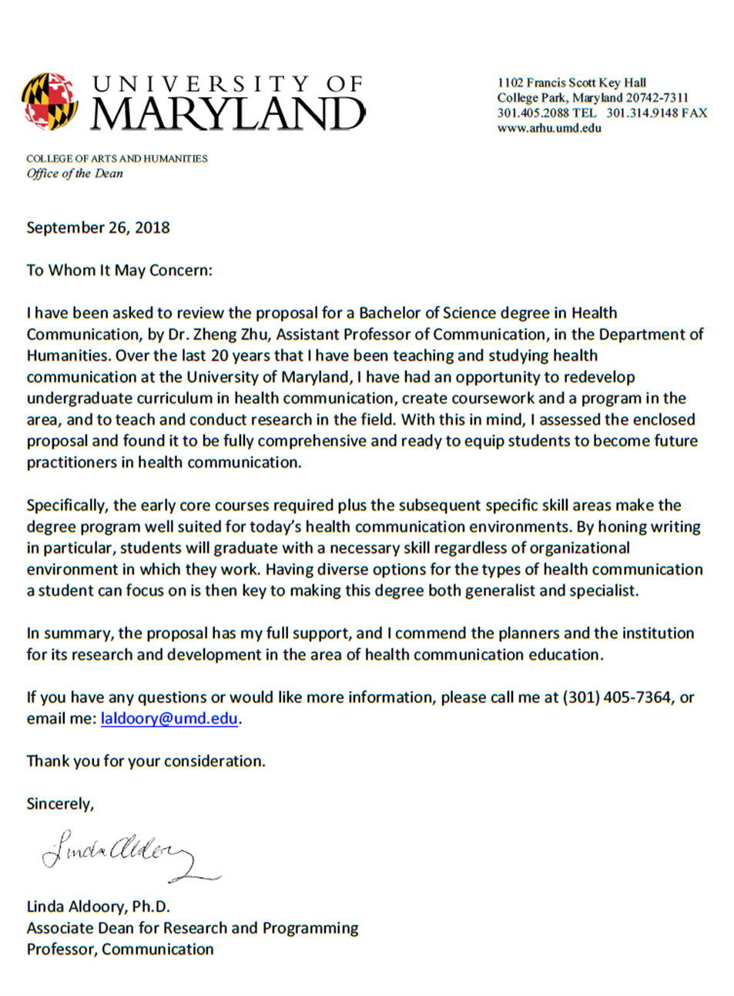

Priscilla DeJesus, NYC Department of Health
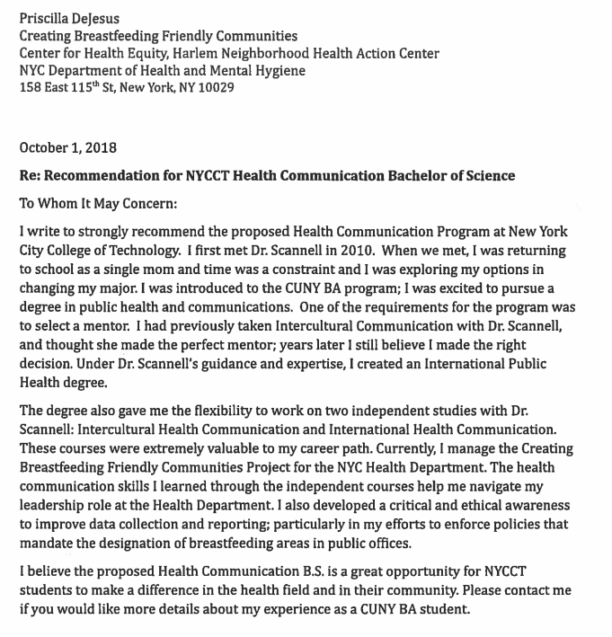
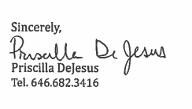

Kathryn Greene, Rutgers University
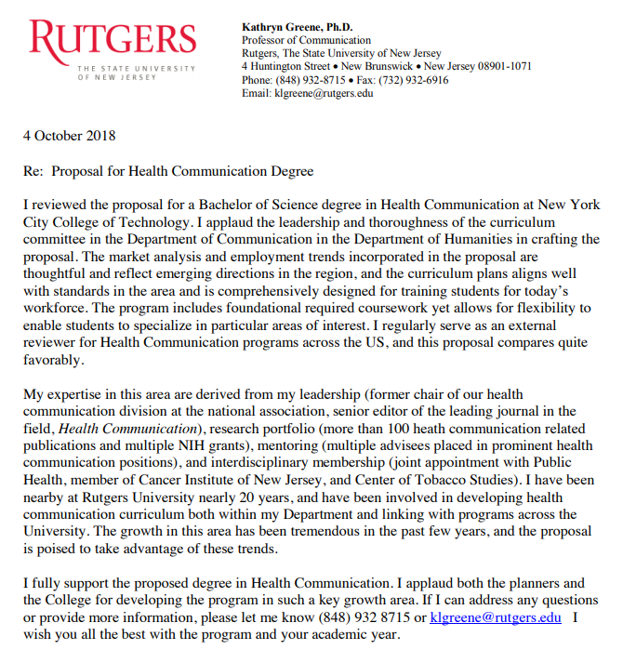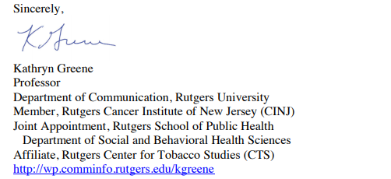

Elaine Hsieh, University of Oklahoma
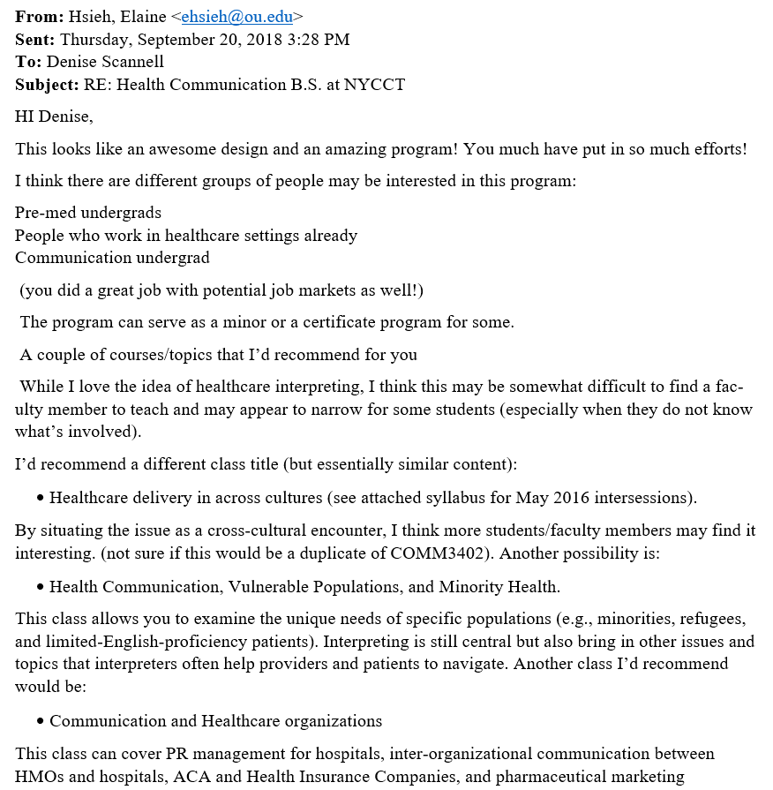
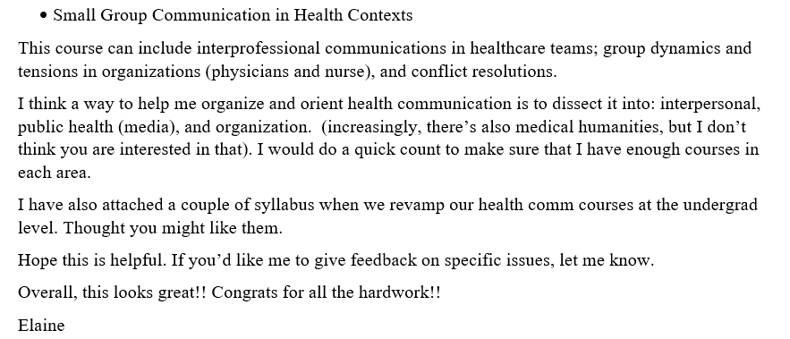

Gary Kreps, George Mason University
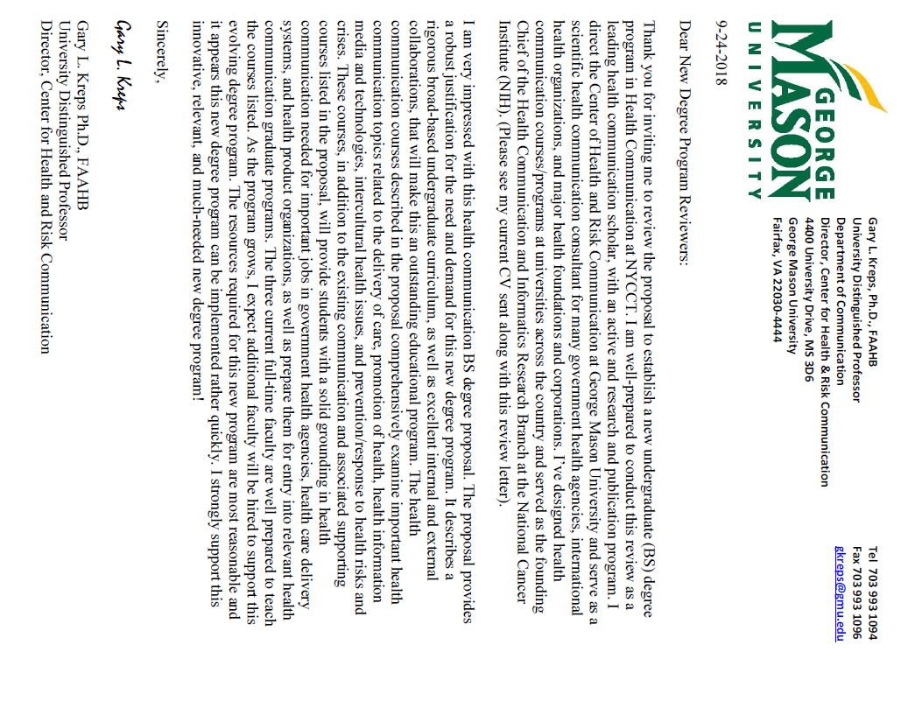

Teresa Thompson, University of Dayton
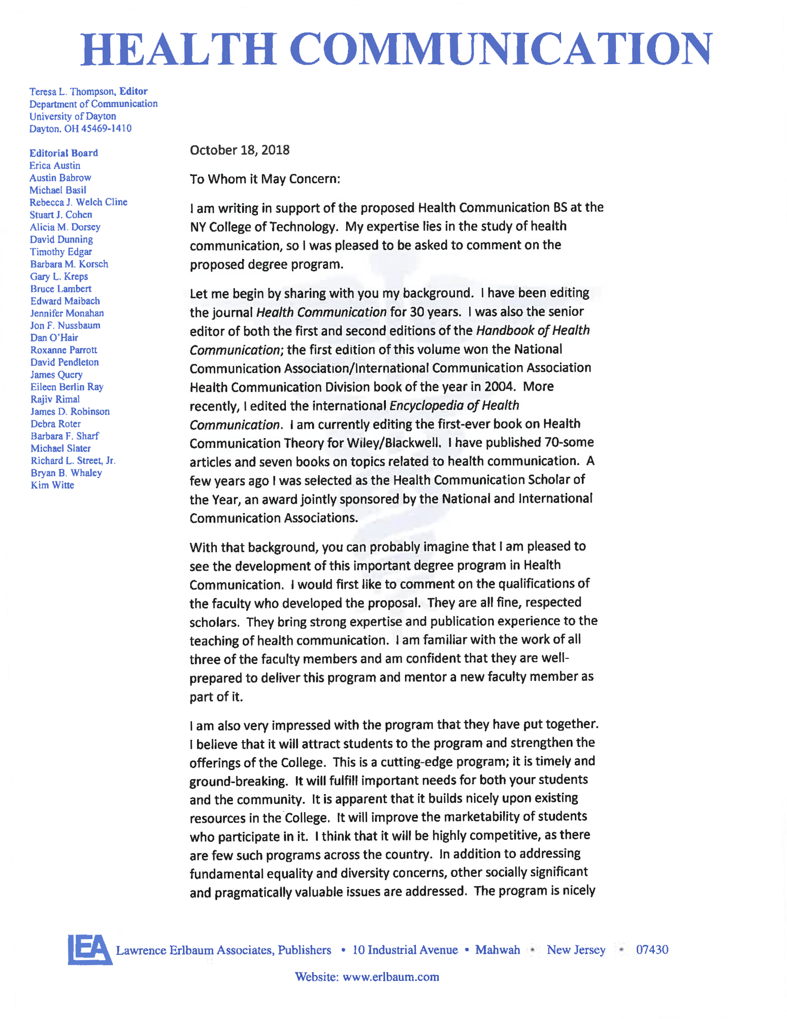
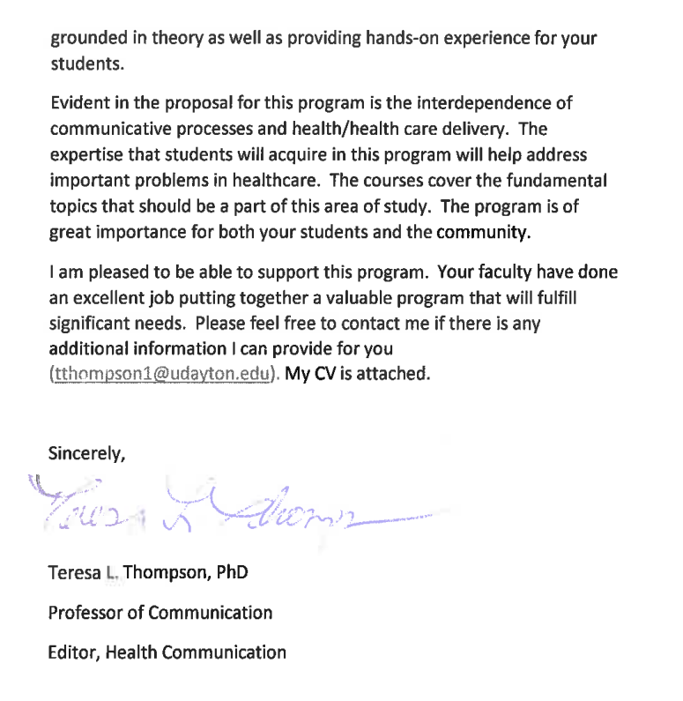

Appendix G: Letters of Support

Part 2: From City Tech Chairs, Deans, Program Directors, etc.

Nina Bannett, English
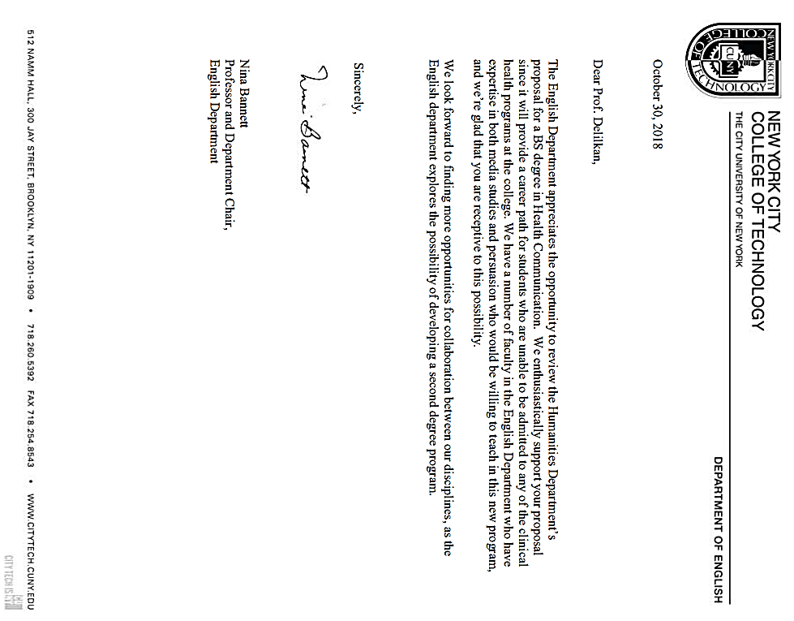

Lucas Bernard, Business
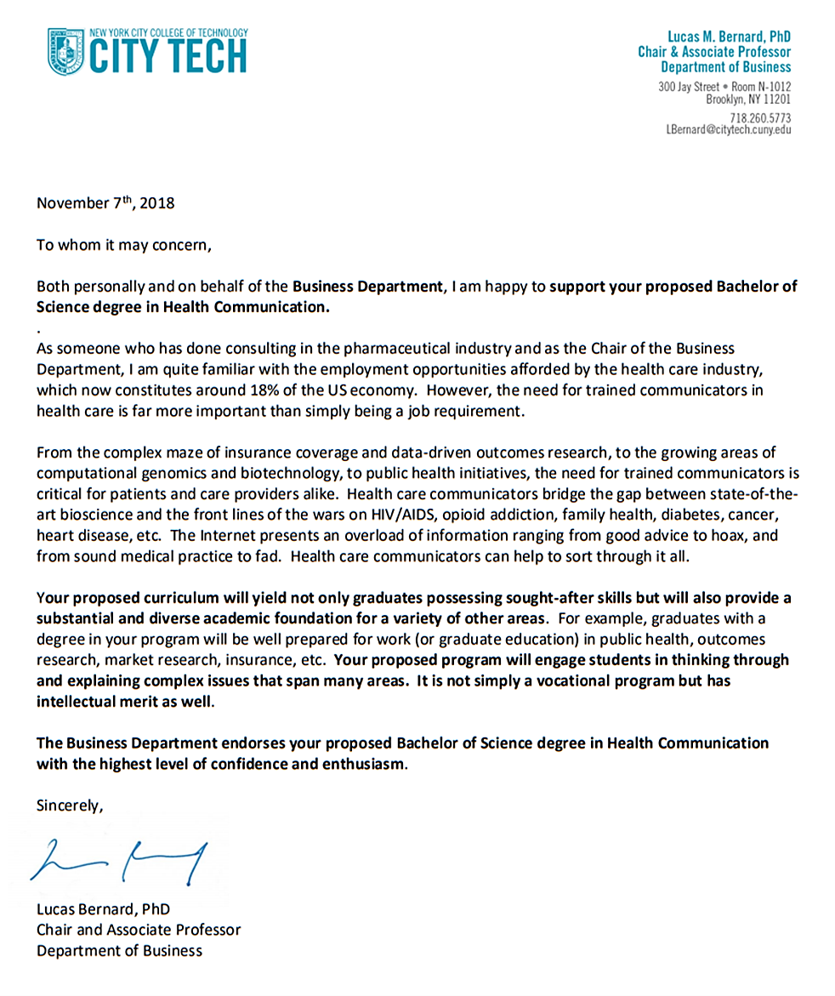

Josef Bohm, Health Services Administration
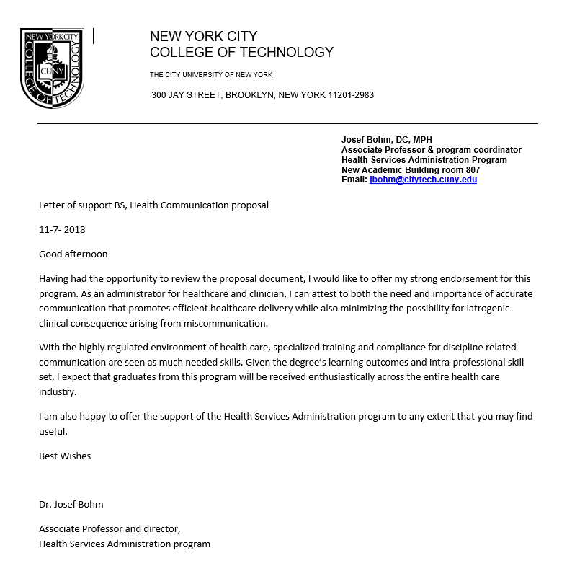

Renata Budny, Restorative Dentistry
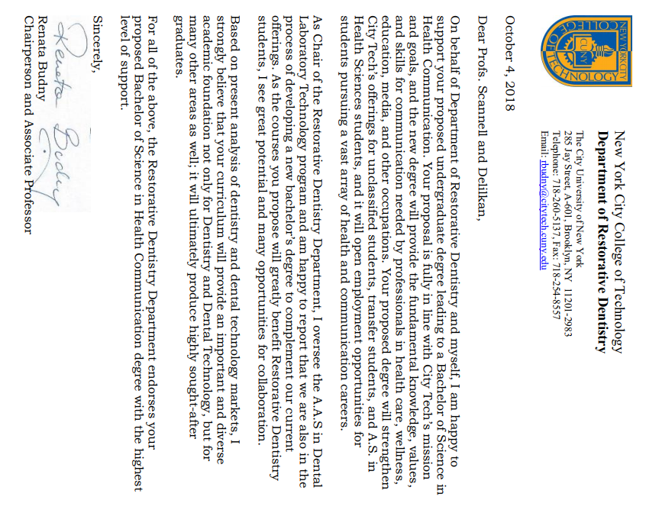

Douglas Davis, Communication Design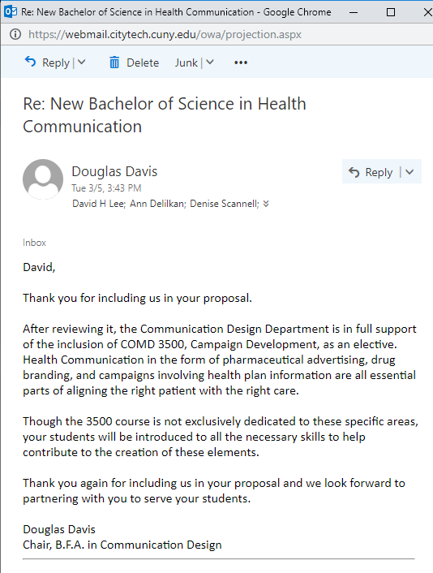

Marta Effinger-Crichlow, African American Studies
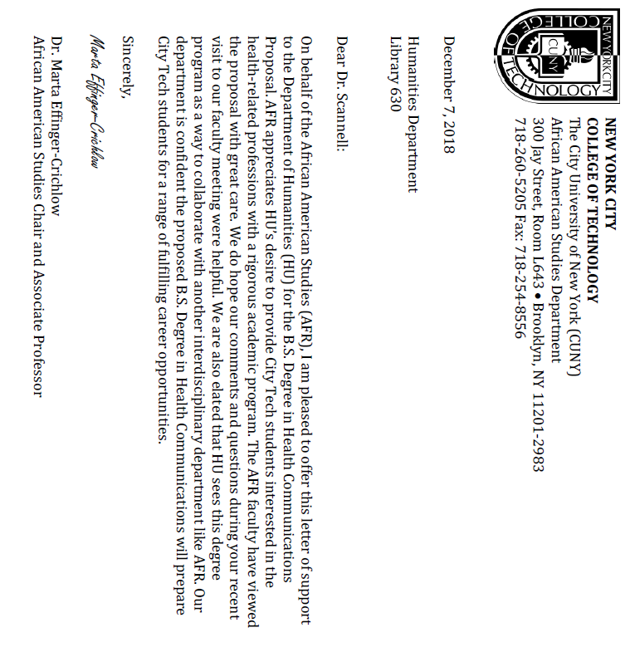

Sunghoon Jang, Computer Engineering Technology
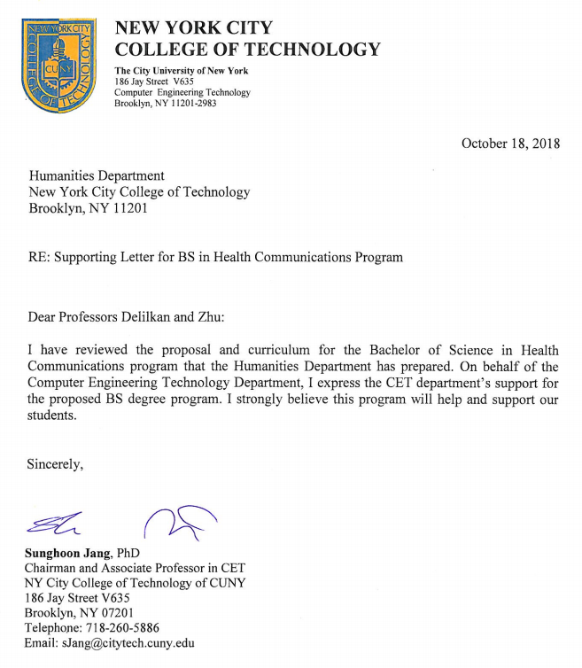

John McCullough, Entertainment Technology
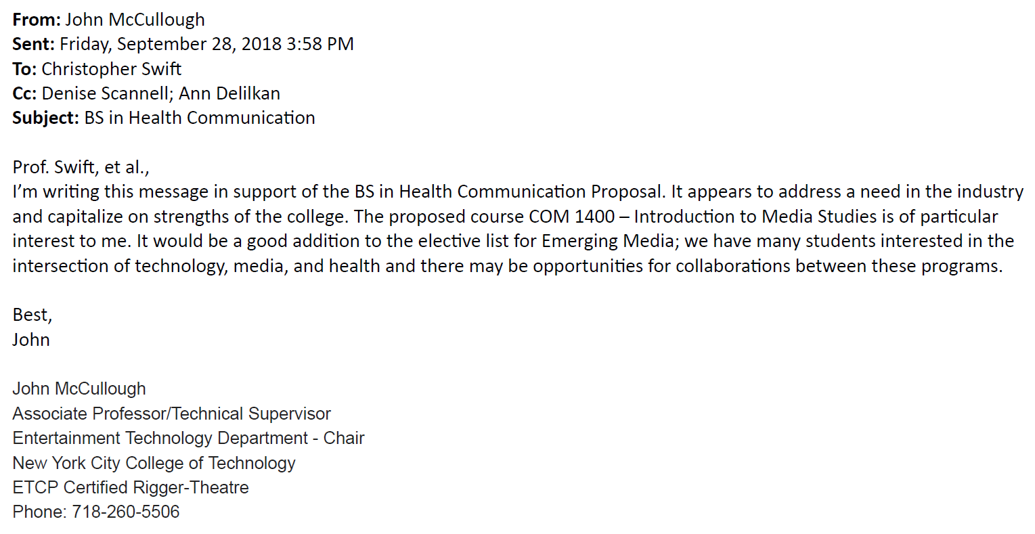

Peter Parides, Social Science
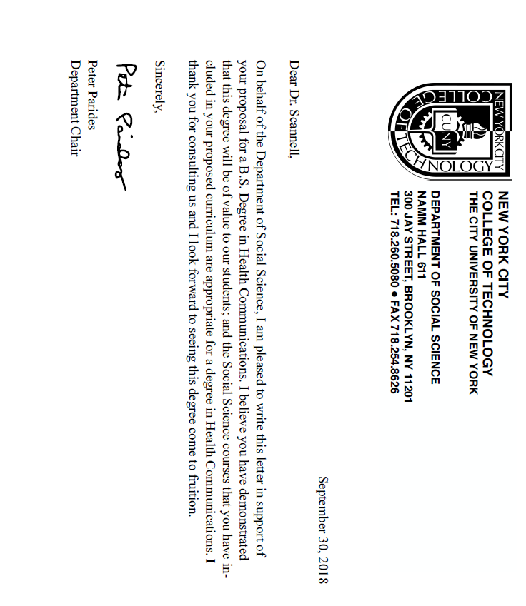

Justine Pawlukewicz, Human Services
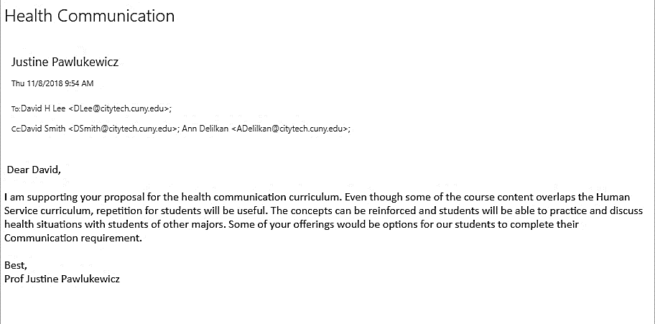

Margaret Rafferty, Nursing
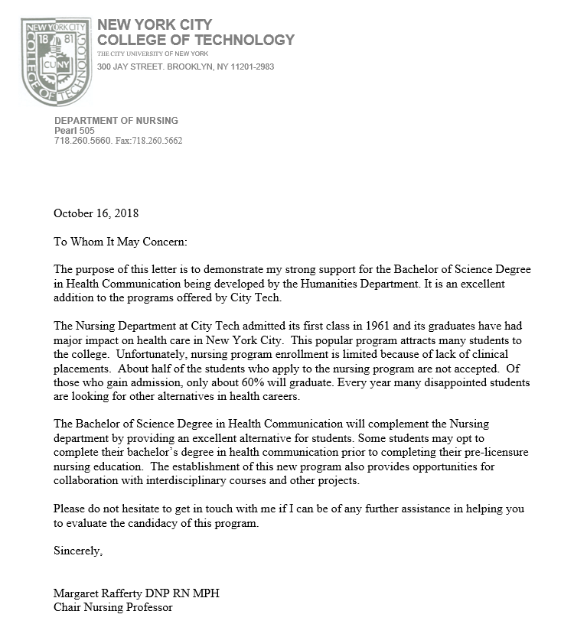

Diana Samaroo, Chemistry
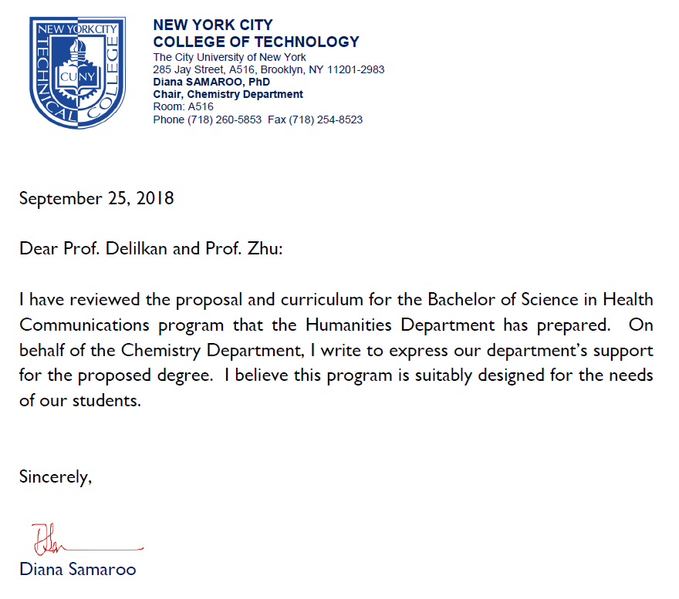

Maura Smale, Library
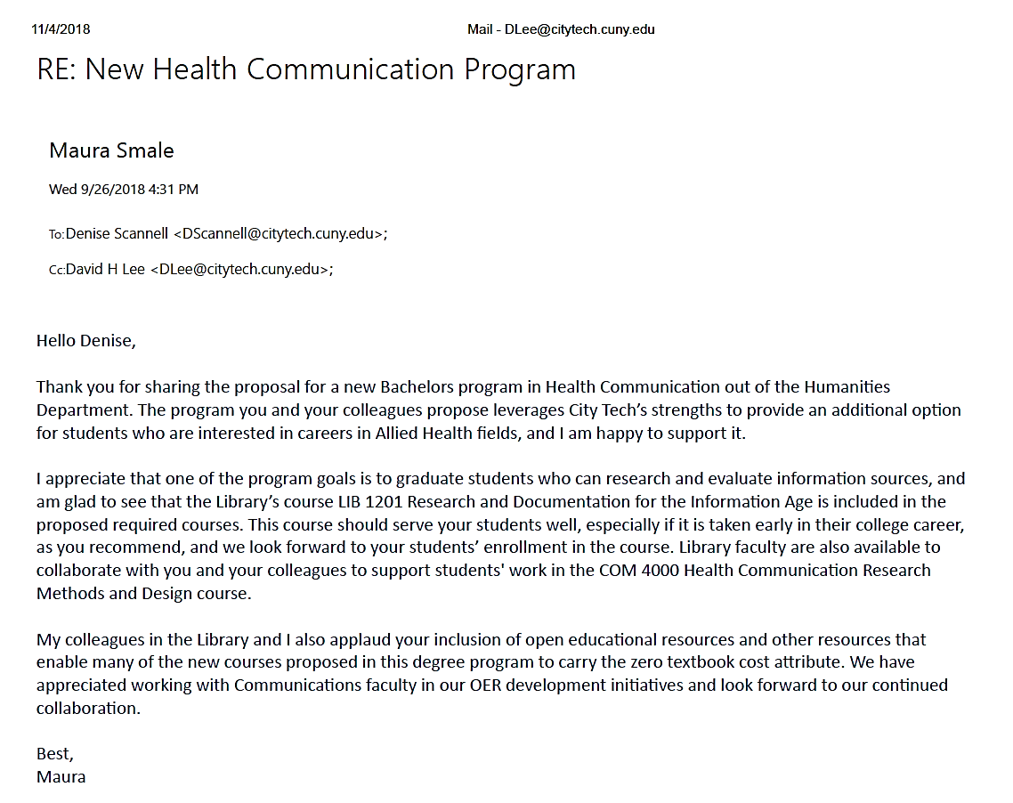
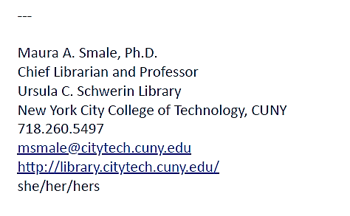

David Smith, School of Professional Studies
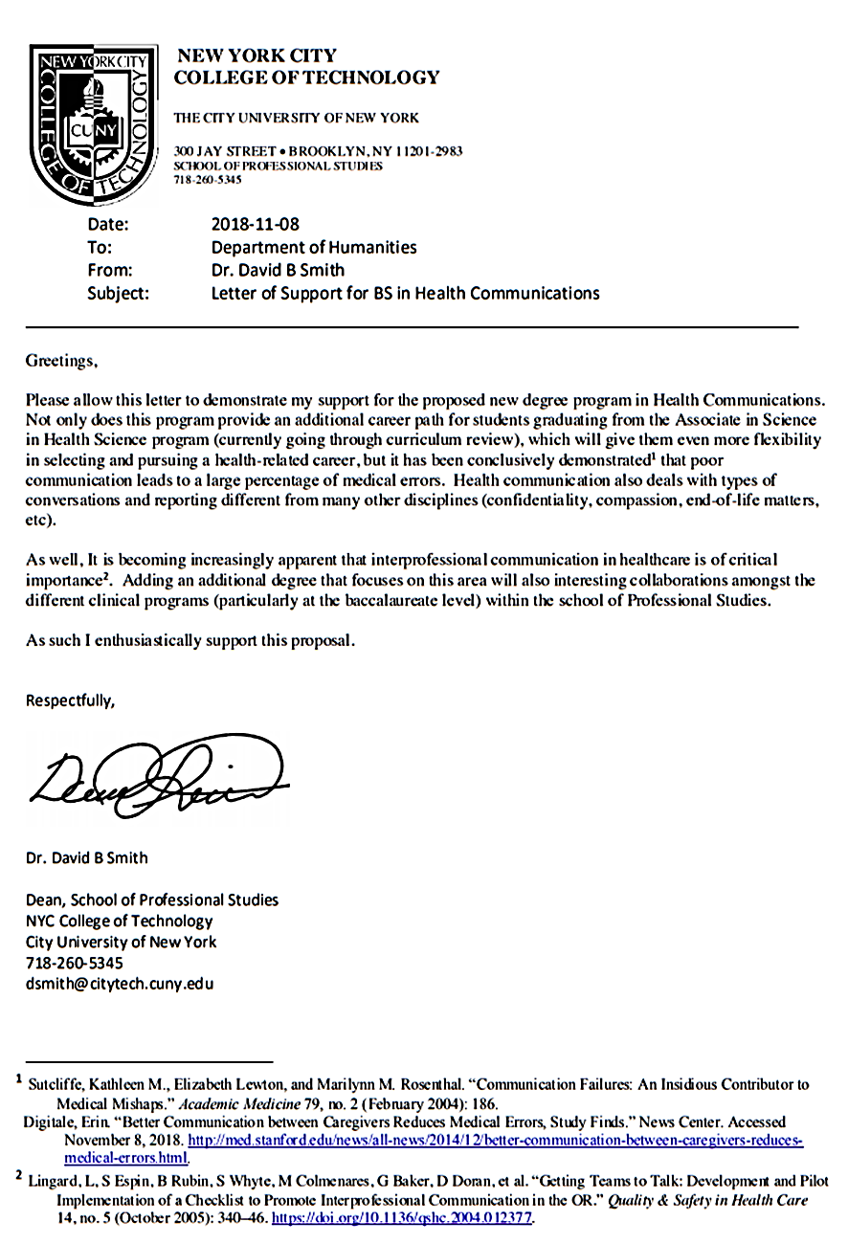

Julian Williams, Liberal Arts and Sciences
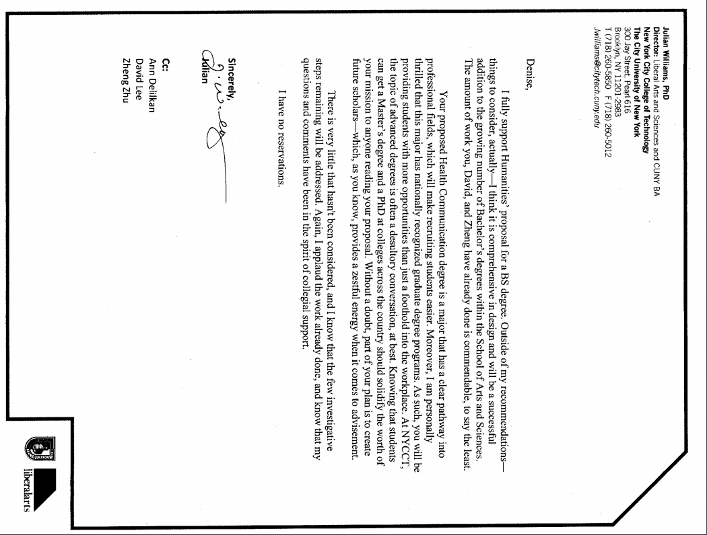

Andleeb Zameer, Biological Sciences
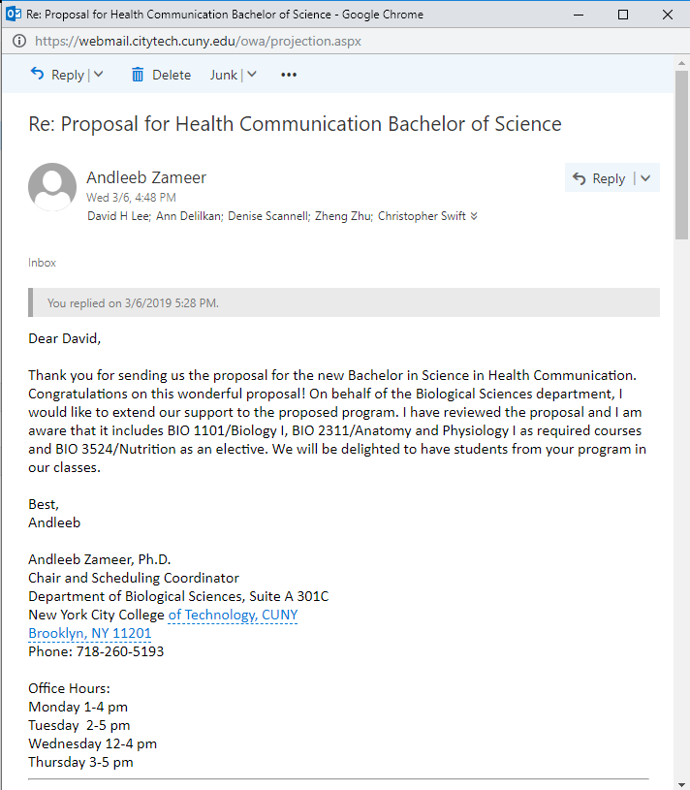

Appendix H: Library Form
LIBRARY RESOURCES & INFORMATION LITERACY: MAJOR CURRICULUM MODIFICATION
Please complete for all major curriculum modifications. This information will assist the library in planning for new courses/programs.
Consult with your library faculty subject specialist (http://cityte.ch/dir) 3 weeks before the proposal deadline.
Course proposer: please complete boxes 1-4. Library faculty subject specialist: please complete box 5.
1 | Title of proposal  Health Communication Bachelor of Science | Department/Program  Humanities Department
 | Proposed by (include email & phone)  Drs. Denise Scannell, David Lee and Zheng Zhu  dscannell@citytech.cuny.edu  (718)260-8298 | Expected date course(s) will be offered  Fall 2019  # of students 10

2 | The library cannot purchase reserve textbooks for every course at the college, nor copies for all students. Consult our website (http://cityte.ch/curriculum) for articles and ebooks for your courses, or our open educational resources (OER) guide (http://cityte.ch/oer). Have you considered using a freely-available OER or an open textbook in this course?  Yes. Four new courses use freely available, OER texts, including COM 1400, 3404, 3405 and 3503

3 | Beyond the required course materials, are City Tech library resources sufficient for course assignments? If additional resources are needed, please provide format details (e.g. ebook, journal, DVD, etc.), full citation (author, title, publisher, edition, date), price, and product link.  Yes. Journals and books relevant to health communication, health care professions, and health campaigns are appropriate and sufficient for the course. Many of the items are already available. Additional resources may be requested as course needs are identified. Subject specialist Morris Hounion has determined that the scholarly journals Health Communication and Journal of Health Communication appear to be available on Communication and Mass Media Complete and Medline databases.

4 | Library faculty focus on strengthening students' information literacy skills in finding, evaluating, and ethically using information. We can collaborate on developing assignments and offer customized information literacy instruction and research guides for your course.  Do you plan to consult with the library faculty subject specialist for your area? Please elaborate.  Professor Lee met with Professor Hounion on Oct. 30, 2018. Prof. Hounion explained the resources offered by the library in support of our curricular efforts. We plan to work closely with the library on information literacy efforts.
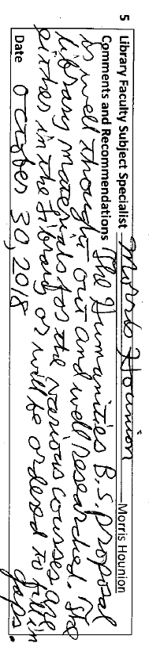

Appendix I: New Course Proposal Forms

COM 1400 Introduction to Media Studies
New York City College of Technology, CUNY
NEW COURSE PROPOSAL FORM
This form is used for all new course proposals. Attach this to the Curriculum Modification Proposal Form and submit as one package as per instructions. Use one New Course Proposal Form for each new course.
Course Title | Introduction to Media Studies
Proposal Date | 12/17/18
Proposer’s Name | David Lee
Course Number | COM 1400
Course Credits, Hours | 3, 3
Course Pre / Co-Requisites | ENG 1101
Catalog Course Description | Introduction to the history, structure and operations of media industries in today’s changing media marketplace. Study of the historical development and convergence of print, radio, film, TV, internet, gaming. Students identify interrelationships between media platforms and communication channels to understand their pervasive presence and decisive influence. Communication theories help explain the intersecting forces of culture, commerce, regulatory policy and the public interest that have shaped the media.
Brief Rationale  Provide a concise summary of why this course is important to the department, school or college. | This is a required course in the proposed Bachelor of Science in Health Communication degree proposal, being submitted simultaneously. These courses are designed to foster inter-professional communication, as well as to provide basic backgrounds in areas of shared interest across the spectrum of the health communication field. This course will also serve students in the allied health professions, or LAA and LAS.
CUNY – Course Equivalencies  Provide information about equivalent courses within CUNY, if any. | MEDST 100 Media Technologies from Gutenberg to the Internet (Queens College).  MEDIA 18000 Introduction to Media Studies (Hunter College)  MCA 101 Introduction to Media Studies (CCNY)  SPCH 250 Introduction to Mass Media (York College)  MCS 214 Introduction to Media and Digital Culture (Lehman College)  COM 245 The Mass Media (BMCC)
Intent to Submit as Common Core  If this course is intended to fulfill one of the requirements in the common core, then indicate which area. | U.S. Experience in its Diversity
For Interdisciplinary Courses:  - Date submitted to ID Committee for review  - Date ID recommendation received  - Will all sections be offered as ID? Y/N | N/A
Intent to Submit as a Writing Intensive Course | N/A

Please include all appropriate documentation as indicated in the NEW COURSE PROPOSAL Combine all information into a single document that is included in the Curriculum Modification Form.
COURSE NEED ASSESSMENT
This course will be required of all students who are pursuing the proposed Health Communication Bachelor of Science degree.
Student enrollment projections for the new degree program indicate that there will be approximately 10 incoming students. COM 1400 will be offered in the first or second semester, depending upon the student. We do not foresee the need for additional physical resources or equipment.
Courses in Media Studies are common in undergraduate Communication programs. COM 1400 will be an important course for the Bachelor of Science in Health Communication because it introduces students to media platforms and communication channels that influence health related decisions.
This course will be taught by a combination of School full time faculty and appropriate adjuncts. This course is not required by an accrediting body: however, the new proposed Bachelor of Science in Health Communication will require this course as part of Health Communication curriculum requirements.
COURSE DESIGN
This is a required, 1000 level course in the Health Communication curriculum. The course will be offered Spring/Fall and projected enrollment is 24 students, which is consistent with other communication courses in the Humanities Department. Teaching and learning methods include:
- Discussions and lectures
- Readings and research
- Multimedia
- Individual and collaborative projects
- Student presentations and feedback
- Online-learning
This course is designed to as “hybrid” or partially online. Students submit all written coursework to Blackboard and complete weekly discussion board assignments there. If the class were to normally meet twice per week, it would only meet once a week. Or, if the class met only once each week, the class period would be approximately 1:15 minutes instead of 2:30.
The benefits of a hybrid course are that it offers greater flexibility for student schedules while retaining the in-person experience so essential for improving face-to-face communication skills. The online discussion board provides more opportunities for students to interact with each other and the instructor outside of the class period. Students may link to relevant websites, articles and multimedia, which expands the knowledge resources of the class and links abstract theories and concepts from the textbook to current examples. Because the online forum is asynchronous, students may complete their homework when it is convenient.
NEW COURSE PROPOSAL CHECK LIST
Use this checklist to ensure that all required documentation has been included. You may wish to use this checklist as a table of contents within the new course proposal.
Completed NEW COURSE PROPOSAL FORM
- Title, Number, Credits, Hours, Catalog course description | X
- Brief Rationale | X
- CUNY – Course Equivalencies | X
Completed Library Resources and Information Literacy Form
Course Outline  Include within the outline the following. | X
Hours and Credits for Lecture and Labs  If hours exceed mandated Carnegie Hours, then rationale for this | X
Prerequisites/Co- requisites | X
Detailed Course Description | X
Course Specific Learning Outcome and Assessment Tables  - Discipline Specific  - General Education Specific Learning Outcome and Assessment Tables | X
Example Weekly Course outline | X
Grade Policy and Procedure | X
Recommended Instructional Materials (Textbooks, lab supplies, etc) | X
Library resources and bibliography | X
Course Need Assessment.  Describe the need for this course. Include in your statement the following information. | X
Target Students who will take this course. Which programs or departments, and how many anticipated?  Documentation of student views (if applicable, e.g. non-required elective). | X
Projected headcounts (fall/spring and day/evening) for each new or modified course. | X
If additional physical resources are required (new space, modifications, equipment), description of these requirements. If applicable, Memo or email from the VP for Finance and Administration with written comments regarding additional and/or new facilities, renovations or construction. | X
Where does this course overlap with other courses, both within and outside of the department? | X
Does the Department currently have full time faculty qualified to teach this course? If not, then what plans are there to cover this? | X
If needs assessment states that this course is required by an accrediting body, then provide documentation indicating that need. | N/A
Course Design  Describe how this course is designed. | X
Course Context (e.g. required, elective, capstone) | X
Course Structure: how the course will be offered (e.g. lecture, seminar, tutorial, fieldtrip)? | X
Anticipated pedagogical strategies and instructional design (e.g. Group Work, Case Study, Team Project, Lecture) | X
How does this course support Programmatic Learning Outcomes? | X
Is this course designed to be partially or fully online? If so, describe how this benefits students and/or program. | X
Additional Forms for Specific Course Categories
Interdisciplinary Form (if applicable) | N/A
Interdisciplinary Committee Recommendation (if applicable and if received)*  *Recommendation must be received before consideration by full Curriculum Committee | N/A
Common Core (Liberal Arts) Intent to Submit (if applicable)
Writing Intensive Form if course is intended to be a WIC (under development)
If course originated as an experimental course, then results of evaluation plan as developed with director of assessment. | N/A
(Additional materials for Curricular Experiments)
Plan and process for evaluation developed in consultation with the director of assessment. (Contact Director of Assessment for more information). | N/A
Established Timeline for Curricular Experiment | N/A

COM 2405 Principles of Persuasion
New York City College of Technology, CUNY
NEW COURSE PROPOSAL FORM
This form is used for all new course proposals. Attach this to the Curriculum Modification Proposal Form and submit as one package as per instructions. Use one New Course Proposal Form for each new course.
Course Title | Principles of Persuasion
Proposal Date | December 15, 2018
Proposer’s Name | David Lee
Course Number | COM 2405
Course Credits, Hours | 3, 3
Course Pre / Co-Requisites | ENG 1121 or higher
Catalog Course Description | Principles of persuasive communication from humanistic and social-scientific perspectives. Topics include rhetorical approaches to audiences, persuasion, propaganda, source credibility and message framing. Students participate in online discussion, critique media products, create a persuasive media campaign and give oral presentations.
Brief Rationale  Provide a concise summary of why this course is important to the department, school or college. | This is a required course in the proposed Bachelor of Science in Health Communication degree proposal, being submitted simultaneously. These courses are designed to foster inter-professional communication, as well as to provide basic backgrounds in areas of shared interest across the spectrum of the health communication field. This course will also serve students in the allied health professions, or LAA and LAS.
CUNY – Course Equivalencies  Provide information about equivalent courses within CUNY, if any. | - HUC136 Persuasion (LaGuardia CC)  - COM 3070 Persuasion (Baruch)  - SPCH350 Persuasion and Propaganda in Mass Media (York)
Intent to Submit as Common Core  If this course is intended to fulfill one of the requirements in the common core, then indicate which area. | U.S. Experience in its Diversity
For Interdisciplinary Courses:  - Date submitted to ID Committee for review  - Date ID recommendation received  - Will all sections be offered as ID? Y/N | N/A
Intent to Submit as a Writing Intensive Course | N/A
Please include all appropriate documentation as indicated in the NEW COURSE PROPOSAL Combine all information into a single document that is included in the Curriculum Modification Form.
COURSE NEED ASSESSMENT
This course will be required of all students who are pursuing the proposed Health Communication Bachelor of Science degree.
Student enrollment projections for the new degree program indicate that there will be approximately 900+ incoming students. COM 2405 Principles of Persuasion will be offered in the first or second semester, depending upon the student. We do not foresee the need for additional physical resources or equipment. COM 2405 will be an important course for the Bachelor of Science in Health Communication because it introduces students to persuasive messages in health care campaigns and teaches them to analyze messages for effectiveness according to target audiences.
There is some overlap with COM 1330 Public Speaking, as students give impromptu and persuasive presentations. However, COM 2405 will cover topics and contain assignments pertinent to health care and not currently offered in COM 1330.
LaGuardia Community College offers a persuasion course. An Articulation agreement with LaGuardia is in progress. Students will be able to transfer this course into the NYCCT Health Communication B.S.
This course will be taught by a combination of full-time faculty (Humanities and English) and appropriate adjuncts. This course is not required by an accrediting body: however, the new proposed Bachelor of Science in Health Communication will require this course as part of Health Promotion and Media concentration requirements.
COURSE DESIGN
This is a required, 2000 level course in the Health Promotion and Media concentration of the Health Communication Program. The course will be offered Spring/Fall and projected enrollment is 24 students, which is consistent with other communication courses in the Humanities Department. Teaching and learning methods include:
- Discussions and lectures
- Readings and research
- Multimedia
- Design-based assignments
- Class Debates
- Individual and collaborative projects
- Student presentations
- Online-learning
This course is designed to be considered as a “hybrid” or partially online. Students submit all written coursework to Blackboard and complete weekly discussion board assignments there. If the class were to normally meet twice per week, it would only meet once a week. Or, if the class met only once each week, the class period would be approximately 1:15 minutes instead of 2:30.
The benefits of a hybrid course are that it offers greater flexibility for student schedules while retaining the in-person experience so essential for improving face-to-face communication skills. The online discussion board provides more opportunities for students to interact with each other and the instructor outside of the class period. Students may link to relevant websites, articles and multimedia, which expands the knowledge resources of the class and links abstract theories and concepts from the textbook to current examples. Because the online forum is asynchronous, students may complete their homework when it is convenient.
NEW COURSE PROPOSAL CHECK LIST
Use this checklist to ensure that all required documentation has been included. You may wish to use this checklist as a table of contents within the new course proposal.
Completed NEW COURSE PROPOSAL FORM
- Title, Number, Credits, Hours, Catalog course description | X
- Brief Rationale | X
- CUNY – Course Equivalencies | X
Completed Library Resources and Information Literacy Form
Course Outline
Include within the outline the following.
Hours and Credits for Lecture and Labs  If hours exceed mandated Carnegie Hours, then rationale for this | X
Prerequisites/Co- requisites | X
Detailed Course Description | X
Course Specific Learning Outcome and Assessment Tables  - Discipline Specific  - General Education Specific Learning Outcome and Assessment Tables | X
Example Weekly Course outline | X
Grade Policy and Procedure | X
Recommended Instructional Materials (Textbooks, lab supplies, etc.) | X
Library resources and bibliography | X
Course Need Assessment.
Describe the need for this course. Include in your statement the following information.
Target Students who will take this course. Which programs or departments, and how many anticipated?  Documentation of student views (if applicable, e.g. non-required elective). | X
Projected headcounts (fall/spring and day/evening) for each new or modified course. | X
If additional physical resources are required (new space, modifications, equipment), description of these requirements. If applicable, Memo or email from the VP for Finance and Administration with written comments regarding additional and/or new facilities, renovations or construction. | X
Where does this course overlap with other courses, both within and outside of the department? | X
Does the Department currently have full time faculty qualified to teach this course? If not, then what plans are there to cover this? | X
If needs assessment states that this course is required by an accrediting body, then provide documentation indicating that need. | X
Course Design
Describe how this course is designed.
Course Context (e.g. required, elective, capstone)
Course Structure: how the course will be offered (e.g. lecture, seminar, tutorial, fieldtrip)? | X
Anticipated pedagogical strategies and instructional design (e.g. Group Work, Case Study, Team Project, Lecture) | X
How does this course support Programmatic Learning Outcomes? | X
Is this course designed to be partially or fully online? If so, describe how this benefits students and/or program. | X
Additional Forms for Specific Course Categories
Interdisciplinary Form (if applicable)
Interdisciplinary Committee Recommendation (if applicable and if received)*
*Recommendation must be received before consideration by full Curriculum Committee
Common Core (Liberal Arts) Intent to Submit (if applicable)
Writing Intensive Form if course is intended to be a WIC (under development)
If course originated as an experimental course, then results of evaluation plan as developed with director of assessment.
(Additional materials for Curricular Experiments)
Plan and process for evaluation developed in consultation with the director of assessment. (Contact Director of Assessment for more information).
Established Timeline for Curricular Experiment

COM 2406 Gender and Health Communication
New York City College of Technology, CUNY
NEW COURSE PROPOSAL FORM
This form is used for all new course proposals. Attach this to the Curriculum Modification Proposal Form and submit as one package as per instructions. Use one New Course Proposal Form for each new course.
Course Title | Gender and Health Communication
Proposal Date | December 15, 2018
Proposer’s Name | Zheng Zhu
Course Number | COM 2406
Course Credits, Hours | 3, 3
Course Pre / Co-Requisites | ENG 1121 or higher
Catalog Course Description | Gender-related health issues have always been the subjects of sensitive social, cultural, and political debates. This course explores current healthcare practices, experiences, and systems that are both affecting and affected by gender norms, performances, and representations. A critical review and analysis of the ways sexual minorities have been treated by health institutions in the major stages of human history are conducted in the class. Students learn the complex interplay among health, communication and gender, with specific foci on how gender-based communication practices affect people’s everyday decision and choices in medical care, and what we can do to improve the current healthcare system and environment.
Brief Rationale  Provide a concise summary of why this course is important to the department, school or college. | This is a required course in the proposed Bachelor of Science in Health Communication degree proposal, being submitted simultaneously. These courses are designed to foster inter-professional communication, as well as to provide basic backgrounds in areas of shared interest across the spectrum of the health communication field. This course will also serve students in the allied health professions, or LAA and LAS.
CUNY – Course Equivalencies  Provide information about equivalent courses within CUNY, if any. | NYCCT: There are gendered focused courses on campus that are fall under the “Gender & Sexuality Studies course cluster or concentration. None other focuses on health topics. This course will be part of the cluster.  BMCC- Gender and Communication COM 265; LaGuardia Community College- HUC118 Gender and Communication; Brooklyn College TVRA 3434 Constructions of Gender and Sexuality in the Media  Articulation with BMCC, Brooklyn College, and LaGuardia agreements in progress.
Intent to Submit as Common Core  If this course is intended to fulfill one of the requirements in the common core, then indicate which area. | U.S. Experience in its Diversity
For Interdisciplinary Courses:  - Date submitted to ID Committee for review  - Date ID recommendation received  - Will all sections be offered as ID? Y/N | N/A
Intent to Submit as a Writing Intensive Course | N/A
Please include all appropriate documentation as indicated in the NEW COURSE PROPOSAL Combine all information into a single document that is included in the Curriculum Modification Form.
COURSE NEED ASSESSMENT
This course will be required of all students who are pursuing the proposed Health Communication Bachelor of Science degree.
Student enrollment projections for the new degree program indicate that there will be approximately 900+ incoming students. COM 2405 Principles of Persuasion will be offered in the first or second semester, depending upon the student. We do not foresee the need for additional physical resources or equipment.
COM 2405 will be an important course for the Bachelor of Science in Health Communication because it introduces students to persuasive messages in health care campaigns and teaches them to analyze messages for effectiveness according to target audiences.
There is some overlap with COM 1330 Public Speaking, as students give impromptu and informative presentations. However, COM 2406 will cover topics and contain assignments pertinent to health care and not currently offered in COM 1330. There are gendered focused courses on campus that are fall under the “Gender & Sexuality Studies” course cluster or concentration. Only COM 2406 focuses on health topics. This course will be part of the cluster.

BMCC, Brooklyn College, and LaGuardia Community College offer Gender and Communication courses. Articulation agreements with BMCC and LaGuardia are in progress. Students will be able to transfer these courses into the NYCCT Health Communication B.S.
This course will be taught by a combination of School full time faculty and appropriate adjuncts. This course is not required by an accrediting body: however, the new proposed Bachelor of Science in Health Communication will require this course as part of Health Communication and Culture concentration requirements.
COURSE DESIGN
This is a required, 2000 level course in the Health Communication and Culture concentration of the Health Communication program. The course will be offered Spring/Fall and projected enrollment is 24 students, which is consistent with other communication courses in the Humanities Department. Teaching and learning methods include:
- Discussions and lecture
- Critical Readings and research
- Multimedia text and communication
- Design-based assignments
- Individual and collaborative projects
- Student presentations, oral feedback, Q& A
- Online-learning
This course is designed to be considered as a “hybrid” or partially online. Students submit all written coursework to Blackboard and complete weekly discussion board assignments there. If the class were to normally meet twice per week, it would only meet once a week. Or, if the class met only once each week, the class period would be approximately 1:15 minutes instead of 2:30.
The benefits of a hybrid course are that it offers greater flexibility for student schedules while retaining the in-person experience so essential for improving face-to-face communication skills. The online discussion board provides more opportunities for students to interact with each other and the instructor outside of the class period. Students may link to relevant websites, articles and multimedia, which expands the knowledge resources of the class and links abstract theories and concepts from the textbook to current examples. Because the online forum is asynchronous, students may complete their homework when it is convenient.
NEW COURSE PROPOSAL CHECK LIST
Use this checklist to ensure that all required documentation has been included. You may wish to use this checklist as a table of contents within the new course proposal.
Completed NEW COURSE PROPOSAL FORM
- Title, Number, Credits, Hours, Catalog course description | X
- Brief Rationale | X
- CUNY – Course Equivalencies | X
Completed Library Resources and Information Literacy Form | X
Course Outline
Include within the outline the following.
Hours and Credits for Lecture and Labs  If hours exceed mandated Carnegie Hours, then rationale for this | X
Prerequisites/Co- requisites | X
Detailed Course Description | X
Course Specific Learning Outcome and Assessment Tables  - Discipline Specific  - General Education Specific Learning Outcome and Assessment Tables | X
Example Weekly Course outline | X
Grade Policy and Procedure | X
Recommended Instructional Materials (Textbooks, lab supplies, etc.) | X
Library resources and bibliography | X
Course Need Assessment.
Describe the need for this course. Include in your statement the following information.
Target Students who will take this course. Which programs or departments, and how many anticipated?  Documentation of student views (if applicable, e.g. non-required elective). | X
Projected headcounts (fall/spring and day/evening) for each new or modified course. | X
If additional physical resources are required (new space, modifications, equipment), description of these requirements. If applicable, Memo or email from the VP for Finance and Administration with written comments regarding additional and/or new facilities, renovations or construction. | X
Where does this course overlap with other courses, both within and outside of the department? | X
Does the Department currently have full time faculty qualified to teach this course? If not, then what plans are there to cover this? | X
If needs assessment states that this course is required by an accrediting body, then provide documentation indicating that need.
Course Design
Describe how this course is designed.
Course Context (e.g. required, elective, capstone) | X
Course Structure: how the course will be offered (e.g. lecture, seminar, tutorial, fieldtrip)? | X
Anticipated pedagogical strategies and instructional design (e.g. Group Work, Case Study, Team Project, Lecture) | X
How does this course support Programmatic Learning Outcomes? | X
Is this course designed to be partially or fully online? If so, describe how this benefits students and/or program. | X
Additional Forms for Specific Course Categories
Interdisciplinary Form (if applicable)
Interdisciplinary Committee Recommendation (if applicable and if received)*
*Recommendation must be received before consideration by full Curriculum Committee
Common Core (Liberal Arts) Intent to Submit (if applicable)
Writing Intensive Form if course is intended to be a WIC (under development)
If course originated as an experimental course, then results of evaluation plan as developed with director of assessment.
(Additional materials for Curricular Experiments)
Plan and process for evaluation developed in consultation with the director of assessment. (Contact Director of Assessment for more information).
Established Timeline for Curricular Experiment

COM 3402 Communicating in Multicultural Healthcare Settings
New York City College of Technology, CUNY
NEW COURSE PROPOSAL FORM
This form is used for all new course proposals. Attach this to the Curriculum Modification Proposal Form and submit as one package as per instructions. Use one New Course Proposal Form for each new course.
Course Title | Communicating in Multicultural Healthcare Settings
Proposal Date | December 15, 2018
Proposer’s Name | D.Scannell
Course Number | COM 3402
Course Credits, Hours | 3, 3
Course Pre / Co-Requisites | COM 1332 or 1403, ENG 1121 or higher
Catalog Course Description | This upper-division course focuses on multicultural health communication within the United States. Special emphasis is placed on the difficulties and challenges to multi-cultural health communication, and the importance of cultural competence for patient satisfaction, patient compliance, and other positive healthcare outcomes. Students examine cultural attitudes, beliefs, and practices integrated into U.S. healthcare policies and systems. Students apply analytical and practical approaches to investigate important issues across diverse healthcare contexts and platforms.
Brief Rationale  Provide a concise summary of why this course is important to the department, school or college. | This is a required course in the proposed Bachelor of Science in Health Communication degree proposal, being submitted simultaneously. These courses are designed to foster inter-professional communication, as well as to provide basic backgrounds in areas of shared interest across the spectrum of the health communication field. This course will also serve students in the allied health professions, or LAA and LAS.
CUNY – Course Equivalencies  Provide information about equivalent courses within CUNY, if any. | None
Intent to Submit as Common Core  If this course is intended to fulfill one of the requirements in the common core, then indicate which area. | U.S. Experience in its Diversity
For Interdisciplinary Courses:  - Date submitted to ID Committee for review  - Date ID recommendation received  - Will all sections be offered as ID? Y/N | N/A
Intent to Submit as a Writing Intensive Course | N/A
Please include all appropriate documentation as indicated in the NEW COURSE PROPOSAL Combine all information into a single document that is included in the Curriculum Modification Form.
COURSE NEED ASSESSMENT
This course will be required of all students who are pursuing the proposed Health Communication Bachelor of Science degree.
Student enrollment projections for the new degree program indicate that there will be approximately 900+ incoming students. COM 3402 will be offered in the second or third semester, depending upon the student. We do not foresee the need for additional physical resources or equipment.
COM 3402 will be an important course for the Bachelors of Science in Health Communication on the difficulties and challenges to multi-cultural health communication.
There is some overlap with COM 2402 Intercultural Communication as students define and discuss culture. However, COM 3402 will cover topics that pertain to health communication in cultural contexts.
This course will be taught by a combination of School full time faculty and appropriate adjuncts. This course is not required by an accrediting body: however, the new proposed Bachelor of Science in Health Communication will require this course as part of Health Communication and Culture concentration requirements.
COURSE DESIGN
This is a required, 3000 level course in the Health Communication and Culture concentration of the Health Communication program. The course will be offered Spring/Fall and projected enrollment is 24 students, which is consistent with other communication courses in the Humanities Department. Teaching and learning methods include:
- Discussions and lectures
- Readings and research
- Multimedia text and communication
- Design-based assignments
- Individual and collaborative projects
- Student presentations
- Online-learning
This course is designed to be considered as a “hybrid” or partially online. Students submit all written coursework to Blackboard and complete weekly discussion board assignments there. If the class were to normally meet twice per week, it would only meet once a week. Or, if the class met only once each week, the class period would be approximately 1:15 minutes instead of 2:30.
The benefits of a hybrid course are that it offers greater flexibility for student schedules while retaining the in-person experience so essential for improving face-to-face communication skills. The online discussion board provides more opportunities for students to interact with each other and the instructor outside of the class period. Students may link to relevant websites, articles and multimedia, which expands the knowledge resources of the class and links abstract theories and concepts from the textbook to current examples. Because the online forum is asynchronous, students may complete their homework when it is convenient.
NEW COURSE PROPOSAL CHECK LIST
Use this checklist to ensure that all required documentation has been included. You may wish to use this checklist as a table of contents within the new course proposal.
Completed NEW COURSE PROPOSAL FORM
- Title, Number, Credits, Hours, Catalog course description | X
- Brief Rationale | X
- CUNY – Course Equivalencies | X
Completed Library Resources and Information Literacy Form | X
Course Outline
Include within the outline the following.
Hours and Credits for Lecture and Labs  If hours exceed mandated Carnegie Hours, then rationale for this | X
Prerequisites/Co- requisites | X
Detailed Course Description | X
Course Specific Learning Outcome and Assessment Tables  - Discipline Specific  - General Education Specific Learning Outcome and Assessment Tables | X
Example Weekly Course outline | X
Grade Policy and Procedure | X
Recommended Instructional Materials (Textbooks, lab supplies, etc.) | X
Library resources and bibliography | X
Course Need Assessment.
Describe the need for this course. Include in your statement the following information.
Target Students who will take this course. Which programs or departments, and how many anticipated?  Documentation of student views (if applicable, e.g. non-required elective). | X
Projected headcounts (fall/spring and day/evening) for each new or modified course. | X
If additional physical resources are required (new space, modifications, equipment), description of these requirements. If applicable, Memo or email from the VP for Finance and Administration with written comments regarding additional and/or new facilities, renovations or construction. | X
Where does this course overlap with other courses, both within and outside of the department? | X
Does the Department currently have full time faculty qualified to teach this course? If not, then what plans are there to cover this? | X
If needs assessment states that this course is required by an accrediting body, then provide documentation indicating that need. | X
Course Design
Describe how this course is designed.
Course Context (e.g. required, elective, capstone) | X
Course Structure: how the course will be offered (e.g. lecture, seminar, tutorial, fieldtrip)? | X
Anticipated pedagogical strategies and instructional design (e.g. Group Work, Case Study, Team Project, Lecture) | X
How does this course support Programmatic Learning Outcomes? | X
Is this course designed to be partially or fully online? If so, describe how this benefits students and/or program. | X
Additional Forms for Specific Course Categories
Interdisciplinary Form (if applicable)
Interdisciplinary Committee Recommendation (if applicable and if received)*
*Recommendation must be received before consideration by full Curriculum Committee
Common Core (Liberal Arts) Intent to Submit (if applicable)
Writing Intensive Form if course is intended to be a WIC (under development)
If course originated as an experimental course, then results of evaluation plan as developed with director of assessment.
(Additional materials for Curricular Experiments)
Plan and process for evaluation developed in consultation with the director of assessment. (Contact Director of Assessment for more information).
Established Timeline for Curricular Experiment

COM 3403 Health Communication and Education
New York City College of Technology, CUNY
NEW COURSE PROPOSAL FORM
This form is used for all new course proposals. Attach this to the Curriculum Modification Proposal Form and submit as one package as per instructions. Use one New Course Proposal Form for each new course.
Course Title | Health Communication and Education
Proposal Date | December 15, 2018
Proposer’s Name | Z. Zhu
Course Number | COM 3403
Course Credits, Hours | 3, 3
Course Pre / Co-Requisites | COM 1332 or 1403, ENG 1121 or higher
Catalog Course Description | This course provides students with comprehensive view and in-depth understanding of contemporary pedagogical approaches to the health communication studies. It is designed to provide students with the fundamental skills and knowledge necessary for careers in health communication and health education. The course emphasizes health promotion, education and communication strategies for working with individuals, organizations and communities.
Brief Rationale  Provide a concise summary of why this course is important to the department, school or college. | This is a required course in the proposed Bachelor of Science in Health Communication degree proposal, being submitted simultaneously. These courses are designed to foster inter-professional communication, as well as to provide basic backgrounds in areas of shared interest across the spectrum of the health communication field. This course will also serve students in the allied health professions, or LAA and LAS.
CUNY – Course Equivalencies
Provide information about equivalent courses within CUNY, if any.

Intent to Submit as Common Core  If this course is intended to fulfill one of the requirements in the common core, then indicate which area. | U.S. Experience in its Diversity
For Interdisciplinary Courses:
- Date submitted to ID Committee for review
- Date ID recommendation received

- Will all sections be offered as ID? Y/N
Intent to Submit as a Writing Intensive Course
Please include all appropriate documentation as indicated in the NEW COURSE PROPOSAL Combine all information into a single document that is included in the Curriculum Modification Form.
COURSE NEED ASSESSMENT
This course will be required of all students who are pursuing the proposed Health Communication Bachelor of Science degree.
Student enrollment projections for the new degree program indicate that there will be approximately 900+ incoming students. COM 3403 Health Communication and Education will be offered in the first or second semester, depending upon the student. We do not foresee the need for additional physical resources or equipment.
COM 3403 will be an important course for the Bachelors of Science in Health Communication because it provides students with the fundamental skills and knowledge necessary for careers in health communication and health education.
This course will be taught by a combination of School full time faculty and appropriate adjuncts. This course is not required by an accrediting body: however, the new proposed Bachelor of Science in Health Communication will require this course as part of Health Communication curriculum requirements.
COURSE DESIGN
This is a required, 3000 level course in the Health Communication curriculum. The course will be offered Spring/Fall and projected enrollment is 24 students, which is consistent with other communication courses in the Humanities Department. Teaching and learning methods include:
- Discussions and lectures
- Readings and research
- Multimedia text and communication
- Debate
- Design-based assignments
- Individual and collaborative projects
- Student presentations and feedback
- Online-learning

This course is designed to be considered as a “hybrid” or partially online. Students submit all written coursework to Blackboard and complete weekly discussion board assignments there. If the class were to normally meet twice per week, it would only meet once a week. Or, if the class met only once each week, the class period would be approximately 1:15 minutes instead of 2:30.
The benefits of a hybrid course are that it offers greater flexibility for student schedules while retaining the in-person experience so essential for improving face-to-face communication skills. The online discussion board provides more opportunities for students to interact with each other and the instructor outside of the class period. Students may link to relevant websites, articles and multimedia, which expands the knowledge resources of the class and links abstract theories and concepts from the textbook to current examples. Because the online forum is asynchronous, students may complete their homework when it is convenient.
NEW COURSE PROPOSAL CHECK LIST
Use this checklist to ensure that all required documentation has been included. You may wish to use this checklist as a table of contents within the new course proposal.
Completed NEW COURSE PROPOSAL FORM
- Title, Number, Credits, Hours, Catalog course description | X
- Brief Rationale | X
- CUNY – Course Equivalencies | X
Completed Library Resources and Information Literacy Form | X
Course Outline
Include within the outline the following.
Hours and Credits for Lecture and Labs  If hours exceed mandated Carnegie Hours, then rationale for this | X
Prerequisites/Co- requisites | X
Detailed Course Description | X
Course Specific Learning Outcome and Assessment Tables  - Discipline Specific  - General Education Specific Learning Outcome and Assessment Tables | X
Example Weekly Course outline | X
Grade Policy and Procedure | X
Recommended Instructional Materials (Textbooks, lab supplies, etc.) | X
Library resources and bibliography | X
Course Need Assessment.
Describe the need for this course. Include in your statement the following information.
Target Students who will take this course. Which programs or departments, and how many anticipated?  Documentation of student views (if applicable, e.g. non-required elective). | X
Projected headcounts (fall/spring and day/evening) for each new or modified course. | X
If additional physical resources are required (new space, modifications, equipment), description of these requirements. If applicable, Memo or email from the VP for Finance and Administration with written comments regarding additional and/or new facilities, renovations or construction. | X
Where does this course overlap with other courses, both within and outside of the department? | X
Does the Department currently have full time faculty qualified to teach this course? If not, then what plans are there to cover this? | X
If needs assessment states that this course is required by an accrediting body, then provide documentation indicating that need. | X
Course Design
Describe how this course is designed.
Course Context (e.g. required, elective, capstone) | X
Course Structure: how the course will be offered (e.g. lecture, seminar, tutorial, fieldtrip)? | X
Anticipated pedagogical strategies and instructional design (e.g. Group Work, Case Study, Team Project, Lecture) | X
How does this course support Programmatic Learning Outcomes? | X
Is this course designed to be partially or fully online? If so, describe how this benefits students and/or program. | X
Additional Forms for Specific Course Categories
Interdisciplinary Form (if applicable)
Interdisciplinary Committee Recommendation (if applicable and if received)*
*Recommendation must be received before consideration by full Curriculum Committee
Common Core (Liberal Arts) Intent to Submit (if applicable)
Writing Intensive Form if course is intended to be a WIC (under development)
If course originated as an experimental course, then results of evaluation plan as developed with director of assessment.
(Additional materials for Curricular Experiments)
Plan and process for evaluation developed in consultation with the director of assessment. (Contact Director of Assessment for more information).
Established Timeline for Curricular Experiment

COM 3405 Public Health Campaigns
New York City College of Technology, CUNY
NEW COURSE PROPOSAL FORM
This form is used for all new course proposals. Attach this to the Curriculum Modification Proposal Form and submit as one package as per instructions. Use one New Course Proposal Form for each new course.
Course Title | Public Health Campaigns
Proposal Date | December 15, 2018
Proposer’s Name | D. Lee
Course Number | COM 3405
Course Credits, Hours | 3, 3
Course Pre / Co-Requisites | COM 1332 or 1403, ENG 1121 or higher
Catalog Course Description | Concepts and skills for developing, implementing and evaluating health communication campaigns for diverse audiences. Students utilize best practices in health message design to explore techniques for formative research, audience segmentation, message development and evaluation. Effective strategies and potential challenges are considered in the development of a multimedia health campaign using multiple communication channels. Translating scientific insights for accessibility are also covered. Specific emphasis on approaches to designing culturally sensitive interventions and reaching under-served populations.
Brief Rationale  Provide a concise summary of why this course is important to the department, school or college. | This is a required course in the proposed Bachelor of Science in Health Communication degree proposal, being submitted simultaneously. These courses are designed to foster inter-professional communication, as well as to provide basic backgrounds in areas of shared interest across the spectrum of the health communication field. This course will also serve students in the allied health professions, or LAA and LAS.
CUNY – Course Equivalencies
Provide information about equivalent courses within CUNY, if any.

Intent to Submit as Common Core  If this course is intended to fulfill one of the requirements in the common core, then indicate which area. | U.S. Experience in its Diversity
For Interdisciplinary Courses:  - Date submitted to ID Committee for review  - Date ID recommendation received  - Will all sections be offered as ID? Y/N | N/A
Intent to Submit as a Writing Intensive Course | N/A
Please include all appropriate documentation as indicated in the NEW COURSE PROPOSAL Combine all information into a single document that is included in the Curriculum Modification Form.
NEED ASSESSMENT
COM 3405 will be offered in the second or third semester, depending upon the student. We do not foresee the need for additional physical resources or equipment. COM 3405 prepares students to explore techniques for formative research, audience segmentation, message development and evaluation.
This course will be taught by a combination of School full time faculty and appropriate adjuncts. This course is not required by an accrediting body: however, the new proposed Bachelor of Science in Health Communication will require this course as part of Health Promotion and Media concentration requirements.
COURSE DESIGN
This is a required, 3000 level course in the Health Promotion and Media concentration of the Health Communication Program. The course will be offered Spring/Fall and projected enrollment is 24 students, which is consistent with other communication courses in the Humanities Department. Teaching and learning methods include: Lectures and discussions
- Readings and research
- Examinations
- Multimedia student presentations
- Online-learning
This course could be offered as a “hybrid” or partially online. Students submit all written coursework to Blackboard and complete weekly discussion board assignments there. If the class were to normally meet twice per week, it would only meet once a week. Or, if the class met only once each week, the class period would be approximately 1:15 minutes instead of 2:30.
The benefits of a hybrid course are that it offers greater flexibility for student schedules while retaining the in-person experience so essential for improving face-to-face communication skills. The online discussion board provides more opportunities for students to interact with each other and the instructor outside of the class period. Students may link to relevant websites, articles and multimedia, which expands the knowledge resources of the class and links abstract theories and concepts from the textbook to current examples. Because the online forum is asynchronous, students may complete their homework when it is convenient.
NEW COURSE PROPOSAL CHECK LIST
Use this checklist to ensure that all required documentation has been included. You may wish to use this checklist as a table of contents within the new course proposal.
Completed NEW COURSE PROPOSAL FORM
- Title, Number, Credits, Hours, Catalog course description | X
- Brief Rationale | X
- CUNY – Course Equivalencies | X
Completed Library Resources and Information Literacy Form
Course Outline
Include within the outline the following.
Hours and Credits for Lecture and Labs  If hours exceed mandated Carnegie Hours, then rationale for this | X
Prerequisites/Co- requisites | X
Detailed Course Description | X
Course Specific Learning Outcome and Assessment Tables  - Discipline Specific  - General Education Specific Learning Outcome and Assessment Tables | X
Example Weekly Course outline | X
Grade Policy and Procedure | X
Recommended Instructional Materials (Textbooks, lab supplies, etc.) | X
Library resources and bibliography | X
Course Need Assessment.
Describe the need for this course. Include in your statement the following information.
Target Students who will take this course. Which programs or departments, and how many anticipated?  Documentation of student views (if applicable, e.g. non-required elective). | X
Projected headcounts (fall/spring and day/evening) for each new or modified course. | X
If additional physical resources are required (new space, modifications, equipment), description of these requirements. If applicable, Memo or email from the VP for Finance and Administration with written comments regarding additional and/or new facilities, renovations or construction. | X
Where does this course overlap with other courses, both within and outside of the department? | X
Does the Department currently have full time faculty qualified to teach this course? If not, then what plans are there to cover this? | X
If needs assessment states that this course is required by an accrediting body, then provide documentation indicating that need. | X
Course Design
Describe how this course is designed.
Course Context (e.g. required, elective, capstone)
Course Structure: how the course will be offered (e.g. lecture, seminar, tutorial, fieldtrip)? | X
Anticipated pedagogical strategies and instructional design (e.g. Group Work, Case Study, Team Project, Lecture) | X
How does this course support Programmatic Learning Outcomes? | X
Is this course designed to be partially or fully online? If so, describe how this benefits students and/or program. | X
Additional Forms for Specific Course Categories
Interdisciplinary Form (if applicable)
Interdisciplinary Committee Recommendation (if applicable and if received)*
*Recommendation must be received before consideration by full Curriculum Committee
Common Core (Liberal Arts) Intent to Submit (if applicable)
Writing Intensive Form if course is intended to be a WIC (under development)
If course originated as an experimental course, then results of evaluation plan as developed with director of assessment.
(Additional materials for Curricular Experiments)
Plan and process for evaluation developed in consultation with the director of assessment. (Contact Director of Assessment for more information).
Established Timeline for Curricular Experiment

COM 3500 U.S. Health Policy and Communication Advocacy
New York City College of Technology, CUNY
NEW COURSE PROPOSAL FORM
This form is used for all new course proposals. Attach this to the Curriculum Modification Proposal Form and submit as one package as per instructions. Use one New Course Proposal Form for each new course.
Course Title | US Health Policy and Communication Advocacy
Proposal Date | December 15, 2018
Proposer’s Name | Z.Zhu
Course Number | COM 3500
Course Credits, Hours | 3, 3
Course Pre / Co-Requisites | COM 1332 OR 1403, ENG 1121 or higher
Catalog Course Description | This course reviews and analyzes some of the key policies affecting people’s health care experiences and the outcomes of their medical procedures. The review of these central policies will include an extensive survey of the past and present decision-making processes at the level of local and national governments where the policies were created. Students will learn the major social, cultural, or political events that have affected the creation, implementation, transformation, or even abolition of the health care policies, how the current policies will affect the population of different cultural and socioeconomic backgrounds, what they can do to help the disadvantaged groups receive equal health care and proper medical treatments.
Brief Rationale  Provide a concise summary of why this course is important to the department, school or college. | This is a required course in the proposed Bachelor of Science in Health Communication degree proposal, being submitted simultaneously. These courses are designed to foster inter-professional communication, as well as to provide basic backgrounds in areas of shared interest across the spectrum of the health communication field. This course will also serve students in the allied health professions, or LAA and LAS.
CUNY – Course Equivalencies
Provide information about equivalent courses within CUNY, if any.

Intent to Submit as Common Core  If this course is intended to fulfill one of the requirements in the common core, then indicate which area. | U.S. Experience in its Diversity
For Interdisciplinary Courses:  - Date submitted to ID Committee for review  - Date ID recommendation received  - Will all sections be offered as ID? Y/N | N/A
Intent to Submit as a Writing Intensive Course | N/A
Please include all appropriate documentation as indicated in the NEW COURSE PROPOSAL Combine all information into a single document that is included in the Curriculum Modification Form.
COURSE ASSESSEMENT
Student enrollment projections for the new degree program indicate that there will be approximately 900+ incoming students. COM 3500 will be offered in the second or third semester, depending upon the student. We do not foresee the need for additional physical resources or equipment. COM 3500 prepares students to review central policies will include an extensive survey of the past and present decision-making processes at the level of local and national governments where the policies were created. This course will be taught by a combination of School full time faculty and appropriate adjuncts. This course is not required by an accrediting body: however, the new proposed Bachelor of Science in Health Communication will require this course as part of Health Promotion and Media concentration requirements.
COURSE DESIGN
This is a required, 3000 level course in the Health Promotion and Media concentration of the Health Communication Program. The course will be offered Spring/Fall and projected enrollment is 24 students, which is consistent with other communication courses in the Humanities Department. Teaching and learning methods include: Lectures and discussions
- Lectures and discussions
- Readings and research
- Multimedia text and communication
- Class Debates
- Individual and collaborative projects
- Student presentations
- Online-learning

This course could be offered as a “hybrid” or partially online. Students submit all written coursework to Blackboard and complete weekly discussion board assignments there. If the class were to normally meet twice per week, it would only meet once a week. Or, if the class met only once each week, the class period would be approximately 1:15 minutes instead of 2:30.
The benefits of a hybrid course are that it offers greater flexibility for student schedules while retaining the in-person experience so essential for improving face-to-face communication skills. The online discussion board provides more opportunities for students to interact with each other and the instructor outside of the class period. Students may link to relevant websites, articles and multimedia, which expands the knowledge resources of the class and links abstract theories and concepts from the textbook to current examples. Because the online forum is asynchronous, students may complete their homework when it is convenient.
NEW COURSE PROPOSAL CHECK LIST
Use this checklist to ensure that all required documentation has been included. You may wish to use this checklist as a table of contents within the new course proposal
Completed NEW COURSE PROPOSAL FORM
- Title, Number, Credits, Hours, Catalog course description | X
- Brief Rationale | X
- CUNY – Course Equivalencies | X
Completed Library Resources and Information Literacy Form
Course Outline
Include within the outline the following.
Hours and Credits for Lecture and Labs  If hours exceed mandated Carnegie Hours, then rationale for this | X
Prerequisites/Co- requisites | X
Detailed Course Description | X
Course Specific Learning Outcome and Assessment Tables  - Discipline Specific  - General Education Specific Learning Outcome and Assessment Tables | X
Example Weekly Course outline | X
Grade Policy and Procedure | X
Recommended Instructional Materials (Textbooks, lab supplies, etc.) | X
Library resources and bibliography | X
Course Need Assessment.
Describe the need for this course. Include in your statement the following information.
Target Students who will take this course. Which programs or departments, and how many anticipated?  Documentation of student views (if applicable, e.g. non-required elective). | X
Projected headcounts (fall/spring and day/evening) for each new or modified course. | X
If additional physical resources are required (new space, modifications, equipment), description of these requirements. If applicable, Memo or email from the VP for Finance and Administration with written comments regarding additional and/or new facilities, renovations or construction. | X
Where does this course overlap with other courses, both within and outside of the department? | X
Does the Department currently have full time faculty qualified to teach this course? If not, then what plans are there to cover this? | X
If needs assessment states that this course is required by an accrediting body, then provide documentation indicating that need. | X
Course Design
Describe how this course is designed.
Course Context (e.g. required, elective, capstone)
Course Structure: how the course will be offered (e.g. lecture, seminar, tutorial, fieldtrip)? | X
Anticipated pedagogical strategies and instructional design (e.g. Group Work, Case Study, Team Project, Lecture) | X
How does this course support Programmatic Learning Outcomes? | X
Is this course designed to be partially or fully online? If so, describe how this benefits students and/or program. | X
Additional Forms for Specific Course Categories
Interdisciplinary Form (if applicable)
Interdisciplinary Committee Recommendation (if applicable and if received)*
*Recommendation must be received before consideration by full Curriculum Committee
Common Core (Liberal Arts) Intent to Submit (if applicable)
Writing Intensive Form if course is intended to be a WIC (under development)
If course originated as an experimental course, then results of evaluation plan as developed with director of assessment.
(Additional materials for Curricular Experiments)
Plan and process for evaluation developed in consultation with the director of assessment. (Contact Director of Assessment for more information).
Established Timeline for Curricular Experiment

COM 3501 Introduction to Healthcare Interpreting
New York City College of Technology, CUNY
NEW COURSE PROPOSAL FORM
This form is used for all new course proposals. Attach this to the Curriculum Modification Proposal Form and submit as one package as per instructions. Use one New Course Proposal Form for each new course.
Course Title | Introduction to Healthcare Interpreting
Proposal Date | December 15, 2018
Proposer’s Name | D. Scannell
Course Number | COM 3501
Course Credits, Hours | 3, 3
Course Pre / Co-Requisites | COM 1332 or 1403, ENG 1121 or higher
Catalog Course Description | This course introduces students to the healthcare interpreting profession. Students explore the various roles, relationships, and communicative tasks in interpreter-mediated medical encounters and examine wide-ranging communication strategies available to interpreters. Students gain a broad understanding of health communication approaches to interpretation studies, and explore bilingual healthcare challenges within diverse U.S. medical contexts.
Brief Rationale  Provide a concise summary of why this course is important to the department, school or college. | This is a required course in the proposed Bachelor of Science in Health Communication degree proposal, being submitted simultaneously. These courses are designed to foster inter-professional communication, as well as to provide basic backgrounds in areas of shared interest across the spectrum of the health communication field. This course will also serve students in the allied health professions, or LAA and LAS.
CUNY – Course Equivalencies  Provide information about equivalent courses within CUNY, if any. | None
Intent to Submit as Common Core  If this course is intended to fulfill one of the requirements in the common core, then indicate which area. | U.S. Experience in its Diversity
For Interdisciplinary Courses:  - Date submitted to ID Committee for review  - Date ID recommendation received  - Will all sections be offered as ID? Y/N | N/A
Intent to Submit as a Writing Intensive Course | N/A
Please include all appropriate documentation as indicated in the NEW COURSE PROPOSAL Combine all information into a single document that is included in the Curriculum Modification Form.
COURSE NEED ASSESSMENT
This course will be required of all students who are pursuing the proposed Health Communication Bachelor of Science degree.
Student enrollment projections for the new degree program indicate that there will be approximately 900+ incoming students. COM 3501 will be offered in the second or third semester, depending upon the student. We do not foresee the need for additional physical resources or equipment.
COM 3501 will be an important course for the Bachelors of Science in Health Communication on the difficulties and challenges to translating health communication.
This course will be taught by a combination of School full time faculty and appropriate adjuncts. This course is not required by an accrediting body: however, the new proposed Bachelor of Science in Health Communication will require this course as part of Health Communication and Culture concentration requirements.
COURSE DESIGN
This is a required, 3000 level course in the Health Communication and Culture concentration of the Health Communication program. The course will be offered Spring/Fall and projected enrollment is 24 students, which is consistent with other communication courses in the Humanities Department. Teaching and learning methods include:
- Discussions and lectures
- Readings and research
- Multimedia text and communication
- Design-based assignments
- Individual and collaborative projects
- Student presentations
- Online-learning
This course is designed to be considered as a “hybrid” or partially online. Students submit all written coursework to Blackboard and complete weekly discussion board assignments there. If the class were to normally meet twice per week, it would only meet once a week. Or, if the class met only once each week, the class period would be approximately 1:15 minutes instead of 2:30.
The benefits of a hybrid course are that it offers greater flexibility for student schedules while retaining the in-person experience so essential for improving face-to-face communication skills. The online discussion board provides more opportunities for students to interact with each other and the instructor outside of the class period. Students may link to relevant websites, articles and multimedia, which expands the knowledge resources of the class and links abstract theories and concepts from the textbook to current examples. Because the online forum is asynchronous, students may complete their homework when it is convenient.
NEW COURSE PROPOSAL CHECK LIST
Use this checklist to ensure that all required documentation has been included. You may wish to use this checklist as a table of contents within the new course proposal.
Completed NEW COURSE PROPOSAL FORM
- Title, Number, Credits, Hours, Catalog course description | X
- Brief Rationale | X
- CUNY – Course Equivalencies | X
Completed Library Resources and Information Literacy Form | X
Course Outline
Include within the outline the following.
Hours and Credits for Lecture and Labs  If hours exceed mandated Carnegie Hours, then rationale for this | X
Prerequisites/Co- requisites | X
Detailed Course Description | X
Course Specific Learning Outcome and Assessment Tables  - Discipline Specific  - General Education Specific Learning Outcome and Assessment Tables | X
Example Weekly Course outline | X
Grade Policy and Procedure | X
Recommended Instructional Materials (Textbooks, lab supplies, etc.) | X
Library resources and bibliography | X
Course Need Assessment.
Describe the need for this course. Include in your statement the following information.
Target Students who will take this course. Which programs or departments, and how many anticipated?  Documentation of student views (if applicable, e.g. non-required elective). | X
Projected headcounts (fall/spring and day/evening) for each new or modified course. | X
If additional physical resources are required (new space, modifications, equipment), description of these requirements. If applicable, Memo or email from the VP for Finance and Administration with written comments regarding additional and/or new facilities, renovations or construction. | X
Where does this course overlap with other courses, both within and outside of the department? | X
Does the Department currently have full time faculty qualified to teach this course? If not, then what plans are there to cover this? | X
If needs assessment states that this course is required by an accrediting body, then provide documentation indicating that need. | X
Course Design
Describe how this course is designed.
Course Context (e.g. required, elective, capstone) | X
Course Structure: how the course will be offered (e.g. lecture, seminar, tutorial, fieldtrip)? | X
Anticipated pedagogical strategies and instructional design (e.g. Group Work, Case Study, Team Project, Lecture) | X
How does this course support Programmatic Learning Outcomes? | X
Is this course designed to be partially or fully online? If so, describe how this benefits students and/or program. | X
Additional Forms for Specific Course Categories
Interdisciplinary Form (if applicable)
Interdisciplinary Committee Recommendation (if applicable and if received)*
*Recommendation must be received before consideration by full Curriculum Committee
Common Core (Liberal Arts) Intent to Submit (if applicable)
Writing Intensive Form if course is intended to be a WIC (under development)
If course originated as an experimental course, then results of evaluation plan as developed with director of assessment.
(Additional materials for Curricular Experiments)
Plan and process for evaluation developed in consultation with the director of assessment. (Contact Director of Assessment for more information).
Established Timeline for Curricular Experiment

COM 3502 Communicating Healthcare Narratives
New York City College of Technology, CUNY
NEW COURSE PROPOSAL FORM
This form is used for all new course proposals. Attach this to the Curriculum Modification Proposal Form and submit as one package as per instructions. Use one New Course Proposal Form for each new course.
Course Title | Communicating Healthcare Narratives
Proposal Date | December 15, 2018
Proposer’s Name | D. Scannell
Course Number | COM 3502
Course Credits, Hours | 3, 3
Course Pre / Co-Requisites | COM 1330 or higher, ENG 1121 or higher
Catalog Course Description | This course focuses on patient narratives within the framework of health communication. Students will concentrate on “thinking with stories,” and developing the ability to read and hear health narratives. Students will consider how health narratives relate to their own lives; examine the rhetorical and social aspects of the account as told; and analyze cultural and structural patterns in healing and illness stories. Special emphasis is placed on recognizing patient agency, communication competency, and healthcare comprehension within the account.
Brief Rationale  Provide a concise summary of why this course is important to the department, school or college. | This is a required course in the proposed Bachelor of Science in Health Communication degree proposal, being submitted simultaneously. These courses are designed to foster inter-professional communication, as well as to provide basic backgrounds in areas of shared interest across the spectrum of the health communication field. This course will also serve students in the allied health professions, or LAA and LAS.
CUNY – Course Equivalencies  Provide information about equivalent courses within CUNY, if any. | There may be some intersection between ENG 3404 The Literature of Illness and Care and COM 3502, but the overall approach and focus are different. ENG 3404 is listed as a free elective in the curriculum.
Intent to Submit as Common Core  If this course is intended to fulfill one of the requirements in the common core, then indicate which area. | Creative Expression
For Interdisciplinary Courses:  Date submitted to ID Committee for review  Date ID recommendation received  - Will all sections be offered as ID? Y/N | N/A
Intent to Submit as a Writing Intensive Course | N/A
Please include all appropriate documentation as indicated in the NEW COURSE PROPOSAL Combine all information into a single document that is included in the Curriculum Modification Form.
COURSE NEED ASSESSMENT
This course will be required of all students who are pursuing the proposed Health Communication Bachelor of Science degree.
Student enrollment projections for the new degree program indicate that there will be approximately 900+ incoming students. COM 3502 will be offered in the second or third semester, depending upon the student. We do not foresee the need for additional physical resources or equipment.
COM 3502 will be an important course for the Bachelors of Science in Health Communication because it teaches students how to recognize patient agency, communication competency, and healthcare comprehension within the medical interview.
There may be a slight intersection ENG 3404 and COM 3502. ENG 3404 is about the study of the literature of illness and care through reading and writing about memoirs, fiction, essays and poetry, whereas COM 3502 focuses on patient narratives within the framework of health communication during the medial encounter. ENG 3403 is listed as a free elective in the curriculum.
This course will be taught by a combination of School full time faculty and appropriate adjuncts. This course is not required by an accrediting body: however, the new proposed Bachelor of Science in Health Communication will require this course as part of Health Communication and Culture concentration requirements.
COURSE DESIGN
This is a required, 3000 level course in the Health Communication and Culture concentration of the Health Communication program. The course will be offered Spring/Fall and projected enrollment is 24 students, which is consistent with other communication courses in the Humanities Department. Teaching and learning methods include:
Discussions and lecture
Critical Readings and research
Individual and collaborative projects
Student presentations, oral feedback, Q& A
Online-learning
This course is designed to be considered as a “hybrid” or partially online. Students submit all written coursework to Blackboard and complete weekly discussion board assignments there. If the class were to normally meet twice per week, it would only meet once a week. Or, if the class met only once each week, the class period would be approximately 1:15 minutes instead of 2:30.
The benefits of a hybrid course are that it offers greater flexibility for student schedules while retaining the in-person experience so essential for improving face-to-face communication skills. The online discussion board provides more opportunities for students to interact with each other and the instructor outside of the class period. Students may link to relevant websites, articles and multimedia, which expands the knowledge resources of the class and links abstract theories and concepts from the textbook to current examples. Because the online forum is asynchronous, students may complete their homework when it is convenient.
NEW COURSE PROPOSAL CHECK LIST
Use this checklist to ensure that all required documentation has been included. You may wish to use this checklist as a table of contents within the new course proposal.
Completed NEW COURSE PROPOSAL FORM
Title, Number, Credits, Hours, Catalog course description | X
Brief Rationale | X
CUNY – Course Equivalencies | X
Completed Library Resources and Information Literacy Form | X
Course Outline
Include within the outline the following.
Hours and Credits for Lecture and Labs  If hours exceed mandated Carnegie Hours, then rationale for this | X
Prerequisites/Co- requisites | X
Detailed Course Description | X
Course Specific Learning Outcome and Assessment Tables  Discipline Specific  General Education Specific Learning Outcome and Assessment Tables | X
Example Weekly Course outline | X
Grade Policy and Procedure | X
Recommended Instructional Materials (Textbooks, lab supplies, etc.) | X
Library resources and bibliography | X
Course Need Assessment.
Describe the need for this course. Include in your statement the following information.
Target Students who will take this course. Which programs or departments, and how many anticipated?  Documentation of student views (if applicable, e.g. non-required elective). | X
Projected headcounts (fall/spring and day/evening) for each new or modified course. | X
If additional physical resources are required (new space, modifications, equipment), description of these requirements. If applicable, Memo or email from the VP for Finance and Administration with written comments regarding additional and/or new facilities, renovations or construction. | X
Where does this course overlap with other courses, both within and outside of the department? | X
Does the Department currently have full time faculty qualified to teach this course? If not, then what plans are there to cover this? | X
If needs assessment states that this course is required by an accrediting body, then provide documentation indicating that need.
Course Design
Describe how this course is designed.
Course Context (e.g. required, elective, capstone) | X
Course Structure: how the course will be offered (e.g. lecture, seminar, tutorial, fieldtrip)? | X
Anticipated pedagogical strategies and instructional design (e.g. Group Work, Case Study, Team Project, Lecture) | X
How does this course support Programmatic Learning Outcomes? | X
Is this course designed to be partially or fully online? If so, describe how this benefits students and/or program. | X
Additional Forms for Specific Course Categories
Interdisciplinary Form (if applicable)
Interdisciplinary Committee Recommendation (if applicable and if received)*
*Recommendation must be received before consideration by full Curriculum Committee
Common Core (Liberal Arts) Intent to Submit (if applicable)
Writing Intensive Form if course is intended to be a WIC (under development)
If course originated as an experimental course, then results of evaluation plan as developed with director of assessment.
(Additional materials for Curricular Experiments)
Plan and process for evaluation developed in consultation with the director of assessment. (Contact Director of Assessment for more information).
Established Timeline for Curricular Experiment

COM 3503 Health, Media and Communication Technology
New York City College of Technology, CUNY
NEW COURSE PROPOSAL FORM
This form is used for all new course proposals. Attach this to the Curriculum Modification Proposal Form and submit as one package as per instructions. Use one New Course Proposal Form for each new course.
Course Title | Health, Media and Communication Technology
Proposal Date | December 15, 2018
Proposer’s Name | D. Lee
Course Number | COM 3503
Course Credits, Hours | 3, 3
Course Pre / Co-Requisites | COM 1330 or higher, ENG 1121 or higher
Catalog Course Description | Healthcare experts call for the global adoption of communication and information technologies to reduce costs and improve access, efficiency and quality. Telehealth, secure patient portals, websites, social media and mobile applications show potential to address multiple goals across systems of health care delivery. This course provides a broad overview of medical media and communication technologies used in the delivery and administration of modern health care systems. Online health communities outside of medical contexts are also a focus. Topics include finding credible information online, Computerized Provider Order Entry (CPOE) systems, Electronic Health Records (EHRs) and the digital divide.
Brief Rationale  Provide a concise summary of why this course is important to the department, school or college. | This is a required course in the proposed Bachelor of Science in Health Communication degree proposal, being submitted simultaneously. These courses are designed to foster inter-professional communication, as well as to provide basic backgrounds in areas of shared interest across the spectrum of the health communication field. This course will also serve students in the allied health professions, or LAA and LAS.
CUNY – Course Equivalencies
Provide information about equivalent courses within CUNY, if any.

Intent to Submit as Common Core  If this course is intended to fulfill one of the requirements in the common core, then indicate which area. | World Cultures and Global Issues
For Interdisciplinary Courses:  Date submitted to ID Committee for review  Date ID recommendation received  - Will all sections be offered as ID? Y/N | N/A
Intent to Submit as a Writing Intensive Course | N/A
Please include all appropriate documentation as indicated in the NEW COURSE PROPOSAL Combine all information into a single document that is included in the Curriculum Modification Form.
COURSE NEED ASSESSMENT
This course will be required of all students who are pursuing the proposed Health Communication Bachelor of Science degree.
COM 3503 will be offered in the second or third semester, depending upon the student. We do not foresee the need for additional physical resources or equipment.
COM 3503 will be an important course for the Bachelor of Science in Health Communication because students learn about the important role of media and communication technologies in communication about health.
This course looks at the impacts of mass media and communication technologies on society. It does not cover bioinformatics, online scheduling and office management software, or train students in any particular platform.
This course will be taught by a combination of School full time faculty and appropriate adjuncts. This course is not required by an accrediting body: however, the new proposed Bachelor of Science in Health Communication will require this course as part of Health Communication and Culture concentration requirements.
COURSE DESIGN
This is a required, 3000 level course in the Health Promotion and Media concentration of the Health Communication program. The course will be offered Spring/Fall and projected enrollment is 24 students, which is consistent with other communication courses in the Humanities Department. Teaching and learning methods include:
- Discussions and lecture
- Critical Readings and research
- Individual and collaborative projects
- Student presentations, oral feedback, Q& A
- Online-learning
This course is designed to be considered as a “hybrid” or partially online. Students submit all written coursework to Blackboard and complete weekly discussion board assignments there. If the class were to normally meet twice per week, it would only meet once a week. Or, if the class met only once each week, the class period would be approximately 1:15 minutes instead of 2:30.
The benefits of a hybrid course are that it offers greater flexibility for student schedules while retaining the in-person experience so essential for improving face-to-face communication skills. The online discussion board provides more opportunities for students to interact with each other and the instructor outside of the class period. Students may link to relevant websites, articles and multimedia, which expands the knowledge resources of the class and links abstract theories and concepts from the textbook to current examples. Because the online forum is asynchronous, students may complete their homework when it is convenient.
NEW COURSE PROPOSAL CHECK LIST
Use this checklist to ensure that all required documentation has been included. You may wish to use this checklist as a table of contents within the new course proposal.
Completed NEW COURSE PROPOSAL FORM
Title, Number, Credits, Hours, Catalog course description | X
Brief Rationale | X
CUNY – Course Equivalencies | X
Completed Library Resources and Information Literacy Form | X
Course Outline
Include within the outline the following.
Hours and Credits for Lecture and Labs  If hours exceed mandated Carnegie Hours, then rationale for this | X
Prerequisites/Co- requisites | X
Detailed Course Description | X
Course Specific Learning Outcome and Assessment Tables  Discipline Specific  General Education Specific Learning Outcome and Assessment Tables | X
Example Weekly Course outline | X
Grade Policy and Procedure | X
Recommended Instructional Materials (Textbooks, lab supplies, etc.) | X
Library resources and bibliography | X
Course Need Assessment.
Describe the need for this course. Include in your statement the following information.
Target Students who will take this course. Which programs or departments, and how many anticipated?  Documentation of student views (if applicable, e.g. non-required elective). | X
Projected headcounts (fall/spring and day/evening) for each new or modified course. | X
If additional physical resources are required (new space, modifications, equipment), description of these requirements. If applicable, Memo or email from the VP for Finance and Administration with written comments regarding additional and/or new facilities, renovations or construction. | X
Where does this course overlap with other courses, both within and outside of the department? | X
Does the Department currently have full time faculty qualified to teach this course? If not, then what plans are there to cover this? | X
If needs assessment states that this course is required by an accrediting body, then provide documentation indicating that need.
Course Design
Describe how this course is designed.
Course Context (e.g. required, elective, capstone) | X
Course Structure: how the course will be offered (e.g. lecture, seminar, tutorial, fieldtrip)? | X
Anticipated pedagogical strategies and instructional design (e.g. Group Work, Case Study, Team Project, Lecture) | X
How does this course support Programmatic Learning Outcomes? | X
Is this course designed to be partially or fully online? If so, describe how this benefits students and/or program. | X
Additional Forms for Specific Course Categories
Interdisciplinary Form (if applicable)
Interdisciplinary Committee Recommendation (if applicable and if received)*
*Recommendation must be received before consideration by full Curriculum Committee
Common Core (Liberal Arts) Intent to Submit (if applicable)
Writing Intensive Form if course is intended to be a WIC (under development)
If course originated as an experimental course, then results of evaluation plan as developed with director of assessment.
(Additional materials for Curricular Experiments)
Plan and process for evaluation developed in consultation with the director of assessment. (Contact Director of Assessment for more information).

COM 4000 Health Communication Research Methods and Design
New York City College of Technology, CUNY
NEW COURSE PROPOSAL FORM
This form is used for all new course proposals. Attach this to the Curriculum Modification Proposal Form and submit as one package as per instructions. Use one New Course Proposal Form for each new course.
Course Title | Health Communication Research Methods and Design
Proposal Date | December 15, 2018
Proposer’s Name | D. Scannell
Course Number | COM 4000
Course Credits, Hours | 4, 4
Course Pre / Co-Requisites | COM 2403, ENG 1121 or higher
Catalog Course Description | This course provides an overview of the social scientific methods communication researchers use to investigate human communication behaviors. This overview consists of understanding the preliminary considerations that go into selecting qualitative, quantitative, or mixed methods research designs. Special attention is paid to defining different approaches, considering worldviews, reviewing literature, understanding theory, thinking critically about questions and solutions, anticipating ethical issues, and developing writing strategies. Aspects of communication research will be explored through readings, lectures, published research, and statistical problems Upon finishing this course, students will have a better understanding of the process and application of research, as well as its importance in various career paths. The final outcome is a thesis proposal that will be completed in COM 4100 Senior Seminar.
Brief Rationale  Provide a concise summary of why this course is important to the department, school or college. | This is a required course in the proposed Bachelor of Science in Health Communication degree proposal, being submitted simultaneously. These courses are designed to foster inter-professional communication, as well as to provide basic backgrounds in areas of shared interest across the spectrum of the health communication field. This course will also serve students in the allied health professions, or LAA and LAS.
CUNY – Course Equivalencies
Provide information about equivalent courses within CUNY, if any.

Intent to Submit as Common Core
If this course is intended to fulfill one of the requirements in the common core, then indicate which area.
For Interdisciplinary Courses:  - Date submitted to ID Committee for review  - Date ID recommendation received  - Will all sections be offered as ID? Y/N | N/A
Intent to Submit as a Writing Intensive Course | N/A
Combine all information into a single document that is included in the Curriculum Modification Form.
COURSE NEED ASSESSMENT
This course will be required of all students who are pursuing the proposed Health Communication Bachelor of Science degree.
Student enrollment projections for the new degree program indicate that there will be approximately 900+ incoming students. COM 4000 will be offered in the fourth semester, depending upon the student. We do not foresee the need for additional physical resources or equipment.
COM 4000 will be an important course for the Bachelors of Science in Health Communication because it teaches students about the process and application of research, as well as its importance in various career paths. The final outcome is a thesis proposal that will be completed in COM 4100 Senior Seminar.
This course will be taught by a combination of School full time faculty and appropriate adjuncts. This course is not required by an accrediting body: however, the new proposed Bachelor of Science in Health Communication will require this course as part of Health Communication and Culture concentration requirements.
COURSE DESIGN
This is a required, 4000 level course in the Health Communication curriculum. The course will be offered Spring/Fall and projected enrollment is 24 students, which is consistent with other communication courses in the Humanities Department.
Teaching and learning methods include:
- Discussions and lectures
- Readings and research
- Individual and collaborative projects
- Student presentations
NEW COURSE PROPOSAL CHECK LIST
Use this checklist to ensure that all required documentation has been included. You may wish to use this checklist as a table of contents within the new course proposal.
Completed NEW COURSE PROPOSAL FORM
- Title, Number, Credits, Hours, Catalog course description | X
- Brief Rationale | X
- CUNY – Course Equivalencies | X
Completed Library Resources and Information Literacy Form | X
Course Outline
Include within the outline the following.
Hours and Credits for Lecture and Labs  If hours exceed mandated Carnegie Hours, then rationale for this | X
Prerequisites/Co- requisites | X
Detailed Course Description | X
Course Specific Learning Outcome and Assessment Tables  - Discipline Specific  - General Education Specific Learning Outcome and Assessment Tables | X
Example Weekly Course outline | X
Grade Policy and Procedure | X
Recommended Instructional Materials (Textbooks, lab supplies, etc.) | X
Library resources and bibliography | X
Course Need Assessment.
Describe the need for this course. Include in your statement the following information.
Target Students who will take this course. Which programs or departments, and how many anticipated?  Documentation of student views (if applicable, e.g. non-required elective). | X
Projected headcounts (fall/spring and day/evening) for each new or modified course. | X
If additional physical resources are required (new space, modifications, equipment), description of these requirements. If applicable, Memo or email from the VP for Finance and Administration with written comments regarding additional and/or new facilities, renovations or construction. | X
Where does this course overlap with other courses, both within and outside of the department? | X
Does the Department currently have full time faculty qualified to teach this course? If not, then what plans are there to cover this? | X
If needs assessment states that this course is required by an accrediting body, then provide documentation indicating that need. | X
Course Design
Describe how this course is designed.
Course Context (e.g. required, elective, capstone) | X
Course Structure: how the course will be offered (e.g. lecture, seminar, tutorial, fieldtrip)? | X
Anticipated pedagogical strategies and instructional design (e.g. Group Work, Case Study, Team Project, Lecture) | X
How does this course support Programmatic Learning Outcomes? | X
Is this course designed to be partially or fully online? If so, describe how this benefits students and/or program. | X
Additional Forms for Specific Course Categories
Interdisciplinary Form (if applicable)
Interdisciplinary Committee Recommendation (if applicable and if received)*
*Recommendation must be received before consideration by full Curriculum Committee
Common Core (Liberal Arts) Intent to Submit (if applicable)
Writing Intensive Form if course is intended to be a WIC (under development)
If course originated as an experimental course, then results of evaluation plan as developed with director of assessment.
(Additional materials for Curricular Experiments)
Plan and process for evaluation developed in consultation with the director of assessment. (Contact Director of Assessment for more information).
Established Timeline for Curricular Experiment

COM 4100 Senior Seminar
New York City College of Technology, CUNY
NEW COURSE PROPOSAL FORM
This form is used for all new course proposals. Attach this to the Curriculum Modification Proposal Form and submit as one package as per instructions. Use one New Course Proposal Form for each new course.
Course Title | Senior Seminar
Proposal Date | December 15, 2018
Proposer’s Name | D. Scannell
Course Number | COM 4100
Course Credits, Hours | 4, 4
Course Pre / Co-Requisites | COM 4000 or Senior Standing
Catalog Course Description | The objective of this class is to provide students with the opportunity to produce a longer, more detailed research paper, based upon primary sources, utilizing the research methods and analytical skills that they have acquired in COM 4000 Health Communication Research Methods and Design and other upper-division Communication courses. This course also provides an opportunity for students to identify their chosen area of study within the health communication field, and begin the internship process. The instructor will guide their seminar topic.
Brief Rationale  Provide a concise summary of why this course is important to the department, school or college. | This is a required course in the proposed Bachelor of Science in Health Communication degree proposal, being submitted simultaneously. These courses are designed to foster inter-professional communication, as well as to provide basic backgrounds in areas of shared interest across the spectrum of the health communication field. This course will also serve students in the allied health professions, or LAA and LAS.
CUNY – Course Equivalencies  Provide information about equivalent courses within CUNY, if any. | N/A
Intent to Submit as Common Core  If this course is intended to fulfill one of the requirements in the common core, then indicate which area. | N/A
For Interdisciplinary Courses:  - Date submitted to ID Committee for review  - Date ID recommendation received  - Will all sections be offered as ID? Y/N | N/A
Intent to Submit as a Writing Intensive Course | N/A
Please include all appropriate documentation as indicated in the NEW COURSE PROPOSAL
Combine all information into a single document that is included in the Curriculum Modification Form.
COURSE NEED ASSESSMENT
This course will be required of all students who are pursuing the proposed Health Communication Bachelor of Science degree.
Student enrollment projections for the new degree program indicate that there will be approximately 900+ incoming students. COM 4100 will be offered in the fourth semester, depending upon the student. We do not foresee the need for additional physical resources or equipment.
COM 4100 will be an important course for the Bachelor of Science in Health Communication because it provides an opportunity for students to identify their chosen area of study within the health communication field, and begin the internship process.
This course will be taught by a combination of School full time faculty and appropriate adjuncts. This course is not required by an accrediting body: however, the new proposed Bachelor of Science in Health Communication will require this course as part of Health Communication and Culture concentration requirements.
COURSE DESIGN
This is a required, 4000 level course in the Health Communication curriculum. The course will be offered Spring/Fall and projected enrollment is 24 students, which is consistent with other communication courses in the Humanities Department.
Teaching and learning methods include:
- Discussions and lectures
- Readings and research
- Peer feedback
- Individual projects
- Oral presentations
NEW COURSE PROPOSAL CHECK LIST
Use this checklist to ensure that all required documentation has been included. You may wish to use this checklist as a table of contents within the new course proposal.
Completed NEW COURSE PROPOSAL FORM
- Title, Number, Credits, Hours, Catalog course description | X
- Brief Rationale | X
- CUNY – Course Equivalencies | X
Completed Library Resources and Information Literacy Form | X
Course Outline
Include within the outline the following.
Hours and Credits for Lecture and Labs  If hours exceed mandated Carnegie Hours, then rationale for this | X
Prerequisites/Co- requisites | X
Detailed Course Description | X
Course Specific Learning Outcome and Assessment Tables  - Discipline Specific  - General Education Specific Learning Outcome and Assessment Tables | X
Example Weekly Course outline | X
Grade Policy and Procedure | X
Recommended Instructional Materials (Textbooks, lab supplies, etc.) | X
Library resources and bibliography | X
Course Need Assessment.
Describe the need for this course. Include in your statement the following information.
Target Students who will take this course. Which programs or departments, and how many anticipated?  Documentation of student views (if applicable, e.g. non-required elective). | X
Projected headcounts (fall/spring and day/evening) for each new or modified course. | X
If additional physical resources are required (new space, modifications, equipment), description of these requirements. If applicable, Memo or email from the VP for Finance and Administration with written comments regarding additional and/or new facilities, renovations or construction. | X
Where does this course overlap with other courses, both within and outside of the department? | X
Does the Department currently have full time faculty qualified to teach this course? If not, then what plans are there to cover this? | X
If needs assessment states that this course is required by an accrediting body, then provide documentation indicating that need. | X
Course Design
Describe how this course is designed.
Course Context (e.g. required, elective, capstone) | X
Course Structure: how the course will be offered (e.g. lecture, seminar, tutorial, fieldtrip)? | X
Anticipated pedagogical strategies and instructional design (e.g. Group Work, Case Study, Team Project, Lecture) | X
How does this course support Programmatic Learning Outcomes? | X
Is this course designed to be partially or fully online? If so, describe how this benefits students and/or program. | X
Additional Forms for Specific Course Categories
Interdisciplinary Form (if applicable)
Interdisciplinary Committee Recommendation (if applicable and if received)*
*Recommendation must be received before consideration by full Curriculum Committee
Common Core (Liberal Arts) Intent to Submit (if applicable)
Writing Intensive Form if course is intended to be a WIC (under development)
If course originated as an experimental course, then results of evaluation plan as developed with director of assessment.
(Additional materials for Curricular Experiments)
Plan and process for evaluation developed in consultation with the director of assessment. (Contact Director of Assessment for more information).
Established Timeline for Curricular Experiment

Appendix J: Chancellor’s Report Forms

New course to be offered in the Humanities Department
Department(s) | Humanities
Academic Level | [ X ] Regular [ ] Compensatory [ ] Developmental [ ] Remedial
Subject Area | Communication
Course Prefix | COM
Course Number | 3501
Course Title | Introduction to Healthcare Interpreting
Catalog Description | An introduction to the healthcare interpreting profession, leading to a broad understanding of health communication approaches to interpretation studies and bilingual healthcare challenges within diverse U.S. medical contexts. Students explore the various roles, relationships, and communicative tasks in interpreter-mediated medical encounters and examine wide-ranging communication strategies available to interpreters.
Prerequisite | COM 1332 or 1403, ENG 1121 or higher
Corequisite
Pre- or corequisite
Credits | 3
Contact Hours | 3 cl hrs.
Liberal Arts | [ X ] Yes [ ] No
Course Attribute (e.g. Writing Intensive, etc.)
Course Applicability | [ ] Major [ ] Scientific World  [ ] Gen Ed Required [ X] Gen Ed - Flexible [ ] Gen Ed - College Option  [ ] English Composition [ ] World Cultures [ ] Speech  [ ] Mathematics [X] US Experience in its Diversity [ ] Interdisciplinary  [ ] Science [ ] Creative Expression [ ] Advanced Liberal Arts  [ ] Individual and Society
Effective Term | Spring 2020

Rationale: This course contributes to the fulfillment of the Bachelor of Science in Health Communication degree in the Humanities Department. This course prepares students for a health-related career and fosters inter-professional communication.

New courses to be offered in the Humanities Department
Department(s) | Humanities
Academic Level | [ X ] Regular [ ] Compensatory [ ] Developmental [ ] Remedial
Subject Area | Communication
Course Prefix | COM
Course Number | 3502
Course Title | Communicating Healthcare Narratives
Catalog Description | How to create and interpret patient narratives within the framework of health communication with a concentration on “thinking with stories” and developing the ability to read and hear health narratives. Students consider how health narratives relate to their own lives; examine the rhetorical and social aspects of the account as told; and analyze cultural and structural patterns in healing and illness stories. Special emphasis on recognizing patient agency, communication competency and healthcare comprehension within the account.
Prerequisite | COM 1330 or higher, ENG 1121 or higher
Corequisite
Pre- or corequisite
Credits | 3
Contact Hours | 3 cl hrs
Liberal Arts | [ X ] Yes [ ] No
Course Attribute (e.g. Writing Intensive, etc.)
Course Applicability | [ ] Major  [ ] Gen Ed Required [ X] Gen Ed - Flexible [ ] Gen Ed - College Option  [ ] English Composition [ ] World Cultures [ ] Speech  [ ] Mathematics [ ] US Experience in its Diversity [ ] Interdisciplinary  [ ] Science [ X ] Creative Expression [ ] Advanced Liberal Arts  [ ] Individual and Society  [ ] Scientific World
Effective Term | Spring 2020

Rationale: This course contributes to the fulfillment of the Bachelor of Science in Health Communication degree in the Humanities Department. This course prepares students for a health-related career and fosters inter-professional communication.
New course to be offered in the Humanities Department
Department(s) | Humanities
Academic Level | [ X ] Regular [ ] Compensatory [ ] Developmental [ ] Remedial
Subject Area | Communication
Course Prefix | COM
Course Number | 4000
Course Title | Health Communication Research Methods and Design
Catalog Description | An overview of the social scientific methods communication researchers use to investigate human communication behaviors leading to a better understanding of the process and application of research, as well as its importance in various career paths. Special focus on defining different approaches, considering worldviews, reviewing literature, understanding theory, thinking critically about questions and solutions, anticipating ethical issues and developing writing strategies. Aspects of communication research are explored through readings, lectures, published research and statistical problems. The final outcome is a thesis proposal for research to be conducted in COM 4100 Senior Seminar.
Prerequisite | COM 2403, ENG 1121 or higher
Corequisite
Pre- or corequisite
Credits | 4
Contact Hours | 4 cr hrs
Liberal Arts | [ X ] Yes [ ] No
Course Attribute (e.g. Writing Intensive, etc.) | Writing Intensive
Course Applicability | [ X] Major [ ] Gen Ed - Flexible [ ] Gen Ed - College Option  [ ] Gen Ed Required [ ] World Cultures [ ] Speech  [ ] English Composition [ ] US Experience in its Diversity [ ] Interdisciplinary  [ ] Mathematics [ ] Creative Expression [ ] Advanced Liberal Arts  [ ] Science [ ] Individual and Society  [ ] Scientific World
Effective Term | Spring 2020

Rationale: This course contributes to the fulfillment of the Bachelor of Science in Health Communication degree in the Humanities Department. This course prepares students for the senior seminiar, and an internship in a health related profession.

New courses to be offered in the Humanities Department
Department(s) | Humanities
Academic Level | [ X ] Regular [ ] Compensatory [ ] Developmental [ ] Remedial
Subject Area | Communication
Course Prefix | COM
Course Number | 4100
Course Title | Senior Seminar
Catalog Description | The objective of this class is to provide students with the opportunity to produce a longer, more detailed research paper, based upon primary sources, utilizing the research methods and analytical skills that they have acquired in COM 4000 Health Communication Research Methods and Design and other upper-division Communication courses. This course also provides an opportunity for students to identify their chosen area of study within the health communication field, and begin the internship process. The instructor will guide their seminar topic.
Prerequisite | COM 4000 or Senior Standing
Corequisite
Pre- or corequisite
Credits | 4
Contact Hours | 4 cl hrs
Liberal Arts | [ X ] Yes [ ] No
Course Attribute (e.g. Writing Intensive, etc.) | Writing Intensive
Course Applicability | [ X] Major [ ] Gen Ed - Flexible [ ] Gen Ed - College Option  [ ] Gen Ed Required [ ] World Cultures [ ] Speech  [ ] English Composition [ ] US Experience in its Diversity [ ] Interdisciplinary  [ ] Mathematics [ ] Creative Expression [ ] Advanced Liberal Arts  [ ] Individual and Society  [ ] Science [ ] Scientific World
Effective Term | Fall 2019

Rationale: This course contributes to the fulfillment of the Bachelor of Science in Health Communication degree in the Humanities Department. This course prepares students for graduation, and an internship in a communications or health-related profession.

New Course to be offered in the Humanities department
Department(s) | Humanities
Academic Level | [X] Regular [ ] Compensatory [ ] Developmental [ ] Remedial
Subject Area | Communication Studies
Course Prefix | COM
Course Number | 2406
Course Title | Gender and Health Communication
Catalog Description | Gender-related health issues have always been the subjects of sensitive social, cultural, and political debates. This course explores current healthcare practices, experiences, and systems that are both affecting and affected by gender norms, performances, and representations. A critical review and analysis of the ways sexual minorities have been treated by health institutions in the major stages of human history are conducted in the class. Students learn the complex interplay among health, communication, and gender, with specific foci on how gender-based communication practices affect people’s everyday decision and choices in medical care, and what we can do to improve the current healthcare system and environment.
Prerequisite | ENG 1121 or higher
Corequisite | None
Credits | 3
Contact Hours | 3 Class Hours, 0 Lab Hours
Liberal Arts | [ X ] Yes [ ] No
Course Attribute (e.g. Writing Intensive, etc.)
Course Applicability | [ X] Major [X ] Gen Ed - Flexible [ ] Gen Ed - College Option  [ ] Gen Ed Required [ ] World Cultures [ ] Speech  [ ] English Composition [ X] US Experience in its Diversity [ ] Interdisciplinary  [ ] Mathematics [ ] Creative Expression [ ] Advanced Liberal Arts  [ ] Individual and Society  [ ] Science [ ] Scientific World
Effective Term | FALL 2019

Rationale: This course contributes to the fulfillment of the Bachelor of Science in Health Communication degree in the Humanities Department. This course prepares students for a health-related career and fosters inter-professional communication.

New Course to be offered in the Humanities department
Department(s) | Humanities
Academic Level | [X] Regular [ ] Compensatory [ ] Developmental [ ] Remedial
Subject Area | Communication Studies
Course Prefix | COM
Course Number | 3403
Course Title | Health Communication and Education
Catalog Description | This course provides students with comprehensive view and in-depth understanding of contemporary pedagogical approaches to the health communication studies. It is designed to provide students with the fundamental skills and knowledge necessary for careers in health communication and health education. The course emphasizes health promotion, education and communication strategies for working with individuals, organizations and communities.
Prerequisite | COM 1332 or 1403, ENG 1121 or higher, or Department permission
Corequisite | None
Credits | 3
Contact Hours | 3 Class Hours, 0 Lab Hours
Liberal Arts | [ X ] Yes [ ] No
Course Attribute (e.g. Writing Intensive, etc.) | Yes, it is a Writing Intensive class.
Course Applicability | [ ] Major [ X ] Gen Ed - Flexible [ ] Gen Ed - College Option  [ ] Gen Ed Required [ ] World Cultures [ ] Speech  [ ] English Composition [X] US Experience in its Diversity  [ ] Mathematics [ ] Creative Expression [ ] Advanced Liberal Arts  [ ] Science [ ] Individual and Society [ ] Interdisciplinary  [ ] Scientific World
Effective Term | FALL 2019

Rationale: This course contributes to the fulfillment of the Bachelor of Science in Health Communication degree in the Humanities Department. This course prepares students for a health-related career and fosters inter-professional communication.

New Course to be offered in the Humanities department
Department(s) | Humanities
Academic Level | [X] Regular [ ] Compensatory [ ] Developmental [ ] Remedial
Subject Area | Communication Studies
Course Prefix | COM
Course Number | 3402
Course Title | Communicating in Multicultural Healthcare Settings
Catalog Description | This upper-division course focuses on multicultural health communication within the United States. Special emphasis is placed on the difficulties and challenges to multi-cultural health communication, and the importance of cultural competence for patient satisfaction, patient compliance, and other positive healthcare outcomes. Students examine cultural attitudes, beliefs, and practices integrated into U.S. healthcare policies and systems. Students apply analytical and practical approaches to investigate important issues across diverse healthcare contexts and platforms.
Prerequisite | COM 1332 or 1403, ENG 1121 or higher, or Department permission
Corequisite | None
Credits | 3
Contact Hours | 3 Class Hours, 0 Lab Hours
Liberal Arts | [ X ] Yes [ ] No
Course Attribute (e.g. Writing Intensive, etc.) | Yes, it is a Writing Intensive class.
Course Applicability | [ ] Major [ X ] Gen Ed - Flexible [ ] Gen Ed - College Option  [ ] Gen Ed Required [ ] World Cultures [ ] Speech  [ ] English Composition [X] US Experience in its Diversity  [ ] Mathematics [ ] Creative Expression [ ] Advanced Liberal Arts  [ ] Science [ ] Individual and Society [ ] Interdisciplinary  [ ] Scientific World
Effective Term | FALL 2019

Rationale: This course contributes to the fulfillment of the Bachelor of Science in Health Communication degree in the Humanities Department. This course prepares students for a health-related career and fosters inter-professional communication.

New Course to be offered in the Humanities department
Department(s) | Humanities
Academic Level | [X] Regular [ ] Compensatory [ ] Developmental [ ] Remedial
Subject Area | Communication Studies
Course Prefix | COM
Course Number | 3500
Course Title | U.S. Health Policy and Communication Advocacy
Catalog Description | This course reviews and analyzes some of the key policies affecting people’s health care experiences and the outcomes of their medical procedures. The review of these central policies will include an extensive survey of the past and present decision-making processes at the level of local and national governments where the policies were created. Students will learn the major social, cultural, or political events that have affected the creation, implementation, transformation, or even abolition of the health care policies, how the current policies will affect the population of different cultural and socioeconomic backgrounds, what they can do to help the disadvantaged groups receive equal health care and proper medical treatments.
Prerequisite | COM 1332 OR 1403, ENG 1121 or higher, or Department Permission
Corequisite | None
Credits | 3
Contact Hours | 3 Class Hours, 0 Lab Hours
Liberal Arts | [ X ] Yes [ ] No
Course Attribute (e.g. Writing Intensive, etc.) | Yes, it is a Writing Intensive class.
Course Applicability | [ ] Major  [ ] Gen Ed Required [ X ] Gen Ed - Flexible [ ] Gen Ed - College Option  [ ] English Composition [ ] World Cultures [ ] Speech  [ ] Mathematics [X] US Experience in its Diversity [ ] Interdisciplinary  [ ] Science [ ] Creative Expression [ ] Advanced Liberal Arts  [ ] Individual and Society  [ ] Scientific World
Effective Term | FALL 2019
Rationale: Rationale: This course contributes to the fulfillment of the Bachelor of Science in Health Communication degree in the Humanities Department. This course prepares students for a health-related career and fosters inter-professional communication.
New Course to be offered in the Humanities department
Department(s) | Humanities
Academic Level | [X] Regular [ ] Compensatory [ ] Developmental [ ] Remedial
Subject Area | Communication Studies
Course Prefix | COM
Course Number | 1400
Course Title | Introduction to Media Studies
Catalog Description | Introduction to the history, structure and operations of media industries in today’s changing media marketplace. Study of the historical development and convergence of print, radio, film, TV, internet, gaming. Students identify interrelationships between media platforms and communication channels to understand their pervasive presence and decisive influence. Communication theories help explain the intersecting forces of culture, commerce, regulatory policy and the public interest that have shaped the media.
Prerequisite | ENG 1101
Corequisite | None
Credits | 3
Contact Hours | 3 Class Hours, 0 Lab Hours
Liberal Arts | [ X ] Yes [ ] No
Course Attribute (e.g. Writing Intensive, etc.)
Course Applicability | [ ] Major  [ ] Gen Ed Required [ X ] Gen Ed - Flexible [ ] Gen Ed - College Option  [ ] English Composition [ ] World Cultures [ ] Speech  [ ] Mathematics [X] US Experience in its Diversity [ ] Interdisciplinary  [ ] Science [ ] Creative Expression [ ] Advanced Liberal Arts  [ ] Individual and Society  [ ] Scientific World
Effective Term | FALL 2019
Rationale: This course contributes to the fulfillment of the Bachelor of Science in Health Communication degree in the Humanities Department. This course prepares students for a health-related career and fosters inter-professional communication.
New Course to be offered in the Humanities department
Department(s) | Humanities
Academic Level | [X] Regular [ ] Compensatory [ ] Developmental [ ] Remedial
Subject Area | Communication Studies
Course Prefix | COM
Course Number | 2405
Course Title | Principles of Persuasion
Catalog Description | Principles of persuasive communication from humanistic and social-scientific perspectives. Topics include rhetorical approaches to audiences, persuasion, propaganda, source credibility and message framing. Students participate in online discussion, critique media products, create a persuasive media campaign and give oral presentations.
Prerequisite | ENG 1121 or higher
Corequisite | None
Credits | 3
Contact Hours | 3 Class Hours, 0 Lab Hours
Liberal Arts | [ X ] Yes [ ] No
Course Attribute (e.g. Writing Intensive, etc.)
Course Applicability | [ ] Major  [ ] Gen Ed Required [ X ] Gen Ed - Flexible [ ] Gen Ed - College Option  [ ] English Composition [ ] World Cultures [ ] Speech  [ ] Mathematics [X] US Experience in its Diversity [ ] Interdisciplinary  [ ] Science [ ] Creative Expression [ ] Advanced Liberal Arts  [ ] Individual and Society  [ ] Scientific World
Effective Term | FALL 2019
Rationale: This course contributes to the fulfillment of the Bachelor of Science in Health Communication degree in the Humanities Department. This course prepares students for a health-related career and fosters inter-professional communication.

New Course to be offered in the Humanities department
Department(s) | Humanities
Academic Level | [X] Regular [ ] Compensatory [ ] Developmental [ ] Remedial
Subject Area | Communication Studies
Course Prefix | COM
Course Number | 3503
Course Title | Health, Media and Communication Technology
Catalog Description | Healthcare experts call for the global adoption of communication and information technologies to reduce costs and improve access, efficiency and quality. Telehealth, secure patient portals, websites, social media and mobile applications show potential to address multiple goals across systems of health care delivery. This course provides a broad overview of medical media and communication technologies used in the delivery and administration of modern health care systems. Online health communities outside of medical contexts are also a focus. Topics include finding credible information online, Computerized Provider Order Entry (CPOE) systems, Electronic Health Records (EHRs) and the digital divide.
Prerequisite | ENG 1121 or higher
Corequisite | None
Credits | 3
Contact Hours | 3 Class Hours, 0 Lab Hours
Liberal Arts | [ X ] Yes [ ] No
Course Attribute (e.g. Writing Intensive, etc.)
Course Applicability | [ ] Major  [ ] Gen Ed Required [ X ] Gen Ed - Flexible [ ] Gen Ed - College Option  [ ] English Composition [ X ] World Cultures [ ] Speech  [ ] Mathematics [ ] US Experience in its Diversity [ ] Interdisciplinary  [ ] Science [ ] Creative Expression [ ] Advanced Liberal Arts  [ ] Individual and Society  [ ] Scientific World
Effective Term | FALL 2019
Rationale: This course contributes to the fulfillment of the Bachelor of Science in Health Communication degree in the Humanities Department. This course prepares students for a health-related career and fosters inter-professional communication.
New Course to be offered in the Humanities department
Department(s) | Humanities
Academic Level | [X] Regular [ ] Compensatory [ ] Developmental [ ] Remedial
Subject Area | Communication Studies
Course Prefix | COM
Course Number | 3404
Course Title | Crisis and Emergency Risk Communication
Catalog Description | Effective communication is critical in the event of a crises, because the situation is evolving and the public need for information is high. This course focuses on communication during emergencies, such as environmental disasters, mass shootings, disease outbreaks, food and drug safety incidents, etc. Students learn core principles in Emergency Risk Communication. Case studies illustrate best practices and pitfalls, as students prepare for the challenges of communicating in a variety of scenarios, across numerous channels, with diverse target audiences.
Prerequisite | COM 1403 or 1332, and ENG 1121 or higher
Corequisite | None
Credits | 3
Contact Hours | 3 Class Hours, 0 Lab Hours
Liberal Arts | [ X ] Yes [ ] No
Course Attribute (e.g. Writing Intensive, etc.)
Course Applicability | [ ] Major  [ ] Gen Ed Required [ X ] Gen Ed - Flexible [ ] Gen Ed - College Option  [ ] English Composition [ X ] World Cultures [ ] Speech  [ ] Mathematics [ ] US Experience in its Diversity [ ] Interdisciplinary  [ ] Science [ ] Creative Expression [ ] Advanced Liberal Arts  [ ] Individual and Society  [ ] Scientific World
Effective Term | FALL 2019
Rationale: This course contributes to the fulfillment of the Bachelor of Science in Health Communication degree in the Humanities Department. This course prepares students for a health-related career and fosters inter-professional communication.

New Course to be offered in the Humanities department
Department(s) | Humanities
Academic Level | [X] Regular [ ] Compensatory [ ] Developmental [ ] Remedial
Subject Area | Communication Studies
Course Prefix | COM
Course Number | 3405
Course Title | Public Health Campaigns
Catalog Description | Concepts and skills for developing, implementing and evaluating health communication campaigns for diverse audiences. Students utilize best practices to explore techniques for formative research, audience segmentation, message development and evaluation. Effective strategies and potential challenges are considered in the development of a multimedia health campaign using multiple communication channels. Translating scientific insights for accessibility are also covered. Specific emphasis on approaches to designing culturally sensitive interventions and reaching under-served populations.
Prerequisite | COM 1403 or 1332, and ENG 1121 or higher
Corequisite | None
Credits | 3
Contact Hours | 3 Class Hours, 0 Lab Hours
Liberal Arts | [ X ] Yes [ ] No
Course Attribute (e.g. Writing Intensive, etc.)
Course Applicability | [ ] Major  [ ] Gen Ed Required [ X ] Gen Ed - Flexible [ ] Gen Ed - College Option  [ ] English Composition [ X ] World Cultures [ ] Speech  [ ] Mathematics [ ] US Experience in its Diversity [ ] Interdisciplinary  [ ] Science [ ] Creative Expression [ ] Advanced Liberal Arts  [ ] Individual and Society  [ ] Scientific World
Effective Term | FALL 2019
Rationale: This course contributes to the fulfillment of the Bachelor of Science in Health Communication degree in the Humanities Department. This course prepares students for a health-related career and fosters inter-professional communication.

References and Works Cited
“Proposal to establish an undergraduate degree program leading to a bachelor of arts degree in communication studies.” Approved by Baruch College Governance, September 19, 2013.
Bakalar, N. (2017). Nearly 20 Million Have Gained Health Insurance Since 2010. NYT, May 22. Retrieved from: https://www.nytimes.com/2017/05/22/health/obamacare-health-insurance-numbers-nchs.html
Blouin, A. S. (2011). Improving Hand-Off Communications New Solutions for Nurses. Journal of Nursing Care Quality, Vol. 26, No. 2, pp. 97–100
Bunton, R. and Macdonald, G., eds. (2004). Health promotion: Disciplines, diversity and development, 2nd edition. London: Routledge
Carnevale, A.P., Rose, S.J. & Cheah, B. (2011). The college payoff: Education, occupation and lifetime Earnings. Georgetown Center for Education and the Workforce. Retrieved from: https://1gyhoq479ufd3yna29x7ubjn-wpengine.netdna-ssl.com/wp-content/uploads/2014/11/collegepayoff-complete.pdf
CDC (2017). “About chronic diseases.” U.S. Centers for Disease Control and Prevention, National Center for Chronic Disease Prevention and Health Promotion (NCCDPHP). Retrieved from: https://www.cdc.gov/chronicdisease/about/index.htm
Charon, R. (2006). Narrative medicine: Honoring the stories of illness. New York: Oxford University Press
Cho, H. (Ed.) (2012). Health communication message design: Theory and practice. Thousand Oaks, CA: Sage Publications
“Community Health Faculty.” Hunter College. Retrieved from: http://www.hunter.cuny.edu/communityhealth/faculty
Cross, R., Davis, S. and O’Neil, I. (2017). Health communication: Theoretical and critical perspectives. Malden, MA. Polity Press.
“CUNY Announces New Strategic Vision for The Future” (2017). January 27. Retrieved from: http://www1.cuny.edu/mu/forum/2017/01/27/cuny-announces-new-strategic-vision-for-the-future/
“CUNY The Connected University: CUNY Master Plan 2016–2020.” Retrieved from: http://www2.cuny.edu/wp-content/uploads/sites/4/page-assets/blog/cuny_reusable_comp/master-plan/CUNY_Master_Plan_15-FINAL.pdf
Dixey, R., Cross, R. and Foster, S. (2013). The foundations of health promotion. In Dixey, R. (ed.) Health Promotion: Global Principles and Practices. Wallingford, CABI.
Du Pre, A. (2016). Communicating about health: Current issues and perspectives (5th ed.). Oxford, UK: Oxford University Press.
Dutta, M.J. (2008). Communicating health: A culture-centered approach. Cambridge, UK: Polity Press
Dutta, M.J. and Kreps, G.L., eds. (2013). Reducing health disparities: Communication interventions. New York: Peter Lang Publishing
Gooch, K. (2014). High demand continues for nonclinical and frontline healthcare positions, workforce report shows. Becker’s Hospital Review. November 26. Retrieved from: https://www.beckershospitalreview.com/human-capital-and-risk/high-demand-continues-for-nonclinical-and-frontline-healthcare-positions-workforce-report-shows.html
Guttman, N. (2000). Public health communication interventions: Values and ethical dilemmas. Thousand Oaks, CA: Sage Publications
Hales, Carroll, M.D. Fryar, C.D. & Ogden, C.L. (2017). Prevalence of Obesity Among Adults and Youth: United States, 2015–2016. National Center for Health Statistics Data Brief #288. Retrieved from: https://www.cdc.gov/nchs/data/databriefs/db288.pdf
Harrington, N.G., ed. (2015). Health communication: Theory, method and application. New York: Routledge
Harter, L.M., Japp, P.M & Beck, C.S., eds. (2005). Narratives, Health, and Healing: Communication Theory, Research, and Practice. Mahwah, N.J.: Lawrence Earlbaum Associates, Inc.
Hornik, R.C. ed. (2002). Public health communication: Evidence for behavior change. Mahwah, NJ: Lawrence Erlbaum Associates
Howlett, B. M. A., Rogo, E. J., & Shelton, T. G. (2013). Evidence based practice for health professionals. Burlington, MA: Jones & Bartlett Learning.
Hsieh, E. (2016). Bilingual Health Communication: Working with interpreters in cross-cultural care. New York, NY: Routledge.
“Impact of Communication in Healthcare” (2011). Institute for Healthcare Communication. Retrieved from: https://healthcarecomm.org/about-us/impact-of-communication-in-healthcare/
Institute of Medicine (2015). Improving Diagnosis in Health Care. IOM Report in Brief, Sept. Retrieved from: http://www.nationalacademies.org/hmd/~/media/Files/Report%20Files/2015/Improving-Diagnosis/DiagnosticError_ReportBrief.pdf
James, J. T. (2013). A New, Evidence-based Estimate of Patient Harms Associated with Hospital Care. Journal of Patient Safety. September, Volume 9, Issue 3. pp. 122–128
doi:10.1097/PTS.0b013e3182948a69
Joint Commission (2012). Joint Commission Center for Transforming Healthcare Releases Targeted Solutions Tool for Hand-Off Communications Joint Commission Perspectives, August 2012, Volume 32, Issue 8 Copyright Joint Commission on Accreditation of Healthcare Organizations. Retrieved from: http://www.jointcommission.org/assets/1/6/tst_hoc_persp_08_12.pdf
Kavilanz, P. (2018). The US can't keep up with demand for health aides, nurses and doctors. CNN Money, May 4. Retrieved from: https://money.cnn.com/2018/05/04/news/economy/health-care-workers-shortage/index.html
Kreps, G.L. and Thornton, B. (1984). Health communication theory and practice. White Plains, NY: Longman Inc.
Kreps, G. L. (2015). Health communication inquiry and health promotion: A state of the art review. Journal of Nature and Science, 1(2), 1-12.
Kreighbaum, A. (2018). New Boost for Student Aid and Research: Budget bill would increase size of maximum Pell Grant by $175, add $3 billion to NIH and preserve humanities endowment. Inside Higher Ed, March 22. Retrieved from: https://www.insidehighered.com/news/2018/03/22/omnibus-spending-package-boosts-student-aid-while-restricting-devos-priorities
Lederman, D. (2017). College Enrollment Projected to Grow 15% by 2025. Inside Higher Ed, September 29. Retrieved from: https://www.insidehighered.com/quicktakes/2017/09/29/college-enrollment-projected-grow-15-2025
Liu, J. (2018). Why healthcare jobs are on the rise. The Job Network. Retrieved from: https://www.thejobnetwork.com/why-healthcare-jobs-are-on-the-rise/
Lupton, D. (2012). Medicine as culture: Illness, disease and the body, 3rd edition. Thousand Oaks, CA: Sage Publications
Makary, M.A & Daniel, M. (2016). Medical error—the third leading cause of death in the US. BMJ, Issue 353. Retrieved from: https://www.bmj.com/content/353/bmj.i2139
Moore, K. (2018). Study: 73% of Employers Want Candidates with This Skill. Inc. Retrieved from: https://www.inc.com/kaleigh-moore/study-73-of-employers-want-candidates-with-this-skill.html
New York State Department of Labor (2016). The Health Care Sector in New York State. Division of Research and Statistics, June. Retrieved from: https://www.labor.ny.gov/stats/PDFs/The-Health-Care-Sector-in-NYS.pdf
NCA (2017a). Reports on the Discipline 2017: Undergraduate Programs in Communication. Retrieved from:https://www.natcom.org/sites/default/files/Reports_on_the_Discipline_2017_Undergraduate_Programs_in_Communication_1.xls
NCA (2017). Communication is only humanities discipline to experience bachelor’s degree completion growth. National Communication Association C-Brief, Vol. 7, Issue 5. Retrieved from: https://www.natcom.org/sites/default/files/publications/NCA_C-Brief_2017_July.pdf
NCA (2018). Employment outlook for communication graduates. National Communication Association C-Brief, Vol. 8 Issue 2. Retrieved from: https://www.natcom.org/sites/default/files/publications/NCA_C-Brief_2018_February_II.pdf
NCES (2017). Table 322.10. Bachelor's degrees conferred by postsecondary institutions, by field of study: Selected years, 1970-71 through 2015-16. National Center for Education Statistics. Retrieved from: https://nces.ed.gov/programs/digest/d17/tables/dt17_322.10.asp?current=yes
NCES (2018). Undergraduate Degree Fields. National Center for Education Statistics. Retrieved from: https://nces.ed.gov/programs/coe/indicator_cta.asp
NOHS (n.d.) “What is Human Services?” National Organization for Human Services. Retrieved from: https://www.nationalhumanservices.org/what-is-human-services
“Ottawa Charter for Health Promotion” (1986). The First International Conference on Health Promotion, November 21. Retrieved from: http://www.who.int/healthpromotion/conferences/previous/ottawa/en/
“Our Mission.” New York City College of Technology. Retrieved from: http://www.citytech.cuny.edu/about-us/mission.aspx
“Proposal for an Associate in Science in Health Sciences” (2017). Sponsored by School of Professional Studies, New York City College of Technology, November 3, 2018
Roberts, S. (2010). Listening to (and saving) the world’s languages. New York Times, April 29. Retrieved from: https://www.nytimes.com/2010/04/29/nyregion/29lost.html
Ruben, B. D. (2016). Communication theory and health communication practice: The more things change, the more they stay the same. Health Communication (31), 1-11. doi: 10.1080/10410236.2014.923086
Schiavo, R. (2007). Health communication: From theory to practice. San Francisco, CA: Jossey-Bass
Seeger, M. W., Sellnow, T.L. and Ulmer, R.R., eds. (2008). Crisis communication and the public health. Cresskill, NJ: Hampton Press Inc.
Seltzer, R. (2018). Higher Ed Revenue Growth Better Than Expected. Inside Higher Ed, 8/8. Retrieved from: https://www.insidehighered.com/quicktakes/2018/08/08/higher-ed-revenue-growth-better-expected
Solet, D.J., Norvell, M.J., Rutan, G.H., Frankel, R.N. Lost in Translation: Challenges and opportunities in physician-to-physician communication during patient handoffs. Academic Medicine, Vol. 80, No. 12 /December
“STRATEGIC PLAN: City Tech 2014-2019” (2014). Retrieved from: http://www.citytech.cuny.edu/about-us/docs/2014_2019_strategic_plan.pdf
Thompson, T.L., Parrot, R., & Nussbaum, J.F. (Eds.) (2011). Routledge handbook of health communication. New York, NY: Routledge
“Top 10 College Majors” (2018). The Princeton Review website. Retrieved from: https://www.princetonreview.com/college-advice/top-ten-college-majors
U.S. News Best Colleges (2018). CUNY--New York City College of Technology. Retrieved from: https://www.usnews.com/best-colleges/cuny-tech-2696
Wright, K. B., Sparks, L., & O’Hair, H. D. (2013). Health communication in the 21st century (2nd ed.). Hoboken, NJ: Wiley.
ZipRecruiter.com (2018). What employers want. These are the most sought-after skills in any industry. Bay State Banner, August 3rd. Retrieved from: https://www.baystatebanner.com/2018/08/03/what-employers-want/

see Appendix D: Student Survey Results
See Appendix A: Health Communication Degrees Nationwide
Appendix B: Communication Degrees in New York and Surrounding
A chart showing CUNY health and human service programs is available at http://www2.cuny.edu/wp-content/uploads/sites/4/media-assets/HHS.Grid_.2012.pdf
An earlier draft of this course outline was called COM 1310 Introduction to Communication in Health Professions.
, 7 See Appendix G: Letters of Support.
Communication is a field grounded in Humanities and Social Science, and, although sometimes housed in the same department (for example, Brooklyn College) should be distinguished from Communication Sciences and Disorders, Audiology, Speech Pathology, and other primarily biological/physical science disciplines.
See Appendix C: Jobs in Health Communication
See Section 5.
For the full survey results, see Appendix D, “Student Survey Results”

