New York City College of Technology, CUNY
CURRICULUM MODIFICATION PROPOSAL FORM
This form is used for all curriculum modification proposals. See the Proposal Classification Chartfor information about what types of modifications are major or minor. Completed proposals should be emailed to the Curriculum Committee chair.

Title of Proposal | Proposal for new course:  CET4915: Agile Testing of Embedded Software
Date | Sep 10, 2018
Major or Minor | Major
Proposer’s Name | Yu Wang, Sunghoon Jang, Farrukh Zia
Department
Date of Departmental Meeting in which proposal was approved | Sep 27, 2018
Department Chair Name | Sunghoon Jang
Department Chair Signature and Date
Academic Dean Name | Kevin Hom
Academic Dean Signature and Date
Brief Description of Proposal  (Describe the modifications contained within this proposal in a succinct summary. More detailed content will be provided in the proposal body. | Computer engineering technology department proposes a new technical elective course, CET 4915 Agile Testing of Embedded Software, in Computer Engineering Technology BTech (CEB) program curriculum. CET 4915 is designed for advanced level CEB students.
Brief Rationale for Proposal  (Provide a concise summary of why this proposed change is important to the department. More detailed content will be provided in the proposal body). | Testing has evolved from afterthought to a central activity in certain development methods, particularly agile methods.  This agile testing of embedded software course is designed to meet the needs of CET students for the technical electives.  This course allows students to develop their knowledge further to design tests in the phases of embedded software development. An understanding of agile allows our CET students to obtain entry-level jobs and to work on a project in any sector in the tech field.
Proposal History  (Please provide history of this proposal: is this a resubmission? An updated version? This may most easily be expressed as a list). | Initial submission.  Updated by March 19, 2019

Please include all appropriate documentation as indicated in the Curriculum Modification Checklist.

For each new course, please also complete the New Course Proposal and submit in this document.

Please submit this document as a single .doc or .rtf format. If some documents are unable to be converted to .doc, then please provide all documents archived into a single .zip file.

ALL PROPOSAL CHECK LIST
Completed CURRICULUM MODIFICATION FORM including:
- Brief description of proposal | y
- Rationale for proposal | y
- Date of department meeting approving the modification | y
- Chair’s Signature | y
- Dean’s Signature | y
Evidence of consultation with affected departments  List of the programs that use this course as required or elective, and courses that use this as a prerequisite. | y
Documentation of Advisory Commission views (if applicable).
Completed Chancellor’s Report Form. | y

EXISTING PROGRAM MODIFICATION PROPOSALS

Documentation indicating core curriculum requirements have been met for new programs/options or program changes.
Detailed rationale for each modification (this includes minor modifications)

Table of Contents

NEW COURSE PROPOSAL FORM 5
NEW COURSE PROPOSAL CHECK LIST 6
Rationale: 9
Course Outline 10
Recommended Instructional Materials 11
Textbooks and Reference Books 11
Suggested References 12
Weekly Topic (lecture and lab) 13
Course Policies 14
Course Design and Assessment 16
Course Assessment Criteria 17
General Education Outcomes and Assessment: 17
LIBRARY RESOURCES & INFORMATION LITERACY: MAJOR CURRICULUM MODIFICATION 19
Chancellor’s Report 21
Appendix A: Sample lecture and lab 22
Sample Lecture: Model-driven test design 22
Sample Lab: Extract the testable components from an embedded system 24
Appendix B: Department Meeting Minutes 25

NEW COURSE PROPOSAL FORM
New York City College of Technology, CUNY
This form is used for all new course proposals. Attach this to the Curriculum Modification Proposal Form and submit as one package as per instructions. Use one New Course Proposal Form for each new course.

Course Title | Agile Testing of Embedded Software
Proposal Date | September 10, 2018
Proposer’s Name | Yu Wang, Sunghoon Jang, Farrukh Zia
Course Number | CET 4915
Course Credits, Hours | 3 Class hour, 3 Lab Hours, 4 Credits
Course Pre / Co-Requisites | Pre: CET3510; Pre/Co: CET3640
Catalog Course Description | Introduction to the theory and principles of testing embedded software. The topics cover the basics of test design, test automation, test-driven development, agile principles, values, techniques, practices, procedures, and tools. The lab and cases provide students with the opportunity to apply the theory in practical ways to design tests during the phases of embedded software development.
Brief Rationale  Provide a concise summary of why this course is important to the department, school or college. | This agile testing of embedded software course is designed to meet the needs of computer engineering technology (CET) students for the technical electives.  This course allows students to develop their knowledge further to design tests in the phases of embedded software development. An understanding of agile allows our CET students to work on a project in any sector in the tech field.
CUNY – Course Equivalencies  Provide information about equivalent courses within CUNY, if any. | N.A
Intent to Submit as Common Core  If this course is intended to fulfill one of the requirements in the common core, then indicate which area. | N.A
For Interdisciplinary Courses:  - Date submitted to ID Committee for review  - Date ID recommendation received  - Will all sections be offered as ID? Y/N | N.A
Intent to Submit as a Writing Intensive Course | N.A

Please include all appropriate documentation as indicated in the NEW COURSE PROPOSAL Combine all information into a single document that is included in the Curriculum Modification Form.

NEW COURSE PROPOSAL CHECK LIST
Use this checklist to ensure that all required documentation has been included. You may wish to use this checklist as a table of contents within the new course proposal.
Completed NEW COURSE PROPOSAL FORM
- Title, Number, Credits, Hours, Catalog course description | y
- Brief Rationale | y
- CUNY – Course Equivalencies
Completed Library Resources and Information Literacy Form | y
Course Outline  Include within the outline the following. | y
Hours and Credits for Lecture and Labs  If hours exceed mandated Carnegie Hours, then rationale for this | y
Prerequisites/Co- requisites | y
Detailed Course Description | y
Course Specific Learning Outcome and Assessment Tables  - Discipline Specific  - General Education Specific Learning Outcome and Assessment Tables | y
Example Weekly Course outline | y
Grade Policy and Procedure | y
Recommended Instructional Materials (Textbooks, lab supplies, etc) | y
Library resources and bibliography | y
Course Need Assessment.  Describe the need for this course. Include in your statement the following information. | y
Target Students who will take this course. Which programs or departments, and how many anticipated?  Documentation of student views (if applicable, e.g. non-required elective). | y
Projected headcounts (fall/spring and day/evening) for each new or modified course. | y
If additional physical resources are required (new space, modifications, equipment), description of these requirements. If applicable, Memo or email from the VP for Finance and Administration with written comments regarding additional and/or new facilities, renovations or construction. | y
Where does this course overlap with other courses, both within and outside of the department? | n
Does the Department currently have full time faculty qualified to teach this course? If not, then what plans are there to cover this? | y
If needs assessment states that this course is required by an accrediting body, then provide documentation indicating that need.
Course Design  Describe how this course is designed. | y
Course Context (e.g. required, elective, capstone) | y
Course Structure: how the course will be offered (e.g. lecture, seminar, tutorial, fieldtrip)? | y
Anticipated pedagogical strategies and instructional design (e.g. Group Work, Case Study, Team Project, Lecture) | y
How does this course support Programmatic Learning Outcomes? | y
Is this course designed to be partially or fully online? If so, describe how this benefits students and/or program.
Additional Forms for Specific Course Categories
Interdisciplinary Form(if applicable)
Interdisciplinary Committee Recommendation (if applicable and if received)*
*Recommendation must be received before consideration by full Curriculum Committee
Common Core (Liberal Arts) Intent to Submit (if applicable)
Writing Intensive Form if course is intended to be a WIC (under development)
If course originated as an experimental course, then results of evaluation plan as developed with director of assessment.
(Additional materials for Curricular Experiments)
Plan and process for evaluation developed in consultation with the director of assessment. (Contact Director of Assessment for more information).
Established Timeline for Curricular Experiment

Rationale:
Embedded software testing is a very specialized skill. Embedded testing can be performed manually or by using automated software testing tools. There are many software testing techniques. The tester needs to understand when and how to use them. The role of testing in software development has undergone radical changes in recent years. Testing has evolved from afterthought to a central activity in certain development methods, particularly agile methods. This agile testing course is designed to meet the needs of the growing numbers of CET (computer engineering technology) students for the technical electives. This course teaches them how to identify requirements and execute their ideas. Giving them the ability to determine the proper direction and lead their team.
Embedded software testing plays a major role in the development of embedded systems. Embedded systems are any electronic systems with interdependencies. Due to the complexity of each part of an embedded system, a more thorough testing approach is needed. This creates many different requirements on the testing side in order to cover each aspect of the system. The embedded testing skill sets become partitioned by discipline: hardware developer, firmware developer, software developer, and software and system tester. In order to manage and track these efforts, many organizations have adopted an agile approach.
Over the past decade or more, the software team has benefited from the agile method. Agile testing brings many advantages to teams, from increasing overall product quality to providing greater scope for flexibility. According to VersionOne - State of Agile Survey 2017, 32% of respondents stated that more than half of the teams in their organizations are using agile practices. Of the engineering teams interviewed, 74% are using unit tests that are a core part of agile development. Agile methodology has been widely adopted in software development and testing. Embedded software testing methodologies share much in common with software testing. Agile practices can apply well to embedded product development including hardware, electronics, and software.
The principles of the agile testing in software are applicable everywhere. An understanding of the agile allows our CET students to get entry point in tech fields and to work on any project in any sector. Indeed search for Software testing Tech job in New York shows that 40.2% job descriptions require agile testing experience (2847 job requires agile testing experience over 7079 jobs of software testing in New York). Agile testing knowledge is essential for CET students who want to become better engineers or technicians. Agile testing helps students better understand software debugging, which in turn leads to better projects. This understanding can help students to enable their ideas from inception to release, create better systems, and communicate on a professional team. Students have an option to get the career booster of software testing –ISTQB Foundation Level software testing certification (CTFL) after taking this course. This certification gives students a common testing vocabulary and principles and opens a software and embedded testing career path for our CET students.

Course Outline

Course outline
New York City College of Technology
Computer Engineering Technology Department
BTech Program in Computer Engineering Technology

CET4915: Agile Testing of Embedded Software

Prepared by | Yu Wang, Sunghoon Jang, Farrukh Zia | Revision date | 3/7/2019
Course No. & Title | CET 4915 Agile Testing of Embedded Software
Course Description | Introduction to the theory and principles of testing embedded software. The topics cover the basics of test design, test automation, and test-driven development, agile principles, values, techniques, practices, procedures, and tools. The lab and cases provide students with the opportunity to apply the theory in practical ways to design tests during the phases of embedded software development.
Hours / Credits | 3 Class hour, 3 Lab Hours, 4 Credits
Pre-requisites | Pre-Requisites: CET3510
Pre / Co-requisites | Pre/Co-Requisites: CET 3640
Gen-Ed Objectives | - SKILLS/Inquiry/Analysis: Students will employ scientific reasoning and logical thinking.  - SKILLS/Communication: Students will communicate in diverse settings and groups, using written (both reading and writing), oral (both speaking and listening), and visual means  - INTEGRATION/Integrate learning: Students will resolve difficult issues creatively by employing multiple systems and tools.  - VALUES, ETHICS, RELATIONSHIPS / Professional/Personal Development: Students will work with teams, including those of diverse composition. Build consensus. Respect and use creativity.
Course Objectives | Upon successful completion of this course, students shall be able to  - Understand fundamental testing principles and processes associated with embedded systems.  - Distinguish between traditional and agile testing approaches.  - Understand agile core principles and values.  - Design embedded system tests and test software in structured and organized ways.  - Apply agile software principles into practice and procedure.

Recommended Instructional Materials

Textbooks and Reference Books
Text book 1 (required) | Introduction to Software Testing | 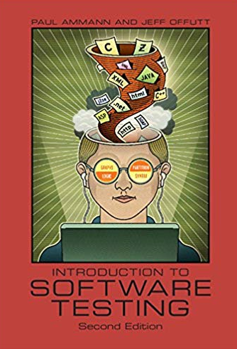
Author | Paul Ammann (Author), Jeff Offutt (Author)
Publisher | Cambridge University Press 2 edition 2016
ISBN | ISBN-10: 9781107172012  ISBN-13: 978-1107172012

Text book 2 (required) | More Agile Testing | 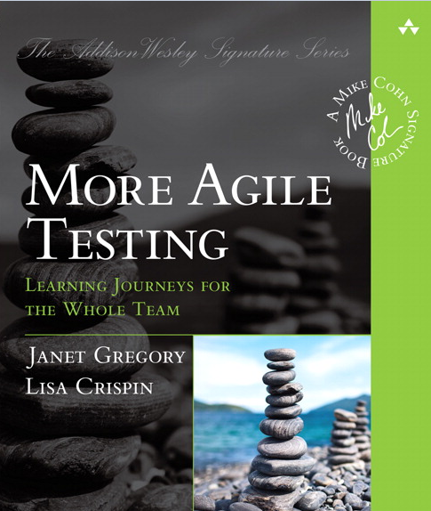
Author | Janet Gregory, Lisa Crispin
Publisher | Addison-Wesley Professional, @2015
ISBN | ISBN-13: 9780133749564

Reference book (optional) | Agile Testing Foundations: An ISTQB Foundation Level Agile Tester guide | 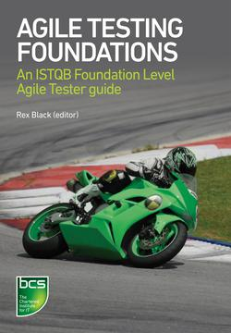
Author | Rex Black
Publisher | BCS Learning & Development Limited 2017
ISBN | ISBN: 9781780173368

Reference book (optional) | Test-Driven Development for Embedded C | 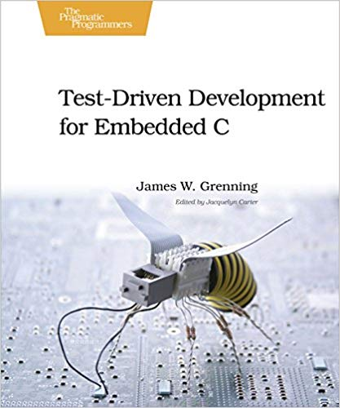
Author | James W. Grenning
Publisher | Pragmatic Bookshelf, 2011
ISBN | ISBN-13: 978-1934356623  ISBN-10: 193435662X

Suggested References

- Foundations of Software Testing, by Aditya P. Mathur, Addison-Wesley Professional, @2014, ISBN ISBN-10: 8131794768, ISBN-13: 978-8131794760
- Test-Driven Java Development , by Alex Garcia, Packt Publishing, 2nd edition, 2018, ISBN-10: 1788836111, ISBN-13: 978-1788836111
- https://www.astqb.org/istqb-foundation-level
- IEEE Standard for Software and System Test Documentation. Institute of Electrical and Electronic Engineers, New York. IEEE Std 829-2008.
- Grindal, M., Offutt, J., and Andler, S. F. (2005). Combination testing strategies: A survey. Software Testing, Verification, and Reliability, 15(2):97–133, Wiley
- Mathur, A. P. (2014). Foundations of Software Testing. Addison-Wesley Professional, Indianapolis, IN, second edition.
- Beck, K., Beedle, M., van Bennekum, A., Cockburn, A., Cunningham, W., Fowler, M., Grenning, J., Highsmith, J., Hunt, A., Jeffries, R., Kern, J., Marick, B., Martin, R. C., Mellor, S., Schwaber, K., Sutherland, J., and Thomas, D. (2001). The agile manifesto. Online Report. http://agilemanifesto.org

Weekly Topic (lecture and lab)

Week | Topic (lecture and lab) | The book name and chapters
1 | Course outline, classroom conduct, academic integrity, attendance, and grading policy. Intro to testing and overview of the test process between hardware and software.  Lab exercise: Extract the testable components from an embedded system - Raspberry Pi, Arduino, sensor, and embedded programming (handout). | Chapter 1  Text book Introduction to Software Testing
2 | Testing levels, fault, failure, error, validation, verification, and SDLC model.  Lab exercise: Design pulse sensor interface embedded software and write the test harness (handout). | Chapter 2.1-2.4  Text book Introduction to Software Testing
3 | Model-driven test design, steps, activities, examples, and technically challenging.  (Quiz 1)  Lab exercise: Design different test cases for given faulty programs under a testing framework. | Chapter 2.5  Text book Introduction to Software Testing
4 | Test automation, unit testing frameworks, and components of a test case.  Lab exercise: Using an embedded device to mock the system for test – identifying components of the system, test plan and design, and test execution (handout). | Chapter 3  Text book Introduction to Software Testing
5 | Putting test first, TDD cycle, BDD cycle, dual target, and automated embedded system testing.  Lab exercise: Use test-driven design to add additional functionality and include a narrative describing each TDD test created (handout). | Chapter 4  Text book Introduction to Software Testing
6 | Coverage criteria, test requirements, test sets, and fault revealing.  (Quiz 2)  Lab exercise: Testing notation, unit testing, and test programming skills (C++, Java, or FPGAs). | Chapter 5  Text book Introduction to Software Testing
7 | State transition and state machine model  Lab exercise: Apply boundary value and state transition to generate test cases for given requirements. | Chapter 8  Text book Introduction to Software Testing
8 | Midterm exam
9 | Graph coverage - control flow criteria  Lab exercise: Draw a control flow graph and design a test case (handout). | Chapter 7  Text book Introduction to Software Testing
10 | Input space partitioning and input domain model  Lab exercise: Derive input space partitioning test inputs and selecting a finite subset of inputs (handout). | Chapter 7  Text book Introduction to Software Testing
11 | Evolution of testing -testing in agile vs. traditional. Agile core principles and values. Agile project inception  (Quiz 3)  Lab report: The agile team approach, team formation, and user stories with agile tools. | Chapter 1, 2, and 3  Textbook  More Agile Testing
12 | Test planning, phases, and roles in embedded systems teams  Lab report: Test phases and roles in embedded systems teams. | Chapter 7  Textbook  More Agile Testing
13 | Agile testing for mobile and embedded systems, agile techniques, exploratory testing and challenges  Final project: Agile testing in practice | Chapter 20 and 21  Textbook  More Agile Testing
14 | Agile tools, testing methods, and continuous improvement  Final project continued: agile testing in practice | Chapter 24  Textbook  More Agile Testing
15 | Final exam

Course Policies

Grading:
- Quizzes 10 %
- Midterm 15 %
- Lab exercises 15 %
- Lab reports 20 %
- Final project with final project report 20 %
- Final Exam 20 %

- Total: 100 %

Score % | < 60 | 60-69.9 | 70-76.9 | 77-79.9 | 80-82.9 | 83-86.9 | 87-89.9 | 90-92.9 | 93-100
Grade | F | D | C | C+ | B- | B | B+ | A- | A

Blackboard and OpenLab:
- Blackboard and OpenLab websites will be used extensively to provide as course material, collect assignments and reports, and provide detailed grading information. Students must make sure their Blackboard login is working in the beginning of the course.

Reading and Reference Material:
- Reading and reference material will be provided in Blackboard and OpenLab.

Software for Lab / Project:
- Software applications will be used in the labs and course project. The links to download the software will be posted in Blackboard.

Lab Reports:
- Lab reports must be submitted
- Lab reports must be in Doc or PDF file format.
- All lab reports must be submitted through Blackboard – Assignments section.
- Each lab report is due one week after the lab work is performed.
- Any late-due lab report will have late penalty one week after due date.
- Additional requirements on lab report’s content and format will be posted on Blackboard or OpenLab. Please read them carefully.

Library Usage:
- Students are encouraged to use the library for supplementary resources in support of the lectures and labs.

Academic Integrity:
Students and all others who work with information, ideas, texts, images, music, inventions, and other intellectual property owe their audience and sources accuracy and honesty in using, crediting, and citing sources. As a community of intellectual and professional workers, the College recognizes its responsibility for providing instruction in information literacy and academic integrity, offering models of good practice, and responding vigilantly and appropriately to infractions of academic integrity.

CUNY Policy on Academic Integrity:
- Academic dishonesty is prohibited in The City University of New York. Penalties for academic dishonesty include academic sanctions, such as failing or otherwise reduced grades, and/or disciplinary sanctions, including suspension, or expulsion.
- The CUNY Academic Integrity Policy is clearly published and distributed to students via the following methods: the NYCCT web site, the Instructional Staff Handbook, the Student Handbook, and via the College email system.

Attendance:
- Per CityTech Policy, attendance and class participation are essential and excessive absences may affect the final grade.

Course Design and Assessment

Due to an increased number of enrolled students, this agile testing course is designed to meet the needs of CET students for the technical electives. The course is offered in lecture and lab combined. The lecture focuses on the theory and principles of testing embedded software. The labs and cases provide students with the opportunity to apply the theory in practical ways to design and implement tests by using real world scenarios. The team project helps students to participate in class and to interact with fellow students. Students will work in an agile team to understand each member’s role in test activities.

This proposed course will provide students with more options to choose 4 credits technical electives in Computer Engineering Technology BTech (CEB) program. The course directly meets the CEB program educational objective. This course will be offered to CET B.Tech program. CEB junior or senior level students who can take this 4 credits course as a technical elective. The course is expected to offer in Fall 2019, once every academic year. Existing CET faculty are eligible to teach this course. The current lab facility is sufficient to run hands-on lab components and a project. Students have an option to get the career booster of software testing –ISTQB ® CTFL after taking this course. The International Software Testing Qualifications Board (ISTQB) Certified Tester Foundation Level (CTFL) qualification is aimed at anyone involved in software testing. This includes people in roles such as testers, test analysts, test engineers, test consultants, test managers, user acceptance testers, and software developers. This certification gives students a common testing vocabulary and principles and opens a software and embedded testing career path for our CET students.

Course Assessment Criteria
Upon successful completion of this course, students shall be able to | Evaluation methods and criteria
Understand fundamental testing principles and processes associated with embedded systems. | Analysis of student performance on quizzes and exams. The students will understand the test process, the major activities, and work products through lab exercises, for example, extract the testable components and write the test harness.
Distinguish between traditional and agile testing approaches. | Analysis of student performance on quizzes and exams. Write a lab report based on reading assignments of evolution of testing, activities of test engineers, and test driven development.
Understand agile core principles and values | Analysis of student performance on short answer questions on quizzes, midterm exam, and final exam, and the role in a lab project within a group.
Design embedded system tests and test software in structured and organized ways | Students will demonstrate their ability to use test-driven design to write and implement additional functionality incrementally in lab exercises.
Apply agile software principles into practice and procedure | Agile is covered so students are able to form agile teams in the final project and understand each member’s role in the team. Students will practice the TDD and BDD approaches in a group.

General Education Outcomes and Assessment:

Learning Outcomes | Assessment Method
SKILLS/Inquiry/Analysis: Students will employ scientific reasoning and logical thinking. | Students will identify embedded system fault and failure by using correct input harness and generating different test cases for given system requirements in lab exercises.
SKILLS/Communication: Students will communicate in diverse settings and groups, using written (both reading and writing), oral (both speaking and listening), and visual means | Students will give the presentation to the class of their projects including the models, software test activities, and the faults related to the designed software. The final project report is required to include the introduction, the principle and models, group test activities, the role of each team member, findings, citations and references.
INTEGRATION/Integrate learning: Students will resolve difficult issues creatively by employing multiple systems and tools. | The agile community has developed several processes and tools to manage automating system tests and integrating the implementation as it is developed. Students work in a group on TDD repeating the cycle of small steps to resolve a technical issue.
VALUES, ETHICS, RELATIONSHIPS / Professional/Personal Development: Students will work with teams, including those of diverse composition. Build consensus. Respect and use creativity. | Students will work in agile team, build consensus and respect and use creativity in all lab activities.

LIBRARY RESOURCES & INFORMATION LITERACY: MAJOR CURRICULUM MODIFICATION

Please complete for all major curriculum modifications. This information will assist the library in planning for new courses/programs.

Consult with your library faculty subject specialist (http://cityte.ch/dir) 3 weeks before the proposal deadline.

Course proposer: please complete boxes 1-4. Library faculty subject specialist: please complete box 5.

1 | Title of proposal  CET 4915 Agile Testing of Embedded Software | Department/Program  Computer Engineering Technology (CET) / BTech in Computer Engineering Technology
 | Proposed by (include email & phone)  Prof. Yu Wang  ywang@citytech.cuny.edu / 718-260-5885  Prof. Sunghoon Jang  SJang@citytech.cuny.edu /718-260-5885  Prof. Farrukh Zia  fzia@citytech.cuny.edu / 718-260-5885 | Expected date course(s) will be offered  Fall 2019  # of students  22

2 | The library cannot purchase reserve textbooks for every course at the college, nor copies for all students. Consult our website (http://cityte.ch/curriculum) for articles and ebooks for your courses, or our open educational resources (OER) guide (http://cityte.ch/oer). Have you considered using a freely-available OER or an open textbook in this course?  Yes

3 | Beyond the required course materials, are City Tech library resources sufficient for course assignments? If additional resources are needed, please provide format details (e.g. ebook, journal, DVD, etc.), full citation (author, title, publisher, edition, date), price, and product link.  No additional resources are required beyond the required course materials.  Sufficient number of papers, articles, journals on this subject are available in the library.

4 | Library faculty focus on strengthening students' information literacy skills in finding, critically evaluating, and ethically using information. We collaborate on developing assignments and customized instruction and research guides. When this course is offered, how do you plan to consult with the library faculty subject specialist for your area? Please elaborate.  Once this course is offered, CET dept faculty will teach the course. We may consult with the library faculty specialist on the resources for the updated teaching reference materials, journal, or online resources.

5 | Library Faculty Subject Specialist: Junior Tidal (Email: jtidal@citytech.cuny.edu  Comments and Recommendations  After surveying the collection, I suggest not only acquiring texts outlined in the syllabus for this course but additional supplemental materials as well. The library has no print monographs related to agile testing. There are numerous eBooks related to conference proceedings related to the topic, however, these books may not be suitable as introductory texts for students. Software testing texts are also available in the library, but I also recommend updating the collection to more recent editions to fully support the course.  Date 10.11.2018

Chancellor’s Report
Section AIV: New Courses

AIV.1. Department: Computer Engineering Technology
New courses to be offered in the Computer Engineering Technology department
Department(s) | Computer Engineering Technology
Academic Level | [ x ] Regular [ ] Compensatory [ ] Developmental [ ] Remedial
Subject Area | Computer Engineering
Course Prefix | CET
Course Number | 4915
Course Title | Agile Testing of Embedded Software
Catalog Description | Introduction to the theory and principles of testing embedded software. The topics cover the basics of test design, test automation, test-driven development, agile principles, values, techniques, practices, procedures, and tools. The lab and cases provide students with the opportunity to apply the theory in practical ways to design tests during the phases of embedded software development.
Prerequisite | CET 3510
Corequisite
Pre- or corequisite | CET3640
Credits | 4
Contact Hours | 3 Class Hours, 3 Lab Hours
Liberal Arts | [ ] Yes [ x ] No
Course Attribute (e.g. Writing Intensive, etc) | N.A
Course Applicability | [x ] Major  [ ] Gen Ed Required [ ] Gen Ed – Flexible [ ] Gen Ed - College Option  [ ] English Composition [ ] World Cultures [ ] Speech  [ ] Mathematics [ ] US Experience in its Diversity [ ] Interdisciplinary  [ ] Science [ ] Creative Expression [ ] Advanced Liberal Arts  [ ] Individual and Society  [ ] Scientific World
Effective Term | Fall 2019

Rationale: This course is designed to meet the needs of the growing numbers of CET (Computer Engineering Technology) students for a technical elective in the Computer Engineering Technology BTech program. This course allows students to develop their knowledge further to design tests in the phases of embedded software development. An understanding of agile allows our CET students to obtain entry level jobs and to work on a project in any sector in the tech field.

Appendix A: Sample lecture and lab

Course should focus on using testing to improve embedded systems development, then add agile to show how to further improve it.

Sample Lecture: Model-driven test design
The role of testing in software development has undergone radical changes in recent years. Testing has evolved from afterthought to a central activity in certain development methods—particularly agile methods

Outline:
- Fault and failure model (RIPR model)
- Test activities – “V” model
- Agile testing methods and incremental TDD (test driven development)
- Discussion

- RIPR model
Reachability (R) -a test must reach the location or locations in the program that contain the fault.
Infection (I) - after the location is executed, the state of the program must be incorrect.
Propagation (P) - the infected state must propagate through the rest of the execution and cause some output or final state of the program to be incorrect
Revealability (R) - Finally, the tester must observe part of the incorrect portion of the final program state.
If the tester only observes parts of the correct portion of the final program state, the failure is not revealed.

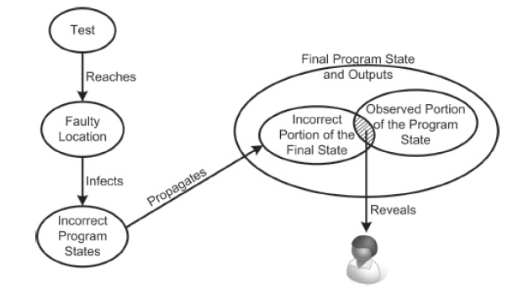
Reachability, Infection, Propagation, Revealability (RIPR) model.

- Activities of test engineers and “V” model
The most time-consuming parts of testing are actually the test design and construction, so test activities can and should be carried out throughout development.
Tests can be derived from requirements and specifications, design artifacts, or the source code. In traditional texts, a different level of testing accompanies each distinct software development activity:
Acceptance Testing - assess software with respect to requirements or users’ needs.
System Testing - assess software with respect to architectural design and overall behavior.
Integration Testing - assess software with respect to subsystem design.
Module Testing - assess software with respect to detailed design.
Unit Testing - assess software with respect to implementation.
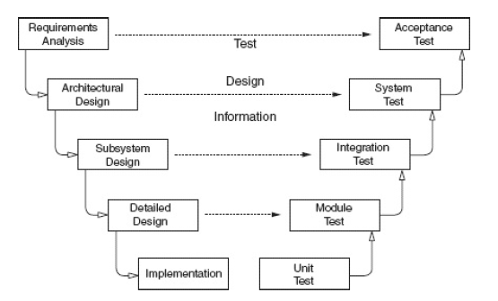
The “V Model”

- The agile community has developed several processes and tools to manage automating system tests and integrating the implementation as it is developed. The core of TDD (test driven development) is a repeating cycle of small steps:
- Add a small test
- Run all the test and see the new one fail
- Make small changes needed to pass the test
- Run all the tests and see the new one pass
- Refactor for remove duplication and improve expressiveness

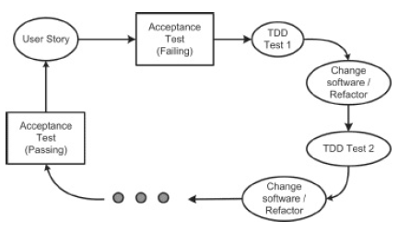
The role of user stories and TDD cycle
- Discussion
- How are faults and failures related to testing and debugging.
- If you have never worked for a software development company, which of the four test activities do you think you are best qualified for? (test design, automation, execution, evaluation)

Sample Lab: Extract the testable components from an embedded system
This diagram here shows how someone may use software testing in an embedded system:

Students need to be able to extract these testable components from an embedded system. Lab focus on getting a basic understanding of that. This is how programming should be approached. For example, in this situation, lab activity needs to:
- write a function to generate random temperature
- write a function to read temperature, and output string in format “%D degrees Fahrenheit”
- write function to test that temperature is valid (between -89.2c and 56.7c)
- write function to test that temperature is converted correctly
- write function to test that string is formatted correctly

Appendix B: Department Meeting Minutes
2018-09-27 Faculty Meeting Minutes
Attendance (excused are in bold): Sunghoon Jang, Robert Armstrong, Seymour Blank, Aparicio Carranza, Ohbong Kwon, Xiaohai Li, Lili Ma, Benito Mendoza, Edward Morton, John Razukas, José M. Reyes Álamo, Yu Wang, Chen Xu, Farrukh Zia, Natalia Maldonado.
Started at 12:49 PM
- Approval of the minutes of the previous departmental meetings.
  - Minutes approved.
- Chair’s statement and report of the current developments in the department and college.
  - More than 10 adjuncts has been hired
  - Department has courses 7 days a week
  - Report on students financial aid by college and finances
  - Email update about the teaching load reductions in the coming years and how the policy may be implemented
  - Tech Fee update on the items approved and the one rejected. The Department got most of the items requested.
  - AIR – Annual Report Summary was discussed. It show the number of students in each programs, the trends, and some demographic information
  - Middle States visit – They made several recommendations, but no major issues were found and the College in general is in good shape.
  - Due to our full week schedule, the Chair requested a COA for the weekend. Email of the discussion with the administration were shown.
  - Some candidates are having problems getting or changing their visas due to long wait times these days.
  - Welcome to Prof. Maldonado who was recently hired and will be teaching in our Department. Prof. Maldonado introduced.
  - College is accepting applications for promotions, please notify the Chair.
- Meeting with Dr. Aiman Erbad – Qatar University
  - Professors representing the government of Qatar and in town for the United Nations General Assembly visited the Department and shared remarks and their background.
- New Faculty Search Committee Report and new full-time subs for Fall 2018
  - Full-time Candidates are being considered
- CET Department Reappointment Committee’s Meeting Schedule.
  - The Committee will set the meeting time and date soon based on the schedule of all the members
- Peer class observation for Fall 2018 and MCF for Spring 2019.
  - Lists and schedules will be distributed later as the Department has several new hires
- Curriculum and academic/research grant proposal update
  - Lab manual for CET 3510 was showcased. Faculty are encouraged to provide similar material to students.
  - Prof Wang showed the proposal for the course Agile Testing of Embedded Systems
  - Prof. Wang also reported on the new forms being used to keep track of the courses
- Report scholarly/creative works during summer
  - Faculty are advised to update their profiles on the College website and contact Prof. Mendoza to do so.
- ABET assessment of CET program by Profs. Zia and Mendoza
  - Prof. Zia reported some of the changes in the evaluation report.
  - The Department should be aware that the 2020 report should use the new framework and the past report has to be remapped into the new one.
- Open House on Oct. 28, Sunday
  - Prof. Li will provide more information about the event.
- Updated list of the IAC members by Prof. Razukas and Kwon
  - The final list of members will be submitted soon.
- Uniform finals
  - The courses that require uniform finals were discussed
Meeting Adjourned at 2:03 PM
Scribe: José M. Reyes Álamo

2019-02-28 Faculty Meeting Minutes
Attendance (excused are in bold): Sunghoon Jang, Robert Armstrong, Seymour Blank, Aparicio Carranza, Ohbong Kwon, Xiaohai Li, Lili Ma, Benito Mendoza, Edward Morton, John Razukas, José M. Reyes Álamo, Yu Wang, Chen Xu, Farrukh Zia.
Started at 12:47PM
- Approval of the minutes of the previous departmental and curriculum meetings.
  - Minutes approved.
- Chair’s statement and report of the current developments in the department and college
  - The department expresses the deepest condolences to Prof. Morton due to his loss. Faculty are encouraged to show their support and solidarity.
  - Presented summary of the Fiscal Year 2020 State Executive Budget analysis
    - Having problems to secure funding for the department, especially to fix the copy machine.
    - There is funding to purchase a scanner.
  - About advisement Prof. Jang is proposing creating a schedule table with all professors’ advisement hours to better help students and allow them to receive advisement when available and minimize the waiting.
    - Discussion about issues with advisement and how to solve them, especially raise awareness to avoid problems before graduation.
    - Prof. Mendoza suggests faculty to show freshman students the courses form with the pre/co requisites for awareness purposes.
  - The Dean will step down, become a Distinguished Visiting Professorship, and then will become a faculty at the Architectural Technology Department.
- New hiring for faculty and CLT for Fall 2019
  - Prof. Aponte was offered a full-time sub position by the College.
  - Hiring full-time CLT will be challenging.
- MCF for summer and Fall 2019
  - Courses offering during summer EMT 1250, and EMT 2370.
  - Prof. Jang explained the process of opening a summer courses and asked faculty about their input on what courses should be offered, and what courses they will be open to teach.
    - Suggestions: EMT 1150, EMT 2410, EMT 2390L, EMT 2480L, CET 3510, CET 3625, CET 4705, CET 4711, CET 4805, CET 4811.
    - Prof. Carranza suggests evening courses during summer if allowed/possible.
    - Prof. Mendoza suggests trying to run the AI courses during Fall.
- Approval for new course proposal CET 4915: Agile Testing of Embedded Software
  - Course proposal voted and approved by the Department.
- Curriculum and Academic/Research Grant proposal updates
  - Prof. Xu gave an update on her GRTI grant.
- ABET Assessment of CET Programs by Prof. Zia and Mendoza
  - Update about the Assessment Meetings on March 15 and March 22
  - Analysis of the ABET Student Outcomes j, k, l. Particularly outcome l is underperforming in two aspects compared to previous years.
    - Prof. Mendoza and Ma indicated that during Spring 20018 one section underperformed, and they are trying to determine the causes. Prof. Jang indicated that they need to monitor these phenomena and get feedback to guide the instructors to cover the necessary material and reassign them if necessary.
    - Prof. Mendoza and Ma indicated that in Fall 2018 some data is incomplete, and they are waiting for it. Some items are borderline and they are expecting the final data set to have the final results.
    - Plans for Spring 2019 is to collect data from EMT 2461 and analyze outcomes d, e, and f.
- BS in Software Engineering Programs by Prof. Li
  - Enrollment to our program is down about 6%, need to pay attention to this trend
  - Prof. Li gave a presentation about the proposal and the materials being used to shape this program.
- Student ready departments 2019 by Profs. Wang and Kwon
  - The math liaison and the relevant document distributed in our dept meeting (Wang)
  - Distributed advisement docs to faculty, how help student to apply for graduation from CUNYFirst, student ready dept and our dept action.
- IAC Meeting by Prof. Razukas.
  - Faculty are encouraged to invite colleagues to the IAC meeting and recommend new members.
  - Meeting will be on May 16th
- Plans by the Chairs of the department committees.

Meeting Adjourned at 2:30 PM
Scribe: José M. Reyes Álamo

