New York City College of Technology, CUNY
CURRICULUM MODIFICATION PROPOSAL FORM
This form is used for all curriculum modification proposals. See the Proposal Classification Chart for information about what types of modifications are major or minor. Completed proposals should be emailed to the Curriculum Committee chair.

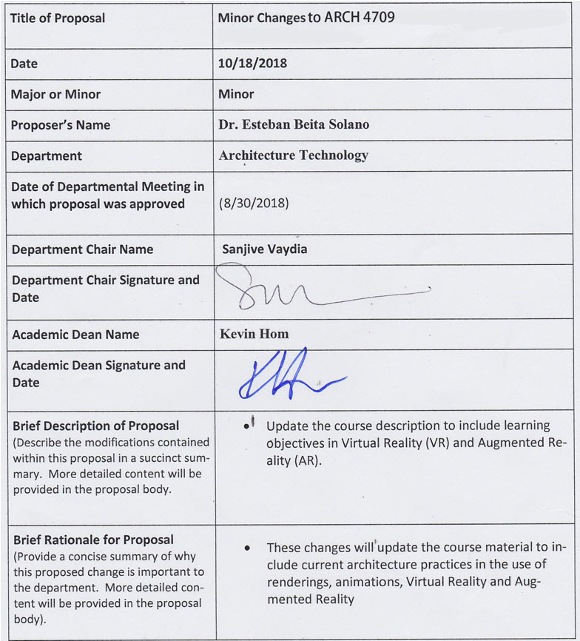

Please include all appropriate documentation as indicated in the Curriculum Modification Checklist.
For each new course, please also complete the New Course Proposal and submit in this document.
Please submit this document as a single .doc or .rtf format. If some documents are unable to be converted to .doc, then please provide all documents archived into a single .zip file.

ALL PROPOSAL CHECK LIST

Completed CURRICULUM MODIFICATION FORM including:
- Brief description of proposal | Y
- Rationale for proposal | Y
- Date of department meeting approving the modification | Y
- Chair’s Signature | Y
- Dean’s Signature | Y
Evidence of consultation with affected departments  List of the programs that use this course as required or elective, and courses that use this as a prerequisite. | N/A
Documentation of Advisory Commission views (if applicable). | N/A
Completed Chancellor’s Report Form. | Y

EXISTING PROGRAM MODIFICATION PROPOSALS

Documentation indicating core curriculum requirements have been met for new programs/options or program changes. | N/A
Detailed rationale for each modification (this includes minor modifications) | Y

List of Courses that use this course as prerequisite.

No courses are currently listing ARCH 4709 as a pre-requisite.
List of the programs that use this course as required or elective.
Currently no programs are listing ARCH 4709 as a required course.

Rationale for the Proposed Minor Changes

The proposed minor change will update the course description to align with current industry practices in architecture in the use of rendering, virtual reality and augmented reality.

Section AV: Changes in Existing Courses

ARCH 4709. Course offered by the Architecture Technology Department.

CUNYFirst Course ID
FROM: |  | TO:
Department(s) |  | Department(s)
Course |  | Course
Prerequisite |  | Prerequisite
Corequisite |  | Corequisite
Pre- or corequisite | (ARCH 1291 or ARCH 1212) with a grade of C or higher | Pre- or corequisite | ARCH 3591
Hours |  | Hours
Credits |  | Credits
Description | This elective course focuses on 3D modeling, rendering, lighting and animation techniques. Most advanced aspects of the rendering software will be explored through a series of exercises designed to acquaint the student with the various commands found within the program used. | Description | This elective course focuses on advanced rendering and animation techniques to create captivating architecture visualizations. The course also looks at current trends and technologies used to facilitate architecture visualization through the use of virtual reality (VR) and augmented reality (AR).
Requirement Designation |  | Requirement Designation
Liberal Arts | [ ] Yes [ ] No | Liberal Arts | [ ] Yes [ ] No
Course Attribute (e.g. Writing Intensive, Honors, etc |  | Course Attribute (e.g. Writing Intensive, Honors, etc
Course Applicability | [ ] Major  [ ] Gen Ed Required  [ ] English Composition  [ ] Mathematics  [ ] Science  [ ] Gen Ed - Flexible  [ ] World Cultures  [ ] US Experience in its Diversity  [ ] Creative Expression  [ ] Individual and Society  [ ] Scientific World  [ ] Gen Ed - College Option  [ ] Speech  [ ] Interdisciplinary  [ ] Advanced Liberal Arts | Course Applicability | [ ] Major  [ ] Gen Ed Required  [ ] English Composition  [ ] Mathematics  [ ] Science  [ ] Gen Ed – Flexible  [ ] World Cultures  [ ] US Experience in its Diversity  [ ] Creative Expression  [ ] Individual and Society  [ ] Scientific World  [ ] Gen Ed - College Option  [ ] Speech  [ ] Interdisciplinary  [ ] Advanced Liberal Arts
Effective Term | Spring, 2019
Rationale: By having ARCH 3591 as a corequisite for ARCH 4709, it will make sure that students entering the course have the modeling and renderings skills to learn advance rendering techniques needed for Virtual Reality.

NEW YORK CITY COLLEGE OF TECHNOLOGY
CITY UNIVERSITY OF NEW YORK
ARCHITECTURE TECHNOLOGY

Section Number: Instructor:

Email Address: Office hours:

Course Name:
ARCH 4709 – Advance 3-Dimensional Modeling and Rendering

Credit Hours:
3 cl hrs, 3 cr

Pre- or corequisite:
ARCH 3591

Course Description:
This elective course focuses on advanced rendering and animations techniques to create captivating architecture visualizations. The course also looks at current trends and technologies used to facilitate architecture visualization through the use of virtual reality (VR) and augmented reality (AR).

Text:
- Autodesk 3ds Max 2018 Complete Reference Guide, Kelly L. Murdock
- Autodesk 3ds Max 2018 Essentials, Dariush Derakhshani
- 3D Photorealistic Rendering: Interior & Exteriors with Vray and 3ds Max
- V-Ray My Way: A Practical Designer’s Guide to Creating Realistic Imagery Using V- Ray & 3ds Max

Format:
Series of lectures followed by lab work and one-to-one instruction. Bi-weekly quizzes will be given.

Attendance Policy:
No more than 10% absences are permitted during the semester. For the purposes of record, two late arrivals are considered as one absence. Exceeding this limit will expose the student to grade penalties at the discretion of the instructor due to lack of class participation and mastery of class material.

Academic Integrity:
Students and all others who work with information, ideas, texts, images, music, inventions and other intellectual property owe their audience and sources accuracy and honesty in using, crediting and citation of sources. As a community of intellectual and professional workers, the college recognizes its responsibility for providing instruction in information literacy and academic integrity, offering models of good practice, and responding vigilantly and appropriately to infractions of academic integrity. Accordingly, academic dishonesty is prohibited in The City University of New York and is punishable by penalties, including failing grades, suspension and expulsion.

Course Structure:
There will be one design project and three research assignments. 2D and 3D drawings, and physical study models and final models will be utilized in program development, design and presentations. Throughout the semester, the review of historical precedents and selected cities will help to create a historical perspective.

Grading:
Your final grade will be a combination of grades given for weekly homework assignments, three class projects and attendance. There is no final exam, but all projects must be turned in on the dates given. Students who are absent are responsible for finding out what the assignments are from classmates and turning it in on time. Late submissions will be graded down 1/3 grade for each day late.

20% Homework Assignments
20% Projects, introductory
20% Projects, development
30% Projects, final
10% Class Participation

Learning Objectives:

General Education Learning Outcomes / Assessment Methods
Learning Outcomes | Assessment Methods
Upon successful completion of this course the student shall be able to: | To evaluate the students’ achievement of the learning objectives, the professor will do the following:
- KNOWLEDGE; Depth of knowledge,  Students will engage in in-depth, sustained study of animation, rendering, and VR/AR and their effect on industry. | - Evaluate the students’ projects for integrate their expression of architectural space. Measure student’s integration of VR and rendering industry practices into their presentations.
- KNOWLEDGE; Lifelong learning,  Students from project development to presentation will be organized and plan ahead. | - Students project development process will be rated. Students must show they have analyzed their chosen development process.
- SKILLS; Communication,  Communicate ideas of design and architectural space to diverse groups, using a range of forms for visual, written, and oral presentations in more than one form. | - Assess students’ use of communication skills during oral presentations, written descriptions, visual and VR and presentations.

Course Specific Learning Outcomes / Assessment Methods
Learning Outcomes | Assessment Methods
Upon successful completion of this course the student shall be able to: | To evaluate the students’ achievement of the learning objectives, the professor will do the following:
- Develop previously learned computer assisted graphics and rendering skills, and build upon these for learning VR/AR techniques. (Skill) | - Review students’ projects for integration of their expression of architectural space. Measure student’s integration of rendering and VR/AR industry practices into their presentations.
- Students must demonstrate the ability to import files of 3D architectural buildings from other programs for modification and enhancement, and other types of software interoperability important for computer graphics. (Skill) | - Assess the students’ ability to synthesize and apply what is learned from lab work, through the grading of assignments and projects.
- Employ and create lights and daylight/sunlight simulations. (Skill) | - Appraise the students’ ability to synthesize apply what is learned through the grading of assignments, projects and students’ expression of architectural space.
- Create and apply realistic materials as well as color/material alternates. (Skill) | - Assess the students’ ability to synthesize and apply what is learned through the grading of assignments, projects and students’ expression of architectural color and material.
- Create realistic renderings and panoramas that compliment 2D plans and elevations in presenting their design. (Skill) | - Assess the students’ ability to synthesize and apply what is learned through the grading of assignments, projects and student expression of architectural space.
- Create walkthrough/flythrough animations, animate architectural objects and output these animations to video. (Skill) | - Assess the students’ ability to synthesize and apply what is learned through the grading of assignments, projects, students’ expression of architectural space and time.

Lab Regulations:

- You are responsible for backing up your work – do not leave any of your files on lab computers! Your work may be deleted.
- Do not work off your Flash drives. Copy your files to the desktop before working and copy from desktop to your backup disk and erase desktop file before leaving the lab.
- You will be instructed as to the locations for submitting your projects, including via email.

