New York City College of Technology, CUNY

CURRICULUM MODIFICATION PROPOSAL FORM

This form is used for all curriculum modification proposals. See the [Proposal Classification Chart](http://openlab.citytech.cuny.edu/collegecouncil/files/2014/08/2013-10-09-Proposal_Classification_Chart.pdf) for information about what types of modifications are major or minor. Completed proposals should be emailed to the Curriculum Committee chair.

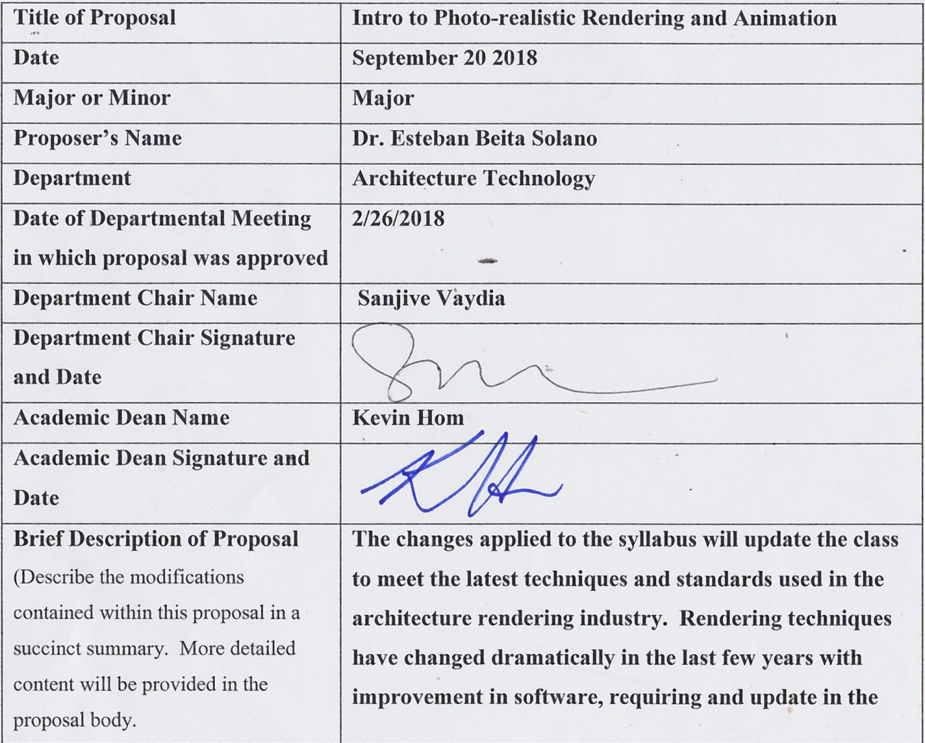

|  |  |
| --- | --- |
| **Title of Proposal** | **Intro to Photo-realistic Rendering and Animation** |
| **Date** | **September 20 2018** |
| **Major or Minor** | **Major** |
| **Proposer’s Name** | **Dr. Esteban Beita Solano** |
| **Department** | **Architecture Technology** |
| **Date of Departmental Meeting in which proposal was approved** | **2/26/2018** |
| **Department Chair Name** | **Sanjive Vaydia** |
| **Department Chair Signature and Date** |  |
| **Academic Dean Name** | **Kevin Hom** |
| **Academic Dean Signature and Date** |  |
| **Brief Description of Proposal**  (Describe the modifications contained within this proposal in a succinct summary. More detailed content will be provided in the proposal body. | **The changes applied to the syllabus will update the class to meet the latest techniques and standards used in the architecture rendering industry. Rendering techniques have changed dramatically in the last few years with improvement in software, requiring and update in the course name and material. Also, in order to align with our new Bachelor of architecture program and make it easier to students to take a range of courses, the course now 3 lab hours and 3 credits.** |
| **Brief Rationale for Proposal**  (Provide a concise summary of why this proposed change is important to the department. More detailed content will be provided in the proposal body). | These changes are important to align with our new Bachelor of architecture program, as well as keeping the class in pace with the needs of the architecture visualization industry. |
| **Proposal History**  (Please provide history of this proposal: is this a resubmission? An updated version? This may most easily be expressed as a list). | **This a modification for an existing course.** |

Please include all appropriate documentation as indicated in the Curriculum Modification Checklist.

For each new course, please also complete the New Course Proposal and submit in this document.

Please submit this document as a single .doc or .rtf format. If some documents are unable to be converted to .doc, then please provide all documents archived into a single .zip file.

**Changes to be offered in the Architectural Technology department**

|  |  |  |  |
| --- | --- | --- | --- |
| **CUNYFirst Course ID** | ARCH 3591 |  |  |
| **FROM:** |  | **TO:** |  |
| **Department(s)** | Architecture Technology | **Department(s)** | Architecture Technology |
| **Course** | ~~ARCH 3591 Computer Assisted Architecture Animation~~ | **Course** | ARCH 3592 Intro to Photo-realistic Rendering and Animation |
| **Prerequisite** | (ARCH 1291 or ARCH 1212) with a grade of C or higher | **Prerequisite** | (ARCH 1291 or ARCH 1212) with a grade of C or higher |
| **Corequisite** | none | **Corequisite** | none |
| **Pre- or corequisite** | none | **Pre- or corequisite** | none |
| **Hours** | ~~4 Lab Hours 2 cl hrs, 2 lab hrs~~ | **Hours** | 3 cl hrs |
| **Credits** | 3 | **Credits** | 3 |
| **Description** | ~~This elective course is an introduction to the use of the computer to assist in the production of 2D architectural animations, composite renderings, 3D animated models, time-lapse studies and other architectural design tools. This course involves the use of the computer, methods of architectural rendering and animation, and the drawing and storage of computer animations with different devices.~~ | **Description** | This visual-oriented course will teach students to visualize space through a combination of photo-realistic renderings, animations, and interactively using 360-degree panoramic renderings and computer-generated scenes that can be viewed and explored as virtual and augmented reality. |
| **Requirement Designation** |  | **Requirement Designation** |  |
| **Liberal Arts** | [ ] Yes [ ] No | **Liberal Arts** | [ ] Yes [ ] No |
| **Course Attribute (e.g. Writing Intensive, Honors, etc** |  | **Course Attribute (e.g. Writing Intensive, Honors, etc** |  |
| **Course Applicability** | |  | | --- | | [ x] Major | | [ ] Gen Ed Required | | [ ] English Composition | | [ ] Mathematics | | [ ] Science | | [ ] Gen Ed - Flexible | | [ ] World Cultures | | [ ] US Experience in its Diversity | | [ ] Creative Expression | | [ ] Individual and Society | | [ ] Scientific World | | [ ] Gen Ed - College Option | | [ ] Speech | | [ ] Interdisciplinary | | [ ] Advanced Liberal Arts | | **Course Applicability** | |  | | --- | | [x ] Major | | [ ] Gen Ed Required | | [ ] English Composition | | [ ] Mathematics | | [ ] Science | | [ ] Gen Ed - Flexible | | [ ] World Cultures | | [ ] US Experience in its Diversity | | [ ] Creative Expression | | [ ] Individual and Society | | [ ] Scientific World | | [ ] Gen Ed - College Option | | [ ] Speech | | [ ] Interdisciplinary | | [ ] Advanced Liberal Arts | |
| **Effective Term** | Spring 2019 |  |  |

**Rationale:** Provides for on hands-on activities and place based learning lab introduction. To reflect this the lab focus proposal has adjusted its workload hours to support a scaffolded introduction to degree programs.

**ARCH 3591 Intro to Photo-realistic Rendering and Virtual Reality**

**Fall 2018**

Friday (8:30 – 11:00AM) 3 Lab Hours, 3 Credits

**Assistant: Prof. Esteban Beita**, Ph.D. Course Coordinator

Email: [ebeitasolano@citytech.cuny.edu](mailto:ebeitasolano@citytech.cuny.edu)

**Course Description:**

This visual-oriented course will teach students to visualize space through a combination of photo-realistic renderings, animations, and interactively using 360-degree panoramic renderings and computer-generated scenes that can be viewed and explored as virtual and augmented reality.

**Prerequisites:**

(ARCH 1291 or ARCH 1212) with a grade of C or higher

**Reference Text:**

**(The texts are not required for the class)**

* *Audodesk 3ds Max 2018 Complete Reference Guide, Kelly L. Murdock*
* *Autodesk 3ds Max 2018 Essenstials, Dariush Derakhshani*
* *3D Photorealistic Rendering: Interior & Exteriors with Vray and 3ds Max*
* *V-Ray My Way: A Practical Designer’s Guide to Creating Realistic Imagery Using V- Ray & 3ds Max*

**Attendance Policy:**

No more than 10% absences are permitted during the semester. For the purposes of record, two late arrivals are considered as one absence. Exceeding this limit will expose the student to grade penalties at the discretion of the instructor due to lack of class participation and mastery of class material.

**Grading**:

Your final grade will be an average of the six projects assigned during the semester. There is no final exam, but all projects must be turned in on time. Students who are absent are responsible for finding out what the assignments are from classmates and turning it in on time. Late submissions will be graded down 1/3 grade for each day late.

**Learning Objectives:**

Upon successful completion of this course, the student should be able to:

* Develop previously learned computer assisted graphics and rendering skills.
* Be able to import files of 3D architectural buildings from other programs for modification and enhancement using class program.
* Create lights and daylight/sunlight simulations.
* Create and apply realistic materials as well as color/material alternates.
* Create realistic renderings that compliment 2D plans and elevations in presenting their design.
* Create walkthrough/flythrough animations, animate architectural objects and output these animations to video.
* Throughout, be organized and plan ahead.

**Lab Regulations**:

* You are responsible for backing up your work – do not leave any of your files on lab computers! They may be erased.
* Do not work on your Flash drives. Copy your files to the desktop before working and copy from desktop to your backup disk and erase desktop file before leaving the lab.
* You will be instructed as to the locations for submitting your projects, including via email.

**PROJECTS**

**01_INTERIOR_DAY – photo-realistic rendering**

**…………………………………………………………………………………………………………………….**

Students will create a series of interior daytime renderings of a selected space. Students have an option of developing a new 3D model for the project or use a model from previously completed project.

**02_INTERIOR_NIGHT – photo-realistic rendering**

**…………………………………………………………………………………………………………………….**

Students will create a series of interior night renderings of a selected space. Students have an option of developing a new 3D model for the project or use a model from previously completed project.

**03_EXTERIOR_DAY – photo-realistic rendering**

**…………………………………………………………………………………………………………………….**

Students will create a series of interior daytime renderings of a selected space. Students have an option of developing a new 3D model for the project or use a model from previously completed project.

**04_EXTERIOR_NIGHT – photo-realistic rendering**

**…………………………………………………………………………………………………………………….**

Students will create a series of interior daytime renderings of a selected space. Students have an option of developing a new 3D model for the project or use a model from previously completed project.

**05_ANIMATION – photo-realistic rendering**

**…………………………………………………………………………………………………………………….**

Students will produce a 30-second animation of one of the previously completed projects.

**06_VR – Virtual Reality Development (VR)**

**…………………………………………………………………………………………………………………….**

Students will learn the steps to create VR panoramic images of their final project

**FALL 2018 SEMESTER SCHEDULE**

Each class will start with a lecture introducing new topics, 3d modeling techniques and rendering techniques for about an hour. After the lecture, students will work on practicing all the material covered in the lecture for the rest of the class, while I walk around and address any problems or questions individually. Finally, towards the end of the course, we will take the last 30 minutes to discuss everything learned during the class, expectations for the following week and the next topic.

**08/31 –** Introduction to class and 3ds Max 2016 / Basic Modeling

**09/07 –** Introduction to V-Ray / V-Ray Materials / Modifying and Applying Materials

**09/14 –** Advance techniques in creating photo-realistic materials

**09/21 –** Introduction to working with interior and exterior lighting / V-Ray Plane

**09/28 –** Start project 01 / Interior photo-realistic rendering / Photoshop post work

**10/05 –** Continue working on interior rendering / V-Ray rendering settings

**10/12 –** Present project 01 / Start work on interior night rendering

**10/19 –** continue working on night renderings

**10/26 –** Present project 02 / Start work on project 03 / Exterior day rendering scene

**11/02 –** Continue working on exterior day rendering

**11/09 –** Present project 03 / Start work on project 04 / Exterior night rendering

**11/16 –** Continue working on exterior night rendering

**11/23 – No Class / Thanksgiving**

**11/30 –** Present project 04 / 3ds Max Animation Techniques / Start preparing scene

**12/07 –** Continue working on animation

**12/14 –** Continue working on animation

**12/21 – Present all material for the semester**

**--------------------------------------------------------------------------------------------------------------------------------------------------------------------------**

**Lesson 1 – Understanding 3DS Max Interface**

**Working in the Computer Lab:**

1. Copy your 3D models, Materials, etc from Flash Drive to the Desktop. DO NOT OPEN FILES DIRECTLY FROM YOUR FLASH DRIVE!

2. Open 3D MAX and in Customize>Configure User Paths>File I/O>AutoBackup and set that to DESKTOP. When your 3D MAX will crash, backup files will be on your desktop as Autoback.max.

3. In Customize>Preferences>Files Enable AutoBackup and set an appropriate time interval for automatic saves.

4. When finished, close 3d MAX and copy your .MAX and .BAK Files from the desktop to your Flash Drive.

**3DMAX Interface:**

**Main Toolbar, Command Panel, Icons and Flyout Icons**

**Viewports and Viewport Navigation**

-Zoom (Middle Button Scroll)

-Pan (Press Middle Mouse Button and Drag)

-Orbit (Press ALT+ Middle Mouse Button)

-Maximize Viewport/Layout Toggle – Lower Right Navigation Controls Group

-Zoom Extents or Zoom Selected Object (White Box Option)

**Viewport Options, Part 1**

-Access by Right-clicking Viewport Name

-Select View – Front, Top, User, etc.

-Shading/Wireframe/Edged Faces Viewport Display

-Viewport Layouts

-Displaying/Hiding Grid

**Create Panel**

-3D Objects/Spline Ojects/Lights/Cameras/Helper Objects

-Parametric Objects Concept – objects can be modified not by editing their geometry, but by typing in their Parameters, Say Width, Length and Height for Box.

-Using numerical entry to modify object parameters.

**Selecting & Grouping Objects**

-Select by clicking

-Select by Window (Left to Right) or Crossing Window (Right to Left), Must be enabled in Customize/Preferences/General/Auto Window Crossing by Direction

-Select in Select by Name Icon and Dialog – Note for the future: Observe object filters for selection

-Add to Selection by holding CTRL and clicking or Window Selection.

-Deselect by holding ALT and clicking or Window Selection.

-MUST NAME OBJECTS AS YOU CREATE THEM. Give descriptive names and give naming plenty of thought as MAX Sorts them by Name.

-Create Named Selection Sets by selecting objects, then typing name in the Selection Set Window in the Main Toolbar Center. Recall saved selection Sets.

-Grouping Objects, Attaching and detaching objects to and from group, Opening and Closing Group. Main difference between Selection Sets and Groups is that all object in a closed group act as a single object, Selection Set is only for convenient selection of objects.

**Transforms & Object Snaps**

-Move, Scale and Rotate.

-Uneven Scale and Squash Scale.

-Using Transform Gizmos.

-Using Axis Constraints Toolbar (Enable Use of Axis Constraints in Right Click Snap Icon on Main Tool Bar, Then Go to Options Tab)

-Enabling Snaps (Click Snap Toggle on Main Toolbar)

-Setting and Using Snaps, Rotate Angle Snaps, Spinner Snap.

-3D, 2.5D and 2D Snaps.

**Displaying & Hiding Objects**

- Use Display Icon in the Command Panel to Either Hide (not displayed or editable) or Freeze (displayed as dark gray, but not selectable or editable)

-Hide Selected/Unselected/By Name, Unhide by Name/Unhide All options.

-Note for the future: Hiding/Unhiding and Freezing/Unfreezing can be assigned to keyboard shortcuts to save time.

-Hiding whole categories of Objects – i.e. Lights, Cameras, etc.

**Modifiers, Part One**

- Modifiers Command Panel Interface.

-Concept of Modifiers vs. Transforms: Modifiers are applied on top of base Object in the Modifier Stack and do not affect the Root Object, Transforms change the Root Object Irrevocably.

**Typical MAX Project Workflow**

-Start by drawing and 3D Modeling in AutoCAD (You can also do some 3D modeling in MAX. What you choose to do in which program will depend on what it is you are modeling: some things are easier done in AutoCAD some in MAX)

-Import Lines and 3D Models into MAX

-Model or modify as required

-Assign Materials

-Create Cameras

-Create Lights

-Create Still Renderings, output to Graphic Files

-Animate Cameras, Objects, Lights, Materials

-Create Animated Video and output to Video Files

-Assemble presentations with drawings, text, renderings and animations in PowerPoint.

**Homework Assignment:**

-Create every type of MAX Object by exploring Create Panel and all sub-types of 3D Geometry (Standard & Extended Primitives, Doors and Windows, Architectural, etc), Shapes (Lines, Circles,NGon, Text, etc.) Lights, Cameras. Do not place any Helpers, Systems or Space Warps.

-Create a scene with all these objects, create 3 camera views and at least 3 lights and be prepared to show that you know how to use parameters to modify the objects (i.e. Door Height or window depth, etc.).

**SPRING 2016 Syllabus**

ARCH 2310_Fall 2015 | Prof.Ian Gordon | igordon@citytech.cuny.edu | 917.804.8155 8/28/15

300 Jay Street, Brooklyn, New York 11201

**SPRING 2016**

**ARCH 3591 Computer Assisted Architectural Animation and Rendering**

D664 3 lab hours, 3 credits

Class times: Tuesdays and Fridays (V811) 8:30am-11:00am

Instructor: Prof. Ian Gordon

Contact: igordon@citytech.cuny.edu, (917)804-8155

Office Hours: Fridays 11:30am by appointment

**Course Description:** Introduction to the use of the computer to assist in the production of 2D architectural animations, composite renderings, 3D animated models, time lapse studies, and other architectural design tools. This course involves the use of the computer, methods of architectural rendering and animation, and the drawing, and storage of computer animations with different devices.

**Course Structure:** This course is an elective. There will be a combination of software tutorials, lectures, critiques, small group reviews and presentations. Students will be responsible for working in class and for completing their work outside of class hours. There will be three projects during the semester.

**Attendance Policy:** No more than 10% absences (2 classes) are permitted during the semester. For the purposes of record, (2) late arrivals are considered as (1) absence. Exceeding this limit will expose the student to failing at the discretion of the instructor.

**Grading:** Project 1 40%

Project 2 40%

Project 3 20%

Overall project grades based on evaluations of: timely submitted assignments, effort during design process, active team participation, quality of work, class participation, reviews and presentations. Note: missing project final reviews will be an automatic drop of half a grade point.

Assignment submissions will be either online to your Tumblr blog site or via Dropbox.

File naming should follows these format : **“3591_LASTNAME_project 1.jpg” SPRING 2016S**

ARCH 2310_Fall 2015 | Prof.Ian Gordon | igordon@citytech.cuny.edu | 917.804.8155 8/28/15



**Academic Integrity:**

Students and all others who work with information, ideas, texts, images, music, inventions and other intellectual property owe their audience and sources accuracy and honesty in using, crediting and citation of sources. As a community of intellectual and professional workers, the college recognizes its responsibility for providing instruction in information literacy and academic integrity, offering models of good practice, and responding vigilantly and appropriately to infractions of academic integrity. Accordingly, academic dishonesty is prohibited in The City University of New York and is punishable by penalties, including failing grades, suspension and expulsion.

**Learning Objectives:**

1. Develop modeling and rendering workflows that make use of multiple software packages

2. Import files 2D and 3D digital assets for modification and enhancement.

3. Create and adjust lights and sunlight systems.

4. Create and apply realistic materials as well as color/material alternates.

5. Create photorealistic renderings

6. Create walkthrough/flythrough animations, animate objects and output these animations to video.

7. Create composite video presentations integrating sounds and credits.

**Assessment :**

Students will be encouraged to work individually as well as in groups. Projects will be graded based on progress throughout the course and final devliverables. Work will be evaluated via posts on individual tumblr blogs as well through uploaded submissions via dropbox.

**Calendar :**