New York City College of Technology, CUNY
CURRICULUM MODIFICATION PROPOSAL FORM
This form is used for all curriculum modification proposals. See the Proposal Classification Chart for information about what types of modifications are major or minor. Completed proposals should be emailed to the Curriculum Committee chair.

Title of Proposal | Modification of Course Catalog Description for ARTH 1103
Date | 9/27/2018
Major or Minor | Minor
Proposer’s Name | Cathy Santore
Department | Humanities
Date of Departmental Meeting in which proposal was approved | 10/4/2018
Department Chair Name | Ann Delilkan
Department Chair Signature and Date | 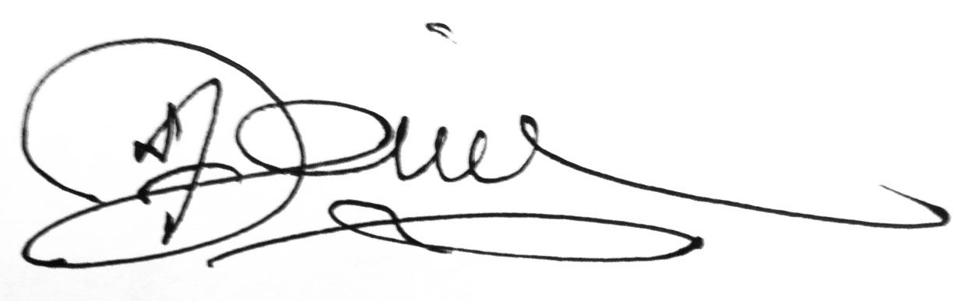  10-30-18
Academic Dean Name | Justin Vazquez-Poritz
Academic Dean Signature and Date | 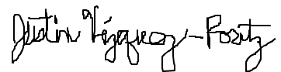 10/30/18
Brief Description of Proposal  (Describe the modifications contained within this proposal in a succinct summary. More detailed content will be provided in the proposal body. | The proposal includes two changes:  1. A change of course title from “Survey of Art History” to “Introduction to the History of Art”  2. A change of course catalog description for ARTH 1103, from “An introduction to art and architecture from ancient Egypt to modern times. Classes sometimes meet at a New York City museum.” to “An introduction to art and architecture from ancient to modern times. The art of Western and Eastern cultures is considered.”
Brief Rationale for Proposal  (Provide a concise summary of why this proposed change is important to the department. More detailed content will be provided in the proposal body). | 1. To clarify that the course is taught on an introductory level. The title “Introduction to the History of Art” is more commonly used for the equivalent of this course in colleges throughout the U. S. This is to conform to the more accurate, current, standard, and traditional title for this course.  2. To emphasize that the coverage of this course includes both Western and Eastern arts.
Proposal History  (Please provide history of this proposal: is this a resubmission? An updated version? This may most easily be expressed as a list). | This is the first submission of this proposal.

Please include all appropriate documentation as indicated in the Curriculum Modification Checklist.

For each new course, please also complete the New Course Proposal and submit in this document.

Please submit this document as a single .doc or .rtf format. If some documents are unable to be converted to .doc, then please provide all documents archived into a single .zip file.
ALL PROPOSAL CHECK LIST
Completed CURRICULUM MODIFICATION FORM including:
- Brief description of proposal | x
- Rationale for proposal | x
- Date of department meeting approving the modification | x
- Chair’s Signature | x
- Dean’s Signature | x
Evidence of consultation with affected departments
List of the programs that use this course as required or elective, and courses that use this as a prerequisite.
Documentation of Advisory Commission views (if applicable).
Completed Chancellor’s Report Form. | x

EXISTING PROGRAM MODIFICATION PROPOSALS

Documentation indicating core curriculum requirements have been met for new programs/options or program changes.
Detailed rationale for each modification (this includes minor modifications)

CHANCELLOR’S REPORT FORM

Section AV: Changes in Existing Courses

AV.1. HUMANITIES

Existing Course Number and Course Title
ARTH1103 Survey of Art History

From: |  | To:
Course Number | ARTH1103 | Course Number | ARTH1103
Course Title | Survey of Art History | Course Title | Introduction to the History of Art
Description | An introduction to art and architecture from ancient Egypt to modern times. Classes sometimes meet at a New York City museum. | Description | An introduction to art and architecture from ancient to modern times. The art of Western and Eastern cultures is considered.
Credits | 3 credits | Credits | 3 Credits
Lab Hours |  | Lab Hours
Prerequisite: | CUNY Proficiency in Reading and Writing | Prerequisite: | CUNY Proficiency in Reading and Writing
Corequisite: |  | Corequisite:
Pre/Corequisite: |  | Pre/Corequisite:

Rationale: 1. To clarify that the course is taught on an introductory level. The title “Introduction to the History of Art” is more commonly used for the equivalent of this course in colleges throughout the U. S. This is to conform to the more accurate, current, standard, and traditional title for this course. 2. To emphasize that the coverage of this course includes both Western and Eastern arts.

