New York City College of Technology, CUNY
CURRICULUM MODIFICATION PROPOSAL FORM
This form is used for all curriculum modification proposals. See the Proposal Classification Chart for information about what types of modifications are major or minor. Completed proposals should be emailed to the Curriculum Committee chair.

Title of Proposal | Modification of Course Catalog Description for ARTH 1102
Date | 9/27/2018
Major or Minor | Minor
Proposer’s Name | Michael McAuliffe
Department | Humanities
Date of Departmental Meeting in which proposal was approved | 10/4/2018
Department Chair Name | Ann Delilkan
Department Chair Signature and Date | 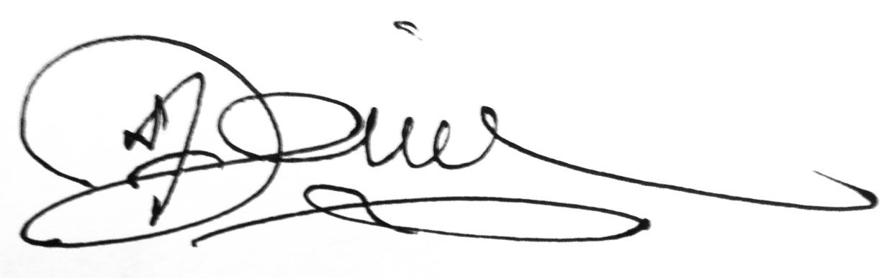10-30-18
Academic Dean Name | Justin Vazquez-Poritz
Academic Dean Signature and Date | 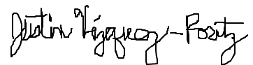 10/30/18
Brief Description of Proposal  (Describe the modifications contained within this proposal in a succinct summary. More detailed content will be provided in the proposal body. | The proposal includes two changes:  1. A change of course title from “History of Art: Renaissance to Modern” to “History of Western Art: Renaissance to Modern.”  2. A change of course catalog description for ARTH 1102, from “Art from the Renaissance to Impressionism” to “An introduction to Western painting, sculpture, and architecture from the Renaissance to the modern period.”
Brief Rationale for Proposal  (Provide a concise summary of why this proposed change is important to the department. More detailed content will be provided in the proposal body). | The revision has two intentions:  1. To add “Western” to the course name to make it “History of Western Art.” This is to reflect the awareness that Western art shouldn’t be presented as the assumed or preeminent art tradition. It is also in line with the specificity of non-Western courses such as Art of Asia (ARTH 1108) and Islamic Art (ARTH 1110). Finally, this distinction is recognized among recent art history textbooks such as Gardner’s Art through the Ages: The Western Perspective, Volume II (15th Edition, Cengage Learning, 2016).  2. To reflect the parameters indicated in the course subtitle “Renaissance to Modern.”
Proposal History  (Please provide history of this proposal: is this a resubmission? An updated version? This may most easily be expressed as a list). | This is the first submission of this proposal.

Please include all appropriate documentation as indicated in the Curriculum Modification Checklist.

For each new course, please also complete the New Course Proposal and submit in this document.

Please submit this document as a single .doc or .rtf format. If some documents are unable to be converted to .doc, then please provide all documents archived into a single .zip file.
ALL PROPOSAL CHECK LIST
Completed CURRICULUM MODIFICATION FORM including:
- Brief description of proposal | x
- Rationale for proposal | x
- Date of department meeting approving the modification | x
- Chair’s Signature | x
- Dean’s Signature | x
Evidence of consultation with affected departments
List of the programs that use this course as required or elective, and courses that use this as a prerequisite.
Documentation of Advisory Commission views (if applicable).
Completed Chancellor’s Report Form. | x

EXISTING PROGRAM MODIFICATION PROPOSALS

Documentation indicating core curriculum requirements have been met for new programs/options or program changes.
Detailed rationale for each modification (this includes minor modifications)

CHANCELLOR’S REPORT FORM

Section AV: Changes in Existing Courses

AV.1. HUMANITIES

Existing Course Number and Course Title
ARTH1102 History of Art: Renaissance to Modern

From: |  | To:
Course Number | ARTH1102 | Course Number | ARTH1102
Course Title | History of Art: Renaissance to Modern | Course Title | History of Western Art: Renaissance to Modern
Description | Art from the Renaissance to Impressionism. | Description | An introduction to Western painting, sculpture, and architecture from the Renaissance to the modern period.
Credits | 3 credits | Credits | 3 Credits
Lab Hours |  | Lab Hours
Prerequisite: | CUNY Proficiency in Reading and Writing | Prerequisite: | CUNY Proficiency in Reading and Writing
Corequisite: |  | Corequisite:
Pre/Corequisite: |  | Pre/Corequisite:

Rationale: 1. To add “Western” to the course name to make it “History of Western Art.” This is to reflect the awareness that Western art shouldn’t be presented as the assumed or preeminent art tradition. It is also in line with the specificity of non-Western courses such as Art of Asia (ARTH 1108) and Islamic Art (ARTH 1110). Finally, this distinction is recognized among recent art history textbooks such as Gardner’s Art through the Ages: The Western Perspective, Volume II (15th Edition, Cengage Learning, 2016). 2. To reflect the parameters indicated in the course subtitle “Renaissance to Modern.”

