New York City College of Technology, CUNY
CURRICULUM MODIFICATION PROPOSAL FORM
This form is used for all curriculum modification proposals. See the Proposal Classification Chart for information about what types of modifications are major or minor. Completed proposals should be emailed to the Curriculum Committee chair.

Title of Proposal | Modification of Course Catalog Description for ARTH 1101
Date | 9/27/2018
Major or Minor | Minor
Proposer’s Name | Cathy Santore
Department | Humanities
Date of Departmental Meeting in which proposal was approved | 10/4/2018
Department Chair Name | Ann Delilkan
Department Chair Signature and Date | 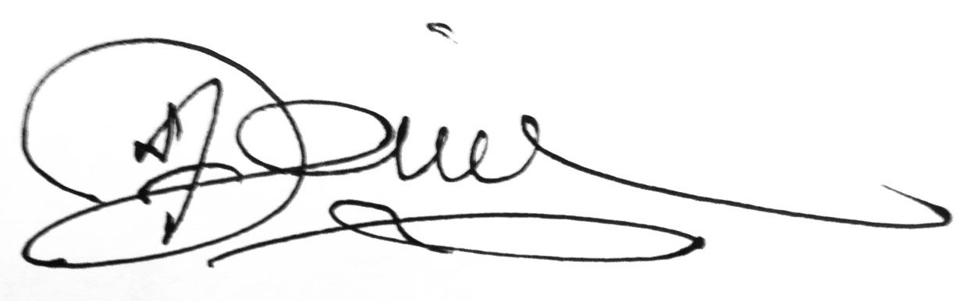10-30-18
Academic Dean Name | Justin Vazquez-Poritz
Academic Dean Signature and Date | 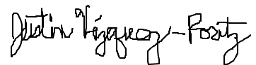 10/30/18
Brief Description of Proposal  (Describe the modifications contained within this proposal in a succinct summary. More detailed content will be provided in the proposal body. | Change of course catalog description for “ARTH1101: History of Art: Prehistoric to Gothic”, from “Art from prehistoric time to the 14th century. Illustrated lectures and discussions (including architecture, sculpture and painting).” to “Art and architecture from prehistory to the 14th century is examined in the context of the culture in which it was produced. Monuments from both Middle Eastern and Western civilizations are considered.”
Brief Rationale for Proposal  (Provide a concise summary of why this proposed change is important to the department. More detailed content will be provided in the proposal body). | To replace with a more accurate description of the breadth of the material covered. The inclusion of the cultural context in which the art was created enriches the historic perspective beyond the formalist approach to teaching that limits exposition to evolution of style and artistic innovation.
Proposal History  (Please provide history of this proposal: is this a resubmission? An updated version? This may most easily be expressed as a list). | This is the first submission of this proposal.

Please include all appropriate documentation as indicated in the Curriculum Modification Checklist.
For each new course, please also complete the New Course Proposal and submit in this document.

Please submit this document as a single .doc or .rtf format. If some documents are unable to be converted to .doc, then please provide all documents archived into a single .zip file.
ALL PROPOSAL CHECK LIST
Completed CURRICULUM MODIFICATION FORM including:
- Brief description of proposal | x
- Rationale for proposal | x
- Date of department meeting approving the modification | x
- Chair’s Signature | x
- Dean’s Signature | x
Evidence of consultation with affected departments
List of the programs that use this course as required or elective, and courses that use this as a prerequisite.
Documentation of Advisory Commission views (if applicable).
Completed Chancellor’s Report Form. | x

EXISTING PROGRAM MODIFICATION PROPOSALS

Documentation indicating core curriculum requirements have been met for new programs/options or program changes.
Detailed rationale for each modification (this includes minor modifications)

CHANCELLOR’S REPORT FORM

Section AV: Changes in Existing Courses

AV.1. HUMANITIES

Existing Course Number and Course Title
ARTH1101 History of Art: Prehistoric to Gothic

From: |  | To:
Course Number | ARTH1101 | Course Number | ARTH1101
Course Title | History of Art: Prehistoric to Gothic |  | History of Art: Prehistoric to Gothic
Description | Art from prehistoric time to the 14th century. Illustrated lectures and discussions (including architecture, sculpture and painting). | Description | Art and architecture from prehistory to the 14th century is examined in the context of the culture in which it was produced. Monuments from both Middle Eastern and Western civilizations are considered.
Credits | 3 credits | Credits | 3 Credits
Lab Hours |  | Lab Hours
Prerequisite: | CUNY Proficiency in Reading and Writing | Prerequisite: | CUNY Proficiency in Reading and Writing
Corequisite: |  | Corequisite:
Pre/Corequisite: |  | Pre/Corequisite:

Rationale: To replace with a more accurate description of the breadth of the material covered. The inclusion of the cultural context in which the art was created enriches the historic perspective beyond the formalist approach to teaching that limits exposition to evolution of style and artistic innovation.

