MINOR Curriculum Modification Proposal (11-19-14)

Update Prerequisite for BUS 2339

Submitted on behalf of the Department of Business

Anne Zissu, Chairperson Lucas Bernard, Assistant Professor

FALL 2014

TABLE OF CONTENTS

Submission Notes 1
Curriculum Modification Proposal Form 2
Chancellor’s Report Form 4
Email from the Chairman of the Department of Mathematics 5

NOTES:

- This is a technical update made at the request of the Registrar.
- A unanimous departmental vote in favor of this modification was determined on November 18th, 2014.
- BUS 2339 is the prerequisite to BUS 2341, but not to any other courses.
- BUS 2339 and BUS 2341 are typically taken only by Business Department students in fulfillment of their course requirements. No other department requires them.

New York City College of Technology, CUNY
CURRICULUM MODIFICATION PROPOSAL FORM
This form is used for all curriculum modification proposals. See the Proposal Classification Chart for information about what types of modifications are major or minor. Completed proposals should be emailed to the Curriculum Committee chair.

Title of Proposal | Update Prerequisite for BUS 2339
Date | 11/19/14
Major or Minor | Minor
Proposer’s Name | Anne Zissu
Department | Business
Date of Departmental Meeting in which proposal was approved | N/A
Department Chair Name | Anne Zissu
Department Chair Signature and Date | 11/19/14
Academic Dean Name | David Smith
Academic Dean Signature and Date | 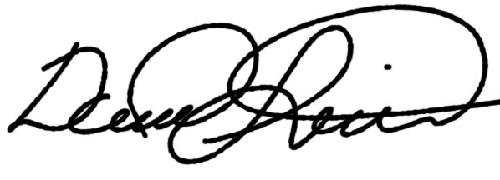 11/21/2014
Brief Description of Proposal  (Describe the modifications contained within this proposal in a succinct summary. More detailed content will be provided in the proposal body. | Technical update: change the prerequisite for BUS 2339 to: “MAT 1190 or higher OR Eligibility for MAT 1275” – at request of Registrar.
Brief Rationale for Proposal  (Provide a concise summary of why this proposed change is important to the department. More detailed content will be provided in the proposal body). | Math requirements have changed for Fashion Marketing & Marketing students; the prerequisites must also be changed to allow students to register.
Proposal History  (Please provide history of this proposal: is this a resubmission? An updated version? This may most easily be expressed as a list). | Initial submission

ALL PROPOSAL CHECK LIST
Completed CURRICULUM MODIFICATION FORM including:
- Brief description of proposal | √
- Rationale for proposal | √
- Date of department meeting approving the modification | √
- Chair’s Signature | √
- Dean’s Signature | √
Evidence of consultation with affected departments  List of the programs that use this course as required or elective, and courses that use this as a prerequisite. | √  √
Documentation of Advisory Commission views (if applicable). | N/A
Completed Chancellor’s Report Form. | √

EXISTING PROGRAM MODIFICATION PROPOSALS

Documentation indicating core curriculum requirements have been met for new programs/options or program changes. | N/A
Detailed rationale for each modification (this includes minor modifications) | N/A

Chancellor’s Report Information

Business Department

BUS 2339: Financial Management
From: |  | To:
Prerequisite: | Eligibility for MAT 1275  or higher | Prerequisite: | MAT 1190 or higher OR Eligibility for MAT 1275
Corequisites: |  | Corequisites:
Pre- or corequisites: |  | Pre- or corequisites:

Rationale: Math requirements have changed for Fashion Marketing & Marketing students; the prerequisites must also be changed to allow students to register.

