**CURRICULUM MODIFICATION PROPOSAL**

**New York City College of Technology, CUNY**

**Title: Curriculum Modification – CET4811 - Capstone Design Project**

By

F. Zia and Y. Wang

**Department of Computer Engineering Technology**

186 Jay Street, V-633, Brooklyn, NY 11201

Phone: (718) 260-5885

**Table of Contents**

CURRICULUM MODIFICATION PROPOSAL FORM 2

ALL PROPOSAL CHECK LIST 3

Section AV: Changes in Existing Courses 4

Section AV: Changes in Existing Courses 5

ABET Criteria 6

Departmental Meeting Minutes 2017-09-28 8

New York City College of Technology, CUNY

### CURRICULUM MODIFICATION PROPOSAL FORM

about what types of modifications are major or minor. Completed proposals should be emailed to the Curriculum Committee chair.

|  |  |
| --- | --- |
| **Title of Proposal** | Curriculum Modification – CET4811 - Capstone Design Project |
| **Date** | 9/27/2017 |
| **Major or Minor** | Minor |
| **Proposer’s Name** | Farrukh Zia, Yu Wang |
| **Department** | Computer Engineering Technology |
| **Date of Departmental Meeting in which proposal was approved** | 9/28/2017 |
| **Department Chair Name** | Sunghoon Jang |
| **Department Chair Signature and Date** |  |
| **Academic Dean Name** | Kevin Hom |
| **Academic Dean Signature and Date** | 10-31-17 |
| **Brief Description of Proposal**  (Describe the modifications contained within this proposal in a succinct summary. More detailed content will be provided in the proposal body. | - Modify CET 4811 course name from  “Computer-Controlled Systems Design II” to  “Capstone Design Project”.  - Modify CET 4711 course name from  “Computer-Controlled Systems Design I” to  “Computer Controlled System Design” |
| **Brief Rationale for Proposal**  (Provide a concise summary of why this proposed change is important to the department. More detailed content will be provided in the proposal body). | ABET requires Capstone/Senior Design course (ABET/ETAC 2016-2017 Accreditation Criteria, page 4) for B.Tech degree.  The proposed change of course name will allow Computer Engineering Technology B.Tech program to comply with the ABET requirement. |
| **Proposal History**  (Please provide history of this proposal: is this a resubmission? An updated version? This may most easily be expressed as a list). | 10/25/2017 – New submission |

Please include all appropriate documentation as indicated in the Curriculum Modification Checklist.

For each new course, please also complete the New Course Proposal and submit in this document.

Please submit this document as a single .doc or .rtf format. If some documents are unable to be converted to .doc, then please provide all documents archived into a single .zip file.

### ALL PROPOSAL CHECK LIST

|  |  |
| --- | --- |
| Completed CURRICULUM MODIFICATION FORM including: |  |
| * Brief description of proposal | ✓ |
| * Rationale for proposal | ✓ |
| * Date of department meeting approving the modification | ✓ |
| * Chair’s Signature |  |
| * Dean’s Signature |  |
| Evidence of consultation with affected departments  List of the programs that use this course as required or elective, and courses that use this as a prerequisite.  - CET 4811 is a required course in Computer Engineering Technology B.Tech program only.  - CET 4811 is not a prerequisite for any other course. | ✓ |
| Documentation of Advisory Commission views (if applicable). | N/A |
| Completed [Chancellor’s Report Form](http://openlab.citytech.cuny.edu/collegecouncil/files/2014/08/2013-10-09-Chancellor_Report_Quick_Reference_Guide1.doc). | ✓ |

**EXISTING PROGRAM MODIFICATION PROPOSALS**

|  |  |
| --- | --- |
| Documentation indicating core curriculum requirements have been met for new programs/options or program changes. | N/A |
| Detailed rationale for each modification (this includes minor modifications)  ABET requires Capstone/Senior Design course (ABET/ETAC 2016-2017 Accreditation Criteria, page 4) for B.Tech degree. The proposed change of course name will allow Computer Engineering Technology B.Tech program to comply with the ABET requirement. | ✓ |

### Section AV: Changes in Existing Courses

**Changes to be offered in the Computer Engineering Technology department**

**CET4811 - Capstone Design Project**

|  |  |  |  |
| --- | --- | --- | --- |
| **CUNYFirst Course ID** | 037661 |  |  |
| **FROM:** |  | **TO:** |  |
| **Department(s)** |  | **Department(s)** |  |
| **Course** | ~~CET4811 – Computer- Controlled Systems Design II~~ | **Course** | CET4811 - Capstone Design Project |
| **Prerequisite** |  | **Prerequisite** |  |
| **Corequisite** |  | **Corequisite** |  |
| **Pre- or corequisite** |  | **Pre- or corequisite** |  |
| **Hours** |  | **Hours** |  |
| **Credits** |  | **Credits** |  |
| **Description** |  | **Description** |  |
| **Requirement Designation** |  | **Requirement Designation** |  |
| **Liberal Arts** | [ ] Yes [ ] No | **Liberal Arts** | [ ] Yes [ ] No |
| **Course Attribute (e.g. Writing Intensive, Honors, etc** |  | **Course Attribute (e.g. Writing Intensive, Honors, etc** |  |
| **Course Applicability** | |  | | --- | | [ ] Major | | [ ] Gen Ed Required | | [ ] English Composition | | [ ] Mathematics | | [ ] Science | | [ ] Gen Ed - Flexible | | [ ] World Cultures | | [ ] US Experience in its Diversity | | [ ] Creative Expression | | [ ] Individual and Society | | [ ] Scientific World | | [ ] Gen Ed - College Option | | [ ] Speech | | [ ] Interdisciplinary | | [ ] Advanced Liberal Arts | | **Course Applicability** | |  | | --- | | [ ] Major | | [ ] Gen Ed Required | | [ ] English Composition | | [ ] Mathematics | | [ ] Science | | [ ] Gen Ed - Flexible | | [ ] World Cultures | | [ ] US Experience in its Diversity | | [ ] Creative Expression | | [ ] Individual and Society | | [ ] Scientific World | | [ ] Gen Ed - College Option | | [ ] Speech | | [ ] Interdisciplinary | | [ ] Advanced Liberal Arts | |
| **Effective Term** | Fall 2018 |  |  |

Rationale: ABET requires Capstone/Senior Design course (ABET/ETAC 2016-2017 Accreditation Criteria, page 4) for B.Tech degree. The proposed change of course name will allow Computer Engineering Technology B.Tech program to comply with the ABET requirement.

### Section AV: Changes in Existing Courses

**Changes to be offered in the Computer Engineering Technology department**

**CET4711 - Computer Controlled System Design**

|  |  |  |  |
| --- | --- | --- | --- |
| **CUNYFirst Course ID** | 037656 |  |  |
| **FROM:** |  | **TO:** |  |
| **Department(s)** |  | **Department(s)** |  |
| **Course** | ~~CET4711 – Computer- Controlled Systems Design I~~ | **Course** | CET4711 - Computer Controlled System Design |
| **Prerequisite** |  | **Prerequisite** |  |
| **Corequisite** |  | **Corequisite** |  |
| **Pre- or corequisite** |  | **Pre- or corequisite** |  |
| **Hours** |  | **Hours** |  |
| **Credits** |  | **Credits** |  |
| **Description** |  | **Description** |  |
| **Requirement Designation** |  | **Requirement Designation** |  |
| **Liberal Arts** | [ ] Yes [ ] No | **Liberal Arts** | [ ] Yes [ ] No |
| **Course Attribute (e.g. Writing Intensive, Honors, etc** |  | **Course Attribute (e.g. Writing Intensive, Honors, etc** |  |
| **Course Applicability** | |  | | --- | | [ ] Major | | [ ] Gen Ed Required | | [ ] English Composition | | [ ] Mathematics | | [ ] Science | | [ ] Gen Ed - Flexible | | [ ] World Cultures | | [ ] US Experience in its Diversity | | [ ] Creative Expression | | [ ] Individual and Society | | [ ] Scientific World | | [ ] Gen Ed - College Option | | [ ] Speech | | [ ] Interdisciplinary | | [ ] Advanced Liberal Arts | | **Course Applicability** | |  | | --- | | [ ] Major | | [ ] Gen Ed Required | | [ ] English Composition | | [ ] Mathematics | | [ ] Science | | [ ] Gen Ed - Flexible | | [ ] World Cultures | | [ ] US Experience in its Diversity | | [ ] Creative Expression | | [ ] Individual and Society | | [ ] Scientific World | | [ ] Gen Ed - College Option | | [ ] Speech | | [ ] Interdisciplinary | | [ ] Advanced Liberal Arts | |
| **Effective Term** | Fall 2018 |  |  |

Rationale: Modify CET 4711 course name from “Computer-Controlled Systems Design I” to “Computer Controlled System Design”, since CET 4811 course name is proposed to be changed from “Computer-Controlled Systems Design II” to “Capstone Design Project”.

### ABET Criteria

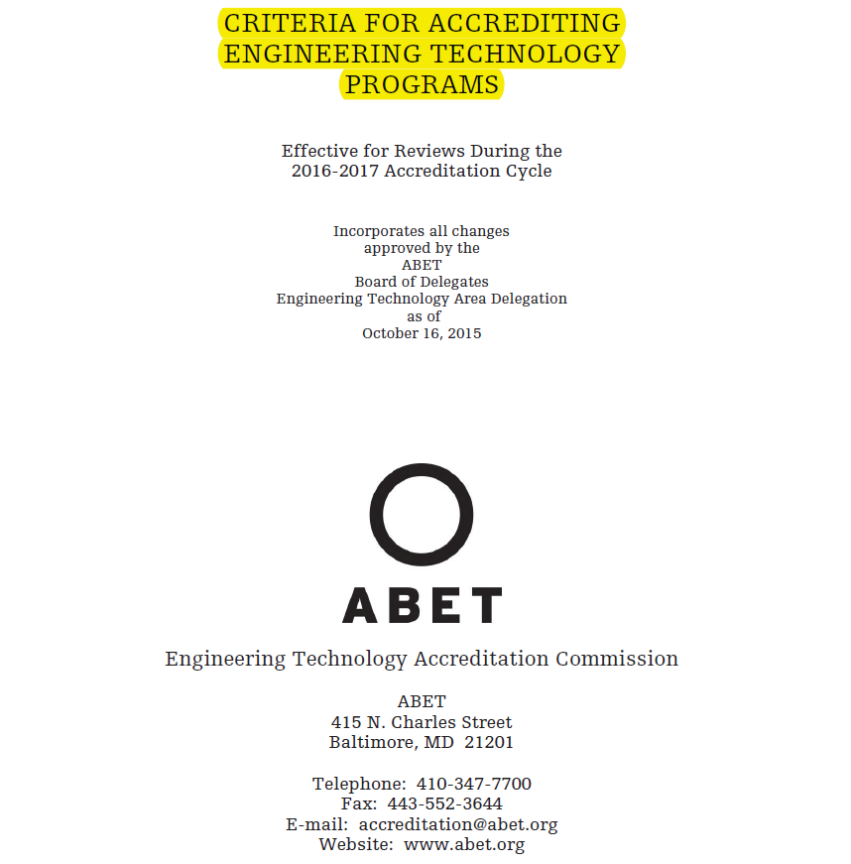

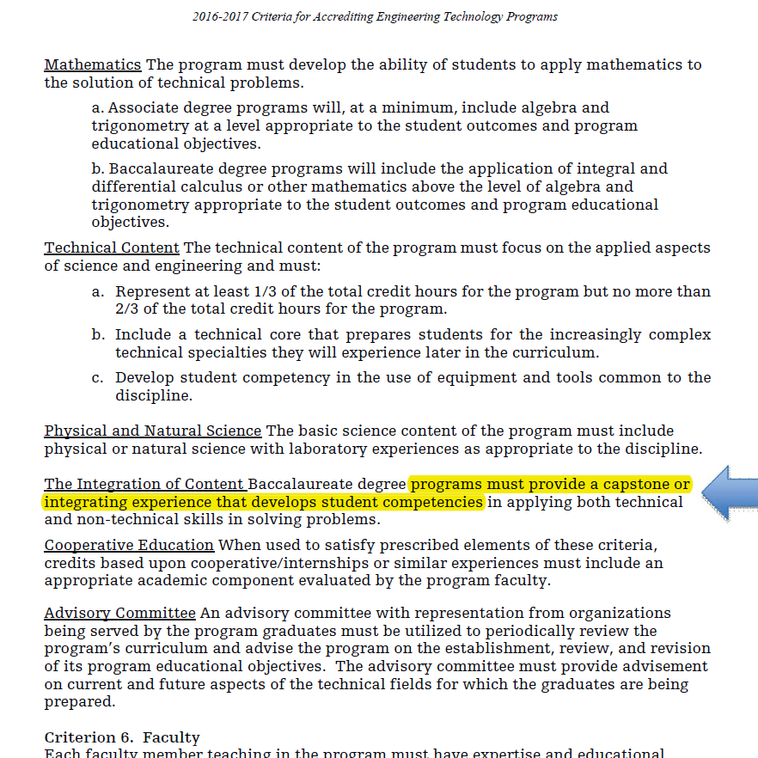

### Departmental Meeting Minutes 2017-09-28

