New York City College of Technology, CUNY

CURRICULUM MODIFICATION PROPOSAL FORM

This form is used for all curriculum modification proposals. See the [Proposal Classification Chart](http://openlab.citytech.cuny.edu/collegecouncil/files/2014/08/2013-10-09-Proposal_Classification_Chart.pdf) for information about what types of modifications are major or minor. Completed proposals should be emailed to the Curriculum Committee chair.

|  |  |
| --- | --- |
| **Title of Proposal** | **Restorative Dentistry Program Curriculum Change** |
| **Date** | **October 19, 2017** |
| **Major or Minor** | **Minor** |
| **Proposer’s Name** | **Renata Budny** |
| **Department** | **Restorative Dentistry** |
| **Date of Departmental Meeting in which proposal was approved** | **2017 10 17** |
| **Department Chair Name** | **Prof. Renata Budny** |
| **Department Chair Signature and Date** | 2017%20eSignature%203 **2017 10 19** |
| **Academic Dean Name** | **Dean David B Smith** |
| **Academic Dean Signature and Date** | **2017-10-26** |
| **Brief Description of Proposal**  (Describe the modifications contained within this proposal in a succinct summary. More detailed content will be provided in the proposal body. | Changing General Education Required Math |
| **Brief Rationale for Proposal**  (Provide a concise summary of why this proposed change is important to the department. More detailed content will be provided in the proposal body). | As the College is retiring MAT 1180, Restorative Dentistry Department decided to change MAT 1180, 4 credit course, to MAT 1275/1275EN, 4 credit course. MAT 1275/1275EN is better aligned with the quantitative reasoning requirements of our degree program, and anticipates our exploration of a baccalaureate level degree.    This minor change will allow Restorative Dentistry to comply with College General Education requirements and raise Commission on Dental Accreditation (CODA) and Dental Laboratory Technology professional standards.  MAT 1275/1275EN will increase the math skills of Restorative Dentistry graduates and meet the demands of a constantly-changing dental technology profession. |
| **Proposal History**  (Please provide history of this proposal: is this a resubmission? An updated version? This may most easily be expressed as a list). | **2017-10-19 First Submission** |

Please include all appropriate documentation as indicated in the Curriculum Modification Checklist.

For each new course, please also complete the New Course Proposal and submit in this document.

Please submit this document as a single .doc or .rtf format. If some documents are unable to be converted to .doc, then please provide all documents archived into a single .zip file.

**ALL PROPOSAL CHECK LIST**

|  |  |
| --- | --- |
| Completed CURRICULUM MODIFICATION FORM including: |  |
| * Brief description of proposal | V |
| * Rationale for proposal | V |
| * Date of department meeting approving the modification | V |
| * Chair’s Signature | V |
| * Dean’s Signature | V |
| Evidence of consultation with affected departments  List of the programs that use this course as required or elective, and courses that use this as a prerequisite. | V |
| Documentation of Advisory Commission views (if applicable). |  |
| Completed [Chancellor’s Report Form](http://openlab.citytech.cuny.edu/collegecouncil/files/2014/08/2013-10-09-Chancellor_Report_Quick_Reference_Guide1.doc). |  |

**EXISTING PROGRAM MODIFICATION PROPOSALS**

|  |  |
| --- | --- |
| Documentation indicating core curriculum requirements have been met for new programs/options or program changes. | V |
| Detailed rationale for each modification (this includes minor modifications) | V |

Restorative Dentistry Degree Checklist shows all courses necessary to complete A.A.S. in Dental Laboratory Technology. The Checklist includes MAT 1180, 4 credit course, which when replaced with RESD 1275/1275EN, also 4 credit course will allow for General Education Required and Flexible Common Core to stay at 20 Credits. This proposal its even credit exchange between math courses.

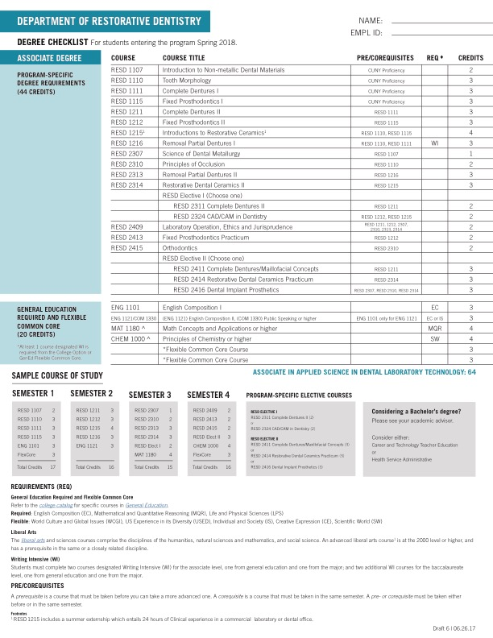

**CHANCELLOR’S REPORT FORM**

**Section AIII: Changes in Degree Programs**

**The following revisions are proposed for Associate in Applied Sciences in Dental Laboratory Technology**

**Program: Restorative Dentistry**

**Program Code: RESD**

**Effective: Spring 2018**

**Modifying the Mathematical and Quantitative Reasoning math requirement for the Restorative Dentistry Program.**

|  |  |
| --- | --- |
| **FROM:** | **TO:** |
| **General Education Common Core 20 CREDITS**  **I – Required Core (3 or 4 COURSES, 11-14 CREDITS)**  **English Composition (1 or 2 courses, 3 or 6 credits)**  ENG 1101 English Composition I 3  ENG 1121 English Composition II1  [3]  **Mathematical and Quantitative Reasoning (1 course~~, 3~~-4 credits)**  ~~Select one of the following courses~~  ~~MAT 1190 Quantitative Reasoning~~~~2~~ ~~3~~  ~~MAT 1180 Math Concepts and Applications 4~~  MAT 1275 College Algebra and Trigonometry 4  ~~or higher~~~~3~~  **Life and Physical Sciences (1 course, 4 credits)**  CHEM 1000 Principles of Chemistry or higher 4  **II - FLEXIBLE CORE (2 OR 3 COURSES, 6 OR 9 CREDITS)**  One course from each of any two groups, plus COM 1330 or higher if ENG 1121 is not taken 6  **World Cultures and Global Issues**  **US Experience in its Diversity**  **Individual and Society**  COM 1330 Public Speaking  or higher1  3    **Creative Expression**  **Scientific World**  **PROGRAM-SPECIFIC DEGREE REQUIREMENTS (44 CREDITS)**  RESD 1107 Introduction to Non-metallic Dental Materials 2  RESD 1110 Tooth Morphology 3  RESD 1111 Complete Dentures I 3  RESD 1115 Fixed Prosthodontics I 3  RESD 1211 Complete Dentures II 3  RESD 1212 Fixed Prosthodontics II 3  RESD 1215 Introduction to Restorative Ceramics 4  RESD 1216 Removable Partial Dentures I 3  RESD 2307 Science of Dental Metallurgy 1  RESD 2310 Principles of Occlusion 2  RESD 2313 Removable Partial Dentures II 3  RESD 2314 Restorative Dental Ceramics II 3  RESD 2409 Laboratory Operation, Ethics and Jurisprudence 2  RESD 2413 Fixed Prosthodontics Practicum 2  RESD 2415 Orthodontics 2  Select one of the following two courses for 2 credits:  RESD 2311 Complete Dentures III  or  RESD 2324 CAD/CAM in Dentistry 2  Select one of the following courses for 3 credits:  RESD 2411 Complete Dentures/Maxillofacial Concepts  or  RESD 2414 Restorative Dental Ceramics Practicum  or  RESD 2416 Dental Implant Prosthetics 3  TOTAL PROGRAM-SPECIFIC REQUIRED AND ELECTIVE COURSES 44  TOTAL GENERAL EDUCATION CREDITS 20  TOTAL CREDITS REQUIRED FOR THE DEGREE 64  1 Students must select either ENG 1121 or COM 1330 or higher; if ENG 1121 is taken, all approved Individual and Society courses are eligible to fulfil a Flexible Core requirement.  ~~2 Students who take MAT 1190 will need one additional general education credit to meet the required 20 credits in liberal arts and sciences. This may be done by taking a 4-credit science or math course or an additional general education course (which will increase the number of required credits for the degree by 2 credits).~~  ~~3 Students who elect to take MAT 1275 but who lack the requisite math background will be required to take MAT 1175 in preparation. This will increase the number of required credits for the degree by 4 credits.~~ | **General Education Common Core 20 CREDITS**  **I – Required Core (3 or 4 COURSES, 11-14 CREDITS)**  **English Composition (1 or 2 courses, 3 or 6 credits)**  ENG 1101 English Composition I 3  ENG 1121 English Composition II1  [3]  **Mathematical and Quantitative Reasoning (1 course, 4 credits)**  MAT 1275/1275EN College Algebra and Trigonometry 4  or higher2  **Life and Physical Sciences (1 course, 4 credits)**  CHEM 1000 Principles of Chemistry or higher 4  **II - FLEXIBLE CORE (2 OR 3 COURSES, 6 OR 9 CREDITS)**  One course from each of any two groups, plus COM 1330 or higher if ENG 1121 is not taken 6  **World Cultures and Global Issues**  **US Experience in its Diversity**  **Individual and Society**  COM 1330 Public Speaking  or higher1  3    **Creative Expression**  **Scientific World**  **PROGRAM-SPECIFIC DEGREE REQUIREMENTS (44 CREDITS)**  RESD 1107 Introduction to Non-metallic Dental Materials 2  RESD 1110 Tooth Morphology 3  RESD 1111 Complete Dentures I 3  RESD 1115 Fixed Prosthodontics I 3  RESD 1211 Complete Dentures II 3  RESD 1212 Fixed Prosthodontics II 3  RESD 1215 Introduction to Restorative Ceramics 4  RESD 1216 Removable Partial Dentures I 3  RESD 2307 Science of Dental Metallurgy 1  RESD 2310 Principles of Occlusion 2  RESD 2313 Removable Partial Dentures II 3  RESD 2314 Restorative Dental Ceramics II 3  RESD 2409 Laboratory Operation, Ethics and Jurisprudence 2  RESD 2413 Fixed Prosthodontics Practicum 2  RESD 2415 Orthodontics 2  Select one of the following two courses for 2 credits:  RESD 2311 Complete Dentures III  or  RESD 2324 CAD/CAM in Dentistry 2  Select one of the following courses for 3 credits:  RESD 2411 Complete Dentures/Maxillofacial Concepts  or  RESD 2414 Restorative Dental Ceramics Practicum  or  RESD 2416 Dental Implant Prosthetics 3  TOTAL PROGRAM-SPECIFIC REQUIRED AND ELECTIVE COURSES 44  TOTAL GENERAL EDUCATION CREDITS 20  TOTAL CREDITS REQUIRED FOR THE DEGREE 64  1 Students must select either ENG 1121 or COM 1330 or higher; if ENG 1121 is taken, all approved Individual and Society courses are eligible to fulfil a Flexible Core requirement. |