New York City College of Technology, CUNY
CURRICULUM MODIFICATION PROPOSAL FORM
This form is used for all curriculum modification proposals. See the Proposal Classification Chart for information about what types of modifications are major or minor. Completed proposals should be emailed to the Curriculum Committee chair.

Title of Proposal | New Course Proposal:  SOC 2380: Sociology of Education
Date | 10/3/2017
Major or Minor | Major
Proposer’s Name | Diana Mincyte
Department | Social Science
Date of Departmental Meeting in which proposal was approved | 10/5/17
Department Chair Name | Peter Parides
Department Chair Signature and Date | 10/5/17
Academic Dean Name | Justin Vazquez-Poritz
Academic Dean Signature and Date | 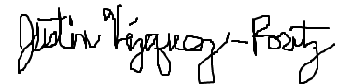10/11/17
Brief Description of Proposal | A new Liberal Arts course that will serve as both a General Education course and a requirement for NYSED certificate programs in the CTTE Department.
Brief Rationale for Proposal  (Provide a concise summary of why this proposed change is important to the department. More detailed content will be provided in the proposal body). | This course will serve as both a General Education course and as a NYSED requirement for the initial certification and the professional certification programs for which CTTE is applying through the state. NYSED states the course should address the history, philosophy, and role of education; the rights and responsibilities of teachers and other professional staff, students, parents, community members, school administrators, and others with regard to education; and the importance of productive relationships and interactions among the school, home, and community. SOC 2380 meets these requirements.
Proposal History  (Please provide history of this proposal: is this a resubmission? An updated version? This may most easily be expressed as a list). | Initial submission

ALL PROPOSAL CHECK LIST
Completed CURRICULUM MODIFICATION FORM including:
- Brief description of proposal | X
- Rationale for proposal | X
- Date of department meeting approving the modification | X
- Chair’s Signature | X
- Dean’s Signature | X
Evidence of consultation with affected departments  List of the programs that use this course as required or elective, and courses that use this as a prerequisite. | N/A
Documentation of Advisory Commission views (if applicable). | N/A
Completed Chancellor’s Report Form. | X

EXISTING PROGRAM MODIFICATION PROPOSALS
Documentation indicating core curriculum requirements have been met for new programs/options or program changes. | N/A
Detailed rationale for each modification (this includes minor modifications) | X

TABLE OF CONTENTS

New Course Proposal Form ………………………. 5-6

Chancellor’s Report………………………………...7-8

New Course Proposal Check List…………………9-10

Course Need Assessment and Design……………….11

Course Outline…………………………………...12-18

Library Resources Form……………………..…..19-20

Common Core Course Submission Form………..21-25

Email from NYSED……………………………...26-30

Email Confirming Prerequisites…………………..…31

Explanation of Recent Revisions………………...….32

New York City College of Technology, CUNY
NEW COURSE PROPOSAL FORM
Course Title | Sociology of Education
Proposal Date | 10/3/17
Proposer’s Name | Diana Mincyte
Course Number | SOC 2380
Course Credits, Hours | 3
Course Pre / Co-Requisites | Any 1000-level SOC course or PSY 1101
Catalog Course Description | Examines the social influences on education and the effects of education and schooling on the social experiences and identities of individuals and groups in contemporary society. Focus is on the history, philosophy and the role of education as well as the responsibilities of teachers, school administrators and other professional staff, students, parents, and community members with regard to education. Emphasizes the importance of productive relationships and interactions among the school, home, and community.
Brief Rationale  Provide a concise summary of why this course is important to the department, school or college. | This course will serve as both a General Education course and as a NYSED requirement for the initial certification and the professional certification programs for which CTTE is applying through the state. NYSED states the course should address the history, philosophy, and role of education; the rights and responsibilities of teachers and other professional staff, students, parents, community members, school administrators, and others with regard to education; and the importance of productive relationships and interactions among the school, home, and community. SOC 2380 meets these requirements.
Intent to Submit as Common Core  If this course is intended to fulfill one of the requirements in the common core, then indicate which area. | Yes, Individual and Society
Intent to Submit as an Interdisciplinary Course | Not at this time
Intent to Submit as a Writing Intensive Course | Yes

CHANCELLOR’S REPORT FORM

Department(s) | Social Science
Academic Level | [ X ] Regular [ ] Compensatory [ ] Developmental  [ ] Remedial
Subject Area | Sociology
Course Prefix | SOC
Course Number | 2380
Course Title | Sociology of Education
Catalog Description | Examines the social influences on education and the effects of education and schooling on the social experiences and identities of individuals and groups in contemporary society. Focus is on the history, philosophy and the role of education as well as the responsibilities of teachers, school administrators and other professional staff, students, parents, and community members with regard to education. Emphasizes the importance of productive relationships and interactions among the school, home, and community.
Prerequisite | Any 1000-level SOC course or PSY 1101
Corequisite | N/A
Pre- or co-requisite | N/A
Credits | 3
Contact Hours | 3 class hours
Liberal Arts | [ X ] Yes [ ] No
Course Attribute (e.g. Writing Intensive, etc) | Yes
Course Applicability | [X] Major  [ ] Gen Ed Required [ X ] Gen Ed - Flexible [ ] Gen Ed - College Option  [ ] English Composition [ ] World Cultures [ ] Speech  [ ] Mathematics [ ] US Experience in its Diversity [ ] Interdisciplinary  [ ] Science [ ] Creative Expression [ ] Advanced Liberal Arts  [ X ] Individual and Society  [ ] Scientific World
Effective Term | Fall 2018

Rationale: This course will serve as both a General Education course and as a NYSED requirement for the initial certification and the professional certification programs for which CTTE is applying through the state. NYSED states the course should address the history, philosophy, and role of education; the rights and responsibilities of teachers and other professional staff, students, parents, community members, school administrators, and others with regard to education; and the importance of productive relationships and interactions among the school, home, and community. SOC 2380 meets these requirements.

NEW COURSE PROPOSAL CHECK LIST
Use this checklist to ensure that all required documentation has been included. You may wish to use this checklist as a table of contents within the new course proposal.
Completed NEW COURSE PROPOSAL FORM
- Title, Number, Credits, Hours, Catalog course description | X
- Brief Rationale | X
Completed Library Resources and Information Literacy Form | X
Course Outline  Include within the outline the following. | X
Hours and Credits for Lecture and Labs  If hours exceed mandated Carnegie Hours, then rationale for this | X
Prerequisites/Co- requisites | X
Detailed Course Description | X
Course Specific Learning Outcome and Assessment Tables  - Discipline Specific  - General Education Specific Learning Outcome and Assessment Tables | X
Example Weekly Course outline | X
Grade Policy and Procedure | X
Recommended Instructional Materials (Textbooks, lab supplies, etc) | X
Library resources and bibliography | X
Course Need Assessment  Describe the need for this course. Include in your statement the following information. | X
Target Students who will take this course. Which programs or departments, and how many anticipated?  Documentation of student views (if applicable, e.g. non-required elective). | X
Projected headcounts (fall/spring and day/evening) for each new or modified course. | X
If additional physical resources are required (new space, modifications, equipment), description of these requirements. If applicable, Memo or email from the VP for Finance and Administration with written comments regarding additional and/or new facilities, renovations or construction. | N/A
Where does this course overlap with other courses, both within and outside of the department? | N/A
Does the Department currently have full time faculty qualified to teach this course? If not, then what plans are there to cover this? | X
If needs assessment states that this course is required by an accrediting body, then provide documentation indicating that need. | X
Course Design  Describe how this course is designed. | X
Course Context (e.g. required, elective, capstone) | X
Course Structure: how the course will be offered (e.g. lecture, seminar, tutorial, fieldtrip)? | X
Anticipated pedagogical strategies and instructional design (e.g. Group Work, Case Study, Team Project, Lecture) | X
How does this course support Programmatic Learning Outcomes? | X
Is this course designed to be partially or fully online? If so, describe how this benefits students and/or program. | N/A
Additional Forms for Specific Course Categories | N/A
Interdisciplinary Form (if applicable) | N/A
Common Core (Liberal Arts) Intent to Submit (if applicable) | X
Writing Intensive Form if course is intended to be a WIC (under development) | X
If course originated as an experimental course, then results of evaluation plan as developed with director of assessment. | N/A
(Additional materials for Curricular Experiments) | N/A
Plan and process for evaluation developed in consultation with the director of assessment. (Contact Director of Assessment for more information). | N/A
Established Timeline for Curricular Experiment | N/A

Course Need Assessment

This course is a requirement of NYSED for the initial certification and the professional certification programs that Career & Technology Teacher Department is applying for through the state. NYSED states the course should include history, philosophy, and role of education; the rights and responsibilities of teachers and other professional staff, students, parents, community members, school administrators, and others with regard to education; and the importance of productive relationships and interaction among the school, home, and community. SOC 2380 will meet this requirement.

This course will be required for the initial and professional certificate programs that the CTTE Department is in the process of writing. This course will be offered as an elective to other two programs, including the Career Teacher Education program and the Technology Teacher Education program. A copy of an email from Ms. Marie B. Irving, an Associate in Teacher Education in the Office of Higher Education/Office of College and University Evaluation, is attached with this proposal.

Course Design:
Credit hours: 3 credit hours
Prerequisites: Any 1000-level SOC course or PSY 1101

This course will be mainly a lecture and discussion type of class. There will be reading assignments for the students to complete before class. The students will be required to write one page summaries for each article that they are assigned to read for class. There will also be group work, case studies, team projects, and individual research projects included in the context of this course.

Enrollment and Staff:
There will be approximately 20-40 students every Fall semester, starting in the Fall of 2018. The projected course enrollment is 30 students.

Prof. Judith Sedaitis is a part-time faculty in the Social Science Department who is qualified to teach the course. Trained in the sociology of education, she continues to do research and publishes in this area. She agreed to teach this class.

Proposal Context:

This proposal is based on collaboration between the Career & Technology Teacher Department and the Social Science Department.

COURSE OUTLINE

SOC 2380: Sociology of Education
Credit Hours: 3 credit hours
Prerequisites: Any 1000-level SOC course or PSY 1101

COURSE DESCRIPTION:
Examines the social influences on education and the effects of education and schooling on the social experiences and identities of individuals and groups in contemporary society. Focus is on the history, philosophy and the role of education as well as the responsibilities of teachers, school administrators and other professional staff, students, parents, and community members with regard to education. Emphasizes the importance of productive relationships and interactions among the school, home, and community.

GENERAL EDUCATION LEARNING OUTCOMES/ASSESSMENT METHODS:
1. SKILLS/Inquiry/Analysis: Develop scientific reasoning and logical thinking. Assessment Methods: Class discussions, teamwork, writing assignments.
2. SKILLS/Communication: Strengthen communicate in diverse settings and groups, using both reading and writing, oral (both speaking and listening), and visual means. Assessment Methods: Combination of class discussions, oral presentations, small group work, writing assignments.
3. VALUES, ETHICS, RELATIONSHIPS / Professional/Personal Development: Understand and apply values, respect, creativity, teamwork, and diverse perspectives in personal, civic, and cultural/global domains. Assessment Methods: Class discussions, teamwork, writing assignments.

COURSE INTENDED LEARNING OUTCOMES/ASSESSMENT METHODS:
- Recognize links between the theories and methods of sociology of education.
- Understand the stratified nature of education design, practice, and outcomes as systematically linked to a racially diverse, hierarchical and economically unequal social order.
- Recognize the structure and main components of educational processes and institutions.
- Distinguish the perspectives on educational thinking, practice, and effects available from sociology from those provided by other disciplines.
- Trace the embeddedness of educational processes and institutions in social and historical contexts.
- Identify social reasons for the diversity of educational practices, forms, and their effects.
- Learn to conduct research at a formal learning site, observe its form, practices, technologies, social relationships, and create an analytical account of reasons for its particular characteristics in sociological terms, using course texts as exemplars and inspiration.
Assessment methods: Combination of class discussions, oral presentations, small group work, writing assignments.

COURSE TEXTS:
Arum, Richard, Irenee R. Beattie, and Karly Ford (2015), The Structure of Schooling: Readings in the Sociology of Education. 3rd ed. Thousand Oaks, CA: Pine Forge Press.
Additional readings will be assigned to supplement lectures, discussions, and assignments.

COURSE ACTIVITIES AND REQUIREMENTS:
The content, activities, and outside work for this course are all designed to contribute to student ability to achieve the previously described objectives. The delivery system for the attainment of these objectives consists of a varied group of activities, including:
- Instructor lectures, class discussions, and frequent in-class group work
These components complement and reinforce one another. They have been chosen to help students understand the content of course ideas and apply them to topics in the real world and research papers.

- Reading assignments
Each class session will address a set of concepts drawn from readings. To do well in this course students will have to come prepared to discuss and completed assignments based on readings.

- Professionalism/participation (attendance & class contributions)
Attendance and participation in course activities are key to successful completion of the course. According to the Social Science Department policy, each faculty member sets their own attendance and lateness policy that is in compliance with City Tech and CUNY policies.
- Writing assignments
There will be up to 60 one-page article summaries required. Due dates for these written assignments appear on the schedule. The course may also require students to prepare and write a research paper.
- Midterm and final examinations
These examinations are designed to evaluate your acquired competencies in all stated course objective areas.

METHOD OF EVALUATION:
Student final evaluation will be based upon the documented attainment of each of the course activities and requirements previously identified. These areas and their designated percentage values are as follows:

Activity % of final grade
Article Summaries and/or Other Writing Assignments . . . . . . 60%
Class Participation . . . . . . . . . . . . . . . . . . . . . . . 10%
Midterm Exam . . . . . . . . . . . . . . . . . . . . . . . . 15%

Final Exam . . . . . . . . . . . . . . . . . . . . . . . . 15% 100% Total

FINAL GRADE SCALE:

93 – 100 = A  90 - 92.9 = A- | 87 - 89.9 = B+  83 - 86.9 = B  80 - 82.9 = B- | 77 - 79.9 = C+  70 - 76.9 = C | 60 - 69.9 = D  0 - 59.9 = F

COURSE SCHEDULE:

Week 1: Introductory Concepts in the Sociology of Education
Overview of Sociology of Education
Social Structure
The School
The Individual
The Sociological Perspective
The Sociological Imagination
The Origins of Sociology
The Importance of a Global Perspective
The Social Conflict Approach
The Functionalist Approach
The Social-Interactionist Approach
Social Class
Race and Ethnicity
Gender Inequalities

Week 2: States of American Education
Historical Overview
Educational Movements
Education Reforms
Social Values and Controls
Organizational Aspects of Education
Governance
Financing
Education and Civil Society
Inclusion Policies
Compulsory Education
Desegregation
Affirmative Action

Weeks 3 and 4: Social Conflict Approaches
The Achievement Gap
Class and Socio-economic Causes
Race and Ethnicity
Gender
Ability
Age
Karl Marx and Capital
The Reproduction of Inequalities

Week 5: Attainment and Ethnic/Racial Inequalities
Inclusion through the Curriculum
Special Education
Language: English as a Second Language Education
Culturally Relevant Education
Debates about Intelligence
Literacy
Illiteracy
Varying Forms of Literacy
Race/Ethnicity and Social Mobility
Double-Consciousness
Multiculturalism

Week 6: Identity Construction in Schools
Symbolic-Interactionism
Looking-Glass Self
Social Construction of Childhood and Gender
Social Construction of Prestige
Social Roles
Social Norms and Values
Sociology of Family
Anette Lareau
Unequal Childhoods

Week 7: Rationalization and Technologies in Education
Rationalization in Education
Max Weber
Standardization
Tests
Evaluations
Curriculum
Sociology of Science and Technology and the Use of Classroom Technologies
Automation
Online Learning
Impact of the New Media on Learning

Week 8: School as an Organization
Social Embeddedness of Education
Community
Urban Inequalities
Urban/Rural Divide
Learning Environments
Class Sizes
Curriculum Content
Learning Styles and Approaches
Managing Crises

Week 9: Deviance in School
Social Theories of Deviance
Labeling Theory
Control Theory
Merton’s Strain Theory
Managing Deviance
Criminal Justice System
Violence (and Safety) in Education

Week 10: Hidden Curriculum
Formal and Informal Education
Emile Durkheim
Socialization Theory
The Forms of Capital in Education
Pierre Bourdieu
James S. Coleman
Social Capital
Cultural Capital
Habitus
Alternatives to Formal Curriculum

Week 11: Religion and Education
Sociology of Religion
Overview of Religious Movements
Culture Wars
Teaching Sciences
Challenges
Developing Curriculum

Week 12: Transitions from School to Work
Social Mobility
Types
Sociology of Labor
Changing Labor Conditions and Politics
Interactions between High Schools and Labor Markets
Life Course
Stages
Aging
Cohorts
Demographic Trends

Week 13: Trends in US Education
Private Schools vs. Public Education
Homeschooling
Charter Schools
Teachers’ Education
Teacher Unions

Week 14: Education in Global Perspective
Sociology of Development
World Systems Theory
Development Theory
Education in Developing World
Universal Education and Mass Schooling around the World

Week 15: Course Review and Final Exam
Future developments
Challenges
Solutions
Resources
Mentorship
Additional opportunities

NEW YORK CITY COLLEGE OF TECHNOLOGY ACADEMIC INTEGRITY POLICY:
Students and all others who work with information, ideas, texts, images, music, inventions, and other intellectual property owe their audiences and sources accuracy and honesty in using, crediting, and citing sources. As a community of intellectual and professional workers, the College recognizes its responsibility for providing instruction in information literacy and academic integrity, offering models of good practice, and responding vigilantly and appropriately to infractions of academic integrity. Accordingly, academic dishonesty is prohibited in The City University of New York and at New York City College of Technology and is punishable by penalties, including failing grades, suspension, and expulsion. The complete text of the Policy on Academic Integrity may be found in the catalog.

STATEMENT ON STUDENTS WITH DISABILITY:
Qualified students with disabilities will be provided reasonable academic accommodations if determined eligible by the Center for Students Accessibility (CSA). Prior to granting a disability accommodation in this course, the instructor must receive written verification of a student’s eligibility from CSA, which is located in Room A-237 (http://www.citytech.cuny.edu/accessibility/). It is the student’s responsibility to initiate contact with the CSA staff and to follow the established procedures for having the accommodation notice sent to the instructor.

USE OF PHONES AND PAGERS:
All cell phones and pagers will be in a silent ring mode or turned off. The only exceptions will be law enforcement, fire protection, medical personnel, or persons on active duty or recall within the military. Proof is required. See me for other exceptions. You will be required to leave the room to answer any call and must not disturb the class in any way. Points will be deducted from your total points in the class for each violation of this rule.

SELECT BIBLIOGRAPHY:
Arum, R., I. R. Beattie, and K. Ford. (2014). The Structure of Schooling: Readings in the Sociology of Education. (3rd edition). Thousand Oaks, CA: Sage.
Bowles, S. and H. Gintis (2010). "Education and Inequality." In Seeing Ourselves, J. Macionis and N. Benkoraitis. 8th edition. Pearson.
Brint, S. (2013). “The ‘Collective Mind’ at Work: A Decade in the Life of U.S. Sociology of Education.” Sociology of Education, 86(4): 273-279.
Delpit, L. (1995). Other People’s Children. New York: New Press.
Fordham, S. and J. U. Ogbu (1986). "Black Students' School Success: Coping with the "Burden of ‘Acting White,’" Urban Review. 18: 176-206.
Gandara. P. and F. Contreras (2009). The Latino Education Crisis: The Consequence of Failed Social Policies Cambridge: Harvard University Press.
Kozol, J. (2005). The Shame of the Nation: The Restoration of Apartheid Schooling in America. New York: Random House.
Lambert. C. (2012). “Twilight of the Lecture.” Harvard Magazine. March-April issue: 23-27. https://harvardmagazine.com/2012/03/twilight-of-the-lecture
Lareau, A. (2011). Unequal Childhoods: Race, Class, and Family Life. 2nd Edition. Berkeley, CA: University of California Press.
Lee, J. and M. Zhou (2015). The Asian American Achievement Paradox. New York: Russell Sage Foundation.
Pollock, M. (2008). Everyday Anti-Racism: Getting Real about Race in School. New York: The New Press.
Ravitch, D. (2011). The Death and Life of the Great American School System. Revised edition. New York: Basic Books.
Ravitch, D. (2001). “Education and Democracy.” In Making Good citizens: Education and Civil Society, D. Ravitch and Vitteriti, eds. New Haven, CT: Yale University Press.
Rothstein, R. (2004). “The Achievement Gap: A Broader Picture.” Educational Leadership 61(3): 193-195.
Russakoff, D. (2015). The Prize: Who’s in Charge of America’s Schools? Boston: Houghton Mifflin.
US Office of Special Educational Programs (2007). History: Twenty Five Years of Progress. Educating Children With Disabilities Through IDEA. Washington, DC
Weber, M. (2011). “The Rationalization of Education and Training.” In The Structure of Schooling: Readings in the Sociology of Education, R. Arum, I. R. Beattie, and K. Ford, eds. (2nd edition). Thousand Oaks, CA: Sage.

LIBRARY RESOURCES & INFORMATION LITERACY:
MAJOR CURRICULUM MODIFICATION
1 | Title of proposal  SOC 2380: Sociology of Education | Department/Program  Social Science
 | Proposed by (include email & phone)  Diana Mincyte  dmincyte@citytech.cuny.edu  718-260-5474 | Expected date course(s) will be offered  Fall 2018  # of students 30
Are City Tech library resources sufficient for course assignments? Please elaborate.
Most of the articles needed are at the library.
3 | Are additional resources needed for course assignments? Please provide details about format of resources (e.g., ebooks , journals, DVDs, etc.), author, title, publisher, edition, date, and price.  Yes, some print books need to be ordered to put on reserve for this course. Please see attached spreadsheet with titles ordered for this course.  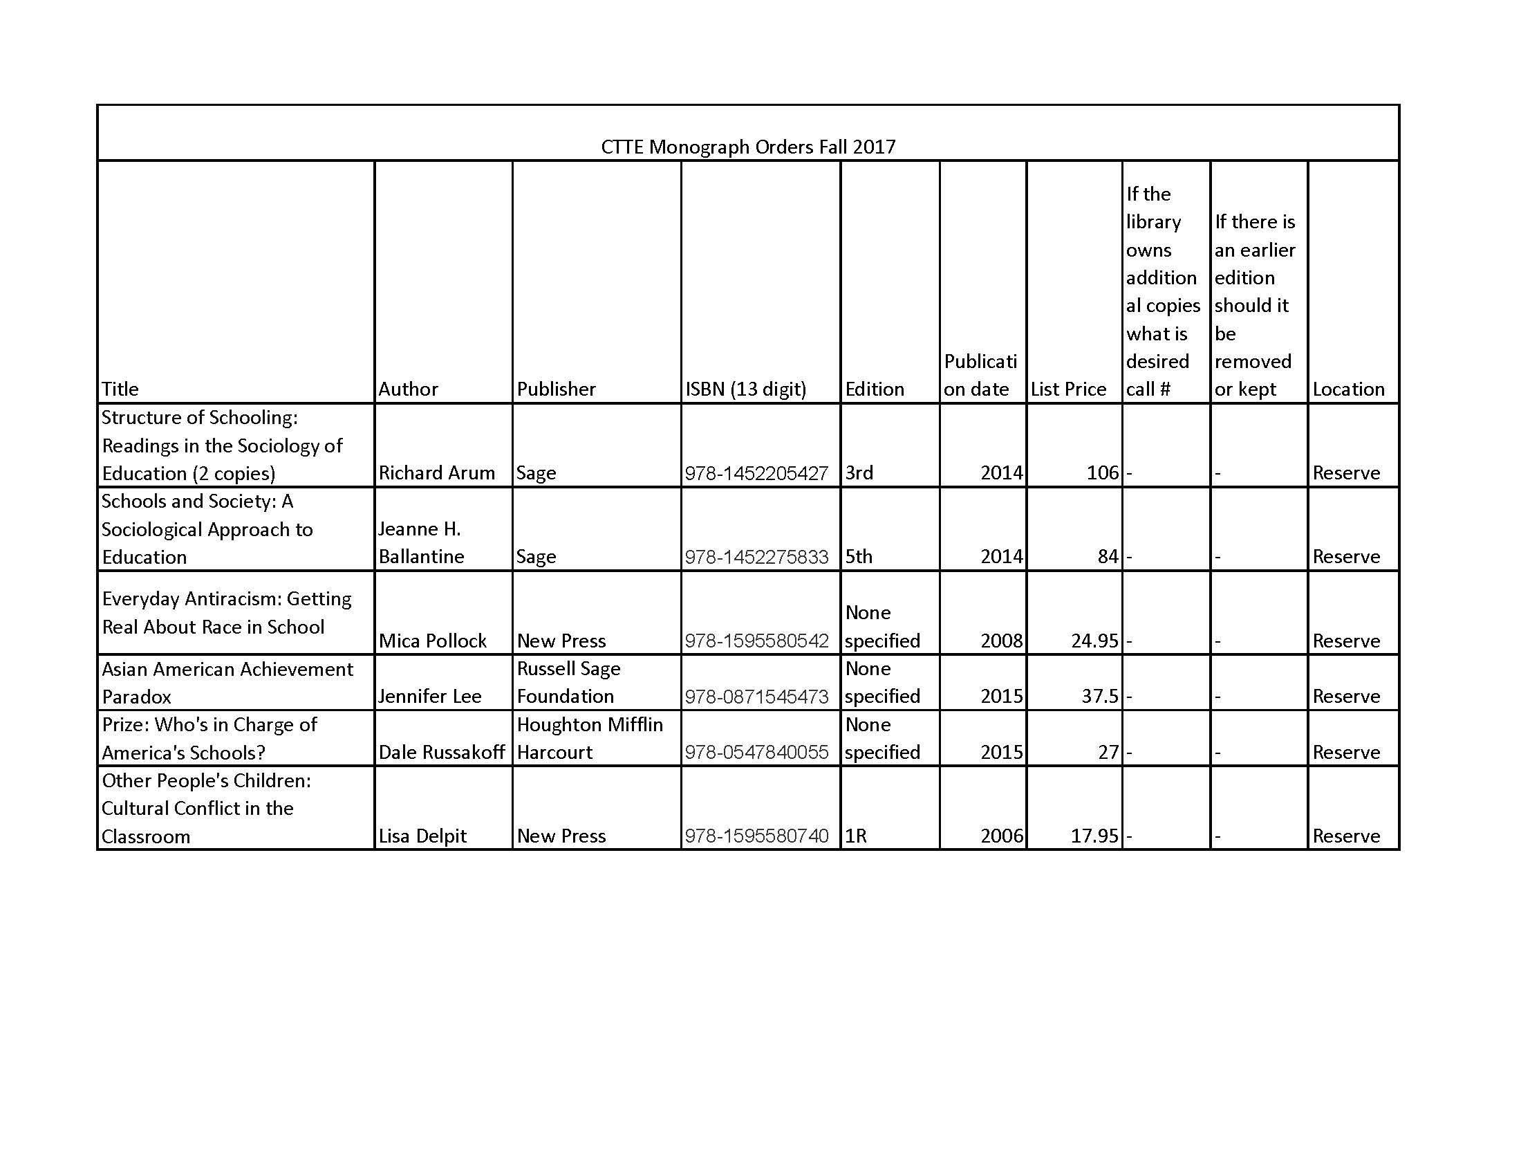
4 | Library faculty focus on strengthening students' information literacy skills in finding, evaluating, and ethically using information. We can collaborate on developing assignments and offer customized information literacy instruction and research guides for your course.  Do you plan to consult with the library faculty subject specialist for your area? Please elaborate. Not at this time.
5 | Library Faculty Subject Selector: _Kimberly Abrams__________________  Comments and Recommendations:  With the purchase of print books for reserve, the resources are sufficient.

CUNY Common Core
Course Submission Form
Instructions: All courses submitted for the Common Core must be liberal arts courses. Courses may be submitted for only one area of the Common Core. All courses must be 3 credits/3 contact hours unless the college is seeking a waiver for another type of Math or Science course that meets major requirements. Colleges may submit courses to the Course Review Committee at any time. Courses must also receive local campus governance approval for inclusion in the Common Core.
College | New York City College of Technology
Course Prefix and Number (e.g., ANTH 101, if number not assigned, enter XXX) | SOC 2380
Course Title | Sociology of Education
Department(s) | Social Science
Discipline | Sociology
Credits | 3
Contact Hours | 3
Pre-requisites (if none, enter N/A) | SOC 1101 or PSY 1101
Co-requisites (if none, enter N/A)
Catalogue Description | Examines the social influences on education and the effects of education and schooling on the social experiences and identities of individuals and groups in contemporary society. Focus is on the history, philosophy and the role of education as well as the responsibilities of teachers, school administrators and other professional staff, students, parents, and community members with regard to education. Emphasizes the importance of productive relationships and interactions among the school, home, and community.
Special Features (e.g., linked courses)
Sample Syllabus | Syllabus must be included with submission, 5 pages max recommended
Indicate the status of this course being nominated:

current course revision of current course a new course being proposed
CUNY COMMON CORE Location

Please check below the area of the Common Core for which the course is being submitted. (Select only one.)
Required  English Composition  Mathematical and Quantitative Reasoning  Life and Physical Sciences |  | Flexible  World Cultures and Global Issues Individual and Society  US Experience in its Diversity Scientific World  Creative Expression
Waivers for Math and Science Courses with more than 3 credits and 3 contact hours

Waivers for courses with more than 3 credits and 3 contact hours will only be accepted in the required areas of “Mathematical and Quantitative Reasoning” and “Life and Physical Sciences.” Three credit/3-contact hour courses must also be available in these areas.
If you would like to request a waiver please check here: |  | Waiver requested
If waiver requested:
Please provide a brief explanation for why the course will not be 3 credits and 3 contact hours.
If waiver requested:
Please indicate whether this course will satisfy a major requirement, and if so, which major requirement(s) the course will fulfill.
Learning Outcomes

In the left column explain the course assignments and activities that will address the learning outcomes in the right column.

II. Flexible Core (18 credits)
Six three-credit liberal arts and sciences courses, with at least one course from each of the following five areas and no more than two courses in any discipline or interdisciplinary field.
D. Individual and Society
A Flexible Core course must meet the three learning outcomes in the right column.

Students read and engage with diverse texts, including textbooks, popular writings, and scholarly literature on education and its institutions. Lectures, class discussions, and research projects introduce students to different points of views. | - Gather, interpret, and assess information from a variety of sources and points of view.
Students evaluate arguments developed in readings and made by others in class discussions. For their research projects and response papers, students evaluate and critically engage with primary and secondary sources. | - Evaluate evidence and arguments critically or analytically.
Response papers and research projects are resigned to improve student writing skills with an emphasis on the use of evidence to support and develop arguments. | - Produce well-reasoned written or oral arguments using evidence to support conclusions.
A course in this area (II.D) must meet at least three of the additional learning outcomes in the right column. A student will:

Combination of class discussions, oral presentations, in-class small group work, and essays directly address the questions about the place individuals in educational institutions and society by engaging with fundamental theories and concepts developed in the sociology of education. | - Identify and apply the fundamental concepts and methods of a discipline or interdisciplinary field exploring the relationship between the individual and society, including, but not limited to, anthropology, communications, cultural studies, history, journalism, philosophy, political science, psychology, public affairs, religion, and sociology.
Reading and writing assignments, class discussions, and lectures focus on underlying values of education and the place of individuals in educational institutions. These assignments are designed to develop a deep understanding of the values and responsibilities of teachers, school administrators and other professional staff, students, parents, and community members. | - Examine how an individual's place in society affects experiences, values, or choices.
 | - Articulate and assess ethical views and their underlying premises.
 | - Articulate ethical uses of data and other information resources to respond to problems and questions.
For their research projects and response papers, students engage with cutting edge scholarship on global and national trends in education. Class discussions and in-class group projects focus on how these global and national processes are shaping individual and collective decision-making in relation to education. | - Identify and engage with local, national, or global trends or ideologies, and analyze their impact on individual or collective decision-making.

LETTER FROM NYSED OUTLINING CERTIFICATION REQUIREMENTS

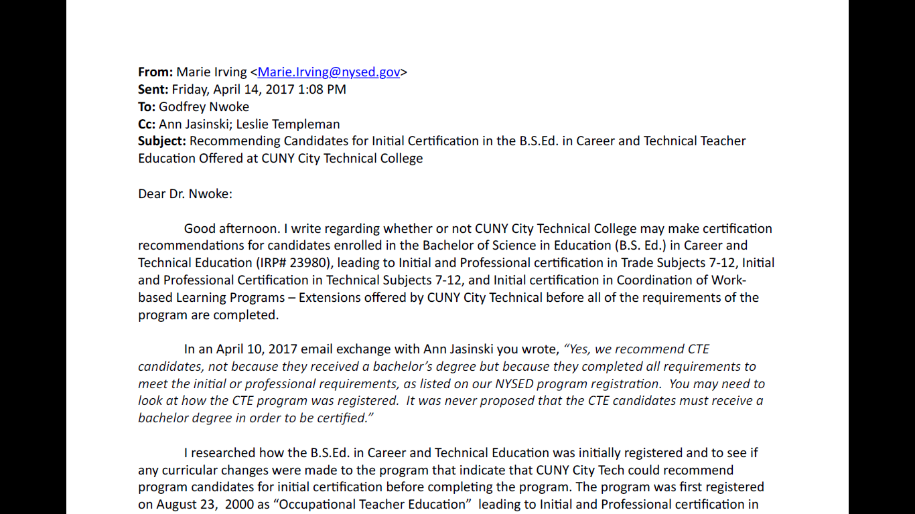
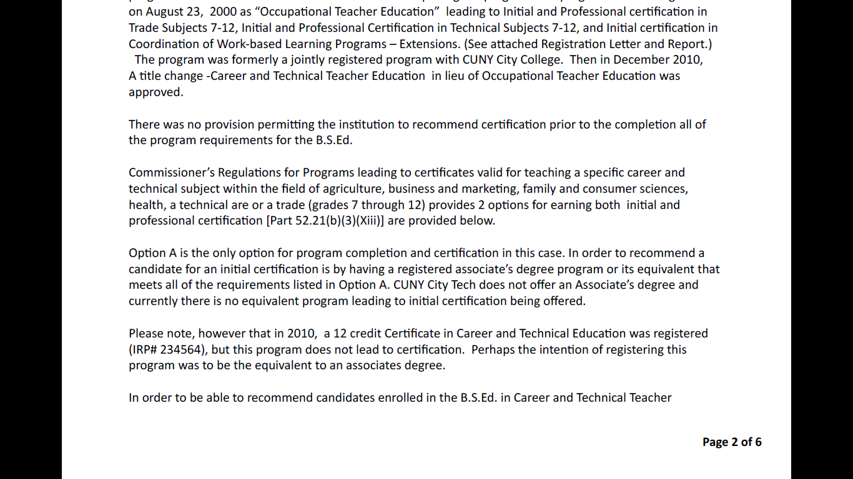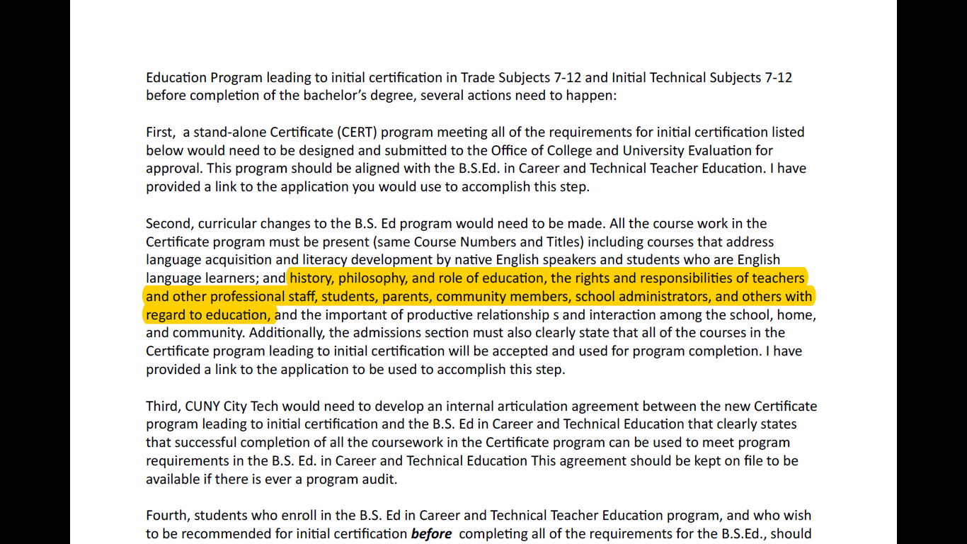
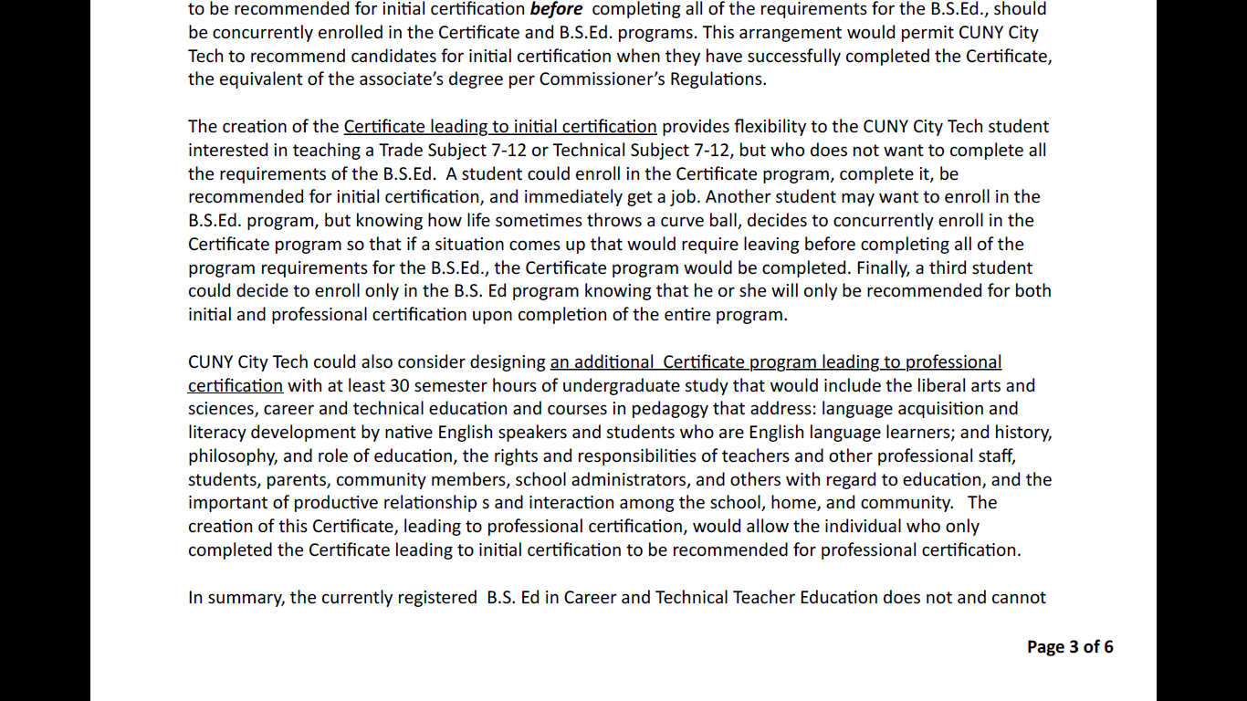
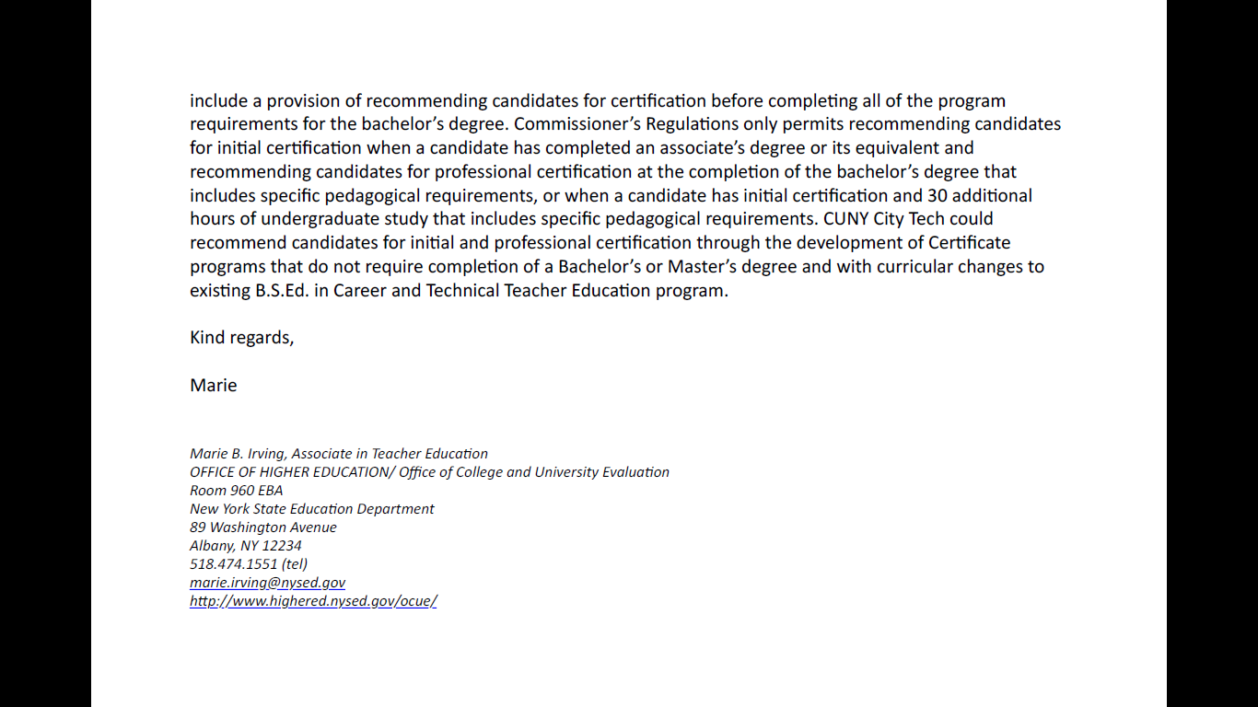
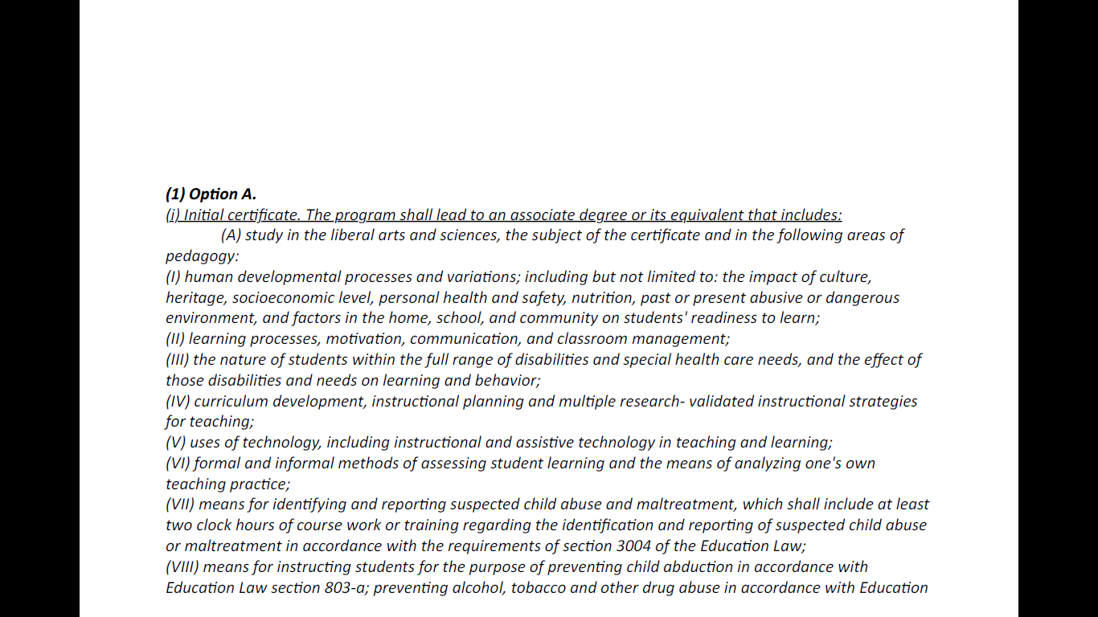

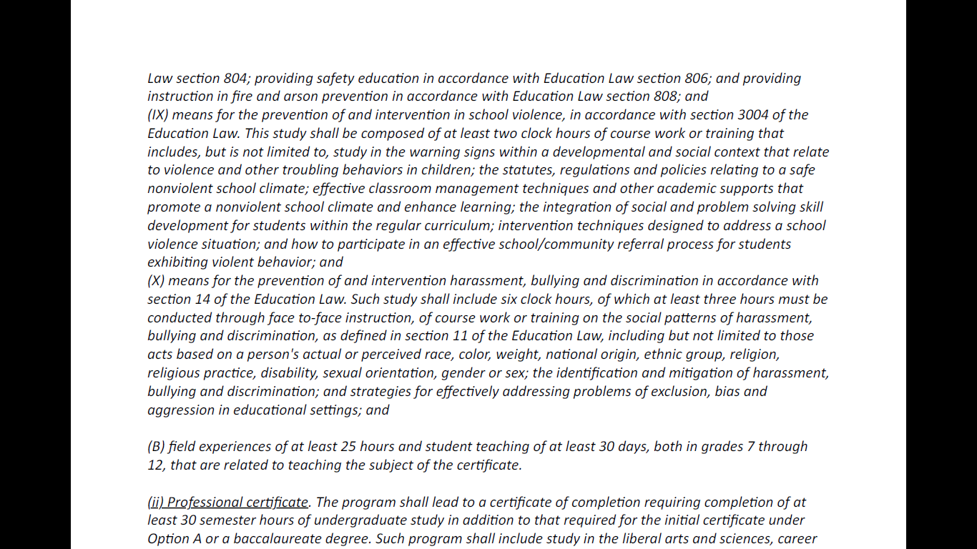
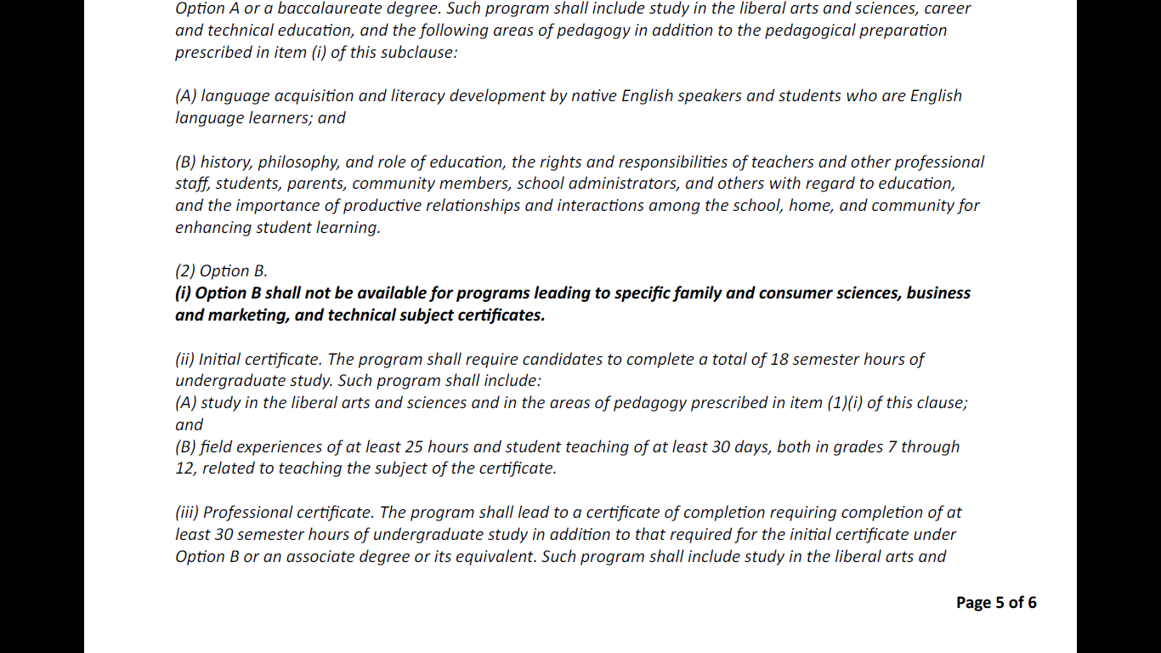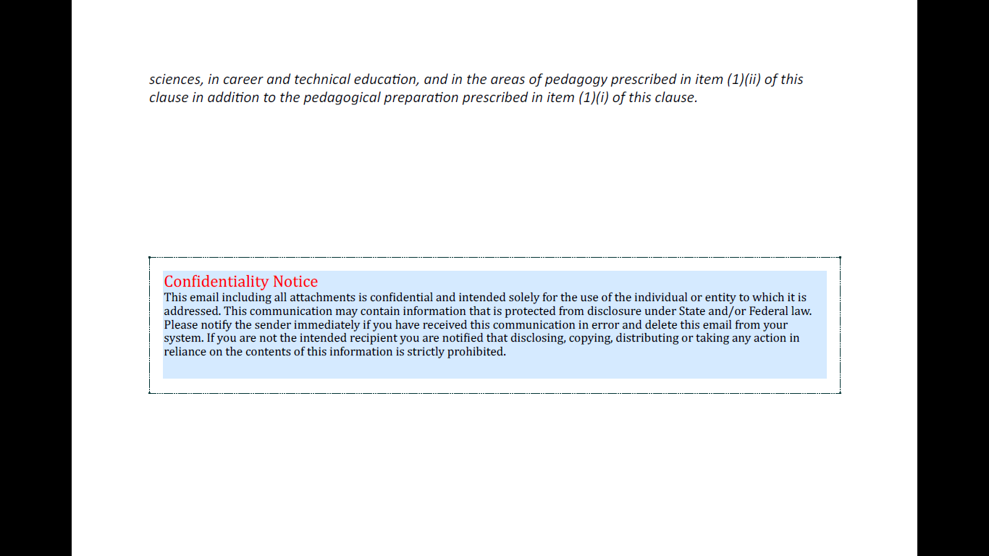
LETTER FROM PROF. MARIA PAGANO RE: PSY 1101 AS A PREREQUISITE
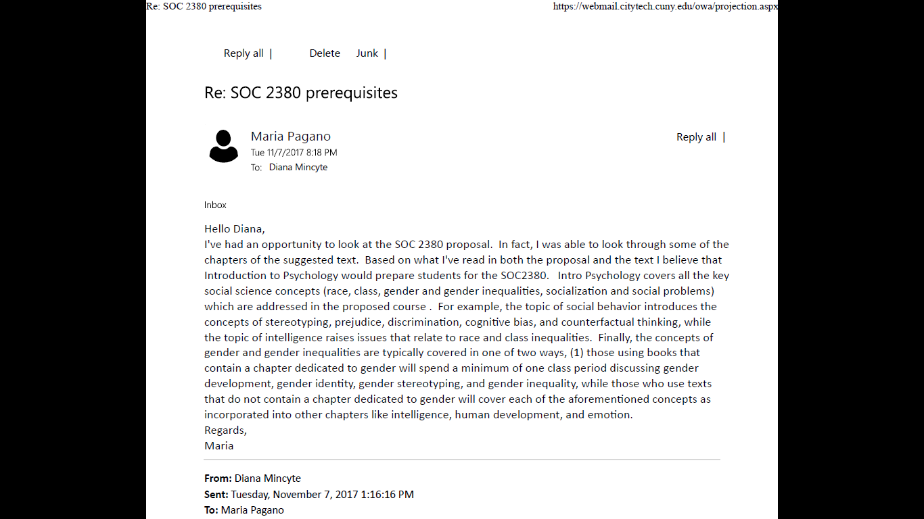

EXPLANATION OF MOST RECENT PROPOSAL REVISIONS
After the meeting with members of the CCCC Subcommittee, Provost August, Associate Provost Brown, Executive Associate for Academic Administration Cardashia and representatives from the Social Science Department on November 1, 2017, the following changes were implemented:

- The course description shortened and streamlined.
- Letter from NYSED included.
- Common Core Course Submission form filled and attached.
- Prerequisites discussed with Social Science Chair Peter Parides and Psychology Discipline Coordinator Maria Pagano. Decision made to keep PSY 1101 as a prerequisite. Email with explanation from Prof. Pagano attached.
- Writing Intensive designation discussed with Social Science Chair Peter Parides. The course will be taught as a Writing Intensive course.

