New York City College of Technology, CUNY
CURRICULUM MODIFICATION PROPOSAL FORM
This form is used for all curriculum modification proposals. See the Proposal Classification Chart for information about what types of modifications are major or minor. Completed proposals should be emailed to the Curriculum Committee chair.

Title of Proposal | Discontinuation and Deactivation of Gerontology AAS degree
Date | 11/8/2016
Major or Minor | Major
Proposer’s Name | Christine W. Thorpe
Department | Health and Human Services
Date of Departmental approved | 4/15/2016
Department Chair Name | Christine W. Thorpe
Department Chair Signature and Date | Christine W. Thorpe  11/8/2016
Academic Dean Name | David Smith
Academic Dean Signature and Date | 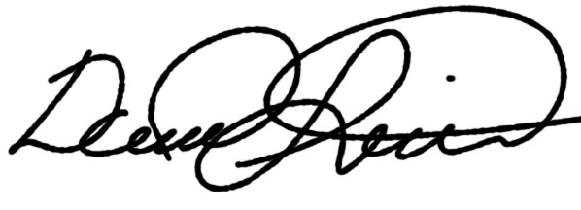 2017-01-03
Brief Description of Proposal  (Describe the modifications contained within this proposal in a succinct summary. More detailed content will be provided in the proposal body. | Deactivation and discontinuation of the Gerontology AAS degree at New York City College of Technology effective December 31, 2016.
Brief Rationale for Proposal  (Provide a concise summary of why this proposed change is important to the department. More detailed content will be provided in the proposal body). | The AAS degree in Gerontology is being discontinued in recognition of the shift towards earning baccalaureate degrees that offer greater job opportunities in the workforce.
Proposal History  (Please provide history of this proposal: is this a resubmission? An updated version? This may most easily be expressed as a list). | First submission.

Please include all appropriate documentation as indicated in the Curriculum Modification Checklist.

For each new course, please also complete the New Course Proposal and submit in this document.

Please submit this document as a single .doc or .rtf format. If some documents are unable to be converted to .doc, then please provide all documents archived into a single .zip file.

ALL PROPOSAL CHECK LIST
Completed CURRICULUM MODIFICATION FORM including:
- Brief description of proposal
- Rationale for proposal
- Date of department meeting approving the modification
- Chair’s Signature
- Dean’s Signature
Evidence of consultation with affected departments
List of the programs that use this course as required or elective, and courses that use this as a prerequisite.
Documentation of Advisory Commission views (if applicable).
Completed Chancellor’s Report Form.

EXISTING PROGRAM MODIFICATION PROPOSALS

Documentation indicating core curriculum requirements have been met for new programs/options or program changes.
Detailed rationale for each modification (this includes minor modifications)

Health and Human Services Department

Part A: Academic Matters

Section AI: Special Actions

AI.1.2 Discontinuation and Deactivation of the AAS Gerontology degree

RESOLVED, that the Gerontology Associate in Applied Science at New York City College of Technology be deregistered, effective June 5, 2017.

EXPLANATION: The AAS degree in Gerontology is being discontinued in recognition of the shift towards earning baccalaureate degrees that offer greater job opportunities in the workforce. No students are currently enrolled. The program has not been in the catalog in the last 5 years.

