New York City College of Technology, CUNY
CURRICULUM MODIFICATION PROPOSAL FORM
This form is used for all curriculum modification proposals. See the Proposal Classification Chart for information about what types of modifications are major or minor. Completed proposals should be emailed to the Curriculum Committee chair.

Title of Proposal | Certificate Deregistration
Date | 10/25/2016
Major or Minor | Major
Proposer’s Name | Kevin Hom, Dean
Department | Deans Office, School of Technology and Design
Date of Departmental Meeting in which proposal was approved | 10/25/2016
Department Chair Name | N/A
Department Chair Signature and Date | N/A
Academic Dean Name | Kevin Hom
Academic Dean Signature and Date | 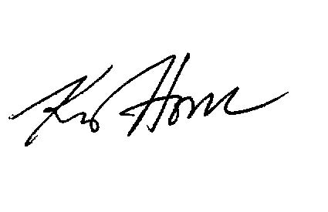
Brief Description of Proposal  (Describe the modifications contained within this proposal in a succinct summary. More detailed content will be provided in the proposal body. | Discontinuation of enrollment and deregistration of Sustainable Technology Certificate
Brief Rationale for Proposal  (Provide a concise summary of why this proposed change is important to the department. More detailed content will be provided in the proposal body). | No current enrollment in certificate program; Curriculum being taught in various degree programs:  Architectural Technology,  Construction Management  Environmental Control
Proposal History  (Please provide history of this proposal: is this a resubmission? An updated version? This may most easily be expressed as a list). | First time submission

Please include all appropriate documentation as indicated in the Curriculum Modification Checklist.

For each new course, please also complete the New Course Proposal and submit in this document.

Please submit this document as a single .doc or .rtf format. If some documents are unable to be converted to .doc, then please provide all documents archived into a single .zip file.

ALL PROPOSAL CHECK LIST
Completed CURRICULUM MODIFICATION FORM including:
- Brief description of proposal
- Rationale for proposal
- Date of department meeting approving the modification
- Chair’s Signature
- Dean’s Signature
Evidence of consultation with affected departments
List of the programs that use this course as required or elective, and courses that use this as a prerequisite.
Documentation of Advisory Commission views (if applicable).
Completed Chancellor’s Report Form.

EXISTING PROGRAM MODIFICATION PROPOSALS

Documentation indicating core curriculum requirements have been met for new programs/options or program changes.
Detailed rationale for each modification (this includes minor modifications)

Chancellor’s Report

Section AI: Special Actions

AI.1 Discontinuation of the following Certificate Program:

Sustainable Technology

RESOLVED, that the program leading to the certificate listed below at New York City College of Technology be deregistered, effective June 2017.

Sustainable Technology (HEGIS # 5317.00, State program code 32466)

RATIONALE: Enrollment in the certificate listed above is insufficient to warrant its continuation.

