

**NEW YORK CITY COLLEGE OF TECHNOLOGY**

THE CITY UNIVERSITY OF NEW YORK

**MAJOR CURRICULUM MODIFICATION PROPOSAL**

**for**

**YEARS ONE AND TWO**

Final Revision 05: February 15, 2017

**Sanjive Vaidya**

**Chairperson**

Prepared by:   
Professors Anzalone, Aptekar, Bouratoglou,

Dikigoropoulou, King, Duddy, Mishara, Montgomery

**Table of Contents**

3 **Curriculum Modification Form**

4-15 **Description of Major Modifications and Rationale**

* **New Course proposal Form and Course Outline**

- **New Course Proposal Checklist**

- **New Course Outline:**

16-22 **Modified Course Outlines of Existing Courses**

23-24 **Minutes from Department Meeting**

25-27  **Consultation with Affected Departments**

28-29  **Letter from Academic Dean**

30 **Library Resources and Information Literacy Form**

31 -36 **CHANCELLOR'S REPORT – Changes to Degree Programs**

37 **CHANCELLOR'S REPORT – New Courses**

38-67 **CHANCELLOR'S REPORT – Changes to Existing Courses**

New York City College of Technology, CUNY

CURRICULUM MODIFICATION PROPOSAL FORM

This form is used for all curriculum modification proposals. See the [Proposal Classification Chart](http://openlab.citytech.cuny.edu/collegecouncil/files/2014/08/2013-10-09-Proposal_Classification_Chart.pdf) for information about what types of modifications are major or minor. Completed proposals should be emailed to the Curriculum Committee chair.

|  |  |
| --- | --- |
| **Title of Proposal** | **Architectural Technology Major Curriculum Modification Proposal for Years One and Two** |
| **Date** | **January 29, 2017** |
| **Major or Minor** | **Major** |
| **Proposer’s Name** | **Sanjive Vaidya** |
| **Department** | **Architectural Technology** |
| **Date of Departmental Meeting in which proposal was approved** | **September 22, 2016 and September 27, 2016, Final on January 26, 2017** |
| **Department Chair Name** | **Sanjive Vaidya** |
| **Department Chair Signature and Date** | **2017 01 28** |
| **Academic Dean Name** | **Kevin Hom** |
| **Academic Dean Signature and Date** | **2017 01 29** |
| **Brief Description of Proposal**  (Describe the modifications contained within this proposal in a succinct summary. More detailed content will be provided in the proposal body. | **The modifications in this proposal are focused on changes to the first two years of our current degree programs. The changes include resequencing courses and shifting credit and teaching hours. The Introduction to Architecture course is a foundational course to the program.** |
| **Brief Rationale for Proposal**  (Provide a concise summary of why this proposed change is important to the department. More detailed content will be provided in the proposal body). | **This proposal is a part of a continued response to our department’s pursuit of accreditation by the National Architectural Accreditation Board (NAAB) and anticipates a future application for a new degree program.** |
| **Proposal History**  (Please provide history of this proposal: is this a resubmission? An updated version? This may most easily be expressed as a list). | **This is a development of the proposal submitted on Nov 13 2016. This proposed refines and reorganizes course developed in the previous proposal. It is further updated by faculty discussion on curriculum alignment with NAAB criteria.** |

**DESCRIPTION OF MAJOR MODIFICATIONS AND RATIONALE**

Upon the completion of our 10 Year Review self study and following the recommendation of our Dean and external reviewer, the faculty of the Department of Architectural Technology have agreed to pursue accreditation through the National Architectural Accreditation Board for a Bachelor of Architecture. This new degree will be in addition to our current degree programs; we will continue to maintain the existing AAS and Bachelor of Technology degrees, with modifications so that all the degrees coordinate where necessary. Each degree serves our students’ varied needs and each offers a different path into the field of architecture and its allied industries. This proposal is the result of our department’s analysis of the changes to our existing curriculum that will enhance our ability to achieve accreditation.

The Department of Architectural Technology is proposing a restructuring of its curriculum of years one and two to prepare for a future alignment with National Architectural Accreditation Board (NAAB) requirements for an accredited Bachelor of Architecture (BARCH) degree, a new degree program that is in development for a subsequent submission. There are currently 59 institutions listed on the NAAB website[1] offering an accredited BARCH degree or are current BARCH candidate programs, including 8 in New York State. CUNY currently offers one accredited BARCH program at City College. The CUNY Chancellor, City Tech’s President and Provost, and the Dean of the School of Technology and Design are all supportive of City Tech’s Department of Architectural Technology pursuit of a BARCH accredited degree program. NAAB states each BARCH program must require a minimum of 150 semester credit hours, with at least 45 credits dedicated to General Studies, and 10 credits to Optional Studies. Our department is working towards a degree program that will require approximately 160 credits total, earned over a 5 year curriculum, a standard requirement that meets New York State requirements[2] and is similar to the requirements of City College (160 credits), Syracuse University (162 credits), SUNY Alfred State (157 credits), and NYIT (160 credits).

Our department offers the most accessible architectural education in the metro area, with competitive tuition and a large enrollment capacity.  NYCCT’s Department of Architectural Technology is known for its workplace-oriented curriculum, leading edge technologies and student-focused environment, providing opportunities for students to engage in real-world community service projects. The introduction of the accredited degree will offer our diverse students a stronger path to licensure, increased recognition in the profession, and strengthen their employment opportunities in architectural practice.

This curriculum proposal for years one and two will provide a stronger basis for all students in the department with its emphasis on Integrated Learning and its application of increased general education as well as scholarship of teaching and learning. This modification puts in place a structure that seeks to prepare as broadly as possible the number of students from our current enrollment that will be eligible for the new BARCH degree. Briefly stated, the changes will involve:

1. ARCH 1101 Introduction to Architecture sequenced the first semester of the program
2. ARCH 1101 Introduction to Architecture - change to credits & hours
3. ARCH 2430 Building Tech IV has been removed from the AAS degree requirement (resulting in the Tech sequence renumbering)
4. Shifting the building technology sequence of classes back a semester
5. ARCH 2480 Structures I (renumbered 2381) credit hours are reduced and the class description edited
6. ARCH 3580 Structures II (renumbered 2481) is added as a requirement for the AAS and the class description edited
7. ARCH 2370 Building Systems has been removed from the AAS degree requirement
8. ARCH 1130, 1230, 2230, & 2430 Building Tech I, II, III, & IV description have been refined.
9. ARCH 2310 Design 3 & ARCH 2410 Design 4 has had their course credits, lab hours and prerequisites revised (renumbered ARCH 2312 & ARCH 2412 respectively)
10. To accommodate these refinements in the curriculum sequence prerequisites and corequisites have been amended as detailed below in changes section 10

Technical content has historically been a central feature of our AAS degree when it was focused on training architectural technicians and CAD drafters.[3] This proposal seeks balance between this vocational legacy and the professional preparation. These changes maintain and enhance the viability of the AAS degree as a stand-alone degree that offers our students a strong foundation in hard skills, soft skills, and knowledge of the discipline that will allow graduates to pursue employment or further education.

The proposed changes to the AAS provide improvements for the benefit of all AAS and BTECH students. The changes are as follows:

DETAILED RATIONALE for AAS CHANGES:

Changes #1,2:

**Arch 1101** **Introduction to Architecture**, was introduced but not placed into the program in the previous curriculum proposal submitted on Nov 13 2016. The structural changes here will position this course as the student’s introduction to the language of architecture. To ensure this course as the proper balance of content it has been reduced by one credit from 3 to 2 credit hours. As this course focuses on hands-on activities and place based learning it is conceived as a laboratory course supporting the Design Foundations sequence. To reflect this change the proposal has adjusted its workload hours, credit hours and course description.

Changes #3&4:

To strengthen student’s foundational knowledge, the Building Technology Sequences was shifted to begin in the second semester of the first year. Thise sequence includes the following classes:

ARCH1130 Building Technology I currently semester 1 proposed shift to 2 semester

renumbered to: ARCH 1231

ARCH1230 Building Technology II currently semester 2 proposed shift to 3 semester

renumbered to: ARCH 2331

ARCH2330 Building Technology III currently semester 3 proposed shift to 4 semester

renumbered to: ARCH 2431

ARCH2430 Building Technology IV currently semester 4 proposed shift to 5 semester (See #8)

renumbered to: ARCH 3531

To support this, the Building Technology IV course, moves to the fifth semester, and is no longer required as part of the AAS degree.

Change #5:

**ARCH 2480 Structures I credit hours are reduced.**

Existing course rewritten to incorporate more interactive and demonstrative study of the mathematics and physical properties required for the design and analysis of building structures. Lab hours were increased in this course, and overall structural sequence was strengthened by the addition of Structures II in the AAS program. The course has been renumbered to ARCH 2381.

Change #7:

**ARCH 3580 Structures II is added as a requirement for the AAS** (See #9)

Structures II is added to focus on the application of content in Structures I through calculation and real-world examples. The two courses will be strengthened by running them as a closer sequence. The course has been renumbered to ARCH 2481.

Change #8:

**ARCH 2430 Building Tech IV has been removed from the AAS degree requirement**

To strengthen the Building Technology sequence the new course Intro to Arch 1101 is a new prerequisite for Building Technology I shifting the sequence back one semester. Building Tech IV now occurs in semester 5 and is no longer required for the AAS Degree. It has been renumbered to ARCH 3531.

Change #9:

**ARCH 2370 Building Systems has been removed from the AAS degree requirement** (See #7)

The Building Systems course was moved to later in the curriculum and is no longer required as part of the AAS degree. This change was required to further develop foundational knowledge necessary for success in the course. Course is exchanged with Structures II.

Change #9:

**ARCH 2330 Building Tech III & ARCH 2430 Building Tech IV** class description edited to align it with the new sequence. The adjustments will also support the future NAAB requirements. To support this alignment number changes have been added as described in change number 3 & 3 above.

Change #10:

**ARCH 2310 Design 3 & ARCH 2410 Design 4**

Studio design courses include critical lab time work on their projects in class with their professors and peers. The department has come to increase class time and contact hours after careful analysis of student achievements, NAAB required Student Performance Criteria (SPC) [4]and evaluation NAAB accredited programs.

Students achievements and were SPC analyzed in the following way. Student work from the design sequence which are the base of meeting NAAB’s SPC were evaluated. The evaluation focus was put on ARCH2310 Design 3 & ARCH2410 Design 4 classes. The work was evaluated by 19 out of the 20 full-time faculty, by New York Institute of Technology (NYIT) Accreditation coordinator David Diamond and Kin DuBois past NAAB President, (2010-2011) president and presently the departments consultant on NAAB accreditation over the course of 4 eight hour sessions. The review outlined where student achievements and SPC needed to be enhanced and indicated that an increase in contact time would be required.

City Tech’s design credit and contact hours were compared to 21 other comparable programs. The comparison focused on similar institutions and included many that are urban commuter schools. The analysis revealed that City Tech to allocates to the least amount of credits out of any of the programs investigated. City Tech also placed second to last in the amount of contact hours’ students received in the designs studios. City Tech’s outlier status is clearly indicated in the following 3 tables.

* Table 1 “Average Design Content Hours Per Semester”
* Table 2 “Average Design Credits Per Semester”
* Table 3 “Total design Content hours”

To address these issues proposes the includes the following changes:

* ARCH 2312 Design 3
  + change credits to: 1 one classroom hour and 8 lab hours = 5 credits
  + ARCH 2310 - Architectural Design III new number ARCH 2312.
* ARCH 2412 Design 4
  + Change credits to: 1 one classroom hour and 8 lab hours = 5 credits
  + ARCH 1291 has been removed as a prerequisite because it is no longer in the curriculum
  + ARCH 1250 added as a prerequisite to ensure student have foundational knowledge to succeed in the course
  + ARCH 2410 - Architectural Design V new number ARCH 2412.

[Tables 1,2 &3 data was generated by faculty analysis of programs and tabulated and graphed by Prof.s Claudia Hernandez-Feiks, Jason Montgomery, & Shelley Smith]

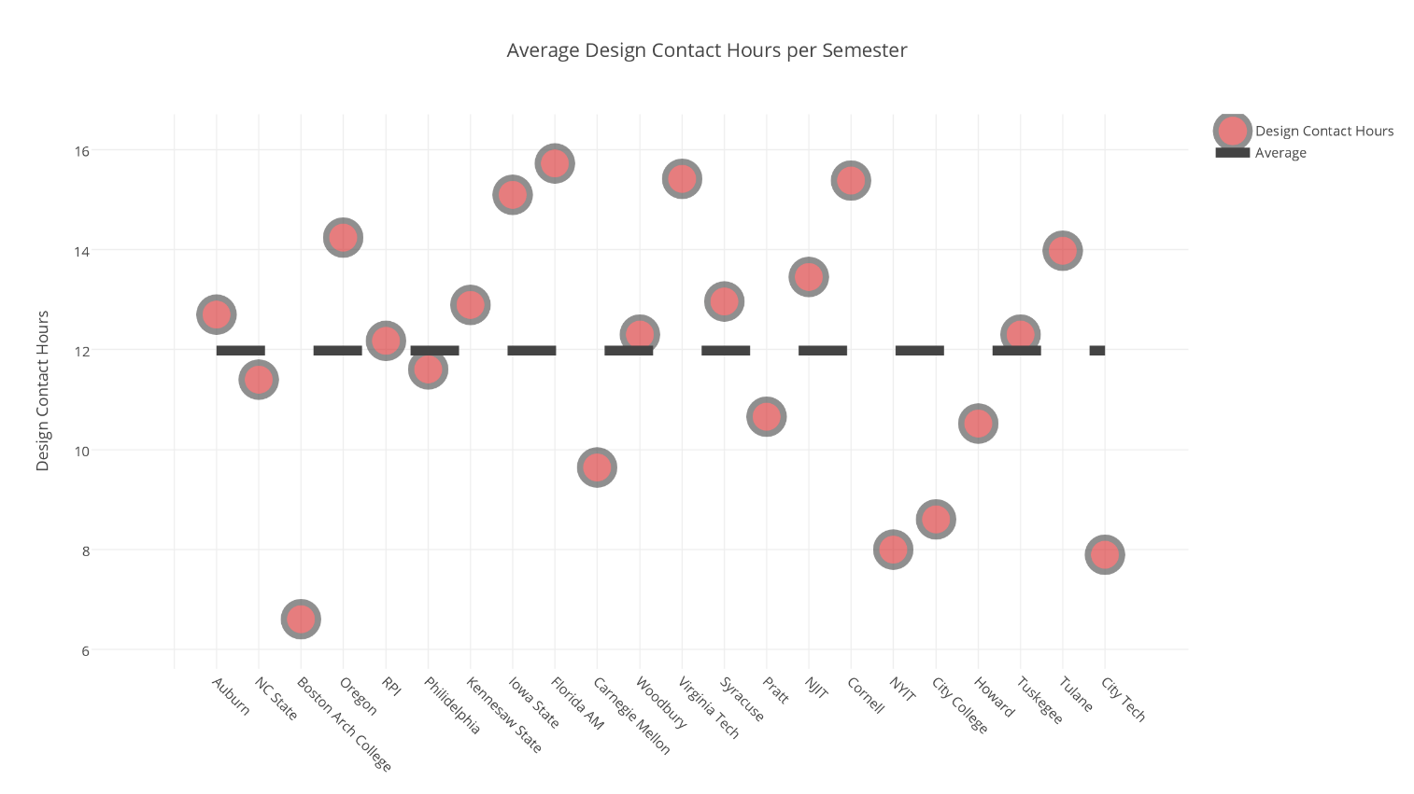

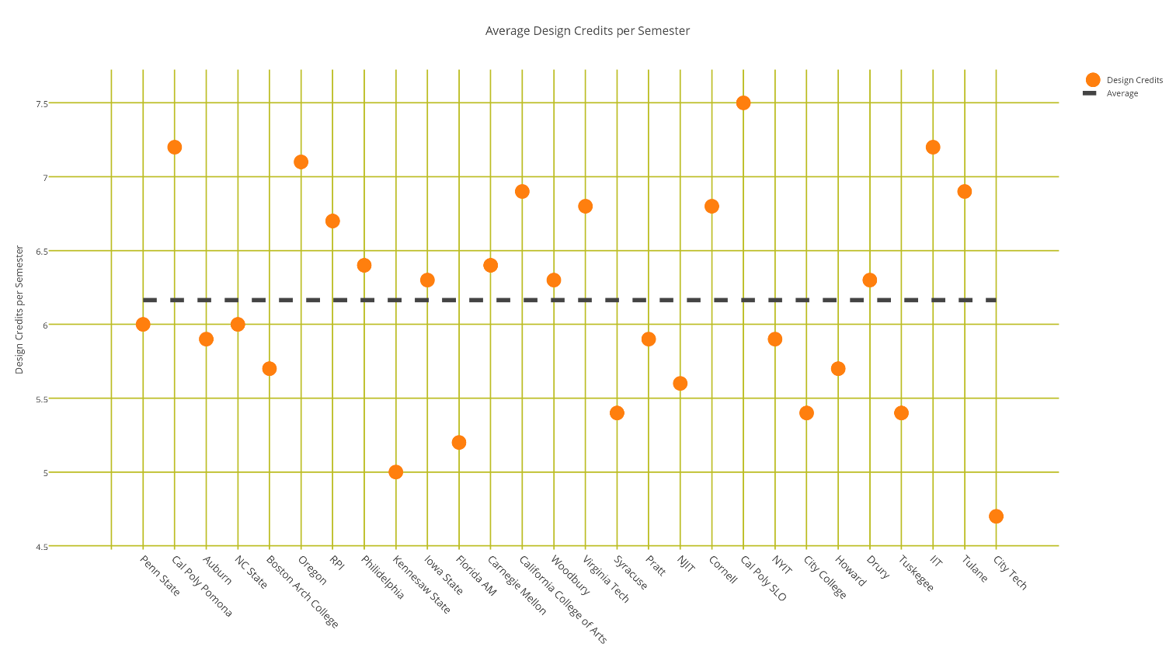

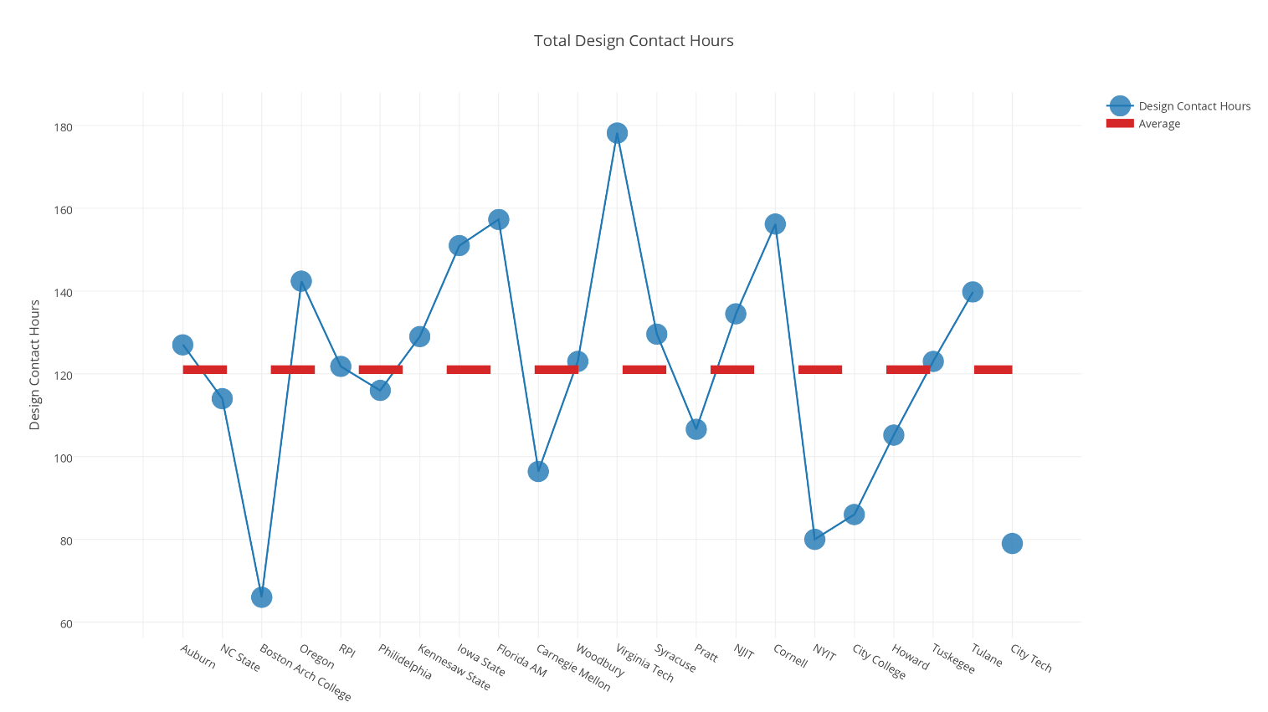

Change #10:

To accommodate the refinements in the curriculum sequence prerequisites and corequisites have been as follows in the following tables. The table includes the changes to required courses, additional refinements have been added to the proposal in the section “CHANCELLOR'S REPORT – Changes to Existing Courses”

Please note: ARCH 3610 prerequisite changes are included for planning purposes only, they will be part of the future curriculum modification proposal

 **Table 2: Comparison of Existing and Proposed Courses**

|  |  |  |  |
| --- | --- | --- | --- |
| Department of Architectural Technology **PROPOSED MAJOR COURSE CHANGES** | | | |
| Original Course Description | Proposed Course Description | Major change | Rationale |
| **ARCH 1101**  **INTRODUCTION TO ARCHITECTURE**  1 cl hr, 4 lab/studio hrs, 3 credits  **Course Description:** Understanding architecture is achieved by developing a visual literacy of New York City’s built environment. Using the city as a living laboratory, students explore concepts of design, composition, and construction by sketching and writing about their direct experience of buildings. Accompanying lectures focus on freehand drawing techniques, basic drafting skill and graphic standards, concepts of composition, writing about buildings and their construction, and reading architectural drawings. Students develop graphic skills and the basic foundation to talk, write, and graphically express architecture and its construction.  **Prerequisites:** none | **ARCH 1101**  **INTRODUCTION TO ARCHITECTURE**  0 cl hr, 4 lab/studio hrs, 2 credits  **Course Description:** Understanding architecture is achieved by developing a visual literacy of New York City’s built environment. Using the city as a living laboratory, students explore concepts of design, composition, and construction by sketching and writing about their direct experience of buildings. Focus workshops on freehand drawing techniques, basic drafting skills, graphic standards, 2D and 3D composition, writing about buildings and their construction, and reading architectural drawings are central to this course. Students develop graphic skills and the basic foundation to talk, write, and graphically express architecture and its construction.  **Prerequisites:**  No change (none) | Change in contact hours and credits | **As this course focuses on hands-on activities and place based learning this constructed as laboratory introduction. To reflect this the lab focus proposal has adjusted its workload hours to support these educational goals of a scaffolded introduction to degree programs.** |

|  |  |  |  |
| --- | --- | --- | --- |
| Department of Architectural Technology **PROPOSED MAJOR COURSE CHANGES** | | | |
| Original Course Description | Proposed Course Description | Major change | Rationale |
| **ARCH 2310**  **ARCHITECTURAL  DESIGN III**  1 cl hr, 6 lab/studio hrs, 4 credits  **Course Description:**  No change  **Prerequisites:**  ARCH 1210 and ARCH 1291, both with a grade of C or higher  **Pre- or corequisite:**  ARCH 1250 | **ARCH 2312**  **ARCHITECTURAL  DESIGN III**  1 cl hr, 8 lab/studio hrs, 5 credits  **Course Description:**  No change  **Prerequisites:**  (ARCH 1212 with a grade of C or higher) or (ARCH 1210 and ARCH 1291, both with a C or higher)  **Pre- or corequisite:** (No change) ARCH 1250 | Change in contact hours, credits and prerequisites. | **This change will add depth to the course. This is depth will report all the students learning objectives. In addition, this increase in depth is necessary for the program to facilitate achieve the National Architectural Accrediting Board’s Student Performance Criteria.** |

|  |  |  |  |
| --- | --- | --- | --- |
| Department of Architectural Technology **PROPOSED MAJOR COURSE CHANGES** | | | |
| Original Course Description | Proposed Course Description | Major change | Rationale |
| **ARCH 2410**  **ARCHITECTURAL  DESIGN IV**  1 cl hr, 6 lab/studio hrs, 4 credits  **Course Description:**  No change  **Prerequisites:**  ARCH 2310, with a grade of C or higher  **Pre- or corequisite:**  ARCH 2321; ARCH 1291 with a grade  of C or higher if it is taken as a  prerequisite | **ARCH 2412**  **ARCHITECTURAL  DESIGN IV**  1 cl hr, 8 lab/studio hrs, 5 credits  **Course Description:**  No change  **Prerequisites:**  (ARCH 2310 or ARCH 2312 with a grade of C or higher), and ARCH 1250 and (ARCH 1291 with a grade of C or 1210 with a grade of C or higher)  **Pre- or corequisite:**  ARCH 2321 and (ARCH 1230 with a grade of C or higher if it is taken as a  Prerequisite or 2331 with a grade of C or higher if it is taken as a  Prerequisite) | Change in contact hours, credits and prerequisites. | **This change will add depth to the course. This is depth will report all the students learning objectives. In addition, this increase in depth is necessary for the program to facilitate achieve the National Architectural Accrediting Board’s Student Performance Criteria.** |

|  |  |  |  |
| --- | --- | --- | --- |
| Department of Architectural Technology **PROPOSED MAJOR COURSE CHANGES** | | | |
| Original Course Description | Proposed Course Description | Major change | Rationale |
| **ARCH 2480**  **STRUCTURES I**  3 cl hr, 0 lab/studio hrs, 3 credits  **Course Description:**  The analysis of architectural structures  and their materials. A study of  wood and steel structures using  basic physical laws, the behavior  of architectural materials in stress  and intuitive reasoning related to  the mathematical treatment of  equilibrium in static structures  **Prerequisites:**  MATH 1275, ENG 1101  **Pre- or corequisite:**  PHYS 1433 or higher | **ARCH 2381**  **STRUCTURES I**  1 cl hr, 2 lab/studio hrs, 2 credits  **Course Description:**  The analysis of basic physical and geometric laws relating to architectural elements and materials, including principles and understanding related to the mathematical treatment of equilibrium in static structures and strength of materials.  **Prerequisites:**  ENG 1101  **Pre- or corequisite:**  MATH 1275, PHYS 1433 or higher | Change in contact hours and credits | Existing course rewritten to incorporate more interactive and demonstrative study of the mathematics and physical properties required for the design and analysis of building structures. Lab hours were increased in this course, and overall structural sequence was strengthened by the addition of Structures II in the AAS program. |

|  |  |  |  |  |  |  |  |  |
| --- | --- | --- | --- | --- | --- | --- | --- | --- |
| **Proposed AAS Curriculum** | | | | | | | | |
|  | **SEMESTER 1** | | **SEMESTER 2** | | **SEMESTER 3** | | **SEMESTER 4** | |
| **REQUIRED COURSES IN ARCHITECTURE** | FOUNDATIONS I  5 CREDITS (combine two existing courses) | | FOUNDATIONS II 5 CREDITS (combine two existing courses) | | ARCH 2312 Architectural Design III | | ARCH 2412 Architectural Design IV | |
|
|
|
|
|  |  |  |  |  |  |  |  |
|  |  | BUILDING TECH I 3 CREDITS | | BUILDING TECH II 3 CREDITS | | BUILDING TECH III 4 CREDITS | |
|  |  |
|  |  |
|  |  |  |  |  |  |
|  |  |  |  |  |  |  |  |
|  |  | SITE PLANNING  2 CREDITS | | STRUCTURES I  2 CREDITS | | STRUCTURES II  3 CREDITS | |
|  |  |
|  |  |  |  |  |  |
|  |  |  |  |  |  |  |  |
| Foundations I Lab:  Intro to Architecture | | WORLD ARCHITECTURE 2 CREDITS | |  |  | ARCH ELECTIVE 3 CREDITS | |
|  |  |
| 2 CREDITS | | 2 CREDITS | |  |  |
|  |  |  |  |  |  |  |  |
| **CORE** | ENG 1101 3 CREDITS | |  |  | ARCH HISTORY 3 CREDITS | | CORE 3 CREDITS | |
|  |  |
|  |  |
|  |  |  |  |  |  |  |  |
| MATH 1275 4 CREDITS | | PHYSICS 4 CREDITS | | CORE 3 CREDITS | |  |  |
|  |  |
|  |  |
|  |  |  |  |
|  |  |  |  |  |  |  |  |

**Proposed BTech Curriculum**

|  |  |  |  |  |  |  |  |  |
| --- | --- | --- | --- | --- | --- | --- | --- | --- |
|  | **SEMESTER 5** | | **SEMESTER 6** | | **SEMESTER 7** | | **SEMESTER 8** | |
| **REQUIRED COURSES IN ARCHITECTURE** | ARCH 3510 Architectural Design V | | ARCH 3610 Architectural Design VI (or choice of ARCH 3630 for BTech) | | ARCH 4710 Architectural Design VII (or Electives) | | ARCH 4810 Architectural Design VIII (or Electives) | |
|
|
|
|
|  |  |  |  |  |  |  |  |
| BUILDING TECH IV 3 CREDITS | |  |  |  |  | Professional Practice 3 CREDITS | |
|  |  |  |  |
|  |  |  |  |
|  |  |  |  |  |  |  |  |
|  |  |  |  |  |  |  | |
|  |  | BUILDING SYSTEMS 3 CREDITS | | Elective or (STRUCTURES III*) 3 CREDITS | |  |  |
|  |  |  |  |
|  |  |  |  |
|  |  |  |  |  |  |  |  |
|  |  |  |  |  |  |  |  |
|  |  |  |  |  |  |  |  |
|  |  |  |  |  |  |  |  |
|  |  |  |  |  |  |  |  |
| **CORE** | HISTORY of NY City Architecture 3 CREDITS | | CORE 3 CREDITS | | CORE 3 CREDITS | | Advanced Liberal Arts 3 CREDITS | |
|
|
|  |  |  |  |  |  |  |  |
| ENG 1121 3 CREDITS | | Speech/Oral Communication | | Interdisciplinary 3 CREDITS | | Additional Liberal Arts 3 CREDITS | |
|
|
|  |  |  |  |  |  |  |  |
|  |  |  |  |  |  |  |  |

* This class is under development and may be part of a future curriculum change

**Modified Course Outlines of Existing Courses**

# ARCH 2381 STRUCTURES I

Credits: 1 Classroom Hour, 2 Lab Hours, 2 Credits

**Description:** The analysis of basic physical and geometric laws relating to architectural elements and materials, including principles and understanding related to the mathematical treatment of equilibrium in static structures and strength of materials.

**Context:** This course is the first in a three-part sequence on building structures. This course covers the basis for the structural analysis and design of a typical residential or small commercial building structure. The following course covers larger building structures. After this course students may choose to take a structural elective in topics such as long-span / tall structures, lightweights and advanced structures, historic structures, or active structures. The structures sequence assumes a foundation in basic mathematics and physics covered in the prerequisites.

**Prerequisites:** ENG 1101, with co/prerequisite of MAT 1275 (Algebra) and PHYS 1433 or higher (Physics).

**Requirements:** The student is expected to attend each class as well as spend approximately one hour per week on the readings and two hours per week on the homework.

**Class Policy:** Class will start promptly at the scheduled time and will end when the students are dismissed. No more than 2 absences are permitted during the semester and 2 late arrivals will count as one absence. If absent for a class, it is entirely the students responsibility to obtain notes and homework assignments for the next week.

Do not be late for exams or quizzes - no extra time will be given for exams.

Cell phones are not permitted to be used in the class room at any time. Computers are not recommended for note taking - all notes should be taken by hand in a sketch book. Simple, non-programable calculators can be used in the class during quizzes and exams. No sharing of phones or calculators are allowed.

**Academic**

**Integrity:** Students and all others who work with information, ideas, texts, images, music, inventions and other intellectual property owe their audience and sources accuracy and honesty in using, crediting and citation of sources. As a community of intellectual and professional workers, the college recognizes its responsibility for providing instruction in information literacy and academic integrity, offering models of good practice, and responding vigilantly and appropriately to infractions of academic integrity. Accordingly, academic dishonesty is prohibited in The City University of New York and is punishable by penalties, including failing grades, suspension and expulsion.

**Text:**  Required Textbook

Simplified Engineering for Architects and Builders (11th edition), Ambrose & Tripeny, Wiley, 2010.

Additional Optional Textbook

Statics and Strength of Materials for Architecture and Building Construction (4th edition), Onouye & Kane, Prentice Hall, 2011. **(PDF)**

Recommended Reading Books (for those interested in expanding their horizons)

The Structural Basis of Architecture, Sandaker, Eggen & Cruvellier, Routledge, 2011.

Why Buildings Stand Up, Salvadori, W. W. Norten, 2002.

Why Buildings Fall Down, Salvador & Levy, W. W. Norten, 2002.

Alternative Text Books (if you have these already please see me)

Simplified Mechanics and Strength of Materials, Ambrose, Wiley 2011. **(PDF)**

Structures for Architects, Dabby & Bedi, Wiley, 2012.

Reference Books (do not buy - parts of these will be referenced in class only)

Minimum Design Loads on Buildings and Other Structures (ACSE/SEI 7-10). **(PDF)**

National Design Specification for Wood Construction & Supplement, (NDS 2015), American Wood Council. **(PDF)**

Steel Construction Manual (13th Edition), AISC, 2006. **(PDF)**

Building Code Requirements for Structural Concrete (ACI 318-11). **(PDF)**

**Sites:**  The most up-to-date information will be posted on the OpenLab websites, and so should be referenced weekly.

**Learning**

**Objectives:** Upon the successful completion of this course the student shall be able to:

1. Understand the fundamental science behind statics and strength of materials.
2. Calculate forces in structural elements based on loading conditions.
3. Analyze and design simple bearing walls, posts, arches, beams and stringers.
4. Design floor decks, roofs, framed walls and other simple diaphragm structures.
5. Have an understanding of simple lateral systems and lateral forces.
6. Have an awareness of digital analysis of structures.
7. Have an awareness of potential structural problems and how best to avoid them.
8. Understand sustainability issues involved with architectural design of building structures
9. Have an awareness of contemporary examples of structural design, theory and application.
10. Students will be expected to have the ability to apply the above knowledge to their studio and building technology projects.

**Assessment:** To evaluate the students’ achievement of the learning objectives, the professor will do the following:

1. Students will attend class and take notes on the lecture and case studies presented by the Professor. Students are expected to actively participate in class by asking questions, answering questions and engaging discussions on the topic.
2. Students will read the sections of the assigned textbook, the supplemental readings and any additional refresher that the student of professor feels is necessary for comprehension of the subject matter. Students are expected to ask questions if the readings are not understandable.
3. Students will complete ten (10) homework assignments that will quiz their comprehension of the lectures and readings.
4. Students will be quizzed in class on the topics to test their ability to recall conceptual and applied procedures of analysis and design of structural elements and systems.
5. Students will take a mid-term and comprehensive final examination to test their analytic, synthetic and conceptual understanding an abilities in architectural structures.

**Grading:** There will be no make up of exams or quizzes. Late homework will be reduced in grade by 25% for each week late. Homework is due at the beginning of class, and will be considered late if not turned in before the class break.

The final grade will be computed as follows:

Attendance & Participation 10% ( - 2% per class missed)

Homework 30% (10 assignments, worth 3% each)

Quizzes 15% (4 quizzes, top 3 worth 5% each)

Midterm 15%

Final 30%

# ARCH 2481 STRUCTURES II

Credits: 3 Classroom Hours, 3 Credits

**Description:** The analysis and design of architectural structures and their materials. Emphasis is placed on the theoretical and practical study and application of wood, steel concrete structures using basic physical laws. The behavior of these various elements under stress, and the proper selection of each, will be discussed~~.~~

**Context:** This course is the second in a sequence on building structures. The first course covers the basis for the structural analysis and design of a typical residential or small commercial building structure. This course covers larger building structures. After this course students may choose to take a structural elective in topics such as long-span / tall structures, lightweights and advanced structures, historic structures, or active structures. The structures sequence assumes a foundation in basic mathematics and physics covered in the prerequisites.

**Prerequisites:** ARCH 2480 or ARCH 2381 (Structures 1), MAT 1275 (Precalculus) and PHYS 1433 or higher (Physics).

**Requirements:** The student is expected to attend each class as well as spend approximately one hour per week on the readings and two hours per week on the homework.

**Class Policy:** Class will start promptly at the scheduled time and will end when the students are dismissed. No more than 2 absences are permitted during the semester and 2 late arrivals will count as one absence. If absent for a class, it is entirely the students responsibility to obtain notes and homework assignments for the next week.

Do not be late for exams or quizzes - no extra time will be given for exams.

Cell phones are not permitted to be used in the class room at any time. Computers are not recommended for note taking - all notes should be taken by hand in a sketch book. Simple, non-programable calculators can be used in the class during quizzes and exams. No sharing of phones or calculators are allowed.

**Academic**

**Integrity:** Students and all others who work with information, ideas, texts, images, music, inventions and other intellectual property owe their audience and sources accuracy and honesty in using, crediting and citation of sources. As a community of intellectual and professional workers, the college recognizes its responsibility for providing instruction in information literacy and academic integrity, offering models of good practice, and responding vigilantly and appropriately to infractions of academic integrity. Accordingly, academic dishonesty is prohibited in The City University of New York and is punishable by penalties, including failing grades, suspension and expulsion.

**Text:**  Required Textbook

Simplified Engineering for Architects and Builders (11th edition), Ambrose & Tripeny, Wiley, 2010.

Additional Optional Textbook

Statics and Strength of Materials for Architecture and Building Construction (4th edition), Onouye & Kane, Prentice Hall, 2011. **(PDF)**

Recommended Reading Books (for those interested in expanding their horizons)

The Structural Basis of Architecture, Sandaker, Eggen & Cruvellier, Routledge, 2011.

Why Buildings Stand Up, Salvadori, W. W. Norten, 2002.

Why Buildings Fall Down, Salvador & Levy, W. W. Norten, 2002.

Alternative Text Books (if you have these already please see me)

Simplified Mechanics and Strength of Materials, Ambrose, Wiley 2011. **(PDF)**

Structures for Architects, Dabby & Bedi, Wiley, 2012.

Reference Books (do not buy - parts of these will be referenced in class only)

Minimum Design Loads on Buildings and Other Structures (ACSE/SEI 7-10). **(PDF)**

National Design Specification for Wood Construction & Supplement, (NDS 2015), American Wood Council. **(PDF)**

Steel Construction Manual (13th Edition), AISC, 2006. **(PDF)**

Building Code Requirements for Structural Concrete (ACI 318-11). **(PDF)**

**Sites:**  The most up-to-date information will be posted on the OpenLab websites, and so should be referenced weekly.

**Learning**

**Objectives:** Upon the successful completion of this course the student shall be able to:

1. Understand the fundamental science behind statics and strength of materials.
2. Calculate forces in structural systems based on loading conditions.
3. Analyze and design beams, columns, trusses, plates and other structural elements.
4. Design connections and integration of multiple elements into systems.
5. Design structural systems to respond to lateral loading conditions.
6. Digital analysis of structures will be incorporated.
7. Awareness of potential structural problems and how best to avoid them.
8. Sustainability issues involved with the architectural design of building structures
9. Awareness of contemporary examples of structural design, theory and application.

**Assessment:** To evaluate the students’ achievement of the learning objectives, the professor will do the following:

1. Students will attend class and take notes on the lecture and case studies presented by the Professor. Students are expected to actively participate in class by asking questions, answering questions and engaging discussions on the topic.
2. Students will read the sections of the assigned textbook, the supplemental readings and any additional refresher that the student of professor feels is necessary for comprehension of the subject matter. Students are expected to ask questions if the readings are not understandable.
3. Students will complete ten (10) homework assignments that will quiz their comprehension of the lectures and readings.
4. Students will perform ten (10) “applied design problems”, each based on the topic of the week, and will test their ability to synthesize their knowledge into real-life problems. The students will then combine all of the applied design problems into a comprehensive structural drawing set at the end of the semester.
5. Students will be quizzed in class on the topics to test their ability to recall conceptual and applied procedures of analysis and design of structural elements and systems.
6. Students will take a mid-term and comprehensive final examination to test their analytic, synthetic and conceptual understanding an abilities in architectural structures.

**Grading:** There will be no make up of exams or quizzes. Late homework will be reduced in grade by 25% for each week late. Homework is due at the beginning of class, and will be considered late if not turned in before the class break.

The final grade will be computed as follows:

Attendance & Participation 10% ( - 2% per class missed)

Homework 30% (10 assignments, worth 3% each)

Quizzes 15% (4 quizzes, top 3 worth 5% each)

Midterm 15%

Final 30%

**Minutes from Department of Architectural Technology Meetings**

**ARCHITECTURE TECHNOLOGY**

New York City College of Technology at the City University of New York

**Date:** Thursday, January 26, 2017

**Present**: Michael Duddy, Sanjive Vaidya, Phillip Anzalone, Agustin (Tim) Maldonado, Esteban Beita, Alexander Aptekar, Jason Montgomery, Paul C. King, Jill Bouratoglou, Anne Leonhardt, Lia Dikigoropoulou, Barbara Smith Mishara, Shelley Smith, Ting Chin, Claudia Hernandez, Ken Conzelmann

**Late:** Illya Azaroff

**Absent**: Jihun Kim, Robert Zagaroli 3rd  , Wendell Edwards,

**Review of Curriculum Proposal for AAS Submission Report**

Faculty meeting on January 18, 19, 25 and 26 for discussion and planning. Votes were taken on January 26, 2017.

The results of the votes were as follows:



**Consultation with Affected Departments**

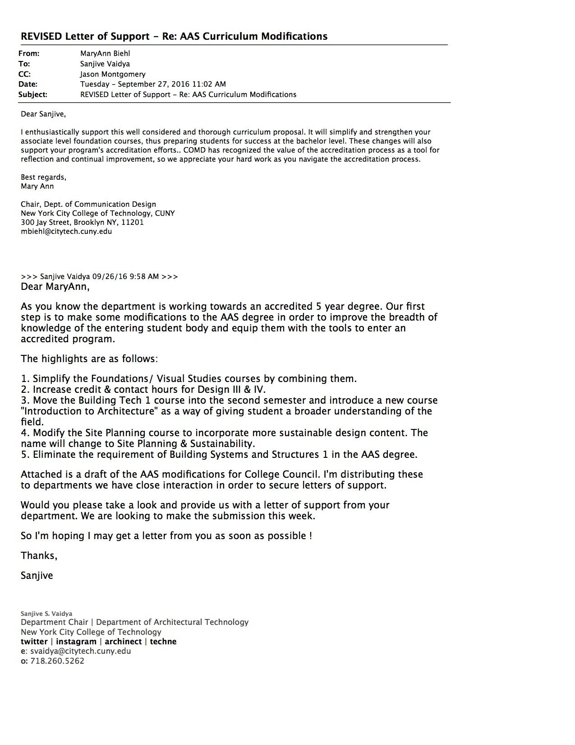

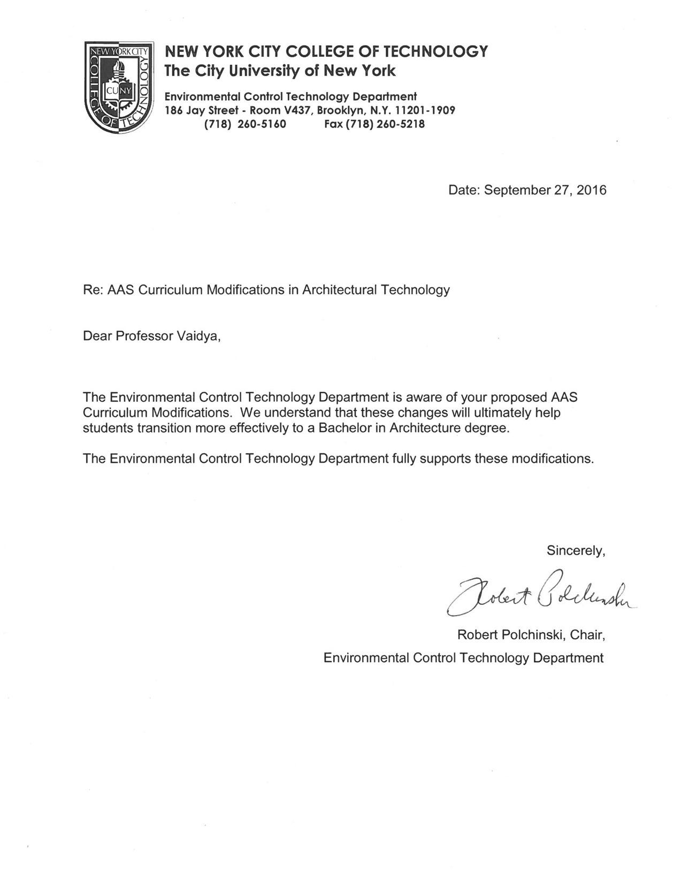

**Letter from Academic Dean**

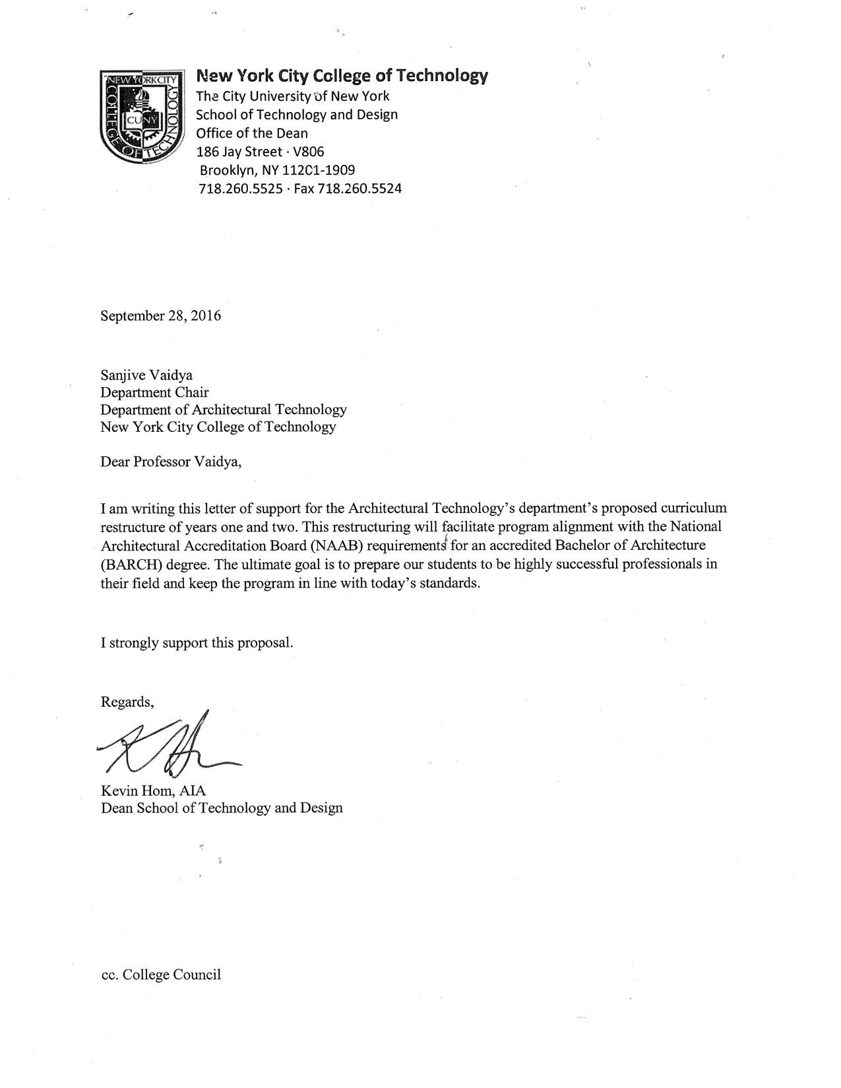

**Library Resources & Information Literacy**

Not applicable as there are no courses content changes that require additional library resources

# CHANCELLOR’S UNIVERSITY REPORT DOCUMENTS

Section AIII: Changes in Degree Programs

**The following revisions are proposed for the AAS in ARCHITECTURAL TECHNOLOGY**

**Program: AAS in ARCHITECTURAL TECHNOLOGY**

**Program Code:**

**Effective Date: 2017 FALL**

|  |  |
| --- | --- |
| **FROM:** | **TO:** |
| **GENERAL EDUCATION COMMON CORE 20-21**  **I – REQUIRED CORE (3 COURSES, 11-12 CREDITS)**  ENG 1101 English Composition I 3  MAT 1275 College Algebra and Trigonometry or higher 4  PHYS 1433 General Physics I: Algebra Based 4  or  PHYS 1441 General Physics I: Calculus Based 5  **II – FLEXIBLE CORE (3 COURSES, 9 CREDITS)**  In addition to the required courses listed below, select one course from two of the other four areas; no more than two courses may be selected from any discipline. 6  **World Cultures and Global Issues**  Any approved course  **US Experience in its Diversity**  Any approved course  **Individual and Society**  Any approved course  **Creative Expression**  ARCH 2321/ARTH23215 History of Architecture 1900 to the Present 3  **Scientific World**  Any approved course  **Writing Intensive Requirement**  Students at New York City College of Technology must complete two courses designated WI for the associate level, one from GenEd and one from the major; and two additional courses designated WI for the baccalaureate level, one from GenEd and one from the major.  **PROGRAM-SPECIFIC DEGREE REQUIREMENTS 44**  ARCH 1112 Architectural Design I: Foundations & Visual Studies 5  ARCH 1121 History of World Architecture to 1900 2  ~~ARCH 1130 Building Technology I 3~~  ARCH 1212 Architectural Design II: Foundations & Visual Studies 5  ~~ARCH 1230 Building Technology II 3~~  ARCH 1250 Site Planning 2  ~~ARCH 2310 Architectural Design III 4~~  ARCH 2321 History of Architecture 1900 to present Met as GenEd  ~~ARCH 2330 Building Technology III 4~~  ~~ARCH 2410 Architectural Design IV 4~~  ~~ARCH 2480 Structures I 3~~  ~~ARCH 2430 Building Technology IV 3~~  ~~ARCH 2370 Building Systems 3~~  ENG 1101 English Composition I Met as GenEd  MAT 1275 _ College Algebra and Trigonometry or higher Met as GenEd  PHYS 1433 General Physics I: Algebra Based Met as GenEd  or  PHYS 1441 General Physics I: Calculus Based Met as GenEd  ELECTIVES (Choose One)  ARCH 3550 Building Performance Workshop 3  ARCH 3551 Sustainability: History and Practice 3  ARCH 3570 Lighting and Acoustics 3  ARCH 3590 Parametric Computation, Materials Fabrication 3 ARCH 3591 Computer assisted Architectural Animation 3  ARCH 3609 Integrated Software in the Architectural Office 3 ARCH 3631 Advance Material Workshop 3  ARCH 3640 Historic Preservation Theory and Practice 3 ARCH 3662 Government Regulations and Approvals 3 ARCH 3690 Intermediate Computation and Fabrication 3  ARCH 3691 Advanced Design and Building Information Modeling 3  ARCH 3900 Study Abroad 3  ARCH 4709 Advanced 3D Modeling and Rendering 3  ARCH 4740 Detail and Construction of Existing Buildings 3 ARCH 4780 Case Studies in Structural Engineering 3  ARCH 4791 Advanced Design and Building Information  Modeling and Integrated Project Delivery 3  ARCH 4831 Design To Build 3  ARCH 4890 Computation and Fabrication: Performative Architecture 3  ARCH 4900 Internship in Architectural Technology 3  **TOTAL PROGRAM-SPECIFIC REQUIRED AND ELECTIVE COURSES** **44**  **TOTAL NYSED LIBERAL ARTS AND SCIENCE CREDITS  20-21**  **TOTAL CREDITS REQUIRED FOR THE DEGREE  64-65**  For progression in and graduation from the Architectural Technology program, a minimum grade of “C” is required in the following courses in the major: all required Design and Construction Technology Studios (ARCH 1112, ARCH 1212, ARCH ~~2310~~, and ARCH ~~2410~~) and Building Technology courses (ARCH ~~1130~~, ARCH ~~1230~~, ARCH ~~2330, ARCH 2430~~). | **GENERAL EDUCATION COMMON CORE 20-21**  **I – REQUIRED CORE (3 COURSES, 11-12 CREDITS)**  ENG 1101 English Composition I 3  MAT 1275 College Algebra and Trigonometry or higher 4  PHYS 1433 General Physics I: Algebra Based 4  or  PHYS 1441 General Physics I: Calculus Based 5  **II – FLEXIBLE CORE (3 COURSES, 9 CREDITS)**  In addition to the required courses listed below, select one course from two of the other four areas; no more than two courses may be selected from any discipline. 6  **World Cultures and Global Issues**  Any approved course  **US Experience in its Diversity**  Any approved course  **Individual and Society**  Any approved course  **Creative Expression**  ARCH 2321/ARTH23215 History of Architecture 1900 to the Present 3  **Scientific World**  Any approved course  **Writing Intensive Requirement**  Students at New York City College of Technology must complete two courses designated WI for the associate level, one from GenEd and one from the major; and two additional courses designated WI for the baccalaureate level, one from GenEd and one from the major.  **PROGRAM-SPECIFIC DEGREE REQUIREMENTS 44**  ARCH 1101 Introduction to Architecture 2  ARCH 1112 Architectural Design I: Foundations & Visual Studies 5  ARCH 1121 History of World Architecture to 1900 2  ARCH 1231 Building Technology I 3  ARCH 1212 Architectural Design II: Foundations & Visual Studies 5  ARCH 2331 Building Technology II 3  ARCH 1250 Site Planning 2  ARCH 2312 Architectural Design III 5  ARCH 2321 History of Architecture 1900 to present Met as GenEd  ARCH 2431 Building Technology III 4  ARCH 2412 Architectural Design IV 5  ARCH 2381 Structures I 2  ARCH 2481 Structures II 3  ENG 1101 English Composition I Met as GenEd  MAT 1275 _ College Algebra and Trigonometry or higher Met as GenEd  PHYS 1433 General Physics I: Algebra Based Met as GenEd  or  PHYS 1441 General Physics I: Calculus Based Met as GenEd  ELECTIVES (Choose One)  ARCH 3550 Building Performance Workshop 3  ARCH 3551 Sustainability: History and Practice 3  ARCH 3570 Lighting and Acoustics 3  ARCH 3590 Parametric Computation, Materials Fabrication 3 ARCH 3591 Computer assisted Architectural Animation 3  ARCH 3609 Integrated Software in the Architectural Office 3 ARCH 3631 Advance Material Workshop 3  ARCH 3640 Historic Preservation Theory and Practice 3 ARCH 3662 Government Regulations and Approvals 3 ARCH 3690 Intermediate Computation and Fabrication 3  ARCH 3691 Advanced Design and Building Information Modeling 3  ARCH 3900 Study Abroad 3  ARCH 4709 Advanced 3D Modeling and Rendering 3  ARCH 4740 Detail and Construction of Existing Buildings 3 ARCH 4780 Case Studies in Structural Engineering 3  ARCH 4791 Advanced Design and Building Information  Modeling and Integrated Project Delivery 3  ARCH 4831 Design To Build 3  ARCH 4890 Computation and Fabrication: Performative Architecture 3  ARCH 4900 Internship in Architectural Technology 3  **TOTAL PROGRAM-SPECIFIC REQUIRED AND ELECTIVE COURSES**  **44**  **TOTAL NYSED LIBERAL ARTS AND SCIENCE CREDITS  20-21**  **TOTAL CREDITS REQUIRED FOR THE DEGREE  64-65**  For progression in and graduation from the Architectural Technology program, a minimum grade of “C” is required in the following courses in the major: all required Design and Construction Technology Studios (ARCH 1112, ARCH 1212, ARCH 2312, and ARCH 2412) and Building Technology courses (ARCH 1231, ARCH 2331, ARCH 2431). |
|  |  |

**The following revisions are proposed for the BACHELOR OF TECHNOLOGY IN ARCHITECTURAL TECHNOLOGY**

**Program: BTech in ARCHITECTURAL TECHNOLOGY**

**Program Code:**

**Effective Date: 2017 FALL**

|  |  |
| --- | --- |
| **FROM:** | **TO:** |
| **BTech candidates must complete the AAS as indicated above**  **PROGRAM-SPECIFIC DEGREE REQUIREMENTS ~~25-28~~**  BACCALAUREATE-LEVEL COURSES  ARCH 3510 Architectural Design V 4  ARCH 3522 History of New York City Architecture Met as GenEd / BTech Elective  ~~ARCH 3580 Structures ll 3~~  ARCH 3610 Architectural Design Vl: Advanced Design  **or**  ARCH 3630 Advanced Detailing Studio 5  ARCH 4710 Architectural Design Vll: Urban Design 5  ARCH 4740 Detail and Construction Technologies for  Existing Buildings 3  ARCH 4810 Architectural Design Vlll: Special Topics  **or**  ARCH 4830 Construction Technology: Special Topics 5  ARCH 4861 Professional Practice 3  **ELECTIVE COURSES IN THE MAJOR (BTECH ELECTIVE)** **~~6-9~~**  **TOTAL PROGRAM-SPECIFIC REQUIRED AND ELECTIVE COURSES 78**  **TOTAL NYSED LIBERAL ARTS AND SCIENCE CREDITS**   **42**  **TOTAL CREDITS REQUIRED FOR THE DEGREE**  **120**  For progression in and graduation from this Architectural Technology program, a minimum grade of “C” is required in the following courses in the major: all required Design and Construction Technology Studios (ARCH 1110, ARCH 1210, ARCH ~~2310~~, ARCH ~~2410~~, ARCH 3510, ARCH 3610, ARCH 3630, ARCH 4710, ARCH 4810 and ARCH 4830), and all required Visual Studies (ARCH 1191, ARCH 1291) and Building Technology courses (ARCH ~~1130~~, ARCH ~~1230~~, ARCH ~~2330~~, ARCH ~~2430~~).  Students may not enroll in multiple studios concurrently, i.e. students may enroll in only one course per semester from the following list: ARCH 3610, ARCH 3630, ARCH 4710, ARCH 4810, ARCH 4830. | **BTech candidates must complete the AAS as indicated above**  **PROGRAM-SPECIFIC DEGREE REQUIREMENTS 28-31**  BACCALAUREATE-LEVEL COURSES  ARCH 3510 Architectural Design V 4  ARCH 3522 History of New York City Architecture Met as GenEd / BTech Elective  ARCH 3610 Architectural Design Vl: Advanced Design  **or**  ARCH 3630 Advanced Detailing Studio 5  ARCH 4710 Architectural Design Vll: Urban Design 5  ARCH 4740 Detail and Construction Technologies for  Existing Buildings 3  ARCH 4810 Architectural Design Vlll: Special Topics  **or**  ARCH 4830 Construction Technology: Special Topics 5  ARCH 4861 Professional Practice 3  ARCH 3531 Building Technology IV 3  ARCH 2370 Building Systems 3  **ELECTIVE COURSES IN THE MAJOR (BTECH ELECTIVE)** **3-6**  (no changes to options)  **TOTAL PROGRAM-SPECIFIC REQUIRED AND ELECTIVE COURSES 78**  (no change)  **TOTAL NYSED LIBERAL ARTS AND SCIENCE CREDITS**   **42**  (no change)  **TOTAL CREDITS REQUIRED FOR THE DEGREE**  **120**  For progression in and graduation from this Architectural Technology program, a minimum grade of “C” is required in the following courses in the major: all required Design and Construction Technology Studios (ARCH 1110, ARCH 1210, ARCH 2312, ARCH 2412, ARCH 3510, ARCH 3610, ARCH 3630, ARCH 4710, ARCH 4810 and ARCH 4830), and all required Visual Studies (ARCH 1191, ARCH 1291) and Building Technology courses (ARCH 1231, ARCH 2331, ARCH 2431, ARCH 3531).  Students may not enroll in multiple studios concurrently, i.e. students may enroll in only one course per semester from the following list: ARCH 3610, ARCH 3630, ARCH 4710, ARCH 4810, ARCH 4830. |
|  |  |

**Section AIV: New Courses**

not applicable no new courses added

# Section AV: Changes to Existing Courses

**Changes to be offered in the Architectural Technology department**

|  |  |  |  |
| --- | --- | --- | --- |
| **CUNYFirst Course ID** | ARCH 1101 |  |  |
| **FROM:** |  | **TO:** |  |
| **Department(s)** |  | **Department(s)** |  |
| **Course** | ARCH 1101 Introduction to Architecture | **Course** | ARCH 1101 Introduction to Architecture |
| **Prerequisite** | none | **Prerequisite** | none |
| **Corequisite** | none | **Corequisite** | none |
| **Pre- or corequisite** | none | **Pre- or corequisite** | none |
| **Hours** | ~~1 cl hr, 4 lab hours~~ | **Hours** | 0 cl hr, 4 lab hours |
| **Credits** | ~~3~~ | **Credits** | 2 |
| **Description** | Understanding architecture is achieved by developing a visual literacy of New York City’s built environment. Using the city as a living laboratory, students explore concepts of design, composition, and construction by sketching and writing about their direct experience of buildings. ~~Accompanying lectures focus on freehand drawing techniques, basic drafting skill and graphic standards, concepts of composition, writing about buildings and their construction, and reading architectural drawings.~~ Students develop graphic skills and the basic foundation to talk, write, and graphically express architecture and its construction. | **Description** | Understanding architecture is achieved by developing a visual literacy of New York City’s built environment. Using the city as a living laboratory, students explore concepts of design, composition, and construction by sketching and writing about their direct experience of buildings. Focus workshops on freehand drawing techniques, basic drafting skills, graphic standards, 2D and 3D composition, writing about buildings and their construction, and reading architectural drawings are central to this course. Students develop graphic skills and the basic foundation to talk, write, and graphically express architecture and its construction. |
| **Requirement Designation** |  | **Requirement Designation** |  |
| **Liberal Arts** | [ ] Yes [ ] No | **Liberal Arts** | [ ] Yes [ ] No |
| **Course Attribute (e.g. Writing Intensive, Honors, etc** |  | **Course Attribute (e.g. Writing Intensive, Honors, etc** |  |
| **Course Applicability** | |  | | --- | | [ ] Major | | [ ] Gen Ed Required | | [ ] English Composition | | [ ] Mathematics | | [ ] Science | | [ ] Gen Ed - Flexible | | [ ] World Cultures | | [ ] US Experience in its Diversity | | [ ] Creative Expression | | [ ] Individual and Society | | [ ] Scientific World | | [ ] Gen Ed - College Option | | [ ] Speech | | [ ] Interdisciplinary | | [ ] Advanced Liberal Arts | | **Course Applicability** | |  | | --- | | [x ] Major | | [ ] Gen Ed Required | | [ ] English Composition | | [ ] Mathematics | | [ ] Science | | [ ] Gen Ed - Flexible | | [ ] World Cultures | | [ ] US Experience in its Diversity | | [ ] Creative Expression | | [ ] Individual and Society | | [ ] Scientific World | | [ ] Gen Ed - College Option | | [ ] Speech | | [ ] Interdisciplinary | | [ ] Advanced Liberal Arts | |
| **Effective Term** | Fall 2017 |  |  |

**Rationale:** Provides for on hands-on activities and place based learning lab introduction. To reflect this the lab focus proposal has adjusted its workload hours to support a scaffolded introduction to degree programs.

**Changes to be offered in the Architectural Technology department**

|  |  |  |  |
| --- | --- | --- | --- |
| **CUNYFirst Course ID** | ARCH 1112 |  |  |
| **FROM:** |  | **TO:** |  |
| **Department(s)** |  | **Department(s)** |  |
| **Course** | ARCH 1112 Architectural Design I:  Foundations & Visual Studies | **Course** | ARCH 1112 Architectural Design I:  Foundations & Visual Studies |
| **Prerequisite** |  | **Prerequisite** |  |
| **Corequisite** |  | **Corequisite** |  |
| **Pre- or corequisite** | ~~none~~ | **Pre- or corequisite** | ARCH 1101 |
| **Hours** |  | **Hours** |  |
| **Credits** |  | **Credits** |  |
| **Description** |  | **Description** |  |
| **Requirement Designation** |  | **Requirement Designation** |  |
| **Liberal Arts** | [ ] Yes [ ] No | **Liberal Arts** | [ ] Yes [ ] No |
| **Course Attribute (e.g. Writing Intensive, Honors, etc** |  | **Course Attribute (e.g. Writing Intensive, Honors, etc** |  |
| **Course Applicability** | |  | | --- | | [ ] Major | | [ ] Gen Ed Required | | [ ] English Composition | | [ ] Mathematics | | [ ] Science | | [ ] Gen Ed - Flexible | | [ ] World Cultures | | [ ] US Experience in its Diversity | | [ ] Creative Expression | | [ ] Individual and Society | | [ ] Scientific World | | [ ] Gen Ed - College Option | | [ ] Speech | | [ ] Interdisciplinary | | [ ] Advanced Liberal Arts | | **Course Applicability** | |  | | --- | | [ x ] Major | | [ ] Gen Ed Required | | [ ] English Composition | | [ ] Mathematics | | [ ] Science | | [ ] Gen Ed - Flexible | | [ ] World Cultures | | [ ] US Experience in its Diversity | | [ ] Creative Expression | | [ ] Individual and Society | | [ ] Scientific World | | [ ] Gen Ed - College Option | | [ ] Speech | | [ ] Interdisciplinary | | [ ] Advanced Liberal Arts | |
| **Effective Term** | Fall 2017 |  |  |

**Rationale: T**o ensure the students taking this class will have the required foundational knowledge for success.

**Changes to be offered in the Architectural Technology department**

|  |  |  |  |
| --- | --- | --- | --- |
| **CUNYFirst Course ID** | ARCH 1130 |  |  |
| **FROM:** | ARCH ~~1130~~ | **TO:** | ARCH 1231 |
| **Department(s)** |  | **Department(s)** |  |
| **Course** | ARCH ~~1130~~ Building Technology I | **Course** | ARCH 1231 Building Technology I |
| **Prerequisite** | CUNY Proficiency in Reading and Mathematics or for high school students enrolled through collaborative programs or City Poly High School who have not yet taken the SAT or completed Regents requirements; in Reading, a PSAT score of 48 or higher in Verbal and/ or Writing or successful completion of six units of high school English with an average of 80 or above and high school recommendation; and in Mathematics, a PSAT score of 50 or higher in Mathematics or a 75 or above on the math Regents exam and the successful completion of 4 units of high school algebra and geometry with an 80 or above average. | Prerequisite | ARCH 1101 and  CUNY Proficiency in Reading and Mathematics or for high school students enrolled through collaborative programs or City Poly High School who have not yet taken the SAT or completed Regents requirements; in Reading, a PSAT score of 48 or higher in Verbal and/ or Writing or successful completion of six units of high school English with an average of 80 or above and high school recommendation; and in Mathematics, a PSAT score of 50 or higher in Mathematics or a 75 or above on the math Regents exam and the successful completion of 4 units of high school algebra and geometry with an 80 or above average. |
| **Corequisite** |  | **Corequisite** |  |
| **Pre- or corequisite** |  | **Pre- or corequisite** |  |
| **Hours** |  | **Hours** |  |
| **Credits** |  | **Credits** |  |
| **Description** | An introduction to basic materials of construction and the fundamental principles of architectural hand drafting and system analysis. The coursework includes surveying existing conditions, development of drawings of plans, elevations, sections, and basic details ~~from foundation to roof~~ as well as the study of material properties and applications ~~with an emphasis on wood and masonry and shallow foundation systems.~~ | **Description** | An introduction to basic materials of construction and the fundamental principles of architectural hand drafting and system analysis. The coursework includes surveying existing conditions, development of drawings of plans, elevations, sections, and basic details as well as the study of material properties and applications. |
| **Requirement Designation** |  | **Requirement Designation** |  |
| **Liberal Arts** | [ ] Yes [ ] No | **Liberal Arts** | [ ] Yes [ ] No |
| **Course Attribute (e.g. Writing Intensive, Honors, etc** |  | **Course Attribute (e.g. Writing Intensive, Honors, etc** |  |
| **Course Applicability** | |  | | --- | | [ ] Major | | [ ] Gen Ed Required | | [ ] English Composition | | [ ] Mathematics | | [ ] Science | | [ ] Gen Ed - Flexible | | [ ] World Cultures | | [ ] US Experience in its Diversity | | [ ] Creative Expression | | [ ] Individual and Society | | [ ] Scientific World | | [ ] Gen Ed - College Option | | [ ] Speech | | [ ] Interdisciplinary | | [ ] Advanced Liberal Arts | | **Course Applicability** | |  | | --- | | [ x ] Major | | [ ] Gen Ed Required | | [ ] English Composition | | [ ] Mathematics | | [ ] Science | | [ ] Gen Ed - Flexible | | [ ] World Cultures | | [ ] US Experience in its Diversity | | [ ] Creative Expression | | [ ] Individual and Society | | [ ] Scientific World | | [ ] Gen Ed - College Option | | [ ] Speech | | [ ] Interdisciplinary | | [ ] Advanced Liberal Arts | |
| **Effective Term** | Fall 2017 |  |  |

**Rationale:** The prerequisite and description are edited to align it with the new sequence and to support the enhancing of student foundational knowledge.

**Changes to be offered in the Architectural Technology department**

|  |  |  |  |
| --- | --- | --- | --- |
| **CUNYFirst Course ID** | ARCH 1212 |  |  |
| **FROM:** |  | **TO:** |  |
| **Department(s)** |  | **Department(s)** |  |
| **Course** | ARCH 1212 Architectural Design II:  Foundations & Visual Studies | **Course** | ARCH 1212 Architectural Design II:  Foundations & Visual Studies |
| **Prerequisite** | ARCH 1112 OR ARCH 1110 and ARCH 1191 with a grade of C or higher | **Prerequisite** | ARCH 1101 and (ARCH 1112 with a grade of C or higher OR (ARCH 1110 and ARCH 1191 with a grade of C or higher)) |
| **Corequisite** |  | **Corequisite** |  |
| **Pre- or corequisite** | MAT 1275 or higher | **Pre- or corequisite** | MAT 1275 or higher |
| **Hours** |  | **Hours** |  |
| **Credits** |  | **Credits** |  |
| **Description** |  | **Description** |  |
| **Requirement Designation** |  | **Requirement Designation** |  |
| **Liberal Arts** | [ ] Yes [ ] No | **Liberal Arts** | [ ] Yes [ ] No |
| **Course Attribute (e.g. Writing Intensive, Honors, etc** |  | **Course Attribute (e.g. Writing Intensive, Honors, etc** |  |
| **Course Applicability** | |  | | --- | | [ ] Major | | [ ] Gen Ed Required | | [ ] English Composition | | [ ] Mathematics | | [ ] Science | | [ ] Gen Ed - Flexible | | [ ] World Cultures | | [ ] US Experience in its Diversity | | [ ] Creative Expression | | [ ] Individual and Society | | [ ] Scientific World | | [ ] Gen Ed - College Option | | [ ] Speech | | [ ] Interdisciplinary | | [ ] Advanced Liberal Arts | | **Course Applicability** | |  | | --- | | [ x ] Major | | [ ] Gen Ed Required | | [ ] English Composition | | [ ] Mathematics | | [ ] Science | | [ ] Gen Ed - Flexible | | [ ] World Cultures | | [ ] US Experience in its Diversity | | [ ] Creative Expression | | [ ] Individual and Society | | [ ] Scientific World | | [ ] Gen Ed - College Option | | [ ] Speech | | [ ] Interdisciplinary | | [ ] Advanced Liberal Arts | |
| **Effective Term** | Fall 2017 |  |  |

**Rationale:** Prerequisites increased to ensure the students taking this class have the required foundational knowledge for success.

**Changes to be offered in the Architectural Technology department**

|  |  |  |  |
| --- | --- | --- | --- |
| **CUNYFirst Course ID** | ARCH 1230 |  |  |
| **FROM:** | ARCH ~~1230~~ | **TO:** | ARCH 2331 |
| **Department(s)** |  | **Department(s)** |  |
| **Course** | ARCH ~~1230~~ Building Technology II | **Course** | ARCH 2331 Building Technology II |
| **Prerequisite** | ARCH 1130 with a grade of C or higher | **Prerequisite** | ARCH 1130 with a grade of C or higher or  ARCH 1231 with a grade of C or higher |
| **Corequisite** |  | **Corequisite** |  |
| **Pre- or corequisite** | ~~ARCH 1191 with a grade of C or higher if it is taken as a prerequisite~~ | **Pre- or corequisite** | ARCH 1112 and MAT 1275 |
| **Hours** |  | **Hours** |  |
| **Credits** |  | **Credits** |  |
| **Description** | A study of the basic materials of construction as well as the theory and practice of building technology. The course will include investigation of the assembly of building components and methods of construction while developing proficiency in both analog and digital drawing  ~~building information modeling (BIM)~~ techniques, and professional level construction drawing. | **Description** | A study of the basic materials of construction as well as the theory and practice of building technology. The course will include investigation of the assembly of building components and methods of construction while developing proficiency in both analog and digital drawing techniques, and professional level construction drawing. |
| **Requirement Designation** |  | **Requirement Designation** |  |
| **Liberal Arts** | [ ] Yes [ ] No | **Liberal Arts** | [ ] Yes [ ] No |
| **Course Attribute (e.g. Writing Intensive, Honors, etc** |  | **Course Attribute (e.g. Writing Intensive, Honors, etc** |  |
| **Course Applicability** | |  | | --- | | [ ] Major | | [ ] Gen Ed Required | | [ ] English Composition | | [ ] Mathematics | | [ ] Science | | [ ] Gen Ed - Flexible | | [ ] World Cultures | | [ ] US Experience in its Diversity | | [ ] Creative Expression | | [ ] Individual and Society | | [ ] Scientific World | | [ ] Gen Ed - College Option | | [ ] Speech | | [ ] Interdisciplinary | | [ ] Advanced Liberal Arts | | **Course Applicability** | |  | | --- | | [ x ] Major | | [ ] Gen Ed Required | | [ ] English Composition | | [ ] Mathematics | | [ ] Science | | [ ] Gen Ed - Flexible | | [ ] World Cultures | | [ ] US Experience in its Diversity | | [ ] Creative Expression | | [ ] Individual and Society | | [ ] Scientific World | | [ ] Gen Ed - College Option | | [ ] Speech | | [ ] Interdisciplinary | | [ ] Advanced Liberal Arts | |
| **Effective Term** | Fall 2017 |  |  |

**Rationale:** The pre- or corequisite and description are edited to align it with the new sequence and to support the enhancing of student foundational knowledge.

**Changes to be offered in the Architectural Technology department**

|  |  |  |  |
| --- | --- | --- | --- |
| **CUNYFirst Course ID** | ARCH 1250 |  |  |
| **FROM:** |  | **TO:** |  |
| **Department(s)** |  | **Department(s)** |  |
| **Course** | ARCH 1250 Site Planning | **Course** | ARCH 1250 Site Planning |
| **Prerequisite** | ~~ARCH 1130 with a grade of C or higher~~ | **Prerequisite** | ARCH 1101 |
| **Corequisite** |  | **Corequisite** |  |
| **Pre- or corequisite** | MAT 1275 or higher, ~~ARCH 1210 with a grade of C or higher if it is a prerequisite~~ | **Pre- or corequisite** | MAT 1275 or higher |
| **Hours** |  | **Hours** |  |
| **Credits** |  | **Credits** |  |
| **Description** | . | **Description** |  |
| **Requirement Designation** |  | **Requirement Designation** |  |
| **Liberal Arts** | [ ] Yes [ ] No | **Liberal Arts** | [ ] Yes [ ] No |
| **Course Attribute (e.g. Writing Intensive, Honors, etc** |  | **Course Attribute (e.g. Writing Intensive, Honors, etc** |  |
| **Course Applicability** | |  | | --- | | [ ] Major | | [ ] Gen Ed Required | | [ ] English Composition | | [ ] Mathematics | | [ ] Science | | [ ] Gen Ed - Flexible | | [ ] World Cultures | | [ ] US Experience in its Diversity | | [ ] Creative Expression | | [ ] Individual and Society | | [ ] Scientific World | | [ ] Gen Ed - College Option | | [ ] Speech | | [ ] Interdisciplinary | | [ ] Advanced Liberal Arts | | **Course Applicability** | |  | | --- | | [ x ] Major | | [ ] Gen Ed Required | | [ ] English Composition | | [ ] Mathematics | | [ ] Science | | [ ] Gen Ed - Flexible | | [ ] World Cultures | | [ ] US Experience in its Diversity | | [ ] Creative Expression | | [ ] Individual and Society | | [ ] Scientific World | | [ ] Gen Ed - College Option | | [ ] Speech | | [ ] Interdisciplinary | | [ ] Advanced Liberal Arts | |
| **Effective Term** | Fall 2017 |  |  |

**Rationale:** The pre- or corequisite and description are edited to align it with the new sequence and to support the enhancing of student foundational knowledge.

**Changes to be offered in the Architectural Technology department**

|  |  |  |  |
| --- | --- | --- | --- |
| **CUNYFirst Course ID** | ARCH 2310 |  |  |
| **FROM:** | ARCH ~~2310~~ | **TO:** | ARCH 2312 |
| **Department(s)** |  | **Department(s)** |  |
| **Course** | ARCH ~~2310~~ Architectural Design III | **Course** | ARCH 2312 Architectural Design III |
| **Prerequisite** | ARCH 1210 and ARCH 1291, both with a grade of C or higher | **Prerequisite** | (ARCH 1212 with a grade of C) or (ARCH 1210 and ARCH 1291, both with a grade of C or higher) |
| **Corequisite** |  | **Corequisite** |  |
| **Pre- or corequisite** | ARCH 1250 | **Pre- or corequisite** | ARCH 1250 |
| **Hours** | 1 cl hr, ~~6 lab/studio hrs~~ | **Hours** | 1 cl hr, 8 lab/studio hrs |
| **Credits** | 4 | **Credits** | 5 |
| **Description** |  | **Description** |  |
| **Requirement Designation** |  | **Requirement Designation** |  |
| **Liberal Arts** | [ ] Yes [ ] No | **Liberal Arts** | [ ] Yes [ ] No |
| **Course Attribute (e.g. Writing Intensive, Honors, etc** |  | **Course Attribute (e.g. Writing Intensive, Honors, etc** |  |
| **Course Applicability** | |  | | --- | | [ ] Major | | [ ] Gen Ed Required | | [ ] English Composition | | [ ] Mathematics | | [ ] Science | | [ ] Gen Ed - Flexible | | [ ] World Cultures | | [ ] US Experience in its Diversity | | [ ] Creative Expression | | [ ] Individual and Society | | [ ] Scientific World | | [ ] Gen Ed - College Option | | [ ] Speech | | [ ] Interdisciplinary | | [ ] Advanced Liberal Arts | | **Course Applicability** | |  | | --- | | [ x ] Major | | [ ] Gen Ed Required | | [ ] English Composition | | [ ] Mathematics | | [ ] Science | | [ ] Gen Ed - Flexible | | [ ] World Cultures | | [ ] US Experience in its Diversity | | [ ] Creative Expression | | [ ] Individual and Society | | [ ] Scientific World | | [ ] Gen Ed - College Option | | [ ] Speech | | [ ] Interdisciplinary | | [ ] Advanced Liberal Arts | |
| **Effective Term** | Fall 2017 |  |  |

**Rationale:** This change will add depth to the course. This is depth will report all the students learning objectives. In addition, this increase in depth is necessary for the program to facilitate achieve the National Architectural Accrediting Board’s Student Performance Criteria.

**Changes to be offered in the Architectural Technology department**

|  |  |  |  |
| --- | --- | --- | --- |
| **CUNYFirst Course ID** | ARCH 2330 |  |  |
| **FROM:** | ~~ARCH 2330~~ | **TO:** | ARCH 2431 |
| **Department(s)** |  | **Department(s)** |  |
| **Course** | ARCH ~~2330~~ Building Technology III | **Course** | ARCH 2431 Building Technology III |
| **Prerequisite** | ARCH 1230 with a grade of C or higher | **Prerequisite** | MAT 1275 and (ARCH 1230 with a grade of C or higher or ARCH 2331 with a grade of C or higher) |
| **Corequisite** |  | **Corequisite** |  |
| **Pre- or corequisite** |  | **Pre- or corequisite** |  |
| **Hours** |  | **Hours** |  |
| **Credits** |  | **Credits** |  |
| **Description** | The course is a continuation of the building technology sequence and introduces the student to building renovation. Using digital technologies, the student analyzes factors, such as codes and government regulations, human ergonomics, and  sustainability which affect building use and construction and creates a set of working drawings and series of reports. | **Description** | The course is a continuation of the building technology sequence and introduces the student to building renovation. Using digital technologies, the student analyzes factors, such as codes and government regulations, human ergonomics, and sustainability which affect building use and construction and creates a set of working drawings and series of reports. Building information modeling (BIM) techniques and tools are utilized in this course. |
| **Requirement Designation** |  | **Requirement Designation** |  |
| **Liberal Arts** | [ ] Yes [ ] No | **Liberal Arts** | [ ] Yes [ ] No |
| **Course Attribute (e.g. Writing Intensive, Honors, etc** |  | **Course Attribute (e.g. Writing Intensive, Honors, etc** |  |
| **Course Applicability** | |  | | --- | | [ ] Major | | [ ] Gen Ed Required | | [ ] English Composition | | [ ] Mathematics | | [ ] Science | | [ ] Gen Ed - Flexible | | [ ] World Cultures | | [ ] US Experience in its Diversity | | [ ] Creative Expression | | [ ] Individual and Society | | [ ] Scientific World | | [ ] Gen Ed - College Option | | [ ] Speech | | [ ] Interdisciplinary | | [ ] Advanced Liberal Arts | | **Course Applicability** | |  | | --- | | [ x ] Major | | [ ] Gen Ed Required | | [ ] English Composition | | [ ] Mathematics | | [ ] Science | | [ ] Gen Ed - Flexible | | [ ] World Cultures | | [ ] US Experience in its Diversity | | [ ] Creative Expression | | [ ] Individual and Society | | [ ] Scientific World | | [ ] Gen Ed - College Option | | [ ] Speech | | [ ] Interdisciplinary | | [ ] Advanced Liberal Arts | |
| **Effective Term** | Fall 2017 |  |  |

**Rationale:** The pre- or corequisite and description are edited to align it with the new sequence and to support the enhancing of student foundational knowledge.

**Changes to be offered in the Architectural Technology department**

|  |  |  |  |
| --- | --- | --- | --- |
| **CUNYFirst Course ID** | ARCH 2410 |  |  |
| **FROM:** | ARCH ~~2410~~ | **TO:** | ARCH 2412 |
| **Department(s)** |  | **Department(s)** |  |
| **Course** | ARCH ~~2410~~ Architectural Design IV | **Course** | ARCH 2412 Architectural Design IV |
| **Prerequisite** | ARCH 2310 with a grade of C or higher | **Prerequisite** | ARCH 1250 and (ARCH 2310 or ARCH 2312 with a grade of C or higher) and (ARCH 1291 or ARCH 1212 with a grade of C or higher) |
| **Corequisite** |  | **Corequisite** |  |
| **Pre- or corequisite** | ARCH 2321; ~~ARCH 1291 with a grade of C or higher if it is taken as a prerequisite~~ | **Pre- or corequisite** | (ARCH 2321) and (ARCH 1230 with a grade of C or higher if it is taken as a prerequisite or ARCH 2331 with a grade of C or higher if it is taken as a prerequisite) |
| **Hours** | 1 cl hr, ~~6 lab/studio hrs~~ | **Hours** | 1 cl hr, 8 lab/studio hrs |
| **Credits** | 4 | **Credits** | 5 |
| **Description** |  | **Description** |  |
| **Requirement Designation** |  | **Requirement Designation** |  |
| **Liberal Arts** | [ ] Yes [ ] No | **Liberal Arts** | [ ] Yes [ ] No |
| **Course Attribute (e.g. Writing Intensive, Honors, etc** |  | **Course Attribute (e.g. Writing Intensive, Honors, etc** |  |
| **Course Applicability** | |  | | --- | | [ ] Major | | [ ] Gen Ed Required | | [ ] English Composition | | [ ] Mathematics | | [ ] Science | | [ ] Gen Ed - Flexible | | [ ] World Cultures | | [ ] US Experience in its Diversity | | [ ] Creative Expression | | [ ] Individual and Society | | [ ] Scientific World | | [ ] Gen Ed - College Option | | [ ] Speech | | [ ] Interdisciplinary | | [ ] Advanced Liberal Arts | | **Course Applicability** | |  | | --- | | [ x ] Major | | [ ] Gen Ed Required | | [ ] English Composition | | [ ] Mathematics | | [ ] Science | | [ ] Gen Ed - Flexible | | [ ] World Cultures | | [ ] US Experience in its Diversity | | [ ] Creative Expression | | [ ] Individual and Society | | [ ] Scientific World | | [ ] Gen Ed - College Option | | [ ] Speech | | [ ] Interdisciplinary | | [ ] Advanced Liberal Arts | |
| **Effective Term** | Fall 2017 |  |  |

**Rationale:** This change will add depth to the course. This is depth will report all the students learning objectives. In addition, this increase in depth is necessary for the program to facilitate achieve the National Architectural Accrediting Board’s Student Performance Criteria.

**Changes to be offered in the Architectural Technology department**

|  |  |  |  |
| --- | --- | --- | --- |
| **CUNYFirst Course ID** | ARCH 2430 |  |  |
| **FROM:** | ARCH ~~2430~~ | **TO:** | ARCH 3531 |
| **Department(s)** |  | **Department(s)** |  |
| **Course** | ARCH ~~2430~~ Building Technology IV | **Course** | ARCH 3531 Building Technology IV |
| **Prerequisite** | ARCH 2330 with a grade of C or higher | **Prerequisite** | (ARCH 2431 with a grade of C or higher) or (ARCH 2330 with a grade of C or higher) |
| **Corequisite** |  | **Corequisite** |  |
| **Pre- or corequisite** |  | **Pre- or corequisite** |  |
| **Hours** |  | **Hours** |  |
| **Credits** |  | **Credits** |  |
| **Description** | The final course in a four-part sequence. Using digital technologies, the student explores the mechanics of building enclosures on ~~steel framed~~ structures and creates a set of working drawings. Emphasis is on communication and collaboration  skills necessary in the professional office. | **Description** | The final course in a four-part sequence. Using digital technologies, the student explores the mechanics of building enclosures and structures and creates a set of working drawings. Emphasis is on communication and collaboration  skills necessary in the professional office. Building information modeling (BIM) techniques and tools emphasized this course. |
| **Requirement Designation** |  | **Requirement Designation** |  |
| **Liberal Arts** | [ ] Yes [ ] No | **Liberal Arts** | [ ] Yes [ ] No |
| **Course Attribute (e.g. Writing Intensive, Honors, etc** |  | **Course Attribute (e.g. Writing Intensive, Honors, etc** |  |
| **Course Applicability** | |  | | --- | | [ ] Major | | [ ] Gen Ed Required | | [ ] English Composition | | [ ] Mathematics | | [ ] Science | | [ ] Gen Ed - Flexible | | [ ] World Cultures | | [ ] US Experience in its Diversity | | [ ] Creative Expression | | [ ] Individual and Society | | [ ] Scientific World | | [ ] Gen Ed - College Option | | [ ] Speech | | [ ] Interdisciplinary | | [ ] Advanced Liberal Arts | | **Course Applicability** | |  | | --- | | [ x ] Major | | [ ] Gen Ed Required | | [ ] English Composition | | [ ] Mathematics | | [ ] Science | | [ ] Gen Ed - Flexible | | [ ] World Cultures | | [ ] US Experience in its Diversity | | [ ] Creative Expression | | [ ] Individual and Society | | [ ] Scientific World | | [ ] Gen Ed - College Option | | [ ] Speech | | [ ] Interdisciplinary | | [ ] Advanced Liberal Arts | |
| **Effective Term** | Fall 2017 |  |  |

**Rationale:** The course description is edited to align it with the new sequence and to support the enhancing of student technical knowledge.

**Changes to be offered in the Architectural Technology department**

|  |  |  |  |
| --- | --- | --- | --- |
| **CUNYFirst Course ID** | ARCH 2480 |  |  |
| **FROM:** | ARCH ~~2480~~ | **TO:** | ARCH 2381 |
| **Department(s)** |  | **Department(s)** |  |
| **Course** | ARCH ~~2480~~: Structures I | **Course** | ARCH 2381: Structures I |
| **Prerequisite** | ~~MATH 1275~~, ENG 1101 | **Prerequisite** | ENG 1101 |
| **Corequisite** |  | **Corequisite** |  |
| **Pre- or corequisite** | PHYS 1433 or higher | **Pre- or corequisite** | MATH 1275, PHYS 1433 or higher |
| **Hours** | ~~3 cl hrs, 0 lab hours~~ | **Hours** | 1 cl hrs, 2 lab hours |
| **Credits** | ~~3~~ | **Credits** | 2 |
| **Description** | ~~The analysis of architectural structures~~  ~~and their materials. A study of~~  ~~wood and steel structures using~~  ~~basic physical laws, the behavior~~  ~~of architectural materials in stress~~  ~~and intuitive reasoning related to~~  ~~the mathematical treatment of~~  ~~equilibrium in static structures~~ | **Description** | The analysis of basic physical and geometric laws relating to architectural elements and materials, including principles and understanding related to the mathematical treatment of equilibrium in static structures and strength of materials. |
| **Requirement Designation** |  | **Requirement Designation** |  |
| **Liberal Arts** | [ ] Yes [ ] No | **Liberal Arts** | [ ] Yes [ ] No |
| **Course Attribute (e.g. Writing Intensive, Honors, etc** |  | **Course Attribute (e.g. Writing Intensive, Honors, etc** |  |
| **Course Applicability** | |  | | --- | | [ ] Major | | [ ] Gen Ed Required | | [ ] English Composition | | [ ] Mathematics | | [ ] Science | | [ ] Gen Ed - Flexible | | [ ] World Cultures | | [ ] US Experience in its Diversity | | [ ] Creative Expression | | [ ] Individual and Society | | [ ] Scientific World | | [ ] Gen Ed - College Option | | [ ] Speech | | [ ] Interdisciplinary | | [ ] Advanced Liberal Arts | | **Course Applicability** | |  | | --- | | [x ] Major | | [ ] Gen Ed Required | | [ ] English Composition | | [ ] Mathematics | | [ ] Science | | [ ] Gen Ed - Flexible | | [ ] World Cultures | | [ ] US Experience in its Diversity | | [ ] Creative Expression | | [ ] Individual and Society | | [ ] Scientific World | | [ ] Gen Ed - College Option | | [ ] Speech | | [ ] Interdisciplinary | | [ ] Advanced Liberal Arts | |
| **Effective Term** | Fall 2017 |  |  |

**Rationale:** Modified to incorporate increased hands-on calculation and demonstration. MATH 1275 is an appropriate co-requisite for the revised content.

**Changes to be offered in the Architectural Technology department**

|  |  |  |  |
| --- | --- | --- | --- |
| **CUNYFirst Course ID** | ARCH 3510 |  |  |
| **FROM:** |  | **TO:** |  |
| **Department(s)** |  | **Department(s)** |  |
| **Course** | ARCH 3510: Architectural Design V | **Course** | ARCH 3510: Architectural Design V |
| **Prerequisite** | ARCH 2410 with a grade of C or higher or an AAS degree in an architecturally-related field | **Prerequisite** | (ARCH 2410 or ARCH 2412 with a grade of C or higher) or an AAS degree in an architecturally-related field |
| **Corequisite** |  | **Corequisite** |  |
| **Pre- or corequisite** | ARCH 1291 with a grade of C or higher if it is taken as a prerequisite | **Pre- or corequisite** | (ARCH 1291 or ARCH 1212) with a grade of C or higher if it is taken as a prerequisite |
| **Hours** |  | **Hours** |  |
| **Credits** |  | **Credits** |  |
| **Description** |  | **Description** |  |
| **Requirement Designation** |  | **Requirement Designation** |  |
| **Liberal Arts** | [ ] Yes [ ] No | **Liberal Arts** | [ ] Yes [ ] No |
| **Course Attribute (e.g. Writing Intensive, Honors, etc** |  | **Course Attribute (e.g. Writing Intensive, Honors, etc** |  |
| **Course Applicability** | |  | | --- | | [ ] Major | | [ ] Gen Ed Required | | [ ] English Composition | | [ ] Mathematics | | [ ] Science | | [ ] Gen Ed - Flexible | | [ ] World Cultures | | [ ] US Experience in its Diversity | | [ ] Creative Expression | | [ ] Individual and Society | | [ ] Scientific World | | [ ] Gen Ed - College Option | | [ ] Speech | | [ ] Interdisciplinary | | [ ] Advanced Liberal Arts | | **Course Applicability** | |  | | --- | | [x ] Major | | [ ] Gen Ed Required | | [ ] English Composition | | [ ] Mathematics | | [ ] Science | | [ ] Gen Ed - Flexible | | [ ] World Cultures | | [ ] US Experience in its Diversity | | [ ] Creative Expression | | [ ] Individual and Society | | [ ] Scientific World | | [ ] Gen Ed - College Option | | [ ] Speech | | [ ] Interdisciplinary | | [ ] Advanced Liberal Arts | |
| **Effective Term** | Fall 2017 |  |  |

**Rationale:** Modified prerequisites to allow for students to take the in depth path of study.

**Changes to be offered in the Architectural Technology department**

|  |  |  |  |
| --- | --- | --- | --- |
| **CUNYFirst Course ID** | ARCH 3580 |  |  |
| **FROM:** | ARCH ~~3580~~ | **TO:** | ARCH 2481 |
| **Department(s)** |  | **Department(s)** |  |
| **Course** | ARCH ~~3580~~: Structures II | **Course** | ARCH 2481: Structures II |
| **Prerequisite** | ARCH 2480, ~~MATH 1375~~, PHYS 1433 or higher | **Prerequisite** | (ARCH 2480 or ARCH 2381), MATH 1275, PHYS 1433 or higher |
| **Corequisite** |  | **Corequisite** |  |
| **Pre- or corequisite** |  | **Pre- or corequisite** |  |
| **Hours** | 3 cl hrs, 0 lab hours | **Hours** | 3 cl hrs, 0 lab hours |
| **Credits** | 3 | **Credits** | 3 |
| **Description** | Emphasis is placed on the theoretical and practical application of structural design principles ~~for new and existing~~ steel and concrete structures.The behavior of these various materials under stress, and the proper selection of each, will be discussed~~. Conditions encountered during renovations and their solutions will be included. The appropriate integration of the mechanical systems (HVAC, plumbing and electrical) for each of these structural applications will be examined.~~ | **Description** | The analysis and design of architectural structures and their materials. Emphasis is placed on the theoretical and practical study and application of wood, steel concrete structures using basic physical laws. The behavior of these various elements under stress, and the proper selection of each, will be discussed~~.~~ |
| **Requirement Designation** |  | **Requirement Designation** |  |
| **Liberal Arts** | [ ] Yes [ ] No | **Liberal Arts** | [ ] Yes [ ] No |
| **Course Attribute (e.g. Writing Intensive, Honors, etc** |  | **Course Attribute (e.g. Writing Intensive, Honors, etc** |  |
| **Course Applicability** | |  | | --- | | [ ] Major | | [ ] Gen Ed Required | | [ ] English Composition | | [ ] Mathematics | | [ ] Science | | [ ] Gen Ed - Flexible | | [ ] World Cultures | | [ ] US Experience in its Diversity | | [ ] Creative Expression | | [ ] Individual and Society | | [ ] Scientific World | | [ ] Gen Ed - College Option | | [ ] Speech | | [ ] Interdisciplinary | | [ ] Advanced Liberal Arts | | **Course Applicability** | |  | | --- | | [x ] Major | | [ ] Gen Ed Required | | [ ] English Composition | | [ ] Mathematics | | [ ] Science | | [ ] Gen Ed - Flexible | | [ ] World Cultures | | [ ] US Experience in its Diversity | | [ ] Creative Expression | | [ ] Individual and Society | | [ ] Scientific World | | [ ] Gen Ed - College Option | | [ ] Speech | | [ ] Interdisciplinary | | [ ] Advanced Liberal Arts | |
| **Effective Term** | Fall 2017 |  |  |

**Rationale:** Modified to enrich the curriculum by increasing the depth of study. Moving some components to a planned future required Structures 3 course.

**Changes to be offered in the Architectural Technology department**

|  |  |  |  |
| --- | --- | --- | --- |
| **CUNYFirst Course ID** | ARCH 3610 |  |  |
| **FROM:** |  | **TO:** |  |
| **Department(s)** |  | **Department(s)** |  |
| **Course** | ARCH 3610: Architectural Design VI | **Course** | ARCH 3610: Architectural Design VI |
| **Prerequisite** |  | **Prerequisite** |  |
| **Corequisite** |  | **Corequisite** |  |
| **Pre- or corequisite** | ARCH 1291 with a grade of C or higher if it is taken as a prerequisite | **Pre- or corequisite** | (ARCH 1291 or ARCH 1212) with a grade of C or higher if it is taken as a prerequisite |
| **Hours** |  | **Hours** |  |
| **Credits** |  | **Credits** |  |
| **Description** |  | **Description** |  |
| **Requirement Designation** |  | **Requirement Designation** |  |
| **Liberal Arts** | [ ] Yes [ ] No | **Liberal Arts** | [ ] Yes [ ] No |
| **Course Attribute (e.g. Writing Intensive, Honors, etc** |  | **Course Attribute (e.g. Writing Intensive, Honors, etc** |  |
| **Course Applicability** | |  | | --- | | [ ] Major | | [ ] Gen Ed Required | | [ ] English Composition | | [ ] Mathematics | | [ ] Science | | [ ] Gen Ed - Flexible | | [ ] World Cultures | | [ ] US Experience in its Diversity | | [ ] Creative Expression | | [ ] Individual and Society | | [ ] Scientific World | | [ ] Gen Ed - College Option | | [ ] Speech | | [ ] Interdisciplinary | | [ ] Advanced Liberal Arts | | **Course Applicability** | |  | | --- | | [x ] Major | | [ ] Gen Ed Required | | [ ] English Composition | | [ ] Mathematics | | [ ] Science | | [ ] Gen Ed - Flexible | | [ ] World Cultures | | [ ] US Experience in its Diversity | | [ ] Creative Expression | | [ ] Individual and Society | | [ ] Scientific World | | [ ] Gen Ed - College Option | | [ ] Speech | | [ ] Interdisciplinary | | [ ] Advanced Liberal Arts | |
| **Effective Term** | Fall 2017 |  |  |

**Rationale:** Modified prerequisites to allow for students to take the in depth path of study

1. http://www.naab.org/architecture-programs/school-search/
2. New York State Office of the Professions recognizes a NAAB accredited degree as contributory to the Education Requirements for Licensure, http://www.op.nysed.gov/prof/arch/archlic.htm.
3. See AAS description in 2016 catalogue, page 197.
4. for SPC content descriptions see: “Guide to the 2014 Conditions for Accreditation and Preparation of an Architecture Program Report” <http://www.naab.org/wp-content/uploads/2014-Guide-to-Conditions-for-Accreditation.pdf> pages 21-25