New York City College of Technology, CUNY
CURRICULUM MODIFICATION PROPOSAL FORM
This form is used for all curriculum modification proposals. See the Proposal Classification Chart for information about what types of modifications are major or minor. Completed proposals should be emailed to the Curriculum Committee chair.

Title of Proposal | Spanish for Health Professionals
Date | August 1, 2016
Major or Minor | Major Modification
Proposer’s Name | Dr. David Sanchez Jimenez
Department | Humanities
Date of Departmental Meeting in which proposal was approved | September 8, 2016
Department Chair Name | Dr. Ann Delilkan
Department Chair Signature and Date | 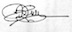 Sept. 26th, 2016
Academic Dean Name | Dr. Justin Vazquez-Poritz
Academic Dean Signature and Date | 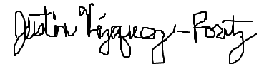September 30, 2016
Brief Description of Proposal  (Describe the modifications contained within this proposal in a succinct summary. More detailed content will be provided in the proposal body. | This new elective course in Spanish offers healthcare workers the necessary vocabulary, medical terminology, as well as pertinent grammatical structures to improve communication with the growing Spanish speaking population. The content of this course focuses on language used in medical professions and on cultural contexts in which doctors, technicians, nurses, and EMTs may find themselves.
Brief Rationale for Proposal  (Provide a concise summary of why this proposed change is important to the department. More detailed content will be provided in the proposal body). | This course provides future medical professionals who apply for programs in Nursing, Vision Care Technology, Dental Hygiene, etc., with the knowledge they need to interact in Spanish with Spanish speaking patients. This course likewise aims to support the proposal of a B.S. degree in Health Communication by the Department of Humanities and echoes the goals of a recently approved course Introduction to Heath Communication (Dr. David Lee), to improve the communication skills between provider and patient.
Proposal History  (Please provide history of this proposal: is this a resubmission? An updated version? This may most easily be expressed as a list). | 9-8-2016- New course proposal  9-30-2016- Submission with signatures  12-1-16- Minor modifications were included  2-7-2017- Approved by the Curriculum Committee

Please include all appropriate documentation as indicated in the Curriculum Modification Checklist.
For each new course, please also complete the New Course Proposal and submit in this document.

Please submit this document as a single .doc or .rtf format. If some documents are unable to be converted to .doc, then please provide all documents archived into a single .zip file.

Table of Contents

New course proposal form……………………………………………………………………...……….....…3
New course proposal checklist………………………………………………………………………....…5
Library Resource and Information Literacy Form………………………………………………….…….7
Course outline……..………………………………………………………………………………..……..9
Course design……………………………………………………………………………….….……..….15
Course need assessment………………………………………………………………………...……...........17
Chancellor’s Report …………………………………………………………………………………….…..20
CUNY Common Core Course Submission Form …………………………………………………………..21
Syllabus sample………………………………………………………………………………….……….....26
Appendix I…………………………………………………………………………………………………..34
Appendix II………………………………………………………………………………………………….38
Appendix III………………………………………………………………………………………………....39
Minor modification SPA 2201 HS……………………………………………………………………...…..40
Minor modification SPA 2202……………………………………………………………………………...43
New York City College of Technology, CUNY
NEW COURSE PROPOSAL FORM
This form is used for all new course proposals. Attach this to the Curriculum Modification Proposal Form and submit as one package as per instructions. Use one New Course Proposal Form for each new course.

Course Title | Spanish for Health Professionals
Proposal Date | September 30, 2016
Proposer’s Name | Dr. David Sánchez Jiménez
Course Number | SPA 2203
Course Credits, Hours | 3 hours 3 credits
Course Pre-Requisites | SPA 1102 with department permission; or SPA 2201; or SPA 2201HS or higher; or placement test and department permission.
Catalog Course Description | Prepares individuals studying or working in healthcare related areas to communicate effectively when providing medical care and attention to Spanish-speaking patients in professional settings. In addition to basic language skills, students acquire new grammatical structures and learn health related vocabulary. Emphasis is placed specifically on patient-professional communication.
Brief Rationale  Provide a concise summary of why this course is important to the department, school or college. | Hispanic Americans continue to be the fastest growing ethnic minority in the United States (56.6 million in 2015; 150 million predicted by 2050), the second largest Spanish-speaking country in the world (after Mexico). It is a fact that language barriers in healthcare affect 14 million patients in the United States (see proposal, Course Need Assessment). However, few healthcare providers are proficient in Spanish, have access to interpreters, or have acquired the cross-cultural sensitivity needed to operate effectively in a bilingual, bicultural community. Therefore, there is currently a need for students in the health professions to develop a working knowledge of Spanish terminology and the necessary cultural competence to serve the Hispanic population. At NYCCT, despite the existence of several Healthcare Professions programs, there is no Spanish course offering to meet such a need. It is worth noting that Spanish heritage speakers make up about 33% of the student body at NYCCT, and that many of them are enrolled in the Healthcare Professions programs. Enrolling in Spanish for Health Professionals will allow students to learn the specialized medical terminology and cultural skills necessary to communicate effectively with Spanish-speaking patients in different healthcare settings. Other CUNY schools (e.g., Hunter College, Brooklyn College, York College, Lehman College, etc.) currently offer courses similar to Spanish for Health Professionals. This course also aims to provide support for the curriculum design for the Health Communication B.S. degree that will be proposed by the Department of Humanities.
Intent to Submit as Common Core  If this course is intended to fulfill one of the requirements in the common core, then indicate which area. | Yes. US Experience in its Diversity
Intent to Submit as An Interdisciplinary Course | NO
Intent to Submit as a Writing Intensive Course | NO

Please include all appropriate documentation as indicated in the NEW COURSE PROPOSAL Combine all information into a single document that is included in the Curriculum Modification Form.

NEW COURSE PROPOSAL CHECK LIST
Use this checklist to ensure that all required documentation has been included. You may wish to use this checklist as a table of contents within the new course proposal.
Completed NEW COURSE PROPOSAL FORM
- Title, Number, Credits, Hours, Catalog course description | X
- Brief Rationale | X
Completed Library Resources and Information Literacy Form
Course Outline
Include within the outline the following.
Hours and Credits for Lecture and Labs  If hours exceed mandated Carnegie Hours, then rationale for this | X
Prerequisites/Co- requisites | X
Detailed Course Description | X
Course Specific Learning Outcome and Assessment Tables  - Discipline Specific  - General Education Specific Learning Outcome and Assessment Tables | X
Example Weekly Course outline | X
Grade Policy and Procedure | X
Recommended Instructional Materials (Textbooks, lab supplies, etc.) | X
Library resources and bibliography
Course Need Assessment.
Describe the need for this course. Include in your statement the following information.
Target Students who will take this course. Which programs or departments, and how many anticipated?  Documentation of student views (if applicable, e.g. non-required elective). | X
Projected headcounts (fall/spring and day/evening) for each new or modified course. | X
If additional physical resources are required (new space, modifications, equipment), description of these requirements. If applicable, Memo or email from the VP for Finance and Administration with written comments regarding additional and/or new facilities, renovations or construction. | N/A
Where does this course overlap with other courses, both within and outside of the department? | X
Does the Department currently have full time faculty qualified to teach this course? If not, then what plans are there to cover this? | X
If needs assessment states that this course is required by an accrediting body, then provide documentation indicating that need. | N/A
Course Design
Describe how this course is designed.
Course Context (e.g. required, elective, capstone) | X
Course Structure: how the course will be offered (e.g. lecture, seminar, tutorial, fieldtrip)? | X
Anticipated pedagogical strategies and instructional design (e.g. Group Work, Case Study, Team Project, Lecture) | X
How does this course support Programmatic Learning Outcomes? | X
Is this course designed to be partially or fully online? If so, describe how this benefits students and/or program. | X
Additional Forms for Specific Course Categories
Interdisciplinary Form (if applicable) | N/A
Common Core (Liberal Arts) Intent to Submit (if applicable) | X
Writing Intensive Form if course is intended to be a WIC (under development) | N/A
If course originated as an experimental course, then results of evaluation plan as developed with director of assessment. | N/A
(Additional materials for Curricular Experiments) | N/A
Plan and process for evaluation developed in consultation with the director of assessment. (Contact Director of Assessment for more information). | N/A
Established Timeline for Curricular Experiment | N/A

LIBRARY RESOURCES & INFORMATION LITERACY: MAJOR CURRICULUM MODIFICATION

Please complete for all major curriculum modifications. This information will assist the library in planning for new acquisitions; it will not affect curriculum proposals either positively or negatively.

Consult with library faculty subject selectors (http://cityte.ch/dir) 3 weeks in advance when planning course proposals to ensure enough time to allocate budgets if materials need to be purchased.

Course proposer: please complete boxes 1-4. Library faculty subject selector: please complete box 5.

1 | Title of proposal  Spanish for Health Professionals | Department/Program  Humanities/ Foreign Languages
 | Proposed by Dr. David Sánchez Jiménez  (dsanchezjimenez@citytech.cuny.edu)  718-260-5018 | Expected date course(s) will be offered  Spring 2017  # of students 22

2 | Are City Tech library resources sufficient for course assignments? Please elaborate.  The library holds a good collection of essential titles for this course. However, the acquisition of the following six (6) materials as additional resources will certainly facilitate the students in their research and studies in learning the language addressed specifically for healthcare professions. Moreover, it will be beneficial for the instructors to have pertinent resources that use different teaching methodologies.  - Hill, Ch., Bender, D, Carl, L. Harlan, Ch., Henshaw, R., Lorch, C., Lunsford, E. & E. Tolman (2011). Interactive Video on DVD for ¡Salud! Pearson. ISBN-13: 978-0205730162  - González-Lee, T., & H. Simon (2011). Medical Spanish: Interviewing the Latino patient. A cross-cultural perspective. Pearson. ISBN-13: 978-0205880423  - De la Torre, A & A Estrada (2001). Mexican Americans and Health: ¡Sana, Sana! Tucson: University of Arizona Press. ISBN-13: 978-0816519767  - Kelz, R. (1999). Conversational Spanish for Health Professionals. Cenage Learning. ISBN-13: 978-0827367753  - Rosa de Juan, C., de Prada, M., Marcé, P. & Salazar, D. (2009). Temas de salud. Edinumen. ISBN: 9788498480337  - Florián, L. & Ruiz, A.M.ª (2005). Ciencias de la Salud. Universidad de Alcalá de Henares. ISBN: 9788481386509

3 | Are additional resources needed for course assignments? Please provide details about format of resources (e.g., ebooks, journals, DVDs, etc.), author, title, publisher, edition, date, and price.  Additional materials such as journals and newspaper/magazine articles will be provided by the instructor.

4 | Library faculty focus on strengthening students' information literacy skills in finding, evaluating, and ethically using information. We can collaborate on developing assignments and offer customized information literacy instruction and research guides for your course.  Not necessary for this course  Do you plan to consult with the library faculty subject specialist for your area? Please elaborate.  Yes, this is to assess the course after its preliminary run. The first course design does not need extra materials other than those already chosen by the instructor. Feedback from the students should provide new perspectives on the course, which may then require the instructor to look for supplemental resources to address such needs and cover the course content.

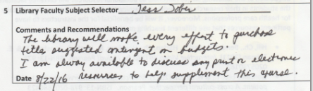

SPA 2203 Spanish for Health Professionals

NEW YORK CITY COLLEGE OF TECHNOLOGY
CITY UNIVERSITY OF NEW YORK

HUMANITIES DEPARTMENT

Course Outline
Spanish for Health Professionals

Course code: SPA 2203
Instructor: David Sánchez Jiménez, PhD
Email: dsanchezjimenez@citytech.cuny.edu
Office hours: Tuesdays from 3:00 pm to 5 pm, and by appointment
Office: A630
Credits: 3 credits
Hours: 3 class hours
Prerequisites: SPA 1102 with department permission; or SPA 2201; or SPA 2201HS or higher; or placement test and department permission

Course Description

Prepares individuals studying or working in healthcare related areas to communicate effectively when providing medical care and attention to Spanish-speaking patients in professional settings. In addition to basic language skills, students acquire new grammatical structures and learn health related vocabulary. Emphasis is placed specifically on patient-professional communication.

Course Specific Learning Objectives

- To develop linguistic and communicative competence in Spanish language with patients whose dominant language is Spanish;
- to acquire basic Spanish language skills (grammatical structures, reading, writing, listening, speaking, and interacting) at a low intermediate level, to communicate with patients;
- to introduce students to proper usage of medical Spanish terminology related to relationship between patient/ physician;
- to identify and define medical conditions using Spanish vocabulary and medical terms;
- to function effectively in a simulated medical consultation with a Spanish-speaking patient, in order to obtain medical history, make an assessment, and give patients information on their condition;
- to recognize the language barriers in health care in the United States for the Spanish-speaking minority with limited English proficiency;
- to address cultural issues that may affect the intended communication between patient and physician and that derive from various attitudes, beliefs, expectations and points of views of Hispanic patients living in the United States, as they relate to medical emergencies, illness, folk medicine, and medical procedures;
- to develop cultural sensitivity through an understanding of Spanish-speaking patients´ real-life situations in their countries of origin and in the United States; and
- to identify legal and ethical responsibilities when interacting with Spanish-speaking patients.

Content Learning Outcomes and Assessment Methods

LEARNING OUTCOMES | ASSESSMENT METHODS
By the end of the course, students will demonstrate a low intermediate level of proficiency in Spanish, having developed the four linguistic skills (reading, listening, speaking, writing). They likewise become acquainted with the target language´s culture and its subtleties. | Quizzes, homework assignments, online activities, class discussions on relevant topics, and essays.
Students carry out the basic communicative functions of a healthcare professional – they are able to interview patients, discuss their medical history and that of their families, perform a physical exam, or communicate the diagnosis and treatment to patients. | Evaluation of class discussions on assigned readings, role-plays, one simulation and one written assignment, midterm and final exams.  Evaluation of student performance in classroom discussions and group activities.  Evaluation of discussions on videos related to health issues that affect the Hispanic community in the US and their relationship with healthcare professionals.
Students express themselves adequately in an interactive medical situation between the provider and the patient. Students carry out tasks such as asking for a diagnosis either as patient or as provider, communicating it to the patient, and performing both clinical exams and other tasks that are carried out on a daily basis by healthcare practitioners. | Performance tasks such as role-playing assignments that address particular situations in a medical setting and reinforcement of this mimetic practice in class.  Assessment will be based on in-class activities and homework assignments. Students are expected to listen attentively, take down notes, locate the speaker´s main ideas and detect organizational patterns. They are also expected to pay attention to verbal and nonverbal cues. Peers review group simulations.
Students demonstrate the ability to work collaboratively and independently on assignments in and out of the classroom setting. | Evaluation of student performance in  classroom discussions, group assignments, and individual oral presentations.
Students write effectively in medical Spanish. They compose messages, memos, or paragraphs to report a physical examination; identify the medical condition; share prognoses; or prescribe and guide the use of medications. | Develop a skit or dialogue for a simulation and write narratives for the midterm and final examination.
Students recognize the impact on the communication relationship between provider and patient of social, cultural, and religious differences; of historical experiences, social/regional contexts and settings; and of personal attitudes and experiences | Class discussions are based on the cultural readings and videos related to health issues shown in class. The contents of such discussion are included in the quizzes, midterm and final exam, as well as in the evaluation of simulation and written assignments.
Students identify the Hispanic linguistic and cultural idiosyncratic characteristics that affect the delivery of healthcare services to Spanish-speaking patients. | Class discussions are based on cultural readings and videos related to health issues shown in class. The contents of such discussion are included in the quizzes, midterm and final exam, as well as in the evaluation of simulation and written assignments.
Students develop awareness of the importance of bilingualism in the healthcare field in the US and the subsequent benefits that such awareness brings, including opening up more opportunities in the labor market. | Through class discussions and research, students make a self-evaluation of the skills learned during the course, and assess the benefits of real world application on such skills.

Weekly course outline

The schedule below shows the outline of the class calendar. A more specific, day-by-day schedule of assignments is provided as we go along for each of chapters. Students are to refer to this schedule as they prepare for each class.

WEEK | DISCUSSION TOPIC | VOCABULARY/ STRUCTURE | CULTURE
1 | Course Introduction; greet your patient and introduce yourself; describe people. | Greetings; professions;  personal characteristics; gender; number, agreement of articles, nouns, and adjectives | Spanish-speakers in the United States
2 | Ask how your patient is feeling; test a patient´s orientation. | Feelings; days of the week; specialties; personal pronouns; verbs ser y estar | Attitudes and ourselves
3 | Discuss colds and influenza; ask whether a patient feels comfortable; discuss pain; diagnose injuries. | Colds and flu symptoms; part of the body; injuries; verbs tener y doler; | Expressions for everyday
4 | Tell patients their vital signs; make and negotiate dates for future appointments; conduct a registration or admissions interview. | Numbers; telling time; personal information; forming questions | U.S. Laws and Policies on Language Access
5 | Take family medical history; determine who helps an infirm family member. | Family members; hereditary illness; regular verbs | What´s in a name?  La familia hispana
6 | Give medication instructions; ask about medication allergies and educate patients about allergic reactions. | Forms of medications; dosing instructions and routes of administration; some classes of medications; allergies reactions; formal and informal commands | La confianza. Las barreras lingüísticas
7 | Review. Midterm.
8 | Ask patients about food preferences; educate patients about special diets. | The USDA food pyramid; meals and diets; colonoscopy and the clear-liquids diet; verbs gustar, querer, preferir | Balancing diet and exercise
9 | Conduct a physical examination; schedule follow-up tests. | Test and procedures; bowel movements; scheduling appointments; the preterit of regular verbs | Cultural beliefs about medicine
10 | Give test results; conduct a pre-surgery interview. | Time in the past; preparing for surgery; preterit and imperfect forms of regular and irregular verbs | Remedios caseros
11 | Ask about correct medical conditions; ask about medical history; ask about symptoms; educate patients about vaccinations. | Illnesses and review of symptoms; infections and tropical diseases; internal organs and glands; some surgeries and procedures; vaccinations; verbs padecer and sufrir; indefinite and negative pronouns | Feeling at home somewhere else
12 | Announce a hospitalization; plan a hospital discharge; teach about dental hygiene; conduct a status mental exam. | Hospital admission; the dentist office; mental illness and symptoms; reflexive verbs; se and unplanned events | Los nervios
13 | Teach about possible complications; coach a delivery; promote safe sex. | Pregnancy; possible complications; sexually transmitted diseases; informal commands | The prevention of sexually transmitted diseases
14 | Review. Oral presentations.
15 | Final exam. Oral presentations.

Grade policy and procedure

Breakdown of final grade Grading scale

11 Quizzes 30% A 93-100
1 Simulation 20% A- 90-92.9
1 essay 10% B+ 87-89.9
Midterm 10% B 83-86.9
Final exam 15% B- 80-82.9
Class participation 10% C+ 77-79.9
Homework 5% C 70-76.9
D 60-69.9
F 59.9 and below
WU Unofficial Withdrawal
WF Withdrew Failing

Instructional materials

Textbook
Robert O. Chase and Clarisa B. Medina (2013). Introduction to Spanish for Health Care Workers. 4rd Edition. New Haven/ London. Yale University Press. ISBN-13: 978-0300212976.

Suggested Text
Purchase an adequate Spanish/English, English/Spanish bilingual dictionary and English/Spanish medical dictionary.

Bibliography

Didactic materials

- Cardenas de la Peña, E. (1996). Terminología médica. Mexico: McGraw-Hill.
- Cotton, Christina E., et al. (2005). A su salud! Spanish for Health Professionals. New Haven: Yale UP. (2 DVDs and 1 CDRom).
- Florián, L. & Ruiz, A.M.ª (2005). Ciencias de la Salud. Madrid: Universidad de Alcalá de Henares.
- González-Lee, T., & H. Simon (2011). Medical Spanish: Interviewing the Latino patient. A cross-cultural perspective. Pearson.
- Hill, Ch., Bender, D, Carl, L. Harlan, Ch., Henshaw, R., Lorch, C., Lunsford, E. & E. Tolman (2011). Interactive Video on DVD for ¡Salud! Pearson.
- Jarvis, A. & Lebredo, R. (2006). Spanish for Medical Personnel. Boston: Houghton Mifflin, 2006.
- Kelz, R. (1999). Conversational Spanish for Health Professionals. Albany: Delmar Publishers.
- Kelz, R. (1997). Delmar’s English-Spanish Pocket Dictionary for Health Professionals. Albany: Delmar, 1997.
- Picardo-La Vallée, O. (1999). Basic Medical Spanish. The University of Texas Medical Branch of Galveston, 10th edition.
- Rogers, Glenn T. (1997) English-Spanish/Spanish-English Medical Dictionary. New York: McGraw-Hill
- Rosa de Juan, C., de Prada, M., Marcé, P. & Salazar, D. (2009). Temas de salud. Madrid: Edinumen.
- Rush, P. (2003). Spanish for HealthCare, Textbook and Workbook. Prentice Hall.
- Schiavo, R. (2007). Health Communication: From theory to practice. San Francisco: Jossey Bass.

General bibliography

- Anderson L, et. al. (2003). Culturally competent health care systems: A Systematic review. Am J Prev Med 24: 68-79
- Armus, D. (2003). Disease in the History of Modern Latin America: From Malaria to AIDS. Durham, NC: Duke University Press.
- Armus, D. (2202). Entre médicos y curanderos. Cultura, historia y enfermedad en la América Latina moderna. Buenos Aires: Grupo Editorial Norma.
- Becker G. (2004). Deadly inequality in the health care “safety net”: Uninsured ethnic minorities’ struggle to live with lifethreatening illnesses. Medical Anthropology Quaterly 18: 258-275.
- Cheng E, A. Chen, &W. Cunningham. (2007). Primary language and receipt of recommended health care among Hispanics in the United States. J Gen Intern Med 22 (suppl 2): 283-288.
- Davidson B. (2000). The interpreter as institutional gatekeeper: The social-linguistic role of interpreters in Spanish-English medical discourse. Journal of Sociolinguistics 4: 379-405.
- De la Torre, A & A Estrada (2001). Mexican Americans and Health: ¡Sana, Sana! Tucson: University of Arizona Press.
- Derose, K, J. Escarce, & N. Lurie. (2007). Immigrants and health care: Sources of vulnerability. Health Affairs 26: 1258-1268.
- Flores, G. (2006). Language barriers to health care in the United States. New England Journal of Medicine 355: 229-231.
- Frenk, J. (2000). La salud de la población: Hacia una nueva salud pública. México: Fondo de Cultura Económico.
- Glanz, K., Rimer, B., & Viswanath, K. (2008). Health Behavior and Health Education: Theory, research,and practice. 4th edition. San Francisco: Jossey Bass.
- Gregg J and S Soha. (2007). Communicative competence: A framework for understanding language barriers in health care. J. Gen Inter Med 22 (suppl 2): 368-370. it. New York: Kaplan.
- Hasnain-Wynia R., J. Yonek, D Pierce, R. Kang & C. Hedges Greising. (2006). Hospital language services for patients with limited English proficiency: Results from a national survey. Chicago: Health Research and Educational Trust.
- Institute of Medicine. (2002). Speaking of Health: Assessing health communication strategies for diverse populations. Washington, DC: National Academies Press.
- Institute of Medicine. (2004). Health Literacy: A Prescription to end confusion. Washington, DC: National Academies Press.
- Karliner L, E. Jacobs, A. H. Chen & S. Mutha. (2007). Do professional interpreters improve clinical care for patients with limited English proficiency? A systematic review of the literature. Health Services Research 42: 727-754.
- Ku. L & S. Matani. (2001). Left out: Immigrants’ access to health care and insurance. Health Affairs 20: 247-256.
- Mohanty, S. (2006). Unequal access: Immigrants and US health care. Washington DC: American Immigration Law Foundation.
- Weiss L, T Bauer, C Hill, J Fuld, and J Bergman. (2006). Language as a barrier to health care for New York City children in immigrant families. New York: The New York Academy of Medicine.
- Wilson E, A. Chen, K. Grumbach, F. Wang, & A. Fernandez. 2005. Effects of limited English proficiency and physician language on health care comprehension. J Gen Intern Med 20: 800-806.

Course design

Course context: The course is offered as elective to fulfill three (3) of the nine (9) foreign language requirements for students in Liberal Arts and Arts (LAA). It aims to address the needs of the students in Healthcare Professions with a prior knowledge in Spanish and with future careers in Nursing, Dental Hygiene, Vision Care Technology, Radiologic Technology and Medical Imagining, etc. The course also caters to patients from the Spanish-speaking community. Students broaden their communicative skills to interact effectively using everyday practical situational Spanish when providing medical care and attention to Spanish-speaking patients in a medical setting. The course introduces students to a wide array of relevant Spanish vocabulary and helps students develop a cultural understanding of medicine and illnesses in the Hispanic world.

Course structure: This is a blended course that combines face-to-face teaching with the use of online resources. The course consists of fifteen (15) didactic units that focus on situational topics. It will be offered in a lecture format and taught twice a week over a 15-week session. Students are assessed in all four areas of language use, which include reading (review patient´s medical history, doctor´s instructions, etc.), writing (appointment making, discharge instructions, etc.), listening and speaking (acquisition of patient data, clarification and assessment of patient symptoms/pain, etc.) throughout the course. There are eleven (11) quizzes, one (1) mid-term exam and one (1) final exam.

Anticipated Pedagogical Strategies and Instructional Design: With focus on healthcare content, Spanish for Health Professions integrates the four communicative skills (reading, listening, oral, writing) necessary to prepare Healthcare Professions students to communicate effectively with Spanish-speaking patients. It also helps them develop their socio-cultural competence in medical setting. A situational approach is used to teach grammatical structures, medical expressions, and health vocabulary through role-play, simulations, writing assignments, simulation assignments for groups, and analysis and discussion on readings/materials used for each unit. Tasks such as practicing these materials via simulations allow students to actively participate in class and convert these into personal skills. Classroom activities involve real communication using the real-life skills of the students, encouraging them to be personally involved in any assigned task. The transmission of content and vocabulary is a priority in Spanish for Health Professions, for which supplemental videos and realia (e.g., patient´s medical history, prescriptions, medical reports, medical and healthcare flyers, etc.) will be used in the class. These instruments, in conjunction with an introduction to real health-related issues that affect Spanish-speaking patients living in the United States, are fundamental to the successful learning of students. In this course, the students are tasked to comprehend and analyze the conversations in the videos. These videos provide the students direct access to the culture and the people of the target language. Such information is not received in a passive manner as students are expected to develop new situations replicating the dialogues analyzed in the textbook and in the videos. Each session includes tasks (e.g., role-plays and simulations) that emphasize vocabulary and interaction used in the medical world, and allows students to conduct basic communication skills with Spanish speakers in healthcare setting. This course requires satisfactory completion of reading materials, as assessed via an essay on one of the cultural topics discussed in class from an intercultural perspective; quizzes; participation in role-playing exercises; weekly individual assignments; group simulation; and two major exams.

How does this course support Programmatic Learning Outcomes: The learning outcomes are met through the continued integration of the four linguistic skills in each didactic unit. Students are given daily assessment – be it in the form of a quiz, essay writing, group simulation, analysis of videos shown and materials used for the day, or in the form of a simple peer-to-peer and peer-to-instructor conversation. Students are expected to work closely and collaborate with both their peers and the instructor.

Course Needs Assessment

As of 2015 there are about 56.6 million Hispanic Americans in the United States and this number is expected to reach 150 million by 2050. Hispanic Americans are undoubtedly the fastest growing ethnic minority in the country. The United States is the second largest Spanish-speaking country in the world.

When the Affordable Care Act came into effect, 2.6 million more Hispanics applied for health insurance coverage (Martinez, 2015). The impact that the ACA brought to the healthcare system signifies an increase in the number of health insurance enrollees from the Spanish-speaking communities. Martinez (2015:5) suggests that “the presence of Spanish speakers in the system is likely to increase substantially and that the types of services are likely to shift as well. Given the linguistic and age profiles of those coming under coverage, we would expect to see an increase of Spanish-speaking patients in preventive and chronic care encounters and relatively stable acute care encounters”.

In his course proposal of COM 2403 “Introduction for Health Communication” (p. 20), Dr Lee states that, according to the Bureau of Labor Statistics (2014), healthcare occupations are among the fastest growing job markets. It is predicted that these jobs will grow from 24% to 43% in the next decade. An article published on the BLS website dated April 2016 states that the private education and health services sector added 701,000 jobs in 2015, out of which 472,000 jobs are from the healthcare field.

The growing population of Spanish speakers will certainly pose a challenge in the healthcare industry. Few healthcare providers can speak Spanish and interpreter services are scarce. On most occasions, they also fail to recognize the cross-cultural subtleties of Spanish-speaking communities. Language barriers or miscommunication between provider and patient can be life-threatening; they can result in harmful effects in patients with limited English proficiency and can even have tragic consequences (Flores, 2006). In his COM 2403 course proposal, Dr. David Lee cites data from the Joint Commission in 2012 that shows an estimated 80% of serious medical errors can be linked to poor communication between providers and patients. The Civil Rights Division of the United States Department of Justice enforces laws that require taking reasonable steps to provide meaningful access for limited English-proficiency individuals (Chase & Medina, 2013). In clinical encounters, providers rely on the patient´s family members, friends, or even strangers to interpret for them. Without professional interpreters, patients’ lives may be at risk, because of the ad hoc interpreters´ limited proficiency in medical terminology (Flores, 2006).

The preceding problem highlights the need for Spanish language professionals to teach Spanish for specific purposes within the health services field. There is an increasing demand for targeted specialized Spanish language instruction in order to meet the needs of the rapidly growing Hispanic population. Students in the health professions are also encouraged to develop communicative working skills in Spanish to meet medical needs. Courses in Spanish for health professions are currently offered at several CUNY Colleges, such as Hunter College, Brooklyn College, York College, and Lehman College. At NYCCT, despite the existence of several Healthcare Professions programs and a course aimed at healthcare professionals, as recommended to the Department of Humanities self-study (Foreign Languages Program self-study) by Professors Granados and Lachheb in 2016 (see p.48), there is no Spanish course offering primarily catered to Healthcare Professions students. This is particularly problematic, considering the fact that NYCCT is a federally designated Hispanic Serving Institution (HSI). In 2012, approximately 33.8% of its student population identified themselves as Hispanic and represent the largest community by ethnicity in City Tech since Fall 2014 (NYCCT, Data overview President´s Convocation Fall 2015), with a total number of 5,573 students (Female: 2,384; Male: 3,189) enrolled in Fall 2015 (Enrollment by Gender and Ethnicity, Assessment & Institutional Research, Fall 2015). Through Spanish for Health Professionals students enrolled in the Healthcare Professions programs have the opportunity to acquire the specialized knowledge of Spanish medical terminology and cultural competence necessary to effectively communicate with Spanish-speaking patients in different healthcare settings.

Effective communication is essential in healthcare, and communication is most effective when both parties share a common language. When the patient and the healthcare provider do not share the same language, there are ways to accommodate the patient, usually involving an interpreter. As mentioned above, the interpreter is frequently selected ad hoc: family members, strangers, etc., are asked to do the job. Problems derive from the interpreter´s low level of proficiency and/or accuracy in the use of medical terminology, the high cost of hiring a qualified interpreter, and the lack of confidentiality between provider and patient when disclosure or medical consultation is interpreter-mediated. (Elderkin-Thompson et al., 2001; Ramirez et al, 2008; Flores, 2006; Ginde et al, 2009; Rose et al, 2010; Schenker et al, 2010).

Diamond et al (2012) suggests that to reduce the lack of comprehension in the interaction and to put forward the intended meaning, it is more convenient to train physicians in assessing their language competence and in recognizing at which level of proficiency it is more likely for them to rely on their own languages skills. Despite having reasonable proficiency in English, Hispanic patients prefer to express themselves in their mother tongue when talking to a physician. Medical interpreters may prove useful for complex communication tasks, but bilingual healthcare workers who share the same language as the patient´s – whether English or Spanish– can establish a more direct, trust-based and valuable communication with the patient. Even engaging in small talk, a Spanish-speaking provider provides a more relaxing and positive environment to the patient. In addition, learning a foreign language entails exploring another culture and thus encourages non-native healthcare professionals to develop a positive attitude towards the second language and its speakers. Bilingual healthcare professionals are, therefore, more culturally sensitive and understanding of the challenges and accomplishments of patients with LEP (limited English proficiency).

The proposed course covers the needs outlined above, ensuring that future generations of healthcare workers enrolled in NYCCT will have the necessary linguistic and cultural knowledge to communicate with efficacy with the Spanish-speaking community. Spanish for Health Professionals addresses the demands of Healthcare Professions students who wish to improve their Spanish and communicate with patients whose dominant language is Spanish. Through in-class activities, interactive discussions, interview/consultation simulation, role-playing, etc., students use their language skills in similar situations that they may encounter in a medical setting with Spanish-speaking patients.

The course also intends to support the B.S. Degree in Health Communication Technology proposed by the Humanities Department, which “would be among the first baccalaureate programs of its kind in the country to train students for an anticipated exposition of healthcare jobs” (Lee, course proposal COM 2403, p. 21).

In addition to effective communication between provider and patient, and cross cultural awareness in the process, SPAN 2203 can create more job opportunities for NYCCT students in the healthcare industry, in which the demand for more bilingual and biliterate English-Spanish professionals has substantially increased (Martinez, 2015). Spanish for Health Professionals fills the current gap in the workforce, supporting the development of linguistically and culturally competent healthcare professionals.

Target students: Students in Healthcare Professions with low intermediate level of Spanish whose goal is to effectively communicate with Spanish-speaking patients. Spanish for Health Professionals is also offered as an elective course to all students enrolled in the LAA Program who wish to study Spanish for Professions at an intermediate level.
Additional physical resources may be required: A placement test is given to determine the student´s Spanish language background and proficiency level.
The number of section (s) anticipated: One section per semester
Projected headcount: Class cap is 22, to provide every student with adequate time for participation in role playing exercises.
Course overlap: Within the Humanities Department, this course may overlap with the regular course SPA 2201. However, while SPA 2201 is intended for students who learn Spanish as a foreign language, SPA 2203 caters to students who wish to specialize in the field of Healthcare, learning the language and cultural skills necessary to function in healthcare settings with Spanish as the principal language, and to effectively give primary care to Hispanic patients with limited English proficiency. Advisement at the Humanities Department selects the best possible option for interested students.
Faculty qualified for teaching this course: The faculty members in the Humanities Department are experts in the fields of Spanish Applied Linguistics, Language for Specific Purposes, and Second Language Acquisition.

Bibliography

Chase, R. & Medina, C. 2013. Introduction to Spanish for Healthcare Workers. 4rd Edition. New Haven/ London. Yale University Press.
Diamond, L., Tuot, D. & Karliner, L. 2012. The use of Spanish language skills by physicians and nurses: Policy implications for teaching and testing. Journal of General Internal Medicine 27, 117-123.
Elderkin-Thompson, V., Silver, R. & Waitzkin, H. 2001. When nurses double as interpreters: A study of Spanish-speaking patients in a US primary care setting. Social Science and Medicine 52, 1343-1358.
Flores, G. 2006. Language barriers to healthcare in the United States. New England Journal of Medicine 355, 229-231.
Ginde, A., Clark, S. & Camargo, C. 2009. Language barriers among patients in Boston emergency departments: Use of medical interpreters after passage of interpreter legislation. Journal of Immigrant and Minority Health 11: 527-530.
Joint Commission Center for Transforming Healthcare Releases Targeted Solutions Tool for Hand-Off Communications (2012). Joint Commission Perspectives, August 2012, Volume 32, Issue 8 Copyright Joint Commission on Accreditation of Healthcare Organizations. Retrieved from: http://www.jointcommission.org/assets/1/6/tst_hoc_persp_08_12.pdf
Martínez, G. 2015. Spanish in the U.S. Health Delivery System. Informes del Observatorio. Instituto Cervantes at the Faculty of Arts and Sciences of Harvard University, 1-22.
Ramirez, D., Engel, K. & Tang, T. 2008. Language interpreter utilization in the emergency department setting: A clinical review. Journal of Healthcare for the Poor and Underserved 19, 352-362.
Rose, D., Tisnado, D., Malin, J., Tao, M, et. al. 2010. Use of interpreters by physicians treating limited English proficient women with breast cancer. Health Services Research 45, 172-194.
Schenker Y, Karter A, Schillinger D et al. 2010. The impact of limited English proficiency and physician language concordance on reports of clinical interactions among patients with diabetes. Patient Education and Counseling 81, 222-228.
U.S. Department of Labor, Bureau of Labor Statistics. 2016. Employment continued to expand in 2015. Washington, DC.
Portions of this course proposal were modelled after the course proposal “Introduction to Health Communication COM 2403” Submitted by: Dr. David Lee – Humanities Department.

Chancellor´s Report

New courses to be offered in the Humanities Department
Department(s) | Humanities
Academic Level | [ X ] Regular [ ] Compensatory [ ] Developmental [ ] Remedial
Subject Area | Foreign Language
Course Prefix | SPA
Course Number | 2203
Course Title | Spanish for Health Professionals
Catalog Description | Prepares individuals studying or working in healthcare related areas to communicate effectively when providing medical care and attention to Spanish-speaking patients in professional settings. In addition to basic language skills, students acquire new grammatical structures and learn health related vocabulary. Emphasis is placed specifically on patient-professional communication.
Prerequisite | SPA 1102 with department permission; or SPA 2201; or SPA 2201HS or higher; or placement test and department permission.
Corequisite | None
Credits | 3
Contact Hours | 3
Liberal Arts | [ X ] Yes [ ] No
Course Attribute (e.g. Writing Intensive, etc) | N/A
Course Applicability | [ ] Major  [ ] Gen Ed Required [ X ] Gen Ed – Flexible [ ] Gen Ed - College Option  [ ] English Composition [ ] World Cultures [ ] Speech  [ ] Mathematics [ X ] US Experience in its Diversity [ ] Interdisciplinary  [ ] Science [ ] Creative Expression [ ] Advanced Liberal Arts  [ ] Individual and Society  [ ] Scientific World
Effective Term | Spring 2017

Rationale: This course provides the future medical professionals who apply for programs in Nursing, Vision Care Technology, Dental Hygiene, etc., with the knowledge they need to conduct brief interactions in Spanish with Spanish-speaking patients.

CUNY Common Core
Course Submission Form
Instructions: All courses submitted for the Common Core must be liberal arts courses. Courses may be submitted for only one area of the Common Core. All courses must be 3 credits/3 contact hours unless the college is seeking a waiver for another type of Math or Science course that meets major requirements. Colleges may submit courses to the Course Review Committee at any time. Courses must also receive local campus governance approval for inclusion in the Common Core.

College | New York City College of Technology, School of Arts and Sciences
Course Prefix and Number (e.g., ANTH 101, if number not assigned, enter XXX) | SPA 2203
Course Title | Spanish for Health Professionals
Department(s) | Humanities
Discipline | Foreign Languages
Credits | 3
Contact Hours | 3
Pre-requisites (if none, enter N/A) | SPA 1102 with department permission; or SPA 2201; or SPA 2201HS or higher; or placement test and department permission.
Co-requisites (if none, enter N/A) | N/A
Catalogue Description | Prepares individuals studying or working in healthcare related areas to communicate effectively when providing medical care and attention to Spanish-speaking patients in professional settings. In addition to basic language skills, students acquire new grammatical structures and learn health related vocabulary. Emphasis is placed specifically on patient-professional communication.
Special Features (e.g., linked courses)
Sample Syllabus | Syllabus must be included with submission, 5 pages max recommended
Indicate the status of this course being nominated:

current course revision of current course a new course being proposed
CUNY COMMON CORE Location

Please check below the area of the Common Core for which the course is being submitted. (Select only one.)
Required  English Composition  Mathematical and Quantitative Reasoning  Life and Physical Sciences |  | Flexible  World Cultures and Global Issues Individual and Society  US Experience in its Diversity Scientific World  Creative Expression
Waivers for Math and Science Courses with more than 3 credits and 3 contact hours

Waivers for courses with more than 3 credits and 3 contact hours will only be accepted in the required areas of “Mathematical and Quantitative Reasoning” and “Life and Physical Sciences.” Three credit/3-contact hour courses must also be available in these areas.
If you would like to request a waiver please check here: |  | Waiver requested
If waiver requested:
Please provide a brief explanation for why the course will not be 3 credits and 3 contact hours.
If waiver requested:
Please indicate whether this course will satisfy a major requirement, and if so, which major requirement(s) the course will fulfill.

Learning Outcomes

In the left column explain the course assignments and activities that will address the learning outcomes in the right column.

II. Flexible Core (18 credits)
Six three-credit liberal arts and sciences courses, with at least one course from each of the following five areas and no more than two courses in any discipline or interdisciplinary field.

A. US Experience in its Diversity

A Flexible Core course must meet the three learning outcomes in the right column.

Gather information on the medical system of Spanish-speaking countries from a variety of written resources to identify cultural realities through another language system.  Recognize other cultural forms of greetings, daily routines and schedules, perception of time and space, oral rhetoric and ways to establish a conversation.  Recognize formal and informal speech situations that require different registers of Spanish.  Identify different text genres (e.g., clinical study reports, patient consent forms, medical history, etc.).  Identify differences between standard and non-standard varieties; dialectal varieties of Spanish (e.g. Puerto Rican, Mexican, and Argentinian varieties). | - Gather, interpret, and assess information from a variety of sources and points of view.
Read assigned readings individually on medical practices and cultural beliefs (el mal de ojo, parteras, curanderas, etc.) in Spanish-speaking countries.  Analyze texts on how language barrier affects communication in healthcare settings. | - Evaluate evidence and arguments critically or analytically.
Learn how to negotiate meanings with peers and instructor through the elaboration of dialogues for a group simulation.  Analyze and present different views/ perspective on assigned readings in the class that focus on the medical practices and cultural beliefs in Spanish-speaking communities. | - Produce well-reasoned written or oral arguments using evidence to support conclusions.
A course in this area (II.A) must meet at least three of the additional learning outcomes in the right column. A student will:

Develop a cultural understanding of medicine and illnesses in Spanish-speaking countries, as well as insights into the culture of the Spanish-speaking communities in the U.S., through text comprehension.  Students write critiques about physician-patient interaction in Hispanic culture through texts and videos, and examine how this knowledge can be used to understand the physician-patient interaction in the U.S.  Students participate in an interactive discussion with peers and instructor on the dialectal varieties of Spanish, such as the Puerto Rican, Mexican, and Argentinian varieties. This is followed by keeping a word journal and pronunciation activities to familiarize students with various Spanish medical terms peculiar to specific Spanish-speaking communities. | - Identify and apply the fundamental concepts and methods of a discipline or interdisciplinary field exploring the U.S. experience in its diversity, including, but not limited to, anthropology, communications, cultural studies, economics, history, political science, psychology, public affairs, sociology, and U.S. literature.
 | - Analyze and explain one or more major themes of U.S. history from more than one informed perspective.
Students are tasked to write plays, in which they will actively participate, and produce essays that will reflect their views and opinions on the medical atmosphere, values, and cultural beliefs of Spanish-speaking communities living in the U.S.  In each chapter, students learn through cultural reading, e.g., how Hispanic immigrants brought their traditions, products, music, etc., to enrich their communities and maintain their cultural values and identity while living in the U.S. Students also discover the new dynamics in the U.S. economy in which Hispanic immigration plays a significant role. | - Evaluate how indigenous populations, slavery, or immigration have shaped the development of the United States.
 | - Explain and evaluate the role of the United States in international relations.
 | - Identify and differentiate among the legislative, judicial, and executive branches of government and analyze their influence on the development of U.S. democracy.
Class activities such as simulations, video showings, and interactive discussions on assigned readings and videos allow students to recognize the diverse set of practices and cultural beliefs that may affect communication with Spanish-speaking patients.  Students learn, through reading comprehension, how the setting in medical institutions in the U.S. has changed in response to new policies concerning the growth of the Spanish-speaking population. | - Analyze and discuss common institutions or patterns of life in contemporary U.S. society and how they influence, or are influenced by, race, ethnicity, class, gender, sexual orientation, belief, or other forms of social differentiation.

SPA 2203 Spanish for Health Professionals
NEW YORK CITY COLLEGE OF TECHNOLOGY
CITY UNIVERSITY OF NEW YORK

HUMANITIES DEPARTMENT

Course Outline
Spanish for Health Professionals

Course code: SPA 2203
Instructor: David Sánchez Jiménez, PhD
Email: dsanchezjimenez@citytech.cuny.edu
Office hours: Tuesday from 3:00 pm to 5 pm, and by appointment
Office: A630
Credits: 3 credits
Hours: 3 class hours
Prerequisites: SPA 1102 with department permission; or SPA 2201; or SPA 2201HS or higher; or placement test and department permission.

Course Description

Prepares individuals studying or working in healthcare related areas to communicate effectively when providing medical care and attention to Spanish-speaking patients in professional settings. In addition to basic language skills, students acquire new grammatical structures and learn health related vocabulary. Emphasis is placed specifically on patient-professional communication.

Instructional materials

Textbook
Robert O. Chase and Clarisa B. Medina (2013). Introduction to Spanish for Health Care Workers. 4rd Edition. New Haven/ London. Yale University Press. ISBN-13: 978-0300212976.

NOTE: Students are required to bring the textbook/reading materials to every single class. Extra material will be available on Blackboard as the course progresses (for more details, see Class Behavior Policy below).

Suggested Text
Purchase an adequate Spanish/English, English/Spanish bilingual dictionary and English/Spanish medical dictionary. The following are some suggested dictionaries:

- Herrera McElroy, Onyria and Lola L. Grabb (2010). Spanish-English English-Spanish Medical Dictionary: Diccionario Médico Español-Inglés Inglés-Español. 4th Edition. LWW.
- Kelz, Rochelle K. (1997). Delmar’s English-Spanish Pocket Dictionary for Health Professionals. Albany. Delmar.
- Rogers, Glenn T. (1997). English-Spanish/Spanish-English Medical Dictionary. McGraw-Hill.

Recommended resources

This syllabus includes a series of medical, cultural and Spanish language tutorial websites for you to practice Spanish outside of the classroom. It is specially recommended for those seeking opportunities to grow and develop linguistic proficiency in the target language. Utilizing these internet educational resources will help match your individual learning style and complement your in-class instruction.

http//spanishchecker.com/
http://itunes.apple.com/us/app/medical-spanish-with-audio/id301655973?mt=8
http://www.123teachme.com/learn_spanish/medical-spanish
http://www.erasalud.com/enfermedades/
http://studyspanish.com/
http://www.medicalspanish.com/
http://www.medicalspanishpodcast.com/
http://www.practicingspanish.com/
http://auditoriamedica.wordpress.com/2009/05/24/glosario-de-terminos-medicos/

Course Specific Learning Objectives

- To develop linguistic and communicative competence in Spanish language with patients whose dominant language is Spanish;
- to acquire basic Spanish language skills (grammatical structures, reading, writing, listening, speaking, and interacting) at a low intermediate level, to communicate with patients;
- to introduce students to proper usage of medical Spanish terminology related to relationship between patient/ physician;
- to identify and define medical conditions using Spanish vocabulary and medical terms;
- to function effectively in a simulated medical consultation with a Spanish-speaking patient in order to obtain medical history, make an assessment, and give the patient information on his/her condition;
- to recognize the language barriers in health care in the United States for the Spanish-speaking minority with limited English proficiency;
- to address cultural issues that may affect the intended communication between patient and physician and that derive from various attitudes, beliefs, expectations and points of views of Hispanic patients living in the United States, as they relate to medical emergencies, illness, folk medicine, and medical procedures;
- to develop cultural sensitivity through an understanding of Spanish-speaking patients´ real-life situations in their country of origin and in the United States; and
- to identify legal and ethical responsibilities when interacting with Spanish-speaking patients.

Grade policy and procedure

Breakdown of final grade Grading scale

11 Quizzes 30% A 93-100
1 Simulation 20% A- 90-92.9
1 Essay 10% B+ 87-89.9
Midterm 10% B 83-86.9
Final exam 15% B- 80-82.9
Class participation 10% C+ 77-79.9
Homework 5% C 70-76.9
D 60-69.9
F 59.9 and below
WU Unofficial Withdrawal
WF Withdrew Failing

Assessment Overview

Simulation: This strategy involves student response to the environment in a real world situation. Simulation often helps the students empathize with a patient´s viewpoint or understand an event better. Students are tasked to prepare and act in role-play activities throughout the course, prior to the final simulation, to be performed at the end of the course. In these oral presentations, students display developed communicative oral competence that relates to the lessons and linguistic skills discussed in the course. Students prepare a script using the example of one of the situations in videos shown during the course. The script is submitted to the instructor one week before the performance. The instructor assesses the capacity to communicate effectively in a medical setting and the use of specific related vocabulary and expressions. Creation and execution of the script is a group activity, with a maximum of four (4) members per group, and to be performed at the end of the semester. Students who fail to perform in the simulation WILL NOT BE ALLOWED any make-up performance or submission of extra work.

Quizzes: These are used to evaluate vocabulary, grammar and acquisition of new expressions every week at the beginning of the class. Quizzes facilitate students assess their own learning and guide them through a daily study habit. The schedule of the quiz is unannounced. It is the student´s responsibility to always come to class prepared - having previously studied the topic from the day before and having reviewed the new lesson by completing the class homework. There are no make-up quizzes for any reason, including tardiness or absences. However, the lowest quiz result will not be included in over-all grading.

Midterm and final examination: Exams cover all aspects of the readings, the lecture and the class discussion, and serve to evaluate students´ understanding of the linguistic and cultural topics discussed in the course. Midterm exam covers materials including Chapters 1-6, while the final exam covers materials including Chapters 7-11. Both are closed-book/closed-notes examinations.

Make-up policy: Examinations must be taken at the time established in the syllabus. When absent on the day of the examination, a student is allowed to take the examination before or on the next class meeting only in case of documented medical emergencies. Students who contact the instructor after they have missed the class will not be allowed to make-up the exam. If the exam is not taken before or on the next class meeting, the student will receive 0 points for the exam.

Homework: Homework is assigned on a regular basis for knowledge reinforcement and further practice class activities. The student is responsible for completing homework every day before class on the website www.yalebooks.com/medicalspanish, as well as for those activities assigned by the instructor in the textbook and other sources. Homework must be type-written and submitted by the beginning of the lecture. No late work is accepted. Please do not forget to write your name on your homework, otherwise it will not be computed.

Essay: Students submit one (1) written assignment in the second half of the course. Grades are based on the quality, cohesion and organization of ideas and on the adequate use of the grammar and vocabulary covered in the course. The composition is mainly focused on the cultural topics discussed in class; should contain 350-400 words, and should pass through two (2) steps: one draft and the final version. The composition counts for 10% of your final grade. The submission must be typewritten and double spaced, in 12-point font and with 1-inch margins. Accent marks and special Spanish characters should likewise be included.

IMPERATIVE: Papers must be submitted in class on the day it is due. Papers submitted after the due date will not be accepted. Extensions will be granted only in case of family or documented medical emergencies, or illness accompanied by a note from the student’s doctor or dean.

A word of caution. While there are many resources available for peer help, the composition must be solely and completely the effort of the individual student. Students should not seek out other students or tutors for them to “fix” grammar problems. No one other than the student him/herself should revise it before it is submitted to the instructor. Students will have a chance to re-write the first draft after the professor has identified grammar or spelling errors for correction.
Do not use electronic devices to translate an English composition into Spanish. It is easy to detect literal translations. Any composition that seems to have been corrected by somebody else or translated using an online translation tool prior to the due date will not be graded (for more details, see below academic policy).

Class participation: Active participation is an essential part of the learning process and it is expected from all enrolled students. Participation means maintaining an active presence in the class by answering questions from the instructor, volunteering for and participating in class activities. There will be a significant deduction of points for students who regularly fail to answer the instructor´s questions or participate in the class activities. Simply attending class does not constitute participation. Other aspects considered under class participation include the regular use of Spanish in class with instructor and peers, constant demonstration of active listening when others speak, and collaboration with fellow students in in-class activities.

Working outside the class: Students are also responsible for working each day outside of class to learn as much as possible on the field of Medical Spanish through readings, assignments and research that you will share in class. Students are expected to invest at least three (3) hours of combined in-class and out-of-class work per week for each academic unit (credit) of coursework; thus, a 3-credit course will typically require a minimum of nine (9) hours of work per week (180 hrs./semester). Plan on spending at least six (6) hours per week outside of class. You will need this time to read the textbook and articles, memorize and practice the vocabulary, complete homework, and prepare the role-plays and oral activities assigned. Students should always look for ways (learning strategies) to grow and develop linguistic proficiency in and outside the classroom.

CLASS BEHAVIOR

Yellow/ red cards system: Side conversations with classmates are not permitted, unless we work in groups. Interaction opportunities will be given to each student in the class. These interactions should be based on the task goal and are never to be considered as an excuse for the student to check his/her electronic devices and/ or chat with his/ her peers on issues not related to class activities. Conversations should be conducted in Spanish to provide practice for the linguistic and communicative skills learned in the class or to solve a task through interaction. Students must, therefore, participate in classroom activities using the target language. If students do not follow this rule, the instructor will give them a first warning (yellow card); a second warning (red card) will result in a full letter grade reduction in their final grade.

Absence is failure to attend any part of the class, from roll call to dismissal. Please note that sleeping or putting your head down on your desk means that you are not present in the class; the same is applied to unauthorized use of electronic devices, leaving the classroom during class, or leaving early.

Students are required to bring the textbook/reading materials to every single class. Extra material will be available in Blackboard as the course progresses. Those who come to class without the book will be asked to leave and marked absent.

Pursuant to College Council resolution (approved May 30, 2000), any electronic devices (e.g. cell phones, tablets, computers, etc.) must be turned off when members of the academic community enter the classroom, and must remain off when the class is in session, unless otherwise indicated by your instructor (for more details, see Technology Policy below).

COURSE POLICIES

Attendance policy
Because practice and feedback are essential in the process of second language acquisition, most courses conducted in Spanish require class attendance, as well as daily homework and regular participation.

Based on the Humanities Department´s policy on absences/tardiness, a student may be absent without penalty for 10% of the number of scheduled class meetings during the semester. A total of 10% of absences (3 allowed absences) from class is permitted, no matter what the excuse. If a student misses a class, it is his/ her responsibility to study and research the lessons covered and complete the assigned homework.

Beyond the three (3) allowed absences, no excused absences will be given. Two (2) late entries to class is equivalent to one (1) absence. The instructor will keep accurate, detailed record of all absences from class and may give a WU (withdrew unofficially) grade to a student who exceeds the limit. More than three (3) absences may result in failure.

A student should keep track of his/her absences/tardiness from class. It is essential for the student to arrive on time in order to be counted as present. Please note that sleeping or putting your head down on your desk means that you are not present in the class; the same is applied to unauthorized use of electronic devices, leaving the classroom during class, or leaving early.

Policy on In-class use of technology
Students are required to log into their City Tech emails and Blackboard regularly (every two to three days) in order to get updated information on course content, download handouts, watch videos, and follow class assignments. Failure to do so is every students´ responsibility and the consequences may affect their final grades. CUNY guidelines state that all communication between students and the instructor must be through your City Tech email address. The professor will use ONLY City Tech email addresses as primary means of communication. The instructor will make every effort to answer email messages promptly (Monday to Friday until 5:00 p.m.).

Pursuant to College Council resolution (approved May 30, 2000), any electronic devices (e.g. cell phones, tablets, computers, etc.) must be turned off when members of the academic community enter the classroom, and remain off when the class is in session, unless otherwise indicated by your instructor. Any evidence of cell phone use (ringing, buzzing, etc.) and similar equipment use will result in an automatic zero in participation for the day´s session, and you will be asked to leave and marked absent. Using a cell phone during a test will result in a test score of zero.

Technological issues are not a valid excuse for lack of participation or lack of course work. Students should foresee potential technical problems and should always have a Plan B in place (e.g., use of computers in the campus).

Academic Honesty & Integrity at City Tech
Academic honesty and integrity is expected from all students. This course demands a high level of scholarly behavior and academic honesty on the part of all students. Academic cheating and plagiarism will not be tolerated. Examples of academic dishonesty include but are not limited to: (1) the use of online translators, translator programs and/or another person completing assignments for the student in part or in whole*; (2) copying from professional works without citing them. Any information you find on the web, at the library or in books must be cited; and (3) any form of cheating on exams. Specifically, copying from another student or using any paper or devices not allowed during the exam will lead to an automatic failure in the course. Violations of such may result in receiving a score of zero in a specific test/assignment, “F” final grade, and/or possible suspension or expulsion from City Tech, as stated in the academic integrity statement listed in the college´s catalog:

“Students and all others who work with information, ideas, texts, images, music, inventions, and other intellectual property owe their audience and sources accuracy and honesty in using, crediting, and citing sources. As a community of intellectual and professional workers, the College recognizes its responsibility for providing instruction in information literacy and academic integrity, offering models of good practice, and responding vigilantly and appropriately to infractions of academic integrity. Accordingly, academic dishonesty is prohibited in The City University of New York and at New York City College of Technology and is punishable by penalties, including failing grades, suspension, and expulsion.”

NOTE: In the event that the instructor finds that the results of students´ homework, scripts, and other at home activities do not correspond to their level of proficiency, students may be called to take an extra exam to prove their capacity to solve tasks similar to those normally assigned in class.

Religious Holidays and Observances
In accordance with University policies, students should notify the instructor before missing class due to religious observance of a holiday.

Reasonable Accommodations
City Tech complies with all provisions of the Americans with Disabilities Act and makes reasonable accommodations to students with documented disabilities. Please contact Disability Resources Services at (718) 260-5143 for more information. The resource office is located in the Atrium Building, Room A-237. If you have a documented disability that requires academic accommodations, please see me in private so that we can discuss the accommodations that you need in this class. It is best to do this at the beginning of the course.

Weekly course outline

The schedule below shows the outline of the class calendar. A more specific, day-by-day schedule of assignments is provided as we go along for each of chapters. Students are to refer to this schedule as they prepare for each class.

WEEK | DISCUSSION TOPIC | VOCABULARY/ STRUCTURE | CULTURE
1 | Course Introduction; greet your patient and introduce yourself; describe people | Greetings; professions;  personal characteristics; gender; number, agreement of articles, nouns, and adjectives | Spanish-speakers in the United States
2 | Ask how your patient is feeling; test a patient´s orientation | Feelings; days of the week; specialties; personal pronouns; verbs ser y estar | Attitudes and ourselves
3 | Discuss colds and influenza; ask whether a patient feels comfortable; discuss pain; diagnose injuries | Colds and flu symptoms; part of the body; injuries; verbs tener y doler; | Expressions for everyday
4 | Tell a patient his or her vital signs; make and negotiate dates for future appointments; conduct a registration or admissions interview | Numbers; telling time; personal information; forming questions | U.S. Laws and Policies on Language Access
5 | Take family medical history; ask who helps an infirm family member | Family members; hereditary illness; regular verbs | What´s in a name?  La familia hispana
6 | Give medication instructions; ask about medication allergies and educate patients about allergic reactions | Forms of medications; dosing instructions and routes of administration; some classes of medications; allergies reactions; formal and informal commands | La confianza. Las barreras lingüísticas
7 | Review. Midterm
8 | Ask patients about food preferences; educate patients about special diets | The USDA food pyramid; meals and diets; colonoscopy and the clear-liquids diet; verbs gustar, querer, preferir | Balancing diet and exercise
9 | Conduct a physical examination; schedule follow-up tests | Test and procedures; bowel movements; scheduling appointments; the preterit of regular verbs | Cultural beliefs about medicine
10 | Give test results; conduct a pre-surgery interview | Time in the past; preparing for surgery; preterit and imperfect forms of regular and irregular verbs | Remedios caseros
11 | Ask about correct medical conditions; ask about medical history; ask about symptoms; educate a patient about vaccinations | Illnesses and review of symptoms; infections and tropical diseases; internal organs and glands; some surgeries and procedures; vaccinations; verbs padecer and sufrir; indefinite and negative pronouns | Feeling at home somewhere else
12 | Announce a hospitalization; plan a hospital discharge; teach about dental hygiene; conduct a status mental exam | Hospital admission; the dentist office; mental illness and symptoms; reflexive verbs; se and unplanned events | Los nervios
13 | Teach about possible complications; Coach a delivery; promote safe sex | Pregnancy; possible complications; sexually transmitted diseases; informal commands | The prevention of sexually transmitted diseases
14 | Review. Oral presentations
15 | Final exam. Oral presentations

Appendix I: Emails in Support of SPA 2203 Spanish for Health Professionals

- Email sent individually to the Chairpersons of the School of Professional Studies, the Health Services Administration Program Coordinator and the Dean of the School of Professional Studies on September 12, 2016

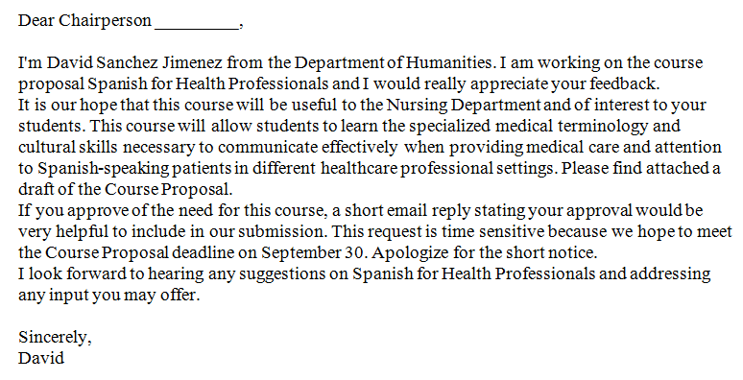

- Email sent to the Chairpersons of the School of Professional Studies, the Health Services Administration Program Coordinator and the Dean of the School of Professional Studies on September 12, 2016

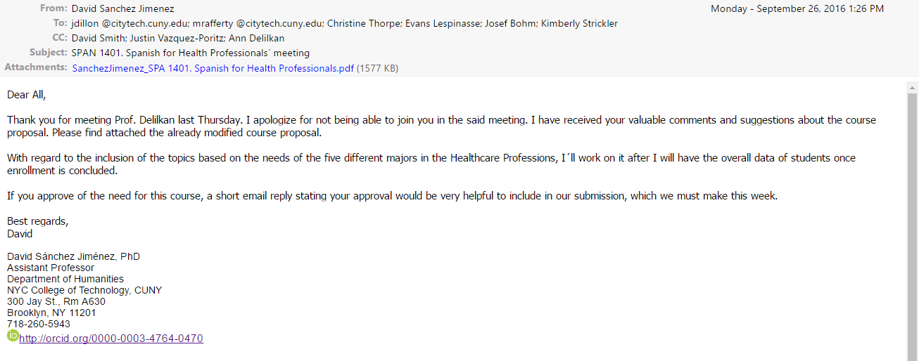

- Dr. Josef Bohm, Health Services Administration Program Coordinator, September 26, 2016

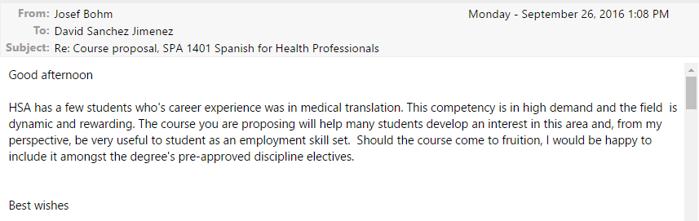

- Dr. Margaret Rafferty, Chair of the Department of Nursing, September 22, 2016

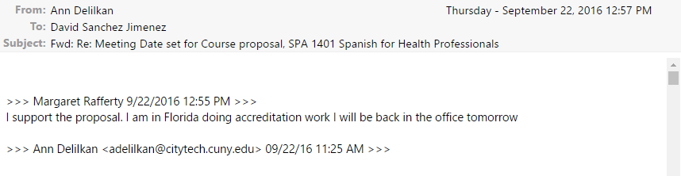

- Dr. Kimberly Strickler, Chair of the Department of Vision Care Technology, September 14, 2016

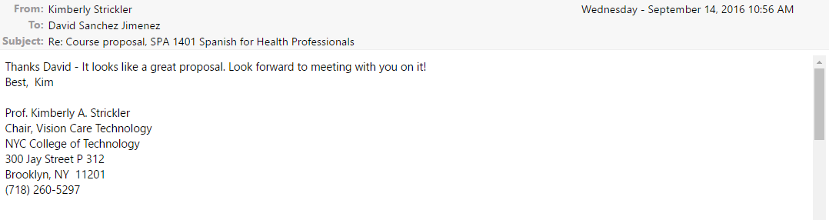

- Dr. Jocelyn Dillon, Chair of the Department of Dental Hygiene, September 13, 2016

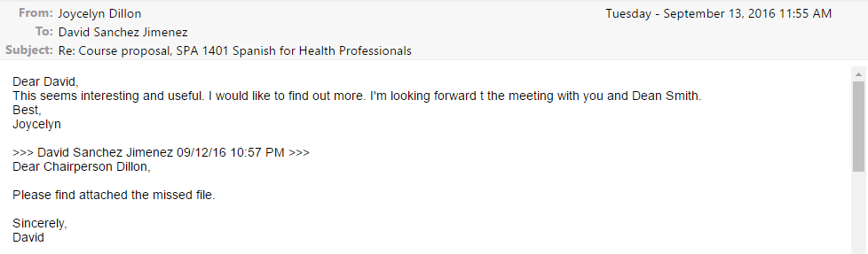

- Dr. Jocelyn Dillon, Chair of the Department of Dental Hygiene, September 27, 2016

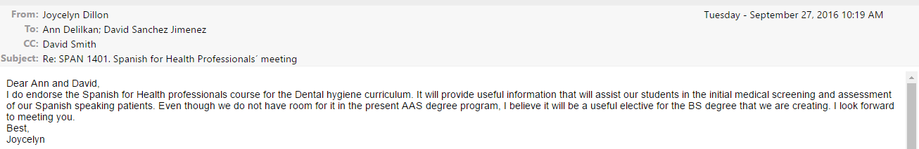

- Dr. Evans Lespinasse, Chair of the Department of Radiologic Technology & Medical Imaging, September 13, 2016

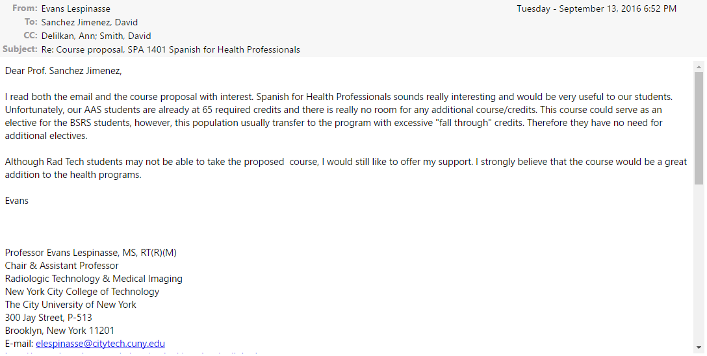

- Dr. Christine Thorpe, Chair of the Department of Health and Human Services, September 29, 2016

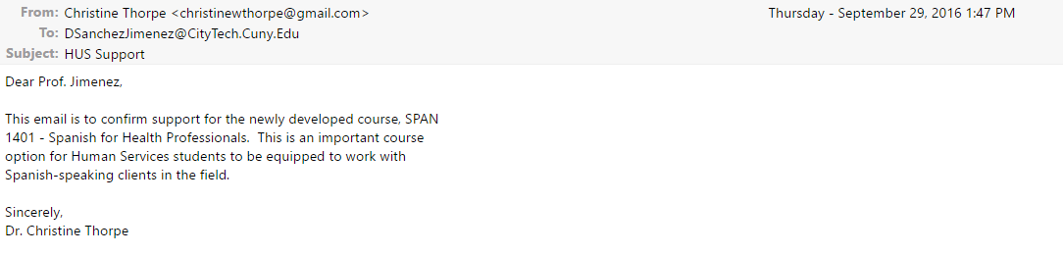

- Dr. David Smith, Dean of City Tech School of Professional Studies, September 13, 2016

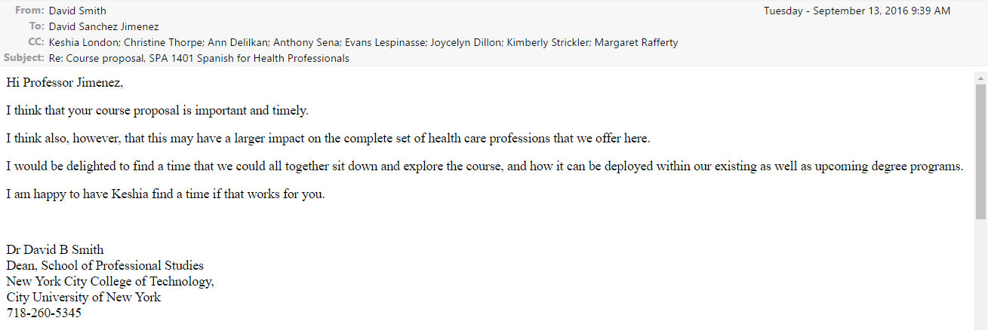

- Dr. David Smith, Dean of City Tech School of Professional Studies, September 26, 2016

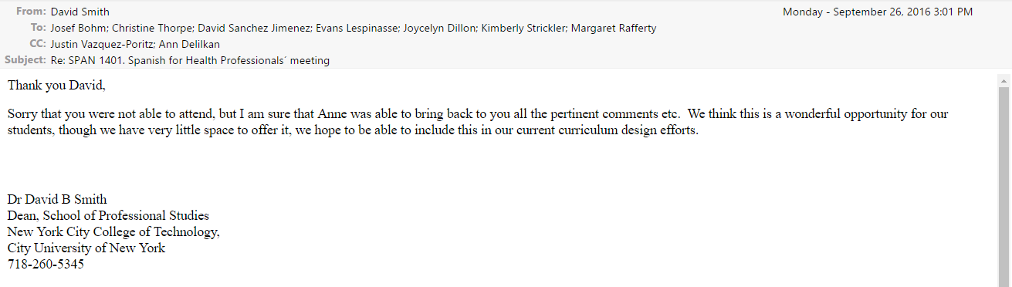

Appendix II: Projected Spanish course sequence model for the academic year 2017-2018

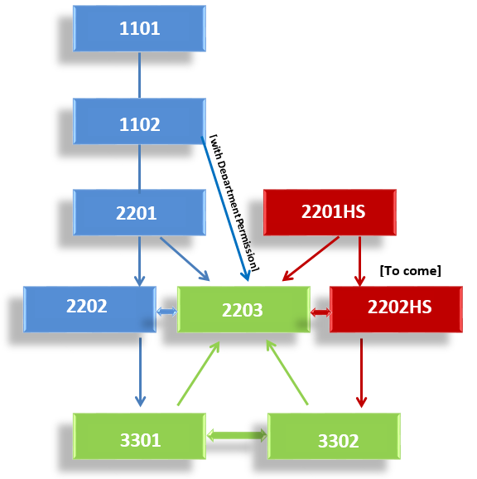

SPA 2203 will be included in the new Spanish course sequence that the Foreign Language committee is preparing for the next academic year 2017-2018. Aside from 3301 and 3302 (in green), SPA 2203 will be one of the three Spanish courses that all students can take. In these courses, Spanish for Speakers of Other Languages (SSOL) and Spanish Heritage Speakers (SHS) will be merged in the class. There will be a specific track for SSOL (in blue) and another one for SHS (in red). SPA 2202HS will be a new addition to this model in Spring 2018. Students who have previously taken SPA 1102 with department permission; or 1301 (to be renamed 2201HS); or 2201; or 2202; or 3301; or 3302; or placement test and department permission will be able to enroll in SPA 2203. After studying SPA 2203, students can continue studying other Spanish courses such as 2201, 2202, or 2202HS within their respective tracks.

Appendix III: A course sequence (for current advisement purpose)*

LAA non-heritage speakers:

2203 2203 2203
1101, 1102, and/ or , and/ or , and/ or
2201 2202 3301 and/ or 3302

LAA heritage speakers:

2203 2203
2201HS, and/ or , and/ or
2202 3301 and/ or 3302

Non LAA (two steps for BA):

1102
or
2201 2203
or
2202

*NOTE: Department permission applicable at beginning of any sequence.

New York City College of Technology, CUNY
CURRICULUM MODIFICATION PROPOSAL FORM
This form is used for all curriculum modification proposals. See the Proposal Classification Chart for information about what types of modifications are major or minor. Completed proposals should be emailed to the Curriculum Committee chair.

Title of Proposal | Minor Modification to SPA courses
Date | 11/20/2016
Major or Minor | Minor modification
Proposer’s Name | David Sánchez Jiménez
Department | Humanities
Date of Departmental Meeting in which proposal was approved | 12/1/2016
Department Chair Name | Ann Delilkan
Department Chair Signature and Date | December 1st, 2016
Academic Dean Name | Dr. Justin Vazquez-Poritz
Academic Dean Signature and Date | 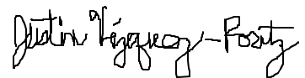December 19, 2016
Brief Description of Proposal  (Describe the modifications contained within this proposal in a succinct summary. More detailed content will be provided in the proposal body. | - Change course number and prerequisite, from SPA 1301 to SPA 2201HS, with placement test and department permission as a prerequisite  - Change course name from “Spanish for Native/ Heritage Speakers” to “Spanish for Heritage Speakers”
Brief Rationale for Proposal  (Provide a concise summary of why this proposed change is important to the department. More detailed content will be provided in the proposal body). | - SPA 2201HS will be the first step of a new track in Spanish created specifically for Spanish heritage speakers.  The new course number reflects the language proficiency level that students achieve in this course, which will be parallel in the Spanish course sequence to SPA 2201. Students of both tracks (heritage speakers and no heritage speakers) have developed different skills (oral, writing, grammar, vocabulary) at this level. For this reason, we recommend that 1. they cannot be mixed in the same class; 2. they are in a parallel language proficiency level, but they need to develop specific skills that they lack at this point of the process of learning a language  - The title is changed because the term “native” is included in the wider term “heritage”
Proposal History  (Please provide history of this proposal: is this a resubmission? An updated version? This may most easily be expressed as a list). | 11-20-2016 New Proposal
Evidence of consultation with affected departments. | N/A
List of the programs that use this course as required or elective, and courses that use this as a prerequisite | SPA 1301 (to come 2201HS) is currently a prerequisite for SPA 2202. In the projected Spanish course sequence that the Humanities department is developing this semester, SPA 2201HS would be a prerequisite for SPA 2202HS (course to come) and SPA 2203 (cf. course proposed for major modification, Appendix II and III).

CHANCELLOR’S REPORT FORM
Section AV: Changes in Existing Courses

AV.1. Humanities

SPA 2201HS Spanish for Heritage Speakers
From: |  | To:
Course Number: | SPA 1301 | Course Number: | SPA 2201HS
Course Title: | Spanish for Native/ Heritage Speakers | Course Title: | Spanish for Heritage Speakers
Prerequisite: | SPA 1102 or department  approval (student must be a heritage  speaker and demonstrate proficiency  to place in SPA 1301) | Prerequisite: | Placement test and department approval (student must be a heritage speaker and demonstrate proficiency to place in SPA 2201HS)

Rationale: New course number clarifies the position of SPA 2201HS within the projected Spanish course sequence, according to the language proficiency level of the students. New prerequisite separates SPA 2201HS from the Spanish non-heritage speakers track with the goal of establishing a Spanish heritage speakers track, which will be expanded in the future.

New York City College of Technology, CUNY
CURRICULUM MODIFICATION PROPOSAL FORM
This form is used for all curriculum modification proposals. See the Proposal Classification Chart for information about what types of modifications are major or minor. Completed proposals should be emailed to the Curriculum Committee chair.

Title of Proposal | Minor Modification to SPA courses
Date | 11/20/2016
Major or Minor | Minor modification
Proposer’s Name | David Sánchez Jiménez
Department | Humanities
Date of Departmental Meeting in which proposal was approved | 12/1/2016
Department Chair Name | Ann Delilkan
Department Chair Signature and Date | December 1st, 2016
Academic Dean Name | Dr. Justin Vazquez-Poritz
Academic Dean Signature and Date | December 19, 2016
Brief Description of Proposal  (Describe the modifications contained within this proposal in a succinct summary. More detailed content will be provided in the proposal body. | Change course prerequisite, from SPA 2201 or 1301 or department approval (placement test) to SPA 2201 or 2201HS or placement test and department permission
Brief Rationale for Proposal  (Provide a concise summary of why this proposed change is important to the department. More detailed content will be provided in the proposal body). | Due to a change in the course code and name of SPA 2201HS, we have to adjust the Spanish course sequence and modify the prerequisites of SPA 2202.
Proposal History  (Please provide history of this proposal: is this a resubmission? An updated version? This may most easily be expressed as a list). | 11-20-2016 New Proposal
Evidence of consultation with affected departments. | N/A
List of the programs that use this course as required or elective, and courses that use this as a prerequisite | SPA 1301 and SPA 2201 are currently a prerequisite for SPA 2202. In the projected Spanish course sequence that the Humanities department is developing this semester, SPA 2201HS and SPA 2201 would be a prerequisite for SPA 2202 (cf. course proposed for major modification, Appendix II and III).

CHANCELLOR’S REPORT FORM
Section AV: Changes in Existing Courses

AV.1. Humanities

SPA 2202 Intermediate Spanish II
From: |  | To:
Course Number: | SPA 2202 | Course Number: | SPA 2202
Course Title: | Intermediate Spanish II | Course Title: | Intermediate Spanish II
Prerequisite: | SPA 2201 or department  approval (placement test) | Prerequisite: | SPA 2201 or SPA 2201HS or placement test and department approval

Rationale: Due to a change in the course code and name of SPA 2201HS, we have to adjust the Spanish course sequence and modify the prerequisites of SPA 2202.

See minor modification attached.
See minor modification attached.
See minor modification attached.

