Trauma-Informed Practice
HEA 3507

Submitted by:
Dr. Deborah M. Courtney
Assistant Professor
Human Services Department

Table of Contents

Independent External Review Report…………………………………………………….3

Curriculum Modification Proposal Form…………………………………………………4

New Course Proposal Form………………………………………………………………6

Course Title, Number, Credits, Hours, Catalog Course Description …………….6

Brief Rationale……………………………………..………………………….….6

Library Resource and Information Literacy Form………………………………………..7

Course Need Assessment ………………………………………………………………..8

Course Design…………………………………………………………………………....8

Chancellor’s Report……………………………………………………………………... 9

New Course Proposal Checklist………………………………………………………….12

Course Outline……………………………………………………………………..…….14

Independent External Review Report
(This reviewer was identified by Provost August and is not known to Dr. Courtney)

Review of Trauma-Informed Practice Course Proposal
Jessica Rosenberg, PhD, LCSW
Professor, LIU-Brooklyn
12/18/16

This is a review of a course proposal entitled “Trauma-Informed Practice. " The review will examine issues related to its appropriateness, design, and utility for an undergraduate program focused on developing practitioners in social work/ human services.
A substantial body of research suggests that a large number of adults and children in mental health, substance abuse, prison or juvenile justice systems, homeless shelters and community-based agencies, have trauma histories. Many of the clients that human service professionals work with in their field placements are impacted by exposure to traumatic events. Underlying trauma, such as being the victim of violence, child abuse, global violence, community violence, bullying, traumatic loss, is often manifested in diagnosed mental health conditions such as substance abuse, personality disorders, and major mental illness. Nonetheless, too often, trauma is unrecognized. There is a growing body of research that documents the crucial relationship between trauma and other mental health conditions. It is imperative that students are trained to understand and recognize trauma and that they are provided with the skills and training to ameliorate it effects.

Accordingly, this course presents an exceptionally well developed rationale for its utility. Human service students are training in field placements where they will be working with persons who have been exposed to trauma, This course provides a well organized design that provides students with both theoretical knowledge and practical skills that will be of value for students training in multiple settings. It is very solid, both in terms of the pedagogical methods described and the selection of texts and reading. It includes several evidence-based practice modalities that are current, it includes training in coping skills, and covers vicarious trauma, which is essential for practitioners who engage in this work.

As a professor and practitioner with a specialization in community mental health, and the author of several multidisciplinary texts and articles that focus on emerging mental health treatment and best practices, I find this course to be exemplary in its design and orientation. There is a tremendous need for front-line practitioners to be trained to understand, recognize, and intervene with clients who are struggling with trauma-induced problems. More educational programs should emulate the work of this proposed course.

New York City College of Technology, CUNY
CURRICULUM MODIFICATION PROPOSAL FORM

Title of Proposal | Trauma-Informed Practice – HEA 3507
Date | 2/23/16 (New Proposal)  3/30/16 (Revision)  9/2/16 (Revision 2)  12/21/16 (Revision 3)
Major or Minor | Major
Proposer’s Name | Dr. Deborah Courtney
Department | Human Services
Date of Departmental Meeting in which proposal was approved | 2/18/16
Department Chair Name | Dr. Christine Thorpe
Department Chair Signature and Date | Christine W. Thorpe  2-25-2016
Academic Dean Name | Dr. David Smith
Academic Dean Signature and Date | 2016-02-25
Brief Description of Proposal  (Describe the modifications contained within this proposal in a succinct summary. More detailed content will be provided in the proposal body. | This is a proposal for a new course on trauma-informed practices in the Human Services Department.
Brief Rationale for Proposal  (Provide a concise summary of why this proposed change is important to the department. More detailed content will be provided in the proposal body). | This course is an important addition to the Human Services Department because human service students are working in field placements, such as mental health clinics and substance abuse treatment centers, and in communities, where the prevalence of trauma is very high. Research continues to explain that traumatic experiences underlie a variety of mental health and behavioral issues, as well as fear based societal reactions to local and global events. It is imperative for human service students and professionals to understand trauma, its impact, and trauma-informed practices, in order to successfully formulate and effectively serve the vulnerable individuals and communities that they work with.  Human service professionals working from micro to macro levels of practice will benefit from the information in this course.
Proposal History  (Please provide history of this proposal: is this a resubmission? An updated version? This may most easily be expressed as a list). | - This is the third revision of a new course proposal.  - The course was presented at College Council (May 2016). Faculty expressed concern about placement of the course in the Human Service Department as opposed to the Psychology Program. After a brief discussion the course was 2 votes short of passing through College Council.  - Revision #2 was shared with the Social Science Department for review, and Professor Courtney and Professor Pawlukewicz consulted with the Social Science Department on 9/1/16. Many of the suggestions from the Social Science Department have been implemented in this revised version.  - Revision #2 was brought before Executive Committee on 11/22/16. A request was made for an external review. This revised proposal has included said external review at the end of the Appendix.

ALL PROPOSAL CHECK LIST
Completed CURRICULUM MODIFICATION FORM including:
- Brief description of proposal | X
- Rationale for proposal | X
- Date of department meeting approving the modification | X
- Chair’s Signature | X
- Dean’s Signature | X
Evidence of consultation with affected departments  List of the programs that use this course as required or elective, and courses that use this as a prerequisite. | X
Documentation of Advisory Commission views (if applicable). | N/A
Completed Chancellor’s Report Form. | X

New York City College of Technology, CUNY
NEW COURSE PROPOSAL FORM.
Course Title | Trauma-Informed Practice
Proposal Date | 2/23/16 (New Proposal)  3/30/16 (Revision)  9/2/16 (Revision 2)
Proposer’s Name | Dr. Deborah M. Courtney
Course Number | HEA 3507
Course Credits, Hours | 3
Course Pre / Co-Requisites | Pre- or Co - Requisite – HUS 2405
Catalog Course Description | Effects of trauma on individuals, families, communities and societies are examined in relation to the human service profession. Effective, trauma-informed, evidence-based practices for human service professionals that promote recovery and healing are presented, along with coping skills, resilience and the importance of human service professional self-care.
Brief Rationale  Provide a concise summary of why this course is important to the department, school or college. | This course is an important addition to the Human Services Department because human service students are working in field placements, such as mental health clinics and substance abuse treatment centers, and in communities, where the prevalence of trauma is very high. Research continues to explain that traumatic experiences underlie a variety of mental health and behavioral issues, as well as fear based societal reactions to local and global events. It is imperative for human service students and professionals to understand trauma, its impact, and trauma-informed practices, in order to successfully formulate and effectively serve the vulnerable individuals and communities that they work with.  Human service professionals working from micro to macro levels of practice will benefit from the information in this course.
Intent to Submit as Common Core  If this course is intended to fulfill one of the requirements in the common core, then indicate which area. | NO
Intent to Submit as An Interdisciplinary Course | NO
Intent to Submit as a Writing Intensive Course | NO

LIBRARY RESOURCES & INFORMATION LITERACY: MAJOR CURRICULUM MODIFICATION

1 | Title of proposal  Trauma-Informed Practice | Department/Program  Human Services
 | Proposed by (include email & phone)  Dr. Deborah M. Courtney  dcourtney@citytech.cuny.edu  914-907-6046 | Expected date course(s) will be offered  Fall 2017  # of students 25-30

2 | Are City Tech library resources sufficient for course assignments? Please elaborate.  Yes. Journals and books relevant to health and human services, social work, psychology, and counseling are appropriate and sufficient for the course.

3 | Are additional resources needed for course assignments? Please provide details about format of resources (e.g., ebooks , journals, DVDs, etc.), author, title, publisher, edition, date, and price.  No additional resources are needed for course assignments.

4 | Library faculty focus on strengthening students' information literacy skills in finding, evaluating, and ethically using information. We can collaborate on developing assignments and offer customized information literacy instruction and research guides for your course.  Do you plan to consult with the library faculty subject specialist for your area? Please elaborate.  No. The relevant course material is within the book chapters, provided articles and online video sources.

5 | Library Faculty Subject Selector: Nancy Gonzalez___________________  Comments and Recommendations:  Having reviewed library resources on the proposed course, I conclude that the library maintains sufficient materials on the subject. Besides the course pact the library will be acquiring, resources on trauma and its related topics are available in the forms of print materials, electronic databases, e-books (Ebrary), as well as other CUNY online resources.  Date 2/26/16

Course Need Assessment

This course is a crucial addition to the Human Service Department, as trauma has profound impacts on individual, family, community, agency and global levels. As future human service professionals, it is imperative for the students to have a theoretical and practical understanding of trauma and trauma-informed practices. This knowledge will allow them to more fully service clients and communities in their field placements as students and upon entering the field as a professional. Therefore, this course is designed for bachelor level human service students. Approximately 25-30 students will take the course in either the Fall or Spring semester. The knowledge gained in this course will allow students to apply trauma-informed theoretical knowledge and skills that are necessary when traumatic experiences are present in the field. The Human Services Department currently has full time faculty available and interested in teaching this course, as it is in line with their expertise.

Course Design

This course will be a Baccalaureate Level Course in the Human Services Department. The course will be an elective option that will meet the student’s requirement to ‘select one HUS/HEA 35XX level course for 3 credits’. It will be taught over a 15-week semester in a weekly, in-class lecture format, involving discussion, small group activities, reflective journaling, role-playing, videos, and other class activities. Students will be required to complete one major paper, an ongoing reflective journal, actively participate in class, and two exams. These requirements will be equally used to assess their ethics, skills and knowledge of trauma-informed practice. This course will engage students in critical thinking, active discussion, exploration, problem solving, creative written expression, and self-reflection about the significance of traumatic experiences and the importance of utilizing this knowledge as a human service professional.

Section AIV: Chancellor’s Report for New Courses

New course to be offered in the Health and Human Services department
Department(s) | Human Services
Academic Level | [ X ] Regular [ ] Compensatory [ ] Developmental [ ] Remedial
Subject Area | Human Services
Course Prefix | HEA
Course Number | 3507
Course Title | Trauma-Informed Practice
Catalog Description | Effects of trauma on individuals, families, communities and societies are examined in relation to the human service profession. Effective, trauma-informed, evidence-based practices for human service professionals that promote recovery and healing are presented, along with coping skills, resilience and the importance of human service professional self-care.
Prerequisite | N/A
Corequisite | N/A
Pre- or co-requisite | HUS 2405
Credits | 3
Contact Hours | 3 class hours
Liberal Arts | [ ] Yes [ X ] No
Course Attribute (e.g. Writing Intensive, etc) | N/A
Course Applicability | [X] Major  [ ] Gen Ed Required [ ] Gen Ed - Flexible [ ] Gen Ed - College Option  [ ] English Composition [ ] World Cultures [ ] Speech  [ ] Mathematics [ ] US Experience in its Diversity [ ] Interdisciplinary  [ ] Science [ ] Creative Expression [ ] Advanced Liberal Arts  [ ] Individual and Society  [ ] Scientific World
Effective Term | Spring 2017

Rationale: This Trauma-Informed Practice course is a great fit for the Human Service Department. The human service students are working in the field with a variety of populations in diverse settings, where research shows the prevalence of trauma is extremely high, such as “community mental health centers; family, child, and youth service agencies, and programs concerned with alcoholism, drug abuse, family violence, and aging.” According to the National Organization for Human Services, the field of Human Services holds “the objective of meeting human needs through an interdisciplinary knowledge base, focusing on prevention as well as remediation of problems, and maintaining a commitment to improving the overall quality of life of service populations” (http://www.nationalhumanservices.org/what-is-human-services). In order for human service professionals to effectively do so they need to have the most current information about how traumatic experiences impact the clients that they work with.

Further, many human service graduates continue on to get masters degrees in Social Work programs. The National Center for Social Work Trauma Education is a major movement that has received millions in funding to implement Core Curriculum based on Trauma-Informed practices in MSW programs (http://www.ncswtraumaed.org/). The article, ‘Trauma Informed Social Work Education’, further emphasizes the importance of educating our social work and human service professionals in trauma informed practices (http://www.socialworktoday.com/archive/031513p18.shtml). The density of such research and information, supports the appropriateness of such a class being offered in the human service department. As a result of giving our bachelor level students access to this foundational information they will be well prepared for next steps in their career trajectory. Similar courses are also being offered in other Human Service and BSW programs around the country. More specifically, The Human Service Department at University of Wisconsin Milwaukee offers the following classes: Trauma Counseling I, Trauma Counseling II, Trauma Informed Care. The Human Service Program at Southern New Hampshire University offers a course on the Role and Impact of Trauma on Children and Families. The Human Service Department at the State University of Denver offers a course on Post Traumatic Stress Disorder and Trauma Informed Care.

The National Center for Social Work Trauma Education has put out a number of suggested syllabi for social work and human service departments to get ideas from in the development of their own trauma classes (http://www.ncswtraumaed.org/wp-content/uploads/2013/11/Syllabi-Packet2.pdf). The course content of the proposed course is similar to that of the material being covered in the suggested materials.

In addition to the suggested content areas, EMDR has also been included in this syllabus because of the growing body of evidence and international treatment guidelines recommending it as an effective treatment of trauma. More specifically,
- The American Psychological Association (2016) lists EMDR as an effective treatment for psychological disorders (http://www.div12.org/psychological-treatments/).
- The American Psychiatric Association (2004) states that EMDR is recognized as an effective treatment of ameliorating symptoms of PTSD (http://psychiatryonline.org/pb/assets/raw/sitewide/practice_guidelines/guidelines/acutestressdisorderptsd.pdf).
- The Substance Abuse and Mental Health Services Administration (SAMHSA) (2011), a US Department of Health and Human Services’ agency, cites EMDR as an evidence based practice of choice to treat PTSD, anxiety and depression symptoms (http://www.samhsa.gov/nrepp).
- The Department of Veterans Affairs (VA) and Department of Defense (DoD) (2004), both recommend EMDR as one of four modalities to use with traumatized individuals, and have rated it for highest level of evidence http://www.healthquality.va.gov/guidelines/MH/ptsd/cpg_PTSD-full-201011612.PDF).
- The World Health Organization (2013) recommended EMDR as one of two modalities to be used with children, adolescents or adults with PTSD (http://apps.who.int/iris/bitstream/10665/85119/1/9789241505406_eng.pdf).
- The National Institute of Health and Clinical Excellence (2005) identify EMDR as a preferred treatment for PTSD.
  - National Institute for Health and Clinical Excellence. (2005). Post traumatic stress disorder (PTSD). London: Author.

Other higher education institutions have also recognized the importance of including newer modalities with growing bodies of evidence, such as EMDR in their curriculum. Specifically, the University of Buffalo devotes an entire course to EMDR in their Social Work program (http://undergrad-catalog.buffalo.edu/courses/?abbr=SW&num=593), while others such as Fordham University and Mercy College bring in guest lecturers to teach on the topic. Many universities, such as the University of Buffalo, Boston University, Adelphi University and Tulane, among others, are offering EMDR courses as certificate programs that can be taken in addition to the core curriculum.

NEW COURSE PROPOSAL CHECK LIST
Use this checklist to ensure that all required documentation has been included. You may wish to use this checklist as a table of contents within the new course proposal.
Completed NEW COURSE PROPOSAL FORM
- Title, Number, Credits, Hours, Catalog course description | X
- Brief Rationale | X
Completed Library Resources and Information Literacy Form | X
Course Outline  Include within the outline the following. | X
Hours and Credits for Lecture and Labs  If hours exceed mandated Carnegie Hours, then rationale for this | X
Prerequisites/Co- requisites | X
Detailed Course Description | X
Course Specific Learning Outcome and Assessment Tables  - Discipline Specific  - General Education Specific Learning Outcome and Assessment Tables | X
Example Weekly Course outline | X
Grade Policy and Procedure | X
Recommended Instructional Materials (Textbooks, lab supplies, etc) | X
Library resources and bibliography | X
Course Need Assessment.  Describe the need for this course. Include in your statement the following information. | X
Target Students who will take this course. Which programs or departments, and how many anticipated?  Documentation of student views (if applicable, e.g. non-required elective). | X
Projected headcounts (fall/spring and day/evening) for each new or modified course. | X
If additional physical resources are required (new space, modifications, equipment), description of these requirements. If applicable, Memo or email from the VP for Finance and Administration with written comments regarding additional and/or new facilities, renovations or construction. | N/A
Where does this course overlap with other courses, both within and outside of the department? | X
Does the Department currently have full time faculty qualified to teach this course? If not, then what plans are there to cover this? | X
If needs assessment states that this course is required by an accrediting body, then provide documentation indicating that need. | N/A
Course Design  Describe how this course is designed. | X
Course Context (e.g. required, elective, capstone) | X
Course Structure: how the course will be offered (e.g. lecture, seminar, tutorial, fieldtrip)? | X
Anticipated pedagogical strategies and instructional design (e.g. Group Work, Case Study, Team Project, Lecture) | X
How does this course support Programmatic Learning Outcomes? | X
Is this course designed to be partially or fully online? If so, describe how this benefits students and/or program. | X
Additional Forms for Specific Course Categories | N/A
Interdisciplinary Form (if applicable) | N/A
Common Core (Liberal Arts) Intent to Submit (if applicable) | N/A
Writing Intensive Form if course is intended to be a WIC (under development) | N/A
If course originated as an experimental course, then results of evaluation plan as developed with director of assessment. | N/A
(Additional materials for Curricular Experiments) | N/A
Plan and process for evaluation developed in consultation with the director of assessment. (Contact Director of Assessment for more information). | N/A
Established Timeline for Curricular Experiment | N/A

COURSE OUTLINE

NEW YORK CITY COLLEGE OF TECHNOLOGY
CITY UNIVERSITY OF NEW YORK
HUMAN SERVICES DEPARTMENT – N401

(718) 260-5135

TRAUMA-INFORMED PRACTICE – HEA 3507

INSTRUCTOR: Dr. Deborah Courtney
E-MAIL ADDRESS: DCourtney@CityTech.Cuny.Edu
OFFICE HOURS:
SECTION: ROOM:

Course Description:
Effects of trauma on individuals, families, communities and societies are examined in relation to the human service profession. Effective, trauma-informed, evidence-based practices for human service professionals that promote recovery and healing are presented, along with coping skills, resilience and the importance of human service professional self-care.

This course is an important addition to the Human Services Department because research continues to point to the significance of traumatic experiences underlying a variety of mental health and behavioral issues, as well as fear based societal reactions to local and global events. It is imperative for human service professionals to understand trauma, its impact, and trauma-informed practices, in order to successfully formulate and effectively serve individuals and communities. Human service professionals working from micro to macro levels of practice will benefit from the information in this course.

Course Objectives:
- Explain the historical perspectives on trauma
- Understand objective and subjective definitions of trauma
- Increase understanding of the importance of trauma-informed practice as a human service professional
- Identify the range of outcomes associated with stress and trauma, including neurobiological development, cognitions, somatic experiencing, behavioral responses and relational patterns
- Explain traumatic impacts on individual, family, community, agency and global levels
- Understand and describe traumatic impacts on a variety of populations
- Begin to understand a variety of evidence based trauma-informed practice approaches
- Provide coping skill education to clients
- Assess and formulate a case from a trauma-informed perspective
- Practice self-assessing for vicarious traumatization and utilizing self care skills
- Gain information about professional roles in trauma-relevant fields

Course Specific Learning Outcomes/Assessment Methods

Learning Outcomes | Assessment Methods
Demonstrate understanding of the impact historical perspectives of trauma has on trauma-informed practice today | Evaluation of student work on written exams and during class discussion
Describe the importance of trauma-informed practice as a human service professional | Evaluation of student work on written exams, journal entries, written assignment and class discussion
Apply knowledge about outcomes associated with stress and trauma, including neurobiological development, cognitions, somatic experiencing, behavioral responses and relational patterns, to case examples | Analysis of student involvement in small group exercises, role plays and written assignment
Utilize theory to understand traumatic impacts on a variety of levels (individual, community, global) and populations | Analysis of student involvement in small group exercises and role plays; evaluation of written assignment and written exams
Identify the appropriate evidence based trauma-informed practice models for specific case examples | Evaluation of student work on written exams, written assignment and class discussion
Practice self-assessing for vicarious traumatization and utilizing self-care skills | Analysis of student work in journal entries and during class exercises
Demonstrate understanding of the various professional roles in trauma-relevant fields | Analysis of class discussion and written assignment

General Education Learning Outcomes/Assessment Methods
Learning Outcomes | Assessment Methods
Demonstrate awareness, sensitivity and respect for diversity in regard to culture, race, ethnicity, gender, sexual orientation, socioeconomic status and disability | Analysis of student’s work on written exams, journal entries, class exercises and class discussions
Demonstrate self-awareness, ability to reflect on bias, and commitment to human service ethics and values. | Analysis of student’s work on written exams, journal entries, class exercises and class discussions

Pre- or Co- requisite: HUS 2405

Credits: 3

Required Textbook:
Textbooks: (Students will read selected excerpts from each of these leading texts in the trauma field). A course pack of these excerpts will be ordered for student purchase so that students do not have to purchase each book.

Van der Kolk, B., McFarlane, A., Weisaeth, L., Editors (1996).
Traumatic Stress: The Effects of Overwhelming Experience on Mind, Body, and
Society. New York: The Guilford Press.

Herman, Judith, M.D.. (1992). Trauma and Recovery. New York, NY: Basic Books.

Dass-Brailsford, Priscilla (2007). A Practical Approach to Trauma: Empowering Interventions. Thousand Oaks, CA: Sage Publications, Inc.

Supplementary Readings:
There will be additional required journal articles assigned each week. These will be found in the course pack or online.

Format:

Class will consist of lectures; class discussions; in-class practice exercises; role-plays; small groups activities; case analyses; videos; and reflection exercises.

Course Requirements:
Students are expected to complete all reading assignments in preparation for the appropriate class. Attendance and positive participation in all classes/exercises/group activities are required and will count toward the Class Participation Grade. Absences exceeding two class sessions without medical (or other approved) documents will result in a letter reduction grade for each additional absence.
All written and exam assignments must be completed by the due date, unless previous arrangements are made with the professor.
*For Human Services majors, a C grade is required to pass this course.

Technology Requirements:
Students will be expected to utilize Blackboard frequently throughout the semester; to keep their reflection journals, access readings and course information, and upload assignments.

Assignments:
Reflection Journal
Each student will keep a reflection journal in which they write a personal reflection at the end of each class. This will be a reflection on the student’s experiences with the class material/exercises. These journals will be reviewed weekly. This journal will count toward the student’s Class Participation Grade.

Midterm and Final Exams
Each exam will be 1.5 hrs and will consist of short answer/essay type questions.

Written Assignment – Trauma Case Analysis Paper
Students are expected to write a trauma case analysis paper (8-10 pages).
See below for a detailed description of this assignment and grading rubric.
*This written assignment MUST BE SUBMITTED via BLACKBOARD. In class, paper submissions will NOT be accepted.

Grading:
- Class Participation/Self Reflective Exercises (Every Class) 25%
- Midterm Exam (Class #8) 25%
- Final Exam (Class #15) 25%
- Written Assignment (Due Class #13) 25%
Course Outline:
1. Overview of Human Service Professionals and Trauma:
- Trauma in Human Service Settings
- Objective, Subjective Definitions
- Historical Perspective of Trauma
- Micro-aggressions
- Introduction to Reflection Journal
- Introduction to Vicarious Trauma and Self Care (to be discussed throughout the course)

2. Significance of Trauma-Informed Practice in the Human Service Profession
- Significance of the Trauma-Informed Perspective
- Moving Beyond PTSD
- Attachment/Relational Issues that result from Trauma
- Intergenerational Transmission
- Community Impact

3. Traumatic Impact on the Individual Client:
- Trauma and the brain (Repression, Flashbacks, Negative Cognitions)
- Trauma and the body (Emotional Storage in the Body)
- In Class Exercises: Cognition Identification and Replacement/Identifying Emotional Storage in the Body

4. Evidence Based Trauma-Informed Practices for the Human Service Professional (to be covered over next three classes)
- EMDR
- TF-CBT
- Ego State Work
- Somatic Experiencing
- Yoga/Mindfulness

5. Trauma-Informed Practices (continued)
- In Class Exercise: Practice skills

6. Trauma-Informed Practices (continued)
- In Class Exercise: Practice skills

7. Midterm Exam/In Class Work on Written Assignment

8. Coping Skills for the Human Service Professional
- Emotional State Shifting
- Container/Safe Place Exercises
- Breath Work
- Emotional Freedom Technique
- Ego State Dialogue
- In Class Exercise: Practice of the above Skills

9. Specific Human Service Population Considerations
(to be covered over next two classes)
- Children/Adolescents
- Aging
- Military/Veterans
- Domestic Violence
- Sexual Abuse/Incest
- Substance Abuse

10. Specific Population Considerations
- Continued from above

11. Working with Traumatic Grief
- Understanding Grief and Loss
- Differences between Traditional Grief and Traumatic Grief
- Terminal Illness
- Spiritual Integration/Meaning Making

12. Traumatic Impact on Communities
- Similarities and Differences between (Natural Disasters, Mass Shootings, Terrorism, Bullying, Poverty, Neighborhood Violence)
- In Class Exercise: Our Response to the Media and Coping Skills Practice

13. Traumatic Impact on Human Service Agencies
Written Assignment Due
- Parallel Process
- The Sanctuary Model

14. Vicarious Trauma and Self-Care for Human Service Professionals
/Review for Final
- What is VT?
- Healthy Boundaries
- Self Care techniques (Boundaries, Release Work, Breath Work)
- In Class Exercise – Practice Self-Care Techniques
- Submission of Reflection Journals

15. Final Exam/Return Reflection Journals

Written Assignment – Trauma Case Analysis

Description:
- Choose an article from a journal, newspaper or magazine that describes an individual, community or global response to a traumatic experience.
- Analyze the case from a human service, strengths based perspective and describe the following:
  - The Trauma: Explain the Trauma
  - Main Problems/Issues Identification: What are the main problems/issues that the person/community/society are now experiencing as a result of this trauma? In other ways, how has the trauma impacted the person/community/society that has been affected by it? If not specifically stated, what do you hypothesize the effects of the trauma might be?
  - Trauma-Informed Analysis: Analyze from a trauma-informed perspective why this traumatic experience may be having or will have these problematic effects.
  - Trauma-Informed Practice Recommendations: Provide recommendations for a human service professional working with this person/community/society from a trauma-informed practice perspective. For instance…What practice models would you use? Why? How would you implement them? Etc.
  - Link to Class Readings and/or Other Journal Articles: Cite at least 5 professional sources throughout the paper.
  - Writing Mechanics and Paper Formatting: The paper should adhere to all APA formatting standards. It should be well organized (with an effective introduction, body and conclusion), and well written (free of grammatical and spelling errors).

Grading Rubric for Trauma Case Analysis

Criterion | Strong (20 points) | Average (15 points) | Weak (10 points)
Main Problems/Issues Identification | Identifies and demonstrates a sophisticated understanding of the main problems/issues in the trauma case. | Identifies and demonstrates an accomplished understanding of most of the problems/issues in the trauma case. | Identifies and demonstrates acceptable understanding of some of the problems/issues in the trauma case.
Trauma-Informed Analysis | Presents an insightful and thorough trauma-informed analysis of all identified problems/issues in the case. | Presents a thorough trauma-informed analysis of most of the problems/issues identified | Presents a superficial or incomplete trauma-informed analysis of some of the identified problems/issues.
Trauma-Informed Practice  Recommendations | Provides strong arguments and well documented evidence to support trauma-informed practice recommendations. | Provides limited reasoning and evidence to support the trauma-informed practice  recommendations. | Little or no action suggested and/or inappropriate solutions proposed to the problems/issues present in the trauma case.
Link Paper to Relevant Class Readings and/or Other Journal Articles | Makes appropriate and powerful connections between ideas and class readings, lectures and additional journal articles;  At least 5 professional sources are correctly cited. | Makes appropriate but somewhat vague connections between ideas and class readings, lectures and additional journal articles; 3 or 4 professional sources are correctly cited. | Makes inappropriate or little connection between ideas and class readings, lectures and additional journal articles; less than 3 professional sources are correctly cited.
Writing Mechanics and Paper Formatting | Paper is well organized (introduction, body, conclusion);  Paper is well written (free from grammatical and spelling errors);  APA format is used throughout the paper  (title page, spacing, indentation, citations) | Paper may lack some organization;  Paper may have occasional grammar or spelling errors, but still clearly presents ideas;  Paper may have occasional APA errors | Paper is poorly organized, unfocused and contains serious errors, with little to no APA formatting used throughout.

Bibliography

Bloom, S. L. and Sreedhar, S. Y. (2008) The Sanctuary Model of Trauma-Informed
Organizational Change. Reclaiming Children and Youth: From Trauma to Trust, 17(3): 48-53.

Cantwell-Bartl, A. (2003). Is This Person Suffering Grief or Trauma or Traumatic Grief?,
Research Gate, 1-3.

Catherall, D. R. (1999). Coping with secondary traumatic stress: The importance of the
therapist’s professional peer group. In B. Hudall Stamm (Ed.), Secondary Traumatic stress: Self-care issues for clinicians, researchers, and educators (pp. 80–92). Baltimore, MD: Sidram Press

Cunningham, M. (1999). The impact of sexual abuse treatment of the social work
clinician. Child and Adolescent Social Work Journal, 16(4), pp.227-290.

Dass-Brailsford, Priscilla (2007). A Practical Approach to Trauma: Empowering
Interventions. Thousand Oaks, CA: Sage Publications, Inc.

Finkerhor, D. & Browne, A. (1985). Traumatic Impact of Child Sexual Abuse: A
Conceptualization. American Journal of Orthopsychiatry, 55(4), 1- 13.

Gamble, S.J. (2nd ed.). (2003). Self-care for bereavement counselors. In N.B. Webb
(Ed.), Helping bereaved children: A handbook for practitioners, pp. 346-364. New York: Guilford

Hecker, T., Braitmayer, L. & van Duijl, M. (2015).Global mental health and trauma
exposure: the current evidence for the relationship between traumatic experiences and spirit possession. European Journal of Psychotraumatology, 6.

Hendricks, A, Cohen, J., Mannarino, A. & Deblinger, E. (2003). Trauma Focused CBT
Workbook. http://www.episcenter.psu.edu/sites/default/files/ebp/Your-Very-Own-TF-CBT-Workbook-Final.pdf

Herman, J. (1992). Trauma and Recovery. New York, NY: Basic Books.

Jackson, K. (2014). Trauma Sensitive Yoga. Social Work Today, 6, 8.

Lobenstine, F. & Courtney, D. (2013). A Case Study: The integration of EMDR and Ego
State Therapy to Treat CoMorbid PTSD, Depression and Anxiety. Journal of EMDR Practice and Research, 7, 2, 65-80.

Maschi, T. Perillo, J. & Courtney, D. (2012). Releasing Their Stories: A qualitative
study of juvenile justice involved youth with histories of mental health issues and violence. Journal of Forensic Social Work, 1(2), 132-158.

McCann, L. & Pearlman, L. (2015). Assessing Personal History: Traumatic Events, the
Social and Cultural Context, and Social Support. Routledge: New York.

Norris, F. H. (2007). Impact of mass shootings on survivors, families, and communities.
PTSD Research Quarterly, 18, 1–7.

Nowill, J. (2010, April). A critical review of the controversy surrounding eye
movement desensitisation and reprocessing. Counselling Psychology Review, 25(1), 63-70.

Rasmussen, L. A. (2001). Integrating cognitive-behavioral and expressive therapy
interventions: Applying the trauma outcome process in treating children with sexually abusive behavior problems. Journal of Child Sexual Abuse, 10(4), 1-29.

Rosenblatt, P, (1996). Grief that does not end. In Continuing bonds: New understandings
of grief. Series in death education, aging, and health care, (pp. 45-58). Klass, Dennis (Ed); Silverman, Phyllis R. (Ed); Nickman, Steven L. (Ed). Philadelphia, PA, US: Taylor & Francis.

Rothschild, B. (1998). PTSD: Identification and Diagnosis. The Swiss Journal of Social
Work.

Shallcross, L. (2012). A Calming Presence. Counseling Today,
http://ct.counseling.org/2012/02/a-calming-presence/

Shamai, M. (2000). Rebirth of the self: How battered women experience treatment.
Clinical Social Work Journal, 28, 85-103.

Van der Kolk, B., McFarlane, A., Weisaeth, L., Editors (1996).
Traumatic Stress: The Effects of Overwhelming Experience on Mind, Body, and
Society. New York: The Guilford Press.

Vondra, J.I. & Toth, S.L. (1989). Ecological perspectives on child maltreatment:
Research and intervention. Early Child Development and Care, 42, 11-29.

Webb, N. (1999). Play Therapy with Children in Crisis: Individual, Group and Family
Treatment. New York: Guilford Press.

ACADEMIC INTEGRITY STANDARDS
CUNY Policy on Academic Integrity

Academic Dishonesty is prohibited in The City University of New York and is punishable by penalties, including failing grades, suspension and expulsion.

New York City College of Technology Policy on Academic Integrity
Students and all others who work with information, ideas, texts, images, music, inventions, and other intellectual property owe their audience and sources accuracy and honesty in using, crediting, and citing sources. As a community of intellectual and professional workers, the College recognizes its responsibility for providing instruction in information literacy and academic integrity, offering models of good practice, and responding vigilantly and appropriately to infractions of academic integrity. Accordingly, academic dishonesty is prohibited in The City University of New York and at New York City College of Technology and is punishable by penalties, including failing grades, suspension, and expulsion. The complete text of the College policy on Academic Integrity may be found in the catalog.

Definitions and Examples of Academic Dishonesty

Cheating is the unauthorized use or attempted use of material, information, notes, study aids, devices or communication during an academic exercise.

The following are some examples of cheating, but by no means is it an exhaustive list.
- Copying from another student during an examination or allowing another to copy your work.
- Unauthorized collaboration on a take-home assignment or examination.
- Using notes during a closed-book examination.
- Taking an examination for another student, or asking or allowing another student to take an examination for you.
- Changing a graded exam and returning it for more credit.
- Submitting substantial portions of the same paper to more than one course without consulting with each instructor.
- Preparing answers or writing notes in a blue book (exam booklet) before an examination.
- Allowing others to research and write assigned papers or do assigned projects, including use of commercial term paper services.
- Giving assistance to acts of academic misconduct/dishonesty.
- Fabricating data (all or in part).
- Submitting someone else’s work as your own.
- Unauthorized use during an examination of electronic devices such as cell phones, palm pilots, computers or other technologies to retrieve or send information.

Plagiarism is the act of presenting another person’s ideas, research or writings as your own.

The following are some examples of plagiarism, but by no means is it an exhaustive list:
- Copying another person’s actual words without the use of quotation marks and footnotes attributing the words to their source.
- Presenting another person’s ideas or theories in your own words without acknowledging the source.
- Using information that is not common knowledge without acknowledging the source.
- Failing to acknowledge collaborators on homework and laboratory assignments.

Internet plagiarism includes submitting downloaded term papers or parts of term papers, paraphrasing or copying information from the internet without citing the source, and “cutting and pasting” from various sources without proper attribution.

Obtaining Unfair Advantage is any activity that intentionally or unintentionally gives a student an unfair advantage in his/her academic work over another student.

The following are some examples of obtaining unfair advantage, but by no means is it an exhaustive list:
- Stealing, reproducing, circulating or otherwise gaining advance access to examination materials.
- Depriving other students of access to library materials by stealing, destroying, defacing, or concealing them.
- Retaining, using or circulating examination materials which clearly indicate that they should be returned at the end of the exam.
- Intentionally obstructing or interfering with another student’s work.

Falsification of Records and Official Documents
The following are some examples of falsification, but by no means is it an exhaustive list:
- Forging signatures of authorization.
- Falsifying information on an official academic record.
- Falsifying information on an official document such as a grade report, letter of permission, drop/add form, ID card or other college document.

Appendix
Supporting Materials

A. Web pages supporting integration of trauma informed practice course in a human service curriculum:
- http://www.nationalhumanservices.org/what-is-human-services
- http://www.ncswtraumaed.org/
- http://www.socialworktoday.com/archive/031513p18.shtml
- http://www.ncswtraumaed.org/wp-content/uploads/2013/11/Syllabi-Packet2.pdf

B. Web pages supported inclusion of EMDR as a content area:
- http://www.div12.org/psychological-treatments/
- http://psychiatryonline.org/pb/assets/raw/sitewide/practice_guidelines/guidelines/acutestressdisorderptsd.pdf
- http://www.samhsa.gov/nrepp
- http://www.healthquality.va.gov/guidelines/MH/ptsd/cpg_PTSD-full-201011612.PDF
- http://apps.who.int/iris/bitstream/10665/85119/1/9789241505406_eng.pdf
- http://undergrad-catalog.buffalo.edu/courses/?abbr=SW&num=593

C. Supporting Letters from Esteemed Researchers and Practitioners:
(See screen shots of emails below from Dr. Ricky Greenwald and Dr. Deborah Korn)

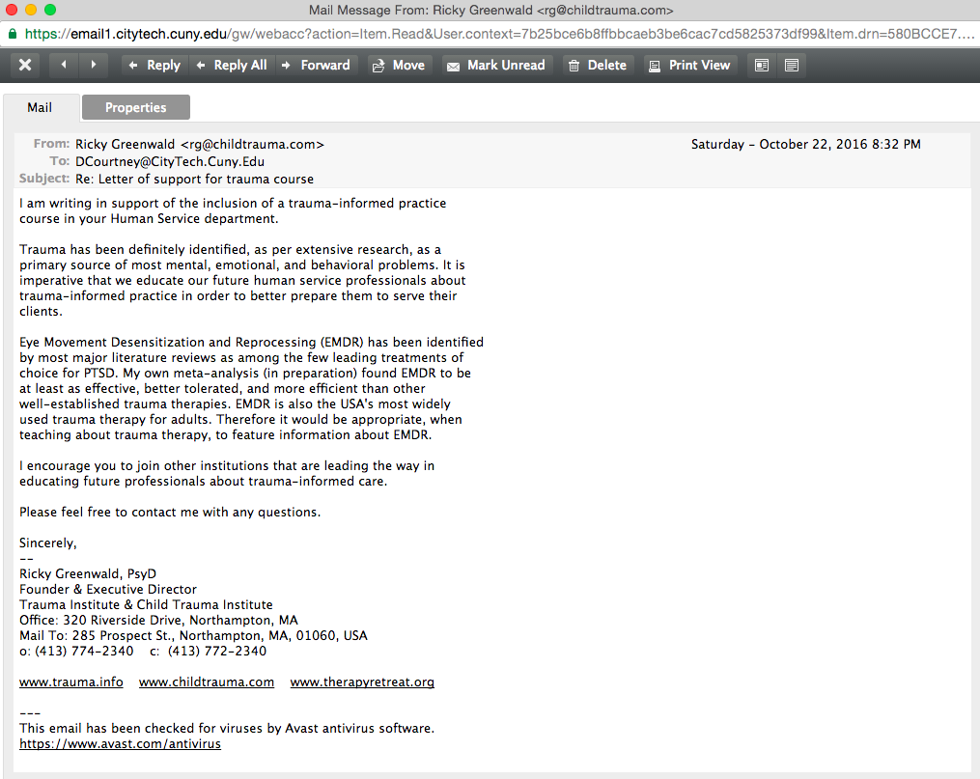
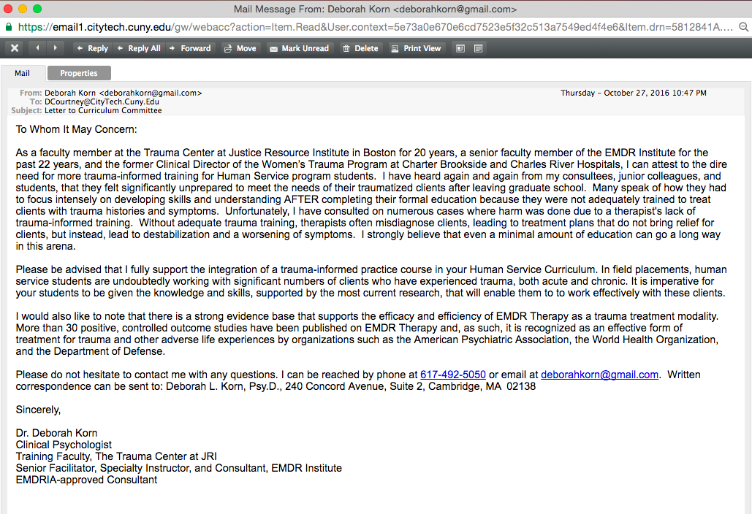

Communication with Social Science Department:
- 9/23/16 - Dr. Courtney shared revised version of proposal based on SS Dept feedback, Chair Hillstrom shared with her faculty
- 10/18/16 – Dr. Courtney follows up with SS Dept Chair regarding any feedback
- 10/19/16 – Chair Hillstrom’s response email
- 11/11/16 – Dr. Her shared feedback from Psychology Discipline
- 11/14/16 – Dr. Courtney responds to feedback after consultation with her department

