New York City College of Technology, CUNY
CURRICULUM MODIFICATION PROPOSAL FORM
This form is used for all curriculum modification proposals. See the Proposal Classification Chart for information about what types of modifications are major or minor. Completed proposals should be emailed to the Curriculum Committee chair.

Title of Proposal | Withdraw of EDU-4420 Energy Systems Course
Date | November 5, 2015
Major or Minor | Minor
Proposer’s Name | Dr. Wm. Edward Roberts
Department | Career & Technology Teacher Education
Date of Departmental Meeting in which proposal was approved | November 4, 2015
Department Chair Name | Dr. Wm. Edward Roberts
Department Chair Signature and Date
Academic Dean Name | David Smith
Academic Dean Signature and Date | 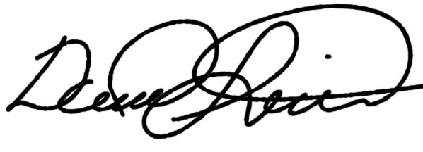2015-11-06
Brief Description of Proposal  (Describe the modifications contained within this proposal in a succinct summary. More detailed content will be provided in the proposal body. | Withdraw EDU-4420 Energy Systems Course. EDU-4420 was a course that was required by ITEEA accreditation in 2004 to make sure we were covering all the technologies in our BS of Technology Teacher Education program. The course is listed in the 2003/2005 catalog, the course has not been taught or listed in the catalog since 2003/2005. This course has never been offered in our program.
Brief Rationale for Proposal  (Provide a concise summary of why this proposed change is important to the department. More detailed content will be provided in the proposal body). | Withdraw EDU-4420 Energy Systems Course. EDU-4420 was a course that was required by ITEEA accreditation in 2004 to make sure we were covering all the technologies in our BS of Technology Teacher Education program. The course is listed in the 2003/2005 catalog, the course has not been taught or listed in the catalog since 2003/2005. This course has never been offered in our program.
Proposal History  (Please provide history of this proposal: is this a resubmission? An updated version? This may most easily be expressed as a list). | Withdraw EDU-4420 Energy Systems Course. EDU-4420 was a course that was required by ITEEA accreditation in 2004 to make sure we were covering all the technologies in our BS of Technology Teacher Education program. The course is listed in the 2003/2005 catalog, the course has not been taught or listed in the catalog since 2003/2005. This course has never been offered in our program.

Please include all appropriate documentation as indicated in the Curriculum Modification Checklist.

For each new course, please also complete the New Course Proposal and submit in this document.

Please submit this document as a single .doc or .rtf format. If some documents are unable to be converted to .doc, then please provide all documents archived into a single .zip file.

Section AVI: Course Withdrawn

Career & Technology Teacher Education
EDU-4420 Energy Systems
Rationale: Withdraw EDU-4420 Energy Systems Course. EDU-4420 was a course that was required by ITEEA accreditation in 2004 to make sure we were covering all the technologies in our BS of Technology Teacher Education program. The course is listed in the 2003/2005 catalog, the course has not been taught or listed in the catalog since 2003/2005. This course has never been offered in our program.

ALL PROPOSAL CHECK LIST
Completed CURRICULUM MODIFICATION FORM including:
- Brief description of proposal | X
- Rationale for proposal | X
- Date of department meeting approving the modification | X
- Chair’s Signature | X
- Dean’s Signature | X
Evidence of consultation with affected departments  List of the programs that use this course as required or elective, and courses that use this as a prerequisite. | N/A
Documentation of Advisory Commission views (if applicable). | N/A
Completed Chancellor’s Report Form. | X

EXISTING PROGRAM MODIFICATION PROPOSALS

Documentation indicating core curriculum requirements have been met for new programs/options or program changes. | N/A
Detailed rationale for each modification (this includes minor modifications) | X

