New York City College of Technology, CUNY
CURRICULUM MODIFICATION PROPOSAL FORM
This form is used for all curriculum modification proposals. See the Proposal Classification Chart for information about what types of modifications are major or minor. Completed proposals should be emailed to the Curriculum Committee chair.

Title of Proposal | Modification of Prerequisites for existing course
Date | Sept 30, 2014
Major or Minor | Minor
Proposer’s Name | Emma Kontzamanis PhD RN
Department | Nursing
Date of Departmental Meeting in which proposal was approved | March 13, 2014  March 20, 2014
Department Chair Name | Margaret Rafferty
Department Chair Signature and Date
Academic Dean Name | Dean Smith
Academic Dean Signature and Date | 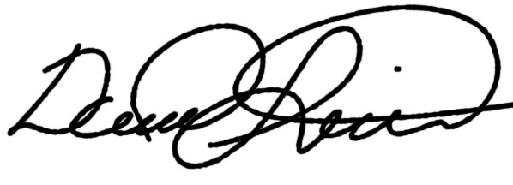9/30/2014
Brief Description of Proposal  (Describe the modifications contained within this proposal in a succinct summary. More detailed content will be provided in the proposal body. | The BS Curriculum Committee proposed that NUR 3130 Nursing Research be a prerequisite for NUR 4010 Community Health. The vote in the BS curriculum Committee was unanimous. The proposal was also voted on in the general faculty meeting.
Brief Rationale for Proposal  (Provide a concise summary of why this proposed change is important to the department. More detailed content will be provided in the proposal body). | The impetus for this modification is that Community Health Nursing clinical environments are changing due to the implementation of the Affordable Care Act. The content of research is now essential for successful completion of Community Health Nursing.
Proposal History  (Please provide history of this proposal: is this a resubmission? An updated version? This may most easily be expressed as a list). | This is the first time that the proposal has been submitted to College Council

Please include all appropriate documentation as indicated in the Curriculum Modification Checklist.

For each new course, please also complete the New Course Proposal and submit in this document.

Please submit this document as a single .doc or .rtf format. If some documents are unable to be converted to .doc, then please provide all documents archived into a single .zip file.

ALL PROPOSAL CHECK LIST
Completed CURRICULUM MODIFICATION FORM including:
- Brief description of proposal | x
- Rationale for proposal | x
- Date of department meeting approving the modification | x
- Chair’s Signature | x
- Dean’s Signature | x
Evidence of consultation with affected departments  List of the programs that use this course as required or elective, and courses that use this as a prerequisite. | n/a
Documentation of Advisory Commission views (if applicable). | n/a
Completed Chancellor’s Report Form. | x

EXISTING PROGRAM MODIFICATION PROPOSALS

Documentation indicating core curriculum requirements have been met for new programs/options or program changes. | n/a
Detailed rationale for each modification (this includes minor modifications) | n/a

Department Name Nursing
NUR 4010 Community Health Nursing

Rationale:
Students in Community Health Nursing require a strong research foundation in order to be successful in the course. This proposal adds Nursing Research NUR 3130 as a pre-requisite for NUR 4010 Community Health.

Chancellor's Report Information
Department: Nursing Proposer: Emma Kontzamanis Date: September 29, 2014
Course Catalog Description: There are no changes to either courses course catalog description.
Rationale: Having Research as a pre-requisite for Community Health will ensure that students have adequate preparation for this clinical course. Community Health requires students to have a strong research background.

