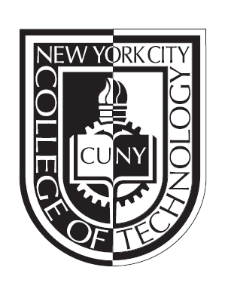
Proposal for New Course:
RESD 2416: Dental Implant Prosthetics

(6 laboratory hours; 1 lecture hour per week; 3 credits)
Prerequisite: RESD 1211, RESD 2307, RESD 2310, RESD 2314

Proposed by Daniel Alter
Survey/Research administered by Avis Smith
Department of Restorative Dentistry
New York City College of Technology
City University of New York

Table of Contents
- Curriculum Modification Proposal……………3
- Curriculum Modification Questions…………..5
- Course Description and Rationale for Proposal.7
- Course Outline…………………………….…..8
- Catalog course description…………………...15
- Minutes of Department Meeting (Unanimous approval of Proposed Course)…………….…16
- Chancellor’s Report Form…………….……..17
- Library Resource Form……………………20
- Documentation of needs assessment and student views…………………..…………………….21
- Minutes of advisory committee meeting……22
- Projected headcounts………………………..24
- Appendix (Student survey results on anticipated implant course Restorative Dentistry curriculum committee (2014)..................................25

New York City College of Technology, CUNY
NEW COURSE PROPOSAL FORM
This form is used for all new course proposals. Attach this to the Curriculum Modification Proposal Form and submit as one package as per instructions. Use one New Course Proposal Form for each new course.

Course Title | Dental Implant Prosthetics
Proposal Date | September 1, 2014
Proposer’s Name | Daniel Alter
Course Number | RESD 2416
Course Credits, Hours | 3 credit; 1 didactic and 6 Laboratory hours
Course Pre / Co-Requisites | RESD 2307, RESD 2310, RESD 2314
Catalog Course Description | An introduction to the theory and practice of fabricating dental implant prosthetics. The course explores both fixed and removable implant systems that are currently available, as well as fabrication, osseointegration, material selection and final dental prosthesis.
Brief Rationale  Provide a concise summary of why this course is important to the department, school or college. | In today’s rapidly evolving dental environment and Dentist’s/patient’s conservative treatment protocols, the Restorative Dentistry student needs to be well versed in the art of dental implantology in order to excel in the workforce. Restorative Dentistry has embraced restoring missing dentition through the use of implant prosthetics. A survey was conducted among current matriculated students and out of 67 surveyed, 100% responded with overwhelming interest in developing an implant curriculum. Therefore, including this dental implantology course into the already robust Restorative Dentistry curriculum will ensure that the students, department and institution remain on the cutting edge of innovation and technology. It would, furthermore, increase the employability and earning potential of the Restorative Dentistry program’s graduates.  *Student survey results on anticipated implant course Restorative Dentistry curriculum committee (2014)
Intent to Submit as Common Core  If this course is intended to fulfill one of the requirements in the common core, then indicate which area. | N/A
Intent to Submit as An Interdisciplinary Course | N/A
Intent to Submit as a Writing Intensive Course | N/A

 |  | Y | N
1. | Has the department approved the modification and recorded the approval in the minutes? | X
Date of Meeting:
May 28, 2014
2. | Has the department consulted with the academic dean? | X
3. | Will other departments be affected by this change? | X
If so, which ones:
4. | Does the content of this course overlap with other courses in the College? | X
If so, which ones:

5.  X | Is this course is a(an):  elective within the dept. Required within the dept. free elective  other _
6. | Will you submit this proposal to the Arts and Sciences Core Curriculum Committee for inclusion in Pathways? | X
7. | How many faculty members are qualified to teach this course?  3
8.  x | When will this course be offered?  spring summer fall day evening
9. | Are there minor changes to your Curriculum that will need to be made as a  result of this new course? | X
10. | Has the Advisory Board recommended this change? | X*
If so, when?

Signatures:

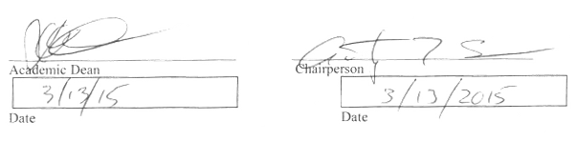

Please attach:
Course Outline-Summary of Student Survey Results (optional)-Library Form-Consultation with Affected Department(s)-Chancellor’s Report

CURRICULUM MODIFICATION Questions: For RESD 2416

For all Curriculum Modifications
- Has the department approved the modification and recorded the approval in the minutes? Yes

- Has the department consulted with the academic dean? Yes

- Has documentation of consultation with affected areas been received? Yes

- Have potential staff space and budget impacts been addressed? Yes

- Have all legal issues and/or restrictions been addressed? N/A

- Is renovation or new construction required? No

- Does new space need to be made available? No

- If applicable, has the VP for Finance and Administration submitted written comments regarding additional and/or new facilities, renovations or construction? No

For New Courses
- Has the form Library Resources and Information Literacy form been completed by proposer and library faculty subject selector? Yes

- Is this course unique in that the content does not significantly overlap with other courses? Yes

- If the proposed modification affects other departments or curricula, have they been consulted? No

- Are more instructional hours required? No

- How many full-time and part-time faculty members are qualified to teach this course? 3

- Does new equipment need to be acquired? No

- Is external funding anticipated? No

- Have you surveyed students to determine their interest in the course and learn why they would be interested in taking the course? Are these results included? Yes; Yes

Role of the course in the curriculum
- Is it a stand-alone course or part of a sequence? Stand alone Capstone elective

- Will this course replace or be an alternative to another course in the curriculum. If a replacement, will another course be removed from the curriculum? Alternative

- Does this course have a prerequisite? RESD 2307, RESD 2310, RESD 2314
If so, how often is that course offered? The prerequisites are offered in sequence through-out the program; the ones listed are all 3rd semester courses, which are the semester prior to the proposed course in the 4th and final semester.

- For which majors will this be a required course? For which majors will this be an elective? Elective for the Restorative Dentistry Major

- Will you submit this proposal to the Arts and Sciences Core Curriculum Committee for inclusion in the core? N/A

Enrollment needs assessment
- When is it expected that this course will this course be offered – spring, summer, fall, day, evening? Spring, day

- Each semester, approximately how many students are enrolled in programs where this course is required or an elective? 45 students

- What is your estimate of the number of students that would enroll in this course each semester it is offered? How many sections do you anticipate offering each semester it is offered? How were these value determined? 45 students in total. 15 students per lab section (an ADA accreditation maximum), 1 or 2 sections of Lecture according to space availability.

NEW YORK CITY COLLEGE OF TECHNOLOGY DEPARTMENT OF
OF THE CITY UNIVERSITY OF NEW YORK RESTORATIVE DENTISTRY

Course Description: An introduction to the theory and practice of fabricating dental implant prosthetics. The course explores both fixed and removable implant systems that are currently available, as well as fabrication, osseointegration, material selection and final dental prosthesis.
Rationale: In today’s rapidly evolving dental environment and Dentist’s/patient’s conservative treatment protocols, the Restorative Dentistry student needs to be well versed in the art of dental implantology in order to excel in the workforce. Restorative Dentistry has embraced restoring missing dentition through the use of implant prosthetics. A survey was conducted among current matriculated students and out of 67 surveyed, 100% responded with overwhelming interest in developing an implant curriculum. Therefore, including this dental implantology course into the already robust Restorative Dentistry curriculum will ensure that the students, department and institution remain on the cutting edge of innovation and technology. It would, furthermore, increase the employability and earning potential of the Restorative Dentistry program’s graduates.

*Student survey results on anticipated implant course Restorative Dentistry curriculum committee (2014)

NEW YORK CITY COLLEGE OF TECHNOLOGY DEPARTMENT OF
THE CITY UNIVERSITY OF NEW YORK RESTORATIVE DENTISTRY

DEPARTMENT: DEPARTMENT OF RESTORATIVE DENTISTRY

COURSE CODE: RESD 2416

COURSE TITLE: Dental Implant Prosthetics

CLASS HOURS AND CREDITS: 6 LABORATORY HOURS, 1 LECTURE HOUR PER
WEEK; 3 CREDITS

NUMBER OF WEEKS: 15 WEEKS

CURRICULUM LEVEL: 4TH SEMESTER

PREREQUISITES: Completion of RESD 2307, RESD 2310, RESD 2314

COURSE DESCRIPTION: An introduction to the theory and practice of fabricating dental implant prosthetics. The course explores both fixed and removable implant systems that are currently available, as well as fabrication, osseointegration, material selection and final dental prosthesis.

TEXT BOOKS: Dental laboratory technology: basic sciences, removable prosthodontics, and orthodontics. (2005). Air Force Pamphlet 47-103, Vol. 1.

Dental laboratory technology: fixed and special prosthodontics. (2005). Air Force Pamphlet 47-103,Vol. 2.

Dental Implant Prosthetics: 2nd edition. Carl E Misch. 2014 Elsevier Publishing.

JOURNALS: Current journal will be utilized as a source of information for the course and can be found in the City Tech library. These include a collection of general and specialty dental journals that carry articles on dental implant prosthetics.

COURSE REQUIREMENTS: Standard college and department attendance and grade regulations. Conformity to safety regulation. Uniform laboratory gowns. Dental instruments and supplies.

OUTCOMES ASSESSMENT: Laboratory: Laboratory Projects 60%
Lecture: Quizzes 10 %
A 93 - 100% Midterm 15%
A- 90 - 92.9% Final Exam 15%
B+ 87 - 89.9% Final Grade 100%
B 83 - 86.9%
B- 80 - 82.9%
C+ 77-79.9%
C 70-76.9%
D 60-69.9%
F 59.9 and below

* Students must earn a 70% or higher average proficiency in both the lecture and laboratory portions of the course to successful complete the course.

CONTACT INFORMATION: Professor Daniel. Alter: dalter@citytech.cuny.edu
Office P-409
Phone (718) 260-5137
Direct (718)260-5154
Fax (718) 254-8557

ATTENDANCE POLICY: "Any student who has exceeded the 10% Absence/lateness policy will receive a grade reduction for that portion of the course (lecture & or lab).

COORDINATOR: Daniel Alter, MSc, C.D.T., M.D.T.
Phone: (718) 260-5154
Office hours:
Mon. 11:00 -1:00 or by appointment
e-mail: dalter@citytech.cuny.edu

ACADEMIC INTEGRITY: New York City College of Technology Policy on Academic Integrity. Students and all others who work with information, ideas, texts, images, music, inventions, and other intellectual property owe their audience and sources accuracy and honesty in using, crediting, and citing sources. As a community of intellectual and professional workers, the College recognizes its responsibility for providing instruction in information literacy and academic integrity, offering models of good practice, and responding vigilantly and appropriately to infractions of academic integrity. Accordingly, academic dishonesty is prohibited in The City University of New York and at New York City College of Technology and is punishable by penalties, including failing grades, suspension, and expulsion. The complete text of the College policy on Academic Integrity may be found in the catalog.

Academic dishonesty is prohibited in the City University of New York and is punishable by penalties, including failing grades, suspension and expulsion.

Cheating is the unauthorized use or attempted use of material, information, notes, study aids, devices or communication during an academic exercise. Copying from another student during an examination or allowing another to copy your work.

Cheating will not be tolerated during quizzes or exams, communication with anyone other than the instructor will be considered cheating. If you have a question during an examination quietly raise your hand and the instructor will come to your desk. There may be more than one version of an examination; the questions of the examinations will be the same but in different order.

Students are responsible for completing their own laboratory projects, allowing others to complete your laboratory project is not permitted. Each student should clearly identify all work.

QUIZZES AND
EXAMINATIONS: Students are responsible for knowing all material covered in reading assignments, handouts, lecture and laboratory. Students are responsible for knowing information from reading assignments regardless of whether it has been covered during class sessions or not. There will be two examinations that will account for the majority of the lecture score (midterm and final). There will be one major quiz that will be scheduled for one lecture session. The exams and quizzes will fulfill the 40% portion of the overall grade.

Students are responsible for completing all the laboratory’s weekly assignments to earn the 60% portion of the overall grade.

Daniel Alter MSc, CDT, MDT 2014

GOALS AND OBJECTIVES
FOR RESD 2416:

Upon successful completion of the course each student should be able to:
Objectives | Assessment
1. Create a working implant soft tissue model (Synthesis) | Evaluate lab work utilizing rubrics.
2. Build implant fixture supported screw retained restorations (Application) | Evaluate lab work utilizing rubrics.
3. Design and parallel individual custom abutments (Synthesis) | Evaluate lab work utilizing rubrics.
4. Design multiple fixture level implant abutment substructure frameworks (Synthesis) | Evaluate lab work utilizing rubrics.
5. Describe the process of Restoring Dental Implants (Analysis) | Evaluate comprehension through projects in the laboratory.
6. Describe the protocol in selecting Dental Implant Prosthetics (Analysis) | Evaluate practical exams with emphasis on the student’s ability to communicate
7. Identify the physical properties of Dental Implant Prosthetics (Comprehension) | Multiple choice exams periodically throughout the semester.
8. Manipulate fixture level dental implant abutments (Synthesis) | Evaluate lab work utilizing rubrics.
9. Assess the factors that must be taken into consideration when choosing appropriate implant prosthetics (Evaluation) | Multiple choice exams periodically throughout the semester.
10. Rate a Dental Implant Prosthetic restoration in accordance to a given prescription (Evaluation) | Evaluate practical exams with emphasis on the student’s ability to communicate.

General Education Student Learning Outcomes:
- Support esthetic values in the dental environment (Evaluation) | Evaluate lab work utilizing rubrics.
Manage appropriate processes associated with Dental Implants (Synthesis) | Evaluate comprehension through projects in the laboratory.
Converse using discipline specific vocabulary accurately. (Evaluation) | Evaluate practical exams with emphasis on the student’s ability to communicate.
Read and interpret professional scholarly journals (Evaluation) | Multiple choice exams periodically throughout the semester

Assessment: The Professor will evaluate the students’ achievement of learning outcome by:

- Administer multiple choice exams periodically throughout the semester.
- Evaluate practical exams with emphasis on the student’s ability to communicate.
- Evaluate comprehension through projects in the laboratory.
- Evaluate lab work utilizing rubrics.

* Students must earn a 70% or higher average proficiency in both the lecture and laboratory portions of the course to successful complete the course.
NEW YORK CITY COLLEGE OF TECHNOLOGY DEPARTMENT OF
OF THE CITY UNIVERSITY OF NEW YORK RESTORATIVE DENTISTRY

COURSE OUTLINE
RESD 2416 – Dental Implant Prosthetics
See table below

I. What is Dental Implantology - THREE LABORATORY HOURS, ONE LECTURE HOUR

- History of Dental Implants
  - Visionaries
  - Branemark
  - Sirona

II. Consideration for Dental Implants – THREE LABORATORY HOURS; ONE LECTURE HOUR,

- Implant surgery
  - Surgical planning
  - Surgical guides
  - Implant placement

B. Patient considerations
- Overall health issues
  - Diabetes
  - Blood

C. Dental Implants and bone
  - Osseointegration
  - Crestal bone/ridge
  - Coated vs. non-coated

III. Dental Implant (Custom vs Stock & Cemented vs. Screw Retained)- TWELVE LABORATORY HOURS, TWO LECTURE HOURS

- Implant abutments
  - Cemented
  - Screw retained

- Dental Implant Fixtures
  - External
  - Internal
  - Engaging
  - Non-engaging
  - Type of Restoration

- Creating an Implant model
  - Closed tray
  - Open tray
  - Soft tissue molage
  - Lab analogues
  - Implant screws

V. QUIZ (During the 5th Lecture Session, one lecture hour)

VI. Designing and manufacturing angled custom abutments – TWENTY FOUR LABORATORY HOURS; THREE LECTURE HOURS

- Placement considerations in the oral cavity
  - Stock implant abutments
  - Custom implant abutments

- Stock implant abutment
  - Milling parallelism
  - Angulated stock abutments
  - Angulated attachments
  - Screw access hole
  - Type of Restorations

- Custom abutments
  - Wax-up of custom abutments
  - Parallelism
  - Plastic burnout-UCLA type of implant
  - Platform/Interphase considerations
  - Type of alloys and use

IX. Midterm (During the 9th Lecture Session, one lecture hour)

X. Multi-unit implant restorations over custom abutments – TWENTY FOUR LABORATORY HOURS, TWO LECTURE HOURS

- Parallelism is critical to multi-unit implant restoration
  - How to parallel
  - If not parallel, then?

- Transfer jig (custom abutments)

- Creating multi-unit substructure over implant supported abutments
  - Waxing
  - Plastic
  - Electro fitting

- Implant prosthetic engagement with natural teeth
- Pontic and margin placement

- Fitting the implant prosthetic

XIV. Screw retained implant prosthetics - TWENTY FOUR LABORATORY HOURS, THREE LECTURE SESSION -

- Future Innovations

- Possibilities are endless

XV. Final Exam (during the 15th Lecture session, one Lecture hour)

Week | Didactic | Laboratory
1 | What is Dental Implantology | What is Dental Implantology/ Consideration for Dental Implants
2 | Consideration for Dental Implants | Dental Implant (Custom vs Stock & Cemented vs. Screw Retained)-
3 | Dental Implant (Custom vs Stock & Cemented vs. Screw Retained) | Dental Implant (Custom vs Stock & Cemented vs. Screw Retained)-
4 | Dental Implant (Custom vs Stock & Cemented vs. Screw Retained) | Designing and manufacturing angled custom abutments
5 | Quiz | Designing and manufacturing angled custom abutments
6 | Designing and manufacturing angled custom abutments | Designing and manufacturing angled custom abutments
7 | Designing and manufacturing angled custom abutments | Designing and manufacturing angled custom abutments
8 | Designing and manufacturing angled custom abutments | Multi-unit implant restorations over custom abutments
9 | Midterm | Multi-unit implant restorations over custom abutments
10 | Multi-unit implant restorations over custom abutments | Multi-unit implant restorations over custom abutments
11 | Multi-unit implant restorations over custom abutments | Multi-unit implant restorations over custom abutments
12 | Screw retained implant prosthetics | Screw retained implant prosthetics
13 | Screw retained implant prosthetics | Screw retained implant prosthetics
14 | Screw retained implant prosthetics | Screw retained implant prosthetics
15 | Final | Screw retained implant prosthetics

Students must complete with at least 70% accuracy at the end the course

Daniel Alter MSc, CDT, MDT 2014

NEW YORK CITY COLLEGE OF TECHNOLOGY DEPARTMENT OF
OF THE CITY UNIVERSITY OF NEW YORK RESTORATIVE DENTISTRY

RESD 2416: Dental Implant Prosthetics

Catalog Course Description: An introduction to the theory and practice of fabricating dental implant prosthetics. The course explores both fixed and removable implant systems that are currently available, as well as fabrication, osseointegration, material selection and final dental prosthesis.

Department of Restorative Dentistry
Minutes of the Department Meeting
May 28th, 2014

In attendance: A. Sena, A. Smith, D. Alter, R. Budny, D. Barthold, P. Russo, N. Manos

Minutes:

- Student Survey: Crown and Bridge and Ceramics were the highest rated courses in student satisfaction.
- RG: The registered Graduate exam now includes implants.
- Implant Course: Implant course is in the works. The department voted to proceed with a fourth semester implant course. The course is being developed and written by Professor Danny Alter and Professor Avis Smith. The course will be an elective to be offered to the students. One area of concern is allocation of credits in the program. Phil and Avis integrate Implants into their courses. Ideally, it is agreed that implant courses must have working models to be effective. Larry added that implants are the wave of the future.
- Laboratory course RESD-212 may need to be modified due to material overload in the course. One suggestion is to eliminate the CAD/CAM segment of the course.
- Open suggestions expressed by the faculty:
- Integrate ceramic pressed to milled zirconia substructures into RESDS-2412
- Implement CAD/CAM (milled copings) in 2nd semester Ceramics courses.

Respectfully submitted…..

Professor Philip Russo
Department of Restorative Dentistry

Chancellor Report New Course
AI.V. Department of Restorative Dentistry
New courses to be offered in the Restorative Dentistry department
Department(s) | Department of Restorative Dentistry
Academic Level | [ x ] Regular [ ] Compensatory [ ] Developmental [ ] Remedial
Subject Area | Dental Laboratory
Course Prefix | RESD
Course Number | 2416
Course Title | Dental Implant Prosthetics
Catalog Description | An introduction to the theory and practice of fabricating dental implant prosthetics. The course explores both fixed and removable implant systems that are currently available, as well as fabrication, osseointegration, material selection and final dental prosthesis.
Prerequisite | RESD 2307, RESD 2310, RESD 2314
Corequisite
Pre- or corequisite
Credits | 3 credit;
Contact Hours | 1 didactic and 6 Laboratory hours
Liberal Arts | [ ] Yes [ x ] No
Course Attribute (e.g. Writing Intensive, etc)
Course Applicability | [x ] Major  [ ] Gen Ed Required [ ] Gen Ed - Flexible [ ] Gen Ed - College Option  [ ] English Composition [ ] World Cultures [ ] Speech  [ ] Mathematics [ ] US Experience in its Diversity [ ] Interdisciplinary  [ ] Science [ ] Creative Expression [ ] Advanced Liberal Arts  [ ] Individual and Society  [ ] Scientific World
Effective Term | Spring 16

Rationale: In today’s rapidly evolving dental environment and Dentist’s/patient’s conservative treatment protocols, the Restorative Dentistry student needs to be well versed in the art of dental implantology in order to excel in the workforce.
*Student survey results on anticipated implant course Restorative Dentistry curriculum committee (2014)

FROM: | To:
REQUIRED COURSES IN THE MAJOR Credits  RESD 1107 Introduction to Non-metallic Dental Materials 2  RESD 1110 Tooth Morphology 3  RESD 1111 Complete Dentures I 3  RESD 1115 Fixed Prosthodontics I 3  RESD 1211 Complete Dentures II 3  RESD 1212 Fixed Prosthodontics II 3  RESD 1215 Introduction to Restorative Dental Ceramics 4  RESD 1216 Removable Partial Dentures I 3  RESD 2307 Science of Dental Metallurgy 1  RESD 2310 Principles of Occlusion 2  RESD 2313 Removable Partial Dentures II 3  RESD 2314 Restorative Dental Ceramics II 3  RESD 2409 Laboratory Operation, Ethics  and Jurisprudence 2  RESD 2413 Fixed Prosthodontics Practicum 2  RESD 2415 Orthodontics 2  Req major credits Subtotal 39  Select one of the following two courses for 2 credits:  RESD 2311 Complete Dentures III  RESD 2324 CAD/CAM in Dentistry  Subtotal 2  Select one of the following two courses for 3 credits:  RESD 2411 Complete Dentures/Maxillofacial Concepts  RESD 2414 Restorative Dental Ceramics Practicum  Subtotal 3  ADDITIONAL REQUIRED COURSES¹  General Education Common Core: 20 Credits  I – Required Core (3 or 4 courses, 11 or 14 credits)  English Composition (1 or 2 courses, 3 or 6 credits)  ENG 1101 English Composition I 3  [ENG 1121 English Composition II] [3]  Mathematical and Quantitative Reasoning (1 course, 4 credits)  Select one of the following courses  MAT 1180 Math Concepts and Applications 4  MAT 1275 College Algebra and Trigonometry or higher 4  Life/ Physical Science (1 course, 4 credits)  CHEM 1000 Principles of Chemistry 4  II – Flexible Core (2 or 3 courses; 6 or 9 credits)  One course from each of any two groups, plus Speech if ENG 1121 is not taken: 6  World Cultures and Global Issues  US Experience in its Diversity  Creative Expression  Individual and Society  US Experience in its Diversity  Creative Expression  Individual and Society  [SPE 1330 Effective Speaking or higher] [3]  Scientific World  Subtotal 20  TOTAL CREDITS REQUIRED FOR THE DEGREE 64 | REQUIRED COURSES IN THE MAJOR Credits  RESD 1107 Introduction to Non-metallic Dental Materials 2  RESD 1110 Tooth Morphology 3  RESD 1111 Complete Dentures I 3  RESD 1115 Fixed Prosthodontics I 3  RESD 1211 Complete Dentures II 3  RESD 1212 Fixed Prosthodontics II 3  RESD 1215 Introduction to Restorative Dental Ceramics 4  RESD 1216 Removable Partial Dentures I 3  RESD 2307 Science of Dental Metallurgy 1  RESD 2310 Principles of Occlusion 2  RESD 2313 Removable Partial Dentures II 3  RESD 2314 Restorative Dental Ceramics II 3  RESD 2409 Laboratory Operation, Ethics  and Jurisprudence 2  RESD 2413 Fixed Prosthodontics Practicum 2  RESD 2415 Orthodontics 2  Req major credits Subtotal 39  Select one of the following courses for 2 credits:  RESD 2311 Complete Dentures III  RESD 2324 CAD/CAM in Dentistry  Subtotal 2  Select one of the following courses for 3 credits:  RESD 2411 Complete Dentures/Maxillofacial Concepts  RESD 2414 Restorative Dental Ceramics Practicum  RESD 2416 Dental Implant Prosthetics  Subtotal 3  ADDITIONAL REQUIRED COURSES¹  General Education Common Core: 20 Credits  I – Required Core (3 or 4 courses, 11 or 14 credits)  English Composition (1 or 2 courses, 3 or 6 credits)  ENG 1101 English Composition I 3  [ENG 1121 Composition II¹] [3]  Mathematical and Quantitative Reasoning (1 course, 3 or 4 credits)  Select one of the following courses  MAT 1190 Quantitative Reasoning² 3  MAT 1180 Math Concepts and Applications 4 4  MAT 1275 College Algebra and Trigonometry or higher³ 4 4  Life/ Physical Science (1 course, 4 credits)  CHEM 1000 Principles of Chemistry or higher 4  II – Flexible Core (2 or 3 courses; 6 or 9 credits)  One course from each of any two groups, plus Speech if ENG 1121 is not taken: 6  World Cultures and Global Issues  US Experience in its Diversity  Creative Expression  US Experience in its Diversity  Creative Expression  Individual and Society  [SPE 1330 Effective Speaking or higher] [3]  Scientific World  Subtotal 20  TOTAL CREDITS REQUIRED FOR THE DEGREE 64

Rationale: Addition of a new elective course covering dental implants in the Restorative Dentistry major.

**Minor curriculum change rationale: This change recognizes that higher levels of chemistry above Chem. 1000 principles of Chemistry satisfy the requirement of life and Physical Science. Math 1190 is recognized as an acceptable substitute for math 1180.

LIBRARY RESOURCES & INFORMATION LITERACY: MAJOR CURRICULUM MODIFICATION

Please complete for all major curriculum modifications. This information will assist the library in planning for new acquisitions; it will not affect curriculum proposals either positively or negatively.

Consult with library faculty subject selectors (library.citytech.cuny.edu/about/faculty) 3 weeks in advance when planning course proposals to ensure enough time to allocate budgets if materials need to be purchased.

Course proposer: please complete boxes 1-4. Library faculty subject selector: please complete box 5.

1 | Title of proposal  Dental Implant Prosthetics | Department/Program  Restorative Dentistry
 | Proposed by (include email & phone)  Prof. Daniel Alter 718-260-5137  dalter@citytech.cuny.edu | Expected date course(s) will be offered  Spring 2015  # of students (45 students)

2 | Are City Tech library resources sufficient for course assignments? Please elaborate.  The course’s text book should be purchased for resources, otherwise the current library resources for the Restorative Dentistry Department are sufficient for the course assignments.

3 | Are additional resources needed for course assignments? Please provide details about format of resources (e.g., ebooks , journals, DVDs, etc.), author, title, publisher, edition, date, and price.  Dental Implant Prosthetics: 2nd edition. Carl E Misch. 2014 Elsevier Publishing. $190

4 | Library faculty focus on strengthening students' information literacy skills in finding, evaluating, and ethically using information. We can collaborate on developing assignments and offer customized information literacy instruction and research guides for your course.  Do you plan to consult with the library faculty subject specialist for your area? Please elaborate. Yes, perhaps in a supportive function to research further material matter.

5 | Library Faculty Subject Selector____Joan Grassano______________  Comments and Recommendations  The City Tech library has the resources necessary to support the proposed course. These include a collection of general and specialty dental journals that carry articles on dental implant prosthetics as well as dental implant textbooks and prosthodontics textbooks that address the topic. The library will purchase copies of the title referenced in item #3 above and continue to acquire resources to support the course.  Date: September 23, 2014

STUDENT SURVEY RESULTS ON ANTCIPATED IMPLANT COURSE
RESTORATIVE DENTISTRY CURRICULUM COMMITTEE
(2014)

In anticipation of developing an implant course in the Restorative Dentistry Department at New York City College of Technology, students were surveyed to gain input on their feelings concerning the intentions of our department to development such a curriculum. Out of sixty-seven surveyed, 100 % responded with overwhelming interest. The questions were simple and to the point, which concluded results of the following:

- As for the relevance and need for implant technology to the industry, 73% of the respondents felt there is a significant increase for the use of implant technology.
- When asked how many would register for such a course, greater than 70% of the respondents indicated that they would do so.
- On those students who would seek employment in implant technology at dental facilities, 76% of them indicated that they would pursue employment in the implant phase of dental technology.

Information from the leaders of the National Board of Certification of Dental Laboratories and Dental Technicians, obtained by our Departments Curriculum Committee, also included information on survey data from 2005 on the Number of Dental Implant Prosthetic Devices in the United States, to the anticipated use/need in 2015. This information is evidence of the need to include training of our students in the area of dental implant technology; as it prepares them to better face the future challenges in the field.

Restorative Dentistry
Prof. Avis J. Smith

NEW YORK CITY COLLEGE OF TECHNOLOGY

DEPARTMENT OF RESTORATIVE DENTISTRY
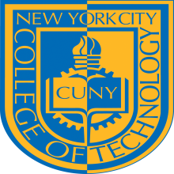
THE CITY UNIVERSITY OF NEW YORK
300 JAY STREET, BROOKLYN, NY 11201-2983
718-260-5137 * FAX 718-254-8557

Minutes of the
Advisory Commission of the
Department of Restorative Dentistry
March 5, 2014

Present: A. Sena, P. Russo, N. Manos, R. Budny, A. Smith, D. Alter, M. Batista, S. Greenberg, J. Choe , J. Glennon, , D. Barthold, L. Andreescu, P. Nagy, R. Rega, L. Ricci, N. Russell, Dr. L. Kobren, D. Wong, L. Mejia, R. Schmucker, J. Palacio (student), J. Olguin (student), S. Wu (student), J. Alleyne (student), M. Hernandez (student), Stephen Soiffer, Jewel Escobar

Absent/excused: A. Fescina, B. Baum, S. Bergen, DDS, Dr. B. Croll, A. Verano, W. Yacola, F. Munzenmeyer,

Meeting Began: 12:00 p.m.

Meeting began in the Janet Lefler Dining room

Dr. Stephen Soiffer, Special Assistant to the President, introduced the plans for the new academic building. A rendering of the new facility was presented.

Plans for a major fund raising campaign were discussed. The campaign includes naming opportunities for laboratories. The department of restorative dentistry will be seeking donations from major dental companies.

Following Stephen Soiffer’s presentation the meeting moved to the Presidents conference room.

Discussion of a proposed implant course was held. The National Board for Certification in dental laboratory technology has implemented an implant specialty. The recognized graduate exam that students take at the completion of the dental laboratory program will include questions on implants beginning this year. It was expressed that this course would move the program in the right direction towards what is a major part of the type of restorations that are currently being performed in the industry.

A vote was called on the proposed Implant course. The result was a unanimous yes in favor of the proposed course.

Meeting Adjourned at 1:45 p.m.

Respectfully Submitted,

Anthony Sena
Department of Restorative Dentistry
New York City College of Technology

NEW YORK CITY COLLEGE OF TECHNOLOGY DEPARTMENT OF
OF THE CITY UNIVERSITY OF NEW YORK RESTORATIVE DENTISTRY

Projected Headcount: The Course’s headcount will be limited to 15 students per Laboratory session and 45 for Didactic (Lecture) sessions. (Spring semester)

Course Context (e.g. required, elective, capstone)
Capstone elective

Course Structure: how the course will be offered (e.g. lecture, seminar, tutorial, fieldtrip)?

1 hour didactic studies and 6 hours of laboratory classroom time.

Appendix:

Rationale for the survey:

Information from the leaders of the National Board of Certification of Dental Laboratories and Dental Technicians, obtained by our Departments Curriculum Committee, also included information on survey data from 2005 on the Number of Dental Implant Prosthetic Devices in the United States, to the anticipated use/need in 2015. This information is evidence of the need to include training of our students in the area of dental implant technology; as it prepares them to better face the future challenges in the field. (Prof. Avis Smith, Restorative Dentistry Department)

NADL 2011-2013 Materials & Equipment Survey Segment Profiles
Created by Valmont Research LLC, November 2013

DEMOGRAPHICS & LABORATORY CHARACTERISTICS

Gender (select one )
 |  |  | Lab Size
 | 2013 | Small | Medium | Large |  | 2012
 | TOTAL | (1-9 empl) | (10-25 empl) | (>25 empl) |  | TOTAL
Valid responses | 625 | 414 | 108 | 103 |  | 576
N/A or Don't know | 0 | 0 | 0 | 0 |  | 0
Female | 25.6% | 24.4% | 29.6% | 26.2% |  | 25.0%
Male | 74.4% | 75.6% | 70.4% | 73.8% |  | 75.0%
 | 100.0% | 100.0% | 100.0% | 100.0% |  | 100.0%

Age (select one )

 |  |  |  | Lab Size
 |  | 2013 | Small | Medium | Large |  | 2012
 |  | TOTAL | (1-9 empl) | (10-25 empl) | (>25 empl) |  | TOTAL
 | Valid responses | 625 | 414 | 108 | 103 |  | 576
 | N/A or Don't know | 0 | 0 | 0 | 0 |  | 0
Under 25 years |  | 1.3% | 1.4% | 0.9% | 1.0% |  | 0.5%
25 - 34 years |  | 8.0% | 6.5% | 13.9% | 7.8% |  | 8.3%
35 - 44 years |  | 18.4% | 15.7% | 20.4% | 27.2% |  | 17.2%
45 - 54 years |  | 29.8% | 30.4% | 29.6% | 27.2% |  | 31.1%
55 - 64 years |  | 33.1% | 34.3% | 29.6% | 32.0% |  | 34.9%
65+ years |  | 9.4% | 11.6% | 5.6% | 4.9% |  | 8.0%
 |  | 100.0% | 100.0% | 100.0% | 100.0% |  | 100.0%
 | mean | 51.0 | 51.9 | 48.7 | 49.4 |  | 51.2
 | median | 50.0 | 50.0 | 50.0 | 50.0 |  | 50.0

Position (select one )
 |  |  | Lab Size
 | 2013 | Small | Medium | Large |  | 2012
 | TOTAL | (1-9 empl) | (10-25 empl) | (>25 empl) |  | TOTAL
Valid responses | 625 | 414 | 108 | 103 |  | 576
N/A or Don't know | 0 | 0 | 0 | 0 |  | 0
Laboratory owner | 59.4% | 73.7% | 38.0% | 24.3% |  | 62.3%
Laboratory manager (non-owner) | 14.6% | 11.8% | 21.3% | 18.4% |  | 13.5%
Department manager (non-owner) | 9.8% | 3.4% | 10.2% | 35.0% |  | 9.2%
Dental technician (non-owner, non- manager) | 16.3% | 11.1% | 30.6% | 22.3% |  | 14.9%
 | 100.0% | 100.0% | 100.0% | 100.0% |  | 100.0%

Employees (select one in each category )

 |  |  | Lab Size
 | 2013 | Small | Medium | Large |  | 2012
 | TOTAL | (1-9 empl) | (10-25 empl) | (>25 empl) |  | TOTAL
Valid responses | 625 | 414 | 108 | 103 |  | 576
N/A or Don't know | 0 | 0 | 0 | 0 |  | 0
All employees (full- and part-time)
1 | 14.9% | 22.5% | 0.0% | 0.0% |  | 14.6%
2 | 14.1% | 21.3% | 0.0% | 0.0% |  | 13.0%
3 | 10.4% | 15.7% | 0.0% | 0.0% |  | 12.3%
4 | 8.2% | 12.3% | 0.0% | 0.0% |  | 7.8%
5 - 9 | 18.7% | 28.3% | 0.0% | 0.0% |  | 19.8%
10 - 25 | 17.3% | 0.0% | 100.0% | 0.0% |  | 16.5%
26 or more | 16.5% | 0.0% | 0.0% | 100.0% |  | 16.0%

 |  | 100.0% | 100.0% | 100.0% | 100.0% |  | 100.0%
 | mean | 14.2 | 3.4 | 15.6 | 56.0 |  | 14.1
 | median | 5.0 | 3.0 | 14.5 | 44.0 |  | 5.0
Full-time employees
0 |  | 1.4% | 1.9% | 0.9% | 0.0% |  | 0.9%
1 |  | 21.0% | 31.4% | 0.9% | 0.0% |  | 20.7%
2 |  | 13.8% | 20.8% | 0.0% | 0.0% |  | 14.1%
3 |  | 10.1% | 15.2% | 0.0% | 0.0% |  | 10.1%
4 |  | 7.0% | 10.4% | 0.9% | 0.0% |  | 6.9%
5 - 9 |  | 15.4% | 20.3% | 11.1% | 0.0% |  | 17.9%
10 - 25 |  | 15.8% | 0.0% | 86.1% | 5.8% |  | 16.0%
26 or more |  | 15.5% | 0.0% | 0.0% | 94.2% |  | 13.5%
 |  | 100.0% | 100.0% | 100.0% | 100.0% |  | 100.0%
 | mean | 12.6 | 2.9 | 13.8 | 50.5 |  | 12.6
 | median | 4.0 | 2.0 | 13.0 | 43.0 |  | 4.0

Full-time certified dental technicians

0 | 6.1% | 6.5% | 7.4% | 2.9% |  | 6.8%
1 | 55.0% | 74.2% | 26.9% | 7.8% |  | 52.3%
2 | 14.7% | 13.5% | 24.1% | 9.7% |  | 16.8%
3 | 6.6% | 3.9% | 14.8% | 8.7% |  | 6.3%
4 | 3.7% | 0.5% | 9.3% | 10.7% |  | 4.5%
5 - 9 | 7.7% | 1.4% | 12.0% | 28.2% |  | 7.3%
10 - 25 | 4.5% | 0.0% | 5.6% | 21.4% |  | 4.3%
26 or more | 1.8% | 0.0% | 0.0% | 10.7% |  | 1.7%
 | 100.0% | 100.0% | 100.0% | 100.0% |  | 100.0%
mean | 3.0 | 1.2 | 2.9 | 10.1 |  | 3.0
median | 1.0 | 1.0 | 2.0 | 5.0 |  | 1.0

Employees
[CONTINUED ] |  |  |  | Lab Size
 |  | 2013 | Small | Medium | Large |  | 2012
 |  | TOTAL | (1-9 empl) | (10-25 empl) | (>25 empl) |  | TOTAL
 | Valid responses | 625 | 414 | 108 | 103 |  | 576
 | N/A or Don't know | 0 | 0 | 0 | 0 |  | 0
Full-time non-certified dental technicians
0 |  | 34.4% | 48.6% | 8.3% | 4.9% |  | 32.5%
1 |  | 15.4% | 22.7% | 1.9% | 0.0% |  | 15.8%
2 |  | 8.5% | 12.3% | 1.9% | 0.0% |  | 8.5%
3 |  | 6.7% | 8.7% | 5.6% | 0.0% |  | 7.1%
4 |  | 5.0% | 5.3% | 8.3% | 0.0% |  | 5.6%
5 - 9 |  | 9.4% | 2.4% | 44.4% | 1.0% |  | 12.3%
10 - 25 |  | 11.4% | 0.0% | 29.6% | 37.9% |  | 9.9%
26 or more |  | 9.3% | 0.0% | 0.0% | 56.3% |  | 8.3%
 |  | 100.0% | 100.0% | 100.0% | 100.0% |  | 100.0%
 | mean | 6.6 | 1.1 | 7.4 | 27.8 |  | 6.3
 | median | 2.0 | 1.0 | 7.0 | 28.0 |  | 2.0

Full-time administrative (including office staff, drivers, and other non-technician staff)

0 | 43.7% | 61.6% | 8.3% | 8.7% |  | 42.0%
1 | 19.0% | 25.4% | 13.0% | 0.0% |  | 22.6%
2 | 10.7% | 9.2% | 25.0% | 1.9% |  | 8.2%
3 | 4.8% | 2.7% | 15.7% | 1.9% |  | 5.7%
4 | 3.8% | 0.5% | 13.9% | 6.8% |  | 4.0%
5 - 9 | 8.2% | 0.7% | 17.6% | 28.2% |  | 7.5%
10 - 25 | 8.0% | 0.0% | 6.5% | 41.7% |  | 7.6%
26 or more | 1.8% | 0.0% | 0.0% | 10.7% |  | 2.4%

 |  | 100.0% | 100.0% | 100.0% | 100.0% |  | 100.0%
 | mean | 3.1 | 0.6 | 3.5 | 12.5 |  | 3.2
 | median | 1.0 | 0.0 | 3.0 | 10.0 |  | 1.0
Part-time employees
0 |  | 53.6% | 60.9% | 42.6% | 35.9% |  | 53.5%
1 |  | 22.7% | 27.8% | 19.4% | 5.8% |  | 22.2%
2 |  | 9.4% | 7.7% | 12.0% | 13.6% |  | 9.5%
3 |  | 5.1% | 2.2% | 11.1% | 10.7% |  | 4.2%
4 |  | 2.6% | 1.4% | 5.6% | 3.9% |  | 3.1%
5 - 9 |  | 3.7% | 0.0% | 7.4% | 14.6% |  | 5.0%
10 - 25 |  | 2.2% | 0.0% | 1.9% | 11.7% |  | 1.6%
26 or more |  | 0.6% | 0.0% | 0.0% | 3.9% |  | 0.9%
 |  | 100.0% | 100.0% | 100.0% | 100.0% |  | 100.0%
 | mean | 1.6 | 0.6 | 1.8 | 5.5 |  | 1.5
 | median | 0.0 | 0.0 | 1.0 | 2.0 |  | 0.0

Employees
[CONTINUED ]

Part-time certified dental technicians

0 | 93.0% | 93.7% | 92.6% | 90.3% |  | 91.5%
1 | 5.0% | 5.8% | 3.7% | 2.9% |  | 6.4%
2 | 1.3% | 0.5% | 1.9% | 3.9% |  | 1.6%
3 | 0.3% | 0.0% | 0.0% | 1.9% |  | 0.2%
4 | 0.0% | 0.0% | 0.0% | 0.0% |  | 0.2%
5 - 9 | 0.5% | 0.0% | 1.9% | 1.0% |  | 0.2%
10 - 25 | 0.0% | 0.0% | 0.0% | 0.0% |  | 0.0%
26 or more | 0.0% | 0.0% | 0.0% | 0.0% |  | 0.0%
 | 100.0% | 100.0% | 100.0% | 100.0% |  | 100.0%
mean | 0.1 | 0.1 | 0.2 | 0.2 |  | 0.1
median | 0.0 | 0.0 | 0.0 | 0.0 |  | 0.0

Part-time non-certified dental technicians

0 | 76.0% | 81.9% | 63.9% | 65.0% |  | 75.3%
1 | 13.4% | 14.3% | 17.6% | 5.8% |  | 15.8%
2 | 5.1% | 2.4% | 8.3% | 12.6% |  | 4.0%
3 | 2.6% | 1.2% | 5.6% | 4.9% |  | 1.0%
4 | 0.8% | 0.2% | 2.8% | 1.0% |  | 1.6%
5 - 9 | 1.1% | 0.0% | 0.9% | 5.8% |  | 0.9%
10 - 25 | 0.5% | 0.0% | 0.9% | 1.9% |  | 1.0%
26 or more | 0.5% | 0.0% | 0.0% | 2.9% |  | 0.3%
 | 100.0% | 100.0% | 100.0% | 100.0% |  | 100.0%
mean | 0.6 | 0.2 | 0.8 | 2.1 |  | 0.7
median | 0.0 | 0.0 | 0.0 | 0.0 |  | 0.0

Part-time administrative (including office staff, drivers, and other non-technician staff)

0 |  | 71.8% | 77.3% | 68.5% | 53.4% |  | 71.4%
1 |  | 16.8% | 20.3% | 12.0% | 7.8% |  | 14.9%
2 |  | 4.0% | 2.4% | 7.4% | 6.8% |  | 5.7%
3 |  | 2.2% | 0.0% | 7.4% | 5.8% |  | 2.4%
4 |  | 1.1% | 0.0% | 1.9% | 4.9% |  | 1.2%
5 - 9 |  | 2.6% | 0.0% | 2.8% | 12.6% |  | 3.1%
10 - 25 |  | 1.0% | 0.0% | 0.0% | 5.8% |  | 1.2%
26 or more |  | 0.5% | 0.0% | 0.0% | 2.9% |  | 0.0%
 |  | 100.0% | 100.0% | 100.0% | 100.0% |  | 100.0%
 | mean | 0.8 | 0.3 | 0.7 | 3.1 |  | 0.7
 | median | 0.0 | 0.0 | 0.0 | 0.0 |  | 0.0

Type of laboratory (select one )
 |  |  | Lab Size
 | 2013 | Small | Medium | Large |  | 2012
 | TOTAL | (1-9 empl) | (10-25 empl) | (>25 empl) |  | TOTAL
Valid responses | 625 | 414 | 108 | 103 |  | 576
N/A or Don't know | 0 | 0 | 0 | 0 |  | 0
Laboratory is independently owned and operated | 77.8% | 81.4% | 75.0% | 66.0% |  | 81.9%
Laboratory is part of a conglomerate (multiple labs owned by same company) | 7.5% | 1.7% | 10.2% | 28.2% |  | 6.6%
Laboratory in a dental office | 6.6% | 8.7% | 4.6% | 0.0% |  | 5.2%
Laboratory in a school of dentistry or dental technology | 2.7% | 2.9% | 2.8% | 1.9% |  | 1.7%
Laboratory in a hospital / clinic | 0.8% | 1.0% | 0.0% | 1.0% |  | 0.7%
Military / government Laboratory | 1.9% | 1.9% | 2.8% | 1.0% |  | 2.3%
Manufacturer laboratory | 1.9% | 1.9% | 1.9% | 1.9% |  | 1.2%
Other | 0.8% | 0.5% | 2.8% | 0.0% |  | 0.3%
Services lab provides (select all t | 100.0%  hat apply) | 100.0% | 100.0% | 100.0% |  | 100.0%
 |  |  | Lab Size
 | 2013 | Small | Medium | Large |  | 2012
 | TOTAL | (1-9 empl) | (10-25 empl) | (>25 empl) |  | TOTAL
Valid responses | 625 | 414 | 108 | 103 |  | 576
N/A or Don't know | 0 | 0 | 0 | 0 |  | 0
Crown and bridge | 77.6% | 70.5% | 90.7% | 92.2% |  | 77.8%
Ceramics | 73.6% | 66.4% | 84.3% | 91.3% |  | 75.9%
Complete dentures | 54.9% | 42.8% | 69.4% | 88.3% |  | 55.7%
Partial dentures | 50.2% | 37.0% | 64.8% | 88.3% |  | 51.2%
Implants | 75.2% | 67.4% | 89.8% | 91.3% |  | 78.0%
Orthodontics | 29.8% | 18.4% | 41.7% | 63.1% |  | 33.9%
Medical appliances (sleep apnea /  snoring devices) | 21.9% | 9.4% | 30.6% | 63.1% |  | 30.2%
Full service (all of the above) | 17.1% | 6.0% | 26.9% | 51.5% |  | 22.7%

For implants, how much your laboratory's work is CUSTOM MILLED ABUTMENTS? (select one )
 |  |  |  | Lab Size
 |  | 2013 | Small | Medium | Large |  | 2012
 |  | TOTAL | (1-9 empl) | (10-25 empl) | (>25 empl) |  | TOTAL
 | Valid responses | 397 | 264 | 65 | 68 |  | 383
 | N/A or Don't know | 228 | 150 | 43 | 35 |  | 193
None (0%) |  | 16.1% | 20.1% | 7.7% | 8.8% |  | 17.5%
Less than 10% |  | 25.2% | 29.9% | 21.5% | 10.3% |  | 27.7%
10% – 25% |  | 10.6% | 9.1% | 12.3% | 14.7% |  | 11.2%
26% – 50% |  | 11.1% | 9.5% | 13.8% | 14.7% |  | 14.1%
More than 50% |  | 37.0% | 31.4% | 44.6% | 51.5% |  | 29.5%
 |  | 100.0% | 100.0% | 100.0% | 100.0% |  | 100.0%

When charging clients, does your laboratory mark up CUSTOM MILLED ABUTMENTS? (select one )
 |  | Lab Size
(New question in 2013) | 2013 | Small Medium Large  (1-9 empl) (10-25 empl) (>25 empl)
 | TOTAL

Valid responses 326 211 53 62
2012
TOTAL
N/A or Don't know 299 203 55 41 NOT AVAILABLE

Yes, by up to 5% | 8.3% | 8.5% | 13.2% | 3.2%
Yes, by 6% – 10% | 10.1% | 12.3% | 9.4% | 3.2%
Yes, by 11% – 19% | 10.7% | 8.1% | 20.8% | 11.3%
Yes, by 20% – 29% | 22.7% | 22.3% | 28.3% | 19.4%
Yes, by 30% or more | 28.8% | 25.1% | 17.0% | 51.6%
No | 19.3% | 23.7% | 11.3% | 11.3%
 | 100.0% | 100.0% | 100.0% | 100.0%

For implants, who designs your CUSTOM MILLED ABUTMENTS? (select one )

 |  |  | Lab Size
 | 2013 | Small | Medium | Large |  | 2012
 | TOTAL | (1-9 empl) | (10-25 empl) | (>25 empl) |  | TOTAL
Valid responses | 355 | 227 | 63 | 65 |  | 345
N/A or Don't know | 270 | 187 | 45 | 38 |  | 231
We design our own | 50.1% | 43.6% | 69.8% | 53.8% |  | 53.0%
We outsource design to another
laboratory 22.5% 29.5% 12.7% 7.7% 23.5%

We outsource design to the
manufacturer 27.3% 26.9% 17.5% 38.5% 23.5%
100.0% 100.0% 100.0% 100.0% 100.0%

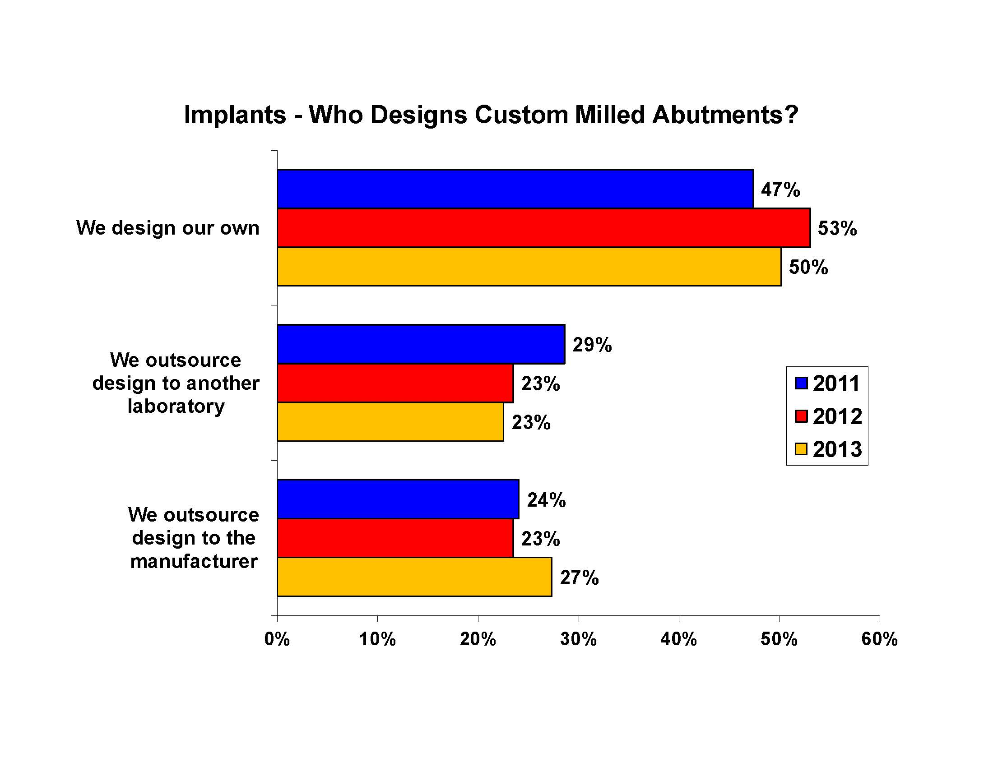
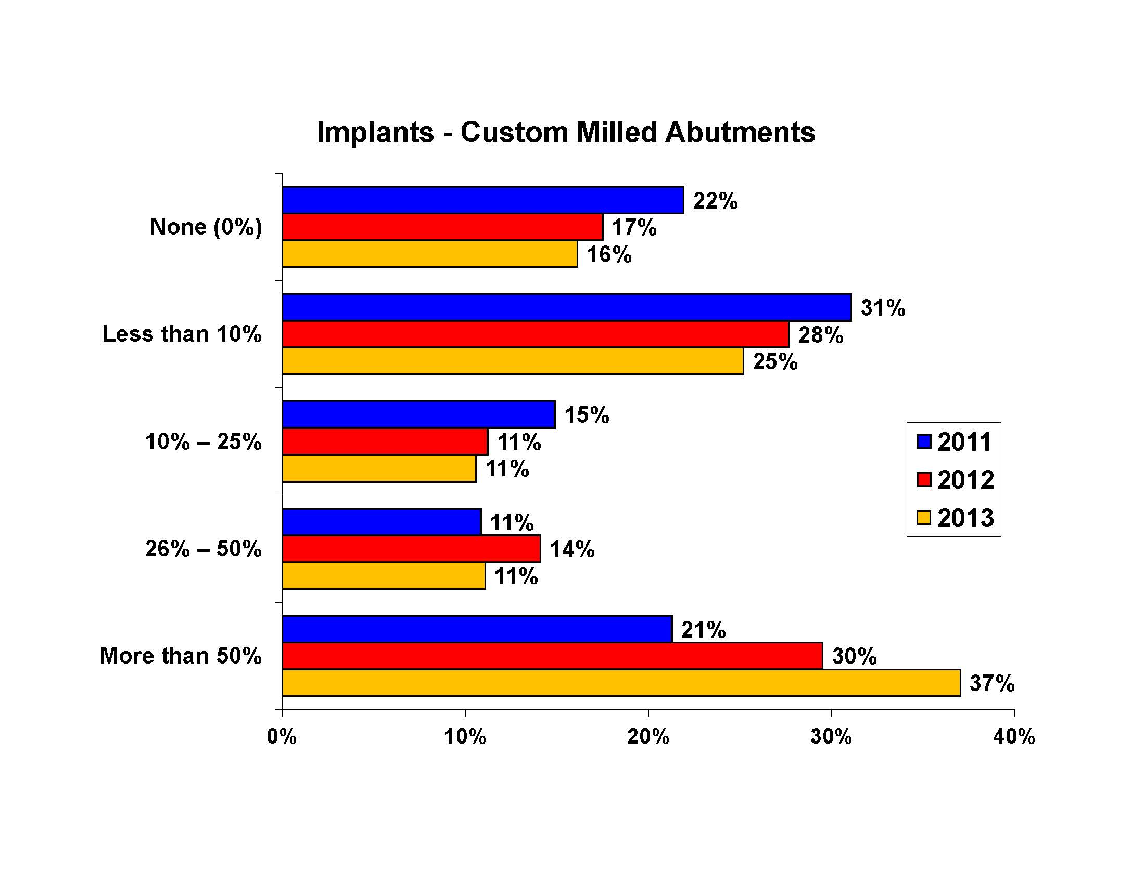

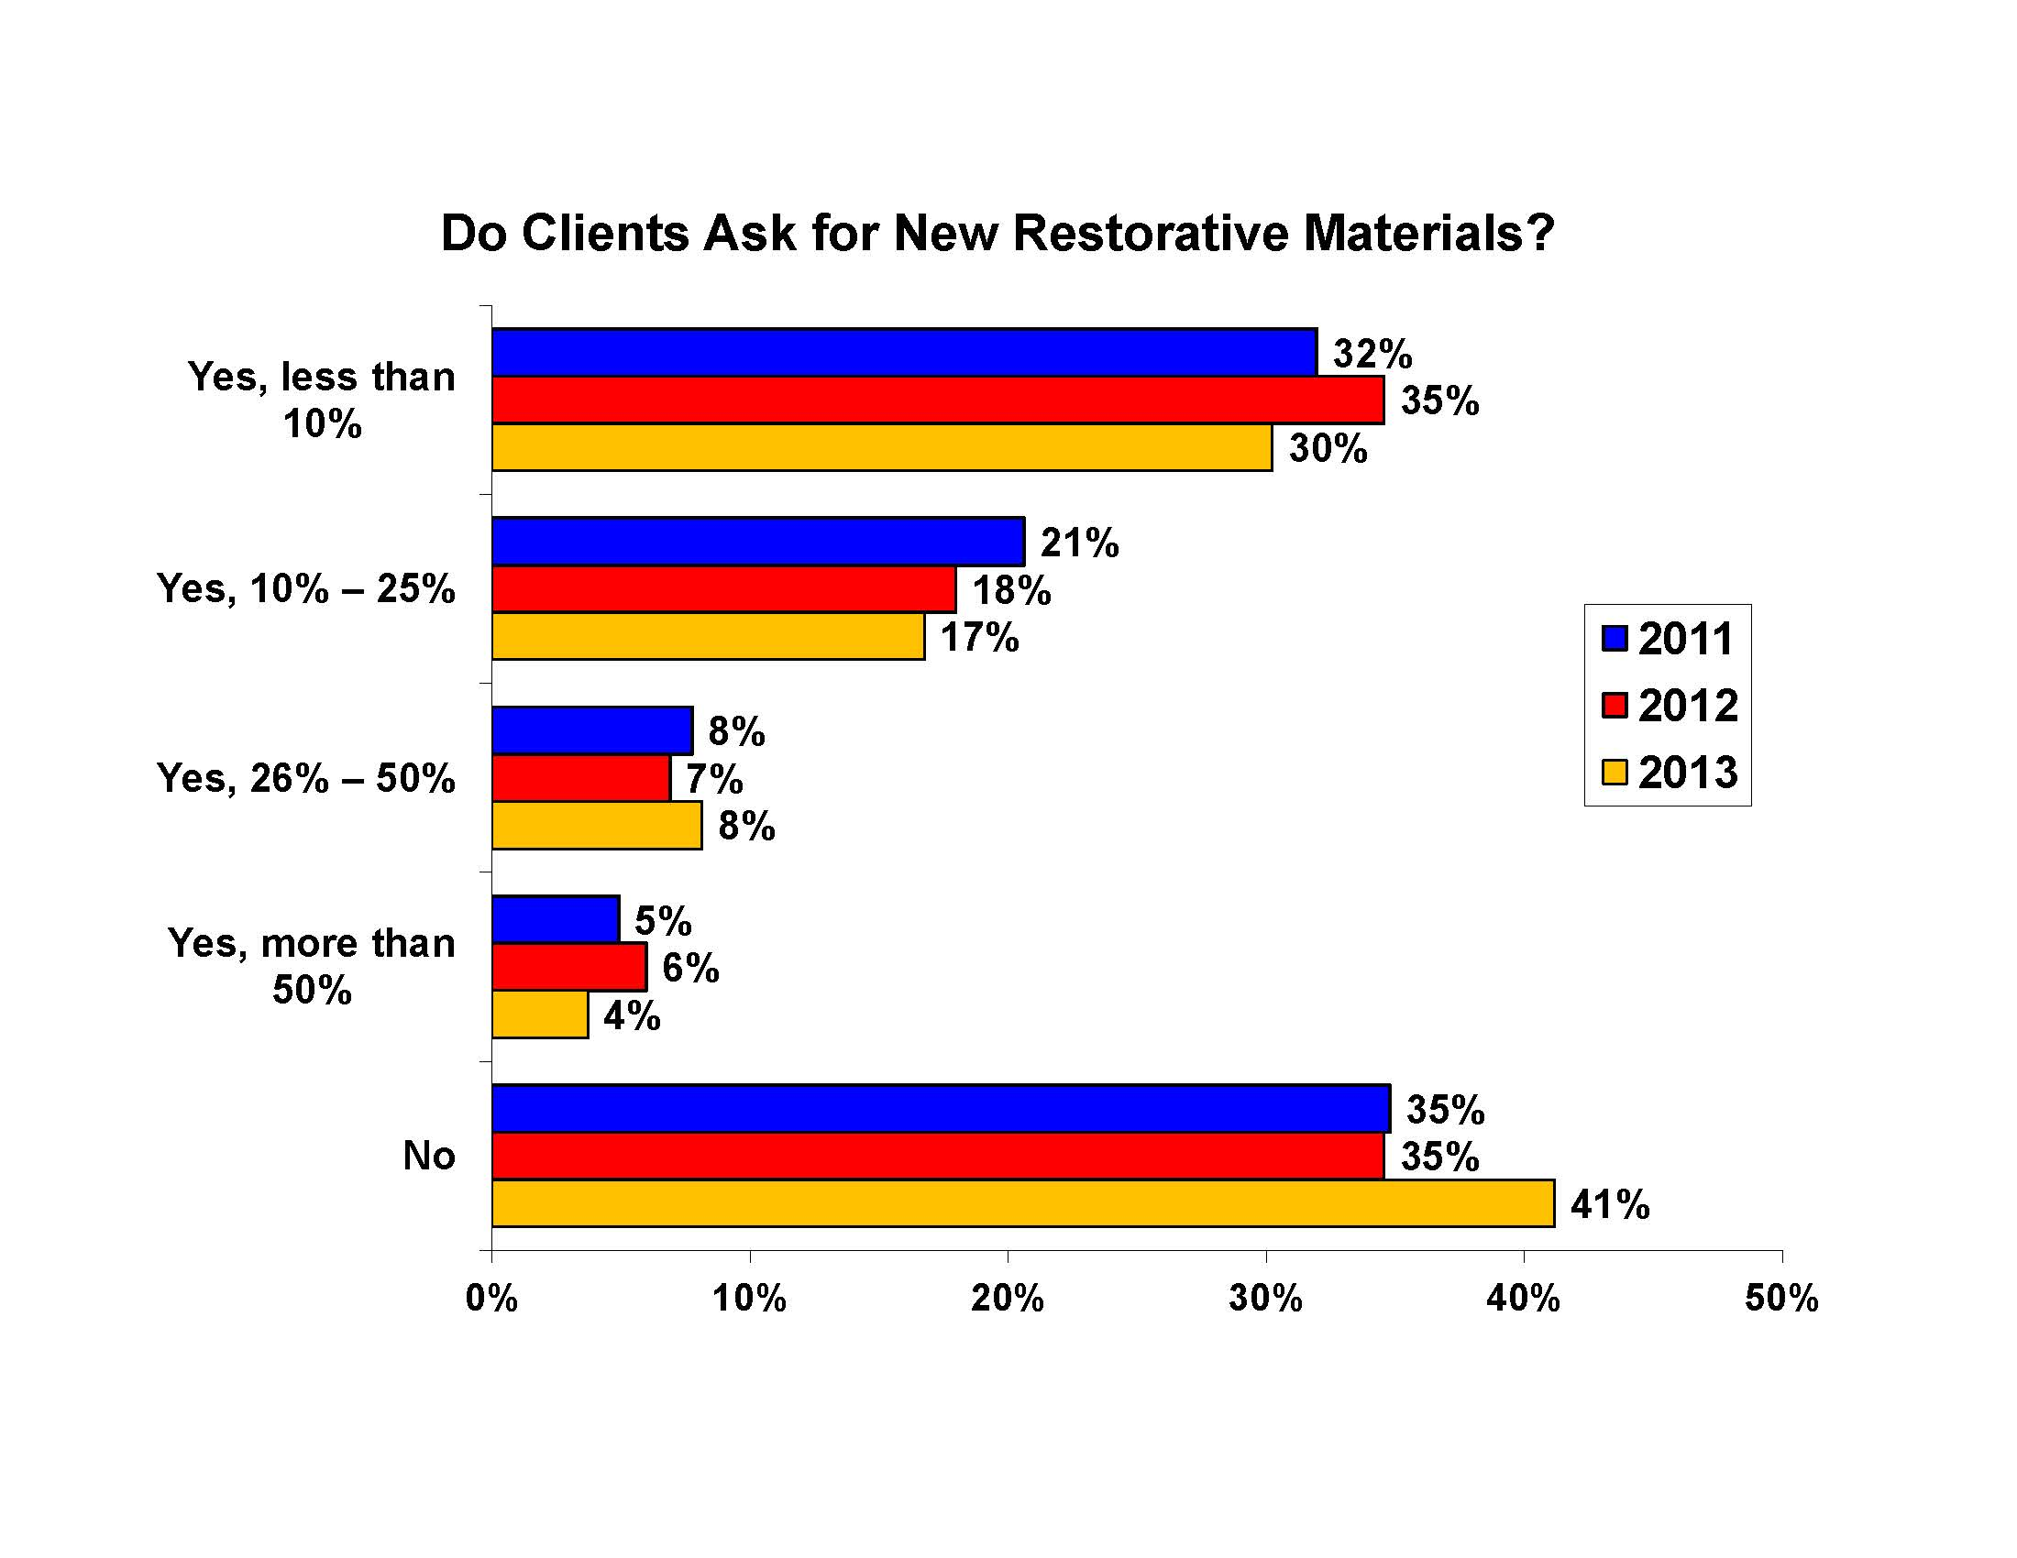
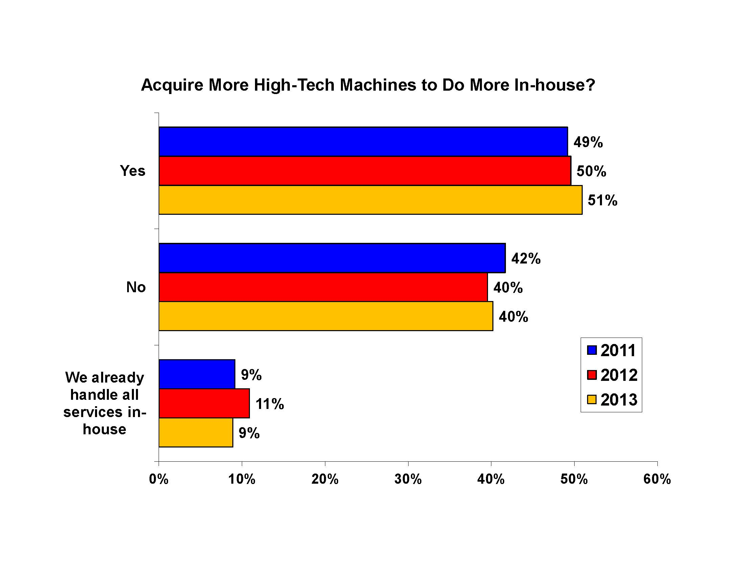

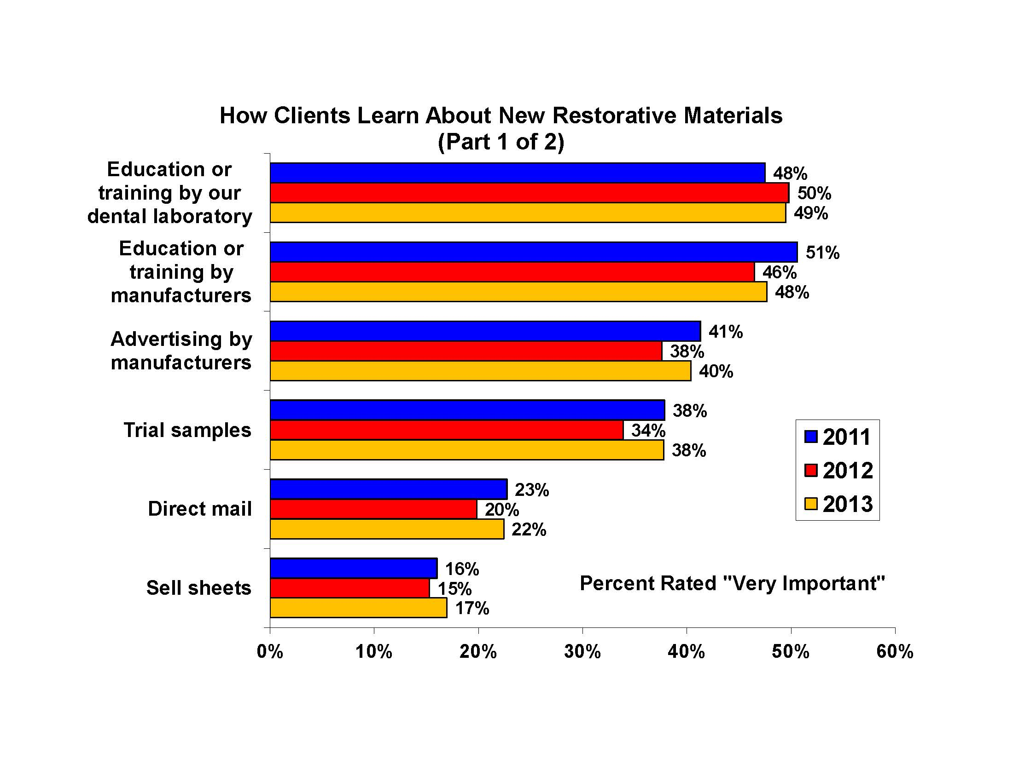

Students must select either ENG 1121 OR SPE 1330 or higher.
2 Students that take Mat 1190 will need to take an additional general education course to meet the required 20 credits in general education. This will increase the number of required credits for the degree by 2 credits 3 Students who elect to take MAT 1275 but who lack the requisite math background will be required to take MAT 1175 in preparation. This will increase the number of required credits for the degree by 4 credits.

