New York City College of Technology, CUNY
CURRICULUM MODIFICATION PROPOSAL FORM
This form is used for all curriculum modification proposals. See the Proposal Classification Chart for information about what types of modifications are major or minor. Completed proposals should be emailed to the Curriculum Committee chair.

Title of Proposal | ENT 2190 Video Editing Skills
Date | February 5th, 2015
Major or Minor | Major
Proposer’s Name | Ryoya Terao
Department | Entertainment Technology
Date of Departmental Meeting in which proposal was approved | January 29, 2015
Department Chair Name Department Chair Signature and Date Academic Dean Name Academic Dean Signature and Date | 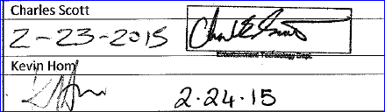
Brief Description of Proposal  (Describe the modifications contained within this proposal in a succinct summary. More detailed content will be provided in the proposal body. | Dept. of Entertainment Technology proposes to add a new course, ENT 2190 Video Editing Skills. The name and prerequisite for ENT4390 will be changed to ENT4390 Video Editing, with new prerequisites.
Brief Rationale for Proposal  (Provide a concise summary of why this proposed change is important to the department. More detailed content will be provided in the proposal body). | This proposed course will be a prerequisite for ENT4390 Advanced Video Editing in the video track in the department of Entertainment Technology. The new course will review basics of the industry-standard editing software to be used in the upper level course.  ENT4390 Non Linear Video Editing will have a name change to Advanced Video Editing and prerequisite change to ENT2190 and ENT2290.
Proposal History  (Please provide history of this proposal: is this a resubmission? An updated version? This may most easily be expressed as a list). | This is the first attempt to submit this new course proposal.

Please include all appropriate documentation as indicated in the Curriculum Modification Checklist.
For each new course, please also complete the New Course Proposal and submit in this document.
Please submit this document as a single .doc or .rtf format. If some documents are unable to be converted to .doc, then please provide all documents archived into a single .zip file.

ALL PROPOSAL CHECK LIST
Completed CURRICULUM MODIFICATION FORM including:
- Brief description of proposal | ✔
- Rationale for proposal | ✔
- Date of department meeting approving the modification | ✔
- Chair’s Signature | ✔
- Dean’s Signature | ✔
Evidence of consultation with affected departments  List of the programs that use this course as required or elective, and courses that use this as a prerequisite. | N/A
Documentation of Advisory Commission views (if applicable). | N/A
Completed Chancellor’s Report Form. | ✔

EXISTING PROGRAM MODIFICATION PROPOSALS
Documentation indicating core curriculum requirements have been met for new programs/options or program changes. | N/A
Detailed rationale for each modification (this includes minor modifications) | ✔

New York City College of Technology, CUNY
NEW COURSE PROPOSAL FORM
This form is used for all new course proposals. Attach this to the Curriculum Modification Proposal Form and submit as one package as per instructions. Use one New Course Proposal Form for each new course.

Course Title | Video Editing Skills
Proposal Date | February 5th, 2015
Proposer’s Name | Ryoya Terao
Course Number | ENT 2190
Course Credits, Hours | 2 Credits, 1 class hr, 2 lab hrs
Course Pre / Co-Requisites | Pre-requisites:  ENT 1190 or COMD 2320  Co-Requisites:  None
Catalog Course Description | Students explore the fundamental features of industry-standard video editing software and gain knowledge of the essentials of effective editing. Short projects are edited with an emphasis on the basics of the software. This course prepares students for ENT 4390 Advanced Video Editing.
Brief Rationale  Provide a concise summary of why this course is important to the department, school or college. | This proposed course will be a prerequisite for ENT4390 Advanced Video Editing. The new course will introduce the basic operation of the industry-standard editing software to be used in the upper level course.
Intent to Submit as Common Core  If this course is intended to fulfill one of the requirements in the common core, then indicate which area. | The proposed course is not intended to fulfill Common Core requirements.
Intent to Submit as An Interdisciplinary Course | N/A
Intent to Submit as a Writing Intensive Course | N/A

Please include all appropriate documentation as indicated in the NEW COURSE PROPOSAL Combine all information into a single document that is included in the Curriculum Modification Form.

NEW COURSE PROPOSAL CHECK LIST
Use this checklist to ensure that all required documentation has been included. You may wish to use this checklist as a table of contents within the new course proposal.
Completed NEW COURSE PROPOSAL FORM
- Title, Number, Credits, Hours, Catalog course description | ✔
- Brief Rationale | ✔
Completed Library Resources and Information Literacy Form | ✔
Course Outline
Include within the outline the following.
Hours and Credits for Lecture and Labs  If hours exceed mandated Carnegie Hours, then rationale for this | ✔
Prerequisites/Co- requisites | ✔
Detailed Course Description | ✔
Course Specific Learning Outcome and Assessment Tables  - Discipline Specific  - General Education Specific Learning Outcome and Assessment Tables | ✔
Example Weekly Course outline | ✔
Grade Policy and Procedure | ✔
Recommended Instructional Materials (Textbooks, lab supplies, etc) | ✔
Library resources and bibliography | ✔
Course Need Assessment.
Describe the need for this course. Include in your statement the following information.
Target Students who will take this course. Which programs or departments, and how many anticipated?  Documentation of student views (if applicable, e.g. non-required elective). | ✔
Projected headcounts (fall/spring and day/evening) for each new or modified course. | ✔
If additional physical resources are required (new space, modifications, equipment), description of these requirements. If applicable, Memo or email from the VP for Finance and Administration with written comments regarding additional and/or new facilities, renovations or construction. | N/A
Where does this course overlap with other courses, both within and outside of the department? | ✔
Does the Department currently have full time faculty qualified to teach this course? If not, then what plans are there to cover this? | ✔
If needs assessment states that this course is required by an accrediting body, then provide documentation indicating that need. | N/A
Course Design
Describe how this course is designed.
Course Context (e.g. required, elective, capstone) | Elective
Course Structure: how the course will be offered (e.g. lecture, seminar, tutorial, fieldtrip)? | ✔
Anticipated pedagogical strategies and instructional design (e.g. Group Work, Case Study, Team Project, Lecture) | ✔
How does this course support Programmatic Learning Outcomes? | ✔
Is this course designed to be partially or fully online? If so, describe how this benefits students and/or program. | N/A
Additional Forms for Specific Course Categories
Interdisciplinary Form (if applicable) | N/A
Common Core (Liberal Arts) Intent to Submit (if applicable) | N/A
Writing Intensive Form if course is intended to be a WIC (under development) | N/A
If course originated as an experimental course, then results of evaluation plan as developed with director of assessment. | N/A
(Additional materials for Curricular Experiments)
Plan and process for evaluation developed in consultation with the director of assessment. (Contact Director of Assessment for more information). | N/A
Established Timeline for Curricular Experiment | N/A

EVIDENCE OF CONSULTATION WITH AFFECTED DEPARTMENTS
The proposed course affects only the video track of the Dept. of Entertainment Technology. The video editing software to be used is the standard in the TV/Film industry.

DETAILED RATIONALE
In the existing video editing course, ENT 4390 Advanced Video Editing, students practice operating the industry standard video editing software, and at the same time, review the philosophy of video/film editing. We have determined that one semester is not sufficient for students to assimilate all these materials. It will be more effective to create a new course focusing on basic features of the software first. Therefore, we wish to make the proposed course a prerequisite before our students take ENT 4390 Advanced Video Editing.
We are requesting a name and prerequisite change for the ENT4390 Non-Linear Video Editing course. It will be changed to ENT4390 Advanced Video Editing. The new prerequisites will be the new ENT2190 Video Editing Skills and ENT2290 Video Studio Operations (replacing the old prerequisites ENT3290 or ENT3390). The addition of the ENT2190 Video Editing Skills allows for the change as it prepares the students to take the ENT4390 Advanced Video Editing at an earlier point in the sequence. Transfer students will then have time to complete the ENT4499 Culmination Project class in the fourth semester of attendance.

Chancellor’s University Reports

Section AIV: New Courses

New courses to be offered in the Entertainment Technology department
Department(s) | Entertainment Technology
Academic Level | [X] Regular [ ] Compensatory [ ] Developmental [ ] Remedial
Subject Area | Entertainment Technology
Course Prefix | ENT
Course Number | 2190
Course Title | Video Editing Skills
Catalog Description | Students explore the fundamental features of industry-standard video editing software and gain knowledge of the essentials of effective editing. Short projects are edited with an emphasis on the basics of the software. This course prepares students for ENT 4390 Advanced Video Editing.
Prerequisite | ENT 1190 or COMD 2320
Corequisite | N/A
Pre- or corequisite | N/A
Credits | 2
Contact Hours | 1 cl hr; 2 lab hrs
Liberal Arts | [ ] Yes [ X ] No
Course Attribute | none
Course Applicability | [X] Major  [ ] Gen Ed Required [ ] Gen Ed - Flexible [ ] Gen Ed - College Option  [ ] English Composition [ ] World Cultures [ ] Speech  [ ] Mathematics [ ] US Experience in its Diversity [ ] Interdisciplinary  [ ] Science [ ] Creative Expression [ ] Advanced Liberal Arts  [ ] Individual and Society  [ ] Scientific World
Effective Term | Spring 2016

Rationale: This proposed course will be a prerequisite for ENT 4390 Advanced Video Editing in the video track in the Department of Entertainment Technology. The new course will review basics of the industry-standard editing software to be used in the upper-level course. Offered each semester.

Section AV: Changes in Existing Courses

AV.1. Entertainment Technology

Existing Course Number and Course Title
From: |  | To:
Course Number: | ENT 4390 | Course Number: | ENT 4390
Course Title: | Non-Linear Video Editing | Course Title: | Advanced Video Editing
Description: | In this upper level course, the role of the video/film editor for both motion picture and live entertainment will be examined. Students will perform intermediate and advanced techniques of modern non-linear video editing software. They will also demonstrate facility in communicating and collaborating effectively with directors, producers and their clients. At the end of the course, students will possess indepth knowledge of the theory and practice of editing moving images. The course includes lectures and laboratory exercises. | Description: | The role of the video/film editor for both motion picture and live entertainment. Students perform intermediate and advanced techniques using contemporary video editing software. Covers communicating and collaborating effectively with directors, producers and their clients. At the end of the course, students possess in-depth knowledge of the theory and practice of editing moving images.
Class Hours : |  | Class Hours:
Lab Hours : |  | Lab Hours:
Credits: |  | Credits:
Prerequisite: | ENT 3290 or ENT 3390 | Prerequisite: | ENT 2190 and ENT 2290
Corequisites: |  | Corequisites:
Pre- or corequisites: |  | Pre- or corequisites:

Rationale: The addition of a prerequisite video editing course calls for the label “advanced” to be added. The course description has been shortened with no change of course content. The prerequisite courses have been adjusted to match the advanced course and its new prerequisite.
Note: There is no need to change the degree program in terms of the required number of credits.

COURSE OUTLINE

ENT2190 Video Editing Skills

HOURS AND CREDITS
Credits: 2.0, Hours: 3.0 (1 lecture, 2 lab hrs)

PRE- /CO-REQUISITES
Pre-requisites: ENT 1190 or COMD 2320

DETAILED COURSE DESCRIPTION

Students explore the fundamental features of industry-standard video editing software and gain knowledge of the essentials of effective editing. Short projects are edited with an emphasis on the basics of the software. This course prepares students for ENT 4390 Advanced Video Editing.

COURSE-SPECIFIC LEARNING OUTCOMES AND ASSESSMENT TABLES

Learning Outcomes and Assessment
INSTRUCTIONAL OBJECTIVES | ASSESMENT
For the successful completion of this course, students should be able to: | Evaluation methods and criteria:
Demonstrate the operation and maintenance of signal routing through and between equipment. | Written tests and practical operation
Demonstrate ability to manage project windows, clips, and bins, assembling sequences, effective use of splicing, overwrite, trimming shots, mixing audio, customizing the software interface, editing multi-camera shots, creating titles and simple transitions, exporting files | Laboratory exercises and projects
Evaluate various editing styles | Class discussion, written tests, and homework assignments
Apply industry-recognized criteria for organizing audio and visual media to elicit predetermined responses in users | Laboratory exercises

General Education Learning Outcomes and Assessment
Apply critical thinking skills to make informed editing decisions | Class discussion, written tests, and homework assignments
Analyze and evaluate visual and aural forms to make aesthetically correct decisions | Project based labs and class discussion

Previous Student Knowledge

Students taking this course will be expected to have an introductory level of experience with digital video editing. They should also have some experience with audio production, and been involved with basic video preproduction and production projects.

Teaching/Learning Methods

- Lecture/readings
- Demonstration
- Project-based labs
- Blackboard
- Open Lab

Required Texts

Plummer, M. (2013). Media Composer 6: Part 1 Editing Essentials, (1st ed.). Boston, MA: Cengage Learning.

GRADE POLICY AND PROCEDURE

Labs & Projects 20%
Quizzes 10%
Midterm 20%
Final Exam 20%
Final Project 20%
Participation/Attendance/Attitude 10%

Late Submission Policy: Delays will result in 10-point reductions per session.

Lateness/Attendance Policy:

- It is NYCCT policy that if you have two unexcused absences, your will fail the class. For the purposes of this policy, if you are late or leave class early twice, it is considered the equivalent of one absence. Completing assignments for other courses or working on a video production is never a valid excuse for an absence from class.

- If you miss a quiz/test, you will receive a zero, unless you provide the instructor with a proper reason and its proof, you cannot make up any missed quiz.

Class Participation:

- Participation in class will be graded. Frequent, meaningful, and interpersonally sensitive participation paired with attentive listening will result in an A (100 points). Infrequent or no voluntary participation but attentive listening will result in a B (85 points).

- Avoid conversations with people sitting around you. The classroom is small—even if you whisper, please realize that other people hear and see you, and that’s distracting to everybody (fellow students and professor). Disruptive behavior or side conversations therefore impact on your participation grade. Each occurrence will lower your grade by 10 points; i.e., frequent disruptions or side conversations may result in a participation grade of F (0 point).

Blackboard/Open Lab: You must make sure that your e-mail address is on the class’ Blackboard (BB) as well as Open Lab accounts. Unless your e-mail address is on it, you won’t be able to receive messages posted through BB and, as a result, will miss important class information. Please contact the City Tech help desk at your earliest convenience concerning this matter.

Academic Integrity: The faculty and administration of New York City College of Technology support an environment free from cheating and plagiarism. Each student is responsible for being aware of what constitutes cheating and plagiarism and for avoiding both. The complete text of the CUNY Academic Integrity Policy and the City Tech procedure for implementing that policy can be found at this site: http://www.citytech.cuny.edu/students/academic_integrity. If a faculty member suspects a violation of academic integrity and, upon investigation, confirms that violation, or if the student admits the violation, the faculty member MUST report the violation.

Course Accommodations for Students with Disabilities: In order to receive disability-related academic accommodations students must first be registered with the Student Support Services Program (SSSP). Students who have a documented disability or suspect they may have a disability are invited to set up an appointment with Ms. Linda Buist, the program manager of SSSP (Phone: 718–260–5143, e-mail: lbuist@citytech.cuny.edu). If you have already registered with SSSP, please provide your professor with the course accommodation form and discuss your specific accommodation with him/her.

EXAMPLE WEEKLY COURSE OUTLINE

Week | Lecture Topic | Lab | Assignment
1 | Exploring the Interface | Working with the project window | Plummer, Lesson 1
2 | Exploring the Interface  (cont.) | Organizing clips and bins | Plummer, Lesson 1  (cont.)
3 | Assembling a Basic Sequence | Performing basic editing | Plummer, Lesson 2
4 | Assembling a Basic Sequence (cont.) | Splicing clips into the timeline | Plummer, Lesson 2 (cont.)
5 | Ingesting File-Based Media | Footage: Importing and linking | Plummer,  Lessons 3
6 | Manual Time Editing  Project I due | Overwriting the timeline and trimming segments | Plummer, Lesson 4
7 | Midterm Exam  Refining the Edit | Trimming options and additional video track | Plummer, Lesson 5
8 | Refining and Mixing Audio | Using audio tool | Plummer, Lesson 6
9 | Customizing the Software | Viewing and changing user settings | Plummer, Lesson 7
10 | Introduction to Multi Camera Editing | Editing with multi camera displays | Plummer, Lesson 8
11 | Titles & Transitions | Creating/editing titles | Plummer, Lesson 9
12 | Exporting a File | Exporting a sequence | Plummer, Lesson 10
13 | Exporting a File (cont.) | Exporting a sequence (cont.) | Plummer, Lesson 10 (cont.)
14 | Review of the semester |  | TBA
15 | Final Exam  Project II due

RECOMMENDED INSTRUCTIONAL MATERIALS

American Cinema Editors. (2011). Retrieved from http://ace-filmeditors.org
Block, B. (2008). The visual story (2nd ed.). Boston, MA: Focal Press.
Chandler, G. (2006). Cut by cut: Editing your film or video. Studio City, CA: Michael Wise Production.
Chandler, G. (2009). Film editing: Great cuts every filmmaker and movie lover must know. Studio City, CA: Michael Wise Production.
Clark, B., & Spohr, S. J. (2002). Guide to postproduction for tv and film: Managing the process (2nd ed.). Boston: Focal Press.
Ondaatje, M. (2002). The conversations: Walter Murch and the art of editing. New York: Knopf.
O’Steen, B. (2009). The invisible cut: How editors make movie magic. Studio City, CA: Michael Wise Production.
Pearlman, K. (2009). Cutting rhythms: Shaping the film edit. Boston, MA: Focal Press.
Pepperman, R. (2009). The eye is quicker: Film editing: making a good film better. Studio City, CA: Michael Wise Production.
Perkins, R. (2004). British film editors. London, UK: BFI Publishing.
Reisz, K., & Millar, G. (2009). Techniques of film editing. (2nd ed.). Boston, MA: Focal Press.

LIBRARY RESOURCES AND BIBLIOGRAPHY

No additional library resources will be required.

TARGET STUDENTS

The proposed course is targeting students in the video track of the Dept. of Entertainment Technology. The course will be required for students who wish to pursue studies in the track, to prepare them for upper level video courses.

PROJECTED HEADCOUNTS

The course is designed for a class of up to 16 students to be offered each semester. The video track was created in the fall of 2013.

PHYSICAL RESOURCES

The Dept. of Entertainment Technology is already equipped with a sufficient number of computer labs for a class of 16 (e.g., V120 and V321).

OVERLAP WITH OTHER COURSES

The survey course ENT 1190 Introduction to Film/Video touches briefly video editing techniques. In the proposed course, students will gain proficiency in the basics of the industry standard editing software. The course will serve as a preparation for ENT 4390 Advanced Video Editing, which covers advanced features of the software as well as philosophy of video editing.

QUALIFIED FULL-TIME FACULTY IN DEPARTMENT

The Dept. of Entertainment Technology has one full-time faculty member to teach video production and post-production.

DOCUMENTATION SHOWING THE COURSE IS REQUIRED BY AN ACCREDITING BODY: Not applicable.

COURSE CONTEXT

All students in the video track will be required to take the proposed course, preferably during the second year of their studies as a video track elective.

COURSE STRUCTURE

The proposed course will consist of 1 lecture hour and 2 lab hours. This course covers basics of the industry standard editing software, and will focus on hands-on exercises. During the class time periods, after each lecture, assignments will be given on specific features of the software. At the end of each class, the instructor gives a critique.

PEDAGOGICAL STRATEGIES

At the beginning of each lesson, a lecture focuses on features/characteristics of the video editing software. Then, the students work on in-class drills to apply the lecture materials as they edit. The instructor gives personal attention during that time. Every week, the students also work on practical homework assignments, which require them to continue editing between the sessions. It is fortunate that the students have access to the software at a sufficient number of work stations in our department’s labs, V120 and V321, as well as the students’ computer lab on the second floor of Voorhees Hall. Through comprehensive written quizzes and exams as well as practical editing projects, the instructor will appraise the students’ progress.
LIBRARY RESOURCES & INFORMATION LITERACY: MAJOR CURRICULUM MODIFICATION
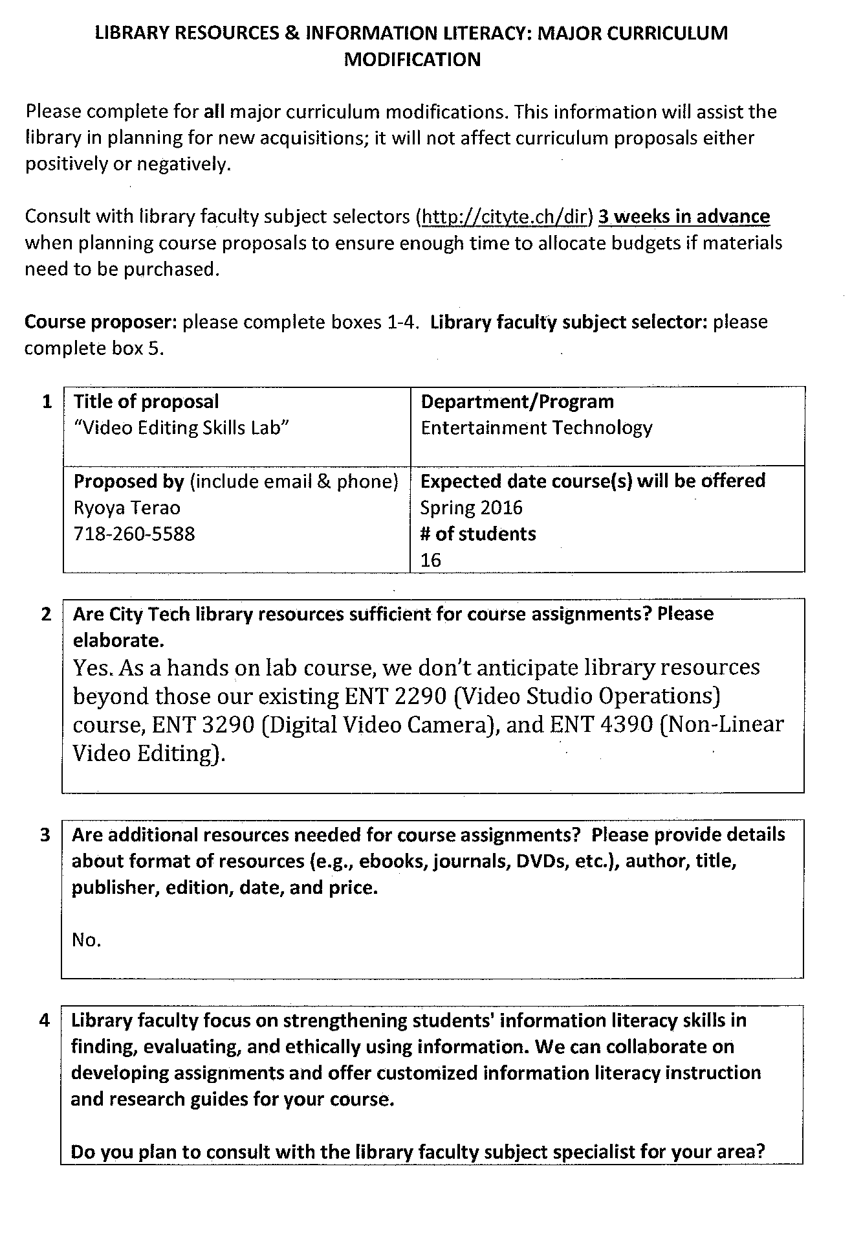
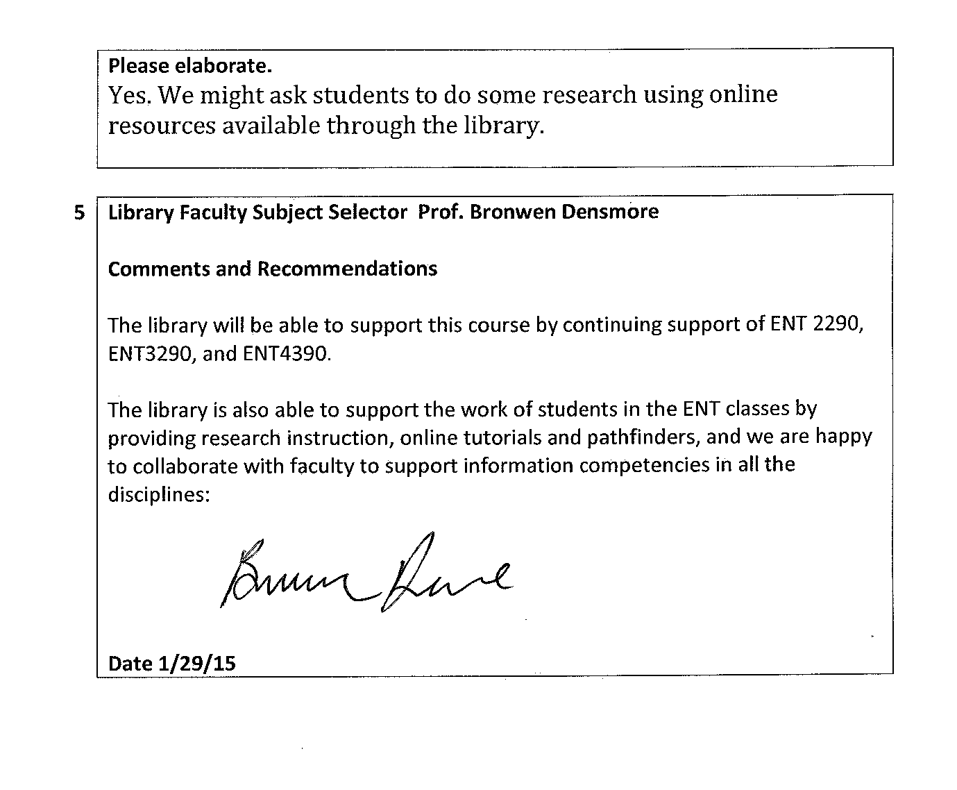

From: | MaryAnn Biehl | Tuesday - March 17, 2015 4:06 PM
To: | Charles Scott
CC: | Ryoya Terao
Subject: | Re: ENT new course proposal

Hi Chip,
I'm sorry for the delay!

Yes, I'm in support of of the course. Please let me know if you need me to write a formal letter.

Thanks,
Mary Ann
>>> Charles Scott 03/11/15 10:31 AM >>>
Maryann,
Had a change to peruse this yet? :-) The provost asked that I include your input or acceptance into the proposal docs.
Chip
Prof. Chip (Charles) Scott
Chair Entertainment Technology Dept. V205
New York City College of Technology, CUNY
Brooklyn, NY, (718) 260-5588
United Scenic Artists Loca829, IATSE

>>> Charles Scott 3/2/2015 3:41 PM >>>
Maryann,
Ryoya Terao has proposed a new course in AVID video editing software skills titled "ENT2190 Video Editing Skills" (file attached). The course has a prereq of ENT1190 or COMD 2320. As per the curriculum proposal guidelines. I was just emailing to see if you support this proposal as your course is a potential prereq to the new ENT2190. The new course would cover software, AVID, not currently covered in COMD courses.
Thank you, and if there are any issues we would be happy to discuss as usual.
Chip

Prof. Chip (Charles) Scott
Chair Entertainment Technology Dept. V205
New York City College of Technology, CUNY
Brooklyn, NY, (718) 260-5588
United Scenic Artists Loca829, IATSE

