Interdisciplinary Special Topics Course:

The Evolving Face of Race, Class, and Gender Identity
HEA 2112

Submitted by: Dr. Christine Thorpe, Chair—Human Services
Dr. Monique Ferrell, English

Table of Contents

Course Proposal……………………………………………………………….3-7

Curriculum Modification Form……………………………………………….8-9

New Course Proposal Form…………………………………………………..10-11

Course Syllabus………………………………………………………………12-24

Letter of Support (Dr. Nina Bannett)……………………………………........25

Letter of Support (Dr. Julian Williams)………………………………………26

Invitations to Guest Lecturers………………………………………………..27-29

Chancellor’s Report………………………………………………………….30

Library Resources & Information Literacy Form……………………………31-32

Application For Interdisciplinary Course Designation Form………………..33-39

Course Outline Form…………………………………………………………40-47

Common Core Form………………………………………………………....48-53

COURSE PROPOSAL

The Interdisciplinary/Special Topics course The Evolving Face of Race, Class, and Gender Identity is designed to address course content and subject matter not currently offered at New York City College of Technology, CUNY. Specifically, the proposed course focuses on the resulting effects of Internal Colonialism as experienced by those defined as American minority groups.

Logic Behind The Proposed Course:

In his seminal essay “Internal Colonialism and Black Revolt,” Robert Blauner argues that there is a distinction between what he terms “classical colonialism” –or colonialism as we understand it—and responses to “colonized status.” This argument, of course, includes cultural movements and representations of nationalism and, as posited by the creators and proposers of this course, expressions in the arts, evolution of speech and language, changes in gender roles/expectations, and changes within respective communities as they relate to racial/community health and healthcare practices.

Additionally, Blauner further asserts that Internal Colonialism is an experience that is not unique to African Americans but, instead, is an experience that is shared by other non-Whites in America and across the globe. Essentially, it is one thing to be colonized and still another to experience it, internalize it, and develop individual and collective responses to colonialism beyond physical resistance/revolt.

To this end, the proposers have designed a course that examines the following areas of academic study/focus:

Using Internal Colonialism as an analytical construct, this course examines the socio-historical, cultural conditions, and gender constructs of marginalized cultural and racial groups in America. A special focus is on Blacks and other Indigenous cultures and populations, such as Native Americans and Mexican Americans. Topics include, but are not limited to, the following: slavery/genocide, racial/cultural blending, integration/segregation, economic deprivation, the impact of public health and mental health, and shifts in gender identity and cultural roles.

The Course at City Tech:

The scope and relevance of the proposed course/subject matter allows for the development of innovative avenues for exploring and understanding racial, cultural, and gender specific responses to trauma, domination, and marginalization (within America) across the disciplines at City Tech.

The proposers envision collaborative efforts among the disciplines: History, Psychology, Anthropology, Economics, African American Studies, English, and across such departments as Health and Human Services, Social Sciences, Hospitality Management, Humanities, Architectural Technology, and Legal Studies.

Some of the efforts could focus on and explore the following areas of academic collaboration:

- Legal systems/outcomes/policies and representations of said issues in different kinds of literature (Legal Studies and English)
- Languages and anthropology (Humanities and Social Sciences—OR—Communications and Social Sciences)
- Cuisine, sustainability, healthcare, and geography (Hospitality Management, Health and Human Services, and Social Sciences)
- Relationships between psychological well-being and economic health (Social Sciences and Health and Human Services)
- Architecture and gentrification (African American Studies, Architectural Technology, Social Sciences)
- Music and resistance movements (Human Services, African American Studies, English Department, Humanities)
- Resistance, Renaissance, and Revolution through Literature (African American Studies and English)

The above suggested collaborations are reflective of types of academic collaborations. They are by no means the only recommendations for Interdisciplinary/Special Topics collaborations. Neither is the suggested course content for said collaborations indicative of what must/should be taught in the event of collaborations between the aforementioned disciplines/departments. There is no single way to teach this course, and professors from diverging departments with distinctive types of expertise can easily identify ways to collaboratively address the topic of Internal Colonialism.

Additional Rationale For Proposed Course:

City Tech serves one of the most diverse campus populations in the nation. Our students thrive on courses that represent and address diverging opinions, ideas, and representations of cultural and racial identity. Beyond the use of scholarly and creative writings, students will also use new media/technologies (film, Blackboard, Skype, Open Lab)—mediums that enhance the classroom learning experience. Additionally, the proposed course is designed to encourage students to study across disciplinary boundaries and assist them as they develop and utilize distinct methodological approaches in academic discussions (written and in-class) about race, classification, and the evolution of gender identities.

Relevancy of the Theme and proposed Sample Syllabus:

From North America to the continent of Africa, in some shape or form, the seven billion people that inhabit this planet can all attest to the impact of “classical” colonial intervention—as it relates to people and changes in environment.

The United States of America is, perhaps, an example of a nation that best reflects the construct of Internal Colonialism. Additionally, its development and evolution as a country, marks historical and generational responses to Internal Colonialism by those defined as minority groups in America. Without question, impacted groups, those deemed as the racialized, cultural, or (en)gendered other, can attest to how said intervention affected/affects the following: self-esteem (personal and cultural), dialect/language, geography, economics, food (eating habits/availability of resources/sustainability, cultural practices, faith/religion/spirituality, educational access/success, mental and physical health and healthcare practices, among other areas of concern.

The sample syllabus focuses on Africans (including their evolution as African Americans) and those indigenous (Native Americans) to the North American continent. Here in the United States, the immediate and long-term consequences of the domination and subordination of these groups brought about enslavement, the signing and breaking of treaties/laws, war, poverty, lack of education, psychological and physical traumas, and segregation of these peoples. Essentially, in the proposed syllabus, Internalized Colonialism is presented as a response to racial, cultural, and Gender Identity trauma.

_______
Health and Human Services Department

The socio-economic exploitation of African Americans and Native Americans based on race has resulted in their existence today as a struggling under-class. The displacement of both of these groups has caused a loss of intergenerational values, traditions, and practices that impact individual and collective growth, particularly as it relates to health (Mohatt et al., 2014). Those lost connections for information transfer, in conjunction with the policies that denied African Americans and Native Americans quality services comparable to the dominant group in power, perpetuated a decline in health that has resulted in extreme disparity rates in this nation. There is research that indicates genetic predispositions among these groups to experience illnesses and diseases at alarming rates (www.healthypeople.gov). However, research conducted by Dr. Jennifer Griffith in Traumatic Possessions: The Body and Memory in African American Women’s Writing and Performance (2010) and Brave Heart et al.’s (2012) work Historical Trauma Among Indigenous Peoples of the Americas detail the connections between the stressful existence of internal colonialism for over 400 years and the post-traumatic syndromes of oppression as well. This research and other bodies of established work illustrate the traumas of African Americans and Native Americans.

_________
English Department (Creative Expression)

Sherman Alexie’s powerfully written Indian Killer (1996) and The Lone Ranger and Tonto Fistfight in Heaven (1993) and Toni Morrison’s poignant novels Song of Solomon (1997) and Paradise (1997) exemplify the use of the written word as an individual and communal response to Internal Colonialism. These authors and, others like them, use poetry, fiction, and creative non-fiction as a means of discussing the following social issue areas of concern/advocacy:

- immigration and migration (forced and unintentional)
- alcoholism and drug abuse
- physical and sexual violation
- segregation and discrimination
- resistance theory and movements (The Ghost Dance and Civil Rights)
- bigotry (external and internal)
- tradition vs. cultural/social integration
- sex, sexuality, sexual orientation
- communal health and well-being

Texts written by authors like Alexie and Morrison examine how critical and cultural thought (within impacted groups), concerning the above themes, were initially constructed. Additionally, these kinds of texts focus on how social, political, and cultural understandings have morphed over time as a result of being colonized peoples. While writers such as these do address the beauty of and within their respective cultures, these authors primarily focus on the ramifications of being historically acted upon peoples and what it means to walk with a perpetual dual identity—simultaneously being and not being and belonging and not belonging. In the end, these creative representations serve two purposes: they unapologetically expose readers to the realities of Black and Native American life (as experienced by the people) and serve as measured responses to traumatic experience.

Final Thoughts:

Internal Colonialism played a vital and volatile role in shaping the identity and prescribing the socio-economic location of African Americans and Native Americans. As a construct, it has also had long term and far reaching implications on each culture, impacting the men and women within these cultural groups differently. The submitted syllabus posits that each group still struggles to obtain their portion of the American Dream. Moreover, they are continually faced with economic disparity, public health issues—mental and physical—and social welfare crises. Additionally, said racial groups face a bevy of socio-economical hardships that appear to place them perpetually beyond the reach of embracing fully a solely American identity.

The proposed sample syllabus, The Evolving Face of Race, Class, and Gender Identity, focuses specifically on why these struggles still exist within these communities, the social traumas of domestic colonialism, as well as the daily challenges of overcoming the legacy of domination and marginalization.

Pedagogical approaches:

The course itself will engage students as they discuss, explore, and write about the effects of and resistance to Internal Colonialism as explored within the fields of Health and Human Services and English Literature. Of particular significance to this course is the use of narrative fiction and creative texts written by Pulitzer and Nobel Prize winning fiction writers as intellectual tools to probe how culture, when broadly conceived, becomes a platform of resistance to domination and an instrument in asserting one’s identity. Additionally, students will utilize new media resources (Open Lab, Blackboard, Skype guest lecture interviews), as well as visual texts (film) to enhance and supplement the learning experience.

All scheduled guest lecturers (onsite visits, in-class visitations, Skype interviews) will be asked to remain available to students for research purposes: email, in-person interviews, or digital interviews.

This multi-tiered approach to student learning will give students unfettered access to resource materials, enhance their learning experience, and assist in sparking classroom discourse. Interviewees will include historians, tribal leaders/elders, social scientists, anthropologists, economists, psychologists, and health care professionals.

Assessment Plan/Interdisciplinary Student Learning Outcomes:

It is anticipated that this course will draw a class size of 25-30 students each semester, and they will be able to take this course as a free elective or capstone because it is a 2000 level course. By the end of the semester, students should be informed scholars able to critically assess and discuss the course content (in writing and during discussion). Additionally, students who take the course will be able to develop workable creative, cultural, economic or political ideas/solutions; additionally, they will possess a useful and informed knowledge of the following:

--Internal or domestic colonialism as an analytical construct in understanding the development of America and American Identity
--African and Indigenous slavery and oppression
--Social issue advocacy as it relates to the subject matter
--Economic systems and hardships experienced by both cultural groups
--Psychological and physical health issues as they relate to both groups
--Racial, academic, social inequalities, and gender role inequality experienced by both groups
--Similarities between the cultural groups and their approaches to advocacy, healing, and resistance
--Government responses to the socioeconomic issues that plague these communities

Students will be asked to demonstrate their integration and comprehension of the aforementioned concepts through the following: four in-class exams, quizzes, group projects/presentations, and possible paper publication.

Feasibility of proposed required team-teaching method/Sustainability:

Drs. Ferrell and Thorpe will split the fifteen-week semester, sharing both the introductory and final classes of the semester. Additionally, they will visit each other’s courses throughout the semester.

They will meet weekly to design and update course content, assess student engagement, schedule and confirm guest speakers, and to design group/individual projects and exams. Despite splitting the course in half, seven weeks per instructor, they will co-design exams and quizzes, co-develop paper topics, and will share grading responsibility for all submitted assignments. This is a structure that must remain in place as other types of interdisciplinary collaborations present themselves. In doing so, students are presented with a uniform approach to teaching and assessment; moreover, collaborating instructors remain clear about their responsibilities to the students and the course; equally important, the workload is shared evenly.

While collaborating departments will choose to address Internal Colonialism or its internal variant through their own unique critical and creative lenses, using material germane to their respective fields, it is imperative that these departments uphold course expectations established by the proposed syllabus:

- Four co-developed in-class exams
- Co-developed midterm and final paper essay prompts
- Use of guest lecturers
- Shared class teaching (first and final class)
- Shared grading responsibilities

New York City College of Technology, CUNY
CURRICULUM MODIFICATION PROPOSAL FORM
This form is used for all curriculum modification proposals. See the Proposal Classification Chart for information about what types of modifications are major or minor. Completed proposals should be emailed to the Curriculum Committee chair.

Title of Proposal | Interdisciplinary Special Topics Course:  The Evolving Face of Race, Class, and Gender Identity
Date | February 24, 2015
Major or Minor | Major Modification
Proposer’s Name | Dr. Christine Thorpe and Dr. Monique Ferrell
Department | Human Services
Date of Departmental Meeting in which proposal was approved | Human Services Department—September 18, 2014
Department Chair Name | Dr. Christine Thorpe
Department Chair Signature and Date | Christine W. Thorpe (in lieu of signature)
Academic Dean Name | Dr. David Smith
Academic Dean Signature and Date | 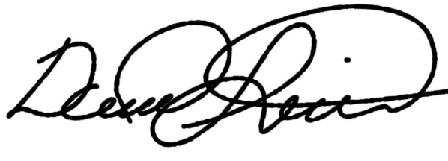10/1/14
Brief Description of Proposal  (Describe the modifications contained within this proposal in a succinct summary. More detailed content will be provided in the proposal body. | Using internal colonialism as an analytical construct, this course examines the socio-historical and cultural conditions, and the gender constructs of marginalized cultural and racial groups in America. A special focus is on Blacks and other Indigenous cultures and populations, such as Native Americans and Mexican Americans. Topics include, but are not limited to, the following: slavery/genocide, racial/cultural blending, integration/segregation, economic deprivation, the impact of public health and mental health, and shifts in gender identity and cultural roles.
Brief Rationale for Proposal  (Provide a concise summary of why this proposed change is important to the department. More detailed content will be provided in the proposal body). | This Special Topics/Interdisciplinary course explores content not currently available within the course curriculum of either proposing department.  As an interdisciplinary course, it utilizes varied sources to address diverse opinions, ideas, and varied understandings of socio-cultural domination and marginalization to be taught by professors from distinct and disparate departments, a necessary factor given City Tech’s diverse student population.  The course underscores the notion that because classic colonialism and America’s internal version developed out of a similar balance of technological, cultural and power relations, a common process of social oppression and marginalization is discernable despite the different historical periods and contexts.  This makes possible for a comparative and interdisciplinary departmental collaboration within the following disciplines: History, Psychology, Anthropology, Economics, African American Studies, English, and other departments such as Health and Human Services, Hospitality Management, and Legal Studies.  The proposed course includes an initial collaborative effort between the English Department, African American Studies and the Department of Health and Human Services.  The course will utilize visual texts and new media/technologies that are part of our students’ everyday lives in order to enhance the classroom learning experience: Film, Skype (interviews with guest lecturers), Blackboard, and Open Lab among others.
Proposal History  (Please provide history of this proposal: is this a resubmission? An updated version? This may most easily be expressed as a list). | - New Class (First Submission)—Fall 2014  - Passed review of College Council Curriculum Committee Review (unanimous vote).—Fall 2104  - Rejected by College Council Executive Committee—clarification(s) requested.  - Proposal updated and edited to clarify discussion of “internal colonialism” and its relation to physical/mental trauma experienced by minority groups and the expression /reaction to and of said by way of creative expression.  - “Colonialism” was removed from the title, thereby broadening applicability across disciplines

New York City College of Technology, CUNY
NEW COURSE PROPOSAL FORM
This form is used for all new course proposals. Attach this to the Curriculum Modification Proposal Form and submit as one package as per instructions. Use one New Course Proposal Form for each new course.

Course Title | Interdisciplinary Special Topics Course:  The Evolving Face of Race, Class, and Gender Identity
Proposal Date | August 25th 2014
Proposer’s Name | Dr. Monique Ferrell and Dr. Christine Thorpe
Course Number | HEA 2112
Course Credits, Hours | 3 Hours 3 Credits
Course Pre / Co-Requisites | English 1101
Catalog Course Description | Using internal colonialism as an analytical construct, this course examines the socio-historical and cultural conditions, and the gender constructs of marginalized cultural and racial groups in America. A special focus is on Blacks and other Indigenous cultures and populations, such as Native Americans and Mexican Americans. Topics include, but are not limited to, the following: slavery/genocide, racial/cultural blending, integration/segregation, economic deprivation, the impact of public health and mental health, and shifts in gender identity and cultural roles.
Brief Rationale  Provide a concise summary of why this course is important to the department, school or college. | This Special Topics interdisciplinary course explores content not currently available within the course curriculum of either proposing department.  As an interdisciplinary course, it utilizes varied sources to address diverse opinions, ideas, and understandings of cultural identity that can be taught by professors from various departments, a necessary factor given City Tech’s diverse student population.  Conceptually, this course will enable students understand in depth the nature and history of exclusion, and the specific forms of its enforcement among marginal cultural groups. Students also develop a better comprehension of the everyday lived experience of these marginal cultural groups and how some of these experiences are mediated by class, race and gender.  The proposed course includes a collaborative effort between the English Department, African American Studies and the Department of Health and Human Services.  Most noteworthy is that it places a special focus on America’s Indigenous cultures and populations. Additionally, the course will utilize visual texts and new media/technologies that are part of our students’ everyday lives in order to enhance the classroom learning experience: Film, Skype (interviews with guest lecturers), Blackboard, and Open Lab among others.
Intent to Submit as Common Core  If this course is intended to fulfill one of the requirements in the common core, then indicate which area. | YES
Intent to Submit as An Interdisciplinary Course | YES
Intent to Submit as a Writing Intensive Course | This course will be both reading and writing intensive.

Please include all appropriate documentation as indicated in the NEW COURSE PROPOSAL Combine all information into a single document that is included in the Curriculum Modification Form.

COURSE SYLLABUS:

NEW YORK CITY COLLEGE OF TECHNOLOGY CITY UNIVERSITY OF NEW YORK

HEA 2112

Prerequisites:
English 1101

Instructors: Dr. Christine Thorpe, Human Services Department
Dr. Monique Ferrell, English Department

The Evolving Face of Race, Class, and Gender Identity

Course Description:
Using internal colonialism as an analytical construct, this course examines the socio-historical and cultural conditions, and the gender constructs of marginalized cultural and racial groups in America. A special focus is on Blacks and other Indigenous cultures and populations, such as Native Americans and Mexican Americans. Topics include, but are not limited to, the following: slavery/genocide, racial/cultural blending, integration/segregation, economic deprivation, the impact of public health and mental health, and shifts in gender identity and cultural roles.
Our Course:
This Special Topics course is interdisciplinary and team taught. In our class, we will be focusing on Africans (African Americans), Native Americans, and how the European colonization of America impacted these two groups in particular. Without question, these two groups have a shared American experience and ancestral cultural bond, which is a direct result of European colonization of America.

The search for and establishment of the United States brought about enslavement, the signing and breaking of treaties/laws, war, poverty, lack of education, psychological and physical traumas, and the segregation of these peoples. Additionally, each of these factors played a vital and volatile role in shaping who African Americans and Native Americans would become post-colonialism, and these same factors have had long term and far reaching implications for both cultural groups, impacting men and women differently.

In many ways, both cultures still struggle against their marginalization and are still coping with economic disparity, public health issues—mental and physical—and social welfare, as well as a bevy of socio-economic hardships that appear to place them perpetually beyond the reach of embracing fully an American identity. The primary question, among others, that we will ponder—through scholarly and creative writing, film, and guest lecturers—is “why does this struggle still exist?”

Expectations:
Using scholarly, creative, and visual texts—students will be asked to assess, explore, and make determinations about the cultural impact and long-term outcome of the colonial status of African American and Native American communities as they relate and correlate to the following: economic disparity, psychological/physical health and well-being, historical implications, alcoholism and drug addiction, chronic illnesses, infant mortality rates, oppression and segregation, education inequality and incarceration rates, and gender inequality.
Students will assess and critically analyze whether or not domestic colonialism has transformed into a systemic form of oppression that neither of the cultural groups are able to transcend. This course is reading and writing intensive.

*In the best interest of the students, as the semester evolves, Professors Ferrell and Thorpe reserve the right to make adjustments to the reading and assignment schedule: adding/deleting texts or changing dates for exam/papers.

Course Texts:

Dr. Thorpe—Weeks 1-7

- Guest Lecturer—Dr. Karl Botchway, Dean of Arts and Sciences:

- Ramón A. Gutiérrez (2004). INTERNAL COLONIALISM: An American Theory of Race. Du Bois Review, 1, pp 281-295. doi:10.1017/S1742058X04042043
- Peter Bohmer, African-Americans as an Internal Colony: The Theory of Internal Colonialism, John Whitehead and Cobie Kwasi Harris, Readings in Black Political Economy (1999, Kendall/Hunt, Dubuque, Iowa)
- Blauner, Robert.1969. “Internal Colonialism and Ghetto Revolt,” Social Problems, 16, no.4 (Spring), 393-408.

- Course Packet of Required Readings

(Readings will be distributed on the first day of class.)

*Suggested Readings:
Fullilove, R.E., & Rosen, D. E. (2014). Mass Incarceration: The HIV/AIDS Epidemic and the Affordable Care Act—What Will the Future Hold?. Journal of HIV/AIDS & Social Services, 13 (1), 5-7.

Traumatic Possessions: The Body and Memory in African American Women’s Writing and Performance by Jennifer L Griffiths (2010)

On Our Own Terms: Race Class and gender in the lives of African American Women by Leith Mullings (1996)

Dr. Ferrell—Weeks 8-14

Indian Killer by Sherman Alexie House Made of Dawn by N. Scott Momaday Song of Solomon by Toni Morrison Too Beautiful For Words by Monique Morris

*Suggested Readings Gardens In The Dunes by Leslie Marmon Silko The Bluest Eye by Toni Morrison

Semester Assignments:
Exams: 25% (4 exams, Essay and Short Answer) Midterm/Short Paper: 15% (6-8pgs, Primary and Secondary Sources, MLA/APA) Assignments: 15% (Presentations, Quizzes, Reader Responses, Group Work) Class Participation: 15% Final Fin Final Paper: 30% (8-10 pgs, Primary and Secondary Sources)
Class Participation: 15%
Assignments: 15% (quizzes, group work, assignments)

Classroom Rules/Etiquette:
- Students must remove headsets before entering the classroom.
- Cellphone use of any kind is not allowed while class is in session.
Absence/Lateness:
- Students will be allowed one unexcused absence. Each additional absence will result in a five point deduction of your final grade.
- Two late arrivals equal one absence.
Additional Classroom Policies:
- Official medical/legal excuses may be submitted to address excessive late arrivals and absences.
- Every course assignment/paper has a due date. Late work will not be accepted without a valid excuse.

Plagiarism:

Plagiarism is intentionally and knowingly presenting the ideas or works of another as one’s own original idea or works in any academic exercise without proper acknowledgment of the source. The purchase and submission of a dissertation, thesis, term paper, essay, report, or other written assignment to fulfill the requirements of this course is plagiarism and violates section 213-b of the State Education Law. Any student caught plagiarizing will fail this course and be presented to the Division Dean for expulsion.

Students and all others who work with information, ideas, texts, images, music, inventions, and other intellectual property owe their audience and sources accuracy and honesty in using, crediting, and citing sources. As a community of intellectual and professional workers, the College recognizes its responsibility for providing instruction in information literacy and academic integrity, offering models of good practice, and responding vigilantly and appropriately to infractions of academic integrity. Accordingly, academic dishonesty is prohibited in The City University of New York and at New York City College of Technology and is punishable by penalties, including failing grades, suspension, and expulsion. The complete text of the College policy on Academic Integrity may be found in the catalog.

Instructional Objectives, Activities, and Assessment for sample syllabus HEA 2112:

The Evolving Face of Race, Class, and Gender Identity

Instructional Objectives: For the successful completion of this course, students should be able to: | Instructional Activities | Assessment: Evaluation methods and criteria
Accurately define and discuss health disparities, public health, Colonialism/Post-colonialism/Internal Colonialism and subsequent movements in history, Post Traumatic Stress Syndrome/trauma, critical scholarship, African American and Native American Literature to mark their impact on both ethnic groups. | Assigned readings, class diagnostic, group work, class discussions | Reader Response mini- essays, quizzes, Open Lab projects, and exams
Outline and discuss the following social constructs and historical events to assess their impact on African Americans and Native Americans as they relate to colonialism/post-colonialism: Slavery/Genocide, medical experimentation, The Civil War, Emancipation, Suffrage, The Jim Crow Era/Segregation, The Civil Rights Movement, The Vietnam War, Women’s Rights Movement, USDHHS, Affordable Care Act, BIA, AIM, Reservation Life, Missionary Schools, American Treaties with Indigenous peoples. | Assigned readings, class discussions, group work, and films | Reader Response mini essays, exams, midterm essay, quizzes, Open Lab projects, and final paper/project
Explore and study the complexity of the following factors as they relate to African American and Native Americans: American Identity, Cultural Identity, Racial mixing, Gender Roles and Expectations, Economics, Mental Well-Being, Violence, Post-traumatic stress, Chronic Illness, Violence. | Assigned readings, films, class discussions, group projects | Reader Response mini- essays, exams, midterm essay, quizzes, Open Lab projects, final paper/project
Explore and study cultural revelations about color consciousness, (C)lass, culture and traditions, Healthcare, Race and Gender and the politics that guide them. | Assigned readings, films, class discussions, group projects | Reader Response mini- essays, exams, midterm essay, quizzes, Open Lab projects, final paper/project
Examine the impact of racism, war, government impact, bigotry, prejudice, intercultural bigotry, sexism, (C)lass, upward mobility, poverty, incarceration, intellectualism and failure/success in academia, the importance of having a cultural “homeland.” | Assigned readings, films, class discussions, group projects | Reader Response mini- essays, exams, Open Lab projects, final paper/project, in person conferences
Discuss and explore feminine and masculine power, religion vs. spirituality, cultural health practices, responsibility to one’s cultural community. | Assigned readings, films, class discussions, group projects | Reader Response mini- essays, exams, quizzes, final paper/project, Open Lab projects, in person conferences
Examine the impact and representation of the following in African American and Native American Literature and Scholarship past and present: Historical representation, Identity and classification, Future expectations, strategies, and recommendations. | Assigned readings, films, class discussions, group projects | Reader Response mini- essays, exams, quizzes, Open Lab projects, final paper/project
Comprehend and utilize the basics of grammar, sentence structure, and MLA and APA Documentation (primary and secondary sources). Utilize the mechanics of writing essays about literature (Scaffolding Format), critical essays, and film. | In-class workshops: grammar and sentence structure, assessing the essay prompt (closed or open), essay format (introductions, body paragraphs, and conclusions) | In-person conferences, pre-drafting of midterm and final papers/projects, Reading Responses mini- essays, Open Lab projects, exams

Schedule of Assignments: Weeks 1-7 Dr. Thorpe

Week 1
Introductions/Syllabus Review (Drs. Thorpe and Ferrell/first hour only)

Guest Lecturer—Dr. Karl Botchway, Dean of Arts & Sciences
Internal Colonialism: African-Americans and Native Americans as an Internal Colony

Assigned Readings:
Ramón A. Gutiérrez (2004). INTERNAL COLONIALISM: An American Theory of Race. Du Bois Review, 1, pp 281-295.
Peter Bohmer, African-Americans as an Internal Colony: The Theory of Internal Colonialism, John Whitehead and Cobie Kwasi Harris, Readings in Black Political Economy (1999, Kendall/Hunt, Dubuque, Iowa).
Blauner, Robert.1969. “Internal Colonialism and Ghetto Revolt,” Social Problems, 16, no.4 (Spring), 393-408.
Week 2
Lecture: Public Health Issues in the African American and Native American Communities
Assigned Readings: Connell, R. (2012). Gender, health and theory: conceptualizing the issue, in local and world perspectives. Social Science and Medicine, 74(11), 1675-1683.
Peters, WM, Green, JM, and Gauthier, PE. (2014). Native American medicine: the implications of history and the embodiment of culture. Multicultural Approaches to Health and Wellness in America [2 Vol] 171.

Week 3
Lecture: Historical Traumas, Present-Day Manifestations
Assigned Reading: Brave Heart, MYH, Chase J, Elkins J, and Altschul DB. (2011). Historical trauma among indigenous peoples of the Americas: concepts, research and clinical considerations. Journal of Psychoactive Drugs, 43(4), 282-290.

Hinrichsen, Lisa (2013). Trauma studies and the literature of the U.S. south. Literature Compass, Vol. 10, Issue 8, pp. 605-617.

Mohatt, N. V., Thompson, A. B., Thai, N. D., & Tebes, J. K. (2014). Historical trauma as public narrative: A conceptual review of how history impacts present-day health. Social Science & Medicine, 106, 128-136.

Week 4
First Hour—Guest Speaker Dr. Robert Fullilove, Professor at Columbia University’s Mailman School of Public Health

Second Hour—Lecture: Evolving Chronic Illnesses; Prep for Exam #1

Assigned Reading: Jernigan, V. B. B., Salvatore, A. L., Styne, D. M., & Winkleby, M. (2011).

Addressing food insecurity on a Native American reservation using community-based participatory research. Health education research, cyr089.

Feagin, J., & Bennefield, Z. (2014). Systemic racism and US health care. Social Science & Medicine, 103, 7-14.

Week 5
First Hour—Exam 1

Second Hour—Lecture: Inter-generational Mental Health Issues

Assigned Reading: Walters, K. L., Mohammed, S. A., Evans-Campbell, T., Beltrán, R. E., Chae, D. H., & Duran, B. (2011). Bodies don't just tell stories, they tell histories. Du Bois Review: Social Science Research on Race, 8(01), 179-189.

Gone, J. P. (2013). Redressing First Nations historical trauma: Theorizing mechanisms for indigenous culture as mental health treatment. Transcultural psychiatry, 50(5), 683-706.

Week 6
Lecture: The Causes of Substance Abuse

Assigned Reading: Wiechelt, S. A., Gryczynski, J., Johnson, J. L., & Caldwell, D. (2012). Historical trauma among urban American Indians: Impact on substance abuse and family cohesion. Journal of Loss and Trauma, 17(4), 319-336.

Short Paper: 6-8 pages Compare and contract one chronic health issue affecting Native American and African American communities, examining past and present

*Midterm Paper: (6-8pages) Compare and contrast one chronic health issue affecting Native American and African American Communities, examining past and present

Week 6
Lecture: Infant Mortality and Challenges of Living; Prep for Exam #2

Assigned Reading: Rosenthal, L., & Lobel, M. (2011). Explaining racial disparities in adverse birth outcomes: Unique sources of stress for Black American women. Social Science and Medicine, 72 (6), 977-983.

Walker, L. O., & Chestnut, L.W. (2010). Identifying health disparities and social inequities affecting childbearing women and infants. Journal of Obstetric, Gynecologic, & Neonatal Nursing, 39 (3), 328-338.

Week 7
First Hour—Exam 2

Second Hour—Lecture: The Challenges of Living (cont.)

Assigned Reading: Weaver, H.N. (2012). Urban and Indigenous: The Challenges of being a Native American in the City. Journal of Community Practice, 20 (4), 470-488.

Williams, D. R., Mohammed, S. A., Leavell, J., & Collins, C. (2010). Race, socioeconomic status, and health: complexities, ongoing challenges, and research opportunities. Annals of the New York Academy of Sciences, 1186 (1), 69-101.

Assigned readings for Dr. Ferrell first class: First 75 pages of Song of Solomon by Toni Morrison

Schedule of Assignments
Weeks 8-14 Dr. Ferrell

Week 8
Lecture: Defining Internal Colonialism and the Introduction to the creative voice: What it means to talk about home (How African American and Native American authors see themselves and understand their American Identity)

Song of Solomon—What it means to be a Black Man in America

Week 9
Lecture: Song of Solomon cont’d—Vocation, Station, and Being/The Role(s) of Black Women

Assign House Made of Dawn by N. Scott Momaday

Week 10
Lecture: First Hour--(Finish discussion of Song of Solomon—Class, Race, Community, Revenge and Retaliation)

Second Hour—Prep for Exam #3/Begin Discussion of House Made of Dawn (Native American, American, or Indigenous?)

Week 11
Hour One—Exam #3

Lecture: Hour Two—House Made of Dawn—(Battling Demons, Culture, Community, Filling the Void)

Assign Indian Killer by Sherman Alexie

Distribute Final Paper Essay Prompts

Week 12
Lecture: Reservation Life, Indian-ness vs American-ness, Contemporary Indian Life, How real is the world of Sherman Alexie’s Indian Killer?

Hour One—House Made of Dawn—Cont’d

Hour Two—Guest Lecturer/Author Professor RevaMariah ShieldChief (Pawnee and Tohono O’odham Nations)

Week 13
Lecture: Alexie’s Indian Killer cont’d—Gender, Class, Death, Reparations

Assign Too Beautiful For Words by Monique Morris—Contemporary Black Life, Class, Power,

Week 14
Lecture: Too Beautiful For Words

Final Review For Exam #4 and Final Paper

Week 15 Final Exam/Final Papers Due

Bibliography on Internal Colonialism: African-Americans as an Internal Colony
Allen, Robert (1990) Black Awakening in Capitalist America, Africa World Press, Trenton, NJ

Blauner, Robert (1969). “Internal Colonialism and Ghetto Revolt,” Social Problems, 16, no.4 (Spring), 393-408.
Bohmer, Peter (1999). African-Americans as an Internal Colony: The Theory of Internal Colonialism, John Whitehead and Cobie Kwasi Harris, Readings in Black Political Economy (1999, Kendall/Hunt, Dubuque, Iowa).

Carmichael, Stokley and Charles V. Hamilton (1967) Black Power: The Politics of Liberation in America, New York, Random House.

Du Bois, W.E.B, (1935). “A Negro Nation within the Nation,” Current History, Vol42 (June), 265-270.

Fanon, Franz, (1961), The Wretched of the Earth, Grove Press, New York

Gutiérrez, Ramón A (2004). INTERNAL COLONIALISM: An American Theory of Race. Du Bois Review, 1, pp 281-295.

Malcolm X (1965). Malcolm X Speaks, Grove Press, New York

Oliver, Christopher (1996). The Internal Colonialism Model: What the Model Has Done to the Education of Native American. A Research Report, ERIC.

African American and Native American Public Health Bibliography (Dr. Christine Thorpe)

Boyd-Franklin, N. (2013). Black families in therapy: Understanding the African American experience. Guilford Publications.

Braithwaite, R. L., Taylor, S. E., & Treadwell, H. M. (Eds.). (2009). Health issues in the black community. John Wiley & Sons.

DeGruy, J. (2010). Post traumatic slave syndrome. Joy DeGruy RSS.
Douglass, F. (1855). My Bondage and My Freedom. New York, NY: Miller, Orton, & Mulligan.
Ehlers, C. L., Gizer, I. R., Gilder, D. A., Ellingson, J. M., & Yehuda, R. (2013). Measuring historical trauma in an American Indian community sample: Contributions of substance dependence, affective disorder, conduct disorder and PTSD. Drug and alcohol dependence, 133(1), 180-187.

Goodkind, J. R., Ross-Toledo, K., John, S., Hall, J. L., Ross, L., Freeland, L., ... & Lee, C. (2010). Promoting healing and restoring trust: Policy recommendations for improving behavioral health care for American Indian/Alaska Native adolescents. American journal of community psychology, 46(3-4), 386-394.

Gone, J. P. (2013). A community-based treatment for Native American historical trauma: prospects for evidence-based practice.

Harrington, E. F., Crowther, J. H., & Shipherd, J. C. (2010). Trauma, binge eating, and the “strong Black woman”. Journal of consulting and clinical psychology, 78(4), 469.
Hodge, F. S. (2012). No meaningful apology for American Indian unethical research abuses. Ethics & Behavior, 22(6), 431-444.
King, W. (2011). Stolen childhood: Slave youth in nineteenth-century America. Indiana University Press.
Krieger, N. (2012). Methods for the scientific study of discrimination and health: an ecosocial approach. American journal of public health, 102(5), 936-944.

LaFromboise, T. D., Albright, K. and Harris, A. 2010. Patterns of hopelessness among American Indian adolescents: Relationships by levels of acculturation and residence. Cultural Diversity and Ethnic Minority Psychology, 16(1): 68–76.

Myhra, L. L. (2011). " It runs in the family": intergenerational transmission of historical trauma among urban American Indians and Alaska Natives in culturally specific sobriety maintenance programs. American Indian and Alaska Native Mental Health Research: The Journal of the National Center, 18(2), 17-40.

Peach, S. J. (2013). TRADITIONAL HEALING AND MODERN MEDICINE. Encyclopedia of American Indian Issues Today [2 Volumes], 260.

People, H., & US Department of Health and Human Services. (2011). Healthy People 2020.

Skloot, R., & Turpin, B. (2010). The immortal life of Henrietta Lacks (p. 369). New York: Crown Publishers.

Washington, H. A. (2006). Medical apartheid: The dark history of medical experimentation on Black Americans from colonial times to the present. Random House LLC.

Weaver, H. N. 2010. The Healthy Living in Two Worlds project: An inclusive model of curriculum development. Journal of Indigenous Voices in Social Work, 1(1): 1–18.

Walters, K. L., Mohammed, S. A., Evans-Campbell, T., Beltrán, R. E., Chae, D. H., & Duran, B. (2011). Bodies don't just tell stories, they tell histories. Du Bois Review: Social Science Research on Race, 8(01), 179-189.

African American and Native American Literature Bibliography (Dr. Monique Ferrell)

Angelou, Maya. I Know Why The Caged Bird Sings. New York: Bantam Books, 1969.

Baker Jr., Houston A.. Modernism and the Harlem Renaissance. Chicago: University of Chicago Press, 1989.

Baldwin, James. Go Tell It On The Mountain. New York: Bantam Doubleday Dell, 1952.

Beck, Peggy, Anna Lee Walters, Nia Francisco. The Sacred: Ways of Knowledge, Sources of Life. Tsaile: Navajo Community College Press, 1995.

Crow Dog, Mary. Lakota Woman. New York: Harper Perennial, 1990.

Erdrich, Louise. Tracks. New York: Henry Holt & Co, 1988.

Erdrich, Louise. Love Medicine. New York: Harper Perennial, 1984.

Erdrich, Heid and Laura Tohe. Sister Nations: Native American Women Writers on Community. St. Paul: Minnesota Historical Press, 2002.

Ferguson, Jeffrey Brown. The Harlem Renaissance: A Brief History with Documents (Bedford Series in History). New York: Beford-St.Martin’s, 2007.

Gates Jr, Henry Louis, ed. The Classic Slave Narratives. New York: Penguin Books, 1987.

Haley, Alex. Roots: The Saga of An American Family. New York: Dell Publishing, 1974.

Harjo, Joy. A Map To The Next World. New York: W.W. Norton Press, 2000.

Harper Locke, Alain and Arnold Rampersad. The New Negro: Voices of the Harlem Renaissance. New York: Touchstone, 1990.

Hill, Laban Carrick. Harlem!: A Cultural History of The Harlem Renaissance. New York: Little, Brown Books, 2009.

Josephy Jr., Alvin M. America In 1492: The World of Indian Peoples Before The Arrival Of Columbus. New York: Vintage Books, 1991.

Larsen, Nella. Passing. New York: Knopf, 1929.

Lewis, David, ed. The Portable Harlem Renaissance Reader. London: Penguin, 1995.

Momaday, N. Scott. Man Made of Words. New York: St. Martin’s Press. 1997.

Momaday, N. Scott. House Made of Dawn. New York: Harper Perennial Modern Classics, 1968.

Momaday, N. Scott. The Way To Rainy Mountain. Albuquerque: University of New Mexico Press, 1969.

Morrison, Toni. Beloved. New York: Penguin Books, 1988.

Morrison, Toni. Song of Solomon. New York: Alfred Knopf, 1977.

Morrison, Toni. The Bluest Eye. New York: Holt, Rinehart, Winston, 1970.

Nerburn, Kent. The Wisdom of Native Americans. New York: MJF Books, 1999.

Owens, Louis. Bone Game. Norman: University of Oklahoma Press, 1994.

Quashie, Everod Kevin, Joyce Lausch, Keith D. Miller. New Bones: Contemporary Black Writers In America. Saddle River: Prentice Hall, 2001.

Owens, Louis. Other Destinies: Understanding The American Indian Novel. Norman: University of Oklahoma Press, 1992.

Trafzer, Clifford E. Blue Dawn, Red Earth. New York: Doubleday, 1996.

Thurman, Wallace. The Blacker The Berry. New York: MacMillan Publishing, 1929.

Silko, Marmon Leslie. Gardens In The Dunes. New York: Simon & Schuster, 1999.

Silko, Marmon Leslie. Almanac of The Dead. New York: Simon & Schuster, 1991.

Van Vechten, Carl. Nigger Heaven. Chicago: University of Illinois Press, 1926.

Vizenor, Gerald. Native American Literature: A Brief Introduction and Anthology. New York: Harper Collins College Publishers, 1995.

Walker, Alice. The Color Purple. New York: Pocket Books, 1982.

Walker, Alice. In Search of Our Mothers’ Gardens: Womanist Prose. New York: Harcourt Brace & Company, 1983.

Zafar, Rafia, ed. Harlem Renaissance Novels: The Library of America Collection. New York: Library of America, 2011.

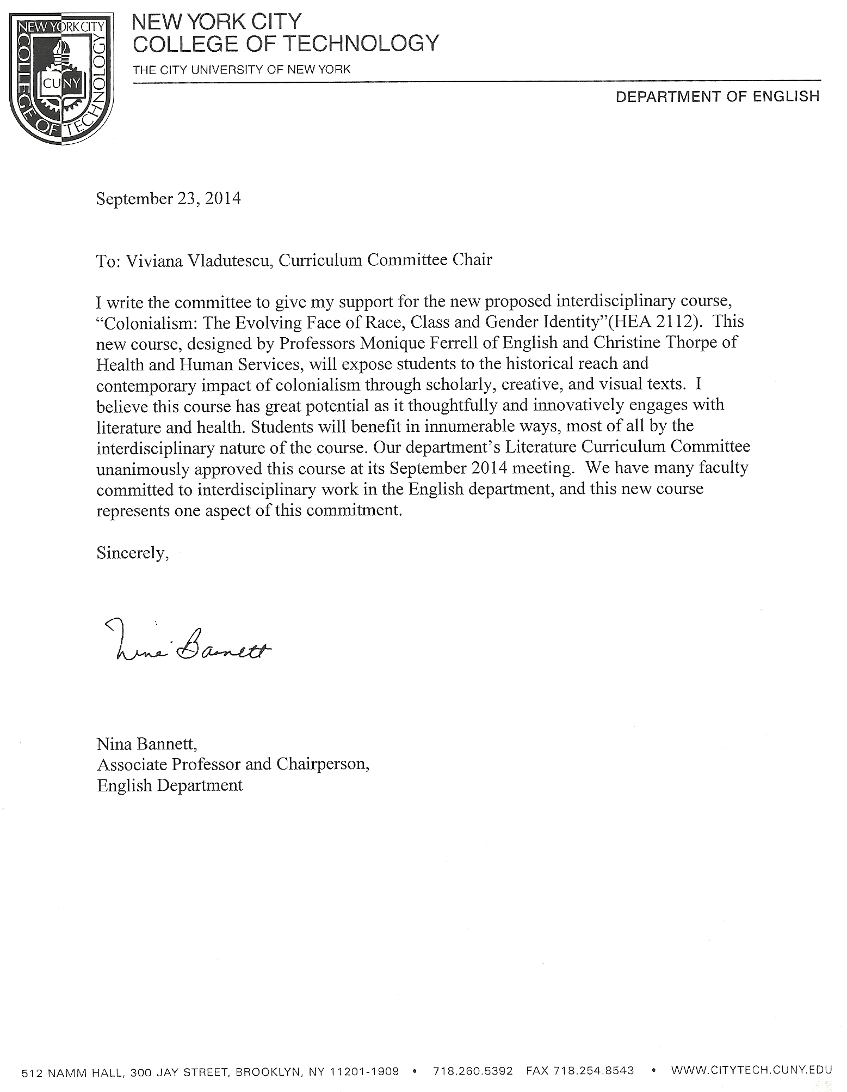

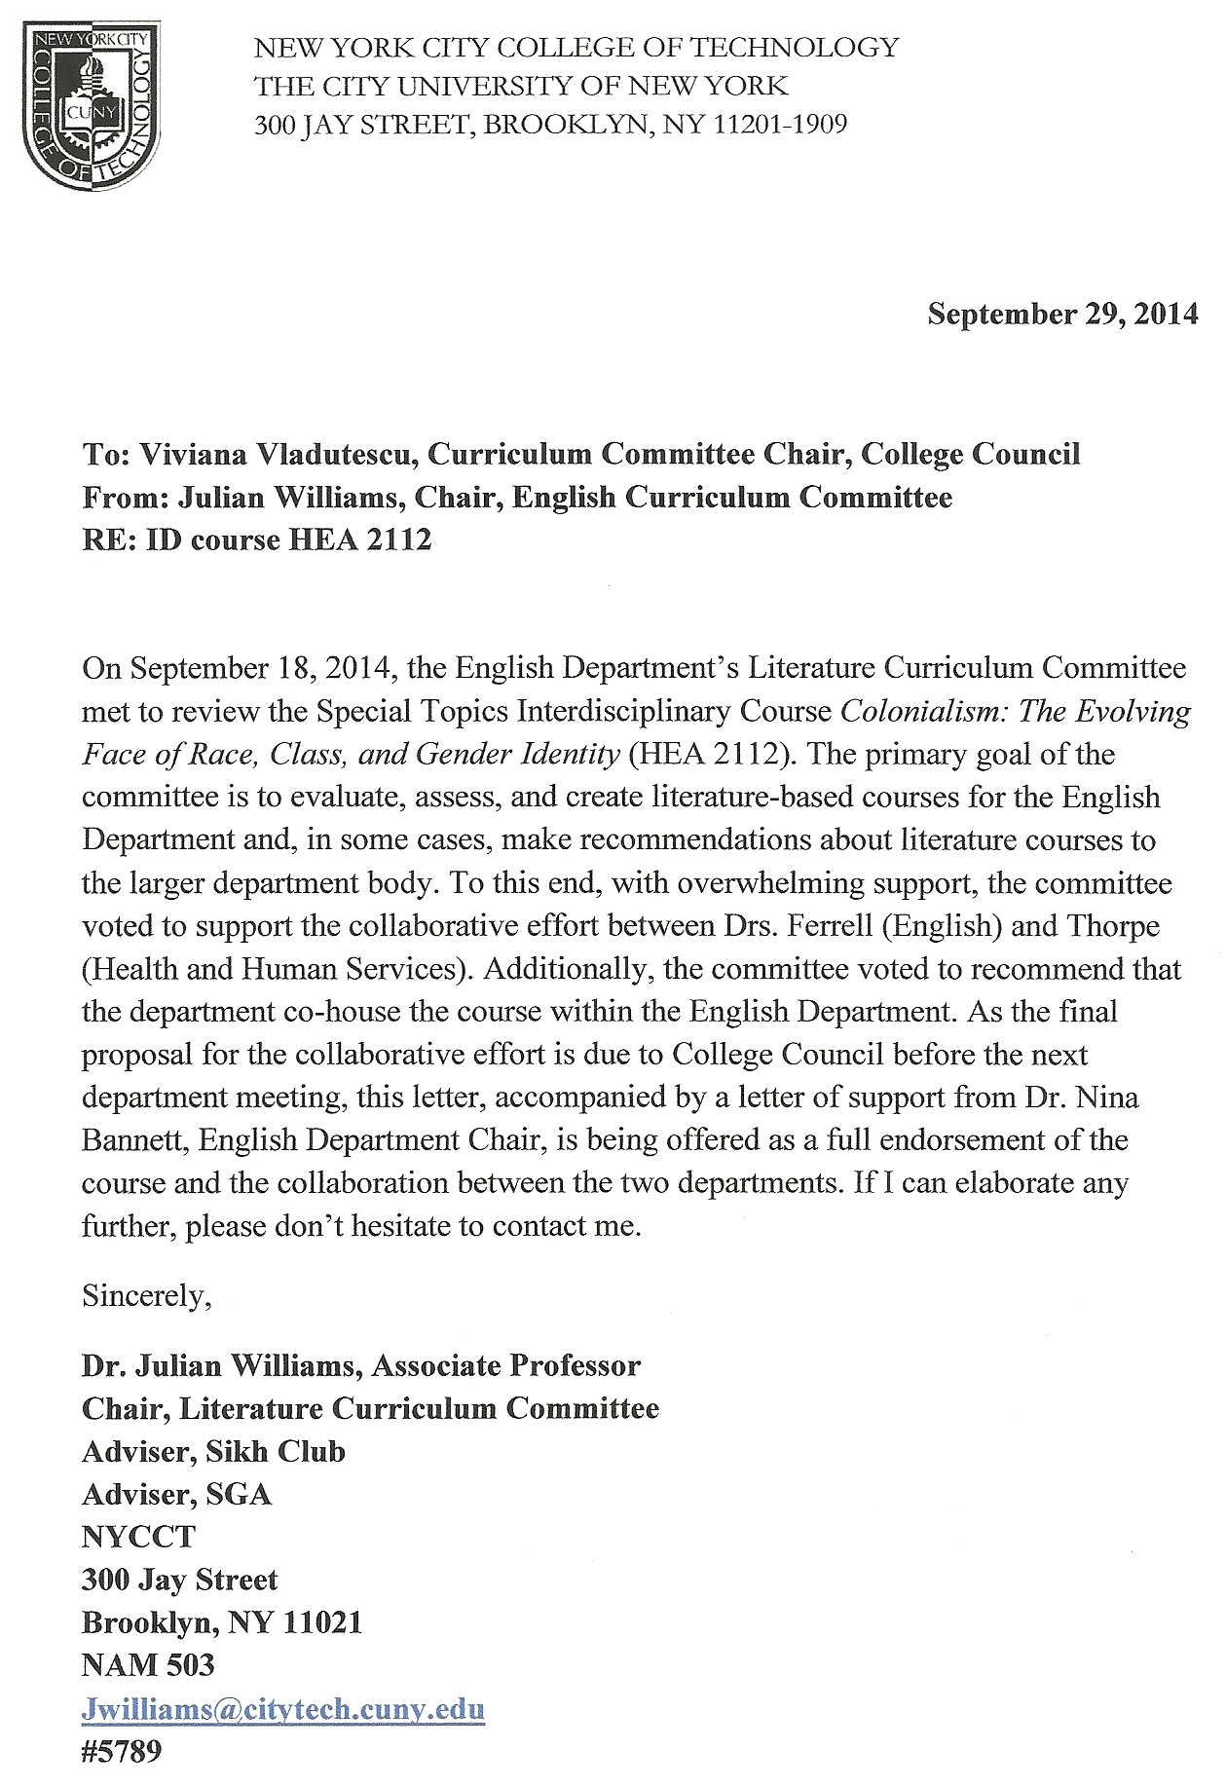

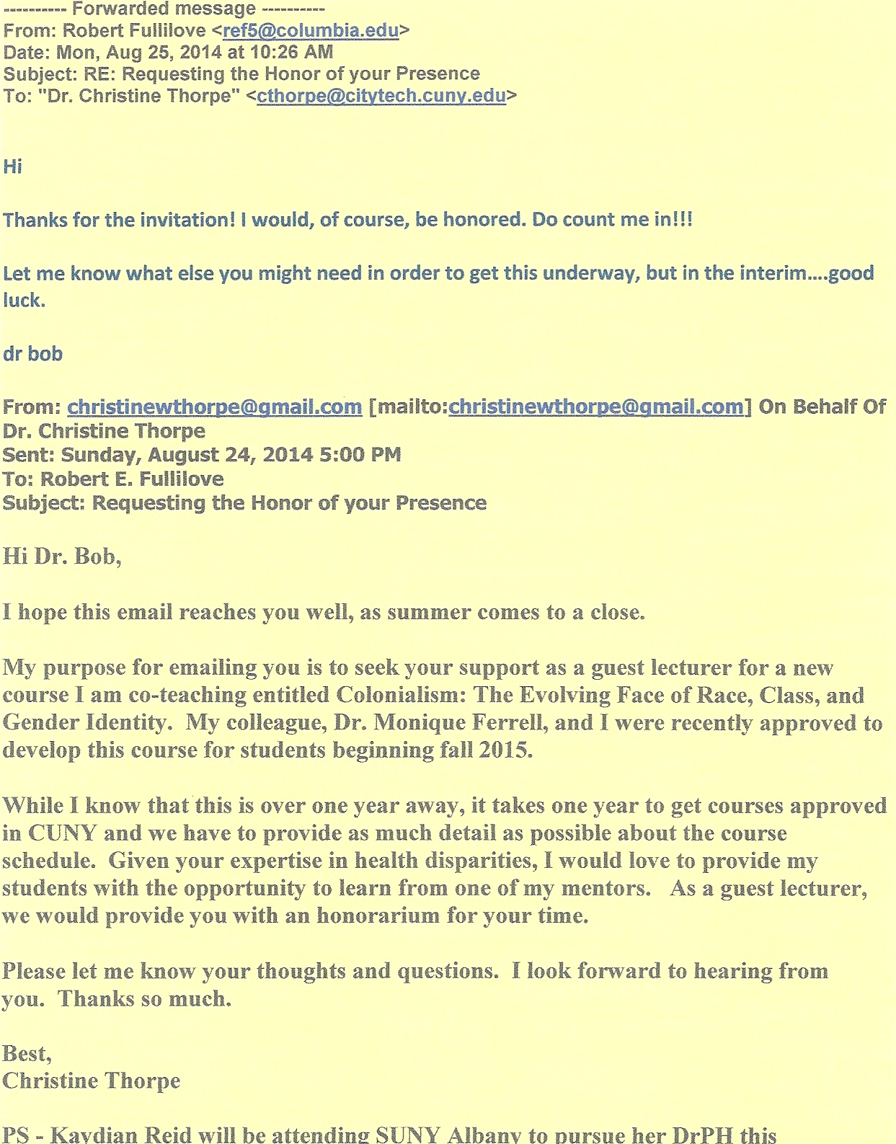

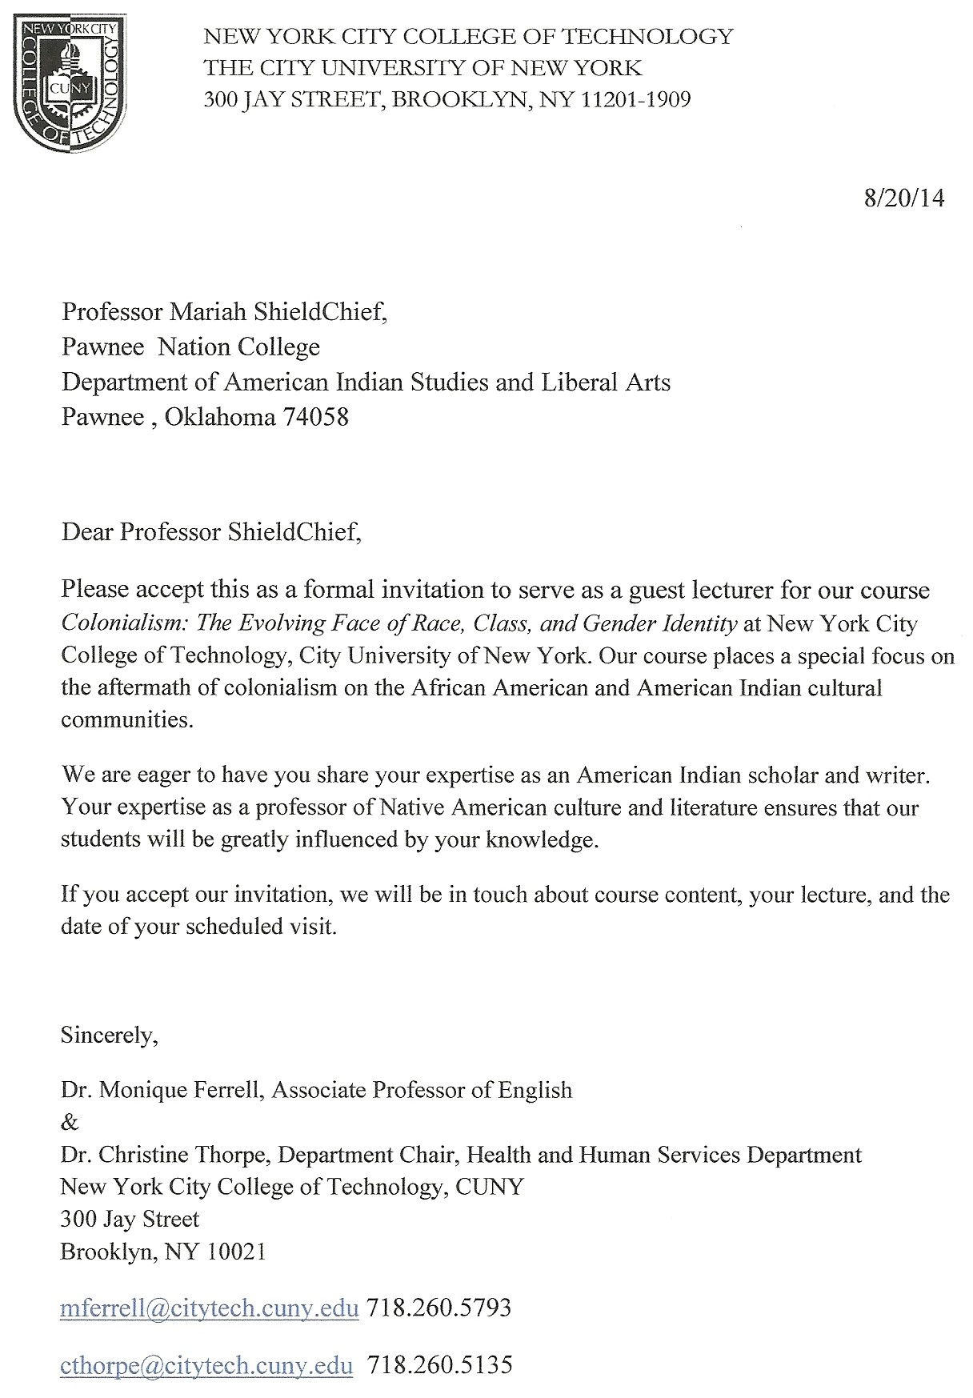

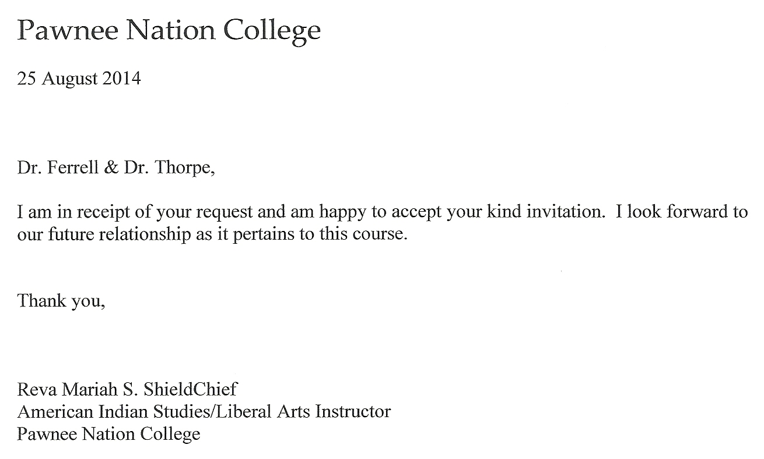

Chancellor’s Report New or Experimental Courses

New interdisciplinary course to be offered in the English Department and Human Services Department

Department(s) | Human Services
Academic Level | [ X ] Regular [ ] Compensatory [ ] Developmental [ ] Remedial
Subject Area | Special Topics/Interdisciplinary course
Course Prefix | HEA
Course Number | 2112
Course Title | The Evolving Face of Race, Class, and Gender Identity
Catalog Description | Using internal colonialism as an analytical construct, this course examines the socio-historical, cultural conditions, and gender constructs of marginalized cultural and racial groups in America. A special focus is on Blacks and other Indigenous cultures and populations, such as Native Americans and Mexican Americans. Topics include, but are not limited to, the following: slavery/genocide, racial/cultural blending, integration/segregation, economic deprivation, the impact of public health and mental health, and shifts in gender identity and cultural roles.
Prerequisite | ENG 1101
Corequisite | none
Pre- or corequisite | none
Credits | 3
Contact Hours | 3 cl hrs
Liberal Arts | [ X ] Yes [ ] No
Course Attribute (e.g. Writing Intensive, etc) | Reading and Writing Intensive
Course Applicability | [ ] Major  [ ] Gen Ed Required [ X ] Gen Ed - Flexible [ ] Gen Ed – College Option  [ ] English Composition [ ] World Cultures [ ] Speech  [ ] Mathematics [ X ] US Experience in its Diversity [ X ] Interdisciplinary  [ ] Science [ ] Creative Expression [ ] Advanced Liberal Arts  [ ] Individual and Society  [ ] Scientific World
Effective Term | Spring 2016
Rationale: This new Special Topics/Interdisciplinary course puts a special focus on America’s Indigenous cultures and populations, and addresses diverse opinions, ideas, and varied understandings of cultural identity that can be co-taught by professors from various departments, a necessary factor given City Tech’s diverse student population.

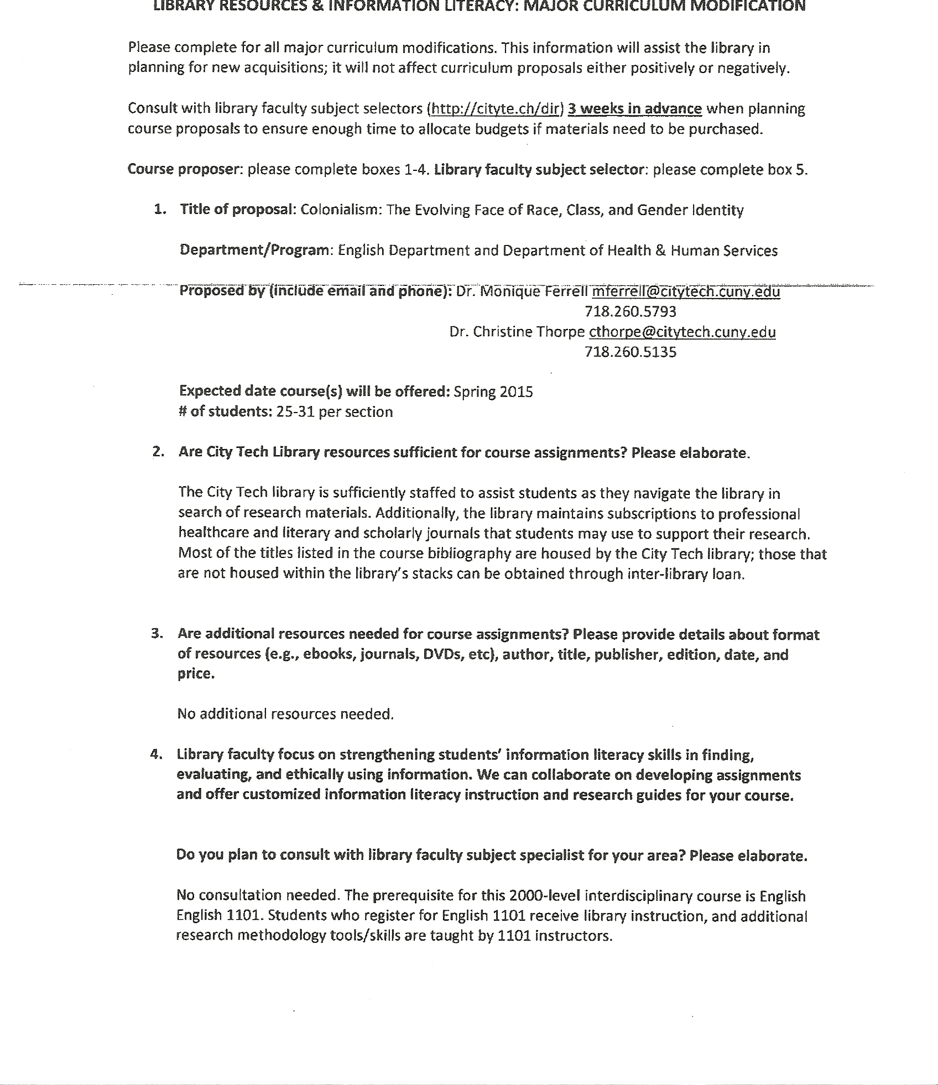

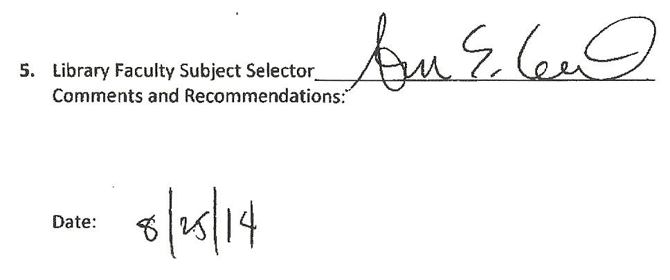

New York City College of Technology
Interdisciplinary Committee

Application for Interdisciplinary Course Designation

Date 4/25/2014

Submitted by Dr. Monique Ferrell and Dr. Christine Thorpe

Department(s) English Department and Human Services Department

- Proposal to Offer an Interdisciplinary Course

- Identify the course type and title:
An existing course____________________________________________________________
x A new course: The Evolving Face of Race, Class, and Gender Identity
A course under development ____________________________________________________
Provide a course description: Using internal colonialism as an analytical construct, this course examines the socio-historical, cultural conditions, and gender constructs of marginalized cultural and racial groups in America. A special focus is on Blacks and other Indigenous cultures and populations, such as Native Americans and Mexican Americans. Topics include, but are not limited to, the following: slavery/genocide, racial/cultural blending, integration/segregation, economic deprivation, the impact of public health and mental health, and shifts in gender identity and cultural roles.

- How many credits will the course comprise? 3 credits How many hours? 3 hours

- What prerequisite(s) would students need to complete before registering for the course? English 1101
- Explain briefly why this is an interdisciplinary course: This interdisciplinary course is a collaborative effort between City Tech’s English Department and the Department of Health & Human Services. This course is a unique blending of scholarly and creative writing, film, new media (Skype, Open Lab, and Blackboard), and guest lecturers that explores the impact/effect of Colonialism on the African American and Native American communities. The professors will share the teaching responsibilities dividing the semester evenly. Additionally, they will co-design and co-grade exams, assignments, and essay prompts for course papers. The professors will also meet weekly to assess and update course curriculum as needed.

- What is the proposed theme of the course? What complex central problem or question will it address? What disciplinary methods will be evoked and applied?

The proposed course (sample syllabus), The Evolving Face of Race, Class, and Gender Identity, focuses specifically on American Colonialism, Africans (evolving to become African Americans) and Native Americans (those indigenous to the North American continent).

Here in the United States, the immediate and long-term consequences of Colonialism brought about enslavement, the signing and breaking of treaties/laws, war, poverty, lack of education, psychological and physical traumas, and segregation of these peoples. Additionally, each of these factors played a vital and volatile role in shaping who African Americans and Native Americans would become post-colonialism, having long term implications for each culture, and impacting the men and women within these cultural groups differently. In many ways, both groups still struggle to obtain their portion of the American Dream and are still coping with economic disparity, public health issues—mental and physical—and social welfare, as well as a bevy of socio-economical hardships that appear to place them perpetually beyond the reach of embracing fully an American identity. The course is designed to explore why these hardships exist and how they are represented in critical and creative texts.

By the end of the course, students should be informed scholars who are able to critically assess and discuss the course content (in writing and during discussion); develop workable creative, cultural, economic or political ideas/solutions, and also possess a useful and informed knowledge of the course material.

The disciplinary methods employed by English and Health and Human Services will involve the examination of critical and creative writings that explore race, class, and gender along with the concepts of public health, health disparities, and government policies. Discussions that include the role of oral/written histories and stories that influence the sociocultural, political, health and well-being of people will be facilitated through debates and examination of policies. The knowledge gained will facilitate the development of rich student papers that integrate both disciplines.

- Which general learning outcomes of an interdisciplinary course does this course address?
Please explain how the course will fulfill the bolded mandatory learning outcome below. In addition, select and explain at least three additional outcomes. (Please see notation below)
X Purposefully connect and integrate across-discipline knowledge and skills to solve problems
See below

X Synthesize and transfer knowledge across disciplinary boundaries
See below

X Comprehend factors inherent in complex problems
See below

X Apply integrative thinking to problem solving in ethically and socially responsible ways
See below

X Recognize varied perspectives
See below

X Gain comfort with complexity and uncertainty
See below

X Think critically, communicate effectively, and work collaboratively
See below

X Become flexible thinkers
See below

*During the course of the semester, students will be able to express their critical and scholarly positions, define relevant subject matter, and explore the following via classroom discourse, essays and assignments, group presentations, and exams:

--Colonialism, Post-Colonialism, and Internal Colonialism as it relates to the development of America and American Identity
--Post-traumatic Stress Syndrome and trauma
--African and Indigenous slavery and oppression
--Social issue advocacy as it relates to the subject matter
--Economic systems and hardships experienced by both cultural groups
--Psychological and physical health issues as they relate to both groups
--Racial, academic, social inequalities, and gender role inequality experienced by both groups
--Similarities between the cultural groups and their approaches to advocacy, healing, and resistance
--Government responses to the socioeconomic issues that plague these communities

Students will be required to demonstrate their integration and comprehension of the aforementioned concepts through the standard assessment methods; additionally, students may be asked to submit their group projects/or essays for presentation or publication. It is our hope that the students transition into publishing scholars who will attempt to develop and construct workable ideas and solutions to the problems that plague both cultural communities.

Other

General Education Learning Goals for City Tech Students
- Knowledge: Develop knowledge from a range of disciplinary perspectives, and hone the ability to deepen and continue learning.
- Skills: Acquire and use the tools needed for communication, inquiry, creativity, analysis, and productive work.
- Integration: Work productively within and across disciplines.
- Values, Ethics, and Relationships: Understand and apply values, ethics, and diverse perspectives in personal, professional, civic, and cultural domains.
- How does this course address the general education learning goals for City Tech students?

This Special Topics/Interdisciplinary course explores content not currently available within the course curriculum of either proposing department.

As an interdisciplinary course, it utilizes varied sources to address diverse opinions, ideas, and varied understandings of socio-cultural domination and marginalization to be taught by professors from distinct and disparate departments, a necessary factor given City Tech’s diverse student population.

The course underscores the notion that because classic colonialism and America’s internal version developed out of a similar balance of technological, cultural and power relations, a common process of social oppression and marginalization is discernable despite the different historical periods and contexts.

This makes possible for a comparative and interdisciplinary departmental collaboration within the following disciplines: History, Psychology, Anthropology, Economics, African American Studies, English, and other departments such as Health and Human Services, Hospitality Management, and Legal Studies.

The proposed course includes an initial collaborative effort between the English Department, African American Studies and the Department of Health and Human Services.

The course will utilize visual texts and new media/technologies that are part of our students’ everyday lives in order to enhance the classroom learning experience: Film, Skype (interviews with guest lecturers), Blackboard, and Open Lab among others.

- Which department would house this course3?

Human Services Department
Would all sections of the course be interdisciplinary? No X Yes

  - Would the course be cross-listed in two or more departments? X No __Yes
Explain.
The course will be housed by the Human Services Department. (A letter of support from the English Department Chair and Literature Curriculum Chair are included within this proposal).

  - How will the course be team-taught4? X Co-taught X Guest lecturers (2 per semester) Learning community
If co-taught, what is the proposed workload hour distribution?

The professors will split the fifteen-week semester, sharing both the introductory and final classes of the semester. The first lecture will be co-taught by both professors to introduce the structure and scope of the course, and key terminology representative of both disciplines. The eighth lecture will also be co-taught to transition the students to the next instructor and discipline focus. During the semester, the professors will meet weekly to design and update course content, assess student engagement, schedule and confirm guest speakers, and to design projects and exams. Despite splitting the course in half—seven weeks per instructor—they will co-design the exams and quizzes, co-develop paper topics, and will share grading responsibility for all submitted assignments. This is a structure that must remain in place as Interdisciplinary collaborations present themselves. In doing so, students are presented with a uniform approach to teaching and assessment. Moreover, collaborating instructors remain clear about their responsibilities to the students and the course; additionally, the workload is shared evenly.

X Shared credits Trading credits
If guest lecturers, for what approximate percentage of the course? Minimum 20%5

X other: __% (Guest lecturers have been allotted one hour slots during weeks 3 and 12)
Please attach the evaluation framework used to assess the interdisciplinarity of the course.6

Co-teaching framework for fifteen week course:

- Shared teaching weeks 1, 3, 8, 12, and 15:

Week 1 (Introductions/Review of Syllabus/Distribution and Discussion of assignment # 1 and readings) - Guest Lecturer – Dr. Karl Botchway /City
Tech School of Arts & Sciences

Week 3 Guest Lecturer—Dr. Robert Fullilove/ Columbia University Mailman School of Public Health

(Team teachers will be on hand to guide and facilitate course discussion and Q & A session)

Week 8 Transition Course (first hour only)

Week 12 Guest Lecturer—Professor Mariah ShieldChief , Pawnee Nation/Pawnee Nation Tribal College—American Indian Studies & Liberal Arts

(Team teachers will be on hand to guide and facilitate course discussion and Q & A session)

- Weekly meetings: Team teachers will meet on Friday afternoons to assess student learning and to update curriculum)
- Co-development of exams and essay prompts (Midterm and Final paper)
- Shared grading of exams and essays:
Enrolled students will take four exams during the course of the semester (short answer and essay). After exams are collected, the team teachers will set aside a block of time to review and grade exams.
- Week 15: Distribution of City Tech SET forms which evaluate student satisfaction and a course assessment form designed by the team teachers. The latter will be used by the team teachers to assess their teaching and to assist in modifying the course as needed.

  - What strategies/resources would be implemented to facilitate students’ ability to make connections across the respective academic disciplines?
Strategies include collaboratively planning the instructional material to select and organize topics that will be examined from both disciplines. We will both be present during the first lecture to explain the interdisciplinary nature of the course to the students, and the importance of integrating perspectives that we will model during each lecture. The lectures will engage students in discussions and activities where they will be asked to analyze lecture topics and readings from the perspective of both disciplines and develop a common ground. Students will also be tested to assess their understanding of critical and creative texts, work in peer groups as they develop group presentations/projects, and submit their scholarly understanding of course readings in the form of essays.

- Would the course be designated as:
X a College Option requirement7? X an elective? X a Capstone course8? other? Explain.
City Tech students are allowed to take 5 courses as part of their Flexible Core and a 2000-level course as a Capstone. As such, this course may fill either requirement for graduation.

Course Outline Form

New York City College of Technology
Human Services Department

COURSE CODE: HEA 2112
TITLE: The Evolving Face of Race, Class, and Gender Identity

Number of class hours: 3 lab hours if applicable: 0 credits: 3

COURSE DESCRIPTION: Using internal colonialism as an analytical construct, this course examines the socio-historical, cultural conditions, and gender constructs of marginalized cultural and racial groups in America. A special focus is on Blacks and other Indigenous cultures and populations, such as Native Americans and Mexican Americans. Topics include, but are not limited to, the following: slavery/genocide, racial/cultural blending, integration/segregation, economic deprivation, the impact of public health and mental health, and shifts in gender identity and cultural roles.

COURSE PREREQUISITE (S): English 1101

RECOMMENDED/TYPICAL/REQUIRED TEXTBOOK (S) and/or MATERIALS*

*Materials: Course Packet of Required Readings for Weeks 1-7

Required Books Weeks 8-14
Title: Indian Killer
Edition: 1996

Author: Sherman Alexie
Publisher: Atlantic Monthly Press

Title: House Made of Dawn
Edition: 1968

Author: N. Scott Momaday
Publisher: Harper Perennial Modern Classics

Title: Song of Solomon
Edition: 1977

Author: Toni Morrison
Publisher: Alfred Knopf

Title: Too Beautiful for Words
Edition: 2012

Author: Monique Morris
Publisher: MWM Books

SAMPLE SEQUENCE OF TOPICS AND TIME ALLOCATIONS*

15 week semester

Dr. Thorpe—Weeks 1-7
- Define Internal Colonialism; Public Health Issues in the African American and Native American Communities
- Historical Traumas, Present-Day Manifestations
- Evolving Chronic Illnesses
- Inter-generational Mental Health Issues
- The Causes of Substance Abuse
- and 7. Infant Mortality and Challenges of Living (2 weeks)
Dr. Ferrell—Weeks 8-14
- Internal Colonialism, Trauma and Representations of these in the Creative Voice
- Vocation, Station, and Being/The Role(s) of Black Women
- Class, Race, Community, Revenge and Retaliation
- Battling Demons, Culture, Community, Filling the Void
- Reservation Life, Indian-ness vs American-ness, Contemporary Indian Life, How real is the world of Sherman Alexie’s Indian Killer?
- Gender, Class, Death, Reparations
- Too Beautiful For Words—Final Exam Prep
- Final Exam/Papers Due

COURSE INTENDED LEARNING OUTCOMES/ASSESSMENT METHODS

LEARNING OUTCOMES | ASSESSMENT METHODS
1. Accurately define and discuss health disparities, public health, Colonialism/Post-colonialism/Internal Colonialism and subsequent movements in history, Post Traumatic Stress Syndrome/trauma, critical scholarship, African American and Native American Literature to mark their impact on both ethnic groups. | Reader Response mini essays, quizzes, Open Lab  projects, and exams
2. Outline and discuss the following social constructs and historical events to assess their impact on African Americans and Native Americans as they relate to colonialism/post-colonialism: Slavery/Genocide, medical experimentation, The Civil War, Emancipation, Suffrage, The Jim Crow Era/Segregation, The Civil Rights Movement, The Vietnam War, Women’s Rights Movement, USDHHS, Affordable Care Act, BIA, AIM, Reservation Life, Missionary Schools, American Treaties with Indigenous peoples. | Reader Response mini essays, exams, midterm essay, quizzes, Open Lab projects, and final paper/project
3. Explore and study the complexity of the following factors as they relate to African American and Native Americans: American Identity, Cultural Identity, Racial mixing, Gender Roles and Expectations, Economics, Mental Well-Being, Violence, Post-traumatic stress, Chronic Illness, Violence. | Reader Response mini essays, exams, midterm essay, quizzes, Open Lab projects, final paper/project
4. Explore and study cultural revelations about color consciousness, (C)lass, culture and traditions, Healthcare, Race and Gender and the politics that guide them. | Reader Response mini essays, exams, midterm essay, quizzes, Open Lab projects, final paper/project
5. Examine the impact of racism, war, government impact, bigotry, prejudice, intercultural bigotry, sexism, (C)lass, upward mobility, poverty, incarceration, intellectualism and failure/success in academia, the importance of having a cultural “homeland.” | Reader Response mini essays, exams, Open Lab projects, final paper/project, in person conferences
6. Discuss and explore feminine and masculine power, religion vs. spirituality, cultural health practices, responsibility to one’s cultural community. | Reader Response mini essays, exams, quizzes,  final paper/project, Open Lab projects, in  person conferences
7. Examine the impact and representation of the following in African American and Native American Literature and Scholarship past and present: Historical representation, Identity and classification, Future expectations, strategies, and recommendations. | Reader Response mini essays, exams, quizzes,  Open Lab projects, final paper/project
8. Comprehend and utilize the basics of grammar, sentence structure, and MLA and APA Documentation (primary and secondary sources). Understand the mechanics of writing essays about literature (Scaffolding Format), critical essays, and film. | In-person conferences, pre-drafting of midterm  and final papers/projects, Reading Responses  mini essays, Open Lab projects, exams

GENERAL EDCUATION LEARNING OUTCOMES/ASSESSMENT METHODS

LEARNING OUTCOMES | ASSESSMENT METHODS
1. Use the arts, sciences and humanities as a forum for the study of values, ethical principles, and the physical world as it relates to colonialism’s impact on humanity. | Reader Response mini essays, exams, midterm  essay, quizzes, Open Lab projects, and final paper/project
2. Communicate in diverse settings and groups about the ways race, class and gender identity have been impacted by colonialism, using written (both reading and writing), oral (both speaking and listening), and a visual means. | Reader Response mini essays, exams,  midterm essay, quizzes, Open Lab projects, and  final paper/project
3. Gather, interpret, evaluate, and apply information on colonialism discerningly from a variety of sources. Make meaningful and multiple connections regarding race, class, and gender identity among and between the liberal arts, and the areas of study leading to a major or profession. | In-person conferences, pre-drafting of midterm and final papers/projects, Reading Responses mini  essays, Open Lab projects, exams
4. Demonstrate intellectual honesty and personal responsibility. Assume responsibility for social justice. Demonstrate social and civic knowledge. Apply knowledge acquired about the impact of colonialism and analyze social, political, economic, and historical issues. Discuss, explore and analyze multiple perspectives as it relates to the evolving face of colonialism. Utilize awareness of cultural differences to bridge cultural and linguistic barriers. | Reader Response mini essays, exams, midterm essay, quizzes, Open Lab projects, and final paper/project

SCOPE OF ASSIGNMENTS and other course requirements*

--Assigned readings for lectures will provide students with the background information relevant to each class topic.
--In-class discussions and films, developed from the assigned readings, will engage students in assessment, exploration, and make determinations about the cultural impact and long-term outcomes of colonialism on the African American and Native American communities.
--Open-lab projects will encourage collaborative work among student groups to discern multiple perspectives.
--Midterm/Short papers and final paper will enable students to demonstrate their understanding and integration of course material. Paper requirements will be discussed at least three weeks prior to due date, with students being provided rubrics to guide the development of their papers and drafts reviewed prior to submission date.

METHOD OF GRADING – elements and weight of factors determining the students’ grade*

Exams: 25% (4 exams, Essay and Short Answer)
Midterm/Short Paper: 15% (6-8pgs, Primary and Secondary Sources, MLA/APA)
Assignments: 15% (Presentations, Quizzes, Reader Responses, Group Work)
Class Participation: 15%
Final Paper: 30% (8-10 pgs, Primary and Secondary Sources)

ACADEMIC INTEGRITY POLICY STATEMENT

Students and all others who work with information, ideas, texts, images, music, inventions, and other intellectual property owe their audience and sources accuracy and honesty in using, crediting, and citing sources. As a community of intellectual and professional workers, the College recognizes its responsibility for providing instruction in information literacy and academic integrity, offering models of good practice, and responding vigilantly and appropriately to infractions of academic integrity. Accordingly, academic dishonesty is prohibited in The City University of New York and at New York City College of Technology and is punishable by penalties, including failing grades, suspension, and expulsion. The complete text of the College policy on Academic Integrity may be found in the catalog.

COLLEGE POLICY ON ABSENCE/LATENESS

A student may be absent without penalty for 10% of the number of scheduled class meetings during the semester as follows:

Class Meets Allowable Absence
1 time/week 2 classes
2 times/week 3 classes
3 times/week 4 classes

**Each department and program may specify in writing a different attendance policy for courses with laboratory, clinical or field work. If the department does not have a written attendance policy concerning courses with laboratory, clinical or field work, the College policy shall govern.

*depending on department policy these may be uniform and required of all instructors of the course or there may be guidelines or samples from which instructors may select or adapt):

Attached course outline written by: Christine Thorpe, Monique Ferrell Date: October 1, 2014 Second Submission February 24, 2015

Reviewed/Revised by: Date:

CUNY Common Core
Course Submission Form
Instructions: All courses submitted for the Common Core must be liberal arts courses. Courses may be submitted for only one area of the Common Core. All courses must be 3 credits/3 contact hours unless the college is seeking a waiver for another type of Math or Science course that meets major requirements. Colleges may submit courses to the Course Review Committee at any time. Courses must also receive local campus governance approval for inclusion in the Common Core.
College | New York City College of Technology
Course Prefix and Number (e.g., ANTH 101, if number not assigned, enter XXX) | HEA 2112
Course Title | Interdisciplinary Special Topics Course:  The Evolving Face of Race, Class, and Gender Identity
Department(s) | English Department, Human Services Department
Discipline | Interdisciplinary
Credits | 3
Contact Hours | 3
Pre-requisites (if none, enter N/A) | ENG 1101
Co-requisites (if none, enter N/A) | N/A
Catalogue Description | Using internal colonialism as an analytical construct, this course examines the socio-historical and cultural conditions, and the gender constructs of marginalized cultural and racial groups in America. A special focus is on Blacks and other Indigenous cultures and populations, such as Native Americans and Mexican Americans. Topics include, but are not limited to, the following: slavery/genocide, racial/cultural blending, integration/segregation, economic deprivation, the impact of public health and mental health, and shifts in gender identity and cultural roles.
Special Features (e.g., linked courses)
Sample Syllabus | Syllabus must be included with submission, 5 pages max recommended
Indicate the status of this course being nominated:

current course revision of current course a new course being proposed
CUNY COMMON CORE Location

Please check below the area of the Common Core for which the course is being submitted. (Select only one.)
Required  English Composition  Mathematical and Quantitative Reasoning  Life and Physical Sciences |  | Flexible  World Cultures and Global Issues Individual and Society  US Experience in its Diversity Scientific World  Creative Expression
Waivers for Math and Science Courses with more than 3 credits and 3 contact hours

Waivers for courses with more than 3 credits and 3 contact hours will only be accepted in the required areas of “Mathematical and Quantitative Reasoning” and “Life and Physical Sciences.” Three credit/3-contact hour courses must also be available in these areas.
If you would like to request a waiver please check here: |  | Waiver requested
If waiver requested:
Please provide a brief explanation for why the course will not be 3 credits and 3 contact hours.
If waiver requested:
Please indicate whether this course will satisfy a major requirement, and if so, which major requirement(s) the course will fulfill.

Learning Outcomes

In the left column explain the course assignments and activities that will address the learning outcomes in the right column.

- Required Core (12 credits)

A. English Composition: Six credits

A course in this area must meet all the learning outcomes in the right column. A student will:

- Read and listen critically and analytically, including identifying an argument's major assumptions and assertions and evaluating its supporting evidence.
- Write clearly and coherently in varied, academic formats (such as formal essays, research papers, and reports) using standard English and appropriate technology to critique and improve one's own and others' texts.
- Demonstrate research skills using appropriate technology, including gathering, evaluating, and synthesizing primary and secondary sources.
- Support a thesis with well-reasoned arguments, and communicate persuasively across a variety of contexts, purposes, audiences, and media.
- Formulate original ideas and relate them to the ideas of others by employing the conventions of ethical attribution and citation.
B. Mathematical and Quantitative Reasoning: Three credits

A course in this area must meet all the learning outcomes in the right column. A student will:
- Interpret and draw appropriate inferences from quantitative representations, such as formulas, graphs, or tables.
- Use algebraic, numerical, graphical, or statistical methods to draw accurate conclusions and solve mathematical problems.
- Represent quantitative problems expressed in natural language in a suitable mathematical format.
- Effectively communicate quantitative analysis or solutions to mathematical problems in written or oral form.
- Evaluate solutions to problems for reasonableness using a variety of means, including informed estimation.
- Apply mathematical methods to problems in other fields of study.

C. Life and Physical Sciences: Three credits

A course in this area must meet all the learning outcomes in the right column. A student will:

 | - Identify and apply the fundamental concepts and methods of a life or physical science.
 | - Apply the scientific method to explore natural phenomena, including hypothesis development, observation, experimentation, measurement, data analysis, and data presentation.
 | - Use the tools of a scientific discipline to carry out collaborative laboratory investigations.
 | - Gather, analyze, and interpret data and present it in an effective written laboratory or fieldwork report.
 | - Identify and apply research ethics and unbiased assessment in gathering and reporting scientific data.

II. Flexible Core (18 credits)
Six three-credit liberal arts and sciences courses, with at least one course from each of the following five areas and no more than two courses in any discipline or interdisciplinary field.

A. World Cultures and Global Issues

A Flexible Core course must meet the three learning outcomes in the right column.

In-person conferences, pre-drafting of midterm and final papers/projects, Reading Responses mini essays, Open Lab projects, exams | - Gather, interpret, and assess information from a variety of sources and points of view.
Reader Response mini essays, exams, midterm essay, quizzes, Open Lab projects, and final paper/project | - Evaluate evidence and arguments critically or analytically.
Reader Response mini essays, exams, midterm essay, quizzes, Open Lab projects, and final paper/project | - Produce well-reasoned written or oral arguments using evidence to support conclusions.
A course in this area (II.A) must meet at least three of the additional learning outcomes in the right column. A student will:

Reader Response mini essays, exams, midterm essay, quizzes, Open Lab projects, and final paper/project | - Identify and apply the fundamental concepts and methods of a discipline or interdisciplinary field exploring world cultures or global issues, including, but not limited to, anthropology, communications, cultural studies, economics, ethnic studies, foreign languages (building upon previous language acquisition), geography, history, political science, sociology, and world literature.
Reader Response mini essays, exams, midterm essay, quizzes, Open Lab projects, and final paper/project | - Analyze culture, globalization, or global cultural diversity, and describe an event or process from more than one point of view.
 | - Analyze the historical development of one or more non-U.S. societies.
Reader Response mini essays, exams, midterm essay, quizzes, Open Lab projects, and final paper/project | - Analyze the significance of one or more major movements that have shaped the world's societies.
Reader Response mini essays, exams, midterm essay, quizzes, Open Lab projects, and final paper/project | - Analyze and discuss the role that race, ethnicity, class, gender, language, sexual orientation, belief, or other forms of social differentiation play in world cultures or societies.
 | - Speak, read, and write a language other than English, and use that language to respond to cultures other than one's own.

B. U.S. Experience in its Diversity

A Flexible Core course must meet the three learning outcomes in the right column.

- Gather, interpret, and assess information from a variety of sources and points of view.
- Evaluate evidence and arguments critically or analytically.
- Produce well-reasoned written or oral arguments using evidence to support conclusions.
A course in this area (II.B) must meet at least three of the additional learning outcomes in the right column. A student will:

- Identify and apply the fundamental concepts and methods of a discipline or interdisciplinary field exploring the U.S. experience in its diversity, including, but not limited to, anthropology, communications, cultural studies, economics, history, political science, psychology, public affairs, sociology, and U.S. literature.
- Analyze and explain one or more major themes of U.S. history from more than one informed perspective.
- Evaluate how indigenous populations, slavery, or immigration have shaped the development of the United States.
- Explain and evaluate the role of the United States in international relations.
- Identify and differentiate among the legislative, judicial, and executive branches of government and analyze their influence on the development of U.S. democracy.
- Analyze and discuss common institutions or patterns of life in contemporary U.S. society and how they influence, or are influenced by, race, ethnicity, class, gender, sexual orientation, belief, or other forms of social differentiation.

C. Creative Expression

A Flexible Core course must meet the three learning outcomes in the right column.

- Gather, interpret, and assess information from a variety of sources and points of view.
- Evaluate evidence and arguments critically or analytically.
- Produce well-reasoned written or oral arguments using evidence to support conclusions.

A course in this area (II.C) must meet at least three of the additional learning outcomes in the right column. A student will:

- Identify and apply the fundamental concepts and methods of a discipline or interdisciplinary field exploring creative expression, including, but not limited to, arts, communications, creative writing, media arts, music, and theater.
- Analyze how arts from diverse cultures of the past serve as a foundation for those of the present, and describe the significance of works of art in the societies that created them.
- Articulate how meaning is created in the arts or communications and how experience is interpreted and conveyed.
- Demonstrate knowledge of the skills involved in the creative process.
- Use appropriate technologies to conduct research and to communicate.

D. Individual and Society
A Flexible Core course must meet the three learning outcomes in the right column.

- Gather, interpret, and assess information from a variety of sources and points of view.
- Evaluate evidence and arguments critically or analytically.
- Produce well-reasoned written or oral arguments using evidence to support conclusions.

A course in this area (II.D) must meet at least three of the additional learning outcomes in the right column. A student will:

- Identify and apply the fundamental concepts and methods of a discipline or interdisciplinary field exploring the relationship between the individual and society, including, but not limited to, anthropology, communications, cultural studies, history, journalism, philosophy, political science, psychology, public affairs, religion, and sociology.
- Examine how an individual's place in society affects experiences, values, or choices.
- Articulate and assess ethical views and their underlying premises.
- Articulate ethical uses of data and other information resources to respond to problems and questions.
- Identify and engage with local, national, or global trends or ideologies, and analyze their impact on individual or collective decision-making.
E. Scientific World
A Flexible Core course must meet the three learning outcomes in the right column.

- Gather, interpret, and assess information from a variety of sources and points of view.
- Evaluate evidence and arguments critically or analytically.
- Produce well-reasoned written or oral arguments using evidence to support conclusions.
A course in this area (II.E) must meet at least three of the additional learning outcomes in the right column. A student will:

- Identify and apply the fundamental concepts and methods of a discipline or interdisciplinary field exploring the scientific world, including, but not limited to: computer science, history of science, life and physical sciences, linguistics, logic, mathematics, psychology, statistics, and technology-related studies.
- Demonstrate how tools of science, mathematics, technology, or formal analysis can be used to analyze problems and develop solutions.
- Articulate and evaluate the empirical evidence supporting a scientific or formal theory.
- Articulate and evaluate the impact of technologies and scientific discoveries on the contemporary world, such as issues of personal privacy, security, or ethical responsibilities.
- Understand the scientific principles underlying matters of policy or public concern in which science plays a role.

