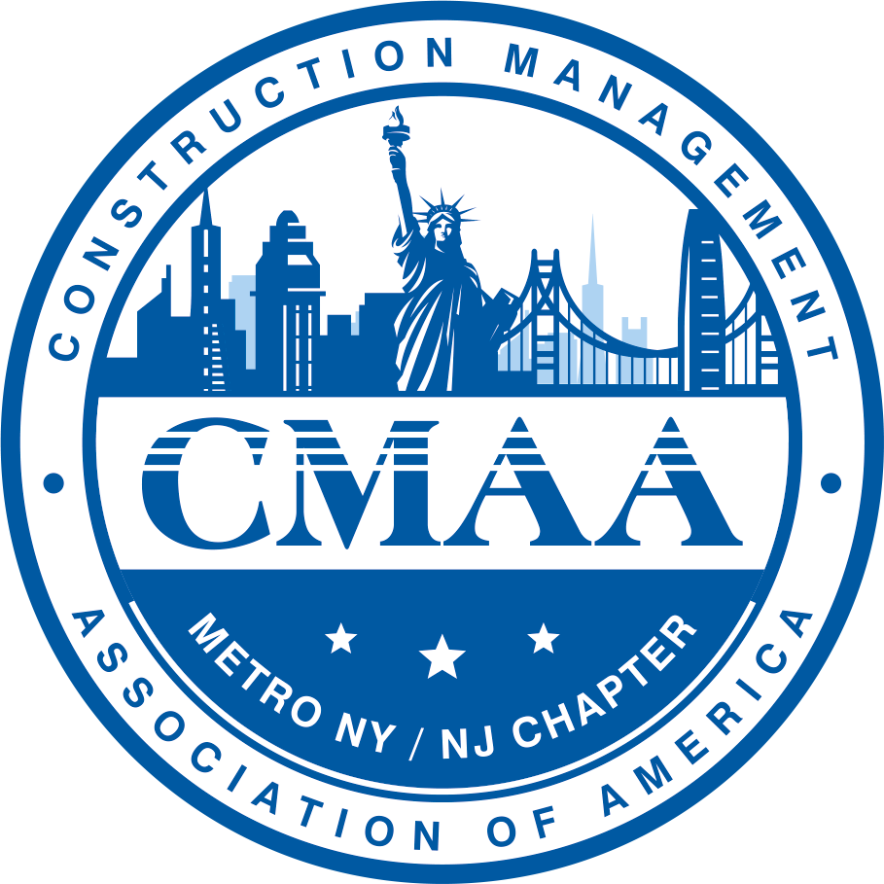

CMAA
Construction Management Association of America
METRO NEW YORK/NEW JERSEY CHAPTER

2024 Scholarship Application Package
for Undergraduate and Graduate Student Applicants

About the CMAA Scholarship

The Construction Management Association of America (CMAA), Metro New York/New Jersey Chapter, is a 501(c)(6) charitable organization, tax identification number is 54-1803080. CMAA Metro New York/New Jersey awards a limited number of scholarships to qualified students to help them defray the costs of pursuing a degree in Construction Management or related-degree programs. Student Scholarship Awards are presented in June at the CMAA Metro NY/NJ Chapter Awards Banquet. The amounts of the scholarships vary from year to year, they can range from $3,000 – 10,000.

CMAA Metro NY/NJ Chapter Student Scholarship Eligibility Criteria

- Students applying for the scholarship must be CMAA student or professional members. If you do not hold a CMAA membership, go to CMAA’s website at https://www.cmaanet.org/join and apply for an Individual Student Membership. CMAA Student Memberships are Free.
- Students must have completed a minimum of one full academic year of studies and has a minimum of one full semester remaining prior to completing a degree program.
- Students must be enrolled in a Construction Management program or related degree program that has a construction curriculum in the New York or New Jersey metropolitan area, and show strong interest in pursuing a career in the Construction Management industry, as demonstrated in the application essay.
- We invite students who are children of United States Military personnel and Veterans, or a Veteran themselves to apply.

CMAA Metro NY/NJ Chapter Scholarship Application Process

The completed application and all supporting documentation needs to be organized into one combined PDF document submitted by email. If the file is too large, send it via WeTransfer, https://wetransfer.com to the following:

Dr. Audrey Schultz Ms. Reema Albahri
V.P. Executive Board, Director of Student Outreach Director of Student Outreach
CMAA Metro New York/New Jersey Chapter CMAA Metro New York/New Jersey Chapter
Email: aschul47@pratt.edu Email: Reema.Albahri@stvinc.com
Phone: (917) 328-6113 Phone: (332) 323-2964

If you are selected to receive a CMAA Metro NY/NJ Student Scholarship, you will be notified by email.

CMAA NY/NJ Metro Chapter Scholarship Review Process

- All scholarship applications are due on April 12, 2024. The Student Outreach Committee members will go through the applications and make recommendations to the CMAA Metro NY/NJ Chapter Board.
- If the student is selected to receive a scholarship, they will be notified via email on or before May 10, 2024. The student will be invited to attend this year’s CMAA Metro NY/NJ Awards Banquet held on June 20, 2024 at Club 101, 101 Park Avenue, New York, NY 10178. Student winners will be announced and a scholarship check will be provided. If the student cannot attend the Awards Banquet, then a check will be mailed after the banquet.
- While not mandatory, the Scholarship winners are strongly encouraged to attend the CMAA National Conference & Trade Show event on October 27-29, 2024, in San Francisco, CA. You will have an opportunity to network and participate in conference activities.

CMAA Metro NY/NJ Chapter Student Scholarship Selection Criteria

The Executive Committee, and the Director and Members of the Student Outreach Committee will review all submitted applications received. Incomplete or late applications will not be considered. If the student is not a CMAA member then their application will be disqualified. Only applicants that hold a CMAA student or professional membership are eligible for scholarships. Submitted applications will be ranked in accordance with the Selection Criteria herein this document. The Student Outreach Director and Committee members will recommend scholarship awards based on rankings to the CMAA Metro NY/NJ Chapter Executive Committee. All information submitted will be held in strict confidentiality and used solely for the purpose of scholarship administration.

Additional scholarship selection criteria are as follows:

- Student is a member of CMAA; membership number must be provided.
- Student is a member of their university CMAA Student Chapter (optional).
- Student has had construction industry-related work experience or internships (optional).
- Student has participated in community service, including non-profit organizations, volunteering activities, leadership and entrepreneurial activities, and club affiliations.
- A quality essay is provided discussing the following:
  - Future career objectives and why you are interested in a career in Construction Management and the Built environment.
  - Why you are deserving of a CMAA Metro NY/NJ Scholarship Award.
- Transcripts and GPA must be provided.
  - Transcripts should be sent directly to Dr. Audrey Schultz, aschul47@pratt.edu and Ms. Reema Albahri, reema.albahri@stvinc.com.
- Academic Evaluation Form with a Recommendation Letter must be submitted no later than April 12, 2024.
  - Only one Academic Evaluation Form with a Recommendation Letter will be accepted.
- Applicants must communicate to the Academic Evaluator that they must submit the Academic Evaluation Form & Recommendation Letter on or before application deadline of April 12, 2024.

💡 Helpful Hints

- All sections of the application, including the Application Checklist, must be completed in full and submitted electronically as part of your application in one combined PDF file. An application missing any sections and without a signature and date, will be disqualified from consideration.
- Submit your application pdf file by email, or WeTransfer with all completed criteria. The subject line of your submitted scholarship application email should include the initial of your first name, spell out your last name, name of school, plus CMAA 2024 Scholarship Application. An example for an applicant “Audrey Schultz '' would have the application e-mail subject named as: ASchultz Pratt Institute CMAA 2024 Scholarship Application.
- The scholarship essay must be a computer-generated typed up document; no handwritten or Google Doc links will be accepted. The document MUST be in PDF format. Be sure to check spelling, formatting, and grammar carefully; presentation is important.
- Student transcripts must be received directly from the university before the application deadline of April 12, 2024.
- CMAA Scholarship Award checks will be provided at the Awards Banquet or thereafter.

CMAA National provides additional student scholarships through the CMAA Foundation. For further information check the Foundation’s website: https://www.cmaanet.org/foundation.

Good Luck! 🙂
Scholarship Application Checklist

To be considered for a CMAA NY/NJ Metro Chapter Student Scholarship, you must complete the following checklist and include it with your application submission:

☐ General Information Form is filled out completely including CMAA Membership number.

☐ Academic Information Form is filled out completely.

☐ Transcript(s) from your current school requested to be provided directly by the university.
Please supply the following information related to your transcript:

School Name: Date of Transcript Request:

______________________________________________________________________________________

☐ Extracurricular Activities Form.

☐ Employment Form (If applicable).

☐ Essay Requirement; Why you would like a career in the Construction Management and the Built
Environment. Future career plans and why you should be awarded the CMAA scholarship.

☐ One Academic Evaluation Form along with only One Recommendation Letter.

Reference Name: Date of Recommendation Letter Request:

☐ Proof your spelling, formatting, grammar, and the presentation of the application package.

☐ Sign and date the application package.

☐ Make a copy of the completed application package; one for you and one to submit.

☐ E-mail or WeTransfer the application in one large combined PDF file, no later than April 12, 2024; with your
first name initial followed by last name spelled out, school name and CMAA 2024 Student Scholarship in the email subject line. An example for an applicant “Audrey Schultz” would have the application email subject named as: ASchultz Pratt Institute CMAA 2024 Scholarship Application.
General Information Form

First Name:
Last Name:
Birth Date:
Permanent
Street Address:
City:
State/Province:
Postal Code:
Country:
Phone Number:
Email:
Current College/
University Name:
School Address :
City:
State/Province:
Postal Code:
Phone Number:
CMAA Member Number? | ☐ Yes ☐ No CMAA Member #_____________________
CMAA Regional Chapter Affiliation other than Metro NY/NJ Chapter? | ☐ Yes ☐ No If yes, provide name:
CMAA Student Chapter Affiliation? | ☐ Yes ☐ No If yes, provide university name:
CMIT or CCM Credential? | ☐ Yes ☐ No
Previous CMAA Foundation Scholarship Recipient? | ☐ Yes ☐ No If yes, when?

Academic Information Form

Student Classification | ☐ Undergraduate ☐ Graduate
Time of Application the Student is in what level and year of university attendance, i.e., 3rd year undergraduate, 1st year graduate
Type of Degree Program, i.e., AA, AS, BS, MA, MS, PhD
Major and Field of Study
Minor (or Concentration) Field of Study
Major GPA
Cumulative GPA
Anticipated Graduation Date

Please list the names, locations, and dates of enrollment for any other colleges or universities you attended while seeking your current degree.
- _
- _
- _
- _
- _

Please list any academic honors and awards you’ve received.
- _
- _
- _
- _
- _
- _
- _
- _

Current Academic Schedule and Transcripts
Please attach your current academic schedule to the application form.

Please have your current school send your transcripts directly to Dr. Audrey Schultz, aschul47@pratt.edu and Ms. Reema Albahri, reema.albahri@stvinc.com. Application packages will not be considered complete unless the current academic schedule and official transcript are included in the application package by the April 12, 2024 deadline.
Extracurricular Activities Form

Please list any extracurricular activity information you consider to be significant, beginning with the most recent and working back chronologically. Emphasis will be given during judging on activities connected to the Construction and Built Environment industry. Provide a general sense of your responsibilities and commitment.

1. Organization Name:
Activity:
Date Range/Hours:
Description:

2. Organization Name:
Activity:
Date Range/Hours:
Description:

3. Organization Name:
Activity:
Date Range/Hours:
Description:

4. Organization Name:
Activity:
Date Range/Hours:
Description:

5. Organization Name:
Activity:
Date Range/Hours:
Description:

6. Organization Name:
Activity:
Date Range/Hours:
Description:

Employment Form

If applicable, please enter information regarding your most recent employment. If you have a current resume, include it with your application.

1. From (month/year): |  | To (month/year):
Company Name:
Address:
Supervisors Name:
Your Position:
Duties:

Hours Per Week:
2. From (month/year): |  | To (month/year):
Company Name:
Address:
Supervisors Name:
Your Position:
Duties:

Hours Per Week:
3. From (month/year): |  | To (month/year):
Company Name:
Address:
Supervisors Name:
Your Position:
Duties:

Hours Per Week:
4. From (month/year): |  | To (month/year):
Company Name:
Address:
Supervisors Name:
Your Position:
Duties:

Hours Per Week:
5. From (month/year): |  | To (month/year):
Company Name:
Address:
Supervisors Name:
Your Position:
Duties:

Hours Per Week:
Essay Requirements

Applicants must submit one original typed-up essay, addressing the following topics.
Please do not exceed two pages, single-spaced.

- Why are you pursuing a career in Construction Management and the Built environment?

- What are your future career plans?
- Why should you be awarded a CMAA Metro NY/NJ Student Scholarship?

- Explain to the scholarship committee why it is important to be a CMAA Metro NY/NJ Chapter Student Scholarship recipient.

Applicant Signature

By submitting this application package for a CMAA Metro NY/NJ Chapter Student Scholarship, I certify that the information contained herein is accurate, factual to the best of my knowledge and submitted by the April 12, 2024 deadline. I acknowledge that all decisions of the scholarship committee are final and fair.

Signature: Date:

Academic Evaluation Form & Recommendation Letter

NOTE TO STUDENT APPLICANT: Only One Academic Evaluation Form and Letter of Recommendation is Required.

NOTE TO ACADEMIC EVALUATOR: If this Academic Evaluation Form & Recommendation Letter are received past the April 12, 2024 deadline, the student applicant’s chances of being selected for a scholarship award will be disrupted.
Student’s Full Name:
College/University :
Department:
Academic Evaluator’s Full Name:

The applicant wishes to be considered for a CMAA Metro NY/NJ Chapter Student Scholarship, which is not complete without this evaluation form and letter of recommendation. You are encouraged to provide a statement regarding the applicant’s knowledge, skills, abilities and accomplishments, and how it correlates to the Construction Management and Built Environment industry. Your evaluation and recommendation will be confidential. The CMAA Student Outreach Committee considers this evaluation form and recommendation letter to be of great importance.

Send this form along with a one-page recommendation letter electronically no later than April 12, 2024, to Dr. Audrey Schultz at aschul47@pratt.edu and Ms. Reema Albahri at reema.albahri@stvinc.com. In the subject line, identify the student’s first name, initial, last name and school. If you have any questions, please contact Dr. Schultz or Ms. Albahri directly.

How long have you known this student? |  | In what capacity?
How often do you interact with the student?
Please place an “X” in the appropriate cell. | Poor | Below Average | Average | Above Average |  | Superior
Cooperation/Teamwork:
Courtesy/Politeness:
Dependability/Reliability:
Industriousness:
Takes Initiative:
Maturity Level:
Ability to Identify and Achieve Goals:
Self-Discipline:
Advisor’s Full Name:
Position:
Organization:
Email:
Phone #:
Date:

*A Recommendation Letter must follow this form and both be sent electronically.

