Christian Marrast Project Proposal
Project description:
I will create a short film that stands as the first episode in a series produced by my company, Mirror One. Using the technical skills, I’ve learned at City tech and following the guidance of Professor and Film Maker Ryoya Terao, Episode one is a development last semesters project produced under the guidance of Professor and Film Maker Mario Trevino, “Thoughts Create Reality”. This new episode showcases the Self Reflection, Positive Affirmation, Awareness of Emotions, and believing in oneself. Acting will be provided by my Birth Mother and myself. I will handle all technical aspects such as shooting, pre-production, Video FX and editing.
It is my focus to utilize my talents and refine my project management, Video Production, and Team co-operation skills to produce Mirror One’s Untitled Episode One. This will inevitably be useful in my chosen career path, not only for the success of Mirror One but for my abilities in visual storytelling and collaborative partnerships as well
Methods:
- Storyboard
- Look book
- Demo Video
- Script
- Shot List
- Solo Production
- Gantt chart
- Avid media composer
- Blue Screen

I’ve proposed a creative workflow that allows me to get my ideas onto paper and to organize them into a thoughtful piece. Firstly, I will be using the hand drawn method of story boarding, a vital tool Introduced to me while at city tech. Look book creation will help dictate the overall feel, stylization, and color depiction of my film.
A video demo will be made to actualize the story and see if it flows, and what should be changed before finalizing a script. Once the script is made and checked by the writing team at City Tech and my Technical Advisor, it’s time to move forward with the production into the shot list and official filming.
Project manager Sue has advised me on the simplicity and ease of using a Gantt chart which will be followed to ensure timely delivery of the final project.
The Film will be shot on the Sony A7 Mirrorless Camera, Edited on Avid media composer, and features reoccurring use of blue screen keying. This project will rely heavily on Video FX, Practical pre-production planning, and a detailed shot list. I’ll be using a Mirrorless Camera as well as an iPhone camera for Demo Video.

Project Deliverables: For my culmination project in Entertainment Technologies course, I will be producing the following deliverables by the end of the semester:
- Budget sheet
- Storyboard
- Look Book
- Script
- Shot list
- Poster
- Timeline
- Master Video
- Demo Video
- Project Update Notes
- OpenLab portfolio

Schedule:

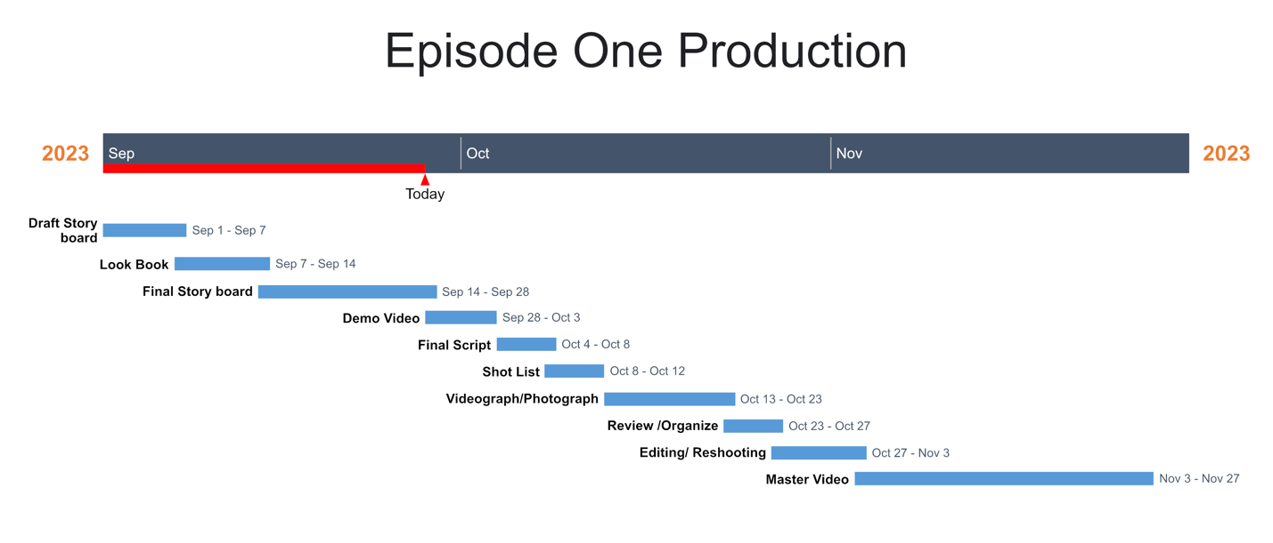

Required Resources:
For my culmination project, I will need access to the followBudgeting resources:
- Computer lab with Avid Media Composer for video editing.
- Microsoft Office for pre-production planning and scheduling.
- Microsoft Office for look book creation.
- Sony A7II camera for video recording and photography.
- Tripod and stabilizer for camera support.
- Ring light for proper lighting setup.
- Blue Yeti Microphone for sound recording.
- Studio Binder for shot list creation.
Budget:
- (BFP) – Bought for Production
- (OBP) – Owned Before Production
Item | Price
(OBP) iPhone 12 Miniseries | $799
(OBP) MacBook Pro | $1,200
(OBP) Avid Media Composer | $499
(OBP) Sony A7II camera | $1,000
(OBP) Blue Yeti Microphone | $128
(OBP) Digital Affirmation Mirror | $150
(OBP) Camera Tripod | $79
(OBP) Smart Mirror | $350
(OBP) Ring Light | $45
(OBP) Gimbal | $300
(OBP) Blue Screen | $35
(OBP) Bubble Wand | $5
(BFP) Lava Lamp | $25
(BFP) iPhone Tripod | $27
(BFP) Poster Print & Copying | $10~$15

Proposed table of contents/ Portfolio outline:
Introduction
- Explanation of the project's purpose and goals
- Overview of the project's scope and intended outcome
- Importance of the project to the Entertainment Technologies field
Methods
- Hand-drawn techniques
- Sony A7II usage
- Avid Media Composer usage
- Shot list made with Studio Binder
- iPhone Videography Demo
- iPhone Editing techniques and software usage
- Master video creation
Draft Stage
- Draft story board
- Demo Video
Pre-production Stage
- Look book creation
- Final story board
- Demo Video
- Shot list
Production Stage
- Execution of the project plan
- Use of necessary equipment and software
- Overcoming challenges and adjusting plans as needed
Post-production Stage
- Video editing and mastering
- Color correction and grading
- Sound mixing and mastering
Conclusion
- Recap of the project's purpose, goals, and outcomes
- Analysis of the project's success and areas for improvement
- Reflection on the project's impact on personal and professional development
Portfolio Deliverables
- Poster
- OpenLab Portfolio showcasing the project's progress and outcome
Budget
- Detailed breakdown of expenses incurred during the project, including materials, equipment, software, and printing/copying costs
Resources
- List of necessary resources, including access to department labs and equipment, as well as outside resources needed to complete the project.

