Expert
Evaluation

Creunis Lors

This is an Expert evaluation of the website www.facebook.com . This evaluation will go into depth about the sites design, content, features, usability and documentation. This expert evaluation will primarily focus on user experience, the negatives and positives of the features of the website and whether or not they effectively help accomplish the purpose of the site and whether or not the site effectively fits the needs of it users.

www.Facebook.com is a social media platform. Facebook can be used for many different things but its mainly used as a site for keeping InTouch and making new friends. Facebook allows users to build their own profile including things such as their name, picture and other facts about themselves. Each user has their own virtual bulletin board where they can post text, video or pictures of any kind for friends and family to see. On face book you can send messages, create groups within Facebook and even play video games online. Facebook allows for coworkers, friends and family to connect, communicate and keep up with what everyone is doing no matter where they are in the world.

Design

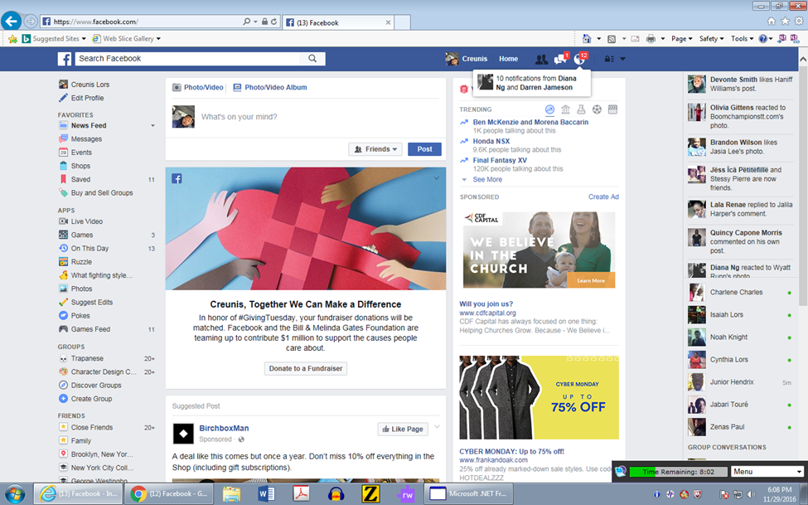

Facebook has a very unique design. The first thing that is at the top of the page is its iconic blue border. there you have a search bar, access to messages, friend invites, new feed updates and account settings. The back ground Is gray and the items on the news feed contain a white back ground. most of the writing on Facebook are either black or blue. Facebook book use of colors are very minimal and basic and what some might consider more on the bland side. But their choice of colors creates good contrast making live links to the other pages on the site easy to identify. Facebook color choice is very tactful. Using colors such as blue and black are easy on the eyes. There not to bright but easily distinguishable. blue and black also complement each very well, the black signifying importance while the blue creates a cool, relaxed kind of stimulation. because of this calm cool colors, it does not strain users or overwhelm them making it possible for users to stare at the site for long periods of time.
The website is designed in a multi columned fashion. you essentially have three main columns on the main page. you have one column that contains links to things such as your messages, events, apps or groups. Then you have you a middle column which is your news feed. On the far right side you have another column dedicated to Facebook messaging where users can see what other users are currently logged in online and available to chat with you.

Facebook functions vertically so by using the scroll wheel on your mouse or the down arrow on your keyboard your able move up and down the web page and see all its contents. navigating Facebook is rather simple. By simply scrolling or clicking you can access anything you want on The Web Page. Another unique thing on face book is that everything contains a live link. so by clicking anything on the webpage it will direct you to an origin of a photo, ad or message. As previously mentioned the links, tabs and icons can easily be identified. Each link or icon if clicked contains some kind some short description of what it does or contains. On the top border there are only a few options so within in a few minutes of navigating you can figure out where everything is.

Content

Each feature on Facebook is essential in accomplishing the purpose of Facebook. which is connect people and socialize. One of the essential components of face book is the newsfeed. The news feed is a feature that you find on your homepage.

This a feature in which users see a constantly updated list of their friends' Facebook activity. News Feed highlights information that includes profile changes, upcoming events, and birthdays, among other updates. With this feature you instantaneously see what everyone is up to without having to visit anyone’s page. Thus in a virtual sense keeping in touch in what they have been up to. Another essential aspect of face book is tagging. by writing an “@” before another users name when creating a post that post will now notify them of said post . Friends can tag each in photos, videos or post that they want them to see. But probably the most important aspect of face book is the reactions/ comments. Under any post, whether it is a photo, video or text. Users can leave a comment expressing their opinion or how they feel in any way they feel. This is comment aspect adds what you would call a forum format to it. Allowing people to respond to each other’s comments and have full blown dissuasions without directly messaging or knowing each other. You can create groups based on similar interest. Where people can have dedicated pages to specific topics such as sports or anime and discuss and post things concerning such topics. You can also create events invite people to your event and create a virtual rsvp where you can send invites and people can confirm their attendance. You can promote business and even video stream yourself live while others communicate with you. In terms of content Facebook is very diverse and does not leave out a single thing. You have multiple ways of communicating with one person, through messaging video calling or even calling all them through your messenger app. you can communicate with multiple people at once by creating groups, group’s chats or just tagging people on your new feed. Face book does a very good job of providing many different ways to communicate with others making it a very intuitive and dynamic platform. Facebook does not limit their users. There is no word limit, photo restrictions the possibilities are endless. Facebook does a very good job of accomplishing its purpose which is for people to socialize.

Documentation

When it comes to documentation face book its very particular yet lacking at the same time. When it comes to documentation that aid users in learning how to navigate and use the site is very has very minimal documentation. Which on Facebook part is a failure. Older people or just people who know nothing about how Facebook works would have a hard time understanding all its features and what they are for. In the beginning of the signing up process they do provide some introductory instructions. Some things they briefly explain are things like: adding a photo for your profile, adding friends and looking at your news feed.
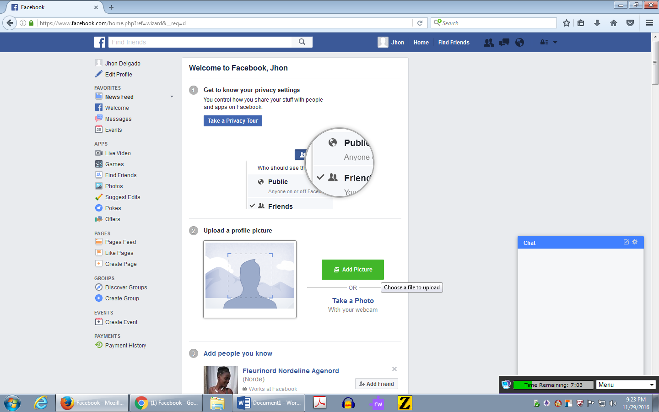

The site contains no step by step instructions of where to find other functions on the web application. Users would have to search and play around with Facebook to discover the features even if they are in plain sight. This kind of design is assuming that first time users will actually search and figure or something and that is a false assumption. I would have expected a quick 15 second tutorial of the basic features but nothing. At the same time the site is laid out in such a fashion that you can see all Facebook has to offer on one page. Someone who is used to social media websites could easily identify the different features without much effort. But discovering these features requires a bit of curiosity on the users part. If Facebook wanted their site to be used to their full capability they would design in such a way where they would be suggested options and features to do the same thing.
(Ex: Sending a message? “Pop up” why not call or send a video instead. In that sense Facebook is lacking and is inferring computer and internet literacy.)

Overall Facebook is a well-designed website. The site is very efficient and effective in accomplishing its goal and meeting the need of users. The design and straight to the point that many users can quickly understand its operation. they are few bad points about it. the average Facebook user does not use all of its features but the average user does find the experience satisfying.

