Crystal Llerena ARTH 1103 Sec. E 414

A Woman with a Dog
Artist: Jean Honoré Fragonard (French, Grasse 1732–1806 Paris)
Date: ca. 1769
Medium: Oil on canvas
Dimensions:32 x 25 3/4 in. (81.3 x 65.4 cm)
Classification: Paintings
Credit Line: Fletcher Fund, 1937
Accession Number:37.118

Woman with a Cat
Artist: Fernand Léger (French, Argentan 1881–1955 Gif-sur-Yvette)
Date:1921
Medium: Oil on canvas
Dimensions:51 1/2 × 35 5/8 in. (130.8 × 90.5 cm)
Classification: Paintings
Credit Line: Gift of Florene M. Schoenborn, 1994
Accession Number:1994.486

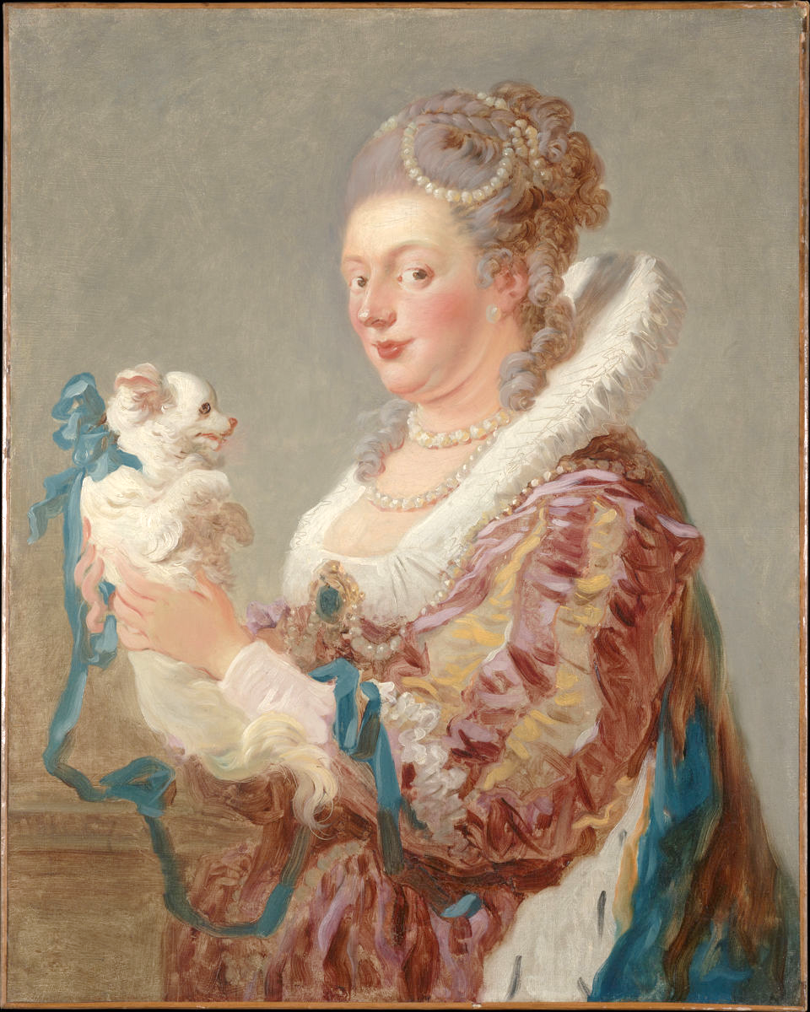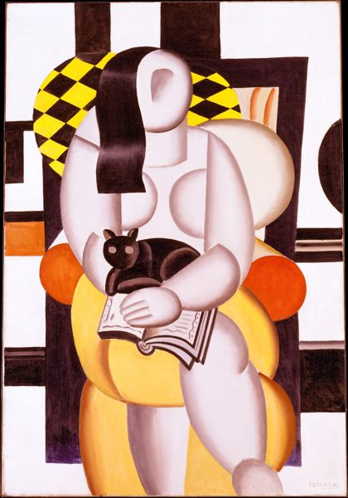

Portraits of Women with their pets

This is a formal compare and contrast analysis between two paintings from the Metropolitan Art Museum. Both by French artists, they are A Woman with a Dog (ca.1769) by Jean Honoré Fragonard and Woman with a Cat (1921) by Fernand Léger. Although the subject matter may be very similar, the method with how they are portrayed are very much in their own distinction. Both women in the paintings are sitting and facing to the front while holding either a dog or cat. These paintings are centuries apart, one from the 18th century and the other from the 20th century, this explains how both artists use their own techniques and unique styles that were popular in their era while achieving the same topic. They are portraits of full length and half-length of sitting women holding either a dog or cat demonstrated by using different aesthetic values.
The portrait of A Woman with a Dog by Jean Honore Fragonard, shows the sitter in an almost profile view, turning her head to face the front to the viewer while holding a lapdog in a half-length portrait. She seems to be a women of higher social status based on her garment, jewelry, hairstyle and the presence she gives off in the painting. The sitter is seen to be wearing a pink silk dress, with white and yellow sleeves and lace cuffs. The top half of the dress features a “Medici collar” which is a very stiff ruffled lace collar. The back of the gown seems to bear a likeness of a black and white fur, suggesting a fur lined cape. The front of the gown has a pointed bodice and low neckline. This may be a type of gown that would be popular in the late 17th century. The sitter is also pictured donning rows of pearls around her neck, on her hair and also on her bodice accompanied by a jeweled brooch.
The colors of the painting give off an impression of being soft and airy, almost to seem delicate. The pink and blue colors from the sitter’s gown and the dog’s ribbon are muted and almost a pastel-like colors. This could possibly be an intention to not give much of a harshness to the overall harmonious effect of the painting. The background of the painting doesn’t take away of the general balance of colors of the painting, the colors seem to blend in together in an overall theme. There are what seems to be quick thin brushstrokes throughout the painting except the face. The face is formed and painted carefully. This may be done to express an idealized face, facial expressions need to be done with precise details to capture the mood and temperament of the sitter. The speediness can be seen in the clothing, particularly in the sitter’s puffy sleeve. The sleeve is of special focus because it seems to show the artist’s attempt to show accents of shadows and lightness by mixing white and yellow to further create depth. These bold brushstrokes seem to be painted quickly but it’s done with accurateness.
The composition of the painting seems to depict a juxtaposition of proportions. Between the sitter and the dog there is a humorous undertone to it because of the vast variation. Concerning the small lapdog and the grand costume of the sitter, it illustrates an asymmetrical balance. Additionally, Women in higher social class were usually seen with lapdogs to symbolize themselves as wealthy during century.
In contrast to A Woman with A Dog, Fernand Leger’s Woman with A Cat is much more stylized and Leger’s perception on an idealized woman. The sitter in this painting is in full length and holding a black cat while in the middle of reading a book. She is sitting on a comfy looking seat. The subject matter is very much considering to be a classical form. The subject of a woman, is a traditional figure used in paintings over centuries. However, in Leger’s distinct style he incorporates geometric shapes to create a

