International palette: A multi-sensory experience as a food critique
Crystal Llerena
BUF 4300
Dr. Adomaitis

The Llama Inn

While searching for a restaurant to write about, I was interested in exploring cuisines from South America. This was because on a personal note, being Bolivian, I wanted to find restaurants that offer this unique and familiar cuisine to me. However there aren't many restaurants dedicated to Bolivian Cuisine in New York City nevertheless I still wanted to search for other South American cuisines. I found a restaurant that offers traditional Peruvian food with a gastronomical twist and had high ratings online as well.. The restaurant is called Llama Inn and is located at 50 Wither St. Brooklyn, NY 11211. I had to make reservations online as it was required, I picked a later time of about 8 pm on a Saturday. On their website, it was informed that customers must wear a mask and get their temperatures checked as they come to the entrance of the restaurant. Like all restaurants in New York, it was going to be outdoor dining because of COVID guidelines that all businesses have to follow.
On a crisp Saturday night, Williamsburg, Brooklyn was busy with people walking around and dining out in the many restaurants and cafes it offers. . The restaurant is located right across the Brooklyn -Queens Expressway and is situated in a triangular area of a long block. As I and my boyfriend approached the restaurant, I noticed the outdoor seating that the restaurant set up, which was positioned right in front of the restaurant. It was a full crowd, with many young people enjoying the food and atmosphere. The restaurant inside seems to be a spacious area with a full view of the workings inside the kitchen and a bar in the center; I could see this because of the huge glass windows in front of the building. . I was then approached by the Maître D of the establishment, who took our reservation. We waited no less than 5 minutes before we were seated and checked our temperatures as well, as it was mandatory. As the Maître D took us to our table, I detected how pretty they set up the outdoor experience. The outdoor dining was surrounded by tall plants and flowers to give a more private ambience even though we were located across the expressway with cars and trucks loudly passing by, the juxtaposition was noticeable. Our waiter then came and introduced himself and gave us our menus. The menu upon looking at it seemed pretty simple by everything featured in one page and the beverage options in the back, this may be so because it would be easy to discard the menu to ensure safety precautions with other customers due to COVID concerns. A Lot of the options on the menu, I have heard before and tried in other Peruvian restaurants in a more casual way. However the way it was presented in the menu seemed to demonstrate the food in a more refined approach to which I was excited to try.
The first thing I noticed on the menu was the anticuchos or food that featured meat in it. These usually inexpensive meat dishes seemed to be approached in a more modern way by adding ingredients that are not featured in the traditional cuisine. The most popular meat dish in Peru, would be anticuchos de corazon or cow heart kebab, which is what i ordered as one of the dishes to try along with Scallop kebabs with capers, tartar sauce and aji amarillo (a yellow hot pepper paste), two items from the fish section, ceviche (raw fish) featuring salmon along with ginger, sesame, peanuts, black pepper and crispy wontons and the other dish was Scallop aguadito (soup) accompanied with cilantro, romesco and Swiss chard. As for the beverages we decided to go for draft beers from Japan (Orion Lager). They had an extensive list of various alcoholic beverages in sections of cocktails on draft, stir or shaken beverages, beer and different types of wine. The cocktails seem to be very unique with names like “llama del rey” and “el chapo” that are concocted in their bar. Many of the cocktails listed in the menu feature a liquor native to Peru called Pisco, a type of brandy or can be also categorized as a distilled grape wine. There weren't any traditional offerings of bread or salad instead we were just given water as soon as we were seated.
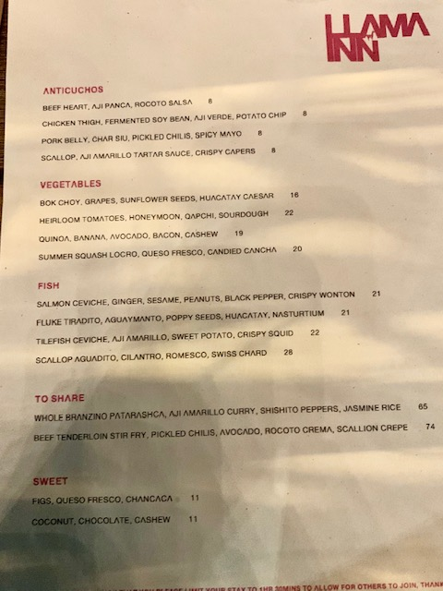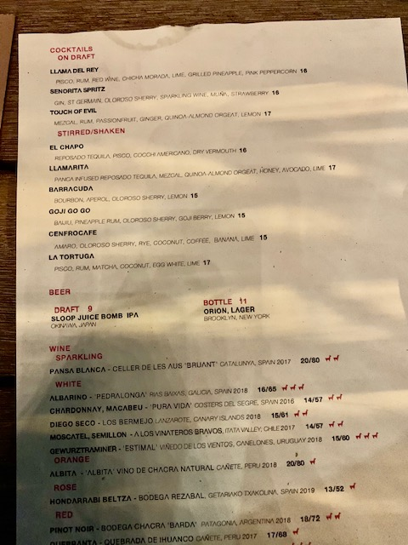
Llerena(2020)
The food reflected the cultural geography to an extent. By combining fine dining and traditional, the food becomes a whole new experience to taste. However main ingredients in traditional Peruvian cuisine are represented in the dishes, like ceviche and aji amarillo. They do give a certain distinction and familiarity to the dishes as I have had traditional Peruvian food before. For example the salmon ceviche had peanuts in it, a very typical ingredient in savory foods from Peru from stews to even sauces. The geography of Peru is very unique in itself, a mix of climates and landscapes from the Andes Mountains to the tropical Amazon Rainforest, Peru has a variety of exotic fruits and ancient grains. Quinoa is an example of the ancient grains found in Peru that is now a very popular healthy option as opposed to rice. It is one of the top six exports from Peru in terms of its agricultural sector. According to (These Are the Main Products That Peru Exports, 2020), “quinoa alone accounts for 86% of the production of Andean grain in Peru, demonstrating the importance of this flagship product.
The customers around us were a young crowd, being in Williamsburg, Brooklyn that is a common occurrence. They were dress casual yet stylish for a night out to eat. In front of me I could see a group of people that I assumed were young professionals. They were laughing and having spirited conservations, I couldn't really tell how they were dressed because it was at night, but I did notice most people had sweaters or light jackets as it started to become a bit chilly during the night. The waiter was dressed in all black, slacks and a button down shirt, since this restaurant was more upscale all the employees were in business casual attire and every employee had on a mask at all times.
The dishes that I and boyfriend ordered were a new experience in terms of taste and sight. As our food came, the Maître D explained what everything was, I was amazed at how everything looked. The fish dishes were served in plates that can be described as rustic, by the earthy colors of it and the skewers were placed on a slab of wood. I believe the way these dishes were represented also represented the Peruvian cuisine because it amplified the relaxed aesthetic. The food was a mixture of flavors and textures, For example the salmon ceviche had an acidic sensation due to the lemon juice in it and also a crunch from the peanuts and crispy wontons that added a salty taste to the dish as well. I never experienced Peruvian cuisine in a gastronomical way and it was a complex mix of flavors for my palette. It was also very fresh as I could smell the aroma of the herb of cilantro in the scallop aguadito dish and the pungent smell of ginger in the ceviche. The draft beers were refreshing and a great combination with the skewers as it had a mild spicy taste due to the hot pepper paste. The staff of the establishment was friendly and professional, our waiter would check in on us routinely. And every employee had a mask and took precautions to follow Covid regulations. I give this restaurant a rating of a B, this is because the authenticity of Peruvian cuisine wasn't clearly represented but the chef’s adaption of the cuisine was still really stellar. The price range also was a bit high for me personally but I could understand why it was priced a bit high due to the presentation of the food and the quality of the dishes that seemed to be meticulously prepared. What I learned from this experience is trying a new modern take on an international cuisine was exciting and adventurous. It may be a bit peculiar to pair certain ingredients together that may not make sense but it did taste really delicious. Even though it may be a bit extravagant to eat at a fine-dining restaurant, the experience is worthwhile.
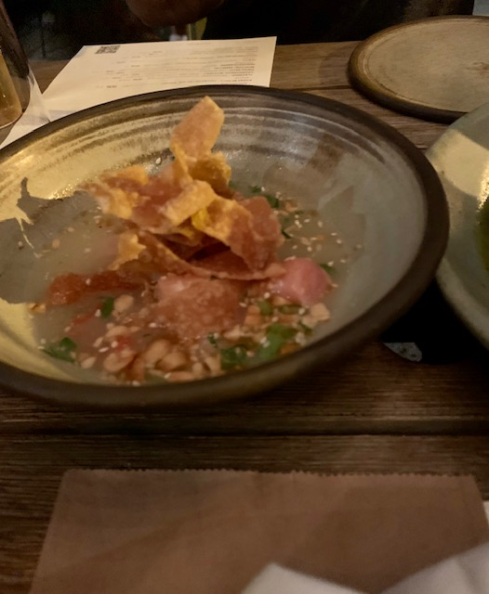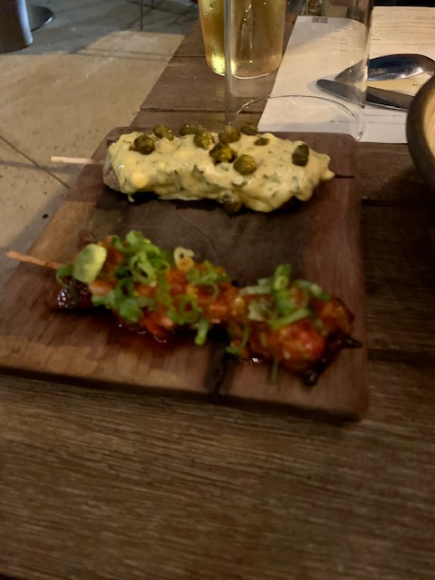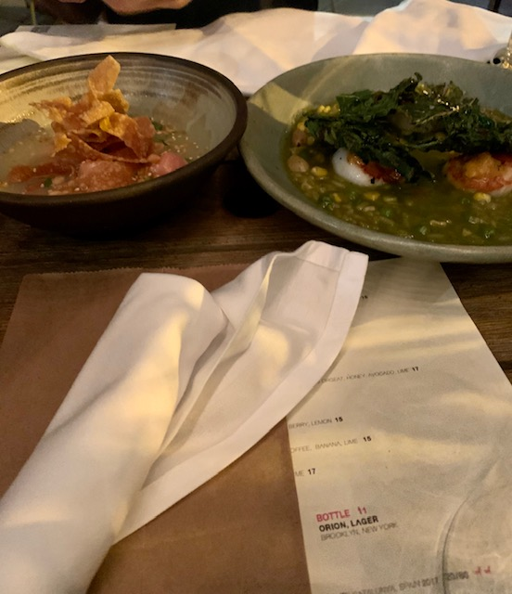
Llerena (2020)

References
These are the main products that Peru exports. (2020). Https://Peru.Info. https://peru.info/en-us/foreign-trade/news/7/29/these-are-the-main-products-that-peru-exports

