Crystal Llerena
ARTH 1103 Sec E 414

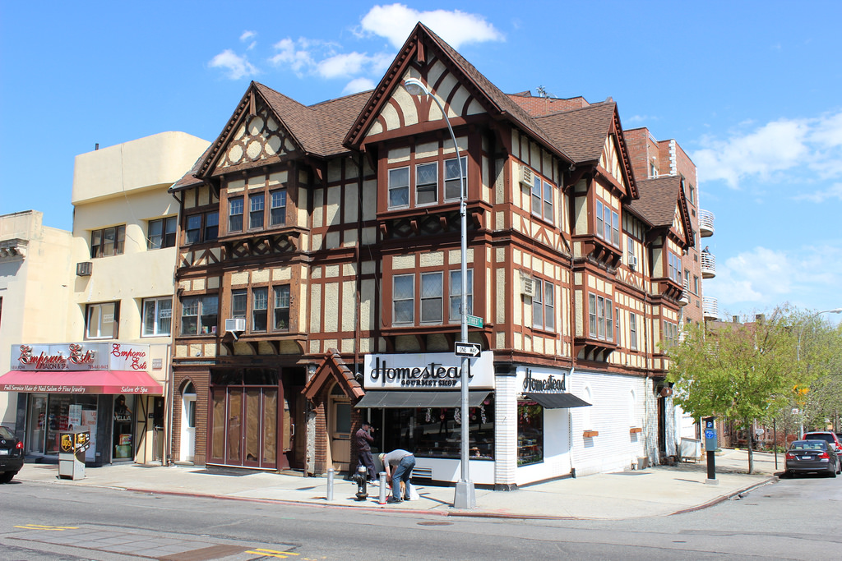

“Homestead” is a commercial/ apartment building. This is located in Queens specifically Kew Gardens along Lefferts Blvd.
This building was built around 1914 but its style is centuries old. The style is considered to be Tudor that comes from England from 1484-1603.This type of style was the final development of the Medieval architecture and as well shown in the beginnings of the Renaissance architecture. The building pictured above closely resembles The Little Moreton Hall, in Cheshire, England. The noted elements of the Tudor style is half-timber or also known as “post and beam” construct, this done by creating structure use to square off and carefully fit and join timber with joint secured by wooden pegs, this can be seen decoratively in the building. Another element to the Tudor style building is the effect of corbels located underneath the windows. This building also compares to Sutton Place, Surrey Manor house by the cross symbols located at the top of the building.

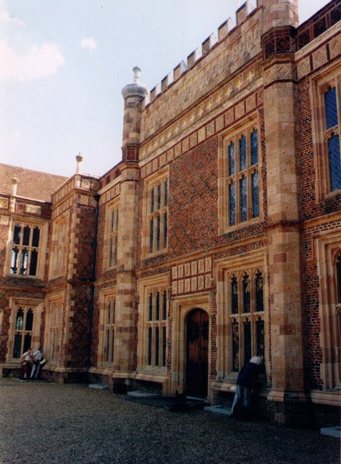
Entrance facade of Sutton Place, Surrey, dating from around 1525

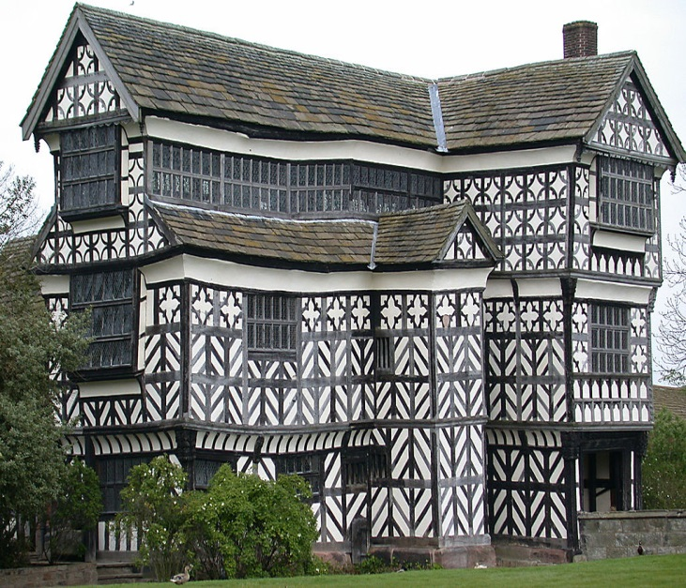

Little Moreton Hall, built in stages between 1504-62

