TERM PAPER
TEXTILES BUF 2246
TOPIC: ACID WASH DENIM
CRYSTAL LLERENA

Crystal Llerena
BUF 2246 Textiles
11/25/17
Term Paper

The garment I chose to discuss is acid wash jeans and the textile would be denim. However this denim, acid wash, has a specific wash to it that gives a different appearance than that of regular denim would. Denim is primarily a cotton warp-faced textile and it's also a twill weave meaning that it has a diagonal pattern when woven (Flatley, 1998 , pg.8). Acid wash denim is produced by a manufactured textile process. Originally the process was called “stone-washing” to initially give jeans a softer and flexible feeling to what denim is, which is more rigid and tough.
It's a process of pumice stones being washed with the jeans for more of a comfortable flare, this process was said to be invented in the 1950’s by Levi Strauss and Co. Decades later, and a newer approach to the wash of jeans was being used. Acid wash was the new look of the 1980’s in denim. Similar to the process of stone washing, acid wash, which realistically is a misnomer, because no acid is actually involved, is a procedure made by the garment maker instead of a textile company. What differs from a standard “stone washing” is that the pumice stones are doused with chlorine before being put in the large machines to wash and this starts to visually bleach out the jeans. During the wash cycle for about 25 minutes the dye of the jeans, usually indigo dye, is slowly turned to a pale blue with many white spots (“Acid Wash Gives a Lift To 7th Avenue,” 1987). This trend became very popular soon after many of the young generation actually took the process to their hands by doing an easier solution at home.
With prices being too high at the time for the target market, young people would get the same effect of acid wash jeans by doing a “D.I.Y” method. By getting the same effects as buying Guess or Levi’s Jeans, young people would take their old pair of jeans and bleach it. In the late 1980’s, a company, Greater Texas Finishing, an industrial laundry, grabbed the rights to patent “acid wash denim” so any jean maker had to consult with the company to use this type of wash for their clothing line (Silverstein, 1990).
This however drew criticism from top jean brands at the time like Jordache, Lee and Wrangler because it put a hold on these brands to use acid wash to their garments without being legally reprehended. There was even a legal battle between the company that patent acid wash jeans and other jean makers, like Jordache for the right to use this wash in their company. jordache Enterprises has joined the legal fight to knock out a patent for an acid-wash process by filing suit in federal court against Golden Trade S.R.L., the Italian company that holds the patent, and Greater Texas Finishing Corp., El Paso, Tex., the United States licensee (Jordache joins legal fray over acid wash patent,1990). The sales of acid wash denim did however rise because of its popularity at the time, a 35 percent increase and a hot commodity for fashion brands to have in their lines (Silverstein, 1990).

Before;
This fashion trend was worn primarily by the younger generation, in the mid to late 80’s. Both boys and girls sported acid wash denim in many different ways, from jeans to accessories. Originally a street style among the punk rock scene it was soon featured in famous clothing brands and worn by celebrities as well. From Madonna to dolly Parton, famous people put their spin on the acid wash denim trend.
The people who potentially wore this trend in the 1980’s were young people and incorporated in many different styles. The punk rock scene was first to popularize acid wash denim for example famous bands like the sex pistols and the clash would be seen in these jeans with their signature Dr. Marten’s boots and leather motorcycle jacket. Thus after acid wash denim was featured in many other subcultures. Others who popularized this trend were pop stars, such as Debbie Gibson, Cyndi Lauper and Robin Sparkles. They wore acid wash jeans, vests, shirts, and dresses with bright colors and tons of accessories. Their fans then also follow suit to the trend as well.
The young generation, as the target market for this garment (14-26) would wear this because of its mass appeal it had with many subcultures in the 1980’s. This garment at first was a revolt from famous punk bands and the heavy metal scene of fashion, adding bleach to jeans was meant to be a form of rebellion. Acid wash denim was everywhere in terms in magazines, clothing stores and seen on celebrities. In fashion magazines like Seventeen and Glamour, there would be advertisements from many fashion brands promoting the acid wash denim trend. A fashion buyer, Nancy Rosen said "When it was hot, it was incredibly hot. Everybody had to have acid-wash” (Silverstein, 1990).
I believe that this fabric choice is important for this fashion trend itself. Denim is the type of fabric that is needed to achieve this look while doing a separate process to it. This garment was simply to take an already existing fabric and develop a process to have an aesthetically different look. The inspiration for choosing this specific garment was the young people of the 1980’s because as a teenager, I would often like to wear what was the hottest trend at the time. Looking back at when I was young I was always conscious about my style and trying to fit in with the rest of my friends. Seeing what was popular in terms of trends was important for me to replicate. As I research and look at the styles these young people were wearing, it's interesting how much of an impact huge trends are in dictating what people would wear and still have a unique style of their own.

After the 1980’s, this fashion trend is worn by few, mostly people with eclectic style and young people as well however it is modernized by being more subtle than originally. Many clothing companies are revisiting the acid wash denim style and bringing it to their collections. For example, Red Engine, a Los Angeles-based denim company, has introduced the 80s Wash, an updated take on the acid-wash style popular 20 years ago (“acid wash redux,” 2005). Another example is luxury brand Dolce & Gabbana, “...is taking that kind of Eighties feel but making it very new with a really low-slung waistline the idea is definitely a kick-back to that time,” (Caplan, 2001). This garment first introduced as a street style is now being re-worked as high fashion in current times. Many luxury brands are mixing this acid wash denim to create a new edgy look that has a uniqueness to it. Other brands to mention are Dsquared, Balmain and Gucci.
This trend is still seen by celebrities and clothing brands. Most recently by Gucci, as it was featured in their resort collection 2017. In their collection, they gave a throwback appearance to the 1980’s punk scene in London by featuring leather black boots, graphic tees and of course acid wash jeans. Major “fast” fashion store chains like forever 21, Asos or H&M do bring back this trend as well and can be seen from time to time in different forms of garments. The popularity of revising this trend is as well seen by today’s famous young celebrities like Gigi Hadid, Rihanna, Nicki Minaj,and Selena Gomez just to name a few. They are seen wearing acid wash jeans, jackets, and dresses true to the trend back in the 1980’s and also a modern twist to it as well.
They would wear this because it's a revival trend that has its comeback in a different form than in the 1980s, for example the jeans would be acid wash skinny jeans or a low waist jean to offset it for a modern take on it. As everything from the past is popular again, the vintage aspect of acid wash denim is a very appealing structure to fashion now. For the young people of today it’s a new look from them. Dana Shelli, director of DollHouse said “to them it's fresh and new,” (Caplan,2001).

WHEN
before 1980’s;
This garment, acid wash jeans, was a reflection on its own time because of the amount of popularity it has gotten from celebrities and the young generation in the1980’s. The style was everywhere from pop stars wearing them to fashion magazines, this trend was a staple to many in the 1980’s.once clothing companies took notice of how this street style was gaining popularity among young people, it took on a whole new appearance within the mainstream culture.
Since denim has been around for decades since the 1980’s, it does consider a pretty mainstream textile. However the style of acid wash was a new twist to regular blue jeans. This wash gave denim a different type of style that no one has seen before. This was more dealt by what the garment maker does rather than a textile company. The maker would deal with how to achieve the acid wash look by using different techniques and even teenagers of the time did their own DIY friendly process for a cheaper alternative. As many clothing brands increase their sales of acid wash denim due to high demands for them. ‘It’s become a real fashion item, with some stores getting as much as $100 for a pair of jeans,” said Richard Gilbert, president and owner of Zena Jeans (Acid wash gives a lift to 7th Avenue, 1987).
This garment was popular then because it was considered one of the biggest trends in the 1980’s. As one fashion merchandiser, Jack Taylor put it, “Acid-washed clothing is the most important thing that has come along in the men's and women's garment industry in years,'' (“Acid wash give a lift to 7th Avenue”, 1987). Many clothing companies were selling good amount of theses acid wash jeans in different price brackets. Celebrities would wear acid wash jeans in almost every type of style. The garment wasn't only jeans however that got acid wash; it was skirts, shorts, jackets and even hats. This wash dominated over the young generation, specifically first seen in the punk rock subculture of the 1980’s. Fashion brands like Guess Jeans and Jordache Jeans took this style and turn it mainstreamed.

Post 1980’s;
Acid wash jeans now have either gone more of an extreme or subtle look to what in the 1980’s was popular then. To have a more subtle appearance it's best to mix and match certain pieces with low key items. The adding of embellishments and the color of the jeans is also a change of the times. For example, Dolce and Gabbana introduced acid wash jeans but in low rise jeans and tapered ankles for their ready to wear collection 2001.
The way this textile, denim is being evolved is by what trend or style is big during a certain time. Denim is such a widely used textile; it can be taken in many ways to express individuality. And so specifically acid wash jeans were a new way to look at basic blue jeans. This wash was an expression of the youth to evolve basic jeans and add an edginess that was different.
I believe this style has endured time because it represents nostalgia for many people who once use to wear it in that decade or it is a vintage style to bring back to modern times. There is always a revival of decades past in fashion and the 1980’s is one of the popular styles that is always brought back to trends todays. According to Caplan (2001), “the return of the acid wash look comes as no surprise to many jeans makers, who said it is part of the eighties revival occurring in fashion.”

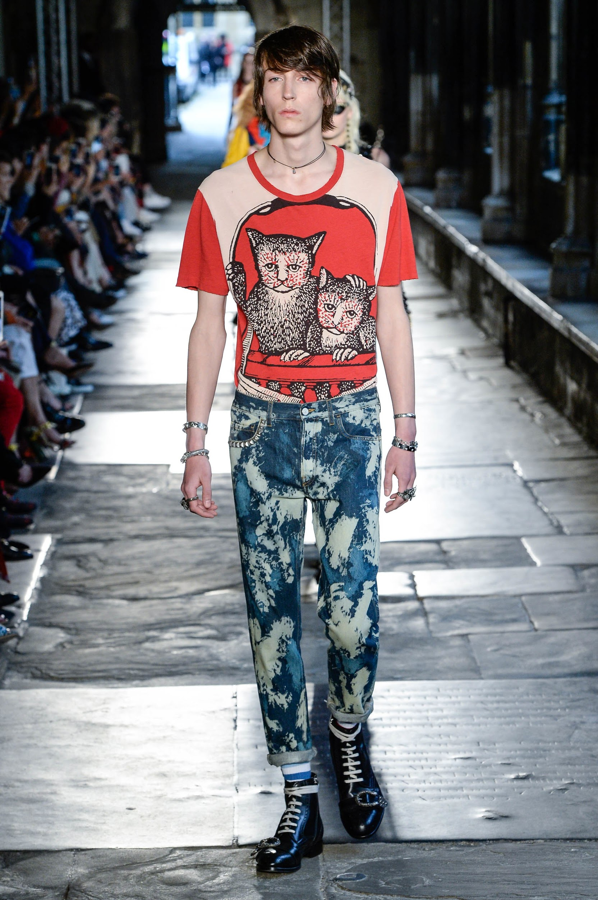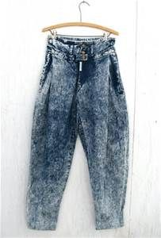
Gucci 2017 resort collection Z Cavaricci Acid Wash Jeans

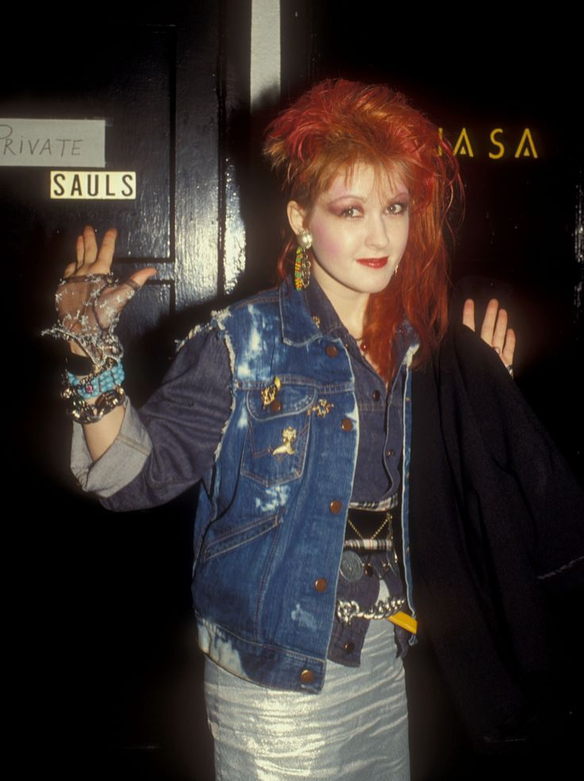

Model, Gigi Hadid Singer, Cyndi Lauper

Works cited:

Flatley, K. A. (1998, May 5). Where do blue jeans come from?. Christian Science Monitor. p. 8.

BUSINESS TECHNOLOGY: ADVANCES; Acid Wash Gives a Lift To 7th Avenue. (1987)The New York Times, Retrieved from www.lexisnexis.com/hottopics/lnacademic

SILVERSTEIN, STUART (1990, October 9). Acid-Wash Patent Holders Targeting Deep Pockets of Jeans Makers. The Los Angeles Times. http://articles.latimes.com/1990-10-09/business/fi-2297_1_acid-wash-jeans

Caplan, D. G. (2001, August 2). DENIM'S ACID TRIP; THE ACID WASH LOOK IS BACK. INSPIRED BY EIGHTIES CHIC, JEANS MAKERS FOR FALL AND HOLIDAY ARE OFFERING THE LOOK ON JEANS, JACKETS AND SKIRTS. WWD, 10B. Retrieved from http://go.galegroup.com/ps/i.do?p=AONE&sw=w&u=cuny_nytc&v=2.1&it=r&id=GALE%7CA77354987&asid=b00847ce2e326fbff810d1d1fc6d0a18

Spevack, R. (1987, August 21). Acid-wash seen strong through 1st period 1988. Daily News Record, 17, 1+. Retrieved from http://go.galegroup.com.citytech.ezproxy.cuny.edu/ps/i.do?p=ITOF&sw=w&u=cuny_nytc&v=2.1&it=r&id=GALE%7CA5126600&asid=b4b226f677eff4ca697c3e0c152dfe60

"Jordache joins legal fray over acid wash patent." WWD, 1 Oct. 1990, p. 2. General OneFile, go.galegroup.com/ps/i.do?p=ITOF&sw=w&u=cuny_nytc&v=2.1&id=GALE%7CA8930710&it=r&asid=74fbbd0ef89911e1b1a4f754409d78dd

"ACID WASH REDUX." WWD, 21 July 2005, p. 8. General OneFile, go.galegroup.com/ps/i.do?p=ITOF&sw=w&u=cuny_nytc&v=2.1&id=GALE%7CA134411952&it=r. Accessed 15 Nov. 2017.

