How the fashion industry is using biosynthetic textiles for a more sustainable future.
BUF 4700-OL85
Prof. Munroe
Crystal Llerena

The fast fashion business model, a rapid availability of popular trendy clothing at reasonable prices, that many major brands in the fashion industry follow have caused negative outcomes in terms of producing waste and production practices that cause hazardous effects to garment workers and the environment as well. Waste is being created by these fashion brands due to consumerism, as it is the desire to want the latest trends in fashion. According to Bick et al. (2018), “the average American throws away approximately 80 pounds of clothing and textiles annually, occupying nearly 5% of landfill space. By occupying a high amount of landfill space, many local communities have to transport this waste to other states therefore omitting greenhouse gases that highly damage the environment.
This is also true for the production of textiles, fast fashion brands use textiles and dyes that damage the environment and also damage water bodies near textile mills. apparel production is a complex array of stages that require creating fibers both from natural and synthetic resources, developing yarns and textiles, producing the garments, consumer acceptance then finally discarding. This process involves heavy usage of chemicals as well as natural resources produce huge amounts of energy to create the end product. Fibers such as cotton which is heavily used in fast fashion require larger amounts of water and pesticides to produce.an interesting fact about how much water is used to cultivate cotton is that “it can take more than 5,000 gallons of water to manufacture just a T-shirt and a pair of jeans” (“Fast Fashion Is the Second Dirtiest Industry in the World, Next to Big Oil,” 2019).Dyes are also a major concern for polluting the environment, as used in the production of apparel, dyes seep into bodies of water releasing heavy metals and other harmful substances As stated by Malik et al. (2019), “Many chemicals used in the textile industry cause environmental and health problems. Among the many chemicals in textile wastewater, dyes are considered important pollutants”. Not Only harmful for the environment, these toxicants can also harm animals and humans that are nearby polluted waterways.
The globalization of fast fashion also presents a negative aspect in the industry concerning social injustice. The manufacturing process of these brands is moved overseas as it is a cheaper option to operate. However the occupational and the safety conditions for garment workers are not sanctioned because of a lack of management by employers and a poor political framework. The unsafe work conditions in these factories can be detrimental to the health of garments workers, as expressed by Bick et al (2018), “The result is a myriad of occupational hazards, including respiratory hazards due to poor ventilation such as cotton dust and synthetic air particulates, and musculoskeletal hazards from repetitive motion tasks”. The infrastructure where these textile mills are located lack safety standards for textile workers and in many cases caused fatal accidents. “Periodic reports of international disasters, such as the 2013 Rana Plaza factory collapse which killed 1134 Bangladeshi workers, are stark reminders of the health hazards faced by garment workers” (Bick et al, 2018). These cases unfortunately still happen in developed countries that fast fashion brands use to manufacture their garments.
With technology and innovation, there are alternatives that are more sustainable to produce textiles and fabrics that don't create negative effects to the environment and workers. The fashion industry seems to now pay attention to these problems by changing the way garments are manufactured and using cutting edge materials to create these alternative sustainable textiles. This sustainable process to create eco-friendly garments has to ultimately make an impact with consumers who are now becoming more socially conscious with their purchasing patterns. These sustainable alternatives can help the fashion industry’s problems with polluting the environment because this industry is the second industry that contributes to pollution right under the oil industry and helps with the social aspect of garment workers.
With cutting edge technology, fibers can now be synthetically formed to produce a more sustainable fabric. A fiber that is “biosynthetic consists of polymers made from renewable resources, either wholly or partly” (“About Biosynthetic fibers”, 2017). This means resources such as corn, sugarcane and other crops can be implemented into polymers that create a biosynthetic fiber. Bio based fibers can now take the place of fibers made from fossil fuel like polyester, which is known to be the most used synthetic fiber for fast fashion brands and is also non-degradable. Another popular and profitable fiber that is also commonly used in fast fashion is cotton. This fiber although natural does require great amounts of water and pesticides to grow which damage the land and create health risks for the farmers growing it as well. Finding alternative fibers are important to help the crisis in the fashion industry that is polluting the environment and threatening the socio-economy.
Natural resources are now being used to recreate textiles in a sustainable way. With the help of technology and innovation, a company dedicated to finding what nature has to offer and produce fibers that benefit the environment not destroy it. This company is Bolt Threads and offers biosynthetic fibers that can mimic different fabrics such as leather and silk. One of their materials is called Mylo, it is “made from mycelium — the complex latticework of underground fibers so strong they hold the planet together” (“Bolt Threads | Sustainable Fashion Biomaterials and Fabrics,”2020). Mycelium is grown underneath the earth in a web-like structure that drifts along the ground, vegetation, and beside beds of water to disintegrate organic matter and supply nutrients to vegetation. This natural material helps produce eco-friendly fabrics that have the same finish of leather thus animal use and synthetic material are not utilized. Another cutting edge material introduced by Bolt Threads is Mircosilk. By taking inspiration from the silk spun by spiders, scientists have found a way to develop the same type of proteins from the silk to create a sustainable fiber that is durable and soft (see figure 1). Since proteins are used to develop this fiber it is considered to be biodegradable as opposed to its counterpart of synthetic fibers that contribute to pollution.
Within the fashion industry, many designers are seeing the damage caused by the business model of fast fashion and created a reaction called slow fashion. As stated by Stanton (2020), “it’s also an argument for hitting the brakes on excessive production, overcomplicated supply chains, and mindless consumption”. Consumers are also being more aware of what they purchase and how the garments they buy are being made to support a more ethical consumption. In recent times there are a plethora of fashion brands dedicated to being sustainable and transparent with their production. For example, a California based fashion brand called Indigenous, are committed to do fair trade with artisans that help manufacture their clothes, which is located in Peru. The brand helps these artisans by ensuring a fair wage and working conditions. The materials used to create their collections are natural and organic fibers. According to their website, (“Organic Clothing - Ethical Fair Trade Fashion,” ND.) “Good style should never sacrifice your values or your health. That’s why we handcraft clothing using 100% natural & organic fabrics, colored with safe, eco-friendly dyes” (See figure 2). Indigenous uses low-impact dyes meaning no harmful chemicals were used when creating the dyes. Synthetic dyes are effluent and release chemicals into waterways that is mostly used to dye polyester and cotton. Indigenous took it one step further by not using any dye for their collection called Pure. Using organic cotton and alpaca wool, colors do omit from these natural resources. Earthy hues naturally show up and that consists of colored fibers that are made for their garments. An example is their Men’s Alpaca raglan crew neck sweater (see figure 3) that shows a natural oatmeal-like color. Another fashion brand to mention is called Outer known, also based in California, this brand uses organic, recycled or regenerated fibers to make their garments. The brand also uses an innovative fiber that turns into a nylon yarn called Econyl. by “Using a cutting edge regeneration process the nets are broken down, combined with other types of pre- and post-consumer waste and transformed into ECONYL®” (“Turning Waste into Nylon”, ND). Discarded fishing nets used by fishermen are then turned into a regenerated material. Recycling these fishnets that pollute the oceans help taking out unnecessary waste. Outer known, produces many garments and accessories with Econyl. One of the garments made with this material is called an evolution hooded jacket (see figure 4) made “100% regenerated ECONYL® nylon shell. 100% recycled polyester fill” (“Turning Waste into Nylon”, ND). The nylon shell is water resistant and still able to regenerate heat for the user against cold weather.
There has been a more conscious effort among consumers to shop sustainably. More specifically younger consumers such as Millennial and Gen Z are likely to become conscious shoppers. According to a study, “ an August 2018 Nielsen report, 81% of respondents of a global survey felt strongly that companies should help to improve the environment, with millennial (85%) coming out ahead as the generation that said it was "extremely" or "very" important that companies work to improve the environment” (Baizely, 2019). With the rise of this awareness among consumers there are aspects of sustainable fashion that may deter them from buying,: the price point. The price points of these fashion brands are more costly than fast fashion brands, because the materials and supply chain used are more sustainable and ethical. However, those price points are high because these fashion brands don't cut corners when manufacturing their products as opposed to fast fashion brands that do, such as cheaper labor and using materials that contribute to global pollution. Sustainable fashion does contribute to a higher wage and living standard to their garment workers and that is what the price of the end product supports.
By the creation of biosynthetic fibers, issues such as waste in landfills, chemicals in freshwater, non-biodegradable products creating pollution, and sweatshop conditions can be significantly changed. With new technology and using natural resources, textiles can be produced to make garments and accessories. According to “About Synthetic Fibers” (2017), “Bio synthetics are an emerging preferred fiber, gaining traction with clothing, footwear, and household brands and retailers due to their use of renewable resources and their potential to mitigate climate change compared to their petroleum-based counterparts”. Popular fashion brands such as Stella McCartney and All birds are incorporating biosynthetic textiles into their garments. This appeal shows that the fashion industry is trying to find alternative textiles to use because using fossil fuel based fibers have devastating effects to the environment and ethical ramifications as well.

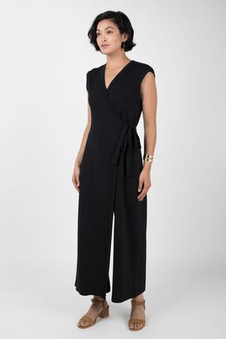
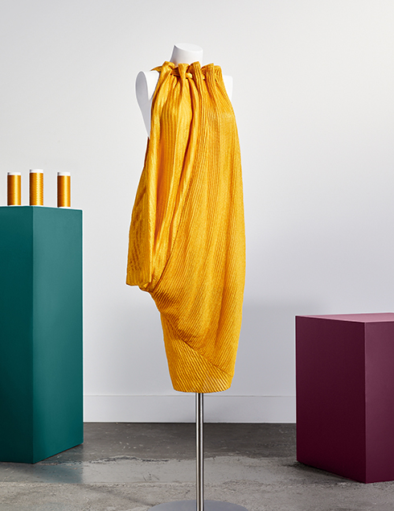
Figure 1
Stella McCartney and MOMA gold dress. (2017). [Photograph].
https://boltthreads.com/technology/microsilk/ Figure 2
Wrap Jumpsuit. (2020). [Photograph]. https://indigenous.com/collections/best-sellers

Figure 3
Alpaca raglan crew neck sweater. (2020). [Photograph]. https://indigenous.com/collections/pure-collection/products/mens-alpaca-raglan-crew?variant=12468712996961

Figure 4
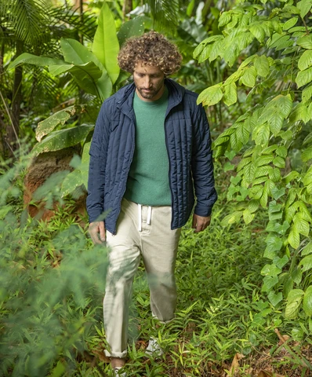
Evolution hooded Jacket. (2020). [Photograph]. https://www.outerknown.com/collections/econyl
References
(2019, April 1). Fast Fashion Is the Second Dirtiest Industry in the World, Next to Big Oil. EcoWatch. https://www.ecowatch.com/fast-fashion-is-the-second-dirtiest-industry-in-the-world-next-to-big--1882083445.html
About Us. (2020, May 15). Piñatex. https://www.ananas-anam.com/about-us/
Baizley, D. (2019). Sustainability and the consumer in 2019. WARC. https://www.warc.com/newsandopinion/opinion/sustainability-and-the-consumer-in-2019/3024

Bick, R., Halsey, E., & Ekenga, C. C. (2018). The global environmental injustice of fast fashion. Environmental Health: A Global Access Science Source, 17(1), N.PAG. https://doi-org.citytech.ezproxy.cuny.edu/10.1186/s12940-018-0433-7
G. (2017). Home. About Biosynthetic Fibers. https://aboutbiosynthetics.org/
M. (2020, October 20). Bolt Threads | Sustainable Fashion Biomaterials and Fabrics. Bolt Threads. https://boltthreads.com/
M. (2020a, September 28). MicrosilkTM | Vegan Silk Inspired by Spider Silk. Bolt Threads. https://boltthreads.com/technology/microsilk/

Malik, A., Grohmann, E., & Akhtar, R. (2014). Environmental Deterioration and Human Health Natural and anthropogenic determinants. Dordrecht: Springer Netherlands.
Stanton, A. (2020, March 2). What Does Slow Fashion Actually Mean? The Good Trade. https://www.thegoodtrade.com/features/what-is-slow-fashion
The Evolution of the Sustainability Mindset. (2018, November 9). THE EVOLUTION OF THE SUSTAINABILITY MINDSET. https://www.nielsen.com/us/en/insights/report/2018/the-education-of-the-sustainable-mindset/
Indigenous. (2020a). Organic Clothing - Ethical Fair Trade Fashion. https://indigenous.com/
Staff Guide. (2020, September 22). 35 Ethical & Sustainable Clothing Brands Betting Against Fast Fashion. The Good Trade. https://www.thegoodtrade.com/features/fair-trade-clothing
Turning Waste into Nylon. (nd). Outerknown. https://www.outerknown.com/blogs/journey/turning-waste-into-nylon

