Alexander McQueen;
A Legacy of Innovated and Provoking Designs
Crystal Llerena
City tech- CUNY

Abstract

This paper discusses the designs, market segmentations, promotional aspects and importance of Alexander McQueen specifically his women’s apparel. Beginning with his background and how he got his start in fashion, the paper will covering every aspect of his life as well after his untimely death and how that impacted the fashion industry and what became of his brand. His eccentric style accompanied with well-structured pieces put him in a league of his own, a juxtaposition he was known for. He was also a controversial figure in the fashion industry because of his eccentric behavior and work. He once said “Fashion should be a form of escapism and not a form of imprisonment.” Included are also pictures from a few of his popular collections throughout his work.

Introduction
His work was never like anyone else’s, he created shock value but with an intent to tell a statement most importantly. He was often mentioned as the “design maverick” because of his unique style he put into his work. His runway shows were an extension of the clothes he made, always unique and controversial. He also earned the nickname “L’Enfant terrible” by the fashion press meaning the bad boy of fashion; he was given this name because of his edgy attitude and stance on issues he believed in. His designs were not for the everyday women; his brand was very much meant for the woman who marched to the beat of her own drum. Interesting silhouettes, one of kind prints accompanied with a well-structured outline, McQueen presented clothing that was distinctive yet classic. McQueen’s outrageous theatrical runway style and unique combination of fierce tailoring and fantasy in his clothing led him to become a well celebrated and well respected designer and household name not only within this generation but for generations to come.
Background
Alexander McQueen was born Lee Alexander McQueen on March 17, 1979 in Lewisham, London. He came from a working-class family, living in public housing during his childhood. Coming from very humble beginnings, his father was a cab driver and his mother was a teacher supporting six children in total. At the age of 16, McQueen dropped out of school and decided to take a tailoring course at Newham College in London. He seemed to have a talent for it because soon thereafter he had the opportunity to serve an apprenticeship with Savile Row tailors.
Savile Row is a street in central London known to have bespoke tailoring for men. Tailors set up shop there during the late 18th century. McQueen worked for Anderson and Sheppard before later joining Gieves and Hawkes (Palomo-Lovinski, 2010). After working at Savile Row and learning all he needed to know about tailoring, he went on to work at a theatrical costume company, Angels and Bermans. There he started to develop is “dramatic” style of designing; it gave him an outlet to be outlandish.
McQueen then left London for Milan, Italy to work as an assistant for fashion designer, Romeo Gigli. After his stint in Milan, he decided to go back to London to attend the prestigious Central Saint Martin’s College of Art and Design. He received his M.A in fashion design in 1992 (Cartner-Morley, 2015). His final project at the school which was his graduation collection was bought in its entirety by Isabella Blow. She bought because she was so impressed by the structure and style of his collection. Isabella blow is an influential fashion stylist. She became an advocator for his work and later a long-time friend. It has been also said that she was credited for McQueen to just go by Alexander McQueen. His connection with Isabella Blow allowed McQueen to garner attention by people in the fashion industry; this synergy with Isabella Blow made her a mentor to McQueen in some ways.
Four years after he Graduated, McQueen was appointed as chief designer of Louis Vuitton owned Givenchy, He severed this position from 1996 to 2000 (Moon & Nicewonger, 2012, p. 102). This was a prominent position for McQueen however he couldn’t help but feel reluctant at the job because he wasn’t given creative freedom and was only doing what the company wanted. He had to tone down his designs but nevertheless continued is dramatic outlook by also working at his own label. The Gucci Group (now Kering) had acquired a majority share (51%) of McQueen’s brand in 2000 however he still was creative director of his own brand (The business impact, 2011).
Creating popularity by theatrical runway shows and distinctive point of view, McQueen had much success as a designer in the fashion industry. However on February 2010, Alexander McQueen sadly took his own life, in that same month his Mother had passed away as well, during those last days McQueen was dealing with personal issues that superseded his career at the time (Cruz, C. & Ram, 2010). He decided to leave his fashion house to his “right-hand woman” Sarah Burton who has worked with McQueen for many years. She has gone to succeed him in a way by honoring McQueen’s talent but also adding her flair to the brand.
Market Segment
McQueen is an un-conventional with his designs, his work is eccentric and that attracted many celebrities, who themselves love fashion too, to his brand because he had his own view point. Famous clients of his are Lady Gaga; she exclusively wore most of his RTW 2010 spring collection “Plato’s Atlantis” in her famous music video “bad romance.” Also actress Sarah Jessica parker, socialite Daphne Guinness and Kate Middleton for her iconic wedding dress just to name a few. The McQueen customer is of wealthy status and tends to buy for quality not quantity. The demographics are women 25 to 50 well established and working, who have an edgy appearance. The pricing strategy for his dresses and jackets can be the most costly at $695 to $6,000, Followed by bags, trousers, and skirts which range to $600 to $7,000 then shoes and tops at $500 to $3000. And lastly the less costly in his brand are the rest of his accessories, like purses, scarves, belts and rings are $195 to $750 (the business impact-Alexander McQueen, 2011).
Design
McQueen’s aesthetic can be described as having flawless tailoring while combining an avant-garde street style. He popularly once said about his design philosophy was that, “To make a piece that can transcend any trend and will still hold as much presence in 100 years’ time when you find it an antique store as when you bought it in my store yesterday (Ness. C, 2016).” He strongly believed the designs he put out were of a high status and will live on to a legacy that unfortunately came to soon.
His inspiration for his collections comes from a variety of different places; he likes to use history as tool. An example of this is from his 1995 collection called “Highland rape” This collection symbolized the Battle of Culloden (1746) in which the England invaded and defeated Scotland (Moon&Nicewonger, 2012). Dedicated to his Scottish roots, McQueen combined plaid prints and showed the violence of the invasion by having holes ripped in the clothing, revealing some of the models breast and crotches. Other tools he used as sources of his inspiration can stem from politics, social issues, technology and economic changes as well. His designs are one of a kind, unlike anything else we see down the runway. His imagination is endless, and that is clear in all of his designs.
A trendsetter: even though McQueen never sought out to produce clothing to become stylish or trendy, he advertently did so with a pair of trouser that was first introduced in his highland rape collection in 1995. Called the “bumster” they are extremely low-rise trousers exposing the backside. McQueen said about the trousers, “It wasn't about showing the bum... To me, that part of the body – not so much the buttocks, but the bottom of the spine – that’s the most erotic part of anyone’s body, man or woman (the Alexander McQueen Bumster, 2013)." This exaggerated design can be said to be an influence to the trend of low-rise jeans. This trend was started in the late 1990’s to 2000’s; low rise jeans or “hipster jeans” started to gain popularity in the 2000’s by famous pop singers like Britney Spears and Christina Aguilera. Popular to young teenagers, stores like Abercrombie and Fitch and American Eagle started selling low-rise jeans.
Unconventional designs; blending a mix of inspirations to create his artistic vision McQueen was known to tell a story with his designs. In his S/S 1999 collection called “No. 13” was inspired from the Arts and Crafts movement, an English aesthetic movement of the second half of the 19th century that represented the beginning of a new gratitude of the decorative arts throughout Europe (Palomo-Lovinski, 2010). His designs in the collection featured wood, lace, leather and raffia (a tropical palm tree use to make baskets). Balsa-wood skirts, in natural tones, expanded out to mimic the spines of a fan, while winged bodices of the same wood connected the use of organic materials. Famously McQueen used a double-amputee model to walk for his show, he put her in wooden prosthetic legs that were intricately designed to make it seemed that they were interesting boots. Another note-worthy aspect of the collection was also when at the end of the show, ballerina Shalom Harlow centered herself on a rotating plinth in between to industrial robots that suddenly shot out black and acid-yellow paint, spraying her. It splashed all over pure white trapeze dress. This was interpreted as a counterpoint to William Morris’s anti-industrial ethic, provoking comment on the interaction between man and machine at the turn of the twenty-first century (Moon&Nicewonger, 2012).
Promotion
Alexander McQueen’s promotion strategy is usually online, by doing campaigns for the latest collections, these are shared through fashion magazines and websites. Along with online promotion are stores. McQueen has stores in busy cities all over the world, as well as flagship stores. They are in London, New York, Los Angeles, Las Vegas and Milan, the other retail stores are in places like Tokyo, Dubai, Turkey and many more. His collections can also be found in department stores like; Harrods, Harvey Nichols, Saks Fifth Avenue, Bergdorf Goodman. Selfridges, Neiman Marcus, Bloomingdales, Barney’s New York and Nordstrom. In 2008, McQueen ventured out of his high-end luxury brand with an exclusive line for mass-market retailer target. The line is called McQ Alexander McQueen for Target and it was the first time target collaborated with an international designer. The line features shirts, jean jackets, dresses, and accessories everything is priced under $129. It’s intended for a younger consumer (17-25) (the Business Impact- Alexander McQueen, 2011).
Relevance
McQueen was awarded the title of British Designer of the Year by the British Fashion Council four times between 1996 and 2001(Cartner-Morley, 2015). In 2003, he was awarded a CBE for his services to the fashion industry and also named International Designer of the Year by the Council of Fashion Designers of America. Celebrities including Nicole Kidman, Sarah Jessica Parker, Bjork and Lady Gaga all wore his designs.
Conclusion
Facing many struggles in his early work, Alexander McQueen did eventually create a lasting signature. “The early death of McQueen, whose talents were unique in vision and genius, represents an astounding loss to the fashion world” (Palomo-Lovinski 177). He was acknowledged as a brilliant rebel who does things that were out of the control. Noticeably, to Alexander McQueen there are no such rules to fashion world he lived in. His creativity and imagination has created a lasting signature and influenced many younger generation.

References

AnOther. (2013, November 14). The Alexander McQueen Bumster. Retrieved from http://www.anothermag.com/fashion-beauty/3181/the-alexander-mcqueen-bumster

Cartner-Morley, J. (2015, February 10). Alexander McQueen: Into the light | Jess Cartner-Morley. Retrieved from https://www.theguardian.com/fashion/2015/feb/10/alexander-mcqueen-into-the-light

Palomo-Lovinski, N. (2010). The world’s most influential fashion designers: Hidden connections and lasting legacies of fashions iconic creators. New York, N.Y: Barrons.

Moon, C., & Nicewonger, T. (2012). Alexander McQueen's Iconic Designs. Design Issues, 28(1), 101-104.

Cruz, C. & Ram, A. (2010). The Shocking Death of a BELOVED DESIGNER. Entertainment
Weekly, (1091), 44-47.

Staff, Wwd. (2011). The Business Impact. (Alexander McQueen). WWD, 201(90), N/a.

Ness. C (2016) Alexander McQueen, Costume, 50:1, 142, DOI: 10.1080/05908876.2016.1134889

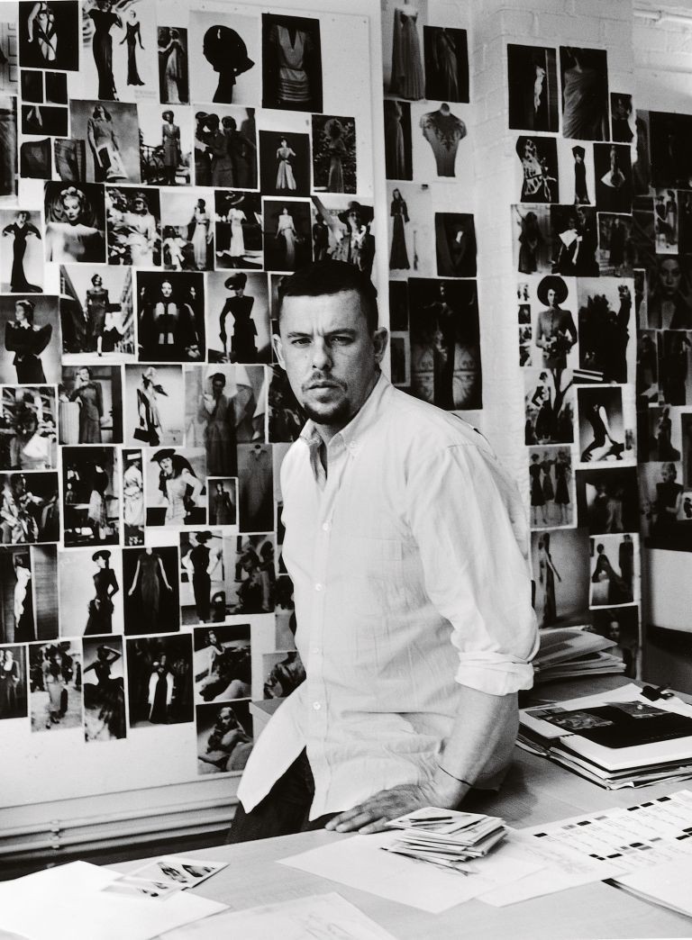
(from Alexander McQueen website)

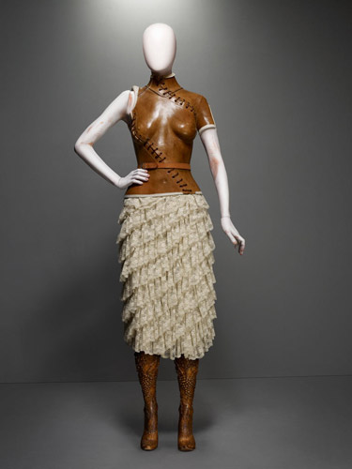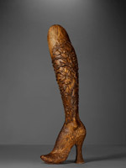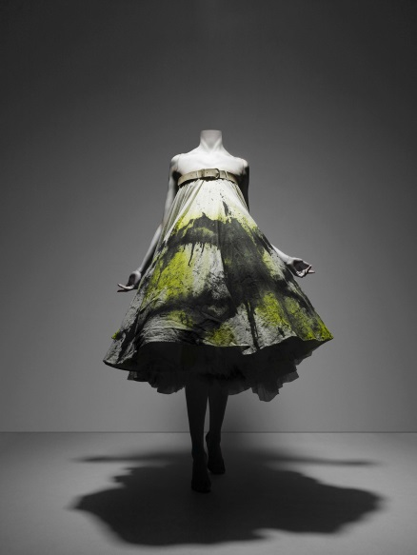

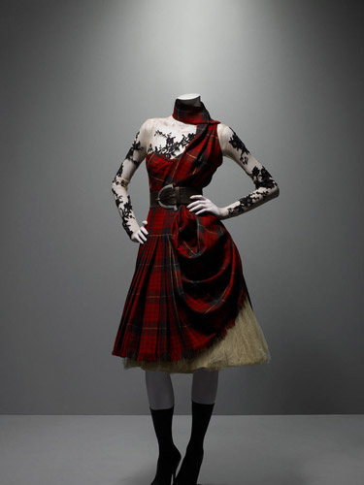
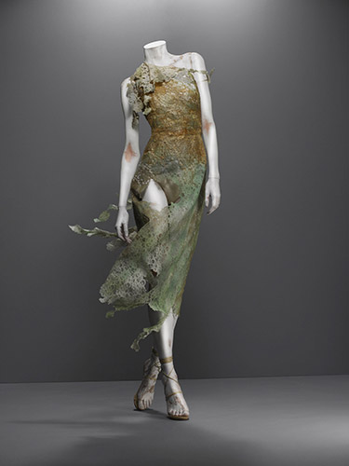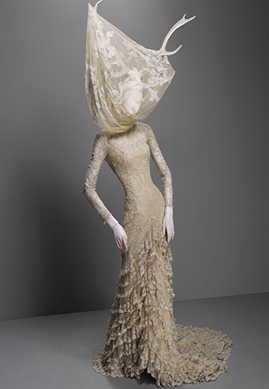

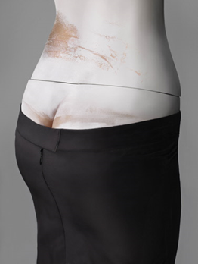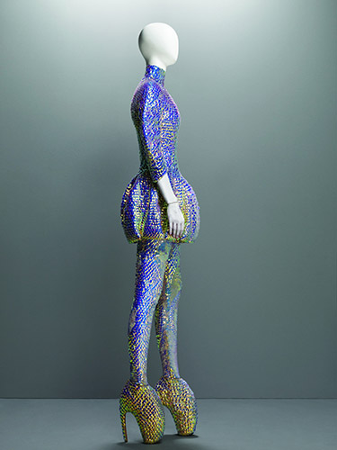
(Rest of images from Metropolitan Museum of Art website)

