ELEMENTS OF ART AND DESIGN
CRYSTAL LLERENA
BUF 2203 VISUAL MERCHANDISING
PROF. ROBERTS

ABSTRACT

In this paper I will discuss about the similarities in design and art of a window display and an artwork. The window display I chose is the Christian Dior (which features their resort 2019 Paris collection) store located in 57th street, New York, and the artwork I chose compared it to is “Rubens, His Wife Helena Fourment (1614–1673), and Their Son Frans (1633–1678),” by Peter Paul Rubens. The similarities between the display and the artwork I found are in subtle details but as well as blatant features. I will discuss further how these two visual mediums relate in terms of color; tones, shades, values, e.tc, texture and appearance, line formations, the repetition, contrast, proportion and dominance of the composition. I will also be examining the elements of design and using the terminology to describe my comparisons. In addition I will feature in this paper of how I comprehended this assignment by its color and texture of the artwork and visual display in a deeper sense

The colors in both the visual display and artwork are overpoweringly achromatic. Both visual mediums do combined colors of black and white as the emphasis in the design strategy for both visual display and artwork. However in its contrast, there were accent hues that played a minuscule part within each strategy. In the window display, which features their 2019 resort collection, the clothes are considered to be part of the neutral color group and this showed unity in its color story (Bell & Ternus, 2017). The colors they used as a contrast were shades of blue and red, resembling of earth tones. This played a cohesive design because neutrals and earth tones do tend to be closer than other color groups. As for the painting, it appears to have the same colors story as well. Neutral tones are represented prominently and accent colors of blue, red and pink are used with different values, however these colors due give a more intensity then in colors used in the window display.
In Ruben’s painting, the texture that seems to be expressed is of softness and mellow, which is my initial reaction. The subjects in the painting also evoke a relaxed and clam approach that gives it a corresponding element to the texture itself. The clothing appears to have sheen because of the light that picks up; this could be done by creating a tint to it. The texture imposes an idealized setting that invokes beauty and serenity. In art there are two types of texture; implied and actual (kleiner, 2009). The actual texture in Ruben’s painting can be seen as soft brushstrokes to then imply that it’s supposed to be visually balanced as well. In Christian Dior’s window display, it conjures up the same concept of texture similarly. The décor used in the display are of a paper material that is supposed to depict leaves of different types found in nature, with the material used it gives of a delicate and soft texture. Similarly this same type of foliage can be seen in the painting as its background too. However there is more of a contrast of textures in the window display then that of the painting which just shows one type of texture. The outfits that the mannequins are wearing are much more structured and rigid. They show crisp white button down shorts, black and white wide brimmed hats and black leather accents, these elements altered the background of the presentation however it’s also consistent. This is due to the fact that the bottom half of the outfits are billowy tulle skirts that correspond with the décor’s softness. This creates juxtaposition that texture in displays usually have, which is a mix of hard and soft components.
Line formations in both visual mediums seem to be vertical, with figures of bodies’ being the main feature, there is a sense of elongation. While in Ruben’s painting the bodies seem to be in motion and active it draws the eye to them while the background is stagnant and has horizontal lines, which invoke clam and stability (Bell & Ternus, 2017). This is the opposite effect of the window display, with movement and action in the background. The direction of lines going vertical and horizontal it seems to create chaos in contrast to the clothing that shows straight vertical lines, which the eye focuses on.
The movement and action of either the background or foreground shows a balance in the visual mediums. In both the window display and the painting a method of balance seems to be demonstrated, informal balance. Items that are an asymmetrical arrangement where one large item is counterbalance by smaller items on the other side of center point (Bell & Ternus, 2017). In Christian Dior’s window display, this is exemplified by the placement of the outfit and accessories. They are focal points of the display and are of different sizes however they all coincide and give off an easy momentum to the whole presentation. The same can be said to Ruben’s painting the center items, which are the three figures, Ruben, his wife and child all set an easy stream of progressiveness that encapsulates informal balance.
Repetition is also demonstrated in both the display and artwork, particular in clothing. In Ruben’s painting, the clothing that all three figures are wearing has a cohesive appearance. Even though the clothing in each figure is different in style and color, it gives off the same texture and effect as they move in motion. In the window display, there is repetition in the outfits, repeated patterns of skirts, hats, tops in black and white is shown as a component in the design. The similarities of clothing with both visual mediums are prominent by showcasing black clothing, voluminous fabrics and black hats as well.
The rhythm of both visual mediums shows a dynamic creation of movement which is important to keep the design from being static (kleiner, 2009). The sequence of line, shape, and form are shown in the backgrounds of both mediums. A natural reoccurrence of vegetation and animals is demonstrated by different methods, brushstrokes with paint and paper design techniques. The rhythm of the backdrop gives emphasis the focal point which is the individuals.
The emphasis and contrast is very important in any visual medium, it’s a decision on what area of the design to highlight or showing a difference between details (Bell & Ternus, 2017). I believe both window display and painting show an emphasis technique to emphasize a center principal point. This is achieved by using lighting, repetition and color. The lighting plays an important on emphasis by brightening the area that is the main subject. In this case it’s the individuals, the three people in the painting by muting the colors in the backdrop and showing stillness while the figures are in motion and the mannequins wearing the latest collection in a way that demonstrates stagnant while there are lines and shapes in the back that create commotion. The repetition is the use of the background space by creating a “nature” setting that creates a pattern. Color is also very important in the use of emphasizing a design. In Christian Dior’s latest collection, colors of earth tones walked down the runway and so this was their color story. I picked Ruben’s painting because it played with similar colors and emphasis on it. This is done by highlighting the darker colors and using touches of lighter colors sprinkled in the backdrop.
The comparison of the art and visual display in an influential circumstance is that it can be seen bluntly in Christian Dior’s window display. By using wallpaper that goes all the way to the bottom, that is a Toile de Jouy print. This print depicts designs of landscapes and figures for which the 18th-century factory of Jouy-en-Josas, near Versailles, Fr., was famous (kleiner, 2009). This print can be compared to the painting I chose to discuss about “Rubens, His Wife Helena Fourment (1614–1673), and Their Son Frans (1633–1678),” by Peter Paul Rubens. This was a clear similarity I first initially saw this while comparing the two mediums. The window display was greatly influence by art, specifically European Paintings of 16 to 18t century. In Ruben’s painting, it displays a European sculpture in the back and this can also be seen in the visual display by usage of animal sculptures in the same manner as in the painting. A resemblance in clothing design as well is perceived by the wide brimmed black hat and bulky fabric.
This assignment has tremendously helped me understand visual display in a deeper sense. Everything being displayed as a purpose or meaning behind it. The end result is to get the customer or potential customer to be intrigued and catch their eye to actually purchase their items. Something as simple as placement of items or figuring the proportion of the items makes or breaks a purposeful window display. Inspiration is also very much exhibited in a well thought out visual display. It gives a reference point to their targeted demographic that is promptly understood. Art and design go hand and hand because of the similar procedures used to show the final outcome. Without understanding art methods and principles it’s difficult to fully create a tactical visual display.

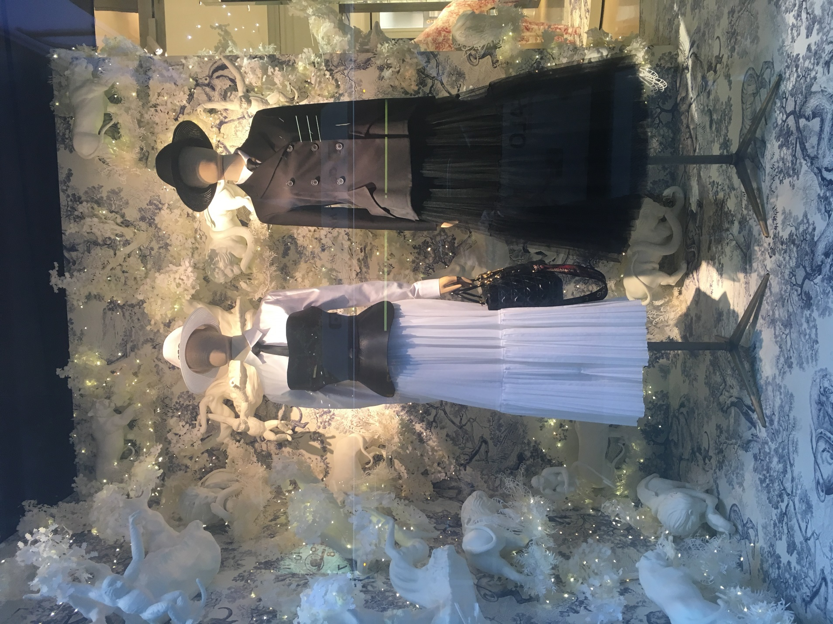

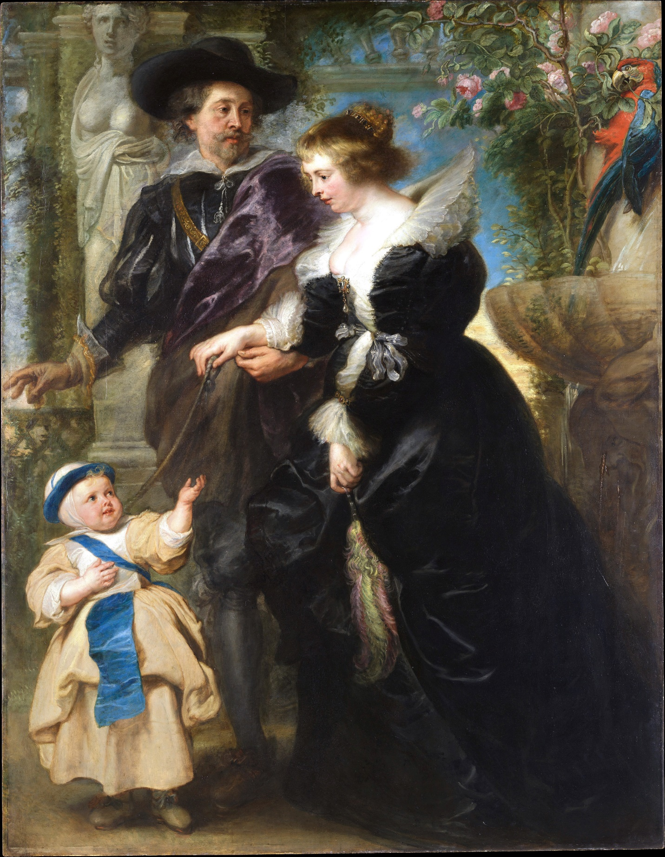

Works Cited

Bell, J., & Ternus, K. (2017). Silent Selling. New York: Bloomsbury Publishing Inc.
kleiner, F. S. (2009). Gardner's art through the ages. Boston, MA: Wadsworth Cengage Learning .
Llerena, C. (2018, November 9). Christian Dior window display . Manhattan, NY, U.S.A.
Rubens, P. P. Rubens, His Wife Helena Fourment (1614–1673), and Their Son Frans (1633–1678). Flemish Paintings in The Metropolitan Museum of Art. Metropolitan Museum of Art , New York .

