Fashion/ Retail store:
RENEW
By:

Crystal Llerena
Denise Aquino
Brittney Crespo

About us

Brand name: Renew

Mission statement: We are a New York City brand by the name of Renew. Our mission is to provide timeless fashion forward clothing, in the most sustainable way possible. Our company wants to shine so light on sustainability. The textile/ fashion industry is known to have major contributions when it comes to, waste and pollution in our environment. We are passionate about two things, cutting edge style and sustainable practices. Our practices will include recycling as much clothing and fabrics as possible. If the company ends up using a fabric that has not been recycled, it would be as green as possible, cut in a way to not waste fabric, and it would not be processed or dyed with any harsh chemicals.

Company profile:

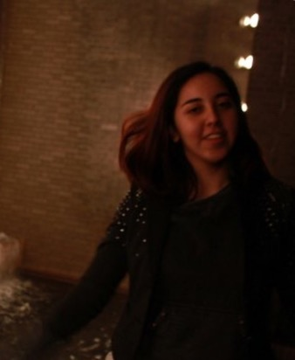
Crystal Llerena
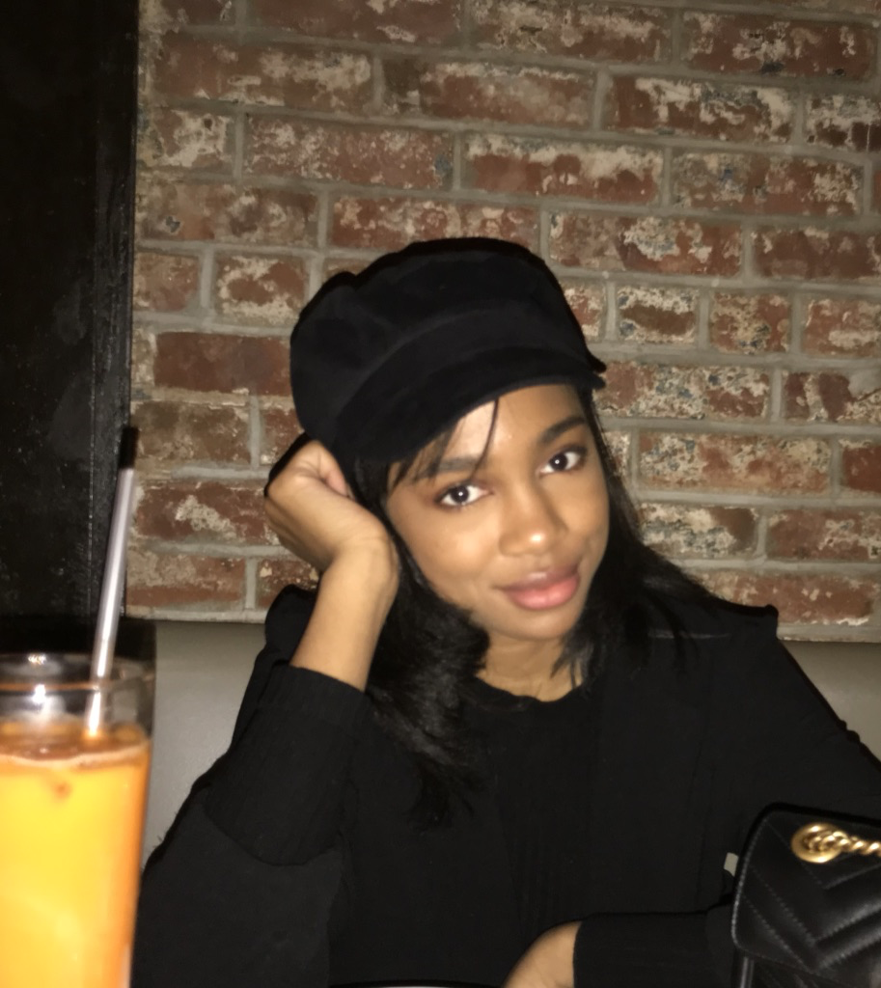
Crystal Llerena is a designer and buyer at Renew. She makes purchasing decisions based on sales and upcoming trends. She has been working in the fashion industry for a few years and established herself as a well-known buyer by previously working for other major retail stores. Her education background includes a bachelor’s degree in fashion business and fine arts. She had internships with stylist Rachel Zoe and designer Marc Jacobs thereby acquiring a knowledge of clothing and design.

Denise Aquino
Denise Aquino is a visual merchandiser at Renew. She’s in charge of bringing Renew aesthetic to life and making customers in store experience as enjoyable as possible. Her education background includes a bachelor's degree in fashion marketing.
Brittney Crespo
Brittney Crespo is in charge of Renews marketing. She will oversee that the marketing practices are performed in a strategic manner yet cost effective. She will oversee the social media account to make sure that consumers are engaged in Renews clothing and practices. She will also oversee the company's website and blog. The website will be clean and easy to navigate. The blog will have a post of one of our stunning pieces weekly showing the consumer's how to mix and match , along with insites on our sustainability. Brittney has a little over five years of experience in marketing, and used to oversee the blog at Barneys.

Type of Store and Location:
A fashion retail store that specializes in selling eco-friendly and trendy outerwear. The store is located at 20 Broadway, Williamsburg, BK 11211. A rental space for $7,169 per month ($75 per sqft). The space is 1,147 sqft

Type of merchandise:
Specializes in women’s outerwear using sustainable fabrics

Customer profile:
- A young female between 25-30 years of age (millennials)
- Lives in an urban setting
- An income of around $50,000 to $75,000
- A recent college graduate or a young professional, who is ambitious.
- She is a fashionable woman and up to date with the trends
- She is highly concerned with being environmentally friendly in her everyday life.
- She shops for eco-friendly clothing of good quality.
- She is decisive when she buys clothing, looking to what she needs rather than what she wants.
- Tech savvy and active on social media
- Politically progressive

Store Layout: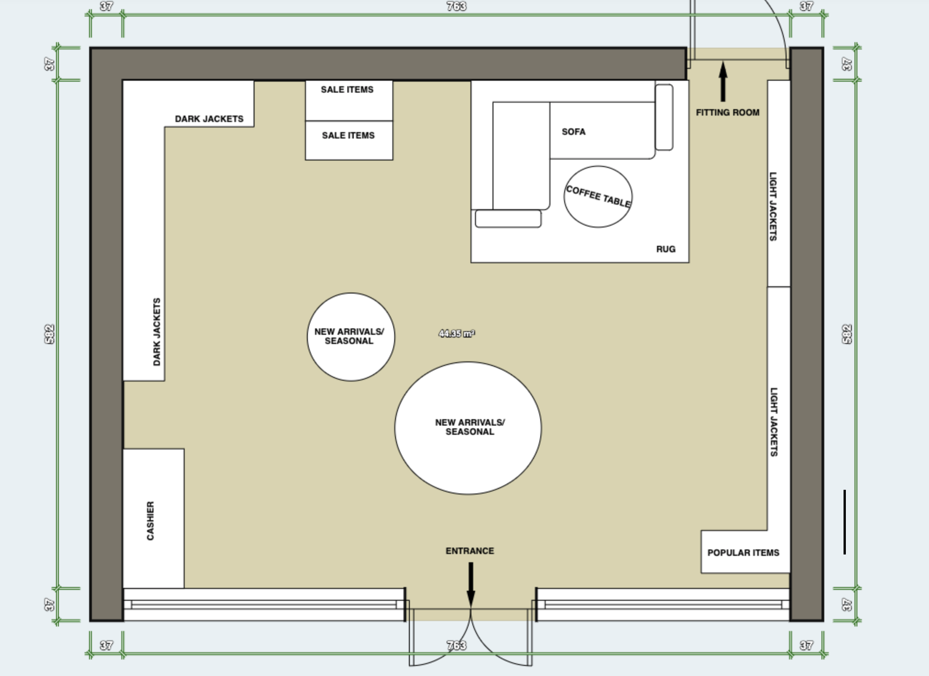

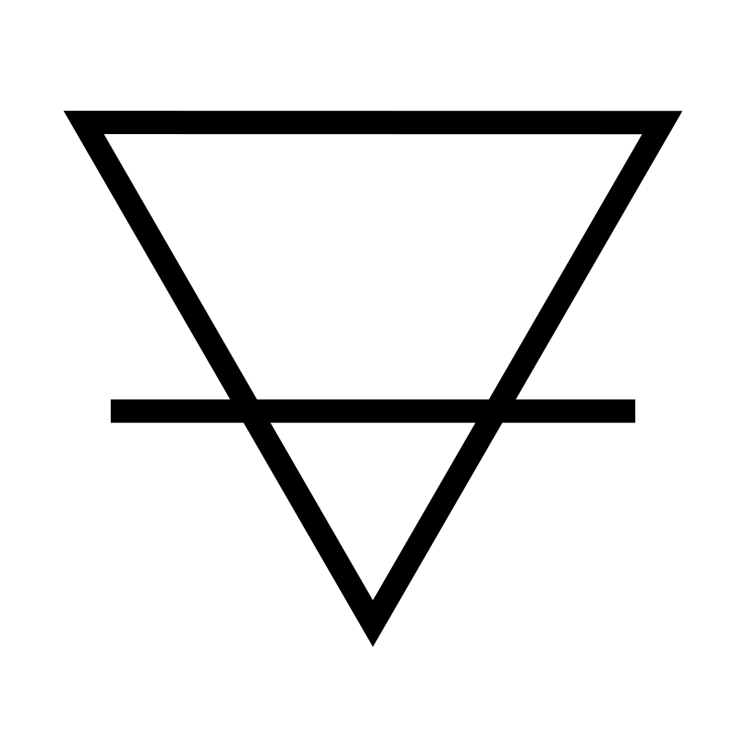
Tag Label:

RENEW
Size:

Style:

Price:

Our Spring/ Summer collection 2020
Descriptions of our five jackets

Puffer Jacket (February) in taupe, black, and light grey. $600.00
It’s a quilted style jacket in a cropped, boxy shape. It Features a padded hood, concealed snap buttons at the front and side pockets. This is made entirely of post-consumer recycled polyester, Material generated by households or by commercial, industrial, and institutional facilities in their role as end-users of the product that can no longer be used for its intended purpose. It is developed using clear plastic water bottles, or PET as the raw material. As for the insulation, the material used is Eco down® it’s the only synthetic product in the market to be made from 100%, post-consumer plastic bottles. It has traditionally been the sustainable alternative to down feathers.

Leather Jacket (March) in olive, black, mocha. $500.00
It’s a slim cropped silhouette, features asymmetrical zipped front closure, press studs on collar, functional zipped pockets, zip cuffs and stitch quilted accent on shoulders. The material used is ULTRALEATHER®, virtually duplicates the surface of genuine leather while maintaining a subtle grain pattern over time. It’s a Producer of microfiber and high-end vegan leather.

Windbreaker (April) in muted mustard, ivory, medium purple. $150.00
A regular fit and length that features a standing collar, long sleeves with elasticized cuffs, adjustable drawcord at cinched waist with metal grommets, zipper pockets at each side. Wind and water resistant, lightweight jacket with a chevron pattern. The fabric used is ECONYL (regenerated nylon), created by Italian firm Aquafil, uses synthetic waste such as industrial plastic, waste fabric and fishing nets from oceans, recycles and regenerates them into a new nylon yarn that is exactly the same quality as virgin nylon.

Jean Jacket (May) in black, white, charcoal. $120.00
A button-down front, long sleeves with button cuffs, basic collar, chest flap pockets with button closures, dropped shoulders, and a cropped silhouette. The fabric used is recycled cotton generally defined as converting cotton fabric into cotton fiber that can be reused in textile products. Recycled cotton is also commonly referred to as regenerated cotton or reclaimed cotton. Recycled content includes recycled raw material, as well as used, reconditioned, and re-manufactured components.

Kimono jacket (June and July) in black with lavender and blush pink flowers, mauve, powder blue. $98.00
Cardigan style and length jacket the features shawl lapels, fully lined, loose fitted and flowing three-quarters length sleeves. The material used is Mircosilk fibers, mimicking real spiders’ silk, to understand the relationship between the spiders’ DNA and the characteristics of the fibers they make. New technology allows making those proteins without using spiders.

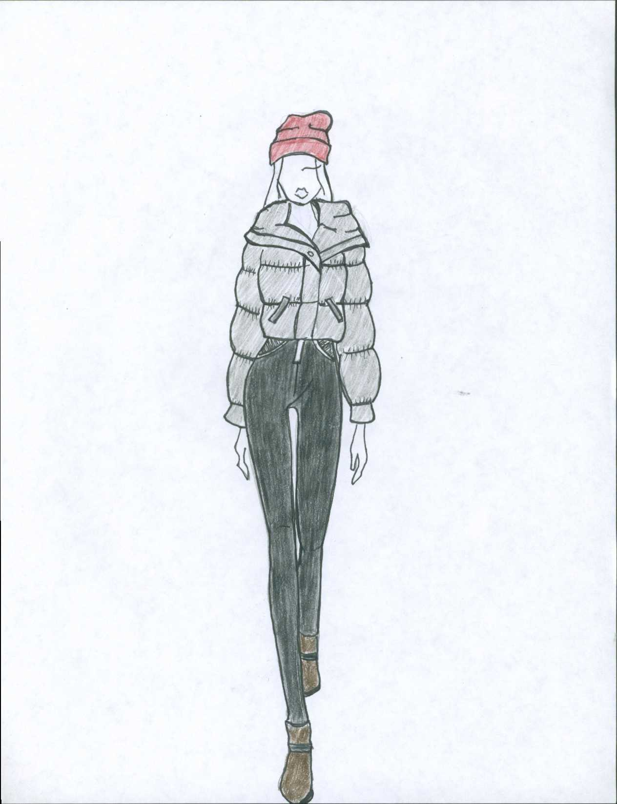
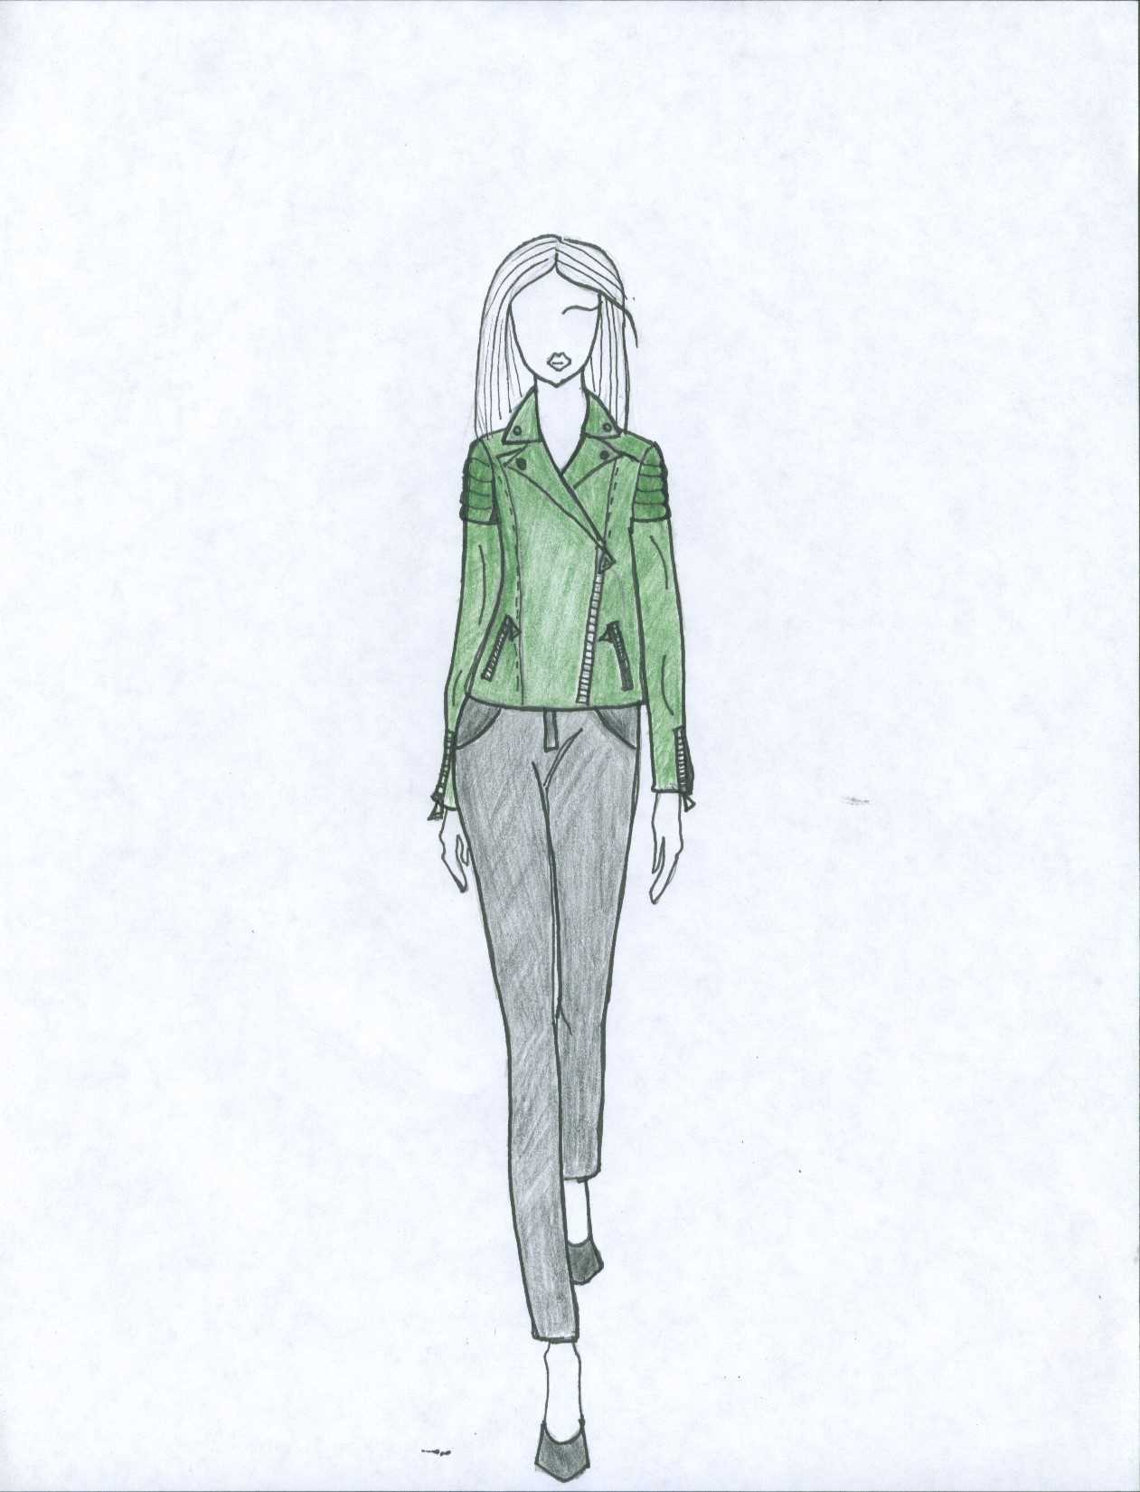

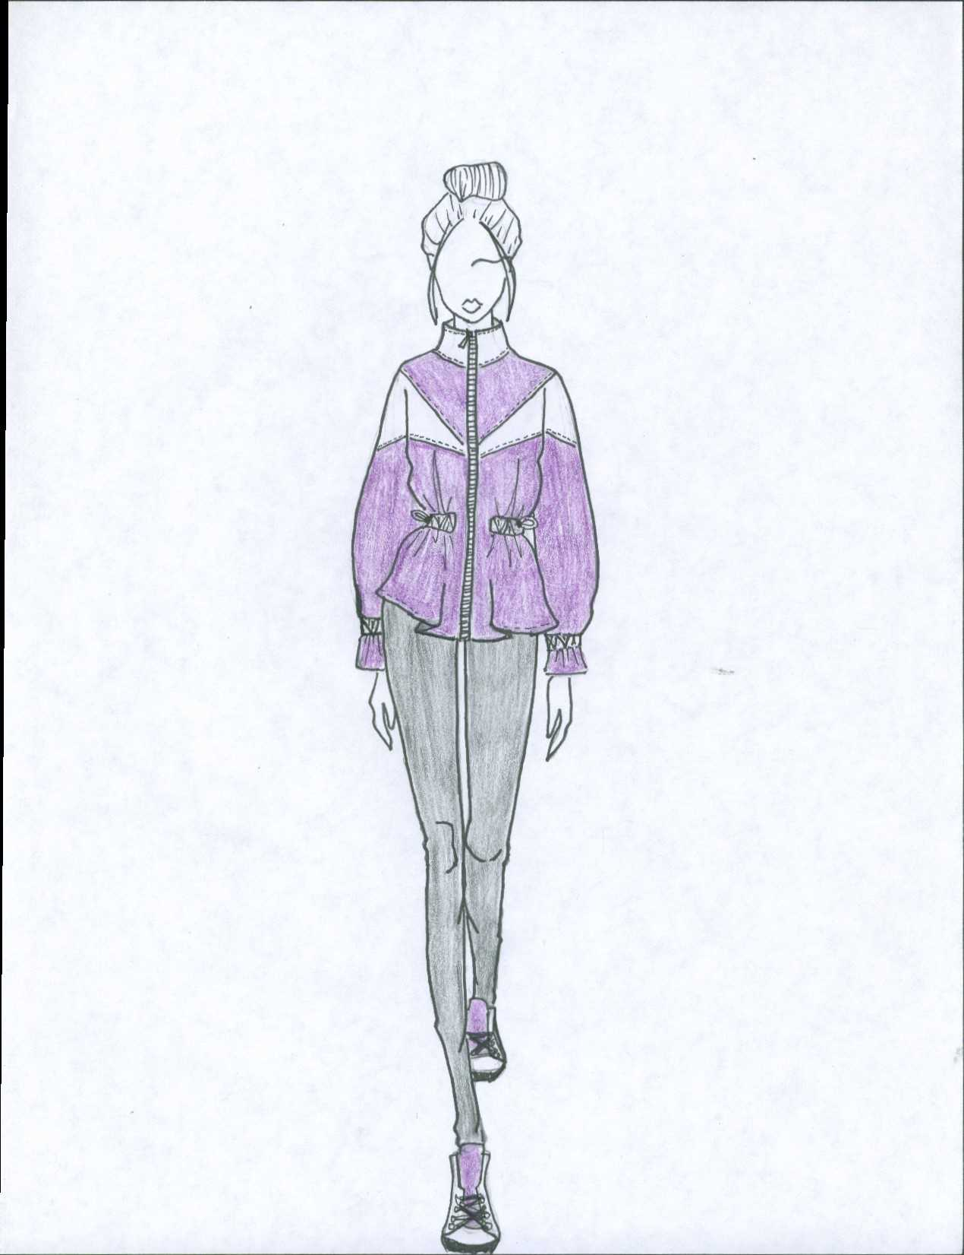
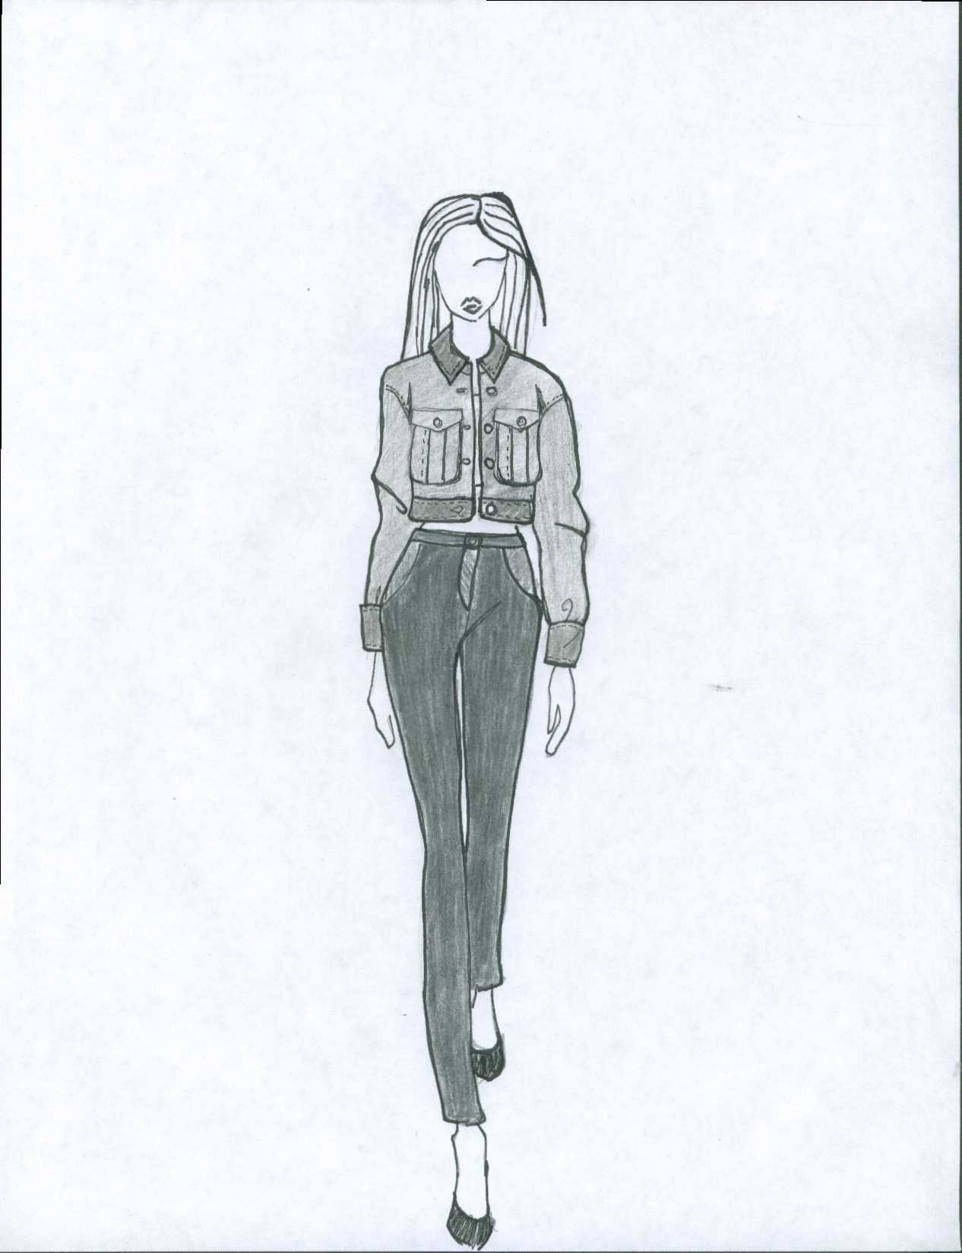
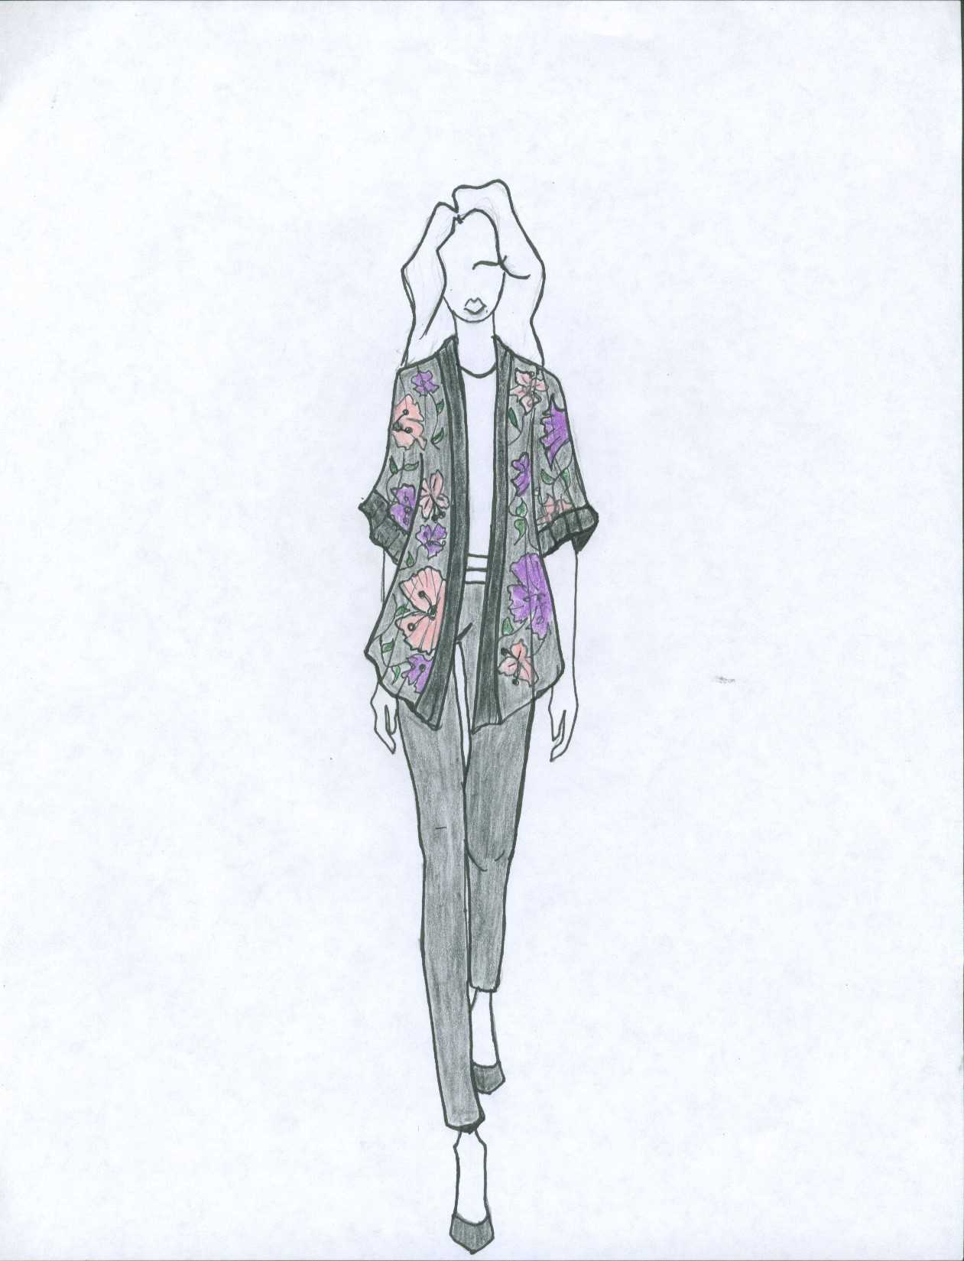

Why are sustainable fabrics better for the environment?

Fabrics are over farmed and manufacturers use tons of chemicals to produce clothing in such high volumes. This ends up having a huge impact on water and soil supplies in the areas they are being produced - and the overall result is very taxing on the environment. Cotton is the most common natural fabric used in fashion and is in nearly 40 percent of our clothing (Stevens, C, 2014). It’s also a very water-intensive crop, which means it needs a lot of water just to grow. In addition, non-organic cotton also uses pesticides, which unsurprisingly trickles into the water supply and soil.

Synthetic and man-made fibers may seem like a better choice from a water preservation standpoint, but they deliver a host of other complications, namely, polyester (including nylon, spandex and acrylic) release microfibers into the water system as well. These tiny plastic fibers contribute to the overall plastic load in our lakes and rivers, and make their way into the food chain. To put it in perspective, washing a single synthetic clothing item can release 1,900 microfibers into the water (Moorhouse, D., & Moorhouse, D, 2018).

Furthermore, Denim and leather are widely viewed as the most toxic fabrics because of the processing and dyeing techniques they undergo. To add insult to injury, most of the leather tanneries, in particular, face worker safety concerns in addition to environmental ones (Cannon, C. B, 2015). Fortunately there are now fabrics that are safe on the environment, recycled or biodegradable and are readily available for brands to use. Little by little, there are brands in mass markets taking notice and becoming more conscious of their practices and fabric usage within their companies.

How does our brand commit to being sustainable?

We want to be as transparent as possible, this will allow our customers to be informed about our sourcing practices and it’s costs. Each material and/ or fabric we use for our jackets will be certified by the GOTS (Global organic textiles standard), to ensure our target market that we practice what we preach. This means not using pesticides and chemicals to treat fabrics, as most speed to market brands do. Choosing organic fibers and sustainable fabrics - such as organic cotton or recycled PET bottles - can drastically cut down on the amount of carbon that is released into the atmosphere and the chemicals that are used in the process (Schultz-Clark, O, 2018). We want to make beautiful jackets that are made with a fraction of the environmental impact that regular fashion has on the world.

SKUS

 | A | B | C | D | E | F | G
1 | Style # | Color # | Season | Size | SKU | IRN | Month
2 | 11234 | 001 - BLK | S/S 2020 | Small | 11234-001-S20-S | 00-1 | February
3 | 11234 | 001 - BLK | S/S 2020 | Medium | 11234-001-S20-M | 00-2 | February
4 | 11234 | 001 - BLK | S/S 2020 | Large | 11234-001-S20-L | 00-3 | February
5 | 11234 | 002- Light Gry | S/S 2020 | Small | 11234-002-S20-S | 00-4 | February
6 | 11234 | 002- Light Gry | S/S 2020 | Medium | 11234-002-S20-M | 00-5 | February
7 | 11234 | 002- Light Gry | S/S 2020 | Large | 11234-002-S20-L | 00-6 | February
8 | 11234 | 003-Taupe | S/S 2020 | Small | 11234-003-S20-S | 00-7 | February
9 | 11234 | 003-Taupe | S/S 2020 | Medium | 11234-003-S20-M | 00-8 | February
10 | 11234 | 003-Taupe | S/S 2020 | Large | 11234-003-S20-L | 00-9 | February
11 | 11235 | 001 - BLK | S/S 2020 | Small | 11235-001-S20-S | 0-10 | March
12 | 11235 | 001 - BLK | S/S 2020 | Medium | 11235-001-S20-M | 0-11 | March
13 | 11235 | 001 - BLK | S/S 2020 | Large | 11235-001-S20-L | 0-12 | March
14 | 11235 | 021-Mocha | S/S 2020 | Small | 11235-021-S20-S | 0-13 | March
15 | 11235 | 021-Mocha | S/S 2020 | Medium | 11235-021-S20-M | 0-14 | March
16 | 11235 | 021-Mocha | S/S 2020 | Large | 11235-021-S20-L | 0-15 | March
17 | 11235 | 004-Olive | S/S 2020 | Small | 11235-004-S20-S | 0-16 | March
18 | 11235 | 004-Olive | S/S 2020 | Medium | 11235-004-S20-M | 0-17 | March
19 | 11235 | 004-Olive | S/S 2020 | Large | 11235-004-S20-L | 0-18 | March
20 | 11236 | 022-MMustard | S/S 2020 | Small | 11236-022-S20-S | 0-19 | April
21 | 11236 | 022-MMustard | S/S 2020 | Medium | 11236-022-S20-M | 0-20 | April
22 | 11236 | 022-MMustard | S/S 2020 | Large | 11236-022-S20-L | 0-21 | April
23 | 11236 | 023-Mpurple | S/S 2020 | Small | 11236-023-S20-S | 0-22 | April
24 | 11236 | 023-Mpurple | S/S 2020 | Medium | 11236-023-S20-M | 0-23 | April
25 | 11236 | 023-Mpurple | S/S 2020 | Large | 11236-023-S20-L | 0-24 | April
26 | 11236 | 005-Ivory | S/S 2020 | Small | 11236-005-S20-S | 0-25 | April
27 | 11236 | 005-Ivory | S/S 2020 | Medium | 11236-005-S20-M | 0-26 | April
28 | 11236 | 005-Ivory | S/S 2020 | Large | 11236-005-S20-L | 0-27 | April
29 | 11237 | 001 - BLK | S/S 2020 | Small | 11237-001-S20-S | 0-28 | May
30 | 11237 | 001 - BLK | S/S 2020 | Medium | 11237-001-S20-M | 0-29 | May
31 | 11237 | 001 - BLK | S/S 2020 | Large | 11237-001-S20-L | 0-30 | May
32 | 11237 | 006 - White | S/S 2020 | Small | 11237-006-S20-S | 0-31 | May
33 | 11237 | 006 - White | S/S 2020 | Medium | 11237-006-S20-M | 0-32 | May
34 | 11237 | 006 - White | S/S 2020 | Large | 11237-006-S20-L | 0-33 | May
35 | 11237 | 007 - Charcoal | S/S 2020 | Small | 11237-007-S20-S | 0-34 | May
36 | 11237 | 007 - Charcoal | S/S 2020 | Medium | 11237-007-S20-M | 0-35 | May
37 | 11237 | 007 - Charcoal | S/S 2020 | Large | 11237-007-S20-L | 0-36 | May
38 | 11238 | 024 - Bfl | S/S 2020 | Small | 11238-024-S20-S | 0-37 | June / July
39 | 11238 | 024 - Bfl | S/S 2020 | Medium | 11238-024-S20-M | 0-38 | June / July
40 | 11238 | 024 - Bfl | S/S 2020 | Large | 11238-024-S20-L | 0-39 | June / July
41 | 11238 | 025 - Mauve | S/S 2020 | Small | 11238-025-S20-S | 0-40 | June / July
42 | 11238 | 025 - Mauve | S/S 2020 | Medium | 11238-025-S20-M | 0-41 | June / July
43 | 11238 | 025 - Mauve | S/S 2020 | Large | 11238-025-S20-L | 0-42 | June / July
44 | 11238 | 026- Bblue | S/S 2020 | Small | 11238-026-S20-S | 0-43 | June / July
45 | 11238 | 026- Bblue | S/S 2020 | Medium | 11238-026-S20-M | 0-44 | June / July
46 | 11238 | 026- Bblue | S/S 2020 | Large | 11238-026-S20-L | 0-45 | June / July

Part B
B1. Open to buy for each month

Month | Planned Sales | + | Planned Reductions | + | Planned EOM | = | Total Monthly Needs | - | BOM Stocks | = | Planned Purchases | - | Merchandise on Order | = | Open to Buy (At Retail)
Feb | $300,000 |  | $20,000 |  | $200,000 |  | $520,000 |  | $160,000 |  | $360,000 |  | $125,000 |  | $235,000
Mar | $200,000 |  | $26,000 |  | $80,000 |  | $306,000 |  | $200,000 |  | $106,000 |  | $15,000 |  | $91,000
Apr | $300,000 |  | $31,000 |  | $110,000 |  | $441,000 |  | $80,000 |  | $361,000 |  | $145,000 |  | $216,000
May | $200,000 |  | $7,000 |  | $90,000 |  | $297,000 |  | $110,000 |  | $187,000 |  | $35,000 |  | $152,000
Jun | $400,000 |  | $46,000 |  | $210,000 |  | $656,000 |  | $90,000 |  | $566,000 |  | $170,000 |  | $366,000
Jul | $250,000 |  | $50,000 |  | $70,000 |  | $370,00 |  | $210,000 |  | $160,000 |  | $24,000 |  | $136,000

B2. Average monthly sales
Planned Sales | ÷ | # of months | Average Monthly Sales
Feb $300,000 |  | 6 | $50,000
Mar $200,000 |  | 6 | $33,333
Apr $300,000 |  | 6 | $50,000
May $200,000 |  | 6 | $33,333
June $400,000 |  | 6 | $66,667
July $250,000 |  | 6 | $41,667

B3. Average monthly on order
On Order
Feb | $125,000
Mar | $15,000
Apr | $145,000
May | $35,000
June | $170,000
July | $24,000
Average monthly on order | $85,667

B4. Markdown % for each month

Month | Planned Sales | ÷ | Markdowns | = | Markdown % for each month
Feb | $300,000 |  | $8,000 |  | 37.5%
Mar | $200,000 |  | $12,000 |  | 16.7%
Apr | $300,000 |  | $4,000 |  | 75%
May | $200,000 |  | $3,000 |  | 66.7%
June | $400,000 |  | $18,000 |  | 22.2%
July | $250,000 |  | $25,000 |  | 10%

Part C
C1. After careful analysis of the economic data from the U. S. Government the XYZ store set a sales plan increase for the next season (Feb.- July) of 6.2%. Based on this year's sales plan what is the company's new projected sales plan for the next season?

Answer: $1,752,300

C2. In the prior year same sales period the XYZ store had actual sales of $1,820,000.00. What was the increase/decrease for the sales period and suggest reasons for the change from one season to the next.

Answer: $67,700

References

A-Z GLOSSARY OF SUSTAINABLE FIBRES. (n.d.). Retrieved from https://www.1millionwomen.com.au/blog/a-z-glossary-of-sustainable-fibres/
Moorhouse, D., & Moorhouse, D. (2018). Designing a sustainable brand strategy for the fashion industry. Clothing Cultures, 5(1), 7+. Retrieved from http://link.galegroup.com.citytech.ezproxy.cuny.edu/apps/doc/A551424181/AONE?u=cuny_nytc&sid=AONE&xid=0384521a
Scaturro, S. (2008). Eco-tech fashion: rationalizing technology in sustainable fashion. Fashion Theory, 12(4), 469+. Retrieved from http://link.galegroup.com.citytech.ezproxy.cuny.edu/apps/doc/A198414073/AONE?u=cuny_nytc&sid=AONE&xid=3b8aa355
Stevens, C. (2014, December). Fletcher, Kate. Sustainable fashion and textiles: design journeys. CHOICE: Current Reviews for Academic Libraries, 52(4), 599. Retrieved from http://link.galegroup.com.citytech.ezproxy.cuny.edu/apps/doc/A392069394/AONE?u=cuny_nytc&sid=AONE&xid=cd1bc0b4
Schultz-Clark, O. (2018). Industry insight: Conscious consumption. Clothing Cultures, 5(1), 193+. Retrieved from http://link.galegroup.com.citytech.ezproxy.cuny.edu/apps/doc/A551424196/AONE?u=cuny_nytc&sid=AONE&xid=1195ab73
Cannon, C. B. (2015, April). Routledge handbook of sustainability and fashion. CHOICE: Current Reviews for Academic Libraries, 52(8), 1302. Retrieved from http://link.galegroup.com.citytech.ezproxy.cuny.edu/apps/doc/A416401798/AONE?u=cuny_nytc&sid=AONE&xid=80af2389

