Electrical and Telecommunications Technology Department

Reflections on Field Trip to

CCW SATCON CONFERENCE

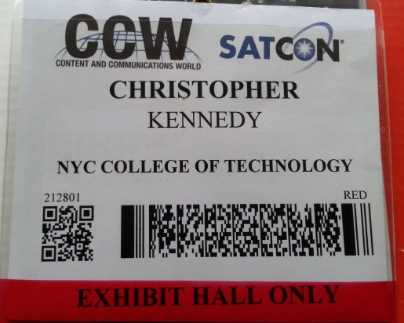

NAME OF STUDENTS: CHRISTOPHER KENNEDY

Field trip date: November 13, 2013

Content and Communication World (CCW) 2013 held at the Jacob Javits Convention Center in New York City on November 13-14, 20013 was my first technology expo in this country that I now call home. It was attended by almost 7000 attendees. Mark your calendar for CCW 2014 – November 12-13 at the Javits Convention Center in New York City.
According to the shows website, “CCW brings together the most inspired minds in media and entertainment production, post and distribution from around the world. Interact with the latest products, explore technological innovations firsthand, and hear from experts who shape the industry at every stage”. With the show also incorporating the SATCON element, it presented a wide array of services and end user products, which when combined together gave the attendant a cross-section of today technological innovations.
The focus of the expo was on:
- Broadcast Engineering  - Ultra HD and 4K  - Content Creation & Production  - Post Production  - Film & Digital Cinema  - Streaming, OTT &  Connected Media  - DAM & Storage | - Content Delivery & Distribution  - Cloud Services  - Enterprise Video  - IT & Network Infrastructure  - Pro Audio  - AV Integration  - Government / Military  - Satellite Communications

The dynamics of the expo was so vast, that for a techie, one could just get lost in the myriad of technology present, from the 4k television, the canon super camera to the 27lb portable fully integrated satellite receiver system from VISLINK that function on all the bands, including the military X band. It was a wonderful experience to see real world application of the satellite link budget and to hear real world users give their take on future technology. Though most of the expo was geared towards getting new customers, there was the ability to see physical low noise amplifiers, high power amplifiers and the various ways in which satellite technology could be integrated with real world situations and demand. New configurations of LCD displays, top end cameras, multimedia systems, you name it, and it was there. I would like to take this moment to thank Professor Razani for the exposure and his years of
experience in the field.
