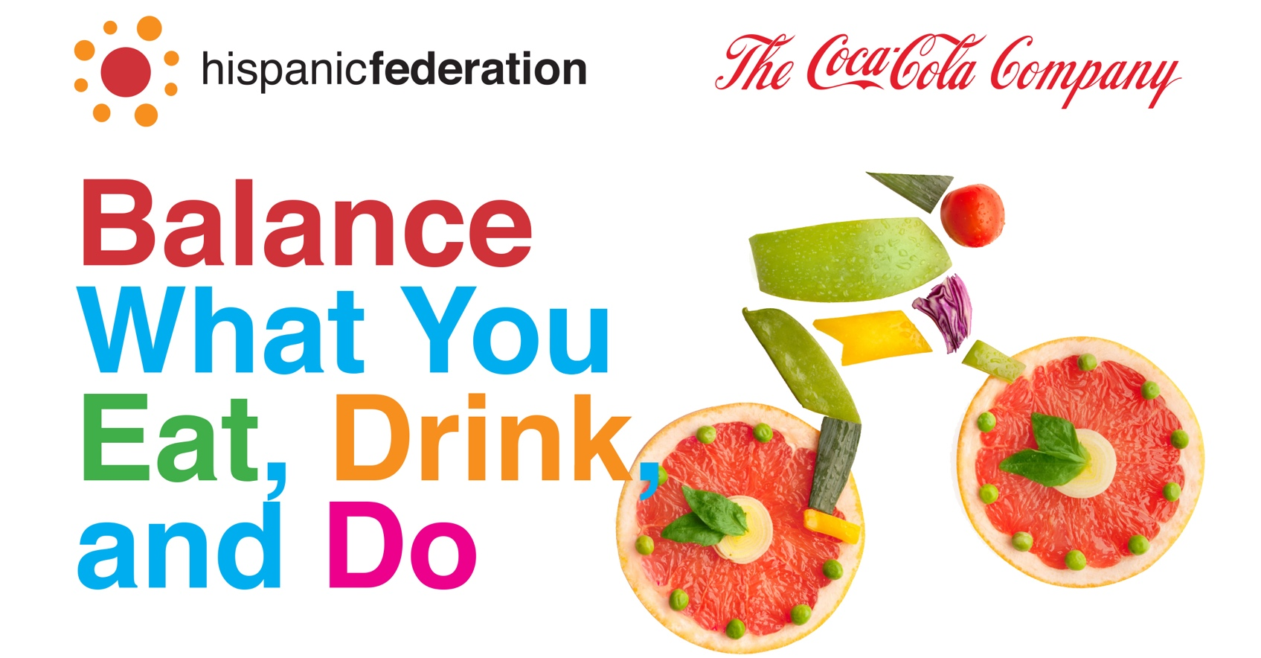

Thursday, October 13th
5:45pm - 7:15pm.
New York City College of Technology
300 Jay Street
Brooklyn, NY 11201
For more information call Bethsy Morales at 212-233-8955 or bmorales@hispanicfederation.org

