Citlalli Villanueva

Financial Management

Pr. Akakazi

December 13th, 2022.

Apple Inc. Project

Company’s mission statement: “serve consumers through online and physical stores and focus on selection, price, and convenience.”

Apple’s corporate headquarters is located in Cupertino, California, and has been reported to have 164,000 employees working for them.

Apple is a company founded by Steve Jobs on April 1st, 1976, in Los Altos California. Jobs was raised by adoptive parents in Cupertino, California. Later in his life, he dropped out of Reed College, in Portland, Oregon, and was a video game designer in early 1974. He then reconnected with Stephen Wozniak, a high school friend and after talking about Wozniak’s computer logic board, Jobs suggested working together. The first product they ever designed was the Apple I, funded by the money from selling Steve Jobs’ Volkswagen and Wozniak’s programmable calculator.

Products sold in the company: iCloud store, Mac, iPads, iPhones, iWatches, AirPods, AppleTV, and AppleHome.

I am a big fan of their phone and laptop designs, I think the quality is good, but the price is what I don’t agree with, it seems to me that yes you are paying for good quality and advanced technology but at the same time you are paying for the name of the brand. Also, they haven’t innovated the iPhone design these past couple of years.

The percentage of Market Share in the global smartphone industry as of Q1 2022 is 18%. After calculating the performance index, I found that Apple is good, they are selling a good amount of goods though they are in second place, right behind their competitor: Samsung.

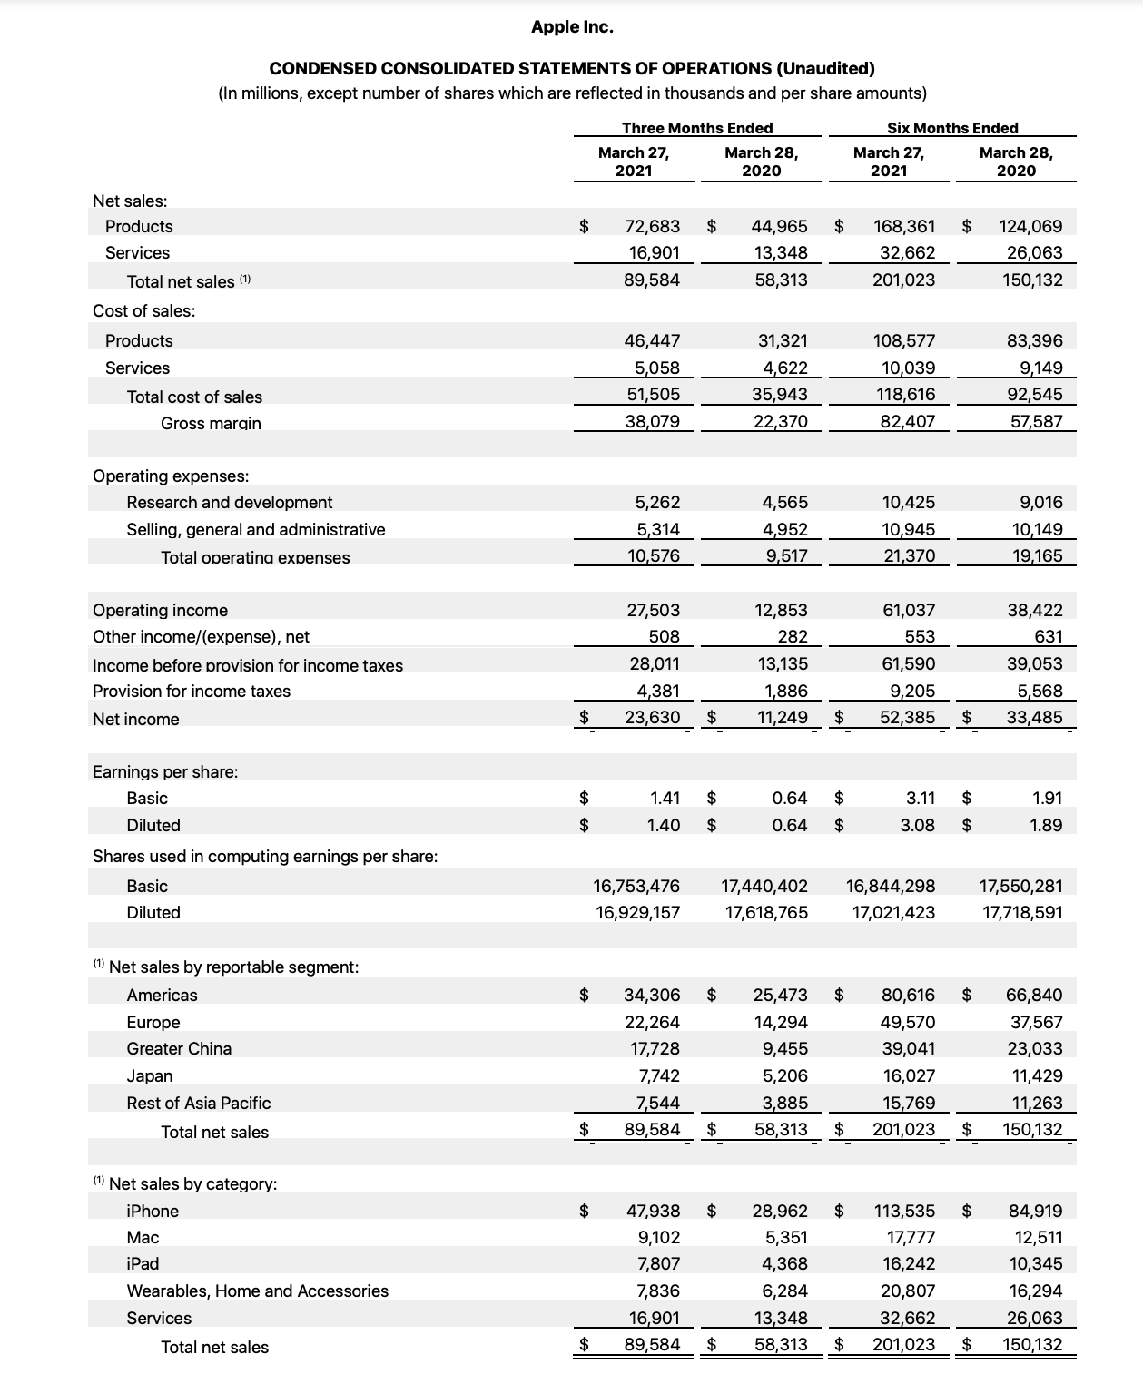

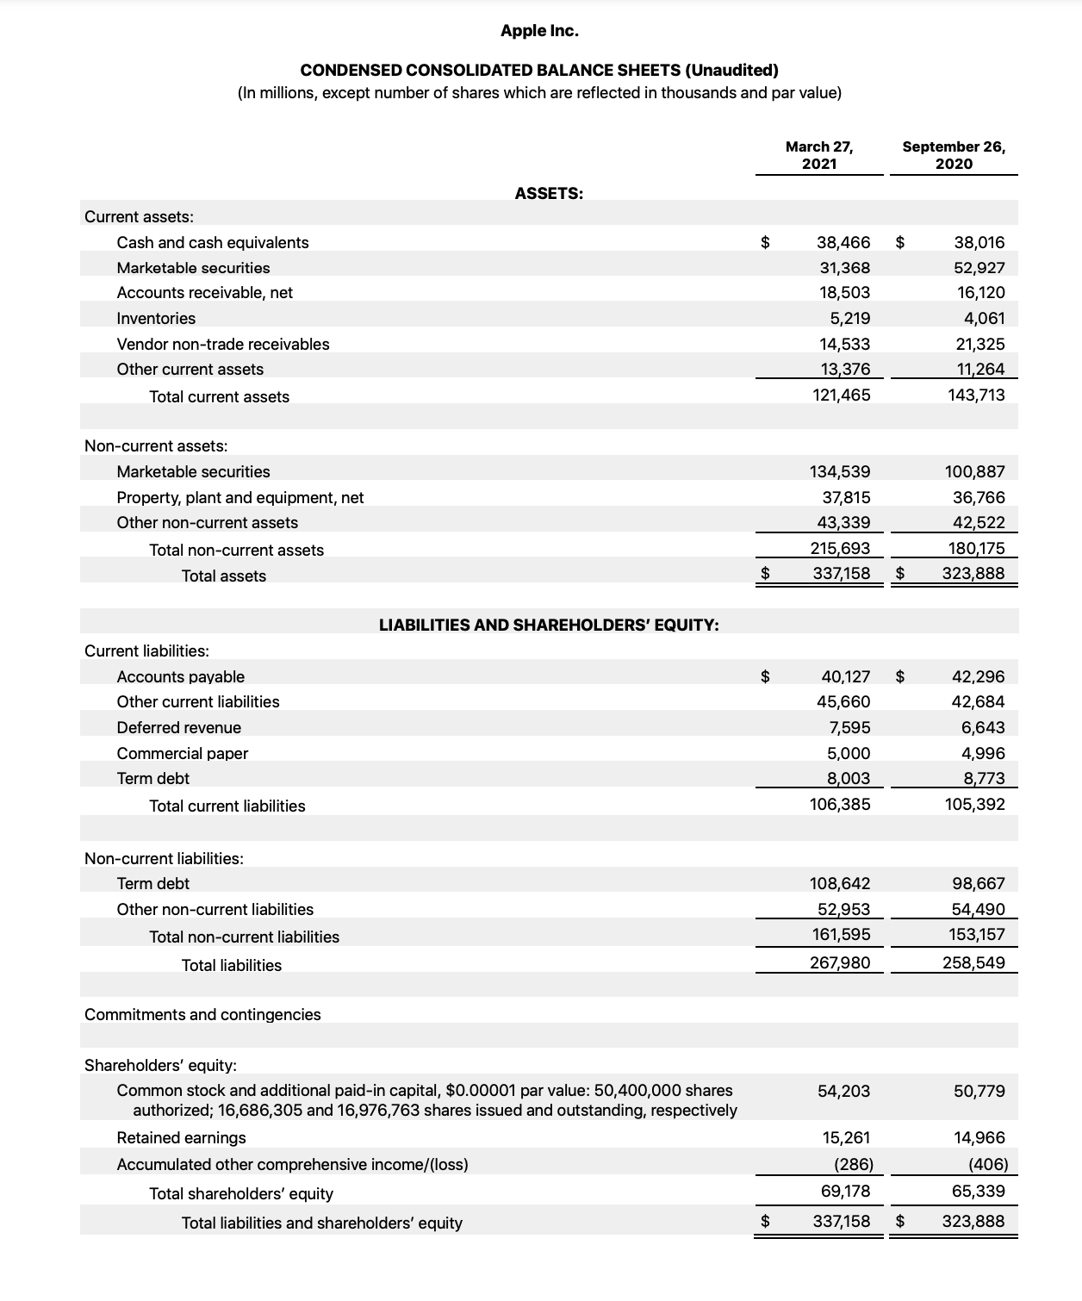

**Final Ratio Analysis:**

*Liquidity Ratios*

Current ratio= 121,465 / 106,385 = 1.1417

Acid-test ratio= 121,465 – 5,219 / 106,385 = 1.0926

Cash ratio= 38,466 / 106,385 = 0.3615

Operating cash flow ratio= 104,038 / 106,385 = 0.9779

*Leverage Financial Ratios*

Debt ratio= 267,980 / 337,158 = 0.7948

Debt to equity ratio= 267,980 / 69,178 = 3.8737

Interest coverage ratio= 108,949 / 2,645 = 10.3981

Debt service coverage ratio= 108,949 / 365,817 = 0.2978

*Efficiency Ratios*

Asset turnover ratio= 89,584 / 330,523 = 0.2710

Inventory turnover ratio= 213,000 / 4,640 = 45.9051

Receivables turnover ratio= 365,817 / 17,311 = 21.1320

Days sales in inventory ratio= 365 days / (213,000 / 4,640) = 7.9511

*Profitability Ratios*

Gross margin ratio= 152,836 / 201,023 = 0.7602

Operating margin ratio= 108,949 / 201,023 = 0.5419

Return on assets ratio= 58,385 / 337,158 = 0.1731

Return on equity ratio= 58,385 / 69,178 = 0.8439

*Market Value Ratios*

Book value per share ratio= (69,178 –14,467) / 16,865 = 3.2440

Dividend yield ratio= 0.22 / 136.50 = 0.0016

Earnings per share ratio= 20,720 / 16,865 = 1.2285

Price-earning ratio= 136.50 / 6.11 = 22.3404

From the previous analysis, I can conclude that Apple Inc had a strong current radio in 2021 and it is positioned as the 2nd best cellphone seller in the world. It is worth investing in them, Apple's stock hit new all-time highs toward the end of 2021.

Websites used.

<https://www.apple.com/newsroom/pdfs/FY22_Q4_Consolidated_Financial_Statements.pdf>

<https://www.britannica.com/biography/Steve-Jobs/Saving-Apple>

<https://www.counterpointresearch.com/global-smartphone-share/>