Midterm Essay Exam

Citlalli Villanueva

Business of Fashion Department, New York City College of Technology

BUF 4900: Internship

Professor Alyssa Adomaitis

November 7th, 2024

**Introduction**

Africa’s Fashion Diaspora exhibition celebrates diversity seen in Black culture fashion. Curator Elizabeth Way was the thoughtful brain behind it, along with the National Endowment for the Arts sponsorship. The exhibition is diverse, including different types of Black culture in different geographical parts, times, and religions. This display of fashion pieces aims to communicate how Black cultures have always used dress as a form of pride, uniqueness, and resilience. In a diverse world, it is essential to understand and recognize different types of cultures to celebrate uniqueness, break stereotypes, and encourage feelings of pride in people.

The curation also emphasizes the global nature of Black fashion influence, showcasing designs from the African continent, the Caribbean, America, and Europe. This exhibition is suitable visual proof of how African fashion aesthetics have always been preserved, then evolved, but always persevered through different generations and eras. In the exhibition, we can appreciate designers like Christian Louboutin. As mentioned before, the team that worked in the exhibition curated every piece, from the clothing to accessories, videos on the walls, and music played, creating an exceptional ambient that wraps you around the culture. Nowadays, representation plays a crucial part in our society, and these exhibitions only help enhance the need to showcase glorious cultures like Black culture.

**Analysis of Garment**

At the exhibition, one can identify the strong patterns that Black culture follows: bright colors such as yellow, orange, pink, black, and green. These bright colors symbolize joy, strength, unity, and nature. Nature-inspired fabrics are used in their garments, headpieces, cutouts, oversized silhouettes, mixed patterns, etc. There is considerable attention to detail, with sequins and beads used for minor details that not everyone’s eye can catch, which are used to symbolize status or beauty. Black culture is rich in heritage, and it is showcased all around the world as one of the most diverse cultures.

This particular garment’s primary colors are deep bright blue, pink, yellow, black, and rose gold, each with significance. Black represents mystery and sophistication; blue is a comfortable color. Pink represents pretty, and yellow represents happiness (Bell & Tetanus, 2017). The variety of tones and shades of this design’s colors create a wealthy group of colors that transmit youthness, joy, and strength, which are well-represented topics in African Diaspora fashion. In this specific design, the line, which refers to the directions of the marks on the design, makes the cape hard to determine due to the cutout distortion on the cape’s fabric. Although the cape is hard to identify, the trousers give the illusion of a vertical line, elongating the mannequin's legs and height. This vertical elongation technique is used in fashion to showcase elegance and pride.

The rhythmic use of patterns and colors in this garment, specifically through the cutouts in the cape and the dots pattern on the blouse, makes the garments feel lively yet balanced. Rhythm creates movement and a sense of flow in the clothing items (Bell & Tetanus, 2017). The type of rhythm used is well-known in traditional African textiles, where it is very typical to mix and match different prominent patterns to create something diverse. A blend of conventional Black culture patterns and colors was made through innovation.

The garments’ forms are cone-like, creating a voluminous silhouette by the end of the cape. This reshapes the body’s original form, emphasizing the cape’s primary purpose as a statement piece. Something characteristic of Black culture is their love to enhance certain parts of the human body. Exaggerating parts of the body makes a celebration of the body, visually focusing on a specific part. Accentuates the cultures’ uniqueness and richness.

There is a symmetrical composition; weight appears balanced if the image is split vertically. If the image is split horizontally, the asymmetry would be shown by the cape’s heavy silhouette at the length of the mannequin’s knees. This dual balance reflects the complexion in which Black culture fashion is designed. While some elements might feel in harmony, others break convention. Black fashion is a mix of creativity and harmony yet a war of vibrant colors that dynamically find their sense of union.

The main contrast in the chosen garments is the colors and the patterns used for the cape and the blouse. The bright blue in this garment is the dominant color due to its impact on the outfit's high value, and it immediately captivates the visitor’s attention. This dominance of blue accentuates the cape as a solo piece but also the meaning of the blue itself, which is comfort and stability. Aside from being partially balanced, the garment's proportions are carefully balanced. The long cape could risk making the silhouette appear short if cut at that height, but the long black trousers maintain an elongated silhouette. The careful balance of proportions is crucial in Black culture fashion to achieve a harmonious look that resembles power and sophistication.

Repetition is non-deniable in the patterns selected for the blouse and the cape, using contrasting colors. The repetition is evident in these garments. At the same time, repetition plays a huge part in African Diaspora fashion, which can be found in multiple designs. The reaped use of dots and vibrant colors in this design also references traditional African textile techniques in the exhibition. The usage of patterns in this culture is a way of celebrating their cultural identity and honoring tradition.

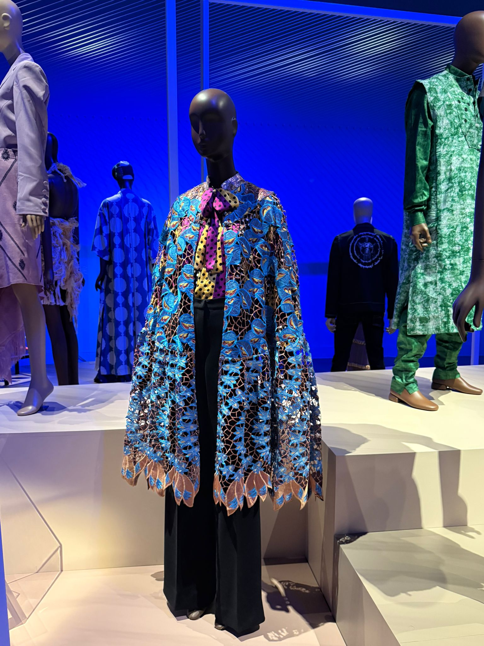

*Figure 1.* FIT Museum selected look

**Texture and Fabric Analysis**

Duro Olowu is the designer behind the chosen outfit—his inspiration comes from his Diaspora Heritage, a mix of Jamaican and Nigerian. The predominant texture in this outfit is the cape, which is cotton and silk lace fabric with an extended cutout pattern. The cape falls gracefully on the mannequin’s body due to its moldable fabric. The cape's texture appears rough, suggesting masculinity. The fabric used for the blouse is silk, which has a shiny finish that makes the colors appear more brilliant, contrasting the masculine look of the cape and adding a touch of femininity. Lastly, the trousers are made of silk and wool fabrics, appearing heavier to the sight and exclaiming elegance (Bell & Tetanus, 2017). With a pleasing drape due to the bagginess of the garment, the fabric falls smoothly through the legs, creating comfort for everyday use.

**Conclusion**

The chosen garment reflects dress in its totality, from its texture to its patterns to its silhouette, drawing attention to its richness and pride. Black culture's uniqueness in fashion and music has always been so distinctive that it has inspired white culture due to its contagious influence. Black culture has been a pioneer of inspiration in a fashion that was often overseen and unfairly discredited (Stacey, n.d). African Diaspora is proof of how unbreakable black culture is. Still, it mainly serves as a celebration of African traditions' survival, evolution, and adaptation.

Social modern movements that advocate more equal rights, social justice, and Black pride also influence fashion. Black culture is portrayed in documentaries, songs, and fashion magazines, which often highlight the struggles and battles they confront in society and remark on the impact of the African Diaspora. Fashion is the open door for Black culture to demonstrate how powerful a visual communicator dress is. An excellent example is the Black Panthers’ use of leather jackets and berets to symbolize militant resistance in the 1960s (Taylor, 2022). Not to forget the unfortunate situation that started the Black Lives movement and how people wore t-shirts with George Floyd’s image as the face of the movement.

This visual communicator extends beyond mere aesthetics, encompassing years of cultural resilience and innovation, just as it did when African communities started sending hidden messages through their braids. Nowadays, dress is so ingrained in them that it is merely essential to their culture for everyone to respect it. The CROWN Act movement is in charge of legislation that protects Black culture against hair discrimination (The Official CROWN Act, n.d). Due to its lack of cultural representation, the fashion industry has been pointed at, and movements like this help diversity.

To conclude, the African Fashion Diaspora is more than a collection of garments; it represents a powerful history of battles, preservations, and diversity. Regardless of the various intentions to erase Black culture, its communities remain more potent than ever. Fashion has served Black communities as armor and a sword when fighting for equality and what they deserve. One will always be amazed by how rich this culture is and how hard it has fought for recognition.

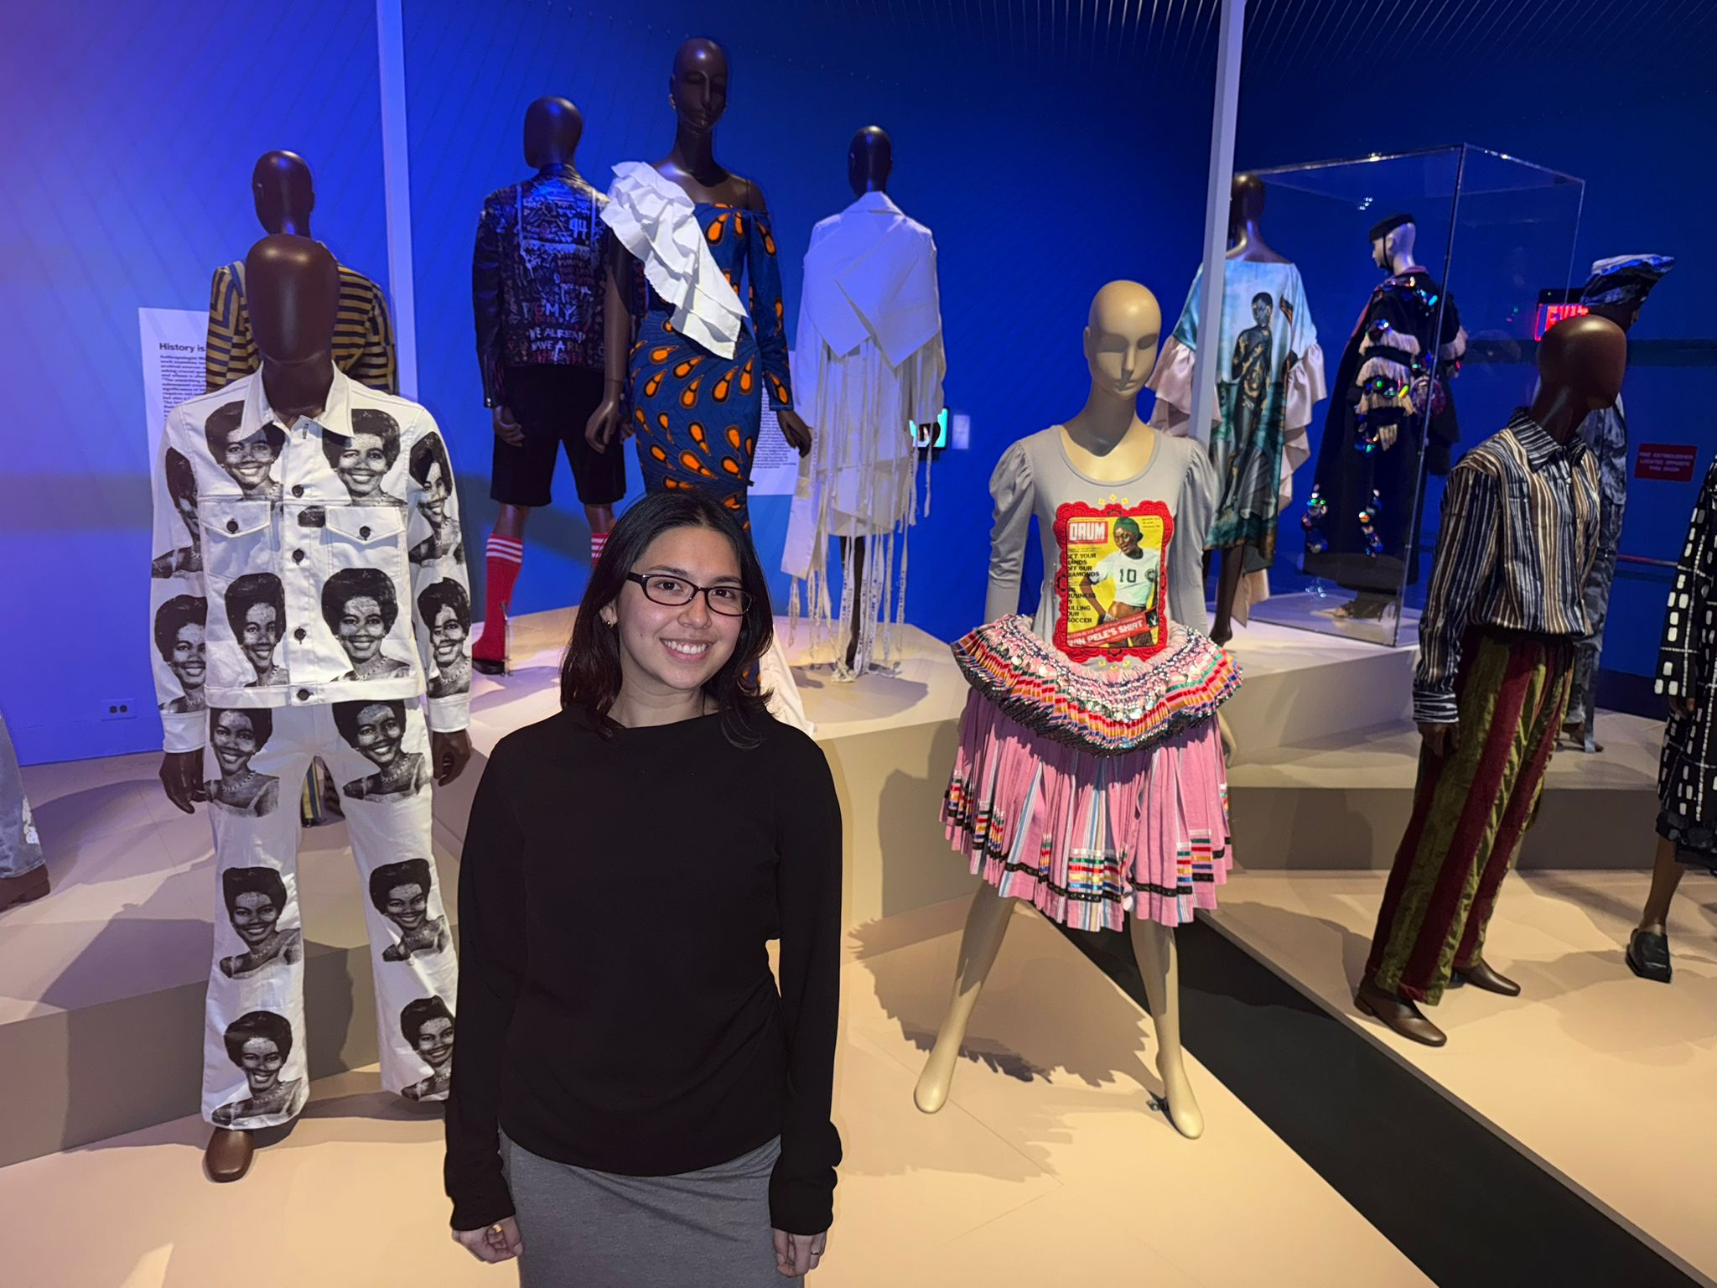

*Figure 2.* Citlalli Villanueva at the FIT Museum

**References**

*About*. The Official CROWN Act. (n.d.). Retrieved from: <https://www.thecrownact.com/about>

*Africa’s fashion diaspora*. Home. (n.d.). Retrieved from:

<https://www.fitnyc.edu/museum/exhibitions/africas-fashion-diaspora/index.php>

Bell, J., & Ternus, K. (2017). *Silent selling: Best practices and effective strategies in visual*

*Merchandising*. Fairchild Books.

*Figure 1.* FIT Museum selected look

*Figure 2.* Citlalli Villanueva at the FIT Museum

Stacey, L. (n.d.). *Four fashion trends rooted in black culture*. Four Fashion Trends Rooted in

Black Culture | Bowie State. Retrieved from: <https://www.bowiestate.edu/academics/colleges/college-of-arts-and-sciences/departments/communications/student-organizations-and-publications/the-spectrum/2023/four-fashion-trends-rooted-in-black-culture.php>

Taylor, N. (2022, September 16). *More than a Fashion Statement The Symbolism behind the Black*

*Panther Party Uniform*. Request rejected. Retrieved from: <https://nmaahc.si.edu/explore/stories/black-panther-party-uniform>