Wardrobe chronicles: wear it again, feel it again

By Citlalli Villanueva

Wardrobe chronicles: wear it again, feel it again

**Prologue**

In life, human beings unconsciously weave memories into fabrics that belong to themselves. An invisible string is made out of thin layers and engraved in our hearts and minds, whether it was the best day ever or the saddest one, clothes are the physical medium to me that allows me to touch a moment in the past. For me, these garments are not mere fabrics, they are repositories of memory. I vividly remember every detail of specific outfits I was wearing when something life-altering happened, from love and loss to unforgettable attires that I hope I barely have to put on in life. This book is a journey through the wardrobe of my life, where garments are the centerpiece of attention as I unravel the stories, places, and feelings that took place at that time. This is my memoir in fabric, in these chapters, I leave a piece of me to wear.

**Forward**

The day Citlalli was born, 2 things happened that the nurses told me would be good luck for her. The first one was that they allowed me to cut the umbilical cord, which would separate her from her mom. Secondly, is that through the small window in the operating room, I could see how it started snowing. Since she was a kid I have noticed that she is a person who sets goals and she thinks profoundly about every step she takes, every step is already visualized in her mind. Every idea she projects in her mind, she calculates to make it a reality in the future. I am a very proud father. She knows she can go as far as she wants to, and understands that we all fall at some point, but the best part is that she knows how to get up and move forward without looking back. Since she was little, she liked to combine her clothes, design bags with my old pants that were no longer in use, make skirts from old or unused t-shirts, and draw her clothing prototypes, these chapters are a reflection of her development as a person and how her life revolves around fashion.

With love,

-Citlalli’s dad.

**Acknowledgment**

This book is a reflection of how people in my surroundings inspire me every day in my fashion decisions. More importantly, the realization that my grandma, Dilia Maria Godina, had a lot to do with it but I was not able to process that information until writing this book. Some other people important to mention are my father, Luis Antonio, and my brother, Luis Adrian, growing up with them in a male household pushed me into my most beautiful feminine side to try to create a contrast between us. Last but not least, my friend, Nicole Lin, and my best friend and boyfriend, Carlos Figueroa filled me up with confidence and support to always be the most authentic version of myself. In these chapters, there is a descriptive journal of every step I took to find my individuality in the Fashion Industry, my path in creativity and major events that altered my life.

**Table of content**

Prologue…………………………………………………………..…………………....p 2

Forward……………………….………………………………..……………………....p 3

Acknowledgment………….………….……………………..………………………....p 4

Chapter 1: The Hannah Montana Look.………………………………………………..p 6

Chapter 2: Rainy Day…………………………………………………………………..p 9

Chapter 3: Wedding Bells.……………………………………………………………..p 12

Chapter 4: First Vintage………………………………………………………………..p 15

Chapter 5: Red..………………………………………………………………………..p 18

Chapter 6: Adiós, abue.………………………………………………………………..p 21

Chapter 7: First Day of a New Life…….……………………………………………..p 24

Chapter 8: The Grudge…………………..……………………………………..……..p 27

Chapter 9: One Spoon for Two………………………………………………………..p 29

Chapter 10: Red lipstick..………………..…………………………………………....p 31

Chapter 11: Leather jacket..………………..………………………………………….p 33

Chapter 12: Low-waisted jeans…….………………………………………………....p 35

Chapter 13: Red Velvet……………….………………………………………….…....p 37

Chapter 14: Ciao!.………………………………………………………………….....p 39

Chapter 15: XXIII………………………………………………………………….....p 41

About the author……………………………………………………………………....p 43

**Chapter 1: The Hannah Montana Look**

As a curious seven-year-old, the Hannah Montana looks were probably my fashion awakening. I used to watch the show with my younger brother, Luis, who was five years old at that time. We shared the room, and our twin beds were side by side to create a bigger bed for us to jump on. We had a big heavy old gray TV in which we watched all our shows together. Our room windows captured a lot of daylight and the bright white walls made the room feel so fresh, our apartment was situated on the second floor of a building, and next to us, there was a big solitary land that had grown lots of wild plants that we could admire from our room window. Hannah Montana was one of my favorites, I loved every one of the youthful, rockstar, fun, and colorful outfits. Sometimes I pretended to be her and jumped on the bed while singing her songs.

Hannah Montana’s signature look was skinny jeans, a graphic red t-shirt, and a bolero leather mini jacket enclosing her arms and shoulders from the show’s song intro. The clothes fitted her so perfectly, they looked amazing to me. I added my personal touch (also learned from her) to my version of her outfit: a *suspended* pink flowy mini skirt over light blue straight-legged jeans and my favorite graphic purple t-shirt that had a heart design in the middle that *enclosed* my torso. No shoes were needed since I only wore the outfit to pretend the bed was my stage. And, of course, a hairbrush that I held as a microphone.

I was so young and by then I had not discovered the world of makeup, my face skin *texture* was impeccable and intact. My teeth were *clean and minty* since my dad, Luis, forced us to brush our teeth constantly after every meal. My nails were probably *bitten*, I used to have the bad habit of biting my nails. My hair was *trimmed* short at the length of my shoulders for most of my kid years. Lastly, my skin was *tanned* and its *texture* was a little bit dry on the back and arms, parts where the sunscreen would wash out very quickly, back then I frequented the beach every weekend. My family and I lived in a small town, Playa del Carmen by the coast in Mexico.

After this period, I remember being more aware of how I wanted my outfits to look, and I started to pay more attention to the different styles of each TV show character that I ever liked. I began to immerse myself and my ideas into what clothes represented. I began to sketch some designs with my cousin, Ana Paula, and we shared our opinions on what was cool to wear and what was a “no-no”. But most importantly, it shaped me somehow in the way that I am now: a fashion enthusiast. Now and then I rewatch some of the episodes and the outfits never cease to impress me.

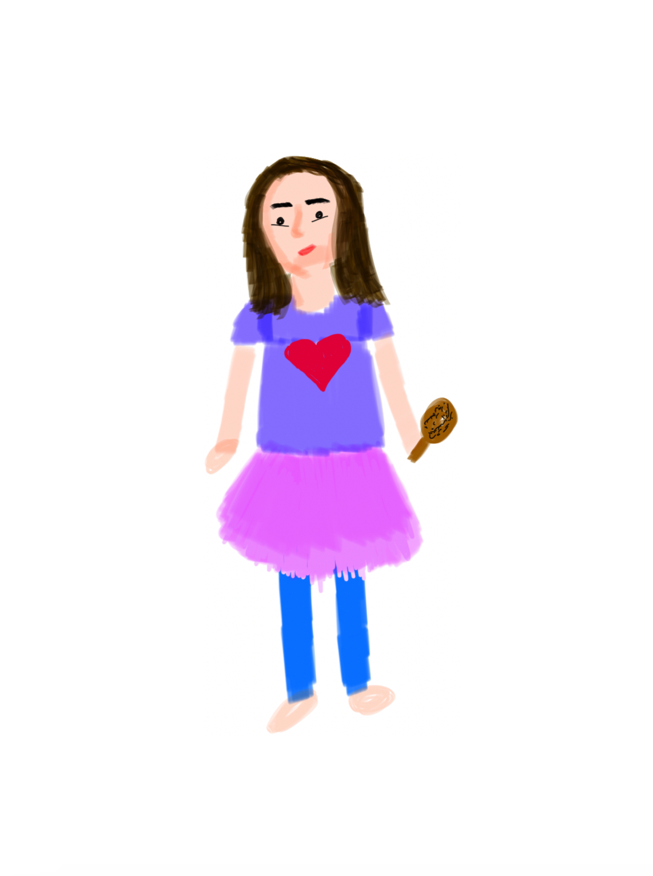

**Chapter 2: Rainy day**

Boots were not a usual shoe wear in the small town where I grew up. Playa del Carmen is located near the beach coast and its weather is very tropical, with this said, it is easy to imagine the weather conditions that I lived in while growing up: lots of rain in the summer, but mostly hot the rest of the year and hurricanes threatening to attack every year. One day, my grandma, Dilia, told me someone had gifted her a pair of rain boots, but that she would not be wearing them, and if I wanted them, I could have them, my immediate response was yes. Luckily, that afternoon it started raining and it was my chance to enjoy the weather and jump in the rain puddles. My front yard had some potholes and was surrounded by four-meter-long palm trees. The smell of wet dirt was so present and the sky was gray.

The navy blue rain boots were a bit old, to the point that once I took them off, some of the cracked plastic that was in the interior, came off. They were mid-length tall ending about six centimeters below my knees *enclosing* my feet. There was a little round metallic charm embedded at the ankle level of the boots that had an umbrella logo, probably the brand of the boots. The end of the shoe was round and had a small two-centimeter heel. To hang out outside I paired the boots with dark blue high-waisted skinny jeans that *enclosed* my legs and a red long-sleeve shirt that had a round neck and stretchy fabric that molded my silhouette perfectly. As always, wearing my small gold hoops *inserted* in my earlobes and put on a small gold chain that was *suspended* from my neck.

My hair was *brushed* and *oiled* from the night before so its *texture* was soft. My nails had clear *nail polish* and were *cut short* since my high school did not allow me to keep long nails. My eyebrows were *overplugged* back then when I was experimenting with eyebrow shapes at that age. My grandma cooked chilaquiles that day, a Mexican dish that I love to eat with chopped onions, so my *breath* was most likely smelling like that. Lastly, I *rubbed* some menthol ointment on my chest to avoid catching a cold and it had a strong scent.

I loved every second of owning my pair of rain boots. They felt very distinct from any other pair of shoes that I owned before. Wearing them made me feel like I was elevating my style, and as a fourteen-year-old, I felt so dreamy. Playing in the rain puddles while wearing them was so fun, it is one of the nicest memories I have from my teenage years. Unfortunately, the boots had been worn before and were old, they lasted about a year, and eventually, the plastic cracked entirely on the right boot inside from the humidity in my closet and they had to be thrown away but I am currently thinking of buying rain boots since they made me so happy back then.

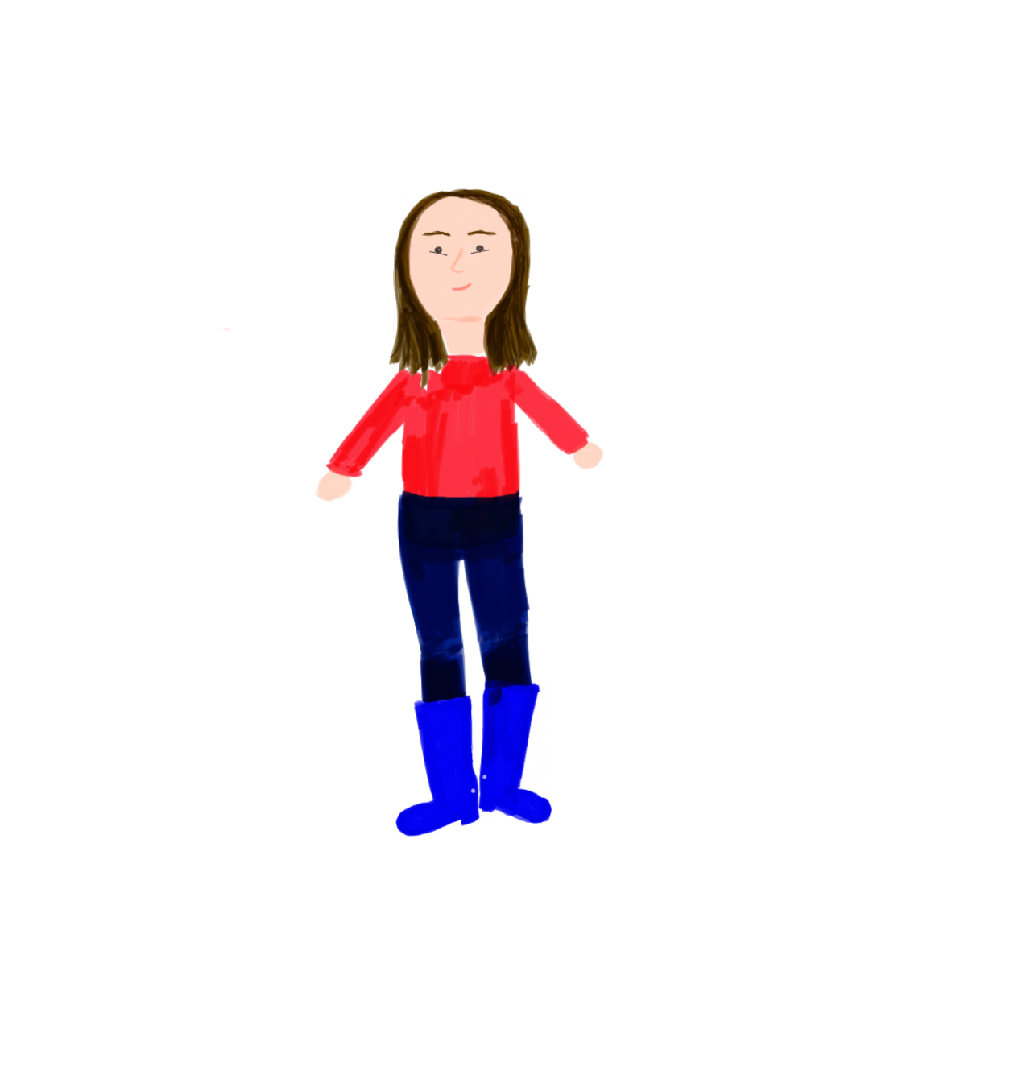

**Chapter 3: Wedding Bells**

My aunt, Pikis, got married in September of 2017 when I was sixteen years old. Her wedding was just beautiful, and it was also the first wedding I had ever attended. The wedding location was by the beach coast, in a big wood open cabin that held around fifteen tables for at least sixty people, there were lots of beautiful and colorful flowers that were part of the decoration of the place. The sound of the waves crashing served as a melody. White cloth on the tables, fancy silverware, and some white slim candles were placed on the tables for the guests. There were light white and cream fabrics hanging from the ceiling serving as part of the decoration for the venue. Some other decorations also helped fill the space like handmade signs with the names of the couple, handmade personalized cards for the guests, a handmade frame for guests to take pictures, etcetera. Pikis invited a good amount of people from our family and some of her and her now spouse, Angel, friends to accompany them on their special day.

My great aunt, Patty, bought me a knee-length light blue dress that had a layer of mesh fabric of the same color and gave the dress a flowy look. The shoulders were uncovered and had a keyhole neckline that *enclosed* my neck. The dress had a zipper on the side but it was seamless to the design of the dress, it had the illusion of a belt that some mesh fabric created by being wrapped around the waist and a small light blue button at the back of the neck to keep the neckline in place. For jewelry, my fake white pearl earrings were *inserted* in my earlobes, and my gold thin band ring on my left middle finger. My favorite small mint purse was the one chosen to carry my gloss, phone, and charger. Lastly, for shoes, I wore some light opaque pink five-centimeter strapped heels that had one thick strap holding my toes to the sole and the other one *enclosing* my ankles.

I got a *haircut* for the wedding, so my hair was symmetrically *trimmed* to the length of my collarbones. My fingernails and toenails had light beige *nail polish* that I applied myself earlier that day. Since the dress had no shoulders, I *shaved* my armpits for a smoother and cleaner look. Some lavender scent moisturizer for my skin to *hydrate* it and have the texture soft. For makeup I used my old technique of just *brushing* my dark eyebrows lightly with the mascara brush, to *enhance the color* of my eyebrows and then *adding* mascara on the eyelashes, some cherry red blush on my cheekbones, and a see-through gloss, nothing extravagant. For perfume, my favorite citrus perfume in its pink bottle and *minty breath* from brushing my teeth and using mouthwash.

The wedding was an amazing memory that I will forever hold in my heart. Everyone always likes to speak volumes about how family is important but I did not understand what they meant until that day. It was the first time that I ever had multiple family members in the same room celebrating in unison, it was so fascinating to watch them all interact. I remember dancing with my grandma’s sisters so much that we even went to the bathroom together to retouch our lipsticks and to take a break, but we were so excited that we even danced in the bathroom. I felt so loved and appreciated that day, but I also gave so much love to others, it was an amazing experience.

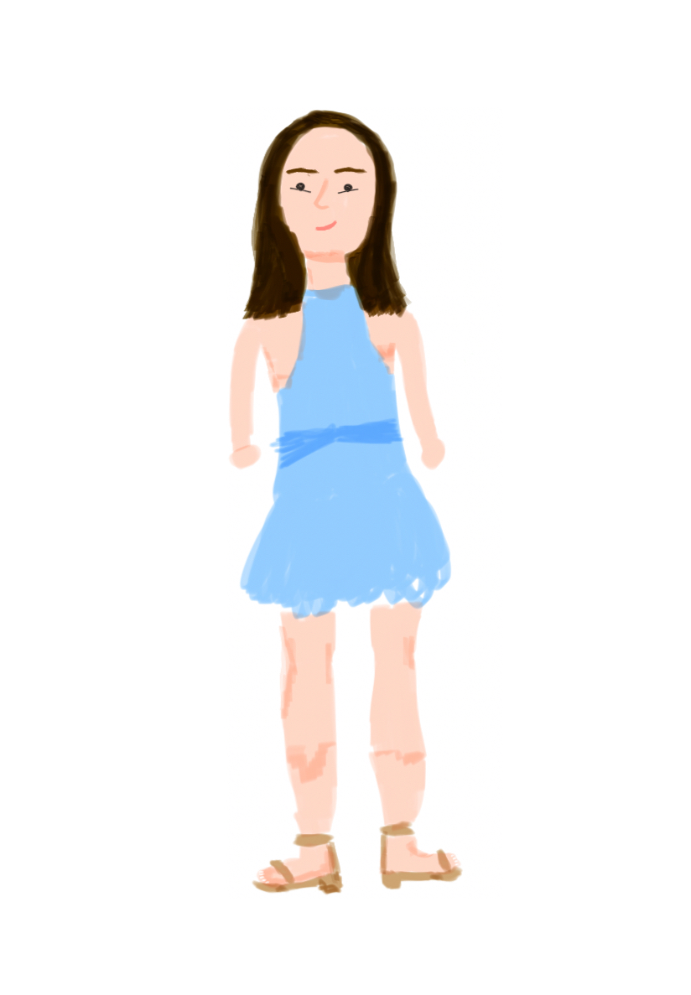

**Chapter 4: First Vintage**

Now and then I would borrow pieces of clothing from my grandma’s closet. To the point that she ended up gifting me a floral purple button-up blouse. Probably one of the first vintage clothing pieces that I have ever owned. I wore the blouse to recite one of my poems in front of the literature class. The blouse somehow made me feel poetic and romantic at the same time. It was a small classroom that could fit around twenty to twenty-four individual chairs with inbuilt tables. There was a big whiteboard and a teacher's desk with its chair, some lockers for our books, and some signs with the rules of poetry. The classroom was on the second floor of my high school, Monteverdi, in Playa del Carmen, my hometown in Mexico.

My high school had a very peculiar dark green uniform that I was not fond of. The skit was plain with built-in shorts that had a length below the knees. The shirt was a white collar polo with the collar in dark green *suspended* from my waist and the tree on top of a bible logo at the left side of the heart level. Long white socks and black shiny leather loafers for shoes, I chose to wear the button-up blouse as a little cover and to appear a little different from the rest of my classroom. Clothing outside of the uniform was not allowed in my high school but that day I did not care. The blouse’s fabric has a mesh texture but it is not as see-through, its print is floral and some of the colors are light green, pink, and white, but the main color is lavender purple and has a nice round collar with a couple of buttons of each long sleeve, it is baggy on me, making it appear flowy.

My high school was strict in their no makeup and extravagant looks policy so I did not wear makeup to go to school but I will admit that applying a lot of chapstick gave a similar finish look as a clear gloss to *hydrate* my lips. My nails were *filled* and short, I used to take care of them every week, and my hair was *pinned up* in a ponytail. My dad gave me small gold hoop earrings that were already *inserted* in my earlobes and my *breath smelled* like strawberry gum because I was so nervous that I started chewing gum. A couple of months after I had suffered an accident, the upper left side of my scalp had a recent scar healing from four stitches that had been *attached* to my scalp. Some perfume from the morning still lingered on my neck, this time I *sprayed on* my grandma’s perfume which had strong wood scents.

That time that I wore it I felt so fashionable, that it seemed like I was somehow “stepping up” my fashion sense from basic one-color tops and/or graphic tees to a multicolor classic flower print blouse. It was one of the first few pieces of clothing that whenever I wore it, I would get compliments for it. To this day it is hard to give away my purple blouse, I have thought about it before because it is a piece of clothing that sits in my closet throughout the whole year but it holds the memory of my grandma so dearly that it is some of the fewest pieces of clothing that I will keep in my life forever.

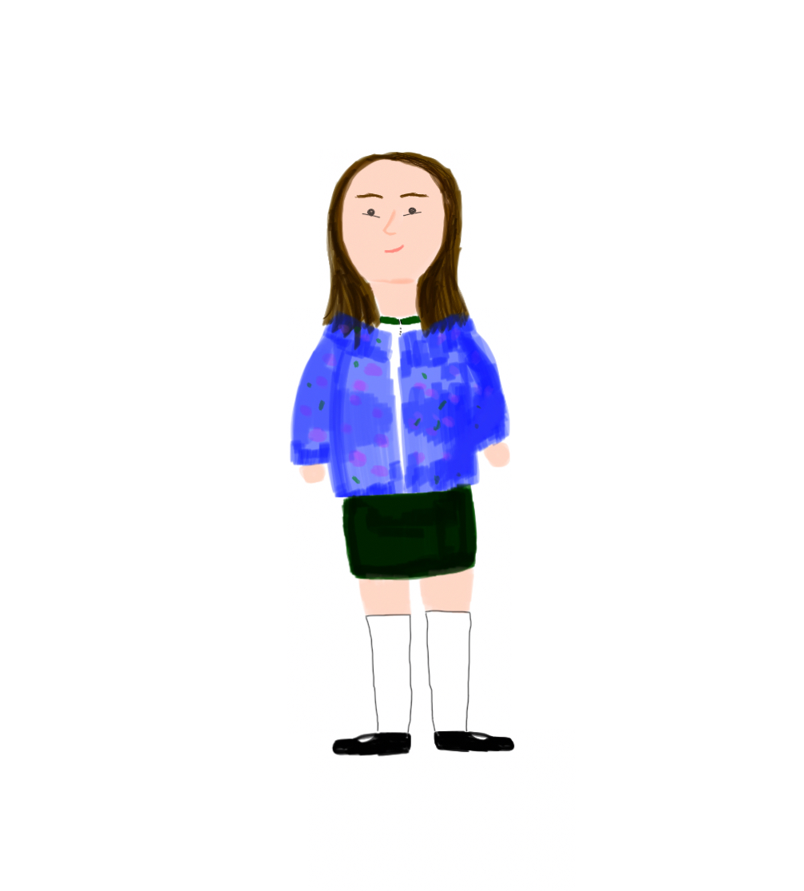

**Chapter 5: Red**

My senior prom day was hectic, I was not prepared at all for things to not work out the way I planned them in my head. After I went to the beauty salon to get my hair, nails, and makeup done, I returned home to finish getting ready. I was in my brother, Luis's, bedroom because he was the only one to have a full-length mirror in our house. Luis’s room was messy, his dirty clothes were on the floor and his full bed was undone, it was easy to see the navy blue sheets spread on the bed, but fortunately, there was a closet that had some sort of vanity that once belonged to me and a full-length mirror leaning on his Persian blue wall. There was not enough lighting in the room due to the dark-colored wall and small window. The wall seemed to absorb the light and space of the room but he was into the color so he did not care about those types of details. When I finished getting ready, I looked in the mirror and felt so delighted by what I saw, it was one of the nicest feelings.

My dress was handmade by my dad’s girlfriend, Nancy, she finished it just by four in the morning on the day of the prom. A beautiful dark red color that almost looked a bit metallic, the dress was long enough to cover my feet on heels and *enclosed* my body perfectly. The dress had a sweetheart type of neckline that uncovered part of my higher chest and shoulders and was thigh on the waist to give an illusion of an hourglass shape with the help of an undercovered but strong zipper on the side of the dress. My heels were about eight centimeters tall and had a plastic transparent strip on the toes and another light beige thin strip around my ankles. For jewelry, some mid-sized gold hoops that we *inserted* in my earlobes and my favorite gold ring on my left middle finger. The chosen purse was a black long clutch that was made out of a fake snake *texture* and had a big metal hoop to carry the clutch on the wrist.

The makeup was so heavy on me, that I did not ask for a makeup trial sample from the beauty salon in advance, so the final results were the opposite of what I expected them to be. It was my first time wearing foundation and it *modified* my skin to a lighter tone. My eyebrows looked *fuller and thicker*, with heavy brown and gold eyeshadow that almost faded into a black shadow at the corners of my eyes. *Dark red lipstick* and some *highlighter* on the tip of my nose and my high cheekbones. *Curly hair* that I thought was going to have more of a wavy finish and white *nail polish* on both my fingernails and toenails.

Prom day was a happy night, I danced around with all my friends, and my family did not join me enough, they mostly stayed at the table eating and chatting but I had the greatest time. The night was worth all the effort, and good, and hard moments I went through in my senior year. By the end of the night, it was time to start saying my goodbyes and that is when a little sadness invaded the room but my classmates and I still had one last chance to be together the next day at a party we had organized. The red dress was magical, it made me feel so pretty at the moment, unfortunately, after going home and checking all the pictures, that feeling went away for a good hour when I saw very badly angled pictures of myself. However, I still keep the dress in hopes of wearing it again and finally making those old pictures justice.

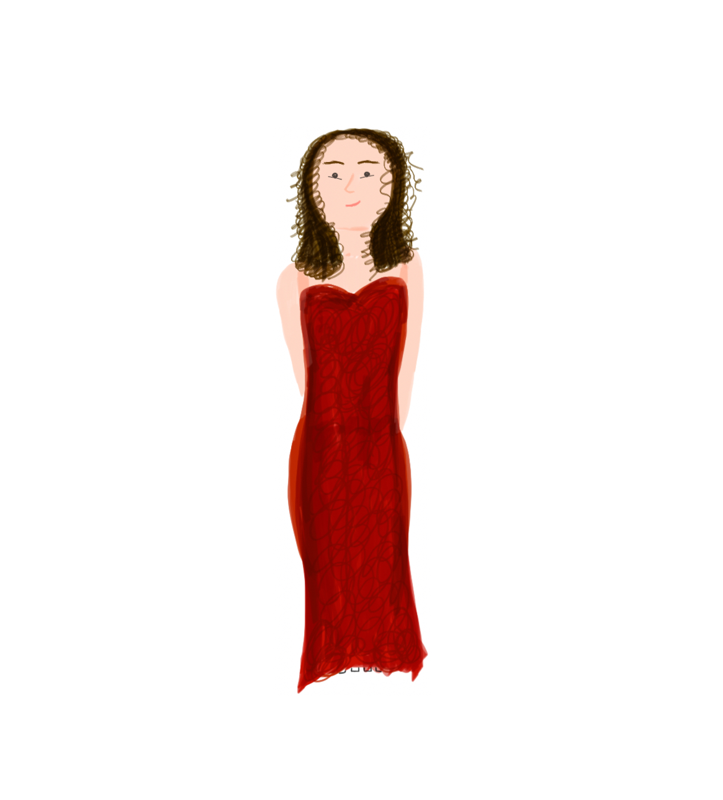

**Chapter 6: Adiós, abue**

My grandmother, Dilia, and I were never as close as I wish we would have had, regardless, love and appreciation were feelings that my heart still holds for her even now. We used to share a small room that could barely fit an individual bed for me and a full bed for my grandma and had no AC for such tropical weather that Playa del Carmen, my hometown, has. Our room had a heavy big old TV, in which my grandma would watch her novelas every night. There was a big handmade wood closet that my father, Luis, and my uncle, Eduardo had built together back in 2004; other than that, we could not fit any other pieces of furniture, and the room was quite small for two people. The white walls somehow helped the room appear bigger and helped balance the freshness of the room, there was a huge window that covered most of the wall next to my bed and it was adorned by beige long curtains that went almost from the ceiling to the floor of our room. Our window view was the front yard which was surrounded by four-meter-long palm trees that helped the room get a good amount of fresh air during the night.

In our closet, a black knee-length dress hung for years until the day to finally wear it came. My grandmother passed away on the morning of August 7th, 2019. The black dress *enclosed* my body nicely and had a nice bow in the back and it was covered in black lace, making it look elegant for the occasion. Regardless, the dress covered my shoulders mid-length but had a back neckline that did not fully cover my back, so I ended up using my grandma’s black old shawl to cover it and it was *suspended* from my shoulders. For shoes, I wore my black flats that had a little bow in the center of where the toes were situated. With no purse and no accessories, my dad gave me very little time to get ready, our relatives were starting to arrive at the mortuary and we needed to be back soon.

I did not wear any makeup that day, I knew my dad was not going to like it, so I just made sure my lips were *hydrated* and added some clear chapstick. I put on my *citrus smell* perfume since due to the rush of the situation, there was no time to take any showers, my skin *texture* was a bit *dry*, and I barely drank water that day. My hair was *brushed and felt soft*, I made sure to keep it out of my face by placing the front sides behind both of my ears. My *breath was minty,* I had *brushed my teeth* before leaving the house. Lastly, my *eyes were red* because I had been crying all day and my cheeks were *flushed* too.

My grandma’s funeral was probably one of the most painful days I have ever lived to experience. Sadness not only surrounded my heart but also in my loved ones’ hearts. I have never seen my dad so heartbroken and fragile, my brother, Luis, who considered our grandma as his mother, had the bluest look in his eyes. The black dress that I wore is an attire that I hope I never wear again. The funeral was a painful experience, but despite everything, I felt the love and support of my family that came to join us that day. I no longer have the dress, I could not bear to keep it in the closet I once shared with her.

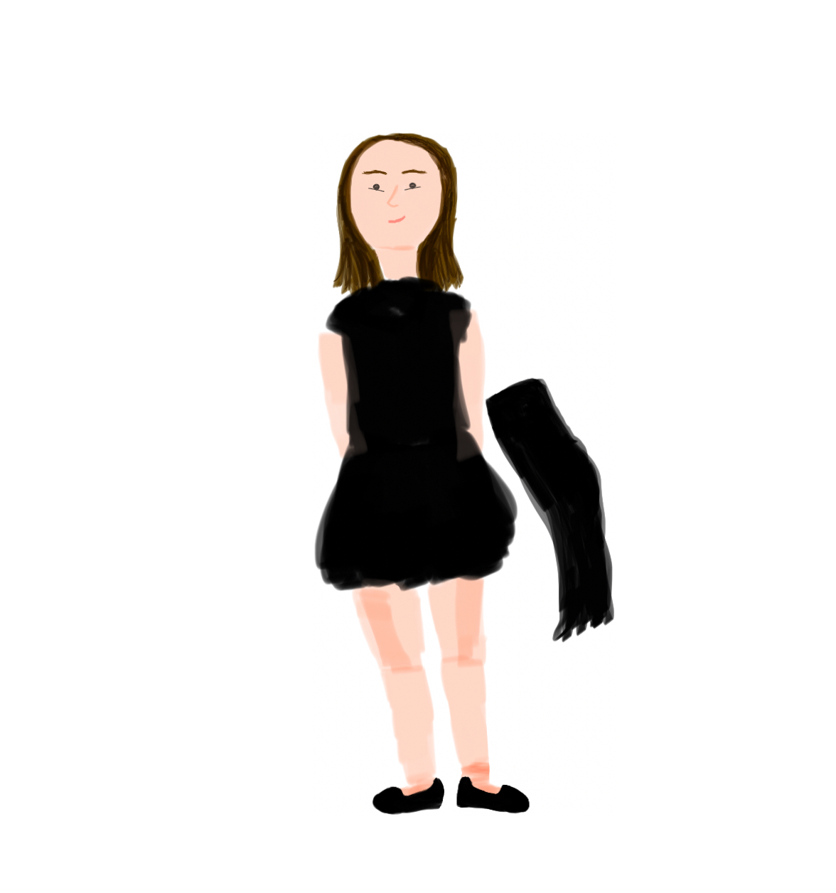

**Chapter 7: First Day of a New Life**

The day that I moved to New York, October 7th, 2019, I woke up in my room next to my dad, Luis. I had asked him if he could sleep next to me since it would be the last time we were going to see each other for a while, I woke up with my head on his chest, the beating of his heart has always been soothing to me. After my grandma’s passing, we got rid of the individual bed and some of her things in the closet that kept on reminding us of her and her natural smell. Our TV was still there, I never owned much so I was able to pack most of my belongings into a big purple checking bag that was situated at the end of my new bed. It was a fresh morning, easy to sense in the air and the weather was chill. The strongest smell was my dad’s natural smell, not sweat or cologne, just his natural essence particular to him that I like so much, I kept my head on his chest as long as I could before waking up.

While getting ready, I put on a checkered salmon red onesie that ended up in shorts and had a nice v-line neck, with short sleeves, the texture felt rough on the outside but soft on my skin, and the piece *enclosed* three-quarters of my body. For shoes, I wore my favorite and most used white Adidas sneakers that had three navy blue lines as the Adidas logo and some short white socks underneath. I wore my grandma’s baby yellow cardigan for good luck. It was a vintage Ralph Lauren cardigan, very soft but long at the torso, it did not cover enough of my chest due to its slim shape. And on my right wrist, a *suspended* thin handmade red bracelet made out of string that one of my ex-coworkers, Grace, gifted me for good luck.

I *brushed* my hair and *pinned it up* into a ponytail with the help of some gel to keep my baby hairs in place, giving my hair a thick *texture* where the gel was put. My eyebrows had recently been waxed, I used to do it often when I was eighteen years old. On my visit to the beauty salon but a different day, I had a *manicure*, my cuticles were *removed*, and white *gelish* was applied to my recently *filed short* fingernails. Lastly, I *sprayed on* my favorite citrus perfume on my neck, wrists, and chest for a nice smell and also *brushed my teeth* before leaving the house, my *breath was minty*.

That morning was so special to me, it was my first time traveling alone, my first time leaving the country in about twelve years and essentially, that morning was the beginning of what my life is right now. As a meaningful morning as it was, I also needed some type of amulet for good luck and protection. My grandma’s baby yellow cardigan was a perfect candidate since her passing had been only two months ago and I was deeply missing her. A mix of different feelings that involved excitement, happiness, fear, and sadness encircle my emotional attachment to the baby yellow cardigan. Now and then I wear it at home if I am dealing with hard emotions as a way to calm myself down. It is a piece of clothing that I will be passing on to my kids someday.

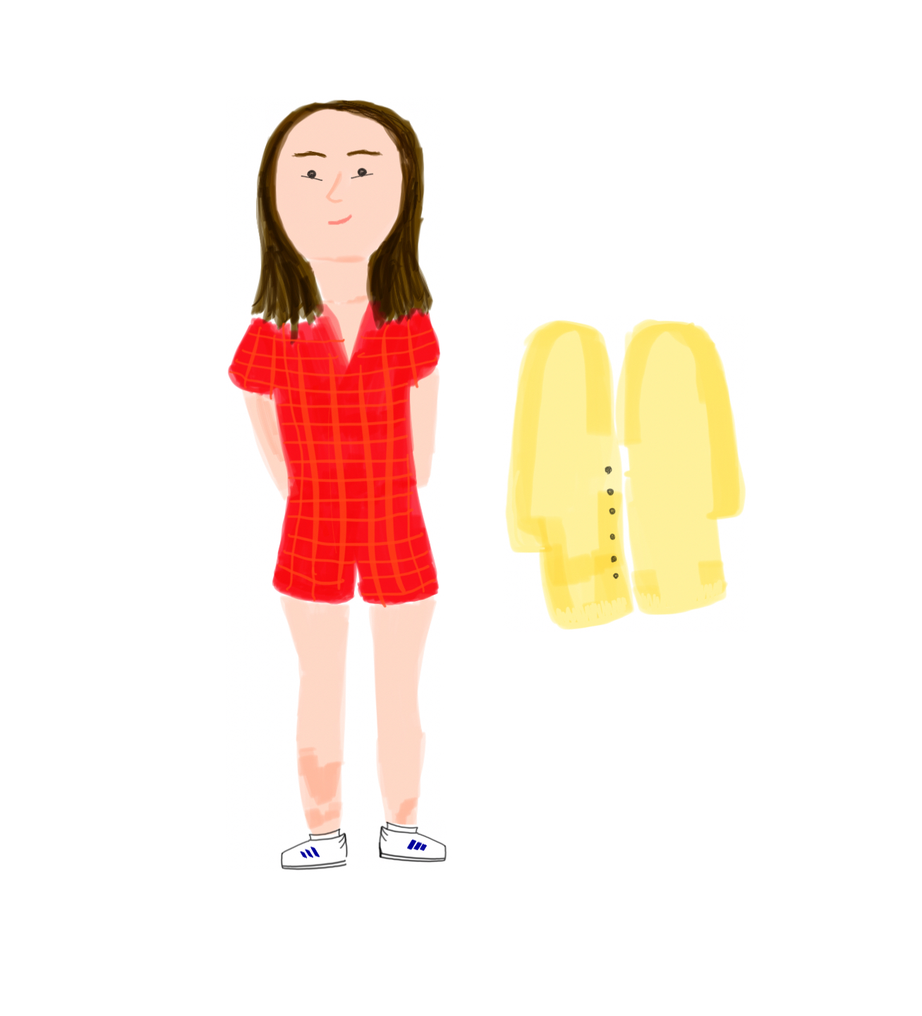

**Chapter 8: The Grudge**

After I moved to New York, I reconnected with my mother’s step-sister, Jessica, for the first time in years. We agreed to meet at Pio Pio, a Peruvian-style food restaurant located at W 43rd and 10 Ave in Manhattan. The place had a rural style to it, with lots of brown, sand, and earthy colors on the walls, decorations, and tables. We sat in a booth and like all tables, our table had kraft paper on top used as a tablecloth. Everything was going well, we talked about life, school, and my plans in New York, until Jessica used this opportunity to break the news to me that my mother, Erika, wanted to reconnect with me after many years of being away.

I wore high plumb heeled boots *pre-shaped* that I put on my feet. Black mesh thighs for a little extra protection from the cold under a handmade long black mesh skirt made by my stepmom, Nancy, that *hung* from my waist down. On my lower waist, I had a *suspended* black leather belt to tie the outfit together. A black turtleneck, and a black leather jacket that had circular metal pins as bottoms that I borrowed from my aunt, Lola. The leather jacket fitted perfectly, *enclosing* my torso and arms.

My hair looked *wavy*, the night before I had slept with braids on so that I would not have to use heat on my hair. I put on a light red lipstick to change the *color* of my lips. My face had a *smooth texture* from the previous night's skincare routine. My nails were *trimmed* short from the nervousness I felt from meeting with my aunt again after more than ten years. And I *curled* my eyelashes with the eyelash curler to make them appear longer.

After the first few months, I came back to that moment at least once a week for half a year. Unfortunately, I have not worn the skirt again, but I have also grown out that style in me. Regardless, it was made out of love from Nancy and I will keep it for as many years as I can, even if I do not wear it. It is one of those occasions in which I will not let a bad memory ruin the good history of a clothing piece. Hopefully, the time will come and I will find a new way to style that beautiful skirt.

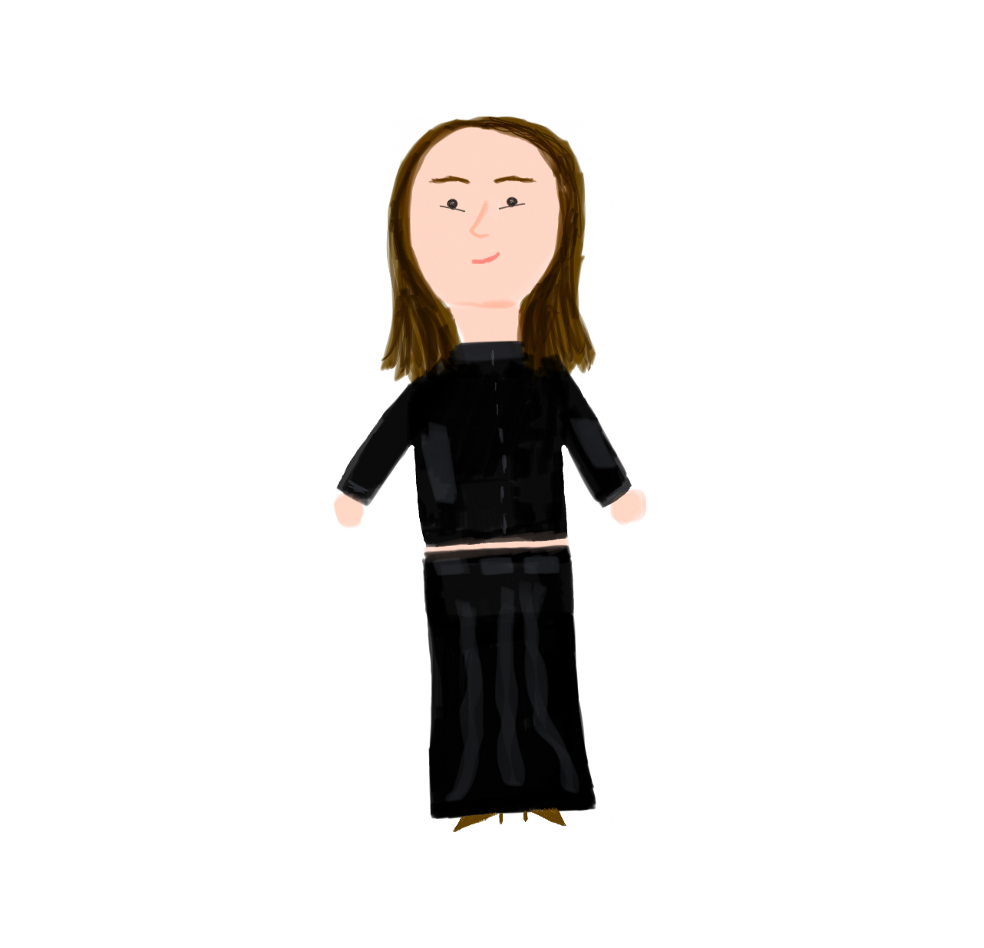

**Chapter 9: One Spoon for Two**

In the awakening of my dating life, my old crush from work, Ivan, reconnected with me while visiting my family for the holidays. We went on a date the day before I left Playa del Carmen, Mexico to return to New York. Agreeing to meet in New York once he came to visit in the summer, in the hopes of it all, I purchased one of the prettiest floral shinny dresses I have ever seen, but the date never occurred. In my Brooklyn room, with baby blue walls, a couple of mirrors, and my full bed covered in a white duvet, I got ready and waited many hours for a text to confirm our date. To my surprise, Ivan never replied until a couple of days later but I took matters into my own hands and took myself for a nice date the day after while wearing the dress.

The dress had a floral print on a silk fabric with tiny dress straps that were crossed on the neck and *enclosed* most of my body until the top of my knees. I put on some *pre-shaped* socks. After, I pair them with my white preshaped tall Converse. Some sunglasses that rested on the top of my head. *Held* my brown mini purse in my right hand.

My hair was *wavy* from the humidity and by just let it dry on its own. I *plugged* my eyebrows before. *Curled* my eyelashes for extra volume. *Painted* my nails with *white nail polish.* Added some vanilla gloss on my lips to make them appear *soft and bright*. *Sprayed on* my favorite citrus perfume for a nice smell.

When I see the dress now, I see evolution. I remember being so naive and insecure waiting for a guy that I was not his priority. I see the dress and know how far I have become and how much I have grown regarding dating situations. It was fun, reckless, and somehow, magical to believe that guys like him were going to change for me. Now he is just another disgusting experience that got me closer to meeting my now boyfriend, Carlos. What is meant to be yours, will not pass you.

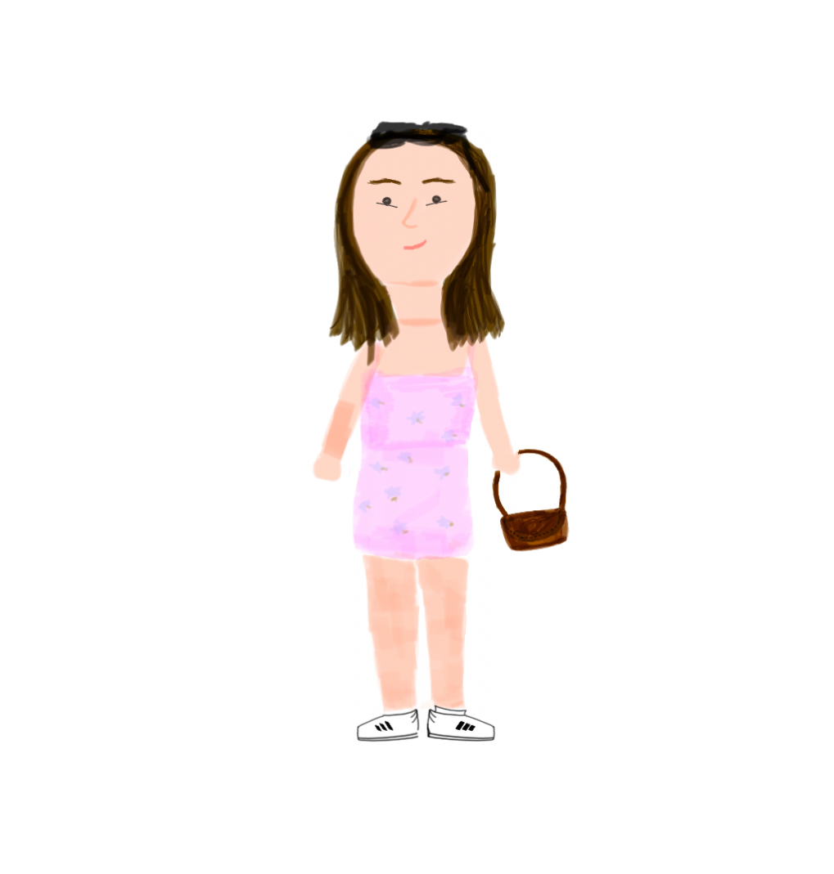

**Chapter 10: Red lipstick**

Growing up, I never wore lipstick, I was insecure about my smile and always thought of how red lipstick would highlight the imperfections of my teeth, which was something that I did not want to happen. After my Invisalign treatment, my friend, Nicole and I went to Sephora in hopes of finding her a new lipstick, while shopping with her, I found a red lipstick that caught my eye, and Nicole encouraged me to try it on. The store, Sephora, was filled with beauty and skincare products from lipsticks. foundations, highlighters, blushes, retinol, toners, and even perfumes of many different brands. Sephora has a white bright light that allows you to differentiate the true colors on your face and the products that anyone wants to try on. It is one of those stores that I would never frequent because I was afraid of choosing the wrong tones of makeup on myself, but always dreamt of building the courage to go alone and try different things.

I wore my long navy blue blazer that looked like a big coat. My hand-knitted sweater vest with stripes in the colors cream, brown, and green that *enclosed* my torso. My black trousers with a belt on the lower waist that *hung* from my hips. A black-knitted soft scarf *wrapped* around my neck. My *preshaped* brown leather boots that *enclosed* my body. And of course, the Sephora shopping bag carrying the red lipstick I had just bought *held* in my left hand.

My small gold hoops were *inserted* into my earlobes. One metal ring that had elephant shapes was *enclosing* my right pointy finger. My hair had just had a fresh *trimmed* at the salon a couple of days ago. I *applied* some blush on my cheeks to make them appear rosy. And lastly, I *filled* my eyebrows with an eyebrow pen to make them appear fuller.

Looking back to that memory today, I feel proud of myself for allowing me to try different things and beat my fears. Nowadays, I love makeup, it feels so personal to me because you put on exactly what you want, not what you need like with skincare. Ever since, I have tried different shades of red on me and fell in love with red lipstick even more. I wear it on every occasion that I can, it makes me feel so happy, powerful, and elegant. I would say that this memory was an altering chemistry moment for my brain.

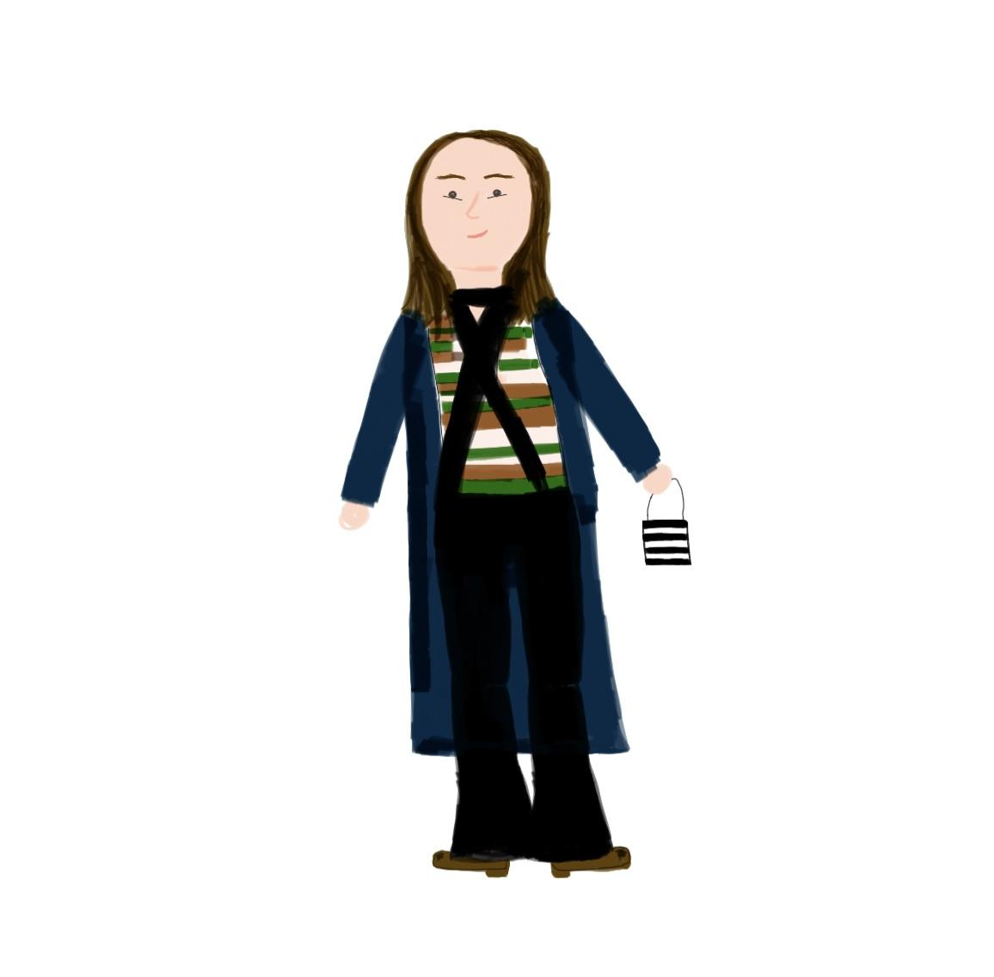

**Chapter 11: Leather jacket**

For a couple of months, I had been very insistent in expressing how much I would love to have a leather jacket and how this simple but stylish item would level up my style. After a long walk in the Lower East Side with my boyfriend, Carlos, we found a place that no longer exists, situated at some point on Delancey St in Manhattan. The place looked like an old bodega and was replete with Italian leather jackets that also left a particular smell in the store. The owner mentioned how the business was soon to close and how all the jackets in the store cost only $100. Catching the perfect deal for the quality and variety that that place had, I spent about an hour and a half trying on more than fifteen leather jackets just to find the one.

I put on my low-waisted jeans that enclosed my legs and a plain white t-shirt that fitted my torso like a glove. My Adidas Samba white pre-shaped sneakers that I put on my feet had gray soles inside them to add comfort. White *pre-shaped* socks on my feet under the sneakers. A white Coach hobo bag that had the logo printed in silver all over the fabric that I *held* in my right hand.

My nails and hair were *strong* from the Olly vitamin supplements that I took every morning back then. My teeth were freshly *whitened* from the at-home kit that I bought to whiten my teeth. I had a fresh new conch piercing *inserted* in my ear cartilage from about a month ago that was still healing. My nails had red *nail polish*, and so did my toenails. The texture of my face was as smooth as possible since that morning I *shaved* my facial hair the previous night using the *hydrating* jojoba oil.

This leather jacket is something I would love to be buried in, to me, it is a reflection of what my style is based on. It is fun, sexy, true to size and the color is so unique. I feel so put together when I wear it, it ties an outfit together. I will bet on this, but I am certain that it is something Hannah Montanna would wear if the show was filmed at this time. I will wear it for as long as it fits my body.

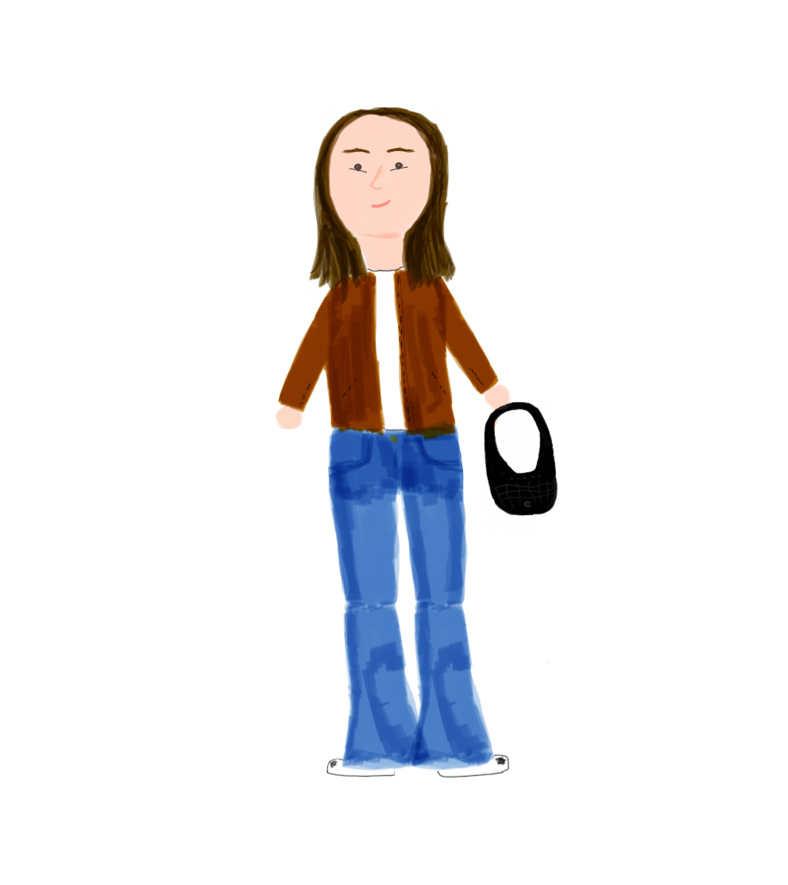

**Chapter 12: Low-waisted jeans**

After brainstorming multiple videos on what fits my body the best and makes me feel the most comfortable, authentic, and confident, high-rise jeans came into doubt. In a random coffee shop at 375 Hudson St in Manhattan, my friend, Nicole and I discussed our fashion objectives. Nicole has an amazing, elegant but simple style, and she has always inspired me to buy things I would keep in my closet for a long time, something like investment pieces. The coffee shop had a multiple wood furniture and elements that made it look like a cabin in the woods. Flowers all around too, plants hanging out from the ceiling as if they were the clouds and big windows for walls. There was a big rectangle table that people could share and around six to eight individual tables on the other side to have more private conversations.

For brunch I wore my low waisted jeans that *enclosed* my legs. A black silk top that had a deep V-neck which same neck *hung* from my neck but the rest of the top *enclosed* my lower torso at the front and half of the back was left uncovered. White *pre shaped* socks and on top, my white *pre shaped* Adidas Samba that I put on my feet. My brown mini purse that I *held* on my left hand.

I put on some mascara on my eyelashes to make them appear *thicker.* I had just taken a shower and put on moistraizure so my skin was *smooth* and *hydrated*. My nails had been just filled by myself back home before meeting with Nicole. My hair *smelled like citrus* from the conditioner I *applied* during the shower. My *breath was minty* from *brushing my teeth* and the mouthwash I used before brunch.

Nicole recalls that day as an “eye-opening” event, saying that I have never dressed the same ever since that day. My first pair of low-waisted jeans is, in fact, a pair that I hold close to my heart, more than jeans, it was me coming to terms with that not what is trendy will make me feel or look the way I desire. It was a realization moment that having your style meant creating it within yourself instead of copying what you see on social media.

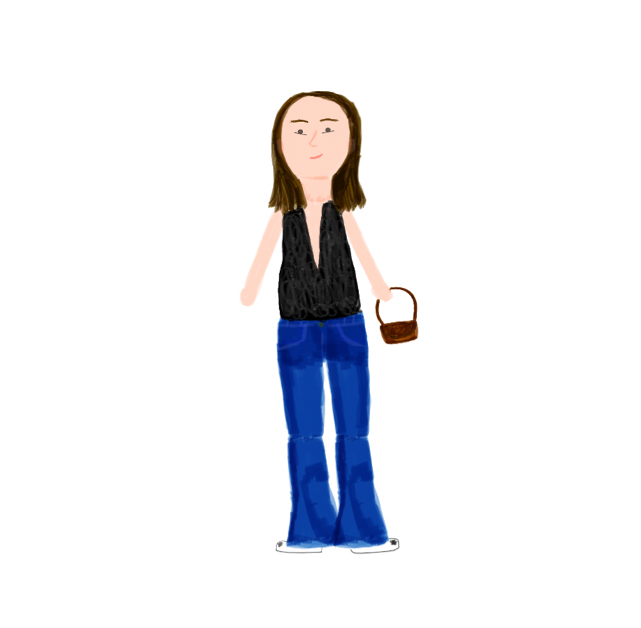

**Chapter 13: Red Velvet**

In the search for different shoes and the incorporation of more colorful items in my closet, I came across these red velvet ballet flats at the Shultz store at 540 Broadway, SoHo in Manhattan. On a random afternoon, I went shopping alone and it was an immediate yes when I saw them on the shelf of the store as soon as I walked in. The store had a modern appearance, its apparel being eye-catching to my eyes with its silver colors, brick wall, and big black bold logo on the window. Funky furniture for their customers to sit down and try on the shoes, a small bar counter in which they were offering bottles of water, sparking water, and some teddy bear-shaped cookies. Some tall flowers in vases around the store too used as decorations.

The day I bought the red ballet flats I was wearing my washed-out low-waisted bootcut jeans and my favorite cotton pink tank top that ended right where the jeans started so it created a nice silhouette on me. A heart gold necklace *hung* from my neck and touched my collarbones. My everyday black Coach purse *hung* from my right shoulder. I loved the shoes so much that I left the store wearing the *pre-shaped* shoes. Red velvet fabric flat shoes that had a small fabric contouring the outline of the shoes, *soft* to the touch, flat at the soles, and had a small metal brooch that was used to adjust the width of the foot. Not forgetting to mention the small barette that was *clipped* to my hair.

My eyebrows were *brushed* and filled with an eyebrow pencil. My hair was down, but its *smell* was chamomile from the chamomile hair oil that I had *applied* earlier that day, leaving a *shiny* look on it as well. I had *sprayed* on my everyday cologne which has a cherry blossom smell. My small triangle-shaped black earrings were *inserted* on the second piercing place of each side of my earlobe and my regular gold small hoops were *inserted* in my main piercing wholes. A small band-aid *adhered* on the top of my right breast from a sample the doctor had taken a couple of weeks ago back them.

My immediate thoughts when I saw these shoes were “This is something my great aunt would wear and my grandma would tell her she loves them”. Growing up I shared a lot of time and love for my grandma’s sister, Patricia, she has always inspired me with confidence and sophistication. These shoes make me like I am in a 90’s room comedy movie and it is about to be Christmas night. I took them to Mexico on my last trip to visit my family and got too many compliments on them, even some boys told me that they would wear them, which I thought was cool. My dad, Luis, was surprised by the way I style them since I usually put them on with red socks, according to him it looks a bit funny but I love them.

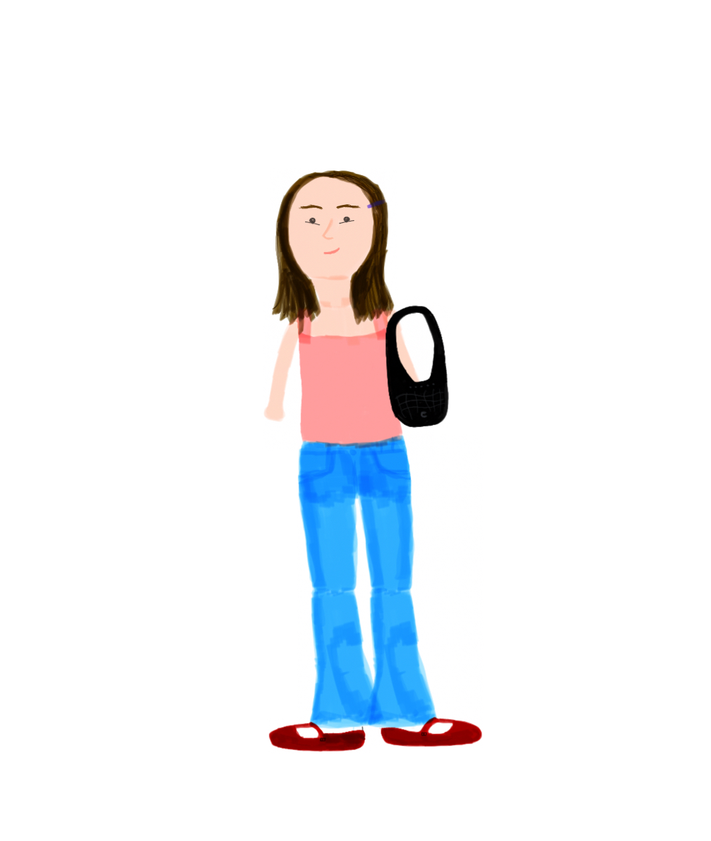

**Chapter 14: Ciao!**

Italy was always my dream country to visit, and last year I was able to travel to Naples, with my cousins, Gabriela, Camila, and Anapaula. During our first few hours in Naples, I was so excited to jump in the water, I love the beach. Gaby and I made a quick stop at a bikini shop that we found on our way to the beach. The store had white walls and plenty of bikini racks, with two rooms, in the first room there was a bikini sale and in the second one some other bikinis and the fitting rooms had three mirrors in each wall and a tall black and heavy curtain used as a door. Gaby found the perfect bikini for me but I needed to try it on before buying it. As I was trying on the beautiful bikini top, I noticed that the blue mole situated in my right breast had grown a little lump underneath it, my heart immediately sank.

The 2 piece bikini was in color dark green with small details of sparkling shine in the fabric. On the top, there was a circular gold metal piece that unified both triangle pieces that covered the breasts. The bottom piece had long strings that made it able to adjust to oneself body size if needed. Both pieces hung *wrapped* around my body, the top from my neck and back and the bottom piece from my hips. The bikini came with an extra string of fabric from the same material to *tie* in the circular gold metal piece and give the bikini a slightly different look but I chose not to tie it on.

My hair had been *brushed* and *added* some muse to keep its shape. I put on some blush on my cheeks to bring up some *color* on my face. I *plugged* my eyebrows a little bit to help keep its shape intact. Strawberry-flavored chapstick for my lips to keep them *hydrated* in the summer. My favorite gold small hoops are *inserted* in my earlobes. Finally, my skin looked and felt *oily* from the tanning oil that I had put in previously to help me achieve the summer tan I had been wishing to have.

Regardless of the scary moment that this bikini could be associated with, I had so many happy moments in it that erased that horrible memory. Some of them are my cousins and I were on the beach chatting, on the rocks, tanning, hiking a little mountain to get to a hidden beach spot, all of us being young and happy. Nowadays it is my most worn bikini and its shape is something that I look for from now on when I am shopping for swimwear. Its beautiful dark green color looks great once my skin gets tanned and it suits my body greatly. I will live in that bikini this upcoming summer.

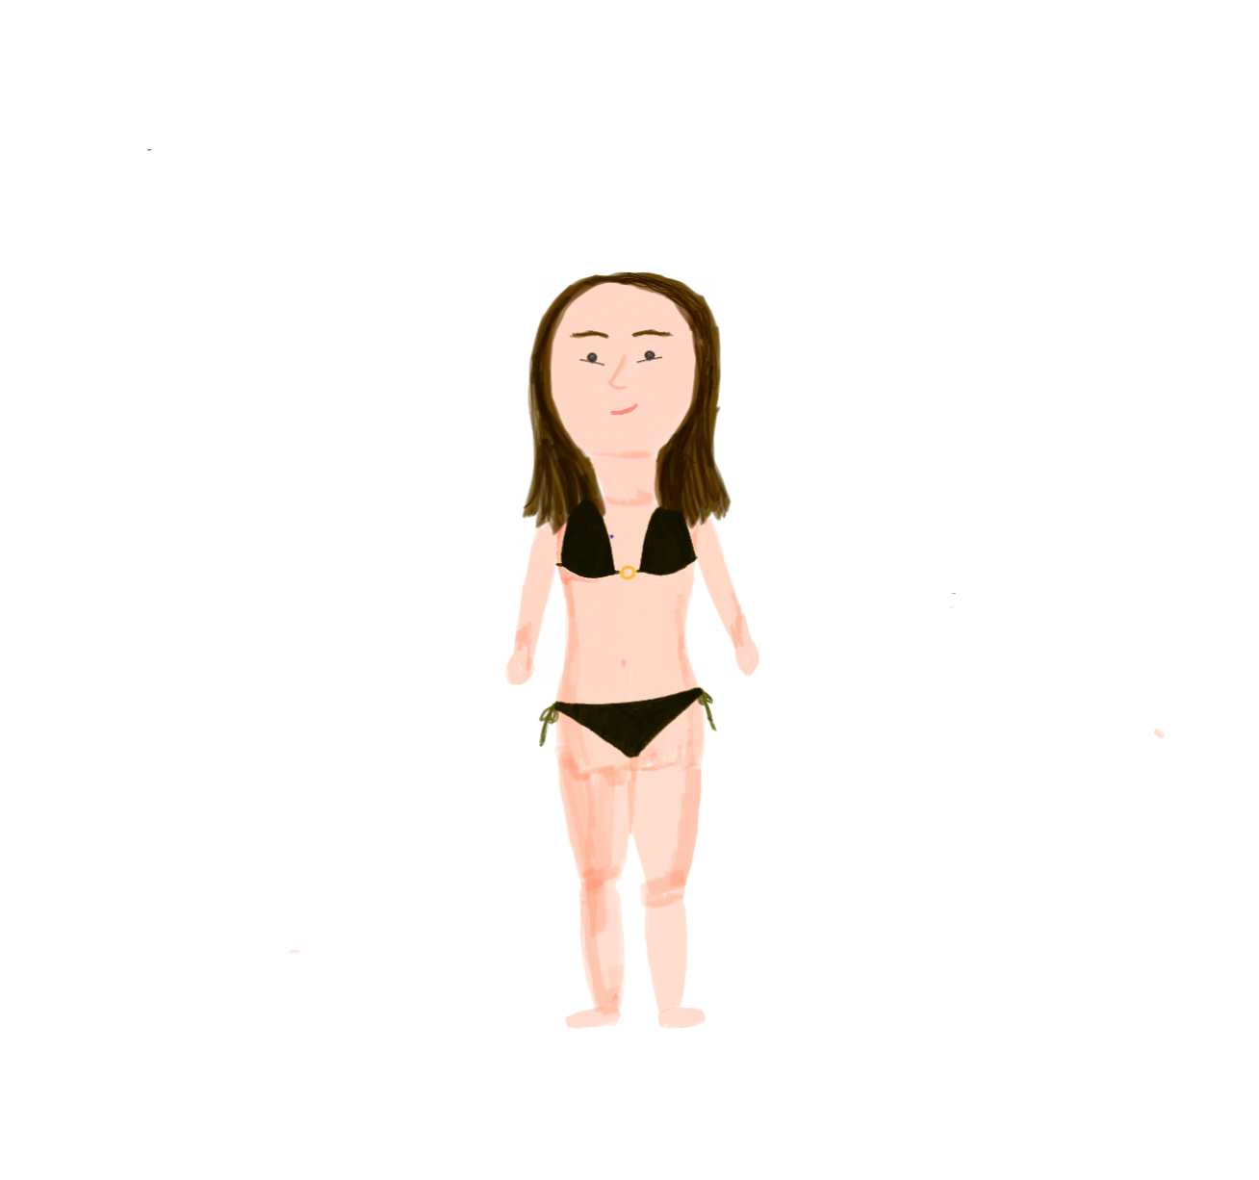

**Chapter 15: XXIII**

I celebrated my twenty-third birthday with my boyfriend, Carlos, and my friends, Nicole, Joohee, Lala, and Sifraah in Felice 56, an Italian restaurant situated at 56th St in Manhattan. The place was beautiful, with white tablecloths, dim light, tall ceilings, and two small trees decorating the center of the place. Our table had a booth that we used as a sitting place and behind us there was a gorgeous cloud big painting that covered most of the wall. The place was full of people having dinner with family and friends too so it was easy to hear everybody’s conversation across the table. My friends looked beautiful and brought some gifts that decorated the 6 top table, I sat in the middle so that I could chat with everyone and enjoy the most of my night.

I wore a black corset from Victoria’s Secret that passed as a nightwear item, it was perfectly *pre-shaped* at the waist to help mold my body shape. A black mini skirt that had a slip-open on the right side that was *suspended* with my hips. Black thighs that *enclosed* my legs and *pre-shaped* plum 4-centimeter heels that were in the color dark purple that put in my feet. My gold ring *encloses* my left-hand middle finger and my wave silver ring *encloses* my right-hand pointy finger. Lastly, my *pre-shaped* oval black purse that I *held* on my left hand to complete the look.

I took a shower before dinner to make sure I smelled *clean* and *fresh*. My hair was *pulled up* in a bun with the help of gel and setting spray to make it stay still. My makeup consisted of six steps: concealer to *cover* my under eye bags and the discoloration of the pigment of my skin, blush to bring some *color* to my cheeks, a bold eyeliner that outlined the shape of my eyes and ended up in a sharp wing along with baby blue eyeshadow under it and contour to make my features appear *sharper*, especially on my jawline and cheeks and lastly, highlighter for the tip of my nose and in the inner corner of my eyes. My nails had dark purple *nail polish* on them that I did myself the day before. *Minty breath* from brushing my teeth and the several mints that I ate before arriving at the restaurant. I put on some gloss lipstick that made the *texture* of my lips *softer* and *brighter*.

It was a special birthday, the food was amazing, and I felt so happy to be surrounded by my loved ones, eating pasta, sharing stories, and introducing my friends to one another. I bought the black corset three years ago in hopes that one day I would feel confident enough in my body to wear it for a special occasion and I could not have chosen a better time, I felt beautiful in it. My twenty-third birthday was the beginning of a shift in me due to many other changes that I have been going through in life and I am grateful for the amazing people that surrounded me that day. Fortunately, I have so many pictures of that night that I will be able to show my kids when I am older, and hopefully, they will think “Wow, mom was so cool”.

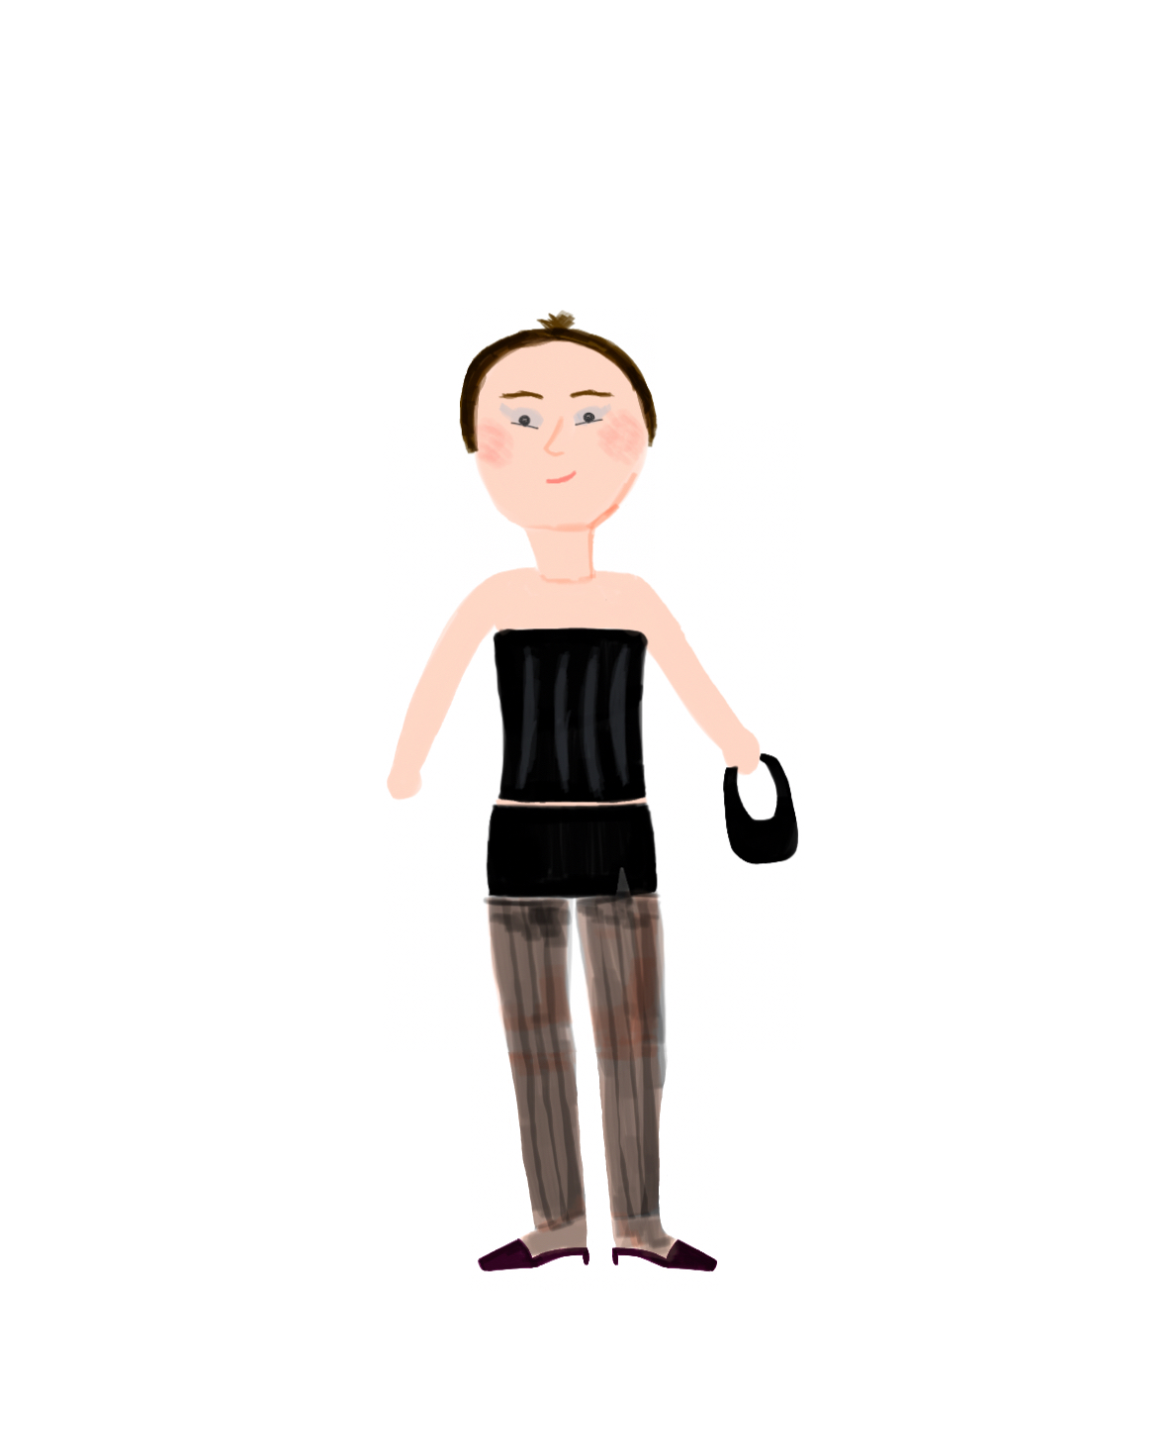

**About the author**

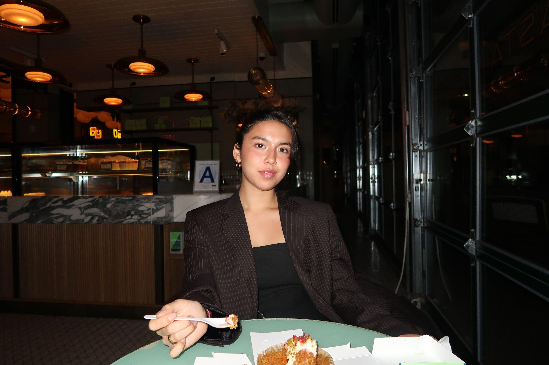

Citlalli Villanueva was born on January 27th, 2001 in Brooklyn, New York. She moved to Playa del Carmen, Mexico after the tragic event of September 11th, 2001 when she was an eight-month-old. When she turned 18, she moved back to Brooklyn, New York, and started her Bachelor’s degree at New York City Technology College. She will graduate in December of this year. Ever since a little kid, Citlalli immersed herself in clothes and designs, from sewing her dad’s old jeans to knitting hats and scarfs and crocheting bikinis, she carries a big desire to create garments of clothes, something that her insatiable mind does not seem to let go of. Create is to bring to life all of her funky ideas and designs for other people to enjoy the insides of her brain, with hopes that in the future, she can achieve her desired job position and keep on diving into this diverse industry that Fashion is.