**Sephora**

New York City College Of Technology

By Taina Lewis, Leilani Morell, Kyra Roberts & Citlalli Villanueva

BUF 4500 Omni-Channel Retailing

Professor Dr. Robert Woods

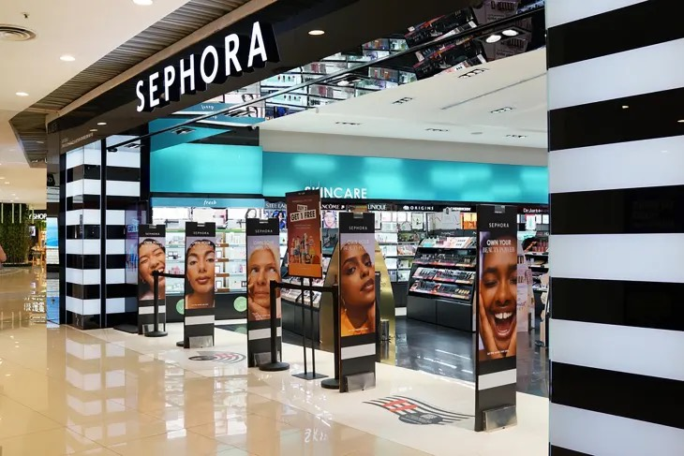

**Background**

Sephora, a prominent French beauty retailer, was established in Paris in 1970 by Dominique Mandonnaud. Zipporah, the wife of Moses from the Bible, inspires its name. Currently, it operates under the umbrella of LVMH Moët Hennessy Louis Vuitton, the leading luxury goods group in the world. With over 2,700 stores in 35 countries, including more than 500 locations across the Americas, Sephora boasts a top-tier e-commerce platform. The brand made its U.S. debut in New York’s SoHo neighborhood in 1998. Known for championing diversity, inclusivity, and empowerment, Sephora is guided by strong company values in its operations.

Sephora is distinguished by its unique open-sell environment, offering a curated selection of products from emerging brands and well-loved classics alongside its line, Sephora Collection. The retailer continues to innovate by introducing exclusive brands, such as Rare Beauty by Selena Gomez and FENTY BEAUTY by Rihanna, and expanding its Clean Beauty assortment. Globally recognized for its exceptional product range, unbiased expert service, and interactive shopping experiences, Sephora is dedicated to relentless innovation in how customers can engage with the brand. The company has received accolades from Forbes as one of America’s Best Employers for four consecutive years (2018-2021) and achieved a perfect score of 100% on the Human Rights Campaign’s Corporate Equality Index for three years in a row (2019-2021), reflecting its commitment to LGBTQ+ inclusion and equality.

**Corporate Mission**

The values of diversity, inclusivity, and social impact are fundamental to Sephora's corporate mission. Sephora is a prominent worldwide omni-retailer that supports all types of beauty and works to foster an atmosphere that values individuality (Ceynar, 2021). The company's efforts, such as the 15 Percent Pledge, which gives a sizable amount of shelf space to Black-owned companies, exemplify its dedication. This strategy helps marginalized communities in the cosmetics business and increases product variety. Moreover, Sephora's commitment to creating a welcoming environment goes beyond its selection of products and employment policies.

Furthermore, Sephora has instituted several initiatives to promote fairness among its employees and customers. These programs include teaching staff members about anti-racism and creating a brand incubator for companies owned by people of color “BIPOC” (Kohan, 2021). Sephora is committed to fostering a more inclusive corporate culture by aggressively seeking to increase Black leadership among its ranks and encourage cultural allyship. In the end, these initiatives are a reflection of Sephora's main goal, which is to make sure that everyone feels included in the beauty community (Kesser, 2023). Apart from these revolutionary endeavors, Sephora's continuous dedication to sustainability and ethical sourcing enhances its goal by guaranteeing that beauty not only celebrates diversity but also honors the environment and its resources.

**~~Financial Data~~**

Sephora, the leading global beauty company, belongs to the group LVMH, a French-owned but multinational conglomerate. Although being part of a big company, its financials are not often shared with publicity, most of the public reports are shown as part of LVMH's financial reports. As the titan of the Sephora market, these past couple of years have been successful for the brand, and LVMH has reported that it has had "record-breaking years" in the categories of revenue and profit. In words of CEO Benard Arnault, he mentioned how Sephora has a “remarkable performance”. Despite the marketing challenges and economic disturbances, Sephora aimed to surpass all previsions and achieved it gracefully. Sephora has been able to develop itself year after year, and with this, secure consistent growth over the past few years, focusing on its strategic positioning in the beauty and cosmetics market. This growth can be attributed to several factors, including Sephora's innovative approach to retail, its strong online presence, and its ability to curate a diverse range of products that cater to various consumer demographics and the various collaborations that they launch every year. Sephora’s strong performance expanded amid the allegations of the luxury market slowing down, its sales rose about 11% on an organic basis.

The company's success is also reflected in its expansive global footprint, with stores in numerous countries across North America, Europe, Asia, and the Middle East. Sephora's business model, which combines a wide selection of prestige beauty products with expert advice and personalized services, has proven to be a winning formula in the competitive beauty industry. Furthermore, the brand's commitment to inclusivity and sustainability has resonated with modern consumers, helping to solidify its position as a leader in the global beauty market. In terms of its financial data performance, LVMH has reported that Sephora’s revenue has had an increase year after year of 25%, which is a quarter of growth every year. Sephora's consistent growth is attributed to its strategic investments in both physical stores and digital platforms. The company's focus on providing a seamless omnichannel experience has strengthened its market position.

**~~Sales and Profit~~**

Sephora’s biggest retail sales increase was pre-pandemic from the year 2017 retrieving $10.96 billion in retail sales to the year 2018, receiving 13.55 billion dollars increasing their retail sales by $3 billion. Sephora remained with a steady incline in retail sales till the Covid-19 pandemic with retail sales being at $14.47 billion in 2019 and decreasing to $12.87 billion dollars 2020. Since the Covid-19 aftermath, Sephora has been on a steady incline for the past four years reaching $15.98 billion dollars in retail sales worldwide in 2023. Sephora reached 7.99 billion dollars in retail sales in the United States in 2023 and made a $1.07 billion dollar increase from the previous year 2022 with $6.92 billion in retail sales. Between the years of 2020 with 5.01 billion dollars in sales and 2021 increasing to $6.01 billion dollars in retail sales, Sephora increased their retail sales by $1 billion. (Petruzzi, 2024) Sephora has shown that even after a pandemic setting limitations on their physical outreach to their audience with their brick-and-mortar they can still overcome.

Although being ranked 52 out of the top 100 competitors in the US. Ulta, Sephora's top competitor, still ranks at 42 out of the top 100 retailers within the United States. Ulta reached $11. 21 billion in retail sales within the United States in 2023. Amazon and Walmart hold the rank of the top two retailers of the top 100 within the United States. (Tighe, 2024) With Amazon, Walmart, and Ulta being ahead of Sephora, it is easy to see that price point is a possible factor in the loss of retail sales compared to its competitors. Sephora has increased its brand presence by significantly increasing in brick-and-mortar stores and expanded online offerings. (Ulta downgraded as competition heats up and promos weigh on margins, 2024) One of Sephora's most recent ventures was collaborating with Kohls to increase their sales and brand outreach. Kohl's goal was to increase their brand’s relevance. Kohls reported an estimated $1.4 billion increase in sales at Sephora at Kohl’s stores in 2023 and the company expects sales to increase $2 billion dollars by 2025. (Torres, 2024) This steady increase has created a great opportunity for Sephora as a still thriving company to expand and grow with different opportunities. The U.S. market is the slowest-growing region for LVMH, with organic revenue increasing by only 3%. (LVMH reports exceptional growth despite economic challenges, 2023) This modest annual increase can be attributed to several factors, including local consumers purchasing luxury goods overseas and growing economic difficulties, such as the rise of living cost.

**Advertising**

Sephora's advertising strategy effectively mirrors its core values of diversity, inclusivity, and innovation through multiple channels, and it's focused on understanding its customers as much as possible, and adapting to trends. The company has developed a sophisticated omnichannel approach that integrates both digital and physical advertising platforms to reach its diverse consumer base. Through social media campaigns and collaborations with digital creators, Sephora maintains strong engagement with younger demographics while emphasizing representation and empowerment (Kohan, 2021). Moreover, the brand's "Beauty Insider" loyalty program serves as an innovative marketing tool, delivering personalized recommendations and exclusive content to members, which exemplifies their efforts in enforcing advertisement as much as possible. With over 17 million members in the US, the program provides Sephora with a wealth of information about customers’ shopping habits, preferences, and engagement levels. This data is crucial in personalizing marketing campaigns and delivering targeted promotions, enhancing the overall customer experience (Miller, 2024).

The company's advertising initiatives gained significant momentum through strategic partnerships together with high point analytics, particularly with celebrity-founded brands like Rare Beauty by Selena Gomez and FENTY BEAUTY by Rihanna. These collaborations, combined with the 15 Percent Pledge supporting Black-owned businesses, demonstrate Sephora's commitment to diverse representation in beauty marketing (Kesser, 2023). The recent partnership with Kohl's, as referred before, has also further expanded Sephora's advertising reach, providing access to new consumer segments and retail environments (Torres, 2024). Through these multifaceted strategies, Sephora continues to position itself as a leader in beauty retail while maintaining its focus on inclusivity and social impact in advertising. These efforts have allowed it to be a referring center for beauty commerce in the United States.

**Omni- channel analysis**

Guillaume Motte told WWD, "Sephora is the only prestige beauty omni-channel retailer that is truly global (Weil, January 2024)." Anca Marola, the global chief digital officer of LVMH, has led business intelligence, client, and customer experience at the company since 2014 (Weil, January 2024). Anca, received her official title in February, she has played a key role in providing profitable results after analyzing data and analytics and transforming it into strategies (Weil, January 2024). Motte continued to tell WWD "Our customers expect a seamless, personalized and rich experience... This is a key driver to our success, and our ambition is clear; we want to continue to delight our community with the best of prestige beauty products and services (Weil, January 2024)." Sephora expanded its target audience and increased their brand awareness in 2023 when it launched several strategies to target younger audiences (Sephora goes after young cosmetics customers with its own brand, 2023). This goes hand in hand with their planned expansion in mexico. Dario Aguilar, the brands general manager in Mexico stated, "the last thing we want is to be an elitist brand (Sephora goes after young cosmetics customers with its own brand, 2023)."

The idea is to bring experiences to the consumer. This also helps sephora to compete with their competitor ulta, which has low price points. We can see this method also assisting with the increase in tourist traffic in Mexico since the COVID 19 pandemic. The brand took the opportunity to increase. Its own personal profile by ranging their skin care products from 50 pesos to 800 pesos (Sephora goes after young cosmetics customers with own brand, 2023). Aguilar told WWD, “The brand could be in the supermarket..we do not have it in the supermarket because what we want is for buyers to visit us in our stores (Sephora goes after young cosmetics customers with own brand, 2023).”

In the beginning of twenty twenty four, the brand sought an issue with consumers where thousands took to tikTok to complain about younger audiences like Generation Z and Generation Alpha (Spruch-Feiner, 2024). The app is flooded with complaints that younger audiences ruin the shopping experience by destroying tester products, being rude to employees, fighting and playing with other tweens, and disturbing the overall sincerity of the experience. Shoppers and staff alike have complained about the disruptive behavior from consumers as young as 9 (Spruch-Feiner, 2024). Within a year we see the negative effects of the increase in target marketing. WWD highlighted the company's data showing they do have the younger generation's brand loyalty (Talwar, 2024).

Nick Perdomo, CEO of Catch, mentions the issue at hand, " young shoppers are incredibly savvy." Perdomo continues to say " value is about getting an amazing product and feeling like you are getting a good deal (Talwar, 2024)." He commemorated ELF as a leader in catching the customer loyalty of gen z and gen alpha, using social platforms and influential collaborations (Talwar, 2024). Sephora continues to have its edge in the market by offering exclusive brands that top retailers, such as amazon and walmart, do not have access to. Sylvie Moreau, president of Sephora Europe and Middle East, told WWD, “ They're looking for what's hot, new and the trends. At the same time, it's our job to make the brands we have already successful. In return, we do ask for differentiation (Weil, May 2024).” Sephora uses innovation to assist over 500 brands (Weil, May 2024).

Sephora's shop-in-shop partnership has increased both brand's awareness. Kohl's was able to elevate their beauty category and management credited sephora in driving beauty sales during their holiday season (Kohl's (KSS) Omni-Channel Strength Aids, High Costs Stay, 2022). WWD reported that more men and families shopped in the Sephora at kohl's than in the traditional Sephora brick and mortar (Weil, May 2024). Kohl's also engages with their consumers during profitable shopping seasons such as back to school, which benefits Sephora's approach to expanding its target audience (Weil, May 2024). Due to its successful partnership, Sephora in May of 2024, launched a hundred additional locations to kohl's stores that month (Weil, May 2024). Sephora abandoned its Korean market and began to close their brick and mortar stores, withdrawing from the market in May of 2024 (Warburton, 2024). With the continuous growing boom of influencers and ecommerce, after an 18 year hiatus, Sephora returned to the United Kingdom market ( Sephora is returning to the UK after 18 years — and betting on AI and gen Z for success,2024).

In April 2024, the Sephora's App was downloaded more than 1.7 million times from the Google Play and Apple App Store (AppMagic, 2024). Sephora has integrated AI to continue to have its competitive edge within the industry. Artificial intelligence gives Sephora the potential to create more engaging shopping experiences with its customers (Sephora is returning to the UK after 18 years — and betting on AI and gen Z for success,2024). Sephora has already integrated the technology by using it to create personalized Skincare routines, make product recommendations for customers based off of their preferences and allow users to virtually try on makeup (Sephora is returning to the UK after 18 years — and betting on AI and gen Z for success,2024). Sephora's usage of AI allows seamless integration between its online platform and in store experience. Influential marketing has sparked the creation and need for customizable innovative approaches to target and instill loyal consumers.

**Omni Promotional Activities**

Sephora provides "tools necessary" to help customers feel "more confident" about making a purchase because the beauty market may be frightening, especially with the abundance of items available (Etailwest, 2022). The Virtual Artist, which was introduced in 2016 and allows users to try on makeup using AI and face recognition technology, is a well-liked addition to the website and in-store. The technology provides clients with information on where to buy the products in-store or online after they have virtually tried them. Launched in 2015 but currently unavailable, Sephora's "Pocket Contour Class" taught customers where and how to apply cosmetics to accentuate face features locations, after which appropriate cosmetics for different skin tones were suggested (Etailwest, 2022). By producing online material to help consumers make better purchasing decisions, the company leverages videos to market its goods.

With 21 million followers and growing, Sephora's Instagram feed has "glittery videos and Instagram stories" as well as "gorgeous lifestyle photos" in addition to content spanning from influencer posts to new launches (Criteo, 2018). On Instagram and Pinterest, where users share, tag, and pin posts, Sephora subtly advertises itself. Customers share and pin films or looks on Pinterest, which directs other users to the website. Editor picks and new releases are featured on the homepage of Sephora's website, which also provides customers with answers to any inquiries they may have while lounging in their homes.

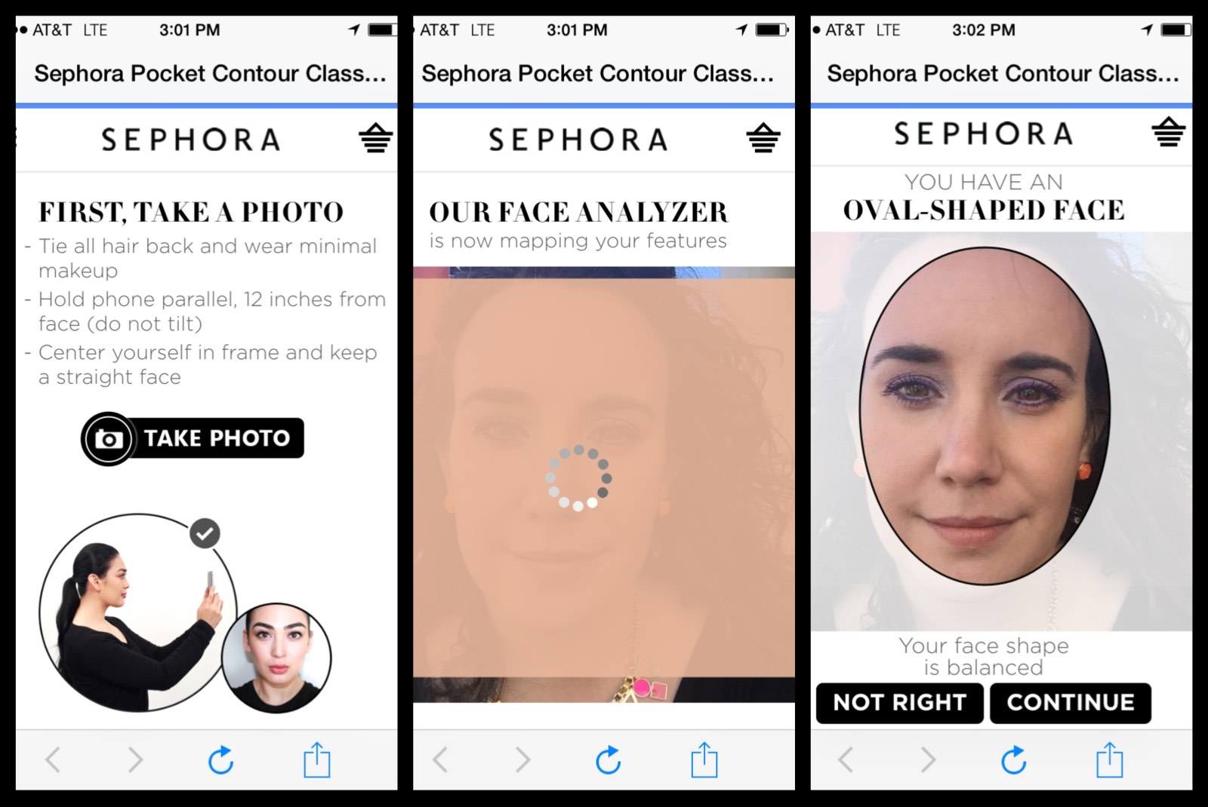

**Important Events**

With 100 locations by 2005 and an online store in 2010, Sephora's success has dominated the beauty business both online and off. Following its launch, the Beauty Insider client loyalty program increased sales tenfold. Soon after, the company started selling gift packages as a cheaper and better value choice, as well as seasonal offers that gave customers 20–30% off their total order in November and December. In 2018, the company made the decision to launch its clean beauty brand, which piqued the interest of a new consumer demographic that was more interested in skincare, clean products, and health. By 2019, customers might take advantage of additional benefits and savings through the Sephora Credit Card Program.

However, Sephora has grown significantly in recent years; this is especially evident in the first quarter of 2024, when average total store visits increased 18.49% year over year (Ewen, 2024). This increase outpaces the 6.28% growth rate of the cosmetics sector as a whole, suggesting a strong post-pandemic recovery. Notably, Sephora's performance is particularly noticeable among younger generations, as evidenced by gains of 21.78% and 21.48% among Gen Z and Gen X, respectively. These striking numbers highlight Sephora's successful engagement tactics, which blend digital advances with in-store encounters. On July 23, 2021, Sephora acquired the UK-based beauty company Feelunique, further expanding its reach into unexplored regions. Founded in 2005, Feelunique is an online retailer with 35,000 products, 800+ brands, and 1.3 million customers (Weil, 2021).According to a WWD story by Samantha Conti and Jennifer Weil quoted in Yahoo Finance, 2021, the acquisition is necessary because new Brexit restrictions and the dominance of Boots, a U.K.-based health and beauty giant, have "locked out of the U.K. market." To be clear, Brexit is the process by which the United Kingdom leaves the European Union, a consortium of 27 European nations.

Due to external dangers brought on by the conflict between Russia and Ukraine in 2022, 88 Sephora locations and 1,200 staff had to cease operations in Russia and change their name to Île de Beauté. Since its founding in 2001, the perfumery chain Île de Beauté has led the "Russian market with 100 stores" following Sephora's 2006 investment in the business (Kovak, 2022). The perfumery was taken over by Sephora in 2016, and in 2018 the chain store organization changed its name to Sephora. But during the COVID outbreak, Sephora was undergoing a rebranding. Kovak (2022) claims that Sephora formally changed its name to Île de Beauté on October 7, 2022. "As the war with Ukraine drags on, and pressure from investors and consumers persists," Sephora has fully cut ties with Russia (Kovak, 2022). However, as seen in figure 28, Sephora and Kohl's joined in 2021 to expand store-in-store. Business Wire (2022) claims that the company's initial 200 locations were so successful that 400 more were opened, with 850 more planned by 2023.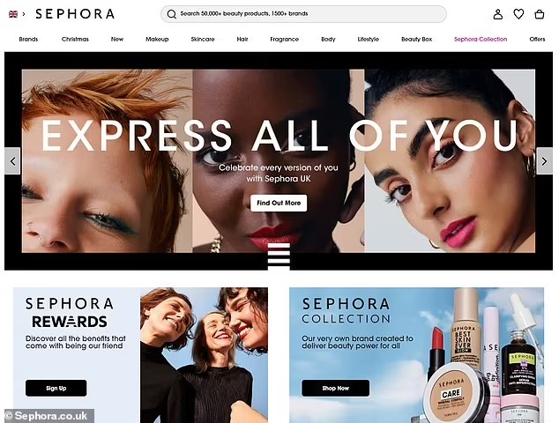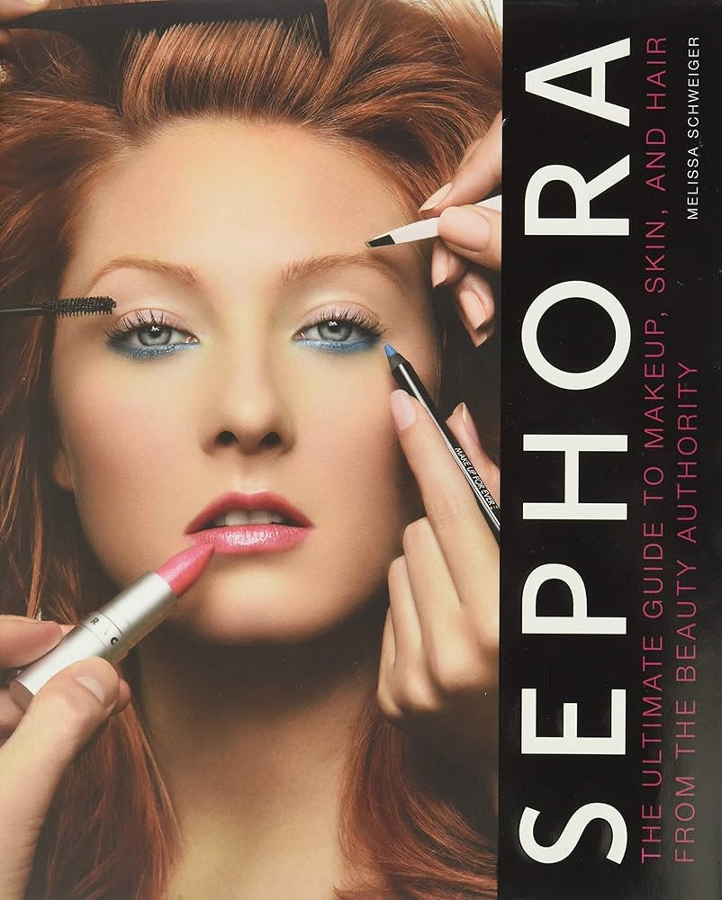

**SWOT Analysis**

**Strengths**Sephora is a globally recognized brand known for its strong brand identity and reputation for high-quality beauty products and services. The company boasts a wide product range, including skincare, makeup, haircare, and fragrances, catering to diverse customer needs. Sephora's exclusive partnerships with renowned brands and unique product collaborations enhance customer loyalty and drive traffic. Its robust omnichannel strategy, seamlessly integrating online and offline experiences, ensures accessibility and convenience for customers. The successful *Beauty Insider* loyalty program fosters repeat purchases and builds strong customer relationships. Sephora remains a leader in innovation by incorporating technology, such as virtual try-ons and personalized recommendations, to elevate the customer experience. Additionally, its commitment to inclusivity through a broad range of products for diverse skin tones and types appeals to a wide audience.

**Weaknesses**Despite its strengths, Sephora faces notable challenges. The brand operates in a highly competitive market, with rivals like Ulta Beauty, department stores, and direct-to-consumer brands vying for market share. Consumers often perceive Sephora as more expensive compared to competitors, potentially deterring price-sensitive shoppers. Furthermore, the company has limited market penetration in emerging regions where beauty demand is growing. Its reliance on luxury and premium brands could alienate cost-conscious customers, limiting its appeal across broader demographics.

**Opportunities**Sephora has significant growth opportunities to capitalize on. The expansion into emerging markets in Asia, Africa, and Latin America can tap into rising beauty product demand. Increasing consumer interest in sustainability and clean beauty aligns with opportunities to offer eco-friendly and cruelty-free products. With digital growth accelerating, Sephora can leverage e-commerce, social media, and influencer marketing to connect with younger audiences. Customization and personalization through AI and data analytics offer potential for creating tailored beauty solutions. Collaborations with influencers and celebrity brands can attract new customer segments, while the growing men’s grooming market provides an avenue for portfolio diversification.

**Threats**Sephora faces external challenges that could impact its growth. Economic uncertainty and recessionary trends may reduce discretionary spending on luxury beauty products. Intense competition from Ulta Beauty, department stores, drugstores, and online platforms like Amazon presents a constant threat. Regulatory scrutiny regarding product ingredients and sustainability practices could lead to increased operational pressures. The rapidly changing nature of beauty trends necessitates frequent updates to product lines, increasing costs and risks. Additionally, the proliferation of counterfeit products online threatens brand reputation and customer trust.

**Conclusion**

In conclusion, Sephora has demonstrated remarkable resilience and adaptability over the years, positioning itself as a global beauty retail industry leader. Its commitment to diversity, inclusivity, and innovation has enabled the company to overcome challenges and continue its steady growth. Despite stiff competition and economic challenges, Sephora's strategic partnerships, such as the collaboration with Kohl's and digital creators, and expanding their outreach have strengthened the brand’s market presence. With a focus on expanding its brick-and-mortar stores, enhancing its digital platform, and catering to evolving consumer preferences, Sephora is well-positioned for continued success and growth in the coming years.

LVMH's operational competence and strategic planning have established it as a leader in the luxury market. LVMH continues to establish industry standards for success by utilizing its wide range of brands and emphasizing innovation within traditional craftsmanship (Chen, 2024) LVMH, the parent company to Sephora, announced its 2023 annual results, reporting another record-setting year with $96,298,330,000 billion in revenue and $25,471,020,000 billion in profit, driven by strong organic growth across most of its divisions. The company's success has been largely attributed to its strategic concentration on mergers and acquisitions, as seen by high-profile acquisitions like Bulgari and Tiffany & Co.These purchases strengthened LVMH's brand management skills and diversified the company's offering, enabling it to generate income continuously even during recessions (Hasee, 2023). One of the main reasons for the company's sustainability is its ability to quickly adjust to shifting consumer preferences, particularly concerning luxury items during the pandemic (Hasse, 2023).LVMH has been able to leverage new markets while also achieving impressive results in existing territories.

Furthermore, by mastering local growth tactics,. One of the main reasons for the company's profitability has been its ability to quickly adjust to shifting consumer preferences, particularly about luxury items during the pandemic (Hasse, 2023). Effective risk management strategies that protect against market volatility are a good complement to this flexibility.

**References:**

Ceynar, E. (2021). Sephora Leads on Corporate Social Impact Beautifully - Tides.

Retrieved from:

<https://www.tides.org/sephora-leads-on-corporate-social-impact-beautifully/>.

Kesser, C. (2023, February 7). *Sephora’s mission: Inclusion at the heart*. Las Vegas Global Economic Alliance. Retrieved from https://www.lvgea.org/inclusion-is-at-the-heart-of-sephoras-mission/

Kohan, S. E. (2021). Here's How Sephora Is Addressing Diversity, Equity And Inclusion In Its Stores.

Retrieved from <https://www.forbes.com/sites/shelleykohan/2021/08/01/sephora-is-walking-the-talk-on-diversity-equity-and-inclusion/>

Ludmir, C. (2024, June 3). Sephora’s record growth in 2023 reaffirms its beauty retail leadership. *Forbes*.

Retrieved From: [https://www.forbes.com/sites/claraludmir/2024/01/29/sephoras-record-growth-in-2023-reaffirms-its-beauty-retail-leadership/#:~:text=Contributor,evolving%20consumer%20 and%20 retail%20 trends.&text=The%20world’s%20leading%20luxury%20group,Europe%20and%20the%20Middle%20East.%E2%80%9D](https://www.forbes.com/sites/claraludmir/2024/01/29/sephoras-record-growth-in-2023-reaffirms-its-beauty-retail-leadership/#:~:text=Contributor,evolving%20consumer%20and%20retail%20trends.&text=The%20world%E2%80%99s%20leading%20luxury%20group,Europe%20and%20the%20Middle%20East.%E2%80%9D)

LVMH reports exceptional growth despite economic challenges. (2023, July 27). *MarketLine NewsWire* (Formerly Datamonitor).

Retrieved From: [https://advance-lexis-com.citytech.ezproxy.cuny.edu/api/document?collection=news&id=urn%3acontentItem%3a68T6-87P1-JC0X-H4XK-00000-00&context=1519360&identityprofileid=N5VPDM51618.](https://advance-lexis-com.citytech.ezproxy.cuny.edu/api/document?collection=news&id=urn%3acontentItem%3a68T6-87P1-JC0X-H4XK-00000-00&context=1519360&identityprofileid=N5VPDM51618)

Petruzzi, D. (2024, August 13). Sephora: Retail sales worldwide 2017-2023. *Statista*.

Retrieved from:

<https://www.statista.com/statistics/1445562/retail-sales-of-sephora-globally/>

Petruzzi, D. (n.d.). Topic: Sephora. *Statista*.

Retrieved From

<https://www.statista.com/topics/11903/sephora/#statisticChapter>

[Statistics report on Sephora. Statista - Campus Access. (n.d.). https://www-statista-com.citytech.ezproxy.cuny.edu/study/163583/sephora/](https://www.statista.com/topics/11903/sephora/#statisticChapter)

Sandler, E. (2024, January 26). *Sephora is a bright spot in LVMH 2023 earnings*. Glossy.

Retrieved from:

[https://www.glossy.co/beauty/sephora-is-a-bright-spot-in-lvmh-2023-earnings](https://www.glossy.co/beauty/sephora-is-a-bright-spot-in-lvmh-2023-earnings/)

Sephora. (n.d.). *About us*. Sephora. Retrieved September 27, 2024. Retrieved from: <https://www.sephora.com/beauty/about-us>

Tighe, D. (2024, July 18). Leading retailers in the US 2023. *Statista*.

Retrieved from:

<https://www.statista.com/statistics/195992/usa-retail-sales-of-the-top-retailers/>

Torres, R. (June 13, 2024). Kohl's cut back on jewelry to make room for Sephora. Now it's looking to boost sales. *USA Today Online.* USA Today Network

Retrieved From: <https://advance-lexis-com.citytech.ezproxy.cuny.edu/api/document?collection=news&id=urn%3acontentItem%3a6C82-VJ31-F03F-K4VV-00000-00&context=1519360&identityprofileid=N5VPDM51618>

Ulta downgraded as competition heats up and promos weigh on margins. (July 24, 2024, Wednesday). *Seeking Alpha* - Premium News.

Retrieved From: [https://advance-lexis-com.citytech.ezproxy.cuny.edu/api/document?collection=news&id=urn%3acontentItem%3a6CJK-Y2R1-F11P-X3PN-00000-00&context=1519360&identityprofileid=N5VPDM51618.](https://advance-lexis-com.citytech.ezproxy.cuny.edu/api/document?collection=news&id=urn%3acontentItem%3a6CJK-Y2R1-F11P-X3PN-00000-00&context=1519360&identityprofileid=N5VPDM51618)

Image Cite: Will, J. (2015, March 18). Nerd alert: Sephora’s new pocket contour class is kind of amazing. GlamNerds.com. https://glamnerdsblog.wordpress.com/2015/03/18/nerd-alert-sephoras-new-pocket-contour-class-is-kind-of-amazing/

Criteo. (2018, December 13). From store to gram: how sephora markets across 5 different channels. Criteo. Retrieved from: https://www.criteo.com/blog/sephora-marketing-strategy/

Etailwest. (2022). How sephora integrates retail & online marketing. ETail. Retrieved from:

<https://etailwest.wbresearch.com/blog/how-sephora-integrates-retail-online-marketing>

Ewen, J., (2024). Sephora's Recent Surge & Wider Analysis Of Cosmetics Stores. Retrieved from<https://passby.com/blog/sephora-cosemtics-beauty/>.

Weil, J. (2021, September 29). Sephora seals deal with feelunique. WWD. Retrieved from https://wwd.com/

beauty-industry-news/beauty-features/sephora- seals-deal-feelunique-1234953615/

Kovak, K. (2022, October 28). Former russian sephora stores reopen under île de beauté brand. Beauty matter. Retrieved from <https://beautymatter.com/articles/former-russian-sephora-stores-reopen->under-ile-de-beaute-brand