**Culture + Company + Costumer**

**Assignment No. 4**

Citlalli Villanueva

Department of Business, New York City College of Technology

Brand Image Marketing

Prof. Shahzad Haider

March 14th, 2023.



***History***

Miu Miu is an Italian high fashion brand founded in 1993 by Miuccia Prada, making it a sister label to Prada. Miuccia Prada finds the opportunity to explore new territory with this brand and create more youthful, playful, and affordable options of clothing for women.

***Culture***

The brand is known for its avant-garde designs that blend traditional and modern elements to create unique and contemporary looks. Miu Miu’s culture is creative, innovative, and experimental, they create looks that are both daring and refined. Their designs often feature bold colors, intricate patterns, and unexpected combinations of materials.

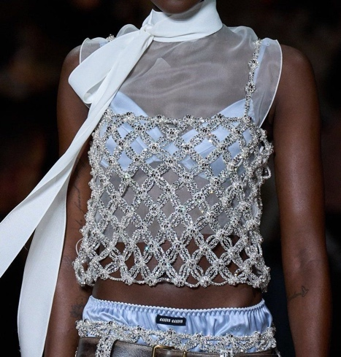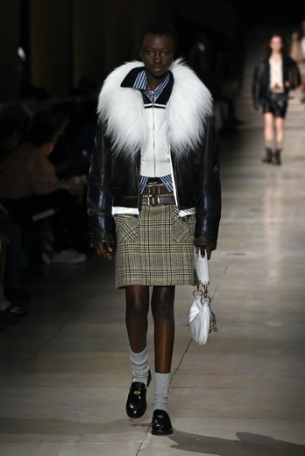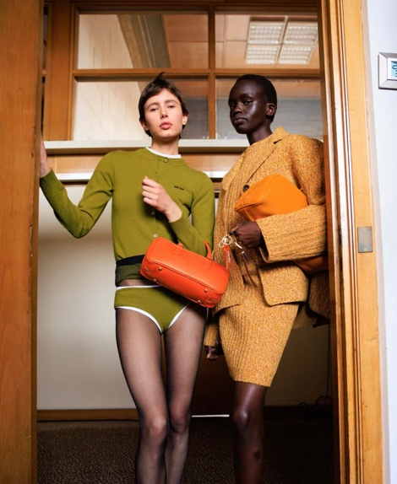

***Structure***

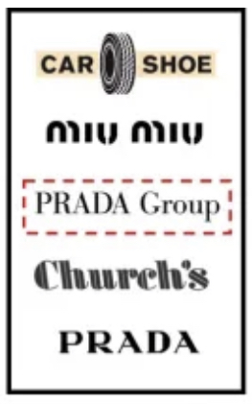

Miu Miu belongs to the Prada Group, an Italian luxury fashion house specializing in leather handbags, travel accessories, shoes, ready-to-wear, perfumes, and many more. The Prada Group was founded in 1913 by Mario Prada.

***Core values***

Sensual and intellectual are Miu Miu’s core values that they try to encapsulate in every collection that they show to the world. They utilize change as the key element to build the world.

***Vision***

“An outpost for the most refined feminist y, a tangible expression of the energy conveyed by women’s natural contradictions and provocative personalities to contemporary society.”

***Mission***

“Our Mission is to provide full service, starting from a raw product to obtaining a final solution. We exponentially grew digital printing to satisfy the new industry’s requests.

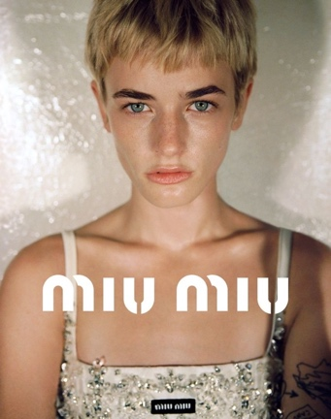

***Objectivity***

Miu Miu has some sustainability goals like planning to reduce absolute scope 1 and scope 2 greenhouse gas emissions by 29.4% by 2026.

***Core and Target market segment***

Miu Miu’s core target market segment consists of women between the ages of 20-40 who are fashion-forward, adventurous, and confident. These women are typically seeking unique and high-quality clothing, shoes, and accessories that make a statement and stand out from the crowd.

Miu Miu’s broad target market segment includes women of all ages who appreciate high-quality, luxury fashion products. Women who are looking for clothing, shoes, and accessories that are chic, stylish, and sophisticated, but also women who have a high disposable income and are willing to invest in clothing items.

***Customer profile examples***

******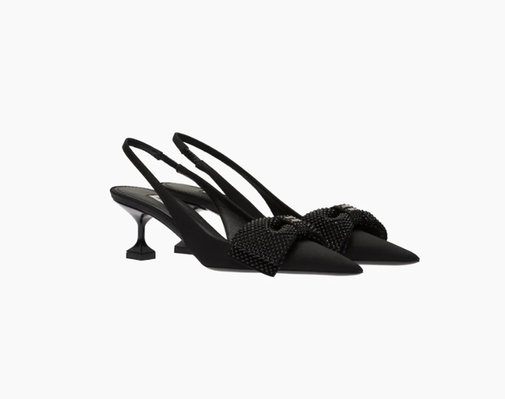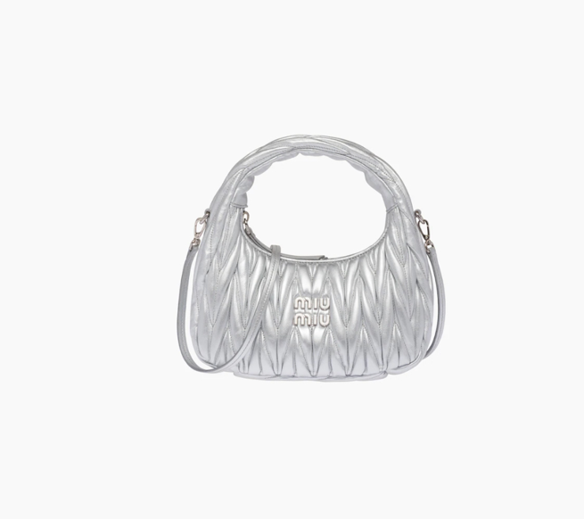Natalia, 26: she is a young professional who works in the creative industry. She’s interested in fashion and enjoys experimenting with new styles and trends. Natalia is confident and outgoing; she is not afraid to stand out from the crowd. She is always looking out for unique pieces that reflect her essence and personality, Miu Miu is one of her favorite clothing brands, and often shops there for statement shoes and bags for her wardrobe.

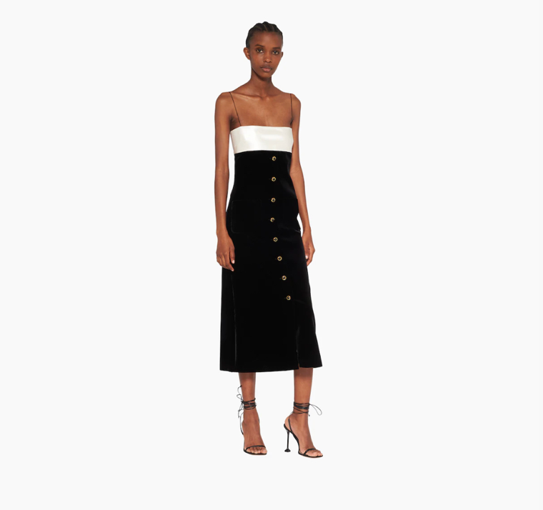-Cassandra, 35: she is an established businesswoman who works in finance. She has a strong sense of style and is more into sophisticated, high-quality fashion looks. Cassandra has a busy schedule so she looks for pieces of clothes that can be versatile in her business and night-out looks, Miu Miu helps her with that; she loves the brand’s attention to detail and its ability to mix classic and contemporary elements, which is just what she is looking for. Some of her favorite pieces from Miu Miu are jackets, dresses, and handbags that add an essence of professionalism and youth to her outfits.

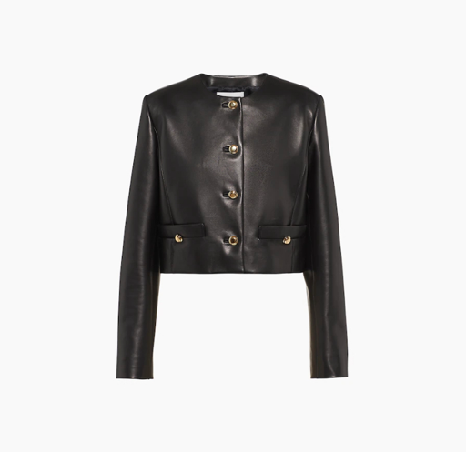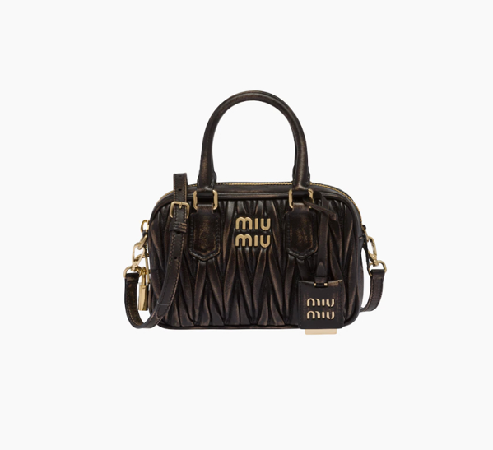

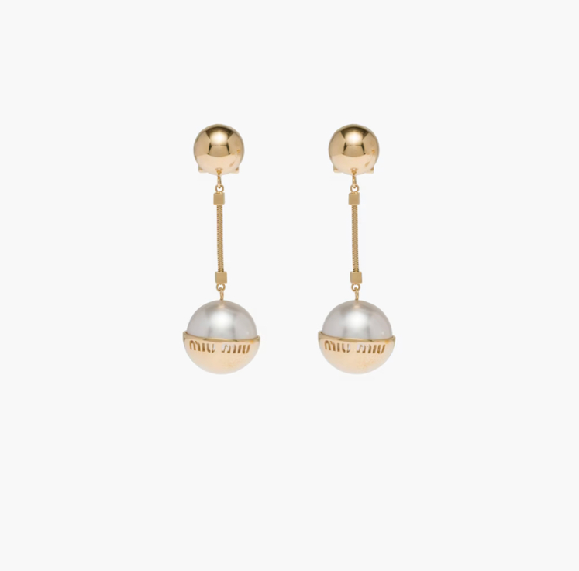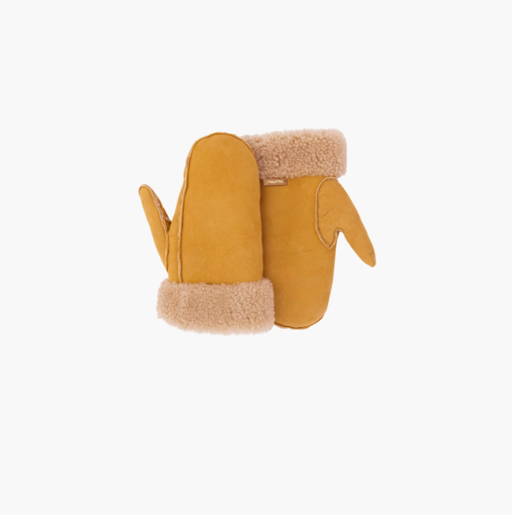

 -Antonella, 44: She is an art professor who has also sold her art in art galleries. Antonella values creativity and self-expression, she loves to attend gallery openings, events, and dinner parties; she has a unique sense of style that her friends and family call “electric and tasteful”, her statement accessories, bright colors, and classic handbags contribute to 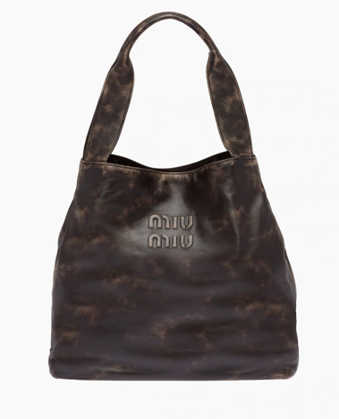that. Miu Miu’s artistic and unconventional designs complete Antonella’s looks and that is why she always shops there for leather handbags, statement jewelry, and colorful accessories.

***Cited Works.***

<https://www.miumiu.com/us/en.html>

<https://www.pradagroup.com/en/brands/miu-miu.html>

<https://fashionretail.blog/2019/04/08/luxury-and-fashion-corporations/>

<https://www.showstudio.com/contributors/miu_miu>

