Donatella Versace

*A gift to the world.*

Citlalli Villanueva

New York City College of Technology

**Background of designer**

Fashion icon, socialite, model, and businesswoman Donatella Versace was born on May 2, 1955, in Regio de Calabria, Italy. She is the youngest of her 3 siblings. Her family molded her into what she is now: her father Antonio Versace worked as a salesman, her mother, Francesca made clothes, and most importantly, Gianni Versace, her older brother, was the one who decided to sumerge the family into the fashion designer business when he first opened the Versace boutique in Milan in 1978. Donatella moved to Florence for her university studies but didn’t last long since she went back to being side-by-side with Gianni and his newborn business. The Versace boutique swiftly drew the attention of the people and was escalating into success, it was considered one of the trendiest clothing stores at the moment. Donatella Versace first started in the family business as the Vice President, hand-to-hand with her oldest brother (“Donatella Versace”, n.d.). Versace got married in 1983 to Paul Beck with whom she had 2 children, Allegra Versace and Daniel Versace, this marriage lasted until the 2000s and then she remarried Manuel Dallori in 2004 with whom she was married for only a year, finalizing their divorce in 2005 (*Donatella Versace marriages and divorces*, n.d.)

Gianni and Donatella had a close relationship, to the point that Donatella was a muse and one of the first ever to have to right to critique his work. In July of 1997, Gianni Versace was murdered, leaving Donatella heartbroken and with a big responsibility on the Versace brand, which was to live up to Gianni’s expectations for the brand. The next 5 years were incredibly tough, she even considered herself lost and acknowledged all the mistakes that she made, some of which turned out to be one of her biggest battles: cocaine addiction. (Cartner-Morley, 2017).

In December of 2017, Donatella was awarded the Fashion Icon of the Year at the British Fashion Council’s The Fashion Awards (Eytan, 2017). Donatella’s designs are meant to empowering women and making them feel confident in their skin, she considers herself a feminist, and her work advocates for this purpose, she is a woman for women.

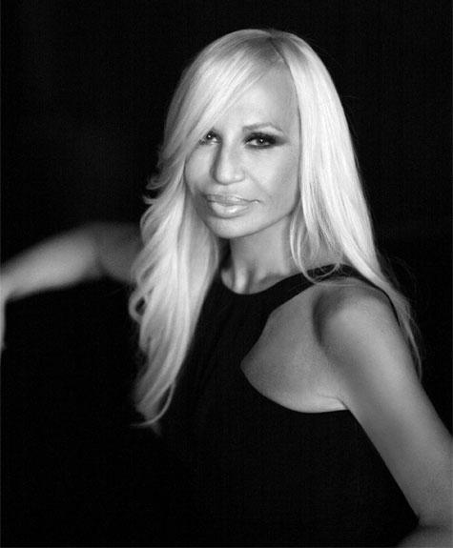

**confident**

Figure 1. Donatella Versace

**The Market Segment**

Versace is considered a high-end leading international Luxury brand due to their premium materials and exclusive designs that compete with other products in the luxury market. (Versace, 2023). Donatella’s designs are inspired by and for women in their late 20s to mid-40s, upper-middle-class women who have discretionary incomes from $100,000 to $150,000. Most of them have a bachelor’s degree or higher, they are professionals with high-profile occupations like celebrities, business executives, and women who work in creative industries (Cherish Riley, 2017). These women choose Versace because they are drawn by its quality and durability, along with the renounced brand name status that Versace has well earned. They like to live an opulent and lavish lifestyle and aren’t afraid to look glamorous and extravagant when needed, they also value luxury pieces of clothing and are willing to invest their money in pieces that will be heirs to their kids and grandchildren one day.

**Design and Manufacture**

When Donatella Versace took the rails of Versace’s future, the world had high expectations of her work and the brand’s reputation, she first wanted to keep Gianni’s legacy and tried to immerse her designs into something that Gianni would have designed himself, yet, she regretted that (Cartner-Morley, 2017). As time went by and she dealt with the loss and grief of her dearest older brother, she came back on track and started to take care of the designs, gifting us Jennifer Lopez’ iconic look in the 2000s at the Grammy’s red carpet. After 26 years, Donatella is still the head designer of Versace. Something that she loves to do is honor her brother’s memory by taking looks out of the achieves and re-designing them by adding her personal touch. A big example of this is the refresh of the butterfly cut dress that was first worn by Elizabeth Hurley (originally designed by Gianni) and then Donatella created versions inspired by her brother’s design that were worn by Naomi Campbell in 1999, Cristina Aguilera in the 2000s and most recently, Dua Lipa for the Grammy’s red carpet in 2021 (Meda, 2021).

Versace’s main headquarters are in Milan, Italy but since their USA market occupies a big portion of their sales, they also have one in New York (Versace, 2023). Manufacturers are 82% located in Italy, the rest is divided between European and Asian countries. Just like every other high-end luxury brand, their official manufacturers are kept confidential for competitive reasons.

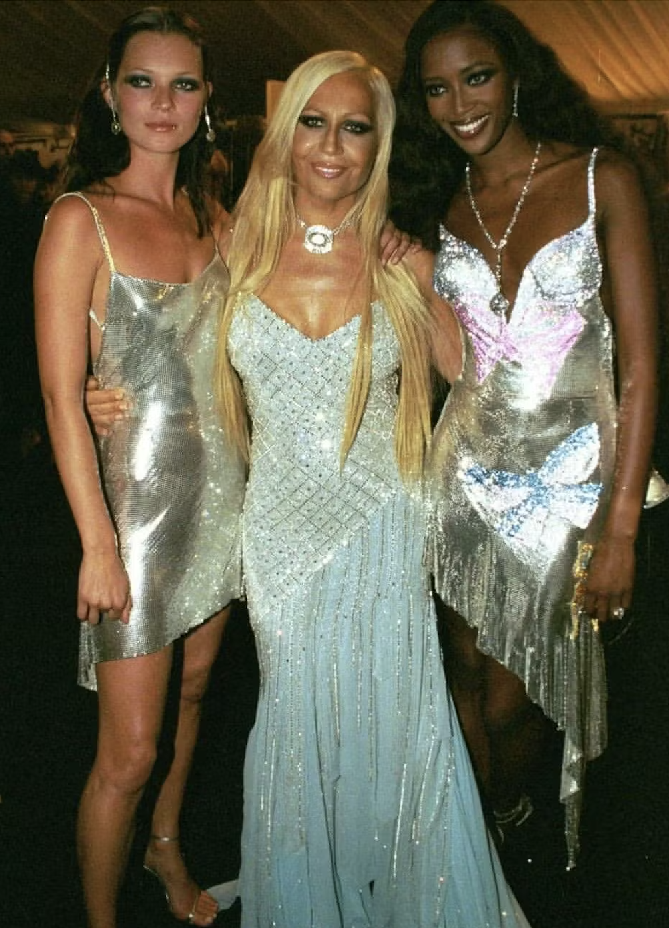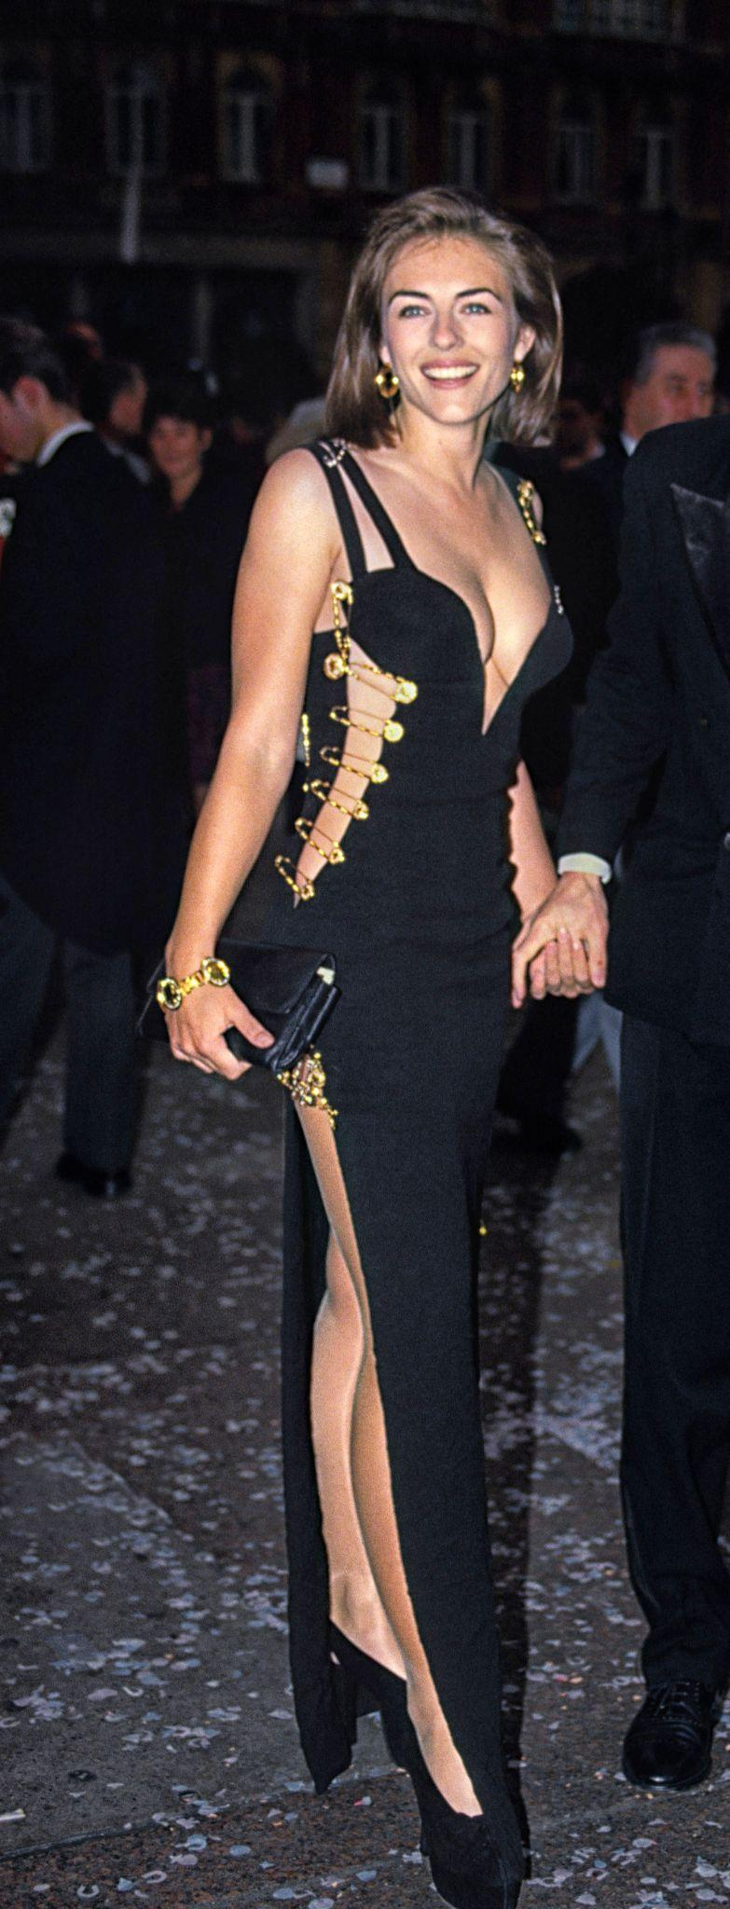

Figure 2. Elizabeth Hurley in iconic Figure 3. Kate Moss, Donatella

butterfly-cut dress designed by Gianni Versace. Versace and Naomi Campbell in

a butterfly-cut dress designed by

Donatella Versace.

**Fabrics**

The most popular fabrics used in Versace’s designs are silk, cotton, leather, Wool, and Spandex all of which reflect the high quality of the brand. The choice of the fabrics relies mostly on the theme of their collections, reflecting the brand’s commitment to detail and craftsmanship. Their fabric materials are Italian sourced.

The metallic Oroton Mesh is a well-known material that comes from the Versaces designs, with which Gianni Versace created the iconic Oroton Gold dress, this fabric was made out of a suppleness of silk with a mix of the metals’ texture to add shiness and a touch of glamour (Icon-Icon, 2016).

**Promotion**

Donatella Versace and her team approach publicity in multiple ways to make their products popular all around the world. Some of the promotion strategies that they work on are fashion shows and events, digital marketing and social media, celebrity deals, collaborations and limited edition products, traditional advertising, and visual merchandising.

Versace counts with accounts on platforms like Instagram, Facebook, Twitter, Pinterest, YouTube, TikTok, and its website and sends e-mails to their customers when they sign up for information about upcoming products. Versace uses their various Social Media accounts to connect with the younger target audience, they specifically use Instagram to connect with millennials (Tovar, 2022). Their website had around 10.5 million views worldwide between July and September 2023, they have an average of monthly visits of 3.502 million views, the USA being at the top of the list with 31.10% of traffic share (Similar Web, 2023).

Models like Cindy Crawford, Naomi Campbell, Carla Bruni, Linda Evangelista, Bella Hadid, Kendall Jenner, and Gigi Hadid have walked their runways, and celebrities like Jennifer Lopez, Taylor Swift, Dua Lipa, Cher, and Madonna have worn Donatella’s looks on various important red carpets, their worldwide tour, music videos and appearances on tv (Okwodu, 2015).

In addition to social media, Donatella Versace promotes the brand traditionality as well, using big billboards in metropolitan cities like New York, London, Milan, Tokyo, and Paris, cities in which they are popular and that concentrate most of their buyers. Versace’s biggest selling market is situated in Europe, Middle East, and Africa with a revenue of 468 million dollars as in the year 2023, second place is occupied by the Americas with a revenue of 408 million dollars and lastly, Asia with a 230 million dollars revenue (*Versace revenue, by region worldwide 2023*, n.d.).

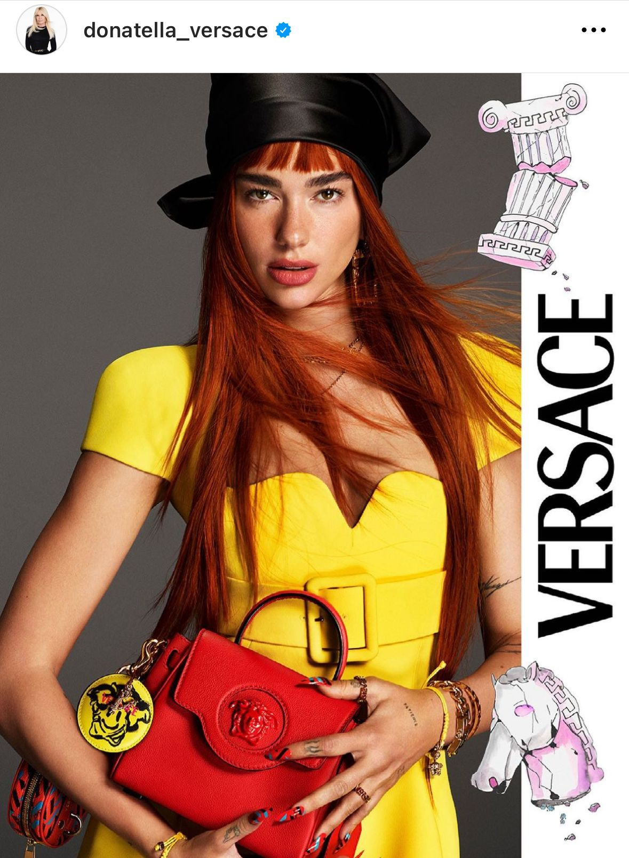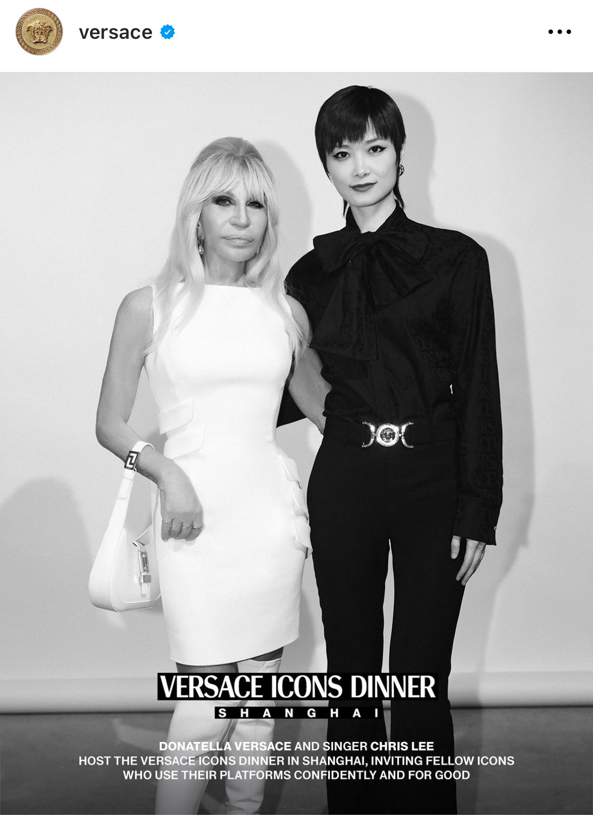

Figure 4. Versace Icons Dinner Figure 5. Dua Lipa for Versace

References

Cartner-Morley, J. (2017, September 14). Donatella Versace: "My brother was the king, and my whole world had crashed around me”. *The Guardian*. Retrieved from

<https://www.theguardian.com/fashion/2017/sep/14/interview-donatella-versace-my-brothers-death-made-me-strong>

Cherish Riley. (2017, January 24). *Versace brand extension final*. Issuu. Retrieved from

<https://issuu.com/cherishriley/docs/versace_brand_extension_final>

Donatella Versace. (n.d.). *Business of Fashion*. Retrieved November 1, 2023.

<https://www.businessoffashion.com/community/people/donatella-versace>

*Donatella Versace marriages and divorces*. (n.d.). Strictlyweddings.com. Retrieved November 2, 2023, from

<https://www.strictlyweddings.com/info/notable-marriages/donatella-versace-572790>

Eytan, D. (2017, November 30). *Donatella Versace to receive “fashion icon of the year” award*. Forbes. Retrieved from

<https://www.forbes.com/sites/declaneytan/2017/11/30/donatella-versace-to-receive-fashion-icon-of-the-year-award/?sh=18744237a098>

Icon-Icon. (2016, January 24). *The oroton dress by Versace*. ICON-ICON.

<https://www.icon-icon.com/en/the-oroton-dress-by-versace/>

Meda, M. (2021, August 24). *Versace Butterfly Dress: From Naomi to Dua Lipa*. L’Officiel UK; L’Officiel. Retrieved from

<https://www.lofficiel.co.uk/fashion/dua-lipa-grammy-versace-butterfly-dress>

Okwodu, J. (2015, September 25). *Supermodels, celebrities, and dominatrixes—Versace’s most iconic runway moments*. Vogue. Retrieved from

<https://www.vogue.com/article/versace-wildest-runway-moments>

Tovar, D. (2022, May 12). *All you need to know about Versace’s marketing strategy*. BluCactus United Kingdom. Retrieved from

<https://www.blucactus.uk/versaces-marketing-strategy/>

(N.d.-b). *Similarweb.com.* Retrieved November 1, 2023, from

[https://pro.similarweb.com/#/digitalsuite/websiteanalysis/overview/website-performance/*/999/3m?webSource=Total&key=versace.com](https://pro.similarweb.com/#/digitalsuite/websiteanalysis/overview/website-performance/*/999/3m?webSource=Total&key=versace.com)

*Versace revenue, by region worldwide 2023*. (n.d.). Statista. Retrieved November 2, 2023, from

<https://www.statista.com/statistics/1013140/versace-revenue-by-region-worldwide/>

(N.d.). Versace.com. Retrieved November 1, 2023. Retrieved from

<https://www.versace.com/us/en/about-us/company-profile.html>