Chynna Caleb-Nicholson

Dr. Alyssa Dana Adomaitis

BUF 4900

July 29, 2024

Statement Sleeves

While visiting the Museum at The Fashion Institute of Technology of New York, there was an abundance of statement sleeve pieces dating back to the 1800’s. Walking through the exhibition, one was reminded of the many events that took place, which has ultimately gotten us to where we are today. The exhibition featured many great designers like Stephen Burrows, Giorgio Armani, Herbert de Givenchy, and Rudi Gernreich, who have made amazing strides in fashion and more specifically with their interpretation of a ***statement sleeve***s. Within this essay, using the eight elements of design, one will see the breakdown of a statement sleeve garment designed by John Galliano.

Bell (2017) describes ***line*** as “a direction – a major composition – the way they are arranged determines the effectiveness of the presentation.” John Galliano does not use literal lines for his printed silk evening ensemble, but one is able to see the symmetry in the way the key patterns align both horizontally and vertically on the skirt and blouse. In regard to the construction of the blouse, princess seam lines are noticeable towards the front of the garment, as well as the side of the skirt, providing a more tailored appearance. The gathering to the left side of the skirt takes the shape of a curved line, which “bring forth a sense of softness and femininity. These graceful lines mirror the natural curves of the human body, imparting a gentle and flowing aesthetic to garments” (Hart, 2023). Nonetheless, the star of the show is the eye-catching origami inspired sleeves.

***Rhythm*** is defined as eye movement from the viewer when observing an object (Bell & Ternus, 2017). Upon viewing the garment, one’s eyes start at the center of the blouse, with focus shifting to the right and then to the left. Once the top portion of the garment is viewed, one's eyes shift to the lower half, which is the skirt, starting at the center, lowering to where it starts bunching/pulling together and it lowers even more to where the skirt falls. Focus on the skirt should be revisited because the ***rhythm*** of the crystal eyelet embellishments can either go from top to bottom, left to right or diagonally depending on the angle one is standing at. (Add 1 sentence)

***Balance*** refers to either mirror imaging, which is known as *symmetrical balance* or *informal balance* which means that something is not an exact replica (Bell & Ternus, 2017). Galliano’s ensemble could be considered both symmetrical and informal. One could argue that the actual construction of the origami sleeves is the same, the seams are equal, the collar of the blouse align, and the embellishments are perfectly placed. Another could argue that the ***tone*** of red used for the blouse and skirt are not the same, the pattern on the silk fabric is not symmetrical for either statement sleeve or the ***sheen*** on the blouse is not the same as the skirt. Overall, Galliano could have purposefully intended for the ensemble to not be exact when considering design elements. *Informal balance* can be executed correctly, and John Galliano has done just that.

According to Bell (2017), ***contrast*** is defined as “a sharp difference, juxtaposition of different forms and lines.” Similarly to ***balance***, the contrast between the color tones makes a huge difference when viewing the piece. Galliano could have chosen to use solid red but instead, he used patterned silk fabric with flowers that is very much Chinese and Japanese inspired. Galliano’s use of two similar but very different cultures is a great form of ***juxtaposition****,* because one could argue that he is exploring a new and different way to bring both cultures together due to previous conflicts. Both countries have not always seen eye to eye in the past, as “conflict broke out when China began a full-scale resistance to the expansion of Japanese influence” (The Editors of Encyclopedia Britannica, 1998).

Bell (2017), defines ***dominance***as standing out. What stands out the most is of course the origami sleeves. Galliano gives the sleeves more height by stacking the sleeves on top and to the sides of one another, creating height/elevation. If someone were to put the garment on, the focal point would be the sleeves because they stand out due to its size and high visual weight. Aside from the eye-catching sleeves, the actual use of the color red stands out too. In western society, the color psychology of the color red is that it is “stimulating, loving, powerful, assertive, demanding and vulgar” (Bell, 2017). In China however, the color red is pivotal to the Chinese way of life, as it is associated with weddings, and happy occasions (He, 2011).

***Proportion*** is “the size of elements in relation to one another” (Chapman, n.d.). The ***proportion*** of the garment is suitable for a more rectangular body shape, which is common amongst models. The princess seams for both the upper and lower halves of the dress add more shape for the garments intended body type. With the sleeves being so bold, the silhouette of the skirt being form fitting, ties the look together. The cut of the jacket/blouse adds layers to the garment because at first glance it looks like a blouse and skirt, but it is an actual dress because the waistline is higher.

***Repetition*** is defined as “repeating or reiterating an idea or motif” (Bell & Ternus, 2017). Although the placement of the pattern on the fabric is not aligned symmetrically on the dress, the floral motif and varying circular patterns are repeated on the dress. The added embellishment is intricately repeated as well.

When John Galliano debuted his Fall 2003 collection, it was two years after 9/11 and the world was still on high alert. The United States of America would invade Iran, resulting in an eight-year war, there was a massive blackout that impacted millions of people and there was a six party talk between the United States, China, Japan, North Korea, South Kora and Russia. It is ironic how Galliano’s piece fit perfectly with the times of 2003. John Galliano should be celebrated for his statement sleeve piece because he along with Alexander McQueen, were able to use “historic references and weird preoccupations poured into fabric, resulting in a statement that was more than the sum of its seams” (Jana, 2024). Many people have had a lot to say about Galliano as a person but his ability to use what was happening in the current to tell a story is remarkable.

Figure 1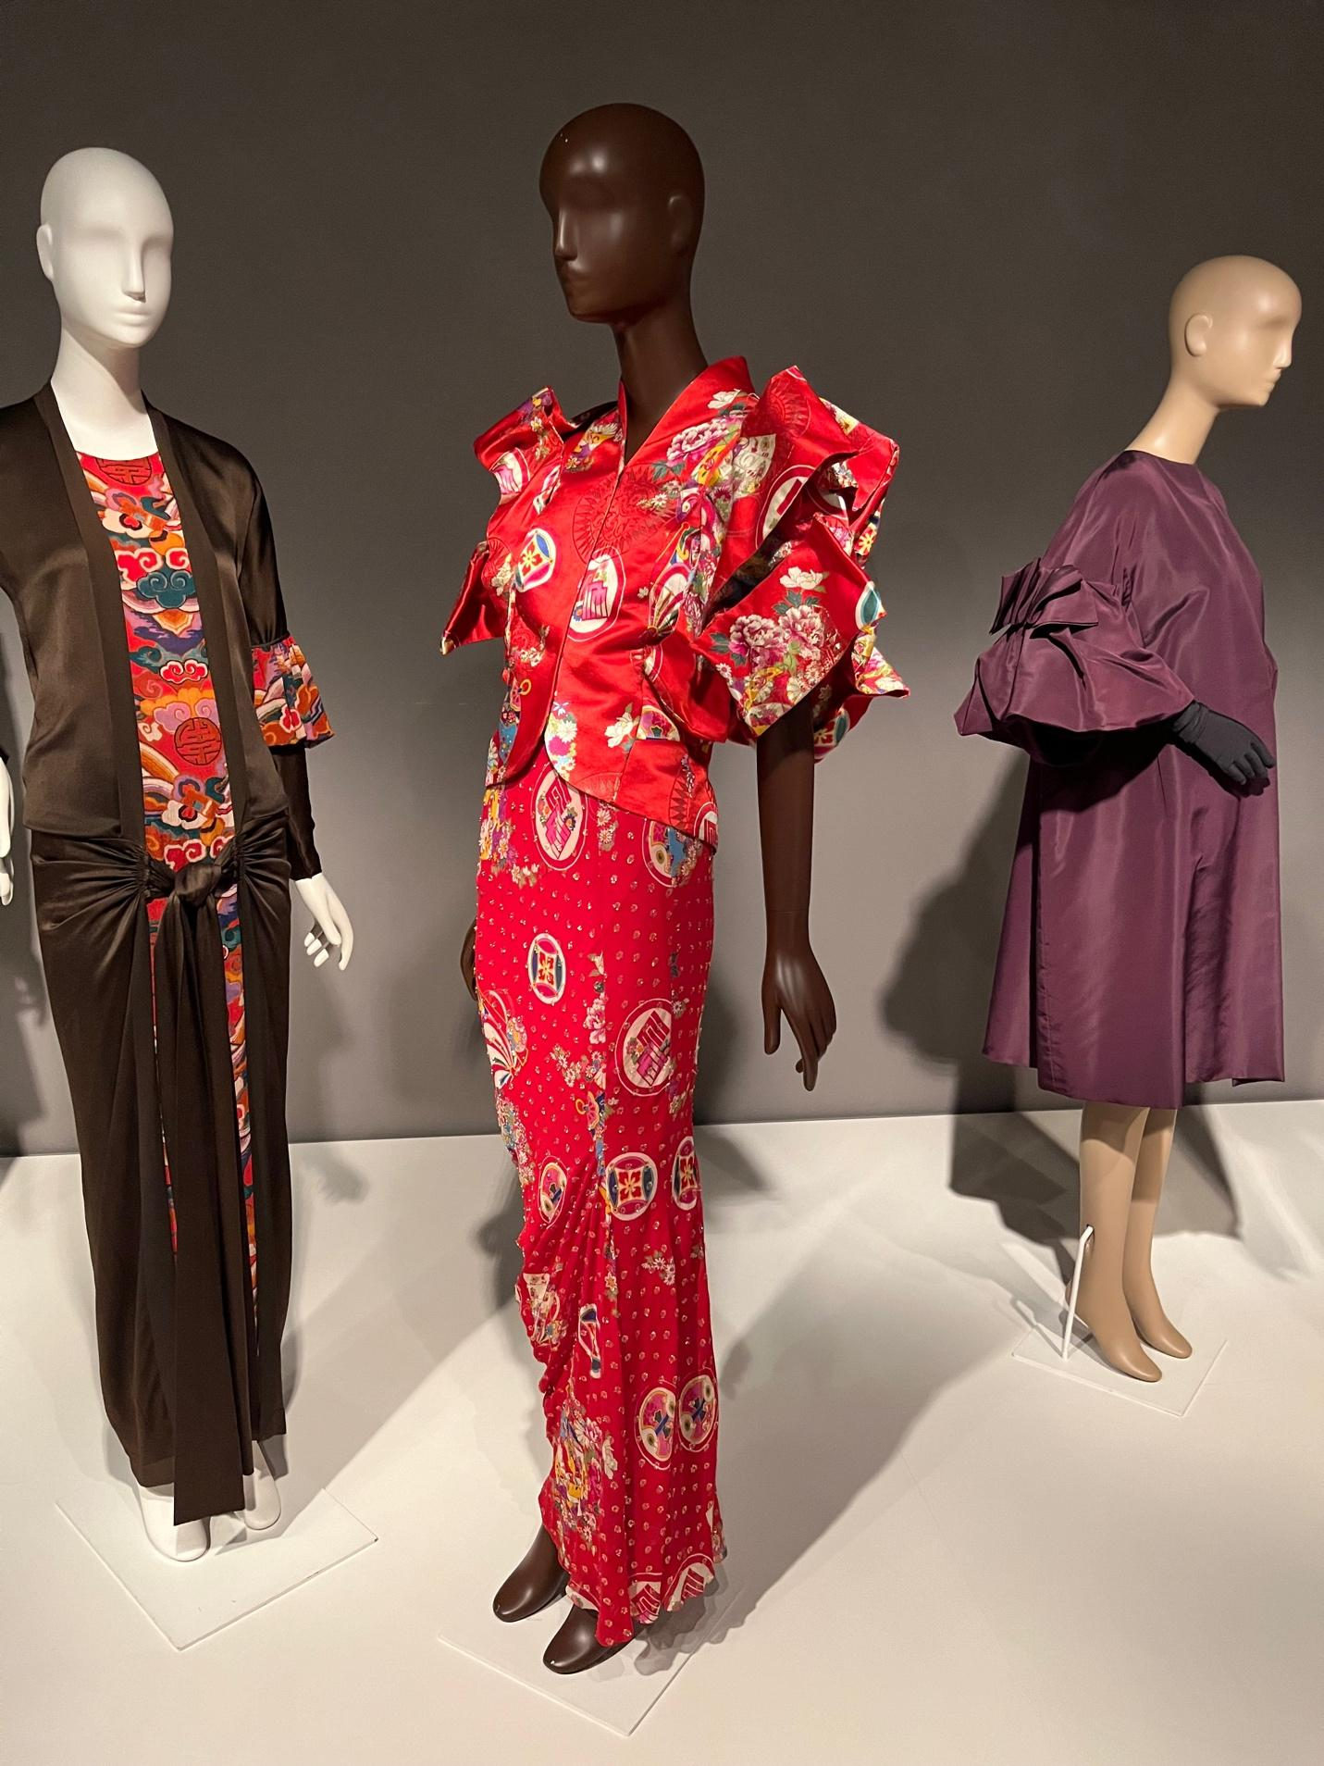

# 

**References**

Bell, J., & Ternus, K. (2017). Silent selling. In *Bloomsbury Publishing Plc eBooks*. https://doi.org/10.5040/9781501315527

Chapman, C. (n.d.). *The Principles of Design and Their Importance*. Toptal.com. https://www.toptal.com/designers/ui/principles-of-design#:~:text=Proportion%20is%20one%20of%20the,more%20important%2C%20smaller%20elements%20less.

Hart, J. (2023). *Types of lines in fashion designing: lines that shape style*. https://www.theknowledgeacademy.com/blog/types-of-lines-in-fashion-designing/#:~:text=Curved%20lines%20in%20Fashion%20Design,and%20flowing%20aesthetic%20to%20garments.

He, G. (2011). A comparative study of color metaphors in English and Chinese. *Theory and Practice in Language Studies*, *1*(12). https://doi.org/10.4304/tpls.1.12.1804-1808

Jana, R. (2024, March 18). *The dramatic rise-fall-and-rise of John Galliano*. https://www.bbc.com/culture/article/20240314-the-dramatic-rise-fall-and-rise-of-john-galliano