**Dior & Balenciaga: Artists of the Times**

Chynna Caleb-Nicholson

Department of Business, New York City College of Technology

BUF 2255: Merch Planning & Buying

Dr. Alyssa Adaomaitis

June 13th, 2022

**Dior & Balenciaga: Artists of the Times**

The ultra impactful Diana Vreeland once said, “Fashion is the part of the daily air and it changes all the time, with all events. You can even see the approaching of a revolution in clothes. You can see and feel everything in clothes.", and she is absolutely correct. Two designers in particular come to mind when envisioning designers who shaped fashion/design in the direction it is in today, Cristóbal Balenciaga and Christian Dior. As noted by Militano (2022), Dior and Balenciaga equally represented luxury dressing whilst creating comparable silhouettes all the while differing in methods. Dior and Balenciaga were so influential in the sense that they were responsible for “reviving both the fashion landscape and France’s crippled economy in the Post-War period, each brought back a decadence to dressing”(Militano, 2022, para. 4).

On June 1st, the Fashion Institute of Technology Museum, located in New York opened an exhibit titled, ***Dior + Balenciaga: The Kings of Couture and Their Legacies***, respectfully showcasing work from both designers. Viewers were given a modest fashion timeline of significant pieces from each designer, while simultaneously seeing their influence in other designers that came after them.

Every piece was beautifully executed but one dress in particular designed by Cristóbal Balenciaga was a standout piece. The overall ***color*** of the garment was jet black, with a glossy finish/coat. ***Scattered*** on the dress like points on a graph were medium sized polka dots. The polka dots varied in ***colors*** such as grey, brunette, tawny, tortilla, and a mix of mauve and grape. The placement of the dots are similar to the ones on a coordinate plane, along the x and y axis.

The ***texture*** of the dress is like a math problem that requires multiplication, division, addition, and subtraction in order to be solved. Due to majority of the dress being made of taffeta silk, the overall feel of the garment is smooth. The polka dots add an additional layer similar to the square root symbol. Velvet is used for the dots figuratively doubling the amount of smoothness like the number two being raised to the second power. As one observes the garment, ones eyes starts to wonder in many ***directions***. The arrangement of polka dots are horizontally and vertically placed, meeting at an intersection like perpendicular ***lines***. Balenciagas “lines related to the body of any woman with innovative and bold fabrics and materials” (McDowell, 2015). The lapels and v neck neckline are made up of jagged lines. Diagonal lines towards the bottom of the skirt bunches the taffeta together adding folds and ruffles to the dress. Curved lines coming from under the dress out, add volume and fluffiness to it’s balloon like hem.

Polka dots were previously mentioned yet more ***shapes*** are used by Balenciaga. Right triangles are placed on each lapel, giving off a 3 dimensional look. The bottom right of the skirt has a flamenco ruffle that takes the shape of a rising slope. The layout of the polka dots on the garment are reminiscent of an array of geometric rhombus’. If a straight line were to be drawn down the middle of the taffeta dress, there would not be even symmetry, instead there would be ***informal balance***.Due to Balenciaga’s creativeness, parts of his silhouette is symmetrical however asymmetrical. Cristóbal probably intended to add ***tension*** to his work to bring awareness to what was happening in France post war.

The ***proportions*** in Cristóbal’s designs are equal to what a human being would be able to wear. Compared to the velvet jacket also designed by Cristóbal next to the taffeta dress, the arms/sleeves are the same ***scale***. As previously stated, there is slight ***informal balance*** in the skirt compared to “normal” designs due to the ruffle at the bottom of the skirt not falling to the same length all around.

Although Cristóbal Balenciaga is no longer alive, there is no denying his impact. Today one can see his work within several designers that have come around after him. Balenciaga and Dior changed couture for the better and because of them one has the ability to see who or what fashions emerge next.

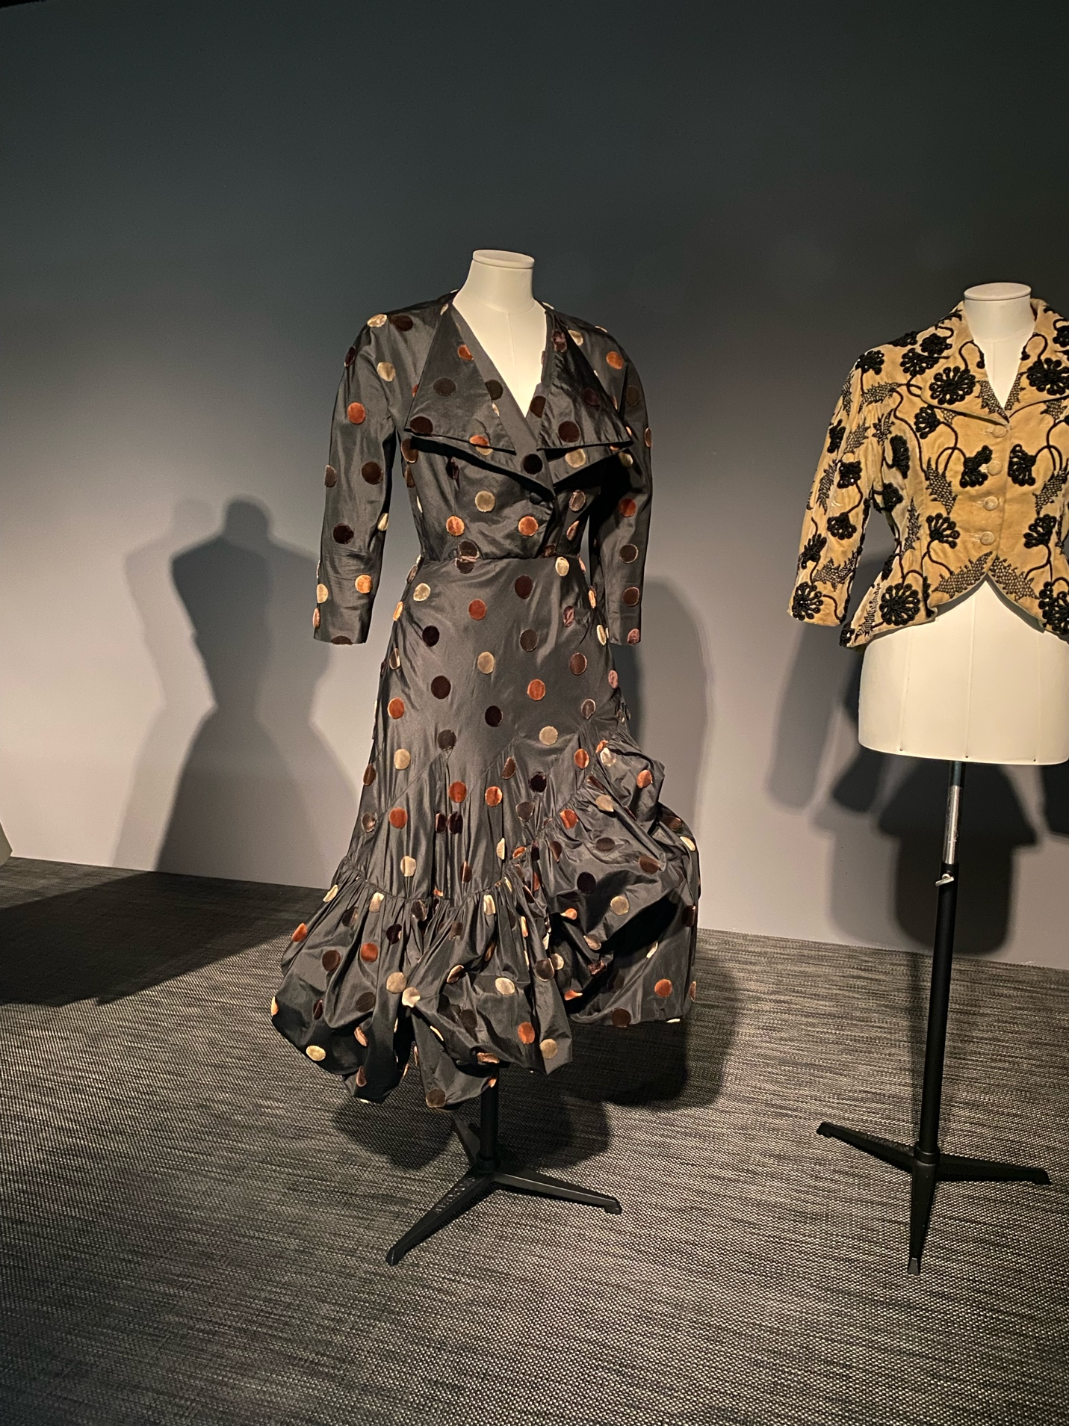Figure 1: A dress (left) and jacket (right) designed by Cristóbal Balenciaga.

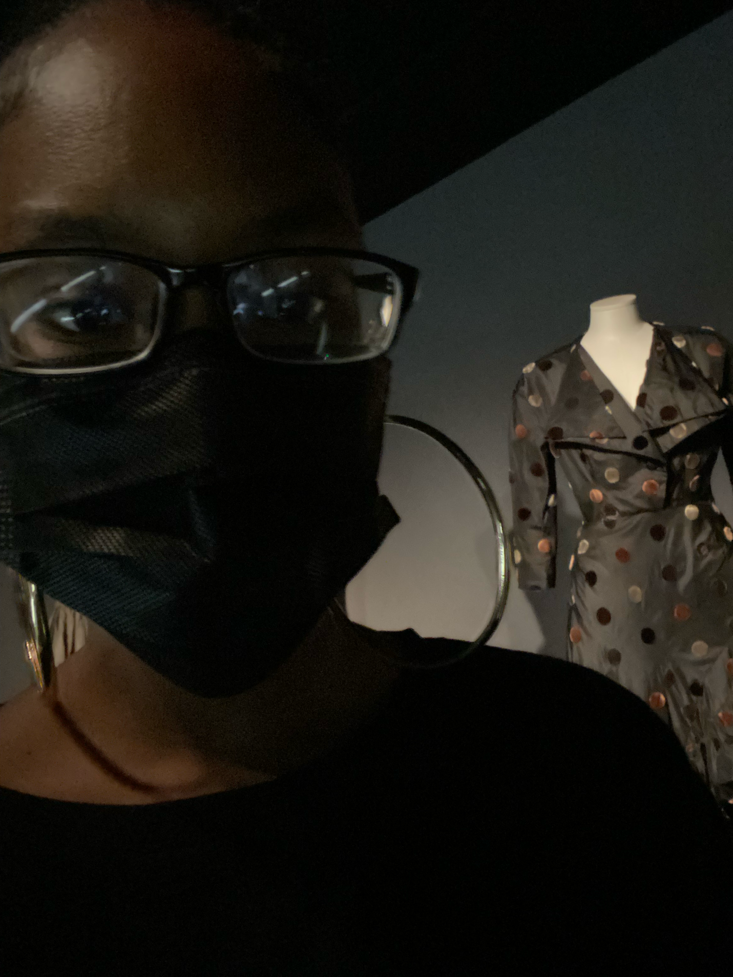

Reference

McDowell, C. (2021, November 18). Cristóbal Balenciaga (1895-1972). *The Business of Fashion.* Retrieved June 10, 2022, from https://www.businessoffashion.com/articles/news-analysis/cristobal-balenciaga-1895-1972/

Militano, H. (n.d.). *The museum at fit opens Cristóbal Balenciaga and Christian Dior Exhibit*. Grazia USA. Retrieved June 10, 2022, from <https://graziamagazine.com/us/articles/museum-fit-exhibit-cristobal-balenciaga-christian-dior/>

F1: *Balenciaga Dress & Jacket.* (2022). photograph, New York.

# 

Figures



Figure 1. [Include all figures in their own section, following references (and footnotes and tables, if applicable). Include a numbered caption for each figure. Use the Table/Figure style for easy spacing between figure and caption.]

For more information about all elements of APA formatting, please consult the APA Style Manual, 6th Edition.