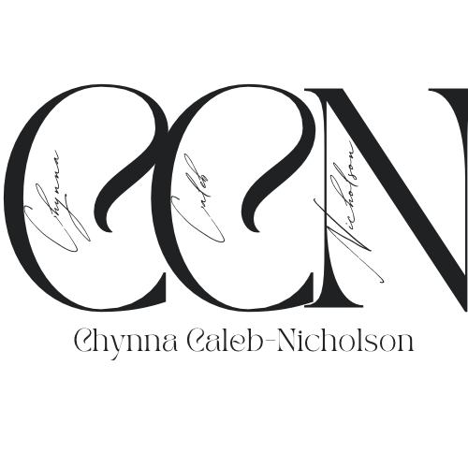

Chynna Caleb-Nicholson currently attends New York City College of Technology, City University of New York (CUNY), and will be obtaining her Bachelorette degree in the Business and Technology of Fashion this upcoming fall. Caleb-Nicholson is family oriented, self driven, respectful, selfless, ambitious, authentic, artistic, passionate, and balanced. Her mission upon completion of her degree is to obtain a job as a Visual Merchandiser Coordinator. In this role, Caleb-Nicholson intends to use her retail sales experience as well as her internship experience to her advantage to excel in this position. Working at a major department store and as an Executive Intern for a luxury women’s brand, Caleb-Nicholson has been given hands on skills selecting merchandise, pulling PR pieces and attending preproduction fittings. Caleb-Nicholson values hard work and dedication. During her final year of college, Caleb-Nicholson was President of her departments *Futurists of Fashion* club, participating in the schools first ever fashion show titled: Luxe of Fashion. What that experience taught was the importance of teamwork and that it is okay to go back to the drawing board and make changes if things are not going as planned.

According to Bell (2017), the colors can “create a mood, expand, or contract.” For Caleb-Nicholson’s logo, she decided to use the color black because the color always adds a sense of togetherness and sleekness. Caleb-Nicholson opted out of using brighter colors because she wanted her logo to look as clear and concise as possible. For her font, Caleb-Nicholson used TAN Pearl for her initials and full name; and Buongiorno Rastellino for the cursive writing within each initial. ***Line*** is defined as “a direction – a major part of composition” (Bell, 2017). To add a little excitement, each name writing in cursive is rotated and aligned vertically. Vertical lines represent “strength, height and pride” and Caleb-Nicholson has shown throughout her college career her resilience to push forward as obstacles have continuously been thrown her way.

PERSONAL GOALS

Get a Drivers License

* Study for written exam
* Complete and pass written exam
* Go to driving school/take courses
* Take driving test and pass
* Obtain license

Own a Brownstone

* Obtain an annual salary job
* Good credit (850 and above)
* $7000 or more to make a down payment
* Find perfect location
* Wait for the market to be stable

Own a Farm

* Decide what to harvest, grow, produce
* Funding
* Finding property
* Machinery
* Research the process of owning and running a farm

Start a Non-Profit Organization

* Purpose of the non-profit
* Brainstorm names
* Research prospective organization members
* Create Internal Plans, Strategy plans,
* Get a lawyer or speak with lawyers

Start a Family

* Be financially stable
* Find a partner I would want to marry and have children with
* Get married
* Make sure health is in order (Health Insurance)
* Have kids!

PROFESSIONAL GOALS

Obtain Bachelorette Degree

* Properly completing my internship at Lafayette148
* Correctly completing internship class assignments
* Passing Internship
* Properly complete DegreeWorks
* Graduate

Work at Lafayette148

* Show up to work on time
* Complete internship projects on time
* Complete Internship and Internship course (Pass)
* Figure out intended role/position
* Participate in an Exploratory Interview

Obtain master's degree

* Research master programs/schools
* Take and pass (GRE) and/or (GMAT) with 730 or higher (GMAT)
* References
* Learn about potential mentors/professors
* Get accepted into a school

Salary Increase

* Perform in role
* Obtain master's degree
* Ask for feedback
* Review work accomplishments
* Get a promotion

Start Branding Agency

* Target Market
* Develop brand identity
* Develop a branding strategy
* Build the team
* Legal help

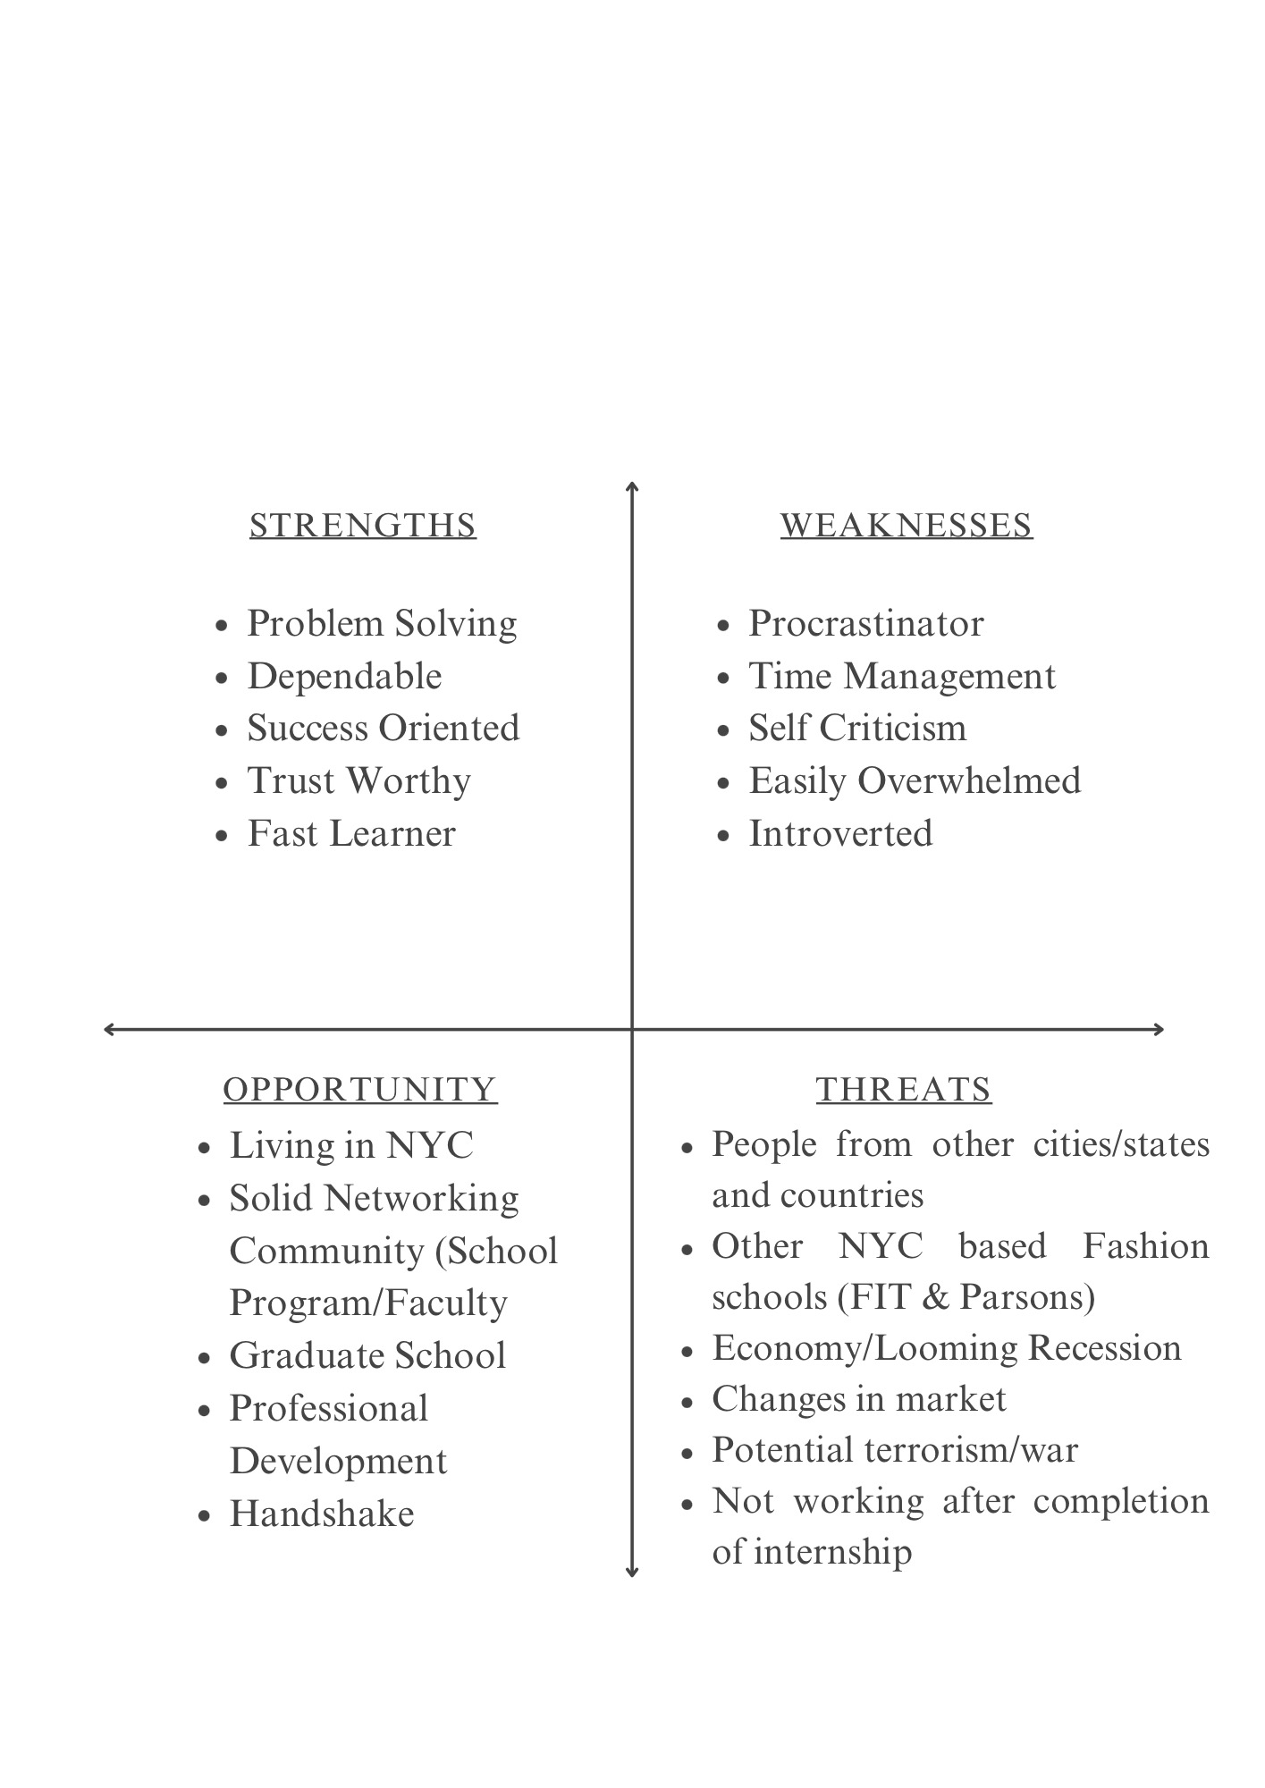

Reference

Bell, J., & Ternus, K. (2017). Silent selling. In *Bloomsbury Publishing Plc eBooks*. https://doi.org/10.5040/9781501315527