NEW YORK CITY COLLEGE OF TECHNOLOGY
CITY UNIVERSITY OF NEW YORK

DEPARTMENT OF ARCHITECTURAL TECHNOLOGY

COURSE OUTLINE

ARCH 1101 INTRODUCTION TO ARCHITECTURE
4 lab hours, 2 credits

Course Description:
The Introduction to Architecture provides a foundation for students entering the BArch / BTech program to develop a “visual literacy” of the built environment. Using New York City as a living laboratory, students explore concepts of design, composition, and construction in the context of the city through their direct experience of buildings. By practicing the basic skills of drafting, sketching, and reading about buildings, and with the opportunity to present their understandings to others through written assignments and verbal presentations, students will develop methods of representing and presenting architecture verbally and graphically.

Course Goals and Objectives:
- Observe buildings in their totality and in detail and convey your observations in sketches. Learn to identify the various styles and tectonic elements within the built environment.
- Translate on-site measurements of a building into scaled drawings that relate the plan, section, and elevation of a building following basic graphic standards.
- Understand the basic concepts of composition such as scale, proportion, balance, and symmetry as experienced in the built environment, and be able to express them in drawing, speaking, and writing.
- Read different formats of architectural writing and become familiar with the way architecture is discussed.
- Develop a vocabulary specific to architecture and construction.
- Research case studies of buildings and urban spaces.
- Work together as a team, learning how to divide responsibilities and manage time.
- Present your work to a jury as an individual and with a team.

It is assumed that students entering this class have no background in architecture and no experience in drawing. Drawing assignments will begin with simple exercises that become more complex as the semester progresses. Students will be evaluated by their determination and improvement during the semester, and on their ability to grasp an understanding and ability to represent the built environment graphically, verbally, and in writing.

Co-requisites: ENG 1101 (ARCH1112 recommended for Arch Tech/BArch majors)
Required Text: Texts will be assigned during class. As an Open Educational Resource (OER), readings are available online at no cost to the students.
Suggested Reference: Francis Ching, Architecture: Form, Space, and Order. Wiley Publishing. This is a good foundation text that students can also use in their design courses.
Attendance Policy: No more than 2 absences are permitted during the semester. For the purposes of the record, two late arrivals are considered as one absence. Exceeding this limit will expose the student to failing at the discretion of the instructor. Besides providing formal instruction, this is a lab class and much of the work is done in class and overseen by the instructor. Missing a class requires the student to make up the work in his/her own time and risk falling behind.

Course requirements & Grading:
- Students will be required to maintain a sketchbook into which they will enter their sketching assignments and record their observations. Sketchbooks can be used for other courses such as Foundations I. Sketchbooks will be reviewed from time to time by the instructor for recommended improvement.
- Students will be required to write several essays in the course of the semester as homework assignments. Students will print out their papers and turn them in to the professor at the following class.
- Students will work on drawing projects during lab time. Since students have varying experience, they should be allowed to work at their own pace. There are no hard deadlines except at the midterm (everything from weeks 1 – 7) and the final (everything from weeks 9 – 15). Students with experience will progress more quickly and can be given the next assignment ahead of schedule or be given an outside bonus assignment as the instructor wishes. Slower students can work past the intended deadline. It is recommended that students keep up in order to avoid having to work on multiple assignments simultaneously.
- Students are required to participate during pinups and class discussions. While instructors recognize that some students are more comfortable speaking up, all students are encouraged to speak. All students will make two presentations to juries (A team presentation and an individual presentation) where they stand before the jurors with their work pinned on the wall.
- Below are the grading percentages. Please note these are close approximations; actual point values will appear on each individual assignment.

Project 1 – Mausoleum: 15%
Midterm: 20%
Project 2 – House Section: 10%
Urban Design Project: 15%
Final Project: 30%
Homework Problems 10%

NOTE TO STUDENTS: the only way students fail this course is by not doing their work. When an assignment is not turned in it gets a zero. If a student misses the midterm, they get a zero. If a student doesn’t show up for the final review, they get a zero. Zeros add up to zero, so please do your work.

Academic Integrity:
Students and all others who work with information, ideas, texts, images, music, inventions, and other intellectual property owe their audience and sources accuracy and honesty in using, crediting and citation of sources. As a community of intellectual and professional workers, the college recognizes its responsibility for providing instruction in information literacy and academic integrity, offering models of good practice, and responding vigilantly and appropriately to infractions of academic integrity. Accordingly, academic dishonesty is prohibited in The City University of New York and is punishable by penalties, including failing grades, suspension, and expulsion.

Course Learning outcomes:
Since this is a first-semester introductory course, it does not meet any of the Student Performance Criteria required by NAAB. Its goal, however, is to give students a broad exposure to architecture.

- Demonstrate an understanding of the relationship between plan, section, and elevation of a simple building.
- Demonstrate the ability to produce a scaled hand-drafted drawings and models from a set of given dimensions.
- Demonstrate the ability to understand a reading about architecture through writing and speaking.
- Demonstrate an understanding of building proportion, rhythm, symmetry, hierarchy, etc. through sketching.
- Demonstrate an ability to stand before a jury and articulate ideas through drawings, models, writing, and speaking

General Education Learning Outcomes / Assessment Methods
Learning Outcomes | Assessment Methods
Upon successful completion of this course the student shall be able to: | To evaluate the students’ achievement of the learning objectives, the professor will do the following:
- Develop Knowledge from the range of architectural disciplinary perspectives presented in the course. | - Review student observations of site visits and lectures and assess written, graphic and oral reports.
- Utilize Skills and demonstrate knowledge needed to facilitate communication and critical thinking. | - Assess student research and critical thinking abilities by monitoring weekly progress of lab work and readings.
- Integrate knowledge and work productively to communicate ideas through oral, graphic and written media. | - Assess the students’ ability to integrate and communicate through peer and juried review of student presentations.

Course Intended Learning Outcomes / Assessment Methods
Learning Outcomes | Assessment Methods
Upon successful completion of this course the student shall be able to: | To evaluate the students’ achievement of the learning objectives, the professor will do the following:
- Observe with a critical eye and engage in discussion on the subject of the course. | - Review student observations and Assess the quality of critical thinking and contributions to discussions during oral and graphic presentations.
- Research and investigate deeply into a given subject so as to contribute to the growth of knowledge. | - Assess student research abilities through written and graphic materials.
- Synthesize and Apply what is learned to synthesize understanding and to complete assignments given in the class. | - Assess the students ability to synthesize apply what is learned from lab work and through the grading of assignments.
- Communicate effectively through presentations to the class using written oral and graphic media. | - Assess the students’ ability to effectively present and communicate what is learned on a given subject.
- Communicate effectively using a vocabulary developed throughout the course. | - Assess the students’ use of professional vocabulary during quizzes, oral presentations and written assignments.

New York City College of Technology ■ The City University of New York
Voorhees Hall, 186 Jay Street, Brooklyn, New York 11201
Department of Architectural Technology

ARCH 1101 INTRODUCTION TO ARCHITECTURE
4 classroom hours, 2 academic credits
Instructor: Robert Christo rchristo@citytech.cuny.edu
OFFICE HOURS: TBD

WEEK 1 Introduction: The Role of the Architect
The Profession of Architecture What do architects do? How do I become an architect? What roles do architects play in our society? These are the types of questions investigated in this first class. Students will be introduced to the BArch and BTech curricula of City Tech to understand the various paths they can follow to pursue a career in architecture and related fields.
Vitruvian Triad Using the framework of the Vitruvian triad as a simple starting point, students will be introduced to fundamental concepts of architecture and to the methods of understanding buildings.

Class Schedule
Discussion and Presentation: Becoming an architect: BArch and BTech at City Tech. Below is a link to a presentation by Chair Vaidya explaining our program.
https://vimeo.com/302735202/203e040818
Lab:
- In-class Writing Exercise: What do you see? Write a one-page description of the building projected on the screen.
- In-class Video: Archiculture: experience architectural studio culture with a visit to Pratt:
https://www.youtube.com/watch?v=62r3UPrOS9k

Homework Assignment:
- Purchase a sketchbook (8”x10” or so), an architect’s scale, drawing pencils, and a triangle.

2) Read Vitruvius, Ten Books of Architecture
Book I, Chapter 2: The Fundamental Principles of Architecture
Book III, Chapter 1: On Symmetry: In Temples and in the Human Body
http://www.gutenberg.org/files/20239/20239-h/20239-h.htm

3) Writing Assignment: In Book III, chapter 1, Vitruvius relates symmetry to the human body. What does Vitruvius mean by symmetry? How is the human body symmetrical? How is a building symmetrical?
1. Write a 200- to 250-word (long paragraph) and describe what Vitruvius means by symmetry. Your paper should be written in full sentences in paragraph form using 12 point Ariel font on 8 1/2 x 11 inch paper. Place your name, date, course number (ARCH1101), professor’s name (Prof. Christo), and assignment number (Assignment 1) in a column in the upper left-hand corner of the paper.
2. Write a 200- to 250-word (long paragraph) and discuss the importance of the principles of Order, Arrangement, and Eurythmy as described by Vitruvius.

New York City College of Technology ■ The City University of New York
Voorhees Hall, 186 Jay Street, Brooklyn, New York 11201
Department of Architectural Technology

ARCH 1101 INTRODUCTION TO ARCHITECTURE
4 classroom hours, 2 academic credits
Instructor: Robert Christo rchristo@citytech.cuny.edu
OFFICE HOURS: TBD

WEEK 2 Grids, Modules, and Rhythms

This week students will consider concepts of organizational systems such as grids and repetitions through demonstrations, and sketching assignments. Students will investigate building elements such as colonnades, bays, modulated fenestrations.
Modes of Representation
Drawings: Manually or digitally graphic representations of things
Photographs: Mechanical representations of things that exist
Writings: Descriptive representations of things in language
Renderings: Manual or digital representations of things that do not exist
Images: Digital representations of things that do not exist
Shapes (massing vs. volume)
Students will examine simple and moderately complex two- and three-dimensional forms and explore their outlines and internal relationships.
Foreshortening
As an aid to building observation and sketching, students will learn the basic concept of foreshortening as it pertains to linear perspective.
Proportions
Students will learn the principles of proportional systems through demonstrations supported by assigned readings. Building examples using harmonic proportions, the golden section, or the Fibonacci spiral will illustrate how these systems were used.
Symmetry and Balance
Concepts of symmetry will be explored in historical examples and in actual buildings in downtown Brooklyn. Readings discussing the principles of classical symmetry will be assigned and discussed, followed by a discussion of the Renaissance church, villa, and palazzo.
Hierarchy
Many buildings are organized as an assembly of several masses, each of which exhibits its own symmetry and proportion. Such assemblies may be symmetrical or asymmetrical. Students will be introduced to examples where buildings of complex mass are balanced and discover how the connections between the masses are visually resolved. Buildings, both simple and complex, exhibit visual hierarchy. Students will be introduced to examples of ways in which buildings exhibit hierarchy and deploy elements to reinforce that hierarchy.

Introduction to Sketching

The ability to sketch is an essential skill for the architect. With a sketch the architect can document attributes encountered in the environment or record a fleeting idea that might be incorporated into a design. Sketching allows the architect to “see” a building much more closely than just looking at it. It is said that an “Architect doesn’t see a building until he draws it.” Furthermore, architects record their first ideas as sketches and often explore those ideas in sketch form before turning to the drafting table or computer to work it out.
Perspective
To assist their sketching techniques, students will be introduced to the science of linear perspective through demonstration and practice. Students will be introduced to basic sketching techniques for documenting their observations upon which they will build their skills in the course of the semester. Readings will reinforce and build technical vocabulary.

Class Schedule
- Class Writing Discussion: Vitruvius
- Lab Demonstration:
    - Proportions, rhythm, and module: sketching the elevation of the Villa Savoye
    - Foreshortening and perspective: sketching the Villa Savoye

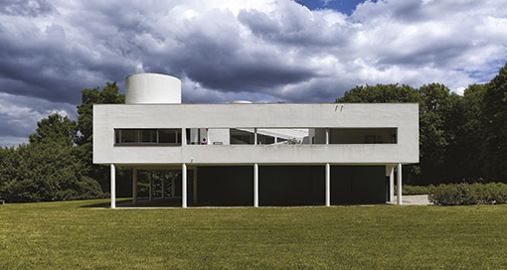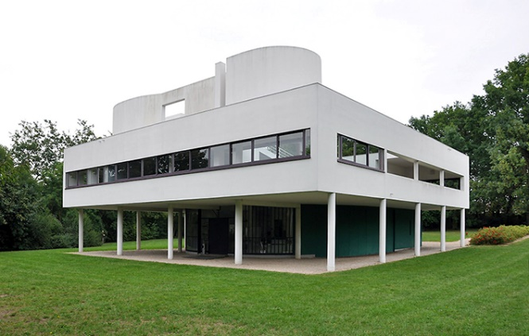

- Lab:
    - On a photograph of a building in perspective, use a scale or straightedge and find the vanishing points and horizon line.
    - Sketching On the paper provided (if you don’t have a sketchbook) practice sketching a simple object (a cup, for example) from multiple points of view.

Vocabulary

Module Bay Rhythm Repetition
Verticality Horizontality Frontal Oblique
Foreshortening Colonnade Fenestration Façade

Assignment
- In the sketchbook make a drawing from a photograph of a complex rectilinear building (Robie, Fallingwater, Unity Temple, for example).
- In the sketchbook, draw a coffee mug, cooking pot, chair, table, or other simple object in your home from multiple points of view (5 sketches).
- Look up the vocabulary words above and be prepared to discuss them next class.

New York City College of Technology ■ The City University of New York
Voorhees Hall, 186 Jay Street, Brooklyn, New York 11201
Department of Architectural Technology

ARCH 1101 INTRODUCTION TO ARCHITECTURE
4 classroom hours, 2 academic credits
Instructor: Robert Christo rchristo@citytech.cuny.edu
OFFICE HOURS: TBD

WEEK 3 Introduction to Architectural Drawings: Measuring, Drawing, Dimensioning
Students must develop an awareness and familiarity with drawing types used in the typical architectural practice. Students review and practice the use of drafting strategies introduced in ARCH 1112 and apply these methods to a more complex drawing problem. Concepts covered will include review of orthographic projection drawings, introduction architectural graphic standards and notation. Understand the co-relation between different drawing types. Students will understand and use the architectural scale.
This class presents methods for surveying and documenting measurements. Students will apply the use of the architectural scale to translate an existing building to its orthographic representation as an elevation.

Class Schedule

Discussion: Homework assignment: vocabulary words
Lab demonstration: Introduction to drafting.
- Using the architectural scale: drawing a simple shape at 1/8, ¼, ½ scales. Start with a simple rectangle at full foot dimensions, say 8’x10’; try a couple at different scales. Learn how to find inches and try a couple of different rectangles.
- Title block
- Lettering
Lab:
- Sketch the elevations of four sides of a chosen object in the classroom. (I use the metal and glass storage case for stone and masonry samples in V305.) Each sketch should resemble its proportions.
- As a class, measure the object and write the dimensions on your sketches.
- The class will pick an appropriate scale and they will draw the four elevations, plan, and section.
- Put in the dimension lines and label the dimensions.

New York City College of Technology ■ The City University of New York
Voorhees Hall, 186 Jay Street, Brooklyn, New York 11201
Department of Architectural Technology

ARCH 1101 INTRODUCTION TO ARCHITECTURE
4 classroom hours, 2 academic credits
Instructor: Robert Christo rchristo@citytech.cuny.edu
OFFICE HOURS: TBD

WEEK 4 Introduction to Architectural Drawings: Field Trip

Students investigate the correspondence between the elevation of a building, which they see, and the plan and section of the building, which they don’t. Students will meet at the front entrance to Greenwood Cemetery, 25th Street and Fifth Avenue in Brooklyn (yes. Brooklyn. One year several students went to Madison Square Park).
Sketching
Immediately inside to the right is the Kohl Mausoleum which I have the students sketch; you are free to choose another. They sketch the four elevations, take pictures, and sketch it perspectivally.
Measuring
I then ask them to measure it for the hands-on experience. I then ask them to think about the footprint: what is the perimeter outline of the building? Their dimensioned drawings will become the basis of their drafted elevations
Exploring
Time permitting, walk deeper into the cemetery and discuss the many styles of architecture; the classical orders, Gothic, Egyptian, etc. I provide a handout of the Classical orders; they are easy to find on Google Images.

Class Schedule
Discussion: Historic styles in the cemetery
Lab: Sketching, measuring, and recording
Assignment:

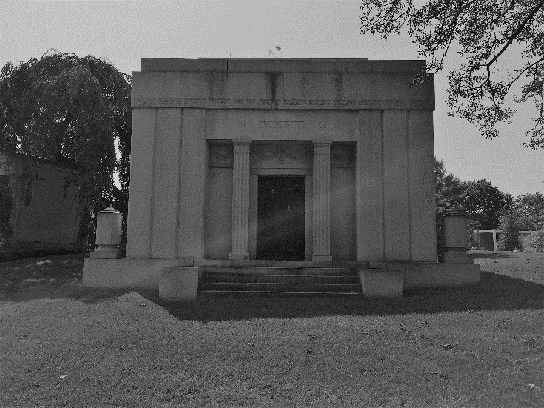
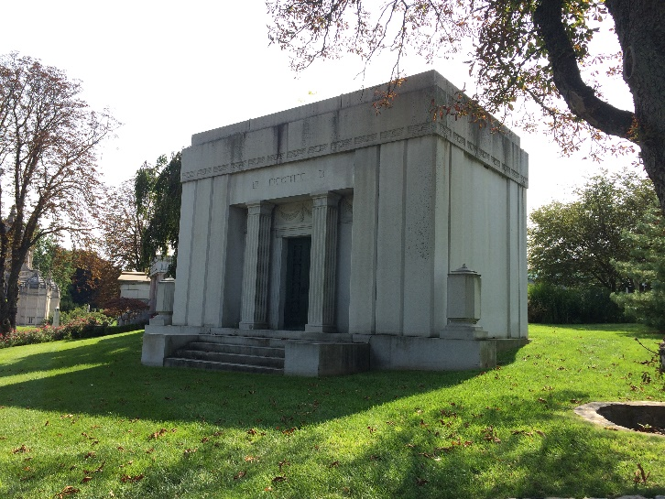
Kohl Mausoleum, Greenwood Cemetery, Brooklyn

New York City College of Technology ■ The City University of New York
Voorhees Hall, 186 Jay Street, Brooklyn, New York 11201
Department of Architectural Technology

ARCH 1101 INTRODUCTION TO ARCHITECTURE
4 classroom hours, 2 academic credits
Instructor: Robert Christo rchristo@citytech.cuny.edu
OFFICE HOURS: TBD

WEEK 5 Introduction to Architectural Drawings: Elevations

After measuring the four sides of a building and noting the openings, projections, bays, etc., students will draft the four elevations to scale at ¼”=1’-0”. Students continue to develop familiarity with drawing types used in the typical architectural practice. This week focuses on drafting elevations.
In the long term, students review and practice the use of drafting strategies introduced in ARCH 1112 and apply these methods to a more complex problem of drawing a building. Concepts covered will include review of orthographic projection drawings, introduction to architectural graphic standards and notation., and understanding the interrelation between different drawing types.

Class Schedule
Discussion: Class pin-up of elevation sketches for comparison of dimensions.
Lab: Students will set up the drawing sheets with a title block and start their drawings. Two elevations should fit on a 11x17 sheet. Professors can specify how they want the students to format their sheets.
Professors will spend the class time moving from student to student helping them advance their drawings and answering any questions.

New York City College of Technology ■ The City University of New York
Voorhees Hall, 186 Jay Street, Brooklyn, New York 11201
Department of Architectural Technology

ARCH 1101 INTRODUCTION TO ARCHITECTURE
4 classroom hours, 2 academic credits
Instructor: Robert Christo rchristo@citytech.cuny.edu
OFFICE HOURS: TBD

WEEK 6 Introduction to Architectural Drawings: Plans and Sections

During the trip to Greenwood, students were asked to sketch the footprint of the perimeter of building based on their “best guess” by what they observed from the outside.

They will continue to develop familiarity with drawing types used in the typical architectural practice. This week will focus on deriving a plan. Students review and practice the use of drafting strategies introduced in ARCH 1112 and apply these methods to a more complex drawing problem. Concepts covered will include review of orthographic projection drawings, introduction architectural graphic standards and notation. Understand the interrelation between different drawing types.
Introduction to differentiating construction vs. design drawings
Students are introduced to concepts of graphic representation in relation to intention and desired communication. Students observe, analyze, and discuss the difference between construction drawings and design drawings.

Class Schedule
Discussion: class pin-up of elevations
Demonstration: How to derive a plan and section from elevations.
Lab: Taking your scaled elevation drawings of a mausoleum, derive a longitudinal and transverse section. Since we don’t have access to the interior of the mausoleum, assume that all the walls, roofs, and floors are 1’- 0” thick. Accurately draft a scaled plan, longitudinal, and transverse section that conforms to the dimensions given and accurately shows door, window, and column locations.
Homework Assignment: Complete lab assignment.

New York City College of Technology ■ The City University of New York
Voorhees Hall, 186 Jay Street, Brooklyn, New York 11201
Department of Architectural Technology

ARCH 1101 INTRODUCTION TO ARCHITECTURE
4 classroom hours, 2 academic credits
Instructor: Robert Christo rchristo@citytech.cuny.edu
OFFICE HOURS: TBD

WEEK 7 Introduction to Architectural Drawings: Axonometric Drawing

In this class students will learn the fundamentals of drawing an axonometric of a simple object.
They will continue to develop familiarity with drawing types used in the typical architectural practice. This week will focus on deriving a plan. Students review and practice the use of drafting strategies introduced in ARCH 1112 and apply these methods to a more complex drawing problem. Concepts covered will include review of orthographic projection drawings, introduction architectural graphic standards and notation. Understand the interrelation between different drawing types.

Class Schedule
Demonstration: Students will draw simple rectangular volumes per the directions of the professor.

Lab:
- The students will draw a rectangular volume. Assume that the volume has a “wall, roof, and floor thickness,” and draw an axonometric that shows a horizontal cut and a vertical cut. Finally, draw an axonometric with combined horizontal and vertical cuts by removing one upper corner of the cube.
- Students are given an isometric of a geometric object. From the view given, they are to draw top view (plan) and the four side views (elevations).

Assignment: Similar to your lab assignment, from the isometric of a geometric object provided, find the plan and elevations.

New York City College of Technology ■ The City University of New York
Voorhees Hall, 186 Jay Street, Brooklyn, New York 11201
Department of Architectural Technology

ARCH 1101 INTRODUCTION TO ARCHITECTURE
4 classroom hours, 2 academic credits
Instructor: Robert Christo rchristo@citytech.cuny.edu
OFFICE HOURS: TBD
WEEK 8 Midterm Exam

3 hours, 20 minutes

You will be given a set of dimensioned elevations and photographs of a simple building provided by your professor. From these sketches and photographs, draw the following at ½” = 1’- 0”:
- One exterior elevation of the front of the building
- One longitudinal section (front to back) showing the interior elevation
- One lateral section (side to side) showing the interior elevation
- One floor plan

Assume all wall, roof, and floor thicknesses are 1’ – 0”

EXTRA CREDIT
- For students who finish early, they can draw for extra credit draw an axonometric of the building (as we did in class),

New York City College of Technology ■ The City University of New York
Voorhees Hall, 186 Jay Street, Brooklyn, New York 11201
Department of Architectural Technology

ARCH 1101 INTRODUCTION TO ARCHITECTURE
4 classroom hours, 2 academic credits
Instructor: Robert Christo rchristo@citytech.cuny.edu
OFFICE HOURS: TBD

WEEK 9 A Section through a Two-story House

Building sections are important when describing the construction of buildings. They show the floor-to-floor height differences, floor construction, and stair configurations. Given a plan of a simple house, students will investigate how to interpret the information given and translate it into a section and an elevation.

Class Schedule
Demonstration: How to read sectional information on a drawing
- Benchmark elevations
- Window and door schedules
Lab: Begin to construct the section and elevation
Assignment:

New York City College of Technology ■ The City University of New York
Voorhees Hall, 186 Jay Street, Brooklyn, New York 11201
Department of Architectural Technology

ARCH 1101 INTRODUCTION TO ARCHITECTURE
4 classroom hours, 2 academic credits
Instructor: Robert Christo rchristo@citytech.cuny.edu
OFFICE HOURS: TBD

WEEK 10 A Section through a Two-story House (continued)

Building sections are important when describing the construction of buildings. They show the floor-to-floor height differences, floor construction, and stair configurations. Given a plan of a simple house, students will investigate how to interpret the information given and translate it into a section and an elevation.

Class Schedule
Demonstration: Students will be shown how to cut a section through a stair using the riser-tread ratio and how to determine its length based on its height.

Lab: Finish constructing the section.

New York City College of Technology ■ The City University of New York
Voorhees Hall, 186 Jay Street, Brooklyn, New York 11201
Department of Architectural Technology

ARCH 1101 INTRODUCTION TO ARCHITECTURE
4 classroom hours, 2 academic credits
Instructor: Robert Christo rchristo@citytech.cuny.edu
OFFICE HOURS: TBD

WEEK 11 Urban Planning and Design
Students will develop awareness of the practice of urban design and site planning though team activity and presentation. Concepts covered will include site observation, site inventory and analysis, principles of climate and the process of selecting the best location for a given use. Discover the relationship of buildings and the space and contexts that surround them, how places are made, and how programs interrelate across and urban setting.

Class Schedule
Demonstration: Presentation of Battery Park City South.
Lab: Fieldtrip to Metrotech

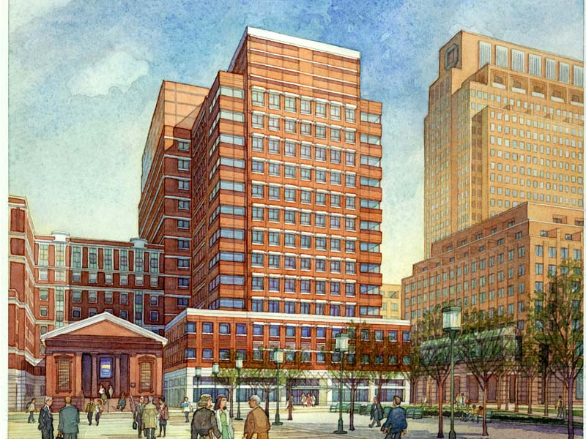

Assignment:

For this assignment you will go out and investigate the built environment. You will be assessed on how well you can express your experience of your place in speech and writing, and how astute you can translate your experience in to critical evaluation of your place. You will work in teams of 3 (or 4) and prepare a PowerPoint presentation of your assigned place as well as write a short paper.

Step 1: Locate: Define the boundaries of your location. For example, if you are doing Rockefeller Center, where is it? At what point, in every direction, are you no longer in it, that is, when are you in Rockefeller Center, and when are you not? When you have determined the boundaries of your location, confirm with your professor.

Step 2: Research: You should always begin a project knowing as much as you can about your site. Provide enough background and history to inform your audience about your location. When was it built? Who built it? Who was the architect? If is wasn’t built at one time, but evolved, how did it evolve? This background and history should be very general; you will be doing more in-depth research and writing with your English professor (Note: Research will be conducted in both ARCH 1101 and ENG 1101).

Step 2: Observe and document: You will go to your location and PHOTOGRAPH things that relate to the topics below. YOU MUST USE YOUR OWN PHOTOGRAPHS, NOT PHOTOS FROM THE INTERNET. I would recommend that you go together so you can discuss what you are documenting and share your observations.
- Although you will only be presenting one topic, each person will address each of the topics below.
- You should each take photos documenting the topics and take notes documenting your observations.
- You will then regroup and share your photos and observation notes.

Step 3: Present: Your team will be required to present ALL the topics below. Each of you will be required to present as part of your team, with each of you presenting at least one topic. Decide among yourselves who is covering which topic and let your professor know. You will present the topic you are assigned and be evaluated on how well you cover it.
TOPICS

- TOPIC 1. Describe the buildings:
  - What do they look like?
  - What are they made of?
  - Do they work together (scale, material, color)?

- TOPIC 2. Describe how the building masses relate to the public spaces
  - What is dominant, the building(s) or the space?
  - Is there a hierarchy among the building?
  - Is there a center of the complex?
  - How do the doors relate to the public spaces?

- TOPIC 3. Describe how the public spaces are treated:
  - Are they landscaped?
  - Are there places for people to meet and sit?
  - What kind of people are there: students, business people, ?
  - What are the people around there doing?
  - Are the ground floors of the buildings welcoming: can you see inside?

- TOPIC 4. How is the infrastructure treated?
  - Where do the cars go?
  - Are the pedestrians separated from the cars?
  - Where do the service trucks go?
  - Where do the cars park?

DELIVERABLES

PART 1
Power point presentation (10% final grade)
- You will present one PowerPoint presentation together as a group.
- Your presentation should have:
- Provide spatial and temporal context. Provide four to five slides showing the location of your place and providing some history and background to orient your audience.
- A site plan showing all the buildings, spaces, streets, etc. (Get this first before you visit the site and take it with you.) You need to understand how the buildings, pedestrian spaces, and streets relate. Mark on it where you take your pictures.
- 15 slides covering EACH topic; there should be a total of at least 65 slides. Each team member will have 15 and there will be at least 5 at the beginning for background and location.
  - Every slide should have a short caption to describe what you are showing.
  - You may put more than one image on a slide.
  - You may have text slides and title slides.
  - If you are showing a street, you should have a site plan showing where that street is.
  - Similarly, if you are showing a building, you should show us on a site plan where that building is.
- Each team presentation will have thirty minutes, with five to ten minutes for questions.

PART 2
An evaluation of your place (10% final grade)
Each of you separately will write a 250-word essay (2 pages, double spaced) that critically evaluates your place. What works and what doesn’t? Is the place a nice place to be: if it is, why; if it is not, why not? What is the best thing about it; the worst? Be specific: if you like something, give us a reason; if it’s nice, tell us why. Cite the things you observe as evidence. For example:
- “The street felt very welcoming to pedestrians, because the buildings on either side were a nice scale at three stories, and proportionally related to each other.”
- “The car traffic was slow enough to allow pedestrians to cross from one side to other comfortably.”
- “The services for the buildings were located on the side streets away from the public plaza.”

ASSESSMENT

Excellent Good Somewhat Not at all
Team 3 2 1 0

Did you present as a team? ᴼ ᴼ ᴼ ᴼ
Did you cover all the topics? ᴼ ᴼ ᴼ ᴼ
Did you provide background on your place? ᴼ ᴼ ᴼ ᴼ

Excellent Good Somewhat Not at all
Individual 2 1 .5 0

Did you completely document your topics? ᴼ ᴼ ᴼ ᴼ
Did your slides represent your point? ᴼ ᴼ ᴼ ᴼ
Were your observations accurate? ᴼ ᴼ ᴼ ᴼ
Were your observations insightful? ᴼ ᴼ ᴼ ᴼ
How well did you follow directions? ᴼ ᴼ ᴼ ᴼ
Was your speaking clear? ᴼ ᴼ ᴼ ᴼ

New York City College of Technology ■ The City University of New York
Voorhees Hall, 186 Jay Street, Brooklyn, New York 11201
Department of Architectural Technology

ARCH 1101 INTRODUCTION TO ARCHITECTURE
4 classroom hours, 2 academic credits
Instructor: Robert Christo rchristo@citytech.cuny.edu
OFFICE HOURS: TBD

WEEK 12 Styles of Architecture: Field Trip to Brooklyn Heights

The appearance of a building is not arbitrary. Most buildings can be assigned to a stylistic category, each of which has its own distinguishing attributes. We use the word “style” to describe buildings with similar qualitative attributes. It is a superficial way to describe a group of similar buildings, but it will serve our purposes as a starting point for recognizing the differences and similarities between buildings we encounter. Classical buildings, for example, have particular types of columns (Doric, Ionic, Corinthian, for example); Gothic has pointed arches, flying buttresses, and pinnacles. In this lesson, we will explore the architecture of Greenwood Cemetery and identify many of the styles of architecture. Most of the styles originated in Europe and Asia and were brought to America in “revival” movements. There are many styles that are specific to times and cultures. In New York, we find many buildings belong to several general categories:

Class Schedule
Discussion: Styles of architecture
Lab:
- In-class sketching exercise: sketch a building projected on the screen
- Field Trip: Walk through Brooklyn Heights and explore the different types of architecture, their composition, and their various elements.
- Sketch Borough Hall from a frontal viewpoint and show patterns, rhythms, and modules and proportions. Draw a perspective of an oblique view of the façade and demonstrate foreshortening.

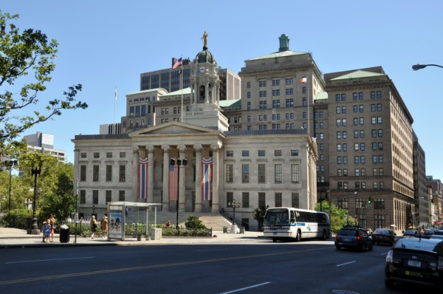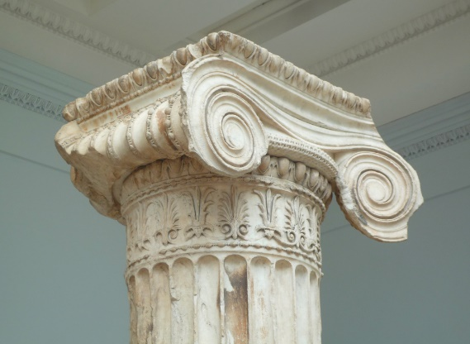

New York City College of Technology ■ The City University of New York
Voorhees Hall, 186 Jay Street, Brooklyn, New York 11201
Department of Architectural Technology

ARCH 1101 INTRODUCTION TO ARCHITECTURE
4 classroom hours, 2 academic credits
Instructor: Robert Christo rchristo@citytech.cuny.edu
OFFICE HOURS: TBD

WEEK 13 Personal Space

This week begins a three-week exercise in which students are asked to develop a concept for a non-programmed space, namely a personal space, and express it in words, and in coordinated plan, sections, elevation, and cutaway axonometrics. In the final class they will present their project to a jury. The purpose of this exercise is to give the students a chance to present a concept that is expressed in architectural drawings. They should not be evaluated by how well their concept corresponds to their design; this they will do in design studio. Rather the evaluation should focus on the completeness of the drawing set, and how well it is coordinated.

Discussion:
What is a concept? How do architects organize their thoughts into a single concept that can be expressed architecturally?
Lab:
- The professor will provided you with a plan showing a 20’ x 20’ square space with window and door positions dimensionally indicated. A window and door schedule will be provided enumerating sill and head heights. The plan is at a smaller scale than the deliverables so you will have to scale it up. You have the option to change window sizes and locations, but the quantity of windows and doors must remain the same. You must have your professors approval for any changes you make to the plan
- Think about the kind of personal experience you want to capture in your space. Make a list of bullet points of the key feelings you have and ways you might want to accommodate them
- Draw a floor plan sketch on tracing paper to represent your concept. Be adventurous.
- Pin-up the list and the plan for in-class discussion. In this discussion, we will select a “concept” for your waiting room, and we will discuss how this “concept” might be interpreted architecturally.
Homework Assignment:
- Each Personal Space must be 20’ wide x 20’ deep x12’ high (18’x18’ interior). Variations are allowable with permission of the professor.
- Compose a one-paragraph description of your concept from your bullet points.
- Using hardline drafting (not freehand) draw the plan and 4 interior elevations of the walls of the space (at 3/8”=1’-0” scale).
- Draw the interior elements you are adding to the space on the plan.
- Place trace paper over each elevation and sketch in the interior elements as they would appear in elevation. Assume you are standing in the center of the room and looking in each direction.
- On the sketches, use notations to identify the major elements.

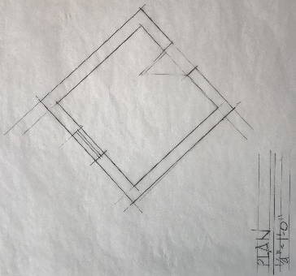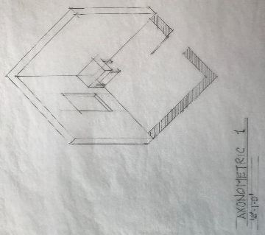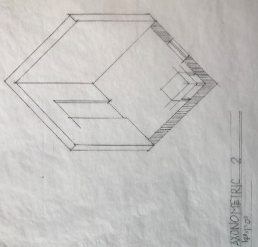

New York City College of Technology ■ The City University of New York
Voorhees Hall, 186 Jay Street, Brooklyn, New York 11201
Department of Architectural Technology

ARCH 1101 INTRODUCTION TO ARCHITECTURE
4 classroom hours, 2 academic credits
Instructor: Robert Christo rchristo@citytech.cuny.edu
OFFICE HOURS: TBD

WEEK 14 Personal Space - Development

This week continues the three-week exercise in which students are asked to develop a concept for a non-programmed space, namely a waiting room, and express it in words, in plan, section, and elevation, and in a model. In the final class they will present their project to a jury.

Lab:
- Review your plan and elevations with your professor.
- Draw two cutaway axonometrics (plan plus two walls) from opposite corners of the room.
Homework Assignment:
Requirements for the final assignment are:
- (1) Plan, (4) interior section/elevations and (2) cut away axonometric drawings on 11 x 17 vellum drawn at 3/4”=1’-0”. You will be graded on the quality of the drawings and the completeness of the drawings.
- Concept statement. You must write 2-3 paragraphs that describe your waiting room with all of the concepts that are being represented in the drawings. You will be graded on the clarity of your written statement, and your ability to clearly communicate your architectural concept. This must be computer printed, and must be pinned up along with the drawings for review. Include any inspirational imagery, or any other diagrams that you used in reaching your final design.

New York City College of Technology ■ The City University of New York
Voorhees Hall, 186 Jay Street, Brooklyn, New York 11201
Department of Architectural Technology

ARCH 1101 INTRODUCTION TO ARCHITECTURE
4 classroom hours, 2 academic credits
Instructor: Robert Christo rchristo@citytech.cuny.edu
OFFICE HOURS: TBD

WEEK 15 Personal Space – Presentation

Class Schedule
- Students will present their Personal Spaces to a jury of faculty members, similar to what you might expect in your Foundations or Studio classes.

- Following the presentation students will have 30 minutes to write about a building projected on the screen. This should be the same building image the wrote about in Week 1.
Instructions
After looking at the building projected on the screen, write a description of what you see.
  - Use terms and concepts we have been discussing throughout the semester in your description.
  - Your essay must be written in full sentences in paragraph form – in other words, don’t use lists or bullet points.
  - You will be evaluated on the depth of your observations and your ability to relate what you see in the building from your experiences from looking, sketching, and talking about buildings.

