Leslie Fuller
12-6-16
Final Project
Professor Swift and Chin

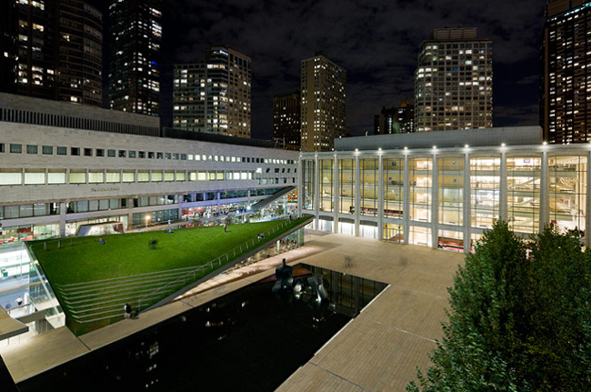

Hypar Pavilion was built in 2010, the building is mainly a restaurant, bar, lounge and grass roof where people can hang out and review all the sites of Lincoln Center. The building is 10804 square feet and it is open for the public and it accessible for the for all people. It I surrounded by the Metropolitan Opera, the New York City Ballet, the New York Phil monic and the Juilliard School. It is located West 65th street. The Hypar Pavilion received the 2011 Design Award from the AIA New York Chapter and the 2011 Innovation Design in Engineering and Architecture with Structural Steel awards program. People can come and play their own music and do other shows. It is an Italian cuisine at that place. We are endearing to create a feeling, engender a mood provide sense of drama and the beauty of what goes on in our halls. We want attract pass by, but we also want to surprise West Siders. The architect also designed the content for the 24 hour blade trying them informative, visually arresting and at times whimsical. The point is to make these screens much more atmospheric and gestural and impressionistic than more posters Ms. Diller said. There are 37 blade templates video sequences of 20 to 90 seconds with different themes, they use both Lincoln Center performance and outside actors. A few more projects still remains, they build a new Hypar Pavilion next to other performing arts center buildings.

Reference Page

http://www.nytimes.com

