Learning Places Fall 2016
Chin/Swift

SITE REPORT [part II A: LINCOLN CENTER] MANHATTAN, N.Y

TREOLINE HALEY

10/14/2016

INTRODUCTION
It was a wet day to be outdoor, but the trip was important for the class to take. The trip was to explore Lincoln Center and assess the architecture of the performance sites. The site was also important to visit because it is one of the class researched project for the finals. The project of the day was to choose an area, sketch and research the area. Lincoln Center theater was re-established in 1985 under the leadership of Chairman John V. Lindsay. The Theater makes every effort to keep admission price low and its doors to stay open.

PRE-VISIT REFLECTION
Prior visiting the site, I was expecting to see one building with actors and performance taken place in front of the building. I was also expecting to see a ticket booth before entering the building. I have never visit the site before.

SITE DOCUMENTATION (photos/sketches)
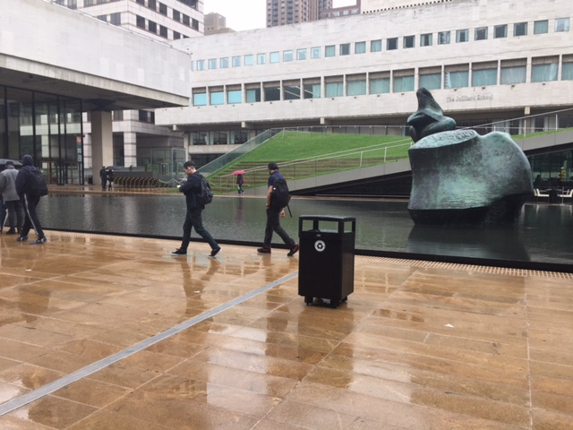
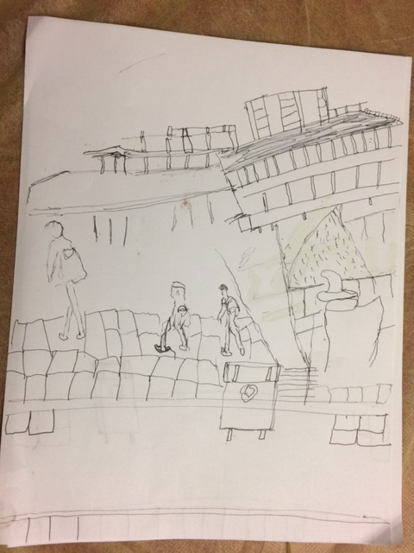

Write description of sketch or photo here, explaining why it is important and what it shows
The photo and sketch is the Illumination Lawn which was designed by Diller Scofidio & Renfro. The Illumination is located in the northwest section of the main Lincoln Center at New York City campus. The lawn is overlooking 65th street, between Columbus and Amsterdam avenues. Mr. Rossi said that the “timing of Lincoln Center's season essentially, fall to spring meant he had to choose a type of grass that would look good even in the cold months”. For a while, he considered embracing the problem and choosing a grass that would forthrightly go brown in winter. "That would have been an extreme look," he said. "It wasn't the look they were going for. I think this Lawn is an apt metaphor for the center. It is a performance area because it would be fascinated for me just to watch people sit and pick nick on the lawn.

Write description of sketch or photo here, explaining why it is important and what it shows

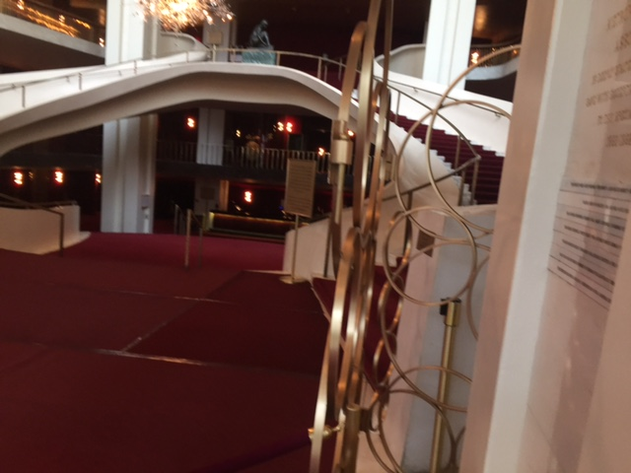

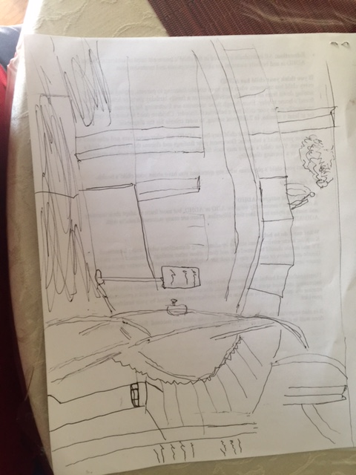

This picture is the pavilion of the Metropolitan Opera House. The scapular and staircase are a “masterpiece” of art which will attract anyone’s eye upon entering the house. As for me I don’t think that performance always has to be live. A crafted elegant masterpiece such as the scapular and the staircase serve as performance for me because I’m amuse by the activities around them. Activities such as people standing next to the sculpture for picture taking and taking picture of themselves while climbing the staircase.

QUALITATIVE SITE OBSERVATIONS
1.Neighborhood / Street Character
a. Business and performance
b. It is an upscale neighborhood

2.Vitality of Place

a. General Description

I think it is an area for business and entertainment

b. Pedestrian Activity
.
There weren’t many people on the day I was there.
c. Vehicular Traffic
The traffic was moderate.

3. Age of Buildings (provide evidence for prediction)
According to “https://en.wikipedia.org/wiki/Lincoln_Center_for_the_Performing_Arts”

a. The New York Public Library 1965

b. Metropolitan opera House Build in 1955 – 1969, but open in 1962.

c. David Geffen Hall 1964.

.
4. Relationship Between Buildings (urbeme)

a. The buildings were mix in structure, some similar and some different.
b. Stones from Italy

5.Building Details (historical/architectural styles, morphemes)

- the buildings have an unique structure such as the beams. There all are in line with each other on each of they own building also the windows have the same size and shape.
- There are much shorter than the buildings that does not belong to the center.
- They all design for entertainment.

6. Building Uses
a. Performances
b. Culture Center
c. picnic
d. relaxation for workers and pederasties

7.Other Observation

QUANTITATIVE DATA for Area of Study
Subject | Data
Street Names | 10 Lincoln Center Plaza, New York, NY 10023.
Street Width | between 64th to 66^{tth} street
Pavement Type | Concrete
Building Heights | vary
Building Widths (Window  Bays) | 16.3 acres wide as a whole
Building Types/Uses | Performance/ Art
Empty Lots / Gardens | Grass lawn for picnic
Shops / Restaurants | Around 16 restaurants in the area
Industrial Shops | Schools, library and office buildings
Other Data | Alice Tully Hall
Other Data
Other Data

QUESTIONS TO RESEARCH FURTHER
QUESTIONS:
- Will there be more infrastructure in the future
- What is the meaning of the structure.
3. type of food and beverage serve in the building
RESEARCH METHOD/SOURCE FOR EACH QUESTION ABOVE:
- Question 1
  - https://en.wikipedia.org/wiki/Lincoln_Center_for_the_Performing_Arts
  - xx
  - xx
- Question 2
  - Google
  - xx
  - xx
- Question 3
a.www.opentable.com/Local-Restaurants‎
  - xx
  - xx
SUMMARY / POST VISIT REFLECTION
It was a pleasure for me visiting Lincoln Center because I’ve never visited it before.

