Learning Places Fall 2016
LIBRARY / ARCHIVE REPORT
Treoline Haley Lincoln Center (Alice Tully Hall)
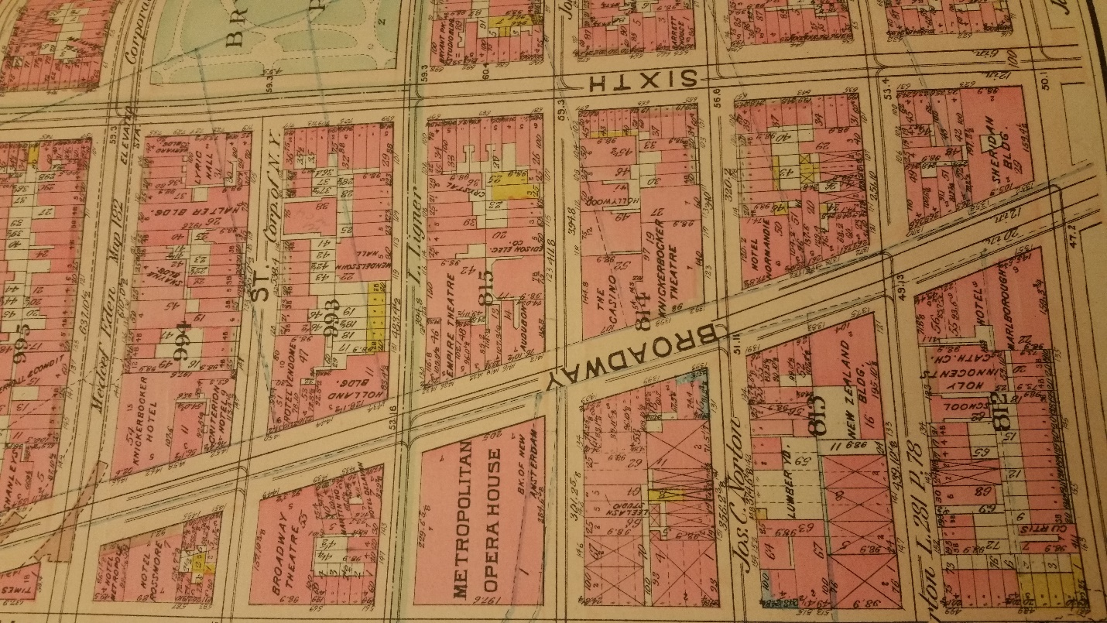

12.03.2016

INTRODUCTION

My theater is Alice Tully Hall. Tully Hall is a concert hall that is incorporate into Lincoln Center. The hall is located in the Juilliard Building at 1941 Broadway New York, 10023. Alice Hall was the last public hall to be completed in the Lincoln Center complex. The significance of the name of the Hall: The Hall was name and design after a New York performer, a philanthropist and a former singer whose name was Alice Tully. The hall was designed by Pietro Belluschi and his two associates: Eduardo Catalano and Helge. The acoustic was design by Heinrich Keilholz. Although there were architects and acoustician, Alice played an influential role in the designing of the hall. Alice was extremely particular and meticulous about her choices of colors and what in the hall would bear her name. She also insisted on having ample space between the rows of seats.

SOURCES found

- http://www.lincolncenter.org/venue/alice-tully-hall
- The Museum of New York https://blog.mcny.org/2015/07/14/from-dazzling-to-dirty-and-back-again-a-brief-history-of-times-square/Creator Name, Title of Document, Source Name, Page or Volume,
- The New York Historical Society and The Map room in the New York Library
DOCUMENTATION of site & resources (maps/archival documents/ photos) 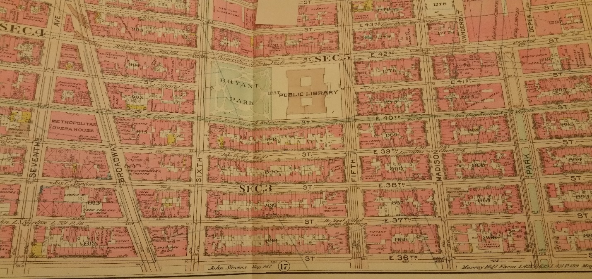
This is a Map of early Manhattan, with Lincoln Square, there were not much business in the area at the time

This is a map of the buildings in Lincoln Center
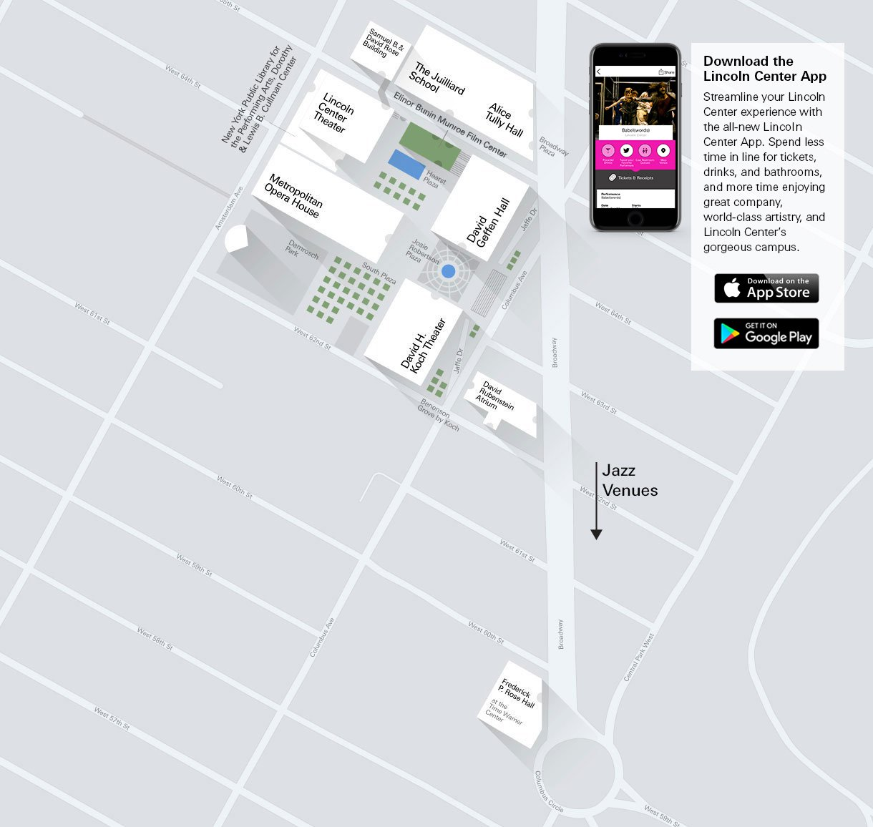

The original building of Alice Tully Hall when first build in 1969. It was an opaque building
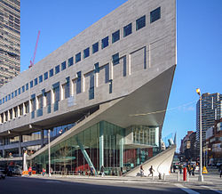.

Alice Tully Hall after renovation in the year 2009. The Hall was elevated to the level of Lincoln Center premier performance venues and a cable-net glass replace the original opaque wall to expose the lobby to pass byers

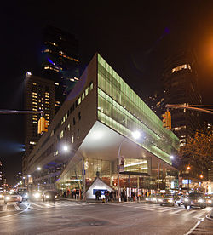

. The theater has designated aisle transfer seats, to accommodate wheelchair and expanded stage. There are 1096 seats in the hall. In 2009 the theater was remodel to make the interior and public space more welcoming and visible to the spectators. After the revelation, the hall renames as the “Starr Theater.” Alice Tully Hall was ranked and praised as being one of the best performance hall in Lincoln

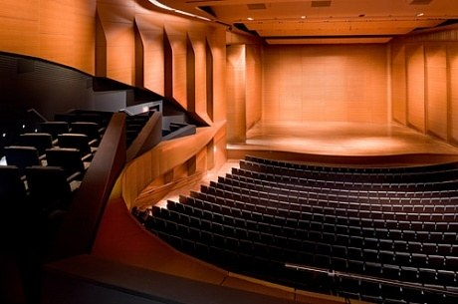

DISCOVERIES
- Neighborhood History
  - Both Square
  - Formerly called San Juan Hill, a predominantly African American neighborhood of tenements.
- Key Events / Historical Dates
  - The Time building (1969)
  - The Renovation and Renaming of Alice Tully Hall (2009)

- Key Players
  - Alice Tully
  - Arthur Houghton
  - Pietro Belluschi
- Relationship Key Players
  - The Hall is part of Lincoln Center which is a consortium of civic leaders and others led by, and under the initiative of, John D. Rockefeller III.
  - New York Time News Paper owner
- Public Perception of Key Events
  - The first music and concert Hall in Lincoln Center
  - The Hall was ranked and praised as being one of the best performance hall in Lincoln
- Important Changes to Neighborhood
  - New Restaurant
  - Residential Buildings
  - Public shows

- Other Observations
  - The theater was remodel to make the interior and public space more welcoming and visible to the spectators.
  - More welcoming

QUANTITATIVE DATA for Area of Study
Subject | Data
Land Ownership | City owned / leased property
Number of Blocks | About 10 Block arounds
# of Buildings on a Typical Block | 4 to 5 buildings per block
Materials | Granite, Marble, Concrete, Glass, and Engineered wood
# of Stories of Buildings | 5 to 8 floor
Residential Bldgs. | Residential and Business
Empty Lots | Have construction going on
Commercial Uses | Just about every building
Industrial Uses | Horse traders and public commute
Other Data | 50,000 people passed through Lincoln Square on a daily basic
Other Data | Business improvement district, cultural & recreational property
Other Data | Side walk café zoning regulations

QUESTIONS to Research Further

QUESTIONS: How much money does the Hall make per show? How many people come from New York vs other states or country?
RESEARCH METHOD/ ADDITIONAL SOURCES NEEDED TO ANSWER EACH QUESTION ABOVE:
- Question 1
Google
- Question 2
http://www.lincolncenter.org/venue/alice-tully-hall
SUMMARY / POST VISIT REFLECTION
I had never visit the site before we taken our class trip so I did not know what et expect. I thought it would have busy lie Time Square what I have visit early in the semester.

