St. Marks church Archive Report

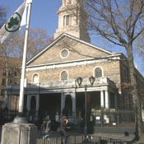

Leslie Fuller
11-11-2016

INTRODUCTION

St Marks Church was first establish in 1799. It is the church full of arts other people perform in the 1920’s and 1930’s. During the era Richard Forman owned the church. There was a fire in the church in 1978 and it was reconstructed after the fire. The space is big, people can come around world and see the art of the church.

SOURCES found
- Creator Name, Title of Document, Source Name, Page or Volume, Date
- Creator Name, Title of Document, Source Name, Page or Volume,

DOCUMENTATION of site & resources (maps/archival documents/ photos)

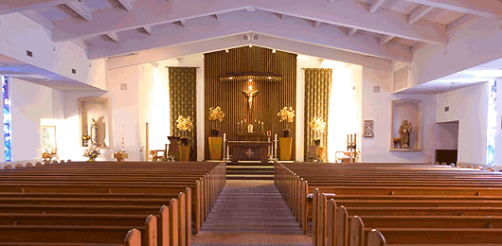

PODCAST The church of St. Mark’s-in-the-Bowery is one of Manhattan’s most interesting and mysterious links to early New York history. descendants with the help of Alexander Hamilton and the architect of New York City Hall built this new chapel with the intention of serving the local farming community of Bowery Village.
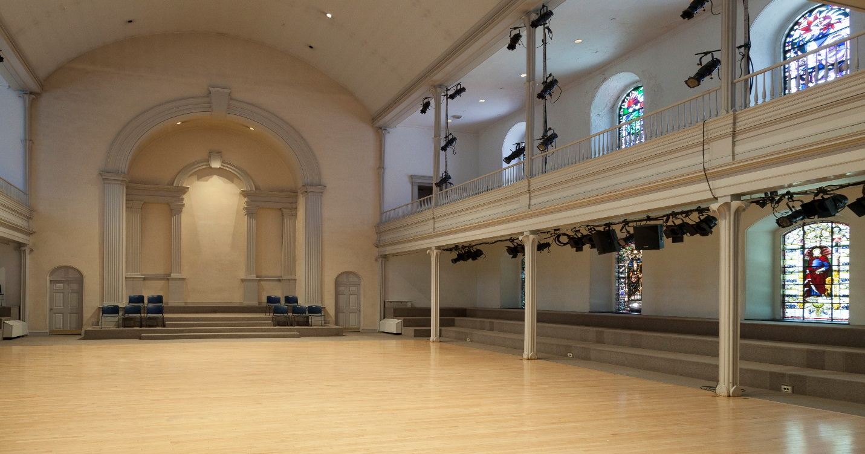

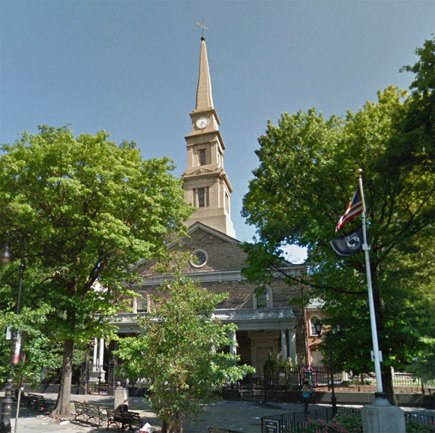

explaining why it is important

mysterious links to early New York history. descendants with the help of Alexander Hamilton and the architect of New York City Hall built this new chapel with the intention of serving the local farming community of Bowery Village

St. Mark’s reflected the changes that swept through Greenwich Village during the 20th century, with experimental and sometimes scandalous church activities, from hypnotism, modern dance and even a trippy foray into psychedelic Christian rock.

qUANTITATIVE DATA for Area of Study
Subject | Data
Land Ownership | It is own by Episcal Diocs of New York
Number of Blocks | It is small church less then a quarter of a block
# of Buildings on a Typical Block | There are two buildings
Materials | The church is part stone and brick
# of Stories of Buildings | It is one story
Residential Bldgs | There is a residents of the building where the preist lives and the rest is office
Empty Lots | There are no empty lots
Commercial Uses | It is a non profit
Industrial Uses | They have ballet and have poetry
Other Data
Other Data
Other Data

QUESTIONS to Research Further
QUESTIONS:
- Lorem ipsum dolor sit amet?
- Consectetuer adipiscing elit?
- Sed diam nonummy nibh euismod?
RESEARCH METHOD/ ADDITIONAL SOURCES NEEDED TO ANSWER EACH QUESTION ABOVE:
- Question 1
  - xx
  - xx
  - xx
- Question 2
  - xx
  - xx
  - xx
- Question 3
  - xx
  - xx
  - xx

SUMMARY / POST VISIT REFLECTION
Lorem ipsum dolor sit amet, consectetuer adipiscing elit, sed diam nonummy nibh euismod tincidunt ut laoreet dolore magna aliquam erat volutpat. Ut wisi enim ad minim veniam, quis nostrud exerci tation ullamcorper suscipit lobortis nisl ut aliquip ex ea commodo consequat. Lorem ipsum dolor sit amet, consectetuer adipiscing elit, sed diam nonummy nibh euismod tincidunt ut laoreet dolore magna aliquam erat volutpat. Ut wisi enim ad minim veniam

