Learning Places Fall 2016
Chin/Swift

SITE REPORT [Signature Theatre]
The Birth of New Performance

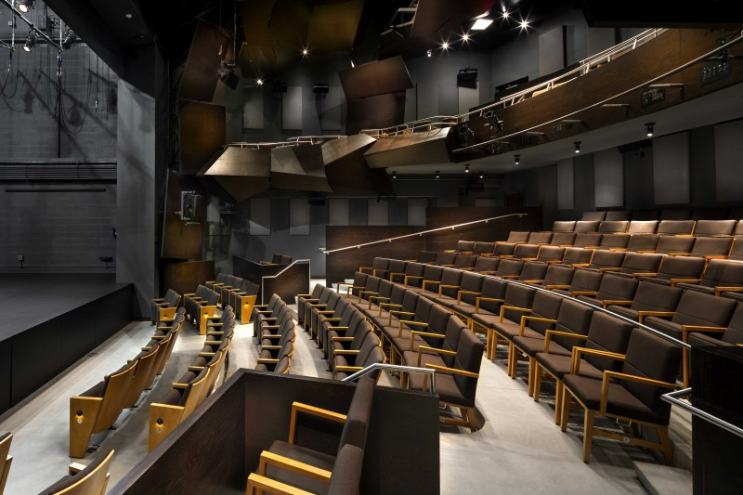

Matthew Norris
11.7.2016

INTRODUCTION
‘The Death of the Last Black Man in the Whole World’, the title of the play in which y invitation to signature Theatre was comprised. This was supposed to be our textbook equivalent and turned out to be much more. Whilst not heavily architecturally decorated, the Signature theatre transparency and simplicity, keeps its focus on theatre and through that, provided me with a standout performance.
PRE-VISIT INFORMATION

Before my visit, I had no expectations or views of the theatre. Initially, I only knew that I was going to a place in Manhattan for a show. So even though, I went there blind we did have some talk about in it in class. So thereby, this was my first time there was first in all regards.

SITE DOCUMENTATION (photos/sketches)
Drawing 1: You May Proceed to the Concierge

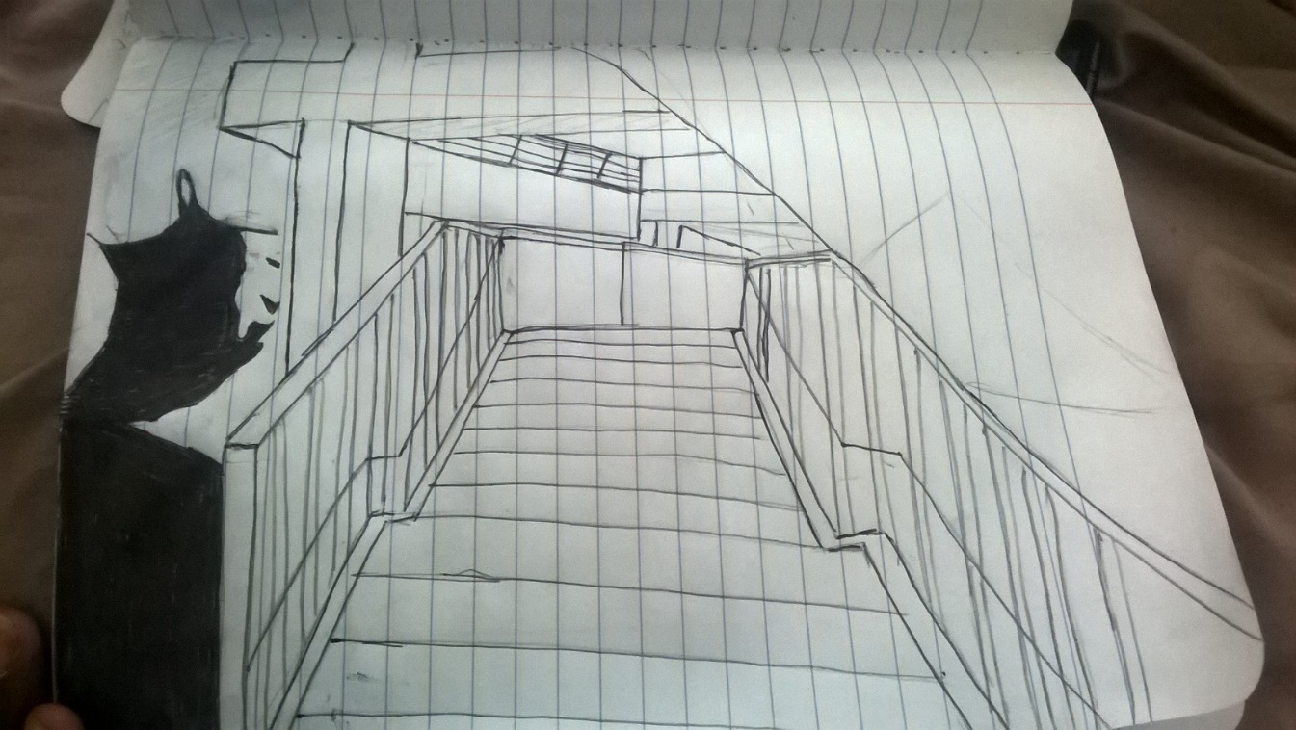

This picture is of the stairs leading to the Concierge and theatres. The Signature Theatre focuses solely on its abstract theatre and thereby its architectural elements are very simple and graduate in attractiveness and flow as one gets closer to the theatres.
Picture 1: The Concierge
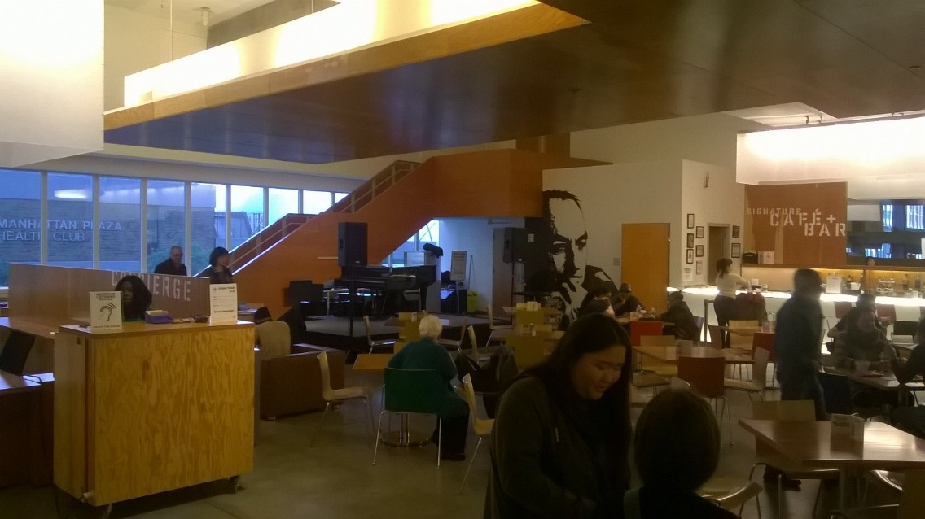

The above photo, features the concierge area of the theatre located on the first floor. This was designed merely for transport to the theatres. Not to say that it isn’t well stocked with a bar and bathroom entrances, but its attractiveness grows with the walkways and stairs to the theatre rooms. Therefore, the concierge is the appetizer, the refreshments made solely to usher you to the final course, the performances
Picture 2: Support
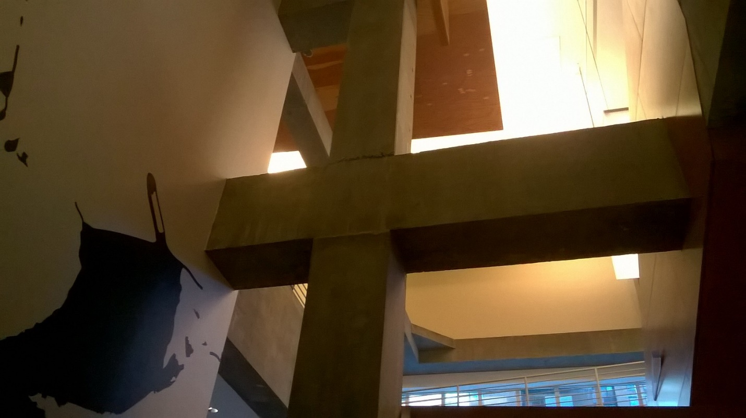
Picture 2, features extruded or rather shown, support beams and floor space from the ground floor. It is interesting because in the Concierge, and up, the visible structure is covered, so the theatre becomes a symbol of progression.
QUALITATIVE SITE OBSERVATIONS
- Description of architectural elements of the auditorium where the performance was held (stage arrangement (proscenium, thrust, in the round, etc.), seating arrangement (amphitheater, orchestra and balcony, etc. aisles, types of seats, risers, etc.)
The Alice Griffin Jewel Box Theatre is not really architecturally sound. The theatre itself, features two floors of seats in a that generic semicircular fashion with the stage being visible around the main viewpoint. However, I was late to the performance and did not experience the feel of the empty theatre evolve into its performing alter ego.

- Description of the physical element on the stage (set pieces, technologies, lighting,

For the piece that I watched, the lighting and equipment on the stage weren’t visible from my point of view but were well placed as each illuminated section was clearly visible (I sat on the top floor, far left). It wasn’t a play with vast technological advances or necessities, it featured enough to compliment the play.

- Description of audience (socio-economic, community identity)
The theatre prices and décor cater to persons of all socio-economic, community identity, race and any other criteria. The employees also represented this, thereby the Signature Theatre caters to equality and thereby all persons. The theatre prices are not exorbitant and therefore, are not ridiculous to those of any financial background.

QUANTITATIVE DATA for Area of Study
Subject | Data
Size of performance space | Alice Griffin Theatre: 19
Size of spectator space | Alice Griffin Jewel Box: 191; Irene Diamond Stage: 294  Romulus Linney Courtyard Theatre: 191
Number of spectators (range) | Almost Full capacity (189)
Length (in time) of performance | 1.5 hours
Cost of performance (if any) | $30.00
Other data | Excellent customer service

QUESTIONS TO RESEARCH FURTHER
QUESTIONS:
- Why is the Signature Theatre farther than most theatres in Manhattan?
- What was Mr.Gehry’s inspiration when designing the Theatre?
RESEARCH METHOD/SOURCE FOR EACH QUESTION ABOVE:
- Question 1
  - In my view, the theatre is that far away from other theatres, due to its size and the availability of the space that was needed. I also believe that it adds to its independence and inherit signature as being that theatre that’s farther from transportation and other theatres but worth the travel.
- Question 2
  - Mr.Gehry’s aim when designing the Theatre was intimacy. Intimacy of stage presence, familiarity and intimacy of feel, by which I mean that the audience doesn’t feel like an audience but rather actors in the play.
  - http://ny.curbed.com/2010/3/16/10518804/frank-gehrys-new-hells-kitchen-theaters-revealed

